Meal Type clustering in Daily Food & Nutrition Dataset using K-Means Clustering
- Modified the existing notebook (Link to Notebook) by changing the dataset and performing the following actions:
Task | Actions Taken | Rationale | Difficulty Level  (1-10) | Time Taken
Data Exploration & Preprocessing | Loaded dataset, removed unwanted columns, handled missing values, encoded categorical features, and removed outliers. | Ensuring data quality and preparing it for clustering. | 5 | 45 min
Feature Engineering | Processed, scaled numerical attributes, and split data into train & test sets. | Standardization is necessary for distance-based clustering methods like K-Means. | 4 | 30 min
Implemented K-Means Clustering | Tested different k values using the elbow method and Silhouette Score to find the optimal number of clusters. | Finding the best k value ensures meaningful cluster formation. | 7 | 1 hour  30 min
Hyperparameter Tuning | Performed grid search over different k values, achieving the highest Silhouette Score (0.0839). | Fine-tuning k improves cluster separation. | 6 | 50 min
Dimensionality Reduction (PCA) | Applied PCA and reduced dimensions to visualise clustering, observed drop in Silhouette Score (0.0407). | PCA helps in visualization but may impact cluster separation. | 5 | 30 min
Model Evaluation | Compared results with different k values and PCA, analyzed cluster quality using Silhouette Score. | Evaluating model performance and cluster coherence. | 4 | 30 min
Conclusion & Future Improvements | Identified suboptimal clustering, decided to explore DBSCAN for potential improvement. | Exploring more advanced clustering algorithms for better results. | 3 | 15 min

- Business Understanding
Objective:
The principal aim of the study is to use K-Means Clustering for meal types as classified by their nutritional values concerning the Daily Food & Nutrition Dataset. This classification should enable understanding dietary habits, optimize meal planning for individual users, and offer specific nutrition recommendations.
Key objectives include:
Meal classification: These should identify clusters of different types of meals such as breakfast, lunch, dinner, and snack by the nutritional profile.
- Dataset Overview:
Dataset Used: Daily Food & Nutrition Dataset
https://www.kaggle.com/datasets/adilshamim8/daily-food-and-nutrition-dataset
Description: This dataset contains 10,000 records of food intake data from 1,000 unique users, covering a wide variety of food items and their nutritional values.
- Preparing Data
The following EDA steps are followed:
1. Load dataset.
2. Drop unwanted columns.
3. Handle missing values.
4. Encode categorical features.
5. Process datetime features (NA)
6. Remove outlier
7. Split into train & test sets.
- Modelling:
Model Hyperparameters:
Number of clusters (k): has to explore for Maximum Silhouette Score.
The K-Means assigns a cluster label (0-11) to each data point based on the closest centroid.
- Evaluation:
Evaluation Metrics:
Best K (optimal clusters) according to Silhouette Score (0.08272176061074789): 2
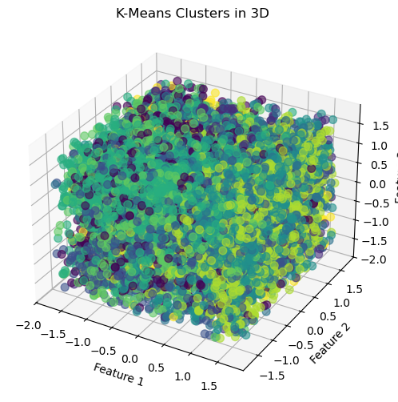
- Observation:

- With hyperparameter tuning (k value grid search), we are able get Silhouette Score of 0.0839295427364303
- After dimensionality reduction, we are able get Silhouette Score (after PCA): 0.04073845946537742
- So, I am planning to explore more advanced algorithm like DBSCAN to get better result.

