Algorithms: Decision Tree and Random Forest (Hyperparameter Tuning)
Dataset: [Germany Used Cars Dataset 2023]: Link to Dataset
- Modified the existing notebook (Link to Notebook) by changing the dataset and performing the following actions:
Task | Actions Taken | Rationale | Difficulty Level  (1-10) | Time Taken
Data Exploration & Preprocessing | Handled missing values, encoded categorical features, removed outliers (IQR method), and scaled numerical features. | Ensuring clean and structured data for better model performance. | 5 | 45 min
Feature Engineering | Selected important features based on domain knowledge and feature importance scores. | Helps in reducing complexity and improving interpretability. | 4 | 30 min
Implemented Decision Tree (Baseline Model) | Trained Decision Tree model using Gini impurity criterion. | Establishes a benchmark for comparison with Random Forest. | 5 | 45 min
Implemented Random Forest (Without Hyperparameter Tuning) | Trained a Random Forest model with default parameters. | Evaluates the default performance before optimization | 6 | 50 min
Hyperparameter Tuning | Performed grid search over different k values, achieving the highest Silhouette Score (0.0839). | Fine-tuning k improves cluster separation. | 6 | 1 hour
Hyperparameter Tuning (Grid Search CV) | Tuned max_depth, min_samples_split, min_samples_leaf, and n_estimators using GridSearchCV. | Finding the best combination of parameters to improve model accuracy. | 8 | 1 hour 30 min
Model Evaluation (Before & After Tuning) | Compared accuracy, precision, recall, and f1-score before and after tuning. | Determines the impact of hyperparameter optimization on performance. | 4 | 30 min
Feature Importance Analysis | Extracted and visualised feature importance from the trained Random Forest model. | Identifies key factors influencing car prices. | 4 | 30 min
Conclusion & Future Improvements | Observed that Random Forest performed well; considered further tuning at a computational cost. | Balancing performance improvement with computational efficiency. | 3 | 20 min
1. Business Understanding
Objective
The target of this study is to perform Random Forest algorithm and compare its working performance with Hyperparameter Tuning, Feature Importance. Such comparison also enables the user to gain insights into the internal working of ensemble methods, especially Random Forest.
2. Data Understanding
Dataset: [Germany Used Cars Dataset 2023]
Dataset: Collection of car offers from one of Germany's largest car sales websites, AutoScout24. This scraped dataset contains a wide range of information about car offers, covering a cars manufactured from 1995 to 2023.
3. Data Preparation
This step follows:
- Handle missing values.
- Encode categorical features.
- Remove outliers by IQR technique
- Scale numerical features using stdscaler
- Split into train & test sets.

4. Modeling - Baseline Implementation
Decision Tree focuses on splitting data based on Gini impurity to make predictions, while a Random Forest combines multiple decision trees for improved accuracy and robustness through majority voting

5. Evaluation
Without hyperparameter tuning:

Random Forest (scikit-learn) Accuracy: 0.9090

precision recall f1-score support

0 0.97 0.96 0.97 1344
1 0.58 0.64 0.61 157
2 0.71 0.68 0.69 121
3 0.00 0.00 0.00 4

accuracy 0.91 1626
macro avg 0.57 0.57 0.57 1626
weighted avg 0.91 0.91 0.91 1626

With hyperparameter tuning,
Fitting 3 folds for each of 108 candidates, totaling 324 fits

Best Hyperparameters:
{'max_depth': None, 'min_samples_leaf': 1, 'min_samples_split': 2, 'n_estimators': 100}

Random Forest (scikit-learn - Tuned) Accuracy: 0.9090

precision recall f1-score support

0 0.97 0.96 0.97 1344
1 0.58 0.64 0.61 157
2 0.71 0.68 0.69 121
3 0.00 0.00 0.00 4

accuracy 0.91 1626
macro avg 0.57 0.57 0.57 1626
weighted avg 0.91 0.91 0.91 1626

Feature importance of this dataset:

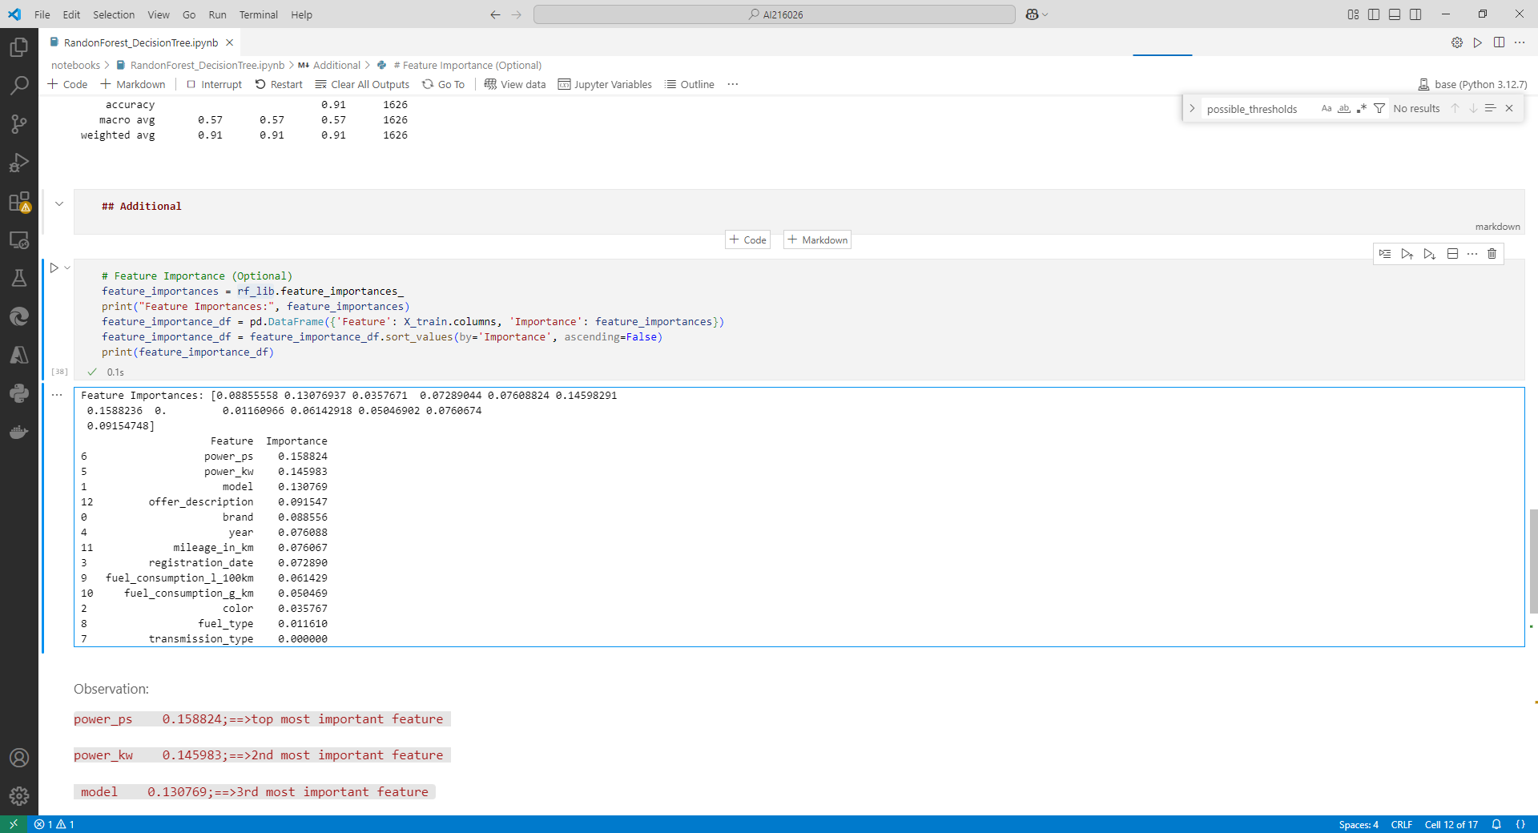
6. Conclusion and future work
Random Forest is performing well. So, changing grid search values furthermore, we can achieve better robust model (but it takes more time to train model which computationally expensive for small datasets).

