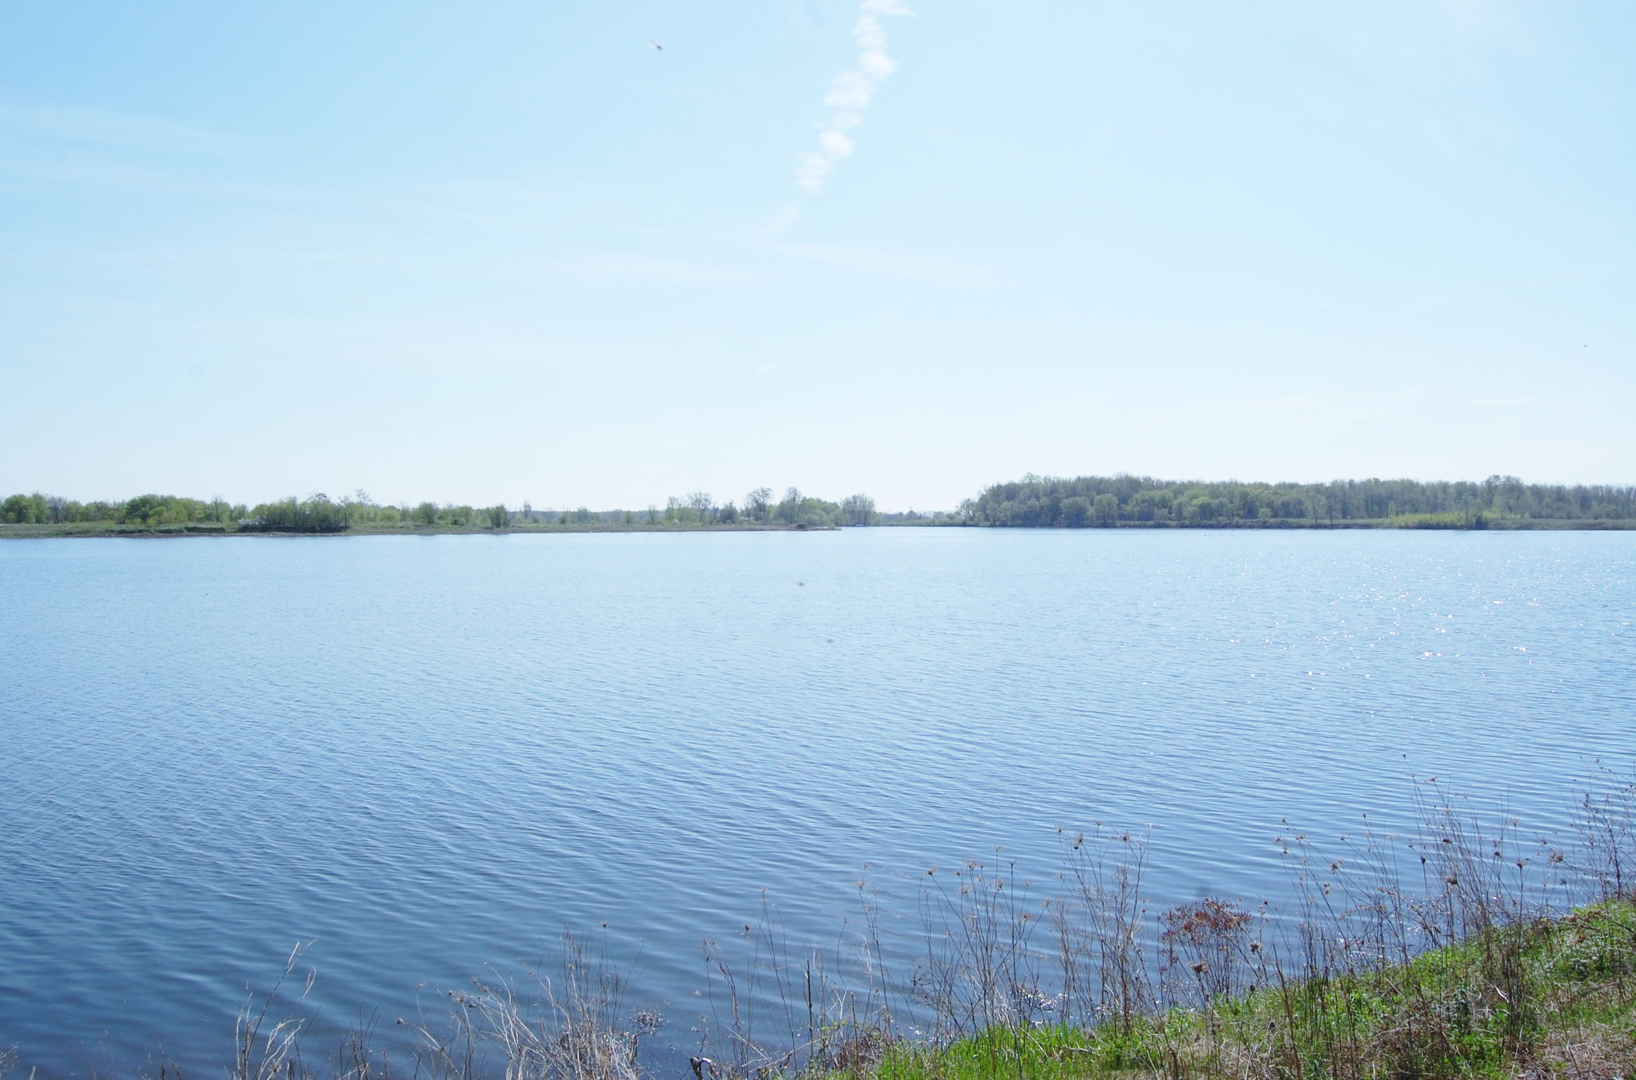
SAVE OUR LAKE

Russell Township has one real lake, Quarry Lake in North Russell, which is privately owned by a corporation headed by the Taggart family, large scale developers from Ottawa, who first intended to turn the 180-acre parcel, with its 40-acre lake, into a landfill.

The site is one of the most beautiful spots in the township, and has high ecological importance, including breeding, feeding and hibernation grounds for numerous species-at-risk. A biodiversity study from 2011 revealed the crucial nature of this rich, highly diverse and unique site. It supports dozens of bird species, reptiles including snakes and turtles, amphibians including salamanders and threatened frogs, numerous mammals, insects including bees and butterflies, endangered plants and animals, a variety of fungi, and even crayfish. It is also a crucial migration stopover for geese, ducks and other waterfowl.

The community has worried about the lake’s fate for almost a decade, even after the landfill plans moved to a site about five km away. Earlier this year Michelle Taggart, of Taggart Construction, stated that the property “would make a good subdivision.”

Quarry Lake is important to the biodiversity and to the people of this area. It contains groundwater in a regional aquifer which supplies local wells and likely connects to the Vars-Winchester esker (water source for thousands of people). Headwaters of many streams rise on this hill and drainage ditches pass immediately beside it. These surface waters flow into the Castor River, with one stream into the Bearbrook. The red shale quarry in North Russell served its community for generations, and still holds the Queenston shale formation, a designated provincially significant resource due to its rarity and superior brick-making qualities. The mostly mined property was the site of some of Russell Township’s earliest settlements, its first school and of course, the brick shale quarry that was the economic making of the village of Russell. Directly across from the main entrance is one of the area’s oldest cemeteries, which is still in use.

The Canadian Parks and Wilderness Society—Ottawa Valley (CPAWS Ottawa Valley), has offered to help us acquire the property and aid us with funding. Its mandate matches our goal of preserving wild spaces for the public. Due to the landfill opposition, Quarry Lake has become known in naturalists’ circles, and there is a growing feeling that this property should be preserved, not only for itself but also its connectivity to other natural spaces. Once CPAWS expressed interest other organizations have said they can also help in some fashion, whether through funding, publicity, help with research and proposals, or other support.

Instead of allowing developers from Ottawa to spoil our landscape and heritage for their profit, we now have an opportunity to improve our local quality of life by ensuring that Quarry Lake again becomes part of the community to which it belongs. Imagine being able to walk, ski or snowshoe along beautiful trails, to kayak on or picnic beside a peaceful lake, and to read plaques celebrating the past and present of this place. Biologists, geologists and other scientists could also benefit, and it would draw visitors to our township.

There are very few natural areas open to the public in all of Russell Township, and none is this large.

The only thing standing in our way now is the owners of the property. CPAWS reached out to Michelle Taggart who said her family were not interested in selling. So to get them to sell it to us they must realize they will NEVER be allowed to develop it. To that end we must make sure the ecological importance of the site is further confirmed and is publicized. The Township and County need to understand that the community will not tolerate any zoning change which would allow habitat destruction of that place. There is so much there to appeal to nature-lovers, budding naturalists, historians, horticulturalists, archaeologists and paleontologists, and anyone who appreciates a lovely place. We need the support of the movers and shakers in our community and we need to speak out.The time has come to SAVE OUR LAKE.

Come to the Russell Township Council Meeting, Monday, Dec. 2, 6 p.m.
Write: Mayor Pierre Leroux, Russell Township 717 Notre-Dame, Embrun ON K0A 1W1, pierreleroux@russell.ca,

