Software System Test Report

1.Introduction

This test report is aims to test and analyse the results of the development and implementation of the DUS system, find the problems in the system, and describe whether the system meets the functional and performance requirements specified in the project requirements specification.

2. Test Plan Description and Test Result Analysis

The test is divided into two parts: functional test and system test. I perform functional testing from the user and administrator interface.

2.1 The User Functional Testing

|  |  |
| --- | --- |
| User page | Test results |
| Sign up | Normal, the password must include minimum 6 characters. |
| Login | Normal, the login user can view personal booking on their home page. |
| Add booking | Normal, but the total cost does not change no matter how many hours the user book. |
| Email confirmation | Normal, but the email cannot receive the total price, only can display the scheduled time period. |
| Search function | Normal, typing keywords can display the search results. |
| View the calendar | Normal, can view the use of facilities according to daily, weekly and monthly. |
| Contact function | Normal, it can automatically jump to the administrator's mailbox. |
| Recovery password | Normal, the user will immediately receive an email to reset the password. |
| Add booking | Normal, but the system cannot recognize the identity of the user and thus cannot provide different discounted facility prices. |
| Block booking function | Normal, the user cannot book the facility when there is a sports exam that day. |

2.2 The Administrator Functional Testing

|  |  |
| --- | --- |
| Administrator  page | Test results |
| Sign up | Normal, the password must include minimum 6 characters. |
| Login | Normal, the login user can view personal booking on their home page. |
| Add booking | Normal, the administrator can add booking manually for those who directly booked by trainer or phone. |
| Cancel booking | Normal, the administrator can cancel booking manually and receive the cancel email confirmation immediately. |
| Facility management | Normal, the administrator can modify the state of the facility. |
| Block booking management | Normal, the administrator can cancel or add the block. |
| Capacity function | Normal, when the administrator tries to add the 21 people in the Athletics Track, the localhost shows that “it cannot be booking.”  . |

2.3 Browser testing

Nowadays, there are more and more browsers selected by users (especially on tablets and mobile devices), so it is critical that our system can run on multiple devices without users adjusting their devices. After testing, it works well and the interface is fully displayed.

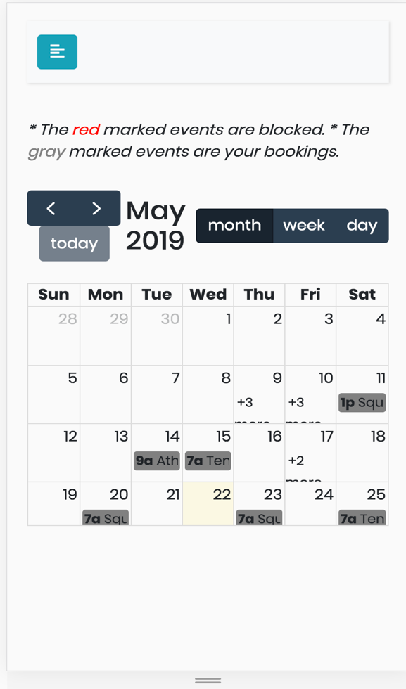

Picture1. On the mobile device

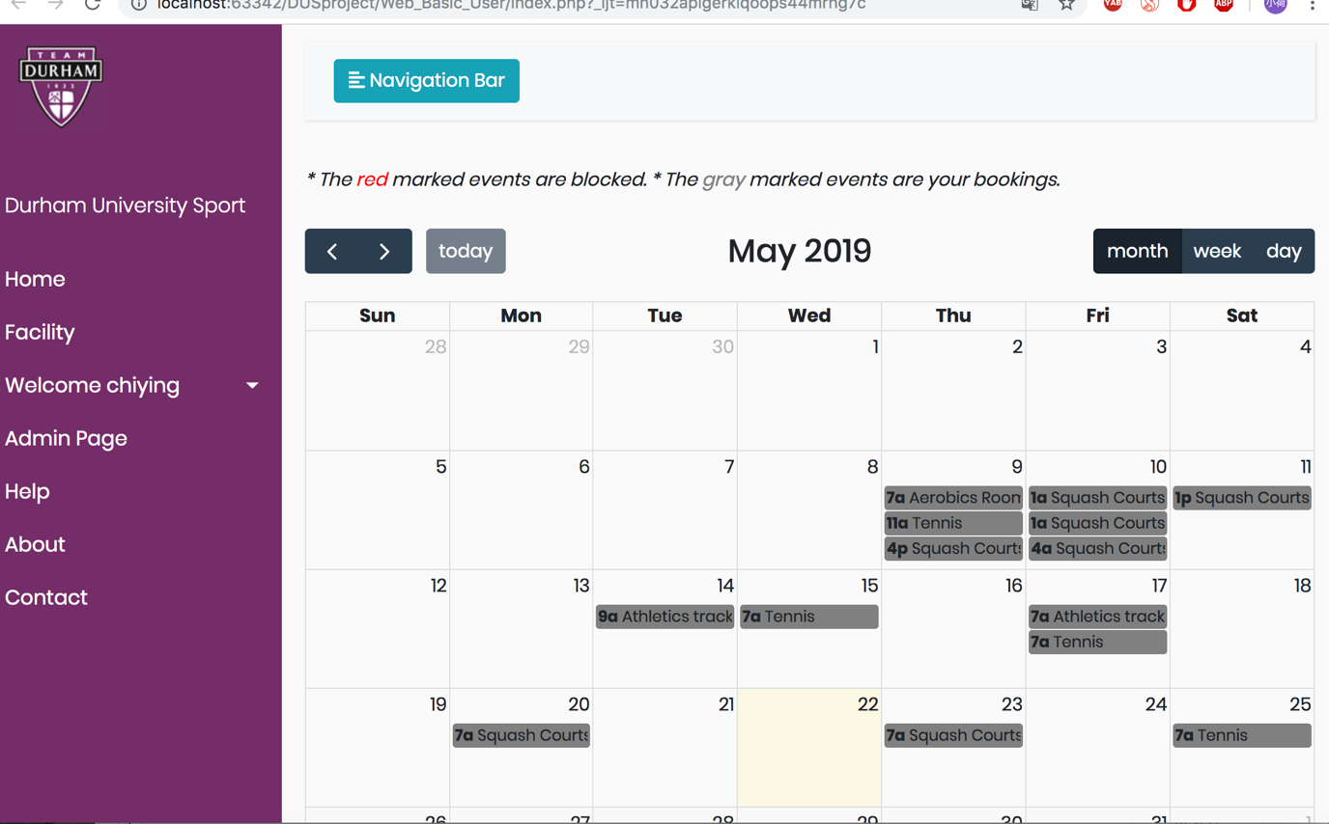

Picture2. On the tablet device

2.4 System Testing

2.4.1 Reliability Testing

|  |  |  |
| --- | --- | --- |
| Testing example | The description of testing | Test results |
| Data Verification Mechanism | The logical relationship between data items should be checked to ensure the Effectiveness of data. | The system complies with this operation, such as validating the start of the search condition, the end the of the date, etc. |
| Data integrity and consistency should be guaranteed, and not be destroyed or left behind by deletion or repeated updates. | System update or delete function does not affect system data. |
| For inconsistent input data, the system should use English to give concise and accurate hints and help when necessary. | The system gives corresponding prompt information for input that does not meet the requirements. |
| Fault Tolerance | When entering wrong data, the system does not crash, exit abnormally and lose data | The system gives the corresponding prompt |

3.4.2 Security Testing

|  |  |  |
| --- | --- | --- |
| Testing example | The description of testing | Testing results |
| Information Ownership Verification | Verify whether the information of different users with the same permission can only be operated by that user, while other users cannot operate on their behalf, so as to ensure the security of each information. | Different users with the same authority cannot perform data operations. |

3.4.3 Usability Testing

|  |  |  |
| --- | --- | --- |
| Testing examples | The description of testing | Testing results |
| Page style consistency | Whether the page structure, navigation, menu, link, search,  page turning and font is consistent. | System page style is consistent. |
| Maneuverability | Providing auxiliary input tools (such as selecting input, default value, etc.), data retrieval is convenient and flexible. | The system provides flexible search bar. |

4. Analysis of the Testing Results

Through the analysis of the testing results, and give a timely feedback to the team member, the design and implementation of the project has finally met the project requirements specification.