Video Analysis for Weapon Detection and Alerting

In this project we are using Deep Learning CNN algorithm to detect weapons like KNIVES and GUNS from images or videos and to implement this project we have used WEAPON dataset which contains KNIVES & GUNS images and below screen showing dataset details

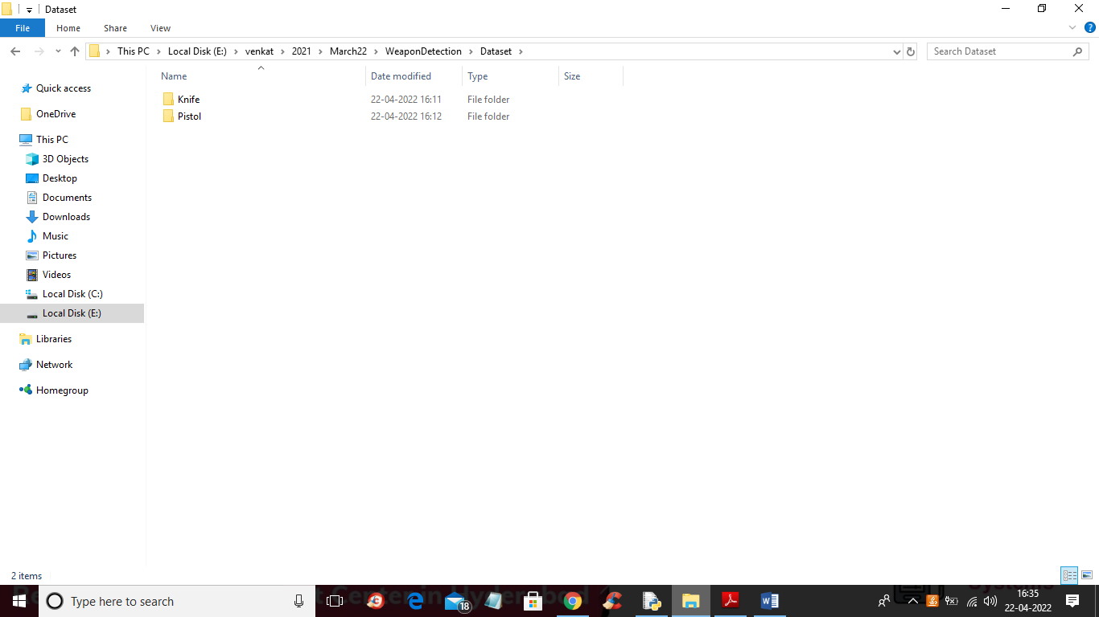

In above screen we can see two folders and go inside any folder to view image and this images available inside ‘Dataset’ folder

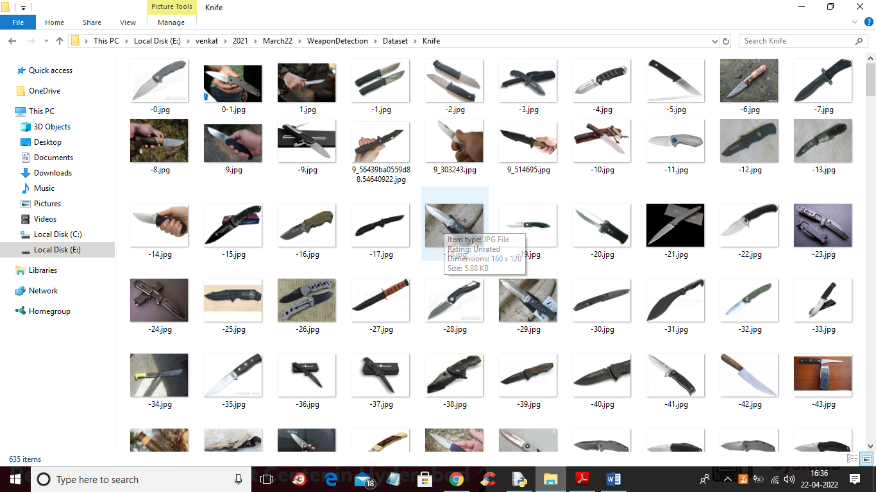

To implement project we have designed following modules

1. Upload Weapon Dataset: using this module we will upload weapon dataset to application and then application will read all images and then resize all images to equal size and then normalize all images pixel values and make ready all images to feed to CNN training model
2. Generate & Load Weapon Detection Model: using this module we will feed all above processed images and then build a CNN model
3. Upload Image: using this module we will upload image to application
4. Detect Weapon from Image: CNN model will be applied on uploaded image to predict weather image contains any weapon or not and if detected then beep sound will be generates
5. Detect Weapon from Video: using this module we will upload video and then CNN will analyse each frame in the video and if weapon detected then it raise beep sound
6. Weapon Detection Training Accuracy-Loss Graph: using this module we will plot CNN weapon detection training accuracy and loss graph

SCREEN SHOTS

To run project double click on ‘run.bat’ to get below output

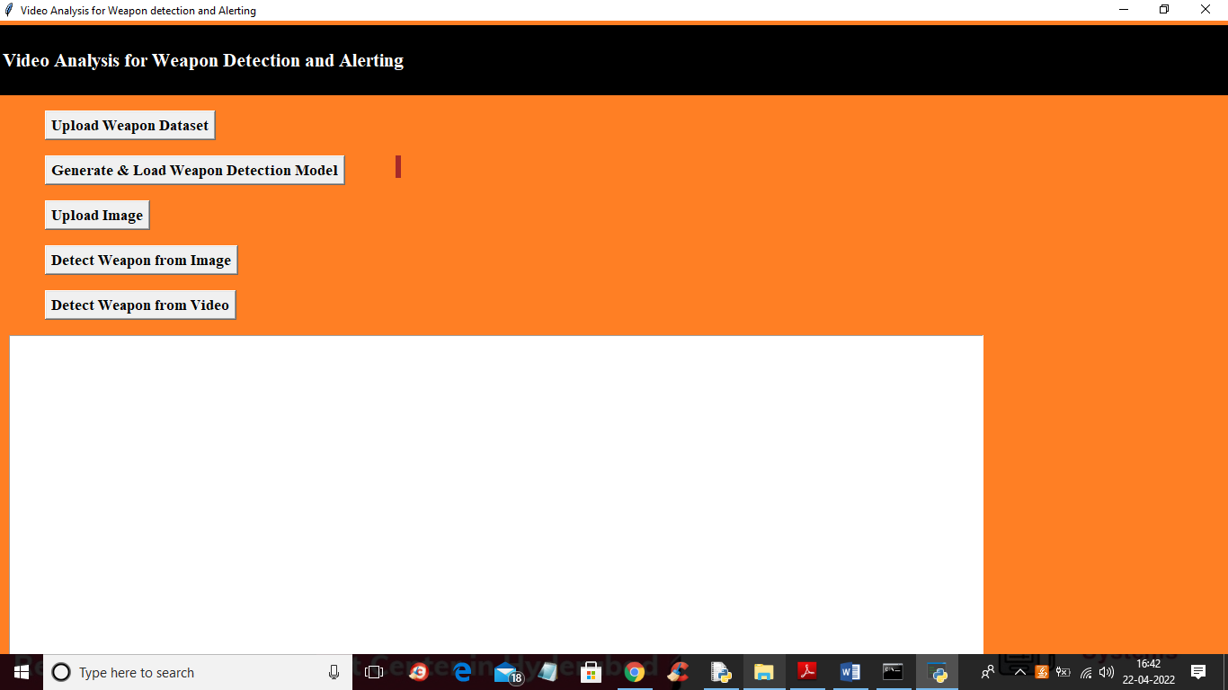

In above screen click on ‘Upload Weapon Dataset’ button to upload dataset to application and then process all images and get below output

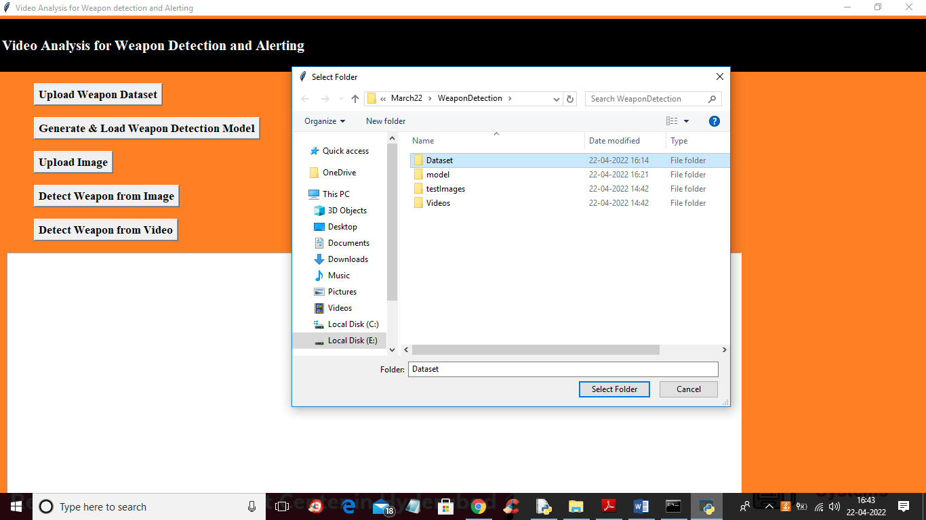

In above screen selecting and uploading ‘Dataset’ folder and then click on ‘Select Folder’ button to load and process dataset and to get below output

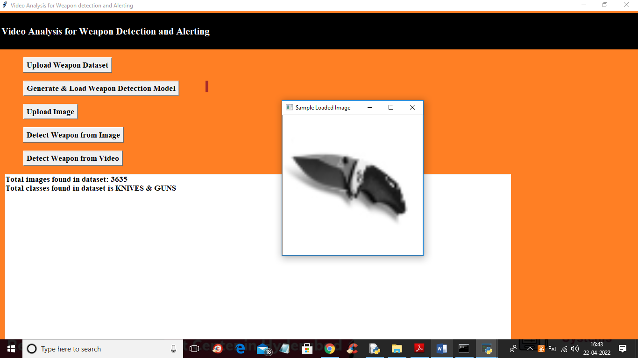

In above screen we can see dataset contains 3535 images from 2 classes called KNIVES and GUNS and displaying one processed image to check all images are loaded properly or not. Now close above image and then click on ‘Generate & Load Weapon Detection Model’ button to generate CNN model and get below output

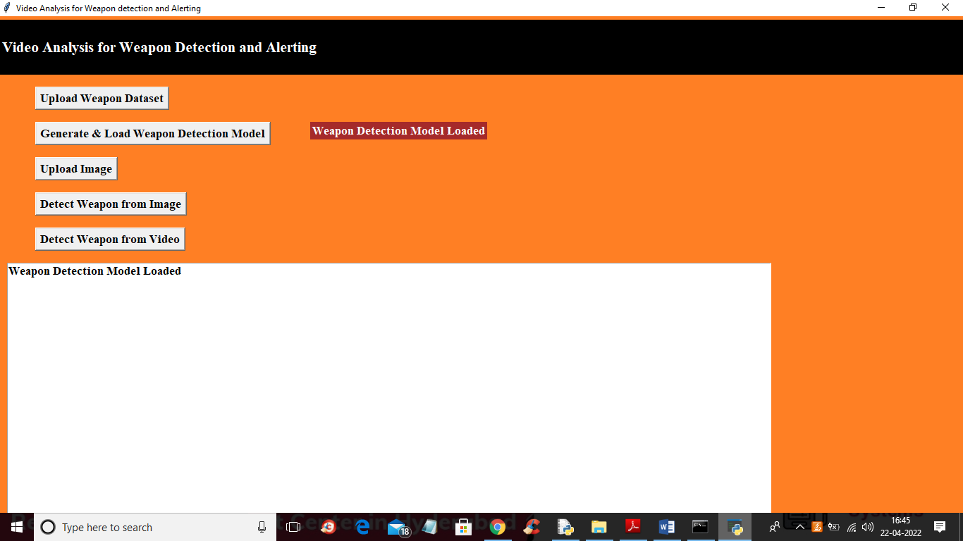

In above screen in red colour text we can see model is generated and loaded and now click on ‘Upload Image’ button to upload test image like below screen

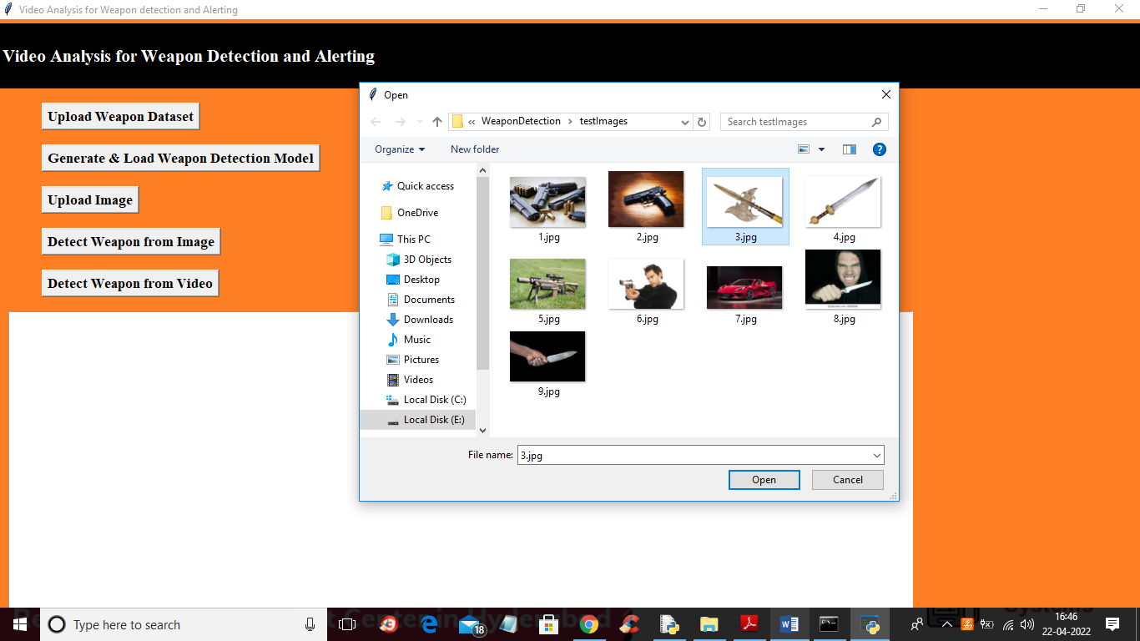

In above screen selecting and uploading ‘3.jpg’ file and then click on “open” button to load image and then click on ‘Detect Weapon from Image’ button to get below output

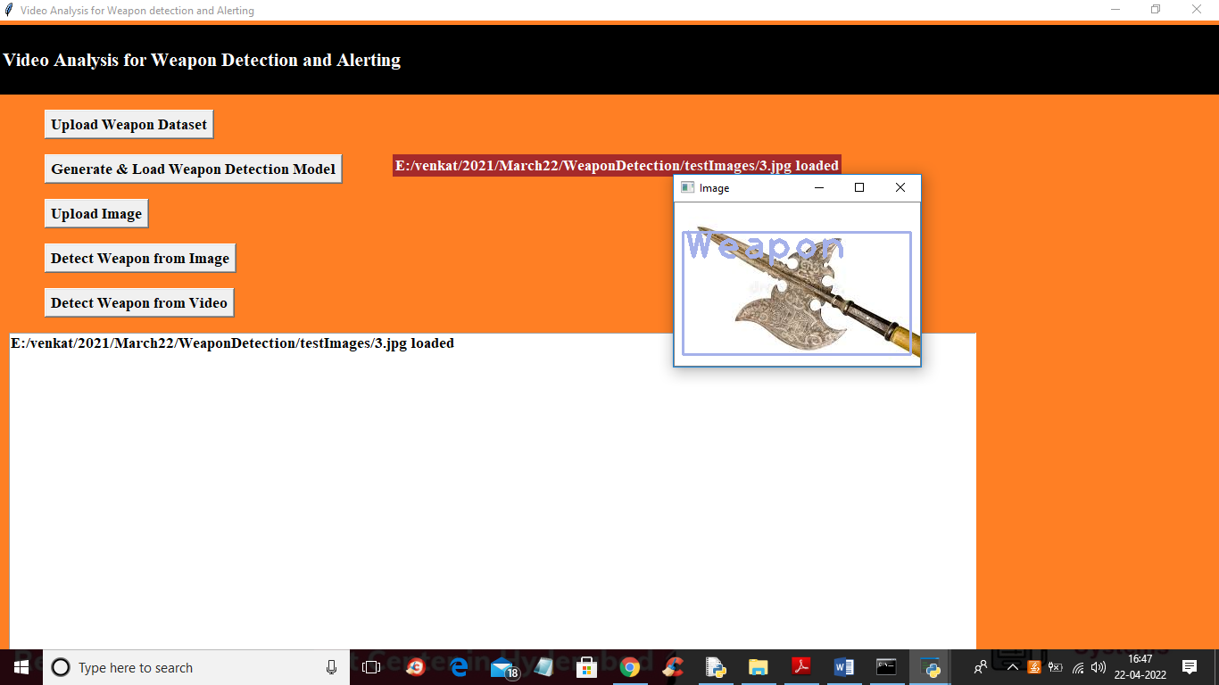

In above screen from uploaded image weapon is detected and you can hear beep sound in your system and now close above image and then click on ‘Upload Weapon from Video’ button to upload video and get below output

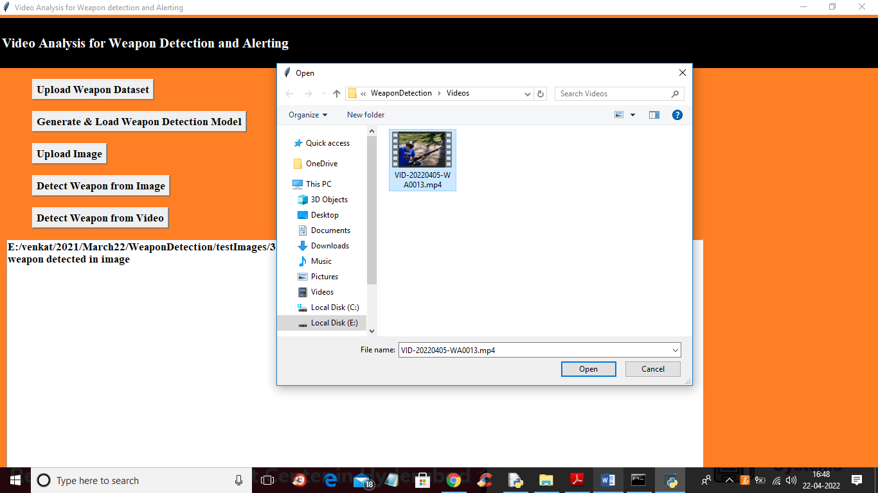

In above screen uploading video and then click on ‘Open’ button to get below output

# 

In above screen from video also weapon is detecting and similarly you can upload any image and video and test application and now click on ‘Weapon Detection Training Accuracy-Loss Graph’ button to get below graph

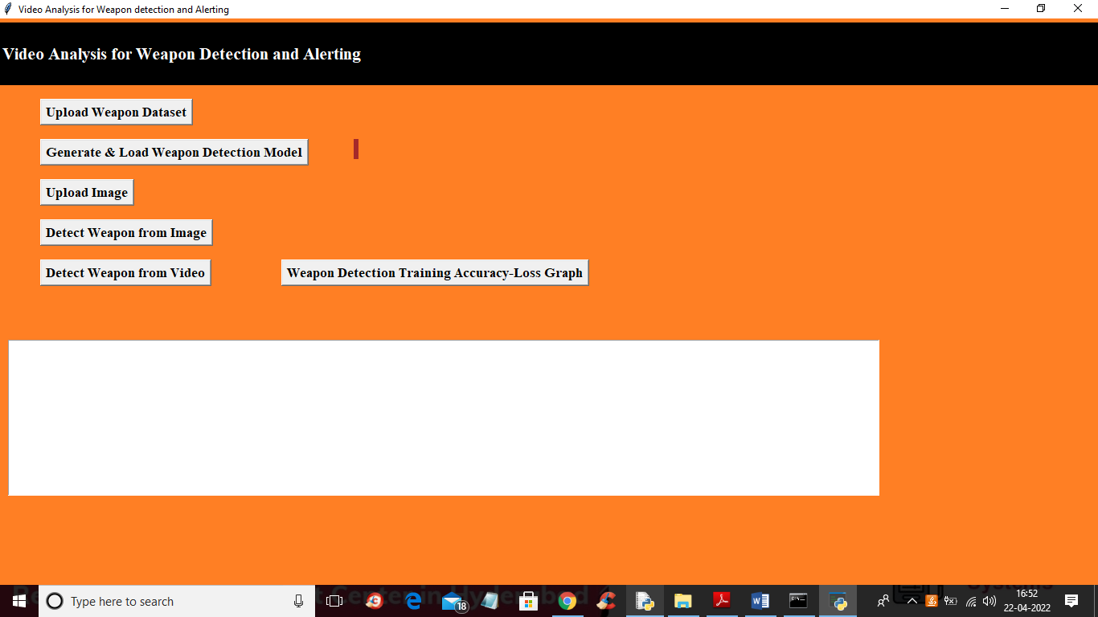

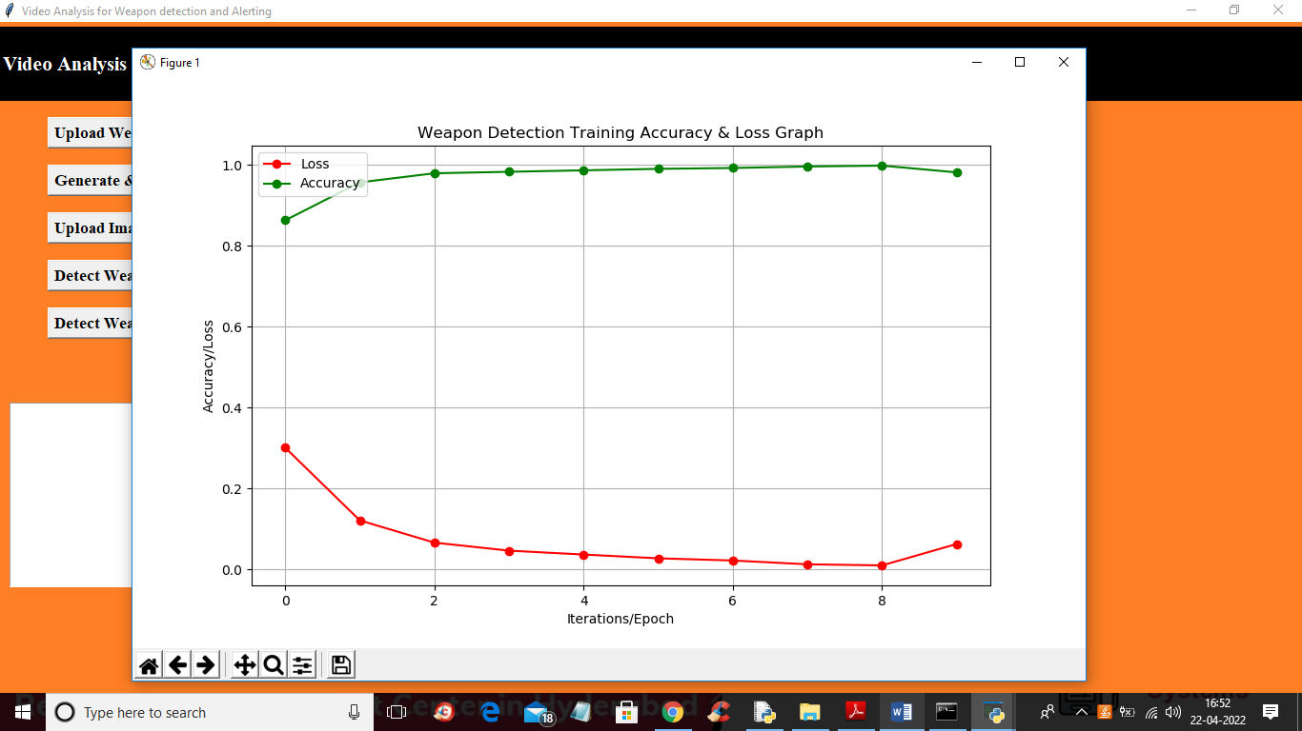

In above graph x-axis represents epoch and y-axis represents loss and accuracy values and in above graph we can see with each increasing epoch accuracy got increased and loss got decreased