NOTE: This template is shareware downloaded from www.processimpact.com. All shareware payments are donated to the Norm Kerth Benefit Fund to help a consultant who is disabled with a brain injury. Please visit http://www.processimpact.com/norm_kerth.html to make a shareware payment ($10 suggested). Thank you!
Software Requirements Specification
for
Task Hawk
Version 1.0 approved
Samuel Gullett
CS445 Group 4
5May2023
eLearning versions of several popular Process Impact training seminars are available at www.processimpact.com/elearning.shtml, including “In Search of Excellent Requirements,” “Exploring User Requirements with Use Cases,” “Writing High-Quality Requirements,” “Software Inspections and Peer Reviews,” and “Project Management Best Practices”. Single-user and corporate-wide site licenses are both available.
Table of Contents
Table of Contents ii
Revision History ii
1. Introduction 1
1.1 Purpose 1
1.2 Document Conventions 1
1.3 Intended Audience and Reading Suggestions 1
1.4 Project Scope 1
1.5 References 1
2. Overall Description 2
2.1 Product Perspective 2
2.2 Product Features 2
2.3 User Classes and Characteristics 2
2.4 Operating Environment 2
2.5 Design and Implementation Constraints 2
2.6 User Documentation 2
2.7 Assumptions and Dependencies 3
3. System Features 3
3.1 System Feature 1 3
3.2 System Feature 2 (and so on) 4
4. External Interface Requirements 4
4.1 User Interfaces 4
4.2 Hardware Interfaces 4
4.3 Software Interfaces 4
4.4 Communications Interfaces 4
5. Other Nonfunctional Requirements 5
5.1 Performance Requirements 5
5.2 Safety Requirements 5
5.3 Security Requirements 5
5.4 Software Quality Attributes 5
6. Other Requirements 5
Appendix A: Glossary 5
Appendix B: Analysis Models 6
Appendix C: Issues List 6

Revision History
Name | Date | Reason For Changes | Version

Introduction

Purpose
The purpose of this app (Task Hawk v1.0) is to provide a convenient and efficient way for users to record and manage their upcoming tasks and events on a calendar. The app aims to improve productivity and organization by allowing users to easily view and prioritize their tasks, set reminders, and track their progress. The app is designed to be user-friendly and customizable to meet the needs of individuals with varying schedules and lifestyles. Overall, the app aims to simplify the task management process and enhance the user's ability to stay on top of their commitments.

Document Conventions
<Describe any standards or typographical conventions that were followed when writing this SRS, such as fonts or highlighting that have special significance. For example, state whether priorities for higher-level requirements are assumed to be inherited by detailed requirements, or whether every requirement statement is to have its own priority.>

Intended Audience and Reading Suggestions
This document is intended for various types of readers, including developers and users. The SRS contains an overview section that provides a high-level summary of the project, including its purpose, goals, and objectives. The functional requirements section describes the specific features and functions that the app must have, including user interface, calendar integration, and task management. The non-functional requirements section describes the performance, usability, and security requirements of the app.

The document is organized in a logical manner that starts with an introduction and overview of the project, followed by a detailed description of the functional and non-functional requirements. The document concludes with appendices that contain additional information, such as glossary of terms and reference materials.

The suggested sequence for reading the document would be as follows:

Introduction and Overall Description- all readers
System Features – all readers
External Interface Requirements - developers
Other Non-functional Requirements - developers
Appendices - developers

Project Scope
This software is a task management application that includes a calendar for recording upcoming tasks. The purpose of the software is to provide users with an easy and efficient way to manage their tasks and keep track of important dates. The benefits of the software include increased productivity, improved time management, and better organization of tasks and events. The objectives of the software are to provide a user-friendly interface, and flexible task management features.

This application can be related to corporate goals and business strategies by enabling employees to be more efficient and productive in their work, leading to increased overall performance and success for the organization. This software can also be used by individuals to help them better manage their personal tasks and responsibilities, leading to improved work-life balance and overall well-being.

References
<List any other documents or Web addresses to which this SRS refers. These may include user interface style guides, contracts, standards, system requirements specifications, use case documents, or a vision and scope document. Provide enough information so that the reader could access a copy of each reference, including title, author, version number, date, and source or location.>

Overall Description

Product Perspective
This product is a new, self-contained application that allows users to record upcoming tasks. This product is not a replacement for any existing system, nor is it part of a larger product family. It is designed to be a standalone application that can be used by individuals or small teams to manage their schedules and tasks efficiently.

Product Features
This product allows users to record upcoming tasks. The major features of the app include the ability to create and edit tasks, view tasks by day, week, or month, and save tasks to lists. A top-level Class Diagram is provided:

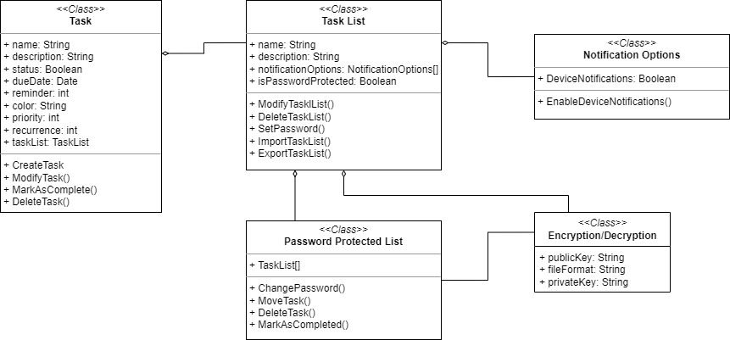

User Classes and Characteristics
<Identify the various user classes that you anticipate will use this product. User classes may be differentiated based on frequency of use, subset of product functions used, technical expertise, security or privilege levels, educational level, or experience. Describe the pertinent characteristics of each user class. Certain requirements may pertain only to certain user classes. Distinguish the favored user classes from those who are less important to satisfy.>

Operating Environment
This will operate on mobile Android platforms. The app will not have any external dependencies other than the very common Java Runtime Environment and will not require any specific hardware or software components other than those typically found on a mobile system. It is expected to peacefully coexist with any other software applications running on the user's system.

Design and Implementation Constraints
The app is constrained to the Android mobile platform. It must not interfere with the normal functioning of other applications on the device. This app should be designed to work with different screen sizes and orientations. Flutter was used to develop the UI. Sqflite was used as the database module because of its flutter support.

User Documentation
No user documentation components have been specified for delivery along with the software. However, it may be possible to generate such documentation if needed. Any user documentation delivery formats or standards will need to be determined based on the specific needs and preferences of the user base for this software.

Assumptions and Dependencies
Assumptions:
- It is assumed that the hardware and software requirements stated in the SRS are accurate and will not change during the development process.
- It is assumed that there will be no changes in the external policies or regulations regarding security and privacy issues during the development process.
- It is assumed that there will be no issues with the third-party components used in this app.
- It is assumed that this app will be used in a normal operating environment, without any extreme conditions that could affect its performance.
Dependencies:
- This depends on the Android operating system and its associated libraries and APIs.

System Features
<This template illustrates organizing the functional requirements for the product by system features, the major services provided by the product. You may prefer to organize this section by use case, mode of operation, user class, object class, functional hierarchy, or combinations of these, whatever makes the most logical sense for your product.>

System Feature 1
<Don’t really say “System Feature 1.” State the feature name in just a few words.>
3.1.1 Description and Priority
<Provide a short description of the feature and indicate whether it is of High, Medium, or Low priority. You could also include specific priority component ratings, such as benefit, penalty, cost, and risk (each rated on a relative scale from a low of 1 to a high of 9).>
3.1.2 Stimulus/Response Sequences
<List the sequences of user actions and system responses that stimulate the behavior defined for this feature. These will correspond to the dialog elements associated with use cases.>
3.1.3 Functional Requirements
<Itemize the detailed functional requirements associated with this feature. These are the software capabilities that must be present in order for the user to carry out the services provided by the feature, or to execute the use case. Include how the product should respond to anticipated error conditions or invalid inputs. Requirements should be concise, complete, unambiguous, verifiable, and necessary. Use “TBD” as a placeholder to indicate when necessary information is not yet available.>

<Each requirement should be uniquely identified with a sequence number or a meaningful tag of some kind.>

REQ-1:
REQ-2:

System Feature 2 (and so on)

External Interface Requirements

User Interfaces
<Describe the logical characteristics of each interface between the software product and the users. This may include sample screen images, any GUI standards or product family style guides that are to be followed, screen layout constraints, standard buttons and functions (e.g., help) that will appear on every screen, keyboard shortcuts, error message display standards, and so on. Define the software components for which a user interface is needed. Details of the user interface design should be documented in a separate user interface specification.>

Hardware Interfaces
This app takes advantage of the touch and gesture interfaces provided by the Android operating system. The main interaction between software and hardware is the tap, which is a single tap on the screen that can be used to select a day or task.

Software Interfaces
<Describe the connections between this product and other specific software components (name and version), including databases, operating systems, tools, libraries, and integrated commercial components. Identify the data items or messages coming into the system and going out and describe the purpose of each. Describe the services needed and the nature of communications. Refer to documents that describe detailed application programming interface protocols. Identify data that will be shared across software components. If the data sharing mechanism must be implemented in a specific way (for example, use of a global data area in a multitasking operating system), specify this as an implementation constraint.>

Communications Interfaces
There are no requirements associated with any communication functions required by this product as there are no communication services used.

Other Nonfunctional Requirements

Performance Requirements
This app has been designed and implemented with efficiency in mind to ensure that it operates smoothly and responsively on the specified hardware platform and operating system. Any future performance requirements will be communicated to the development team in a timely manner and incorporated into the software design and implementation as necessary.

Safety Requirements
This app should not pose any safety hazards to its users. However, it is important to note that the app may be used to schedule important tasks or events, such as medical appointments or deadlines for important projects. Therefore, it is important to ensure that the app is reliable and does not result in loss or harm due to missed appointments or deadlines.

Security Requirements
There are no security or privacy requirements for this product as it does not deal with any sensitive or confidential information. However, if security or privacy concerns arise in the future, appropriate measures should be taken to protect the data and ensure that user identity is authenticated.

Software Quality Attributes
The following quality characteristics are important for the success of this app:
- Usability: The app should be easy to learn and use, with an intuitive interface and clear instructions.
- Reliability: The app should operate reliably without errors and provide consistent results across multiple runs.
- Maintainability: The app should be easy to maintain and update, with well-structured and well-documented code.

Other Requirements
<Define any other requirements not covered elsewhere in the SRS. This might include database requirements, internationalization requirements, legal requirements, reuse objectives for the project, and so on. Add any new sections that are pertinent to the project.>
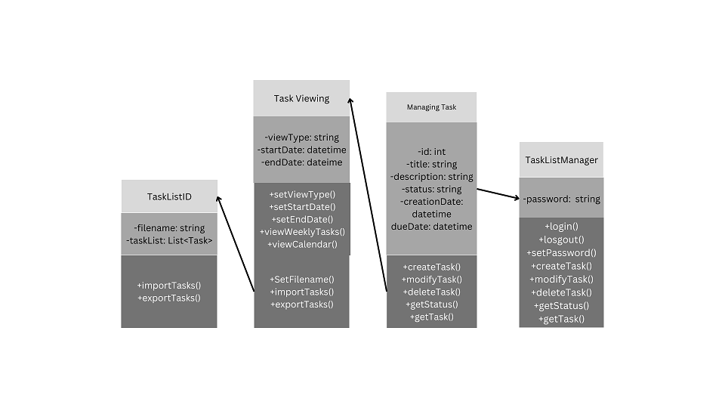
Appendix A: Glossary

<Define all the terms necessary to properly interpret the SRS, including acronyms and abbreviations. You may wish to build a separate glossary that spans multiple projects or the entire organization, and just include terms specific to a single project in each SRS.>
Appendix B: Analysis Models

Class Diagram:

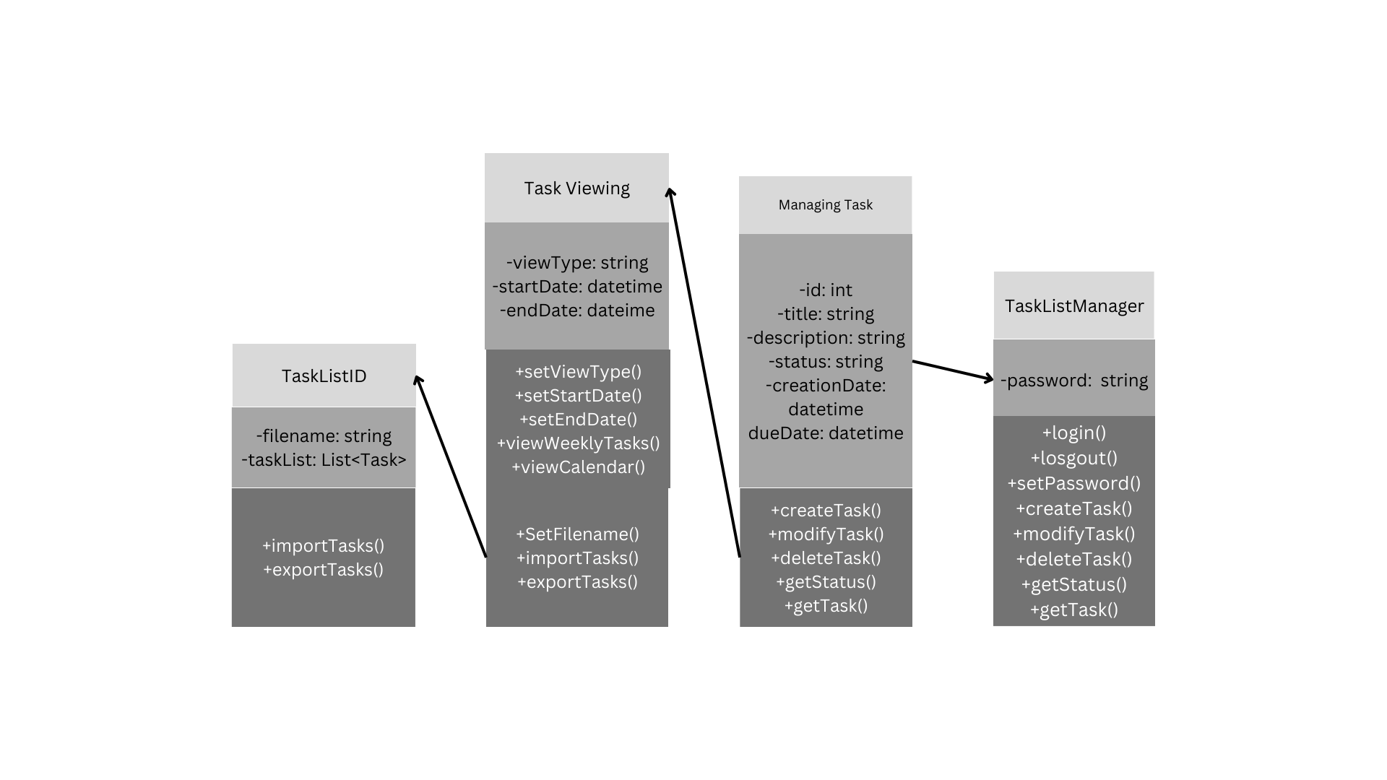

Sequence Diagrams:

Sequence Diagrams:
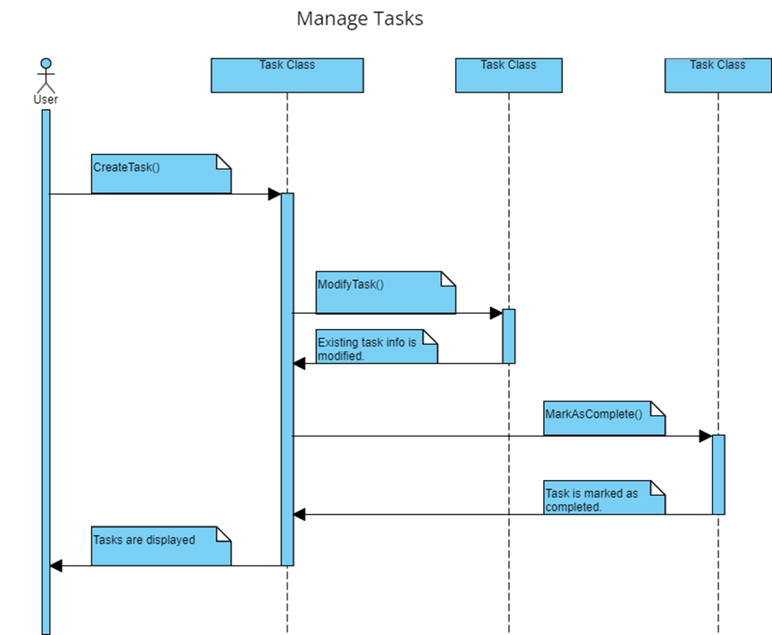

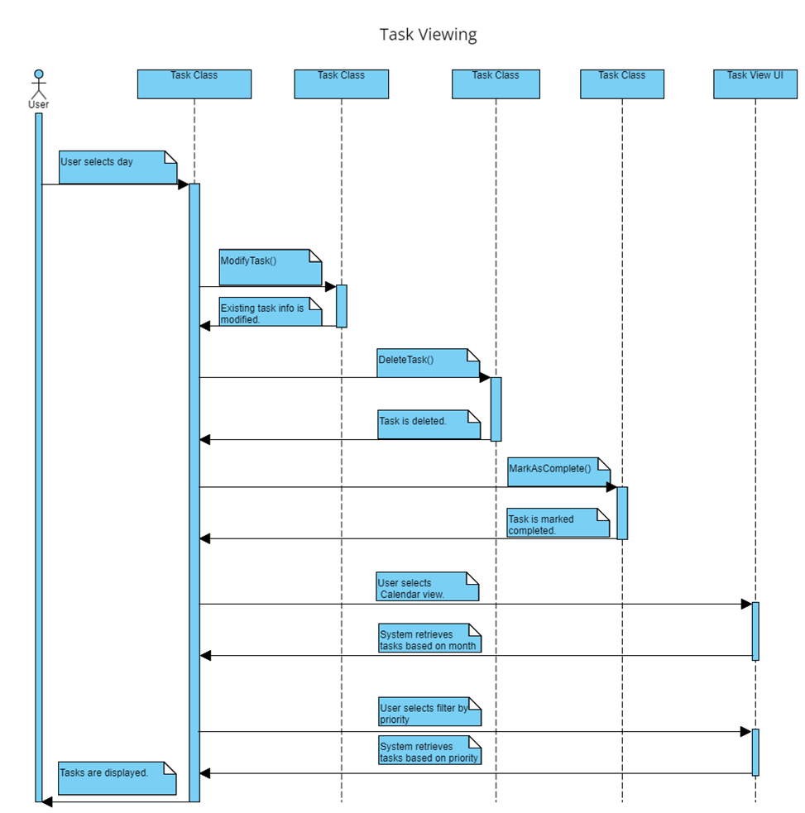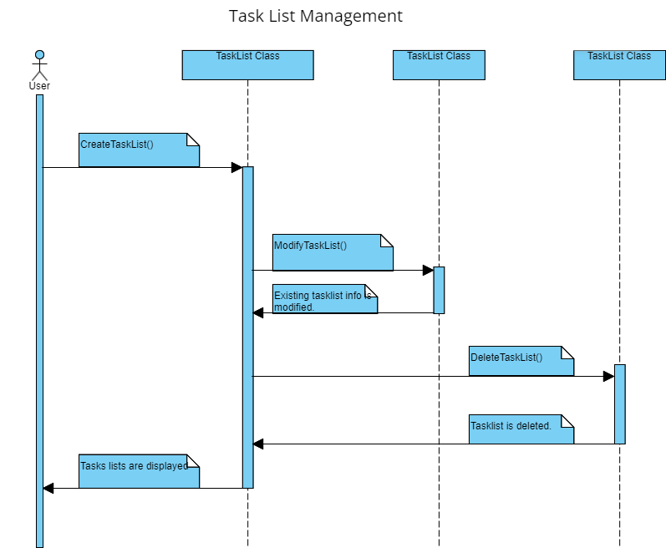
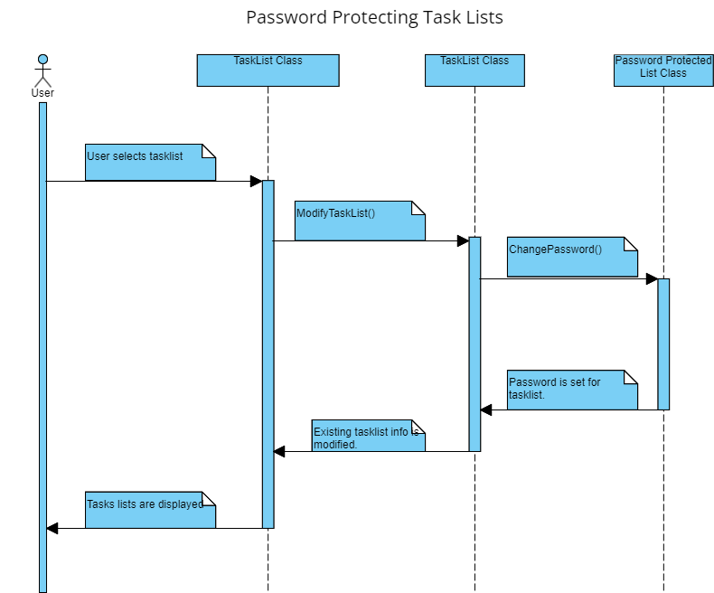

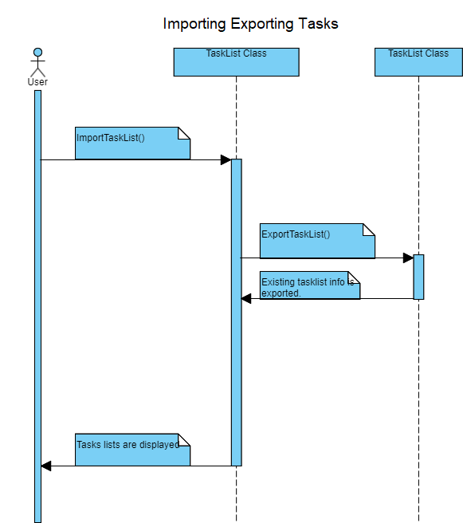
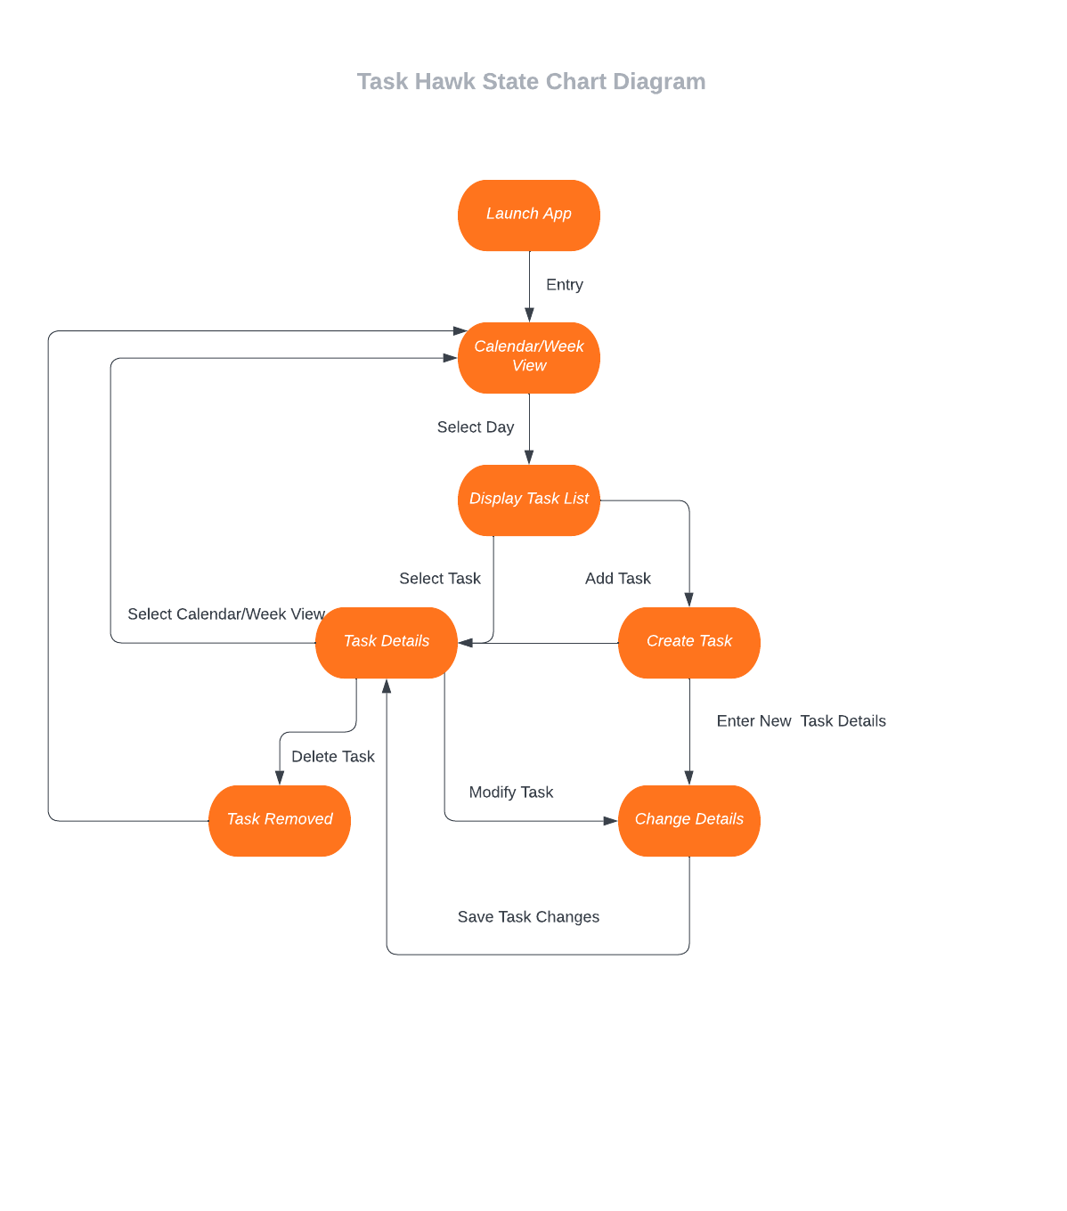
Conceptual Model:
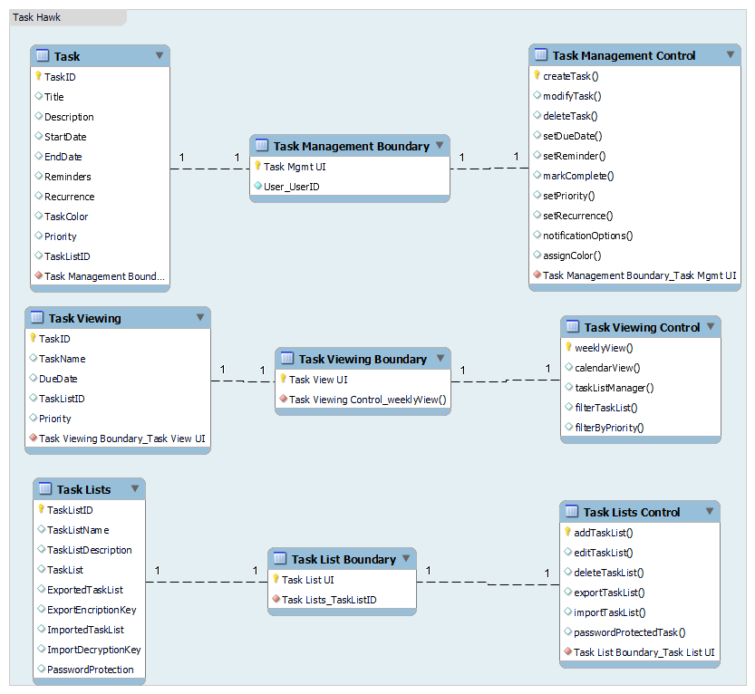
Use Case Diagram:
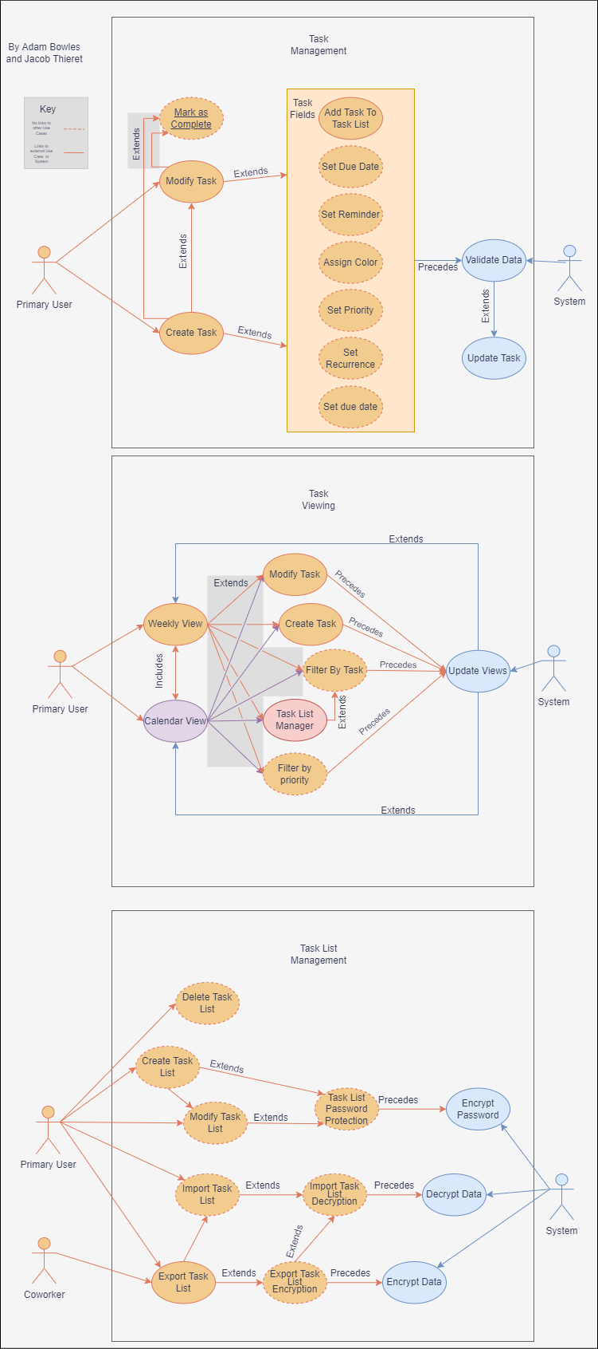

<Optionally, include any pertinent analysis models, such as data flow diagrams, class diagrams, state-transition diagrams, or entity-relationship diagrams.>
Appendix C: Issues List
< This is a dynamic list of the open requirements issues that remain to be resolved, including TBDs, pending decisions, information that is needed, conflicts awaiting resolution, and the like.>

