# Problem 6. Mystery

|  |  |
| --- | --- |
| Program: | mystery.py |

Write a program named mystery.py that implements a function name also mystery. The function should accept two integers a and b greater than zero and return an integer as well. The function should implement the flowchart given in Figure 1. Write code to test the function by calling multiple times on different value. Below sample output produced by calling function through a program that accepts two command line argument.

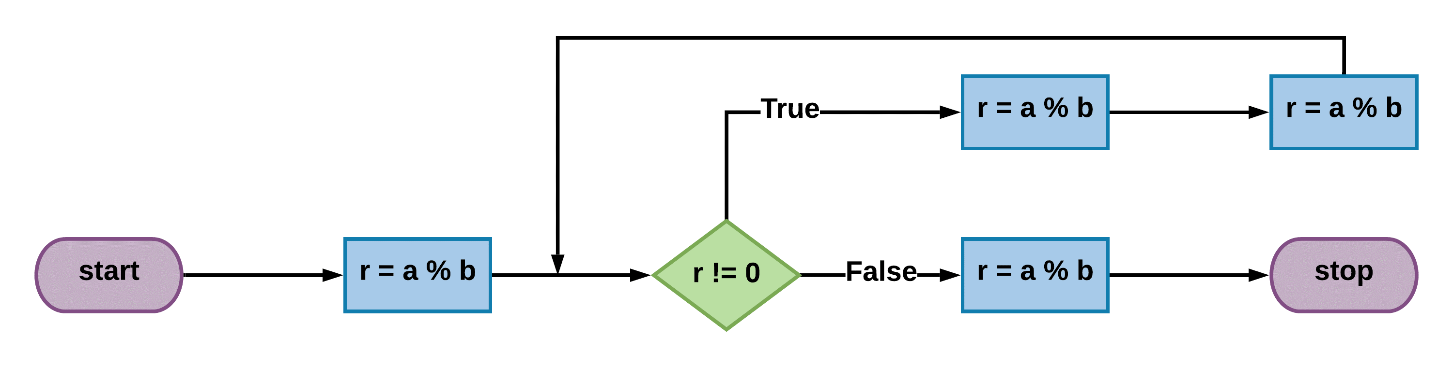

Figure 1: Flowchart of our mystery function

% **python mystery.py 45 27**

The value of mystery(45, 27) is 9

% **python mystery.py 112 98**

The value of mystery(112, 98) is 14

% **python mystery.py 856 1024**

The value of mystery(856, 1024) is 8

Figure 2: Sample output for Problem 6

# Problem 7. Converter

|  |  |
| --- | --- |
| Program: | converter.py |

Write a program named converter that provides the means for doing temperature and time conversion. The program should accept input from the commands line and outputs a message should the conversion based on the user input specification. The output of the program should look like the following.

% **python converter.py f0**

0.00 degrees Fahrenheit is equivalent to -17.78 degrees Celsius.

% **python converter.py f32**

32.00 degrees Fahrenheit is equivalent to 0.00 degrees Celsius.

% **python converter.py f212**

212.00 degrees Fahrenheit is equivalent to 100.00 degrees Celsius.

% **python converter.py c-40**

-40.00 degrees Celsius is equivalent to -40.00 degrees Fahrenheit.

% **python converter.py c-300**

-300.00 degrees Celsius is equivalent to -508.00 degrees Fahrenheit.

% **python converter.py c37**

37.00 degrees Celsius is equivalent to 98.60 degrees Fahrenheit.

% **python converter.py t15**

15 seconds in hh:mm:ss format is 00:00:15.

% **python converter.py t1999**

1999 seconds in hh:mm:ss format is 00:33:19.

% **python converter.py t99999**

99999 seconds in hh:mm:ss format is 27:46:39.

Figure 3: Sample dialog for the program of Problem 7

# Problem 8. Calendar

|  |  |
| --- | --- |
| Program: | cal.py |

Write a program cal.py that takes two command line argument m and y and writes the monthly calendar for the mth month of the year y as in the example below. Implement functions common and repetitive tasks to ensure code readability and maintainability

Hint: Utilize the programs you written for Problem 4 and Problem 2.

**% python cal.py 2 2015**

February 2015

S  M Tu  W Th  F  S

1  2  3  4  5  6  7

8  9 10 11 12 13 14

15 16 17 18 19 20 21

22 23 24 25 26 27 28

# Acknowledgements

Preparation of this problem set would not have been possible without adaptation from (Sedgewick, Wayne, & Dondero, 2015) and (Scobey, 2019). The author gratefully acknowledges the work of the authors cited while assuming complete responsibility for any mistake introduced in the adaptation.

# References

Scobey, P. (2019). CSCI 1227 Computer Programming and Problem Solving. Retrieved November 10, 2019, from http://cs.stmarys.ca/~porter/csc/227/2019/

Sedgewick, R., Wayne, K., & Dondero, R. (2015). *Introduction to Programming in Python* (1st ed.). Addison-Wesley Professional.