hw0_sol Haoyuan Du

**Q1.**

**a.**

φ(w) = ${\left(Xw\right)}^{T}\left(Xw\right)-2{Xw}^{T}y+y^{T}y$

= $w^{T}X^{T}Xw-2w^{T}X^{T}+y^{T}y$

$$\frac{∂φ\left(w\right)}{∂w}=2X^{T}Xw-2X^{T}y=0$$

$$X^{T}Xw= X^{T}y$$

$${\left(X^{T}X\right)}^{-1}\left(X^{T}X\right)w={\left(X^{T}X\right)}^{-1}X^{T}y$$

$$w={\left(X^{T}X\right)}^{-1}X^{T}y$$

Because in equation φ(w) + 2 ${\left[Xδ\right]}^{T}$ [Xw − y] + ${(Xδ) }^{T}$ Xδ, ${\left[Xδ\right]}^{T}$ is a 1*n matrix, [Xw − y] is a n*1 matrix, so the product is a 1*1 matrix which is a positive number. Similarly, ${(Xδ) }^{T}$ is a 1*n matrix. So ${(Xδ) }^{T}$ Xδ is a 1*1 matrix which is a positive number (sum of squares). φ(w) plus a positive number will greater than φ(w) itself which can’t be the optimal solution (minimum). Thus, w must be determined so that φ(w + $δ$) ≥ φ(w) for any possible vector $δ$.

**b.**

$$\frac{∂φ\left(w\right)}{∂w}=2X^{T}Xw-2X^{T}y+2λIw=0$$

$$X^{T}Xw+ λIw=X^{T}y$$

Sol: $$w={(X^{T}X+λI)}^{-1}X^{T}y$$

**Q2.**

**a.**

No. Because the probability can’t be used to determine a single (individual) event. It can only describe a large group of data.

**b.**

Table 1

|  |  |  |  |
| --- | --- | --- | --- |
|  | D | Not D |  |
| Positive+ | P (X = 1|D = 1) = 0.7  1000*0.7 = 700 | 1800 | 2500 |
| Negative- | 300 | P (X = 0|D = 0) = 0.8)  9000*0.8 = 7200 | 7500 |
|  | 10000*0.1 = 1000 | 9000 | 10000 |

As the table above, P(disease) = P(b) = 0.1, P(positive | disease) = 0.7, P(positive) = P(a) = 2500 / 10000 = 0.25

Thus, according to the Bayes Rule: p(b|a) = p(a|b)p(b) / p(a) = 0.7*0.1 / 0.25 = 0.28

We can get the same answer from the table: 700/2500 = 0.28

**Q3.**

81 iterations for convergence. Error rate = 0.09.

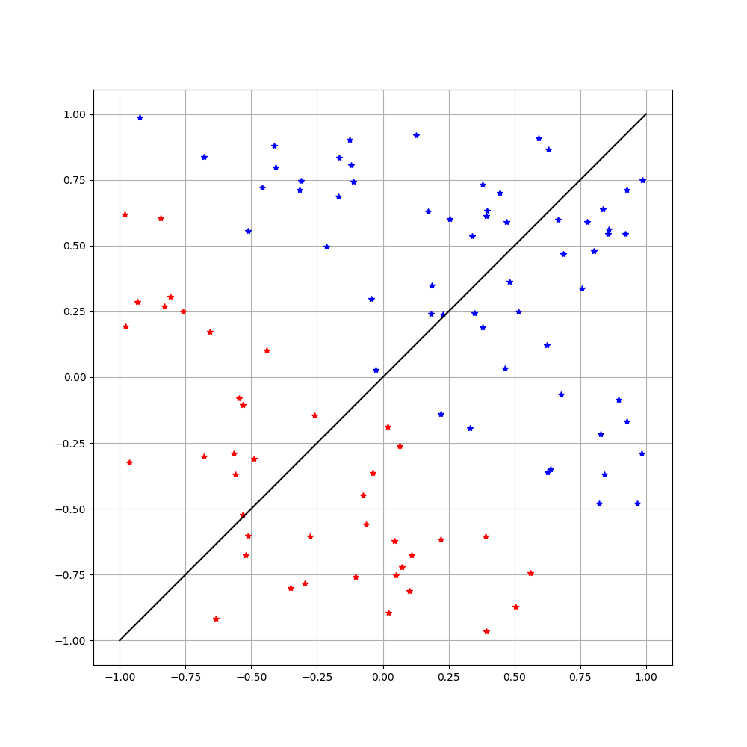

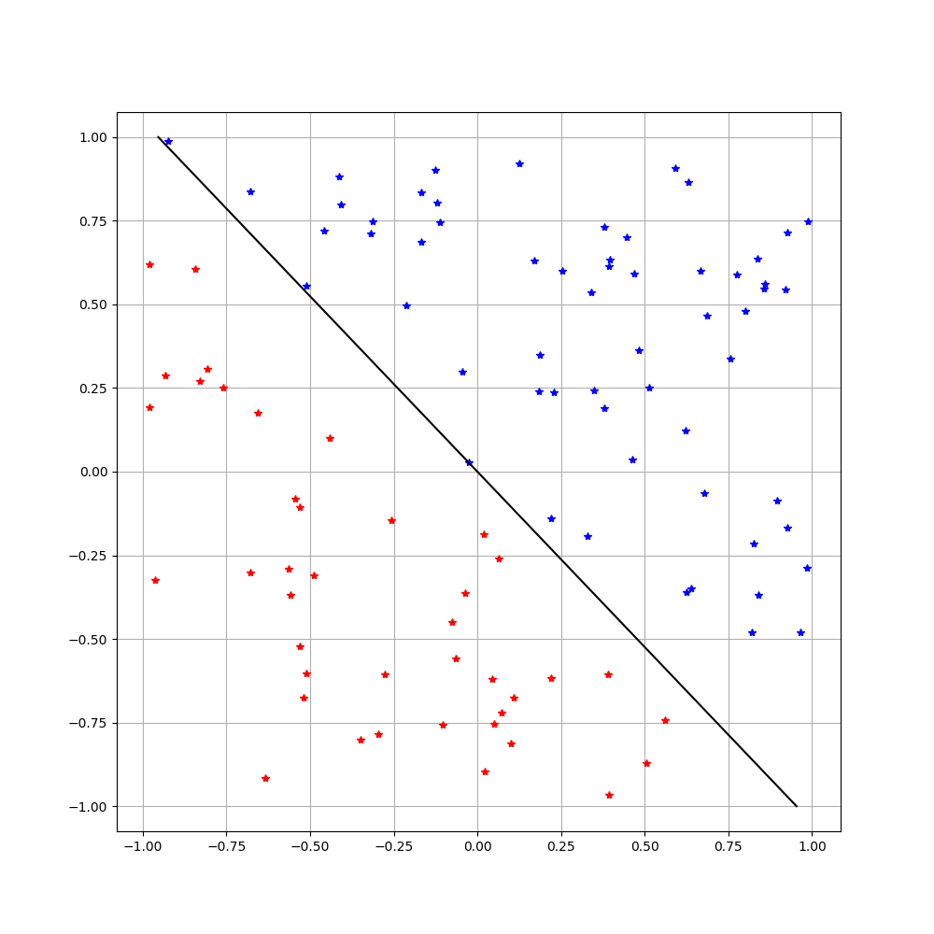

**Q4**.

error rate = 0.00

