Slide 1



____________________________________________________________________________________________________________________________________________________________________________________________________________________________________________________________________________________________________________________________________________________________________________________________________________________________________________________________________________________________________________________________________________________________________________________________________________________________________________________________________________________________________________________________________________________________________________________________________________________________________________________________________________________________
Slide 2

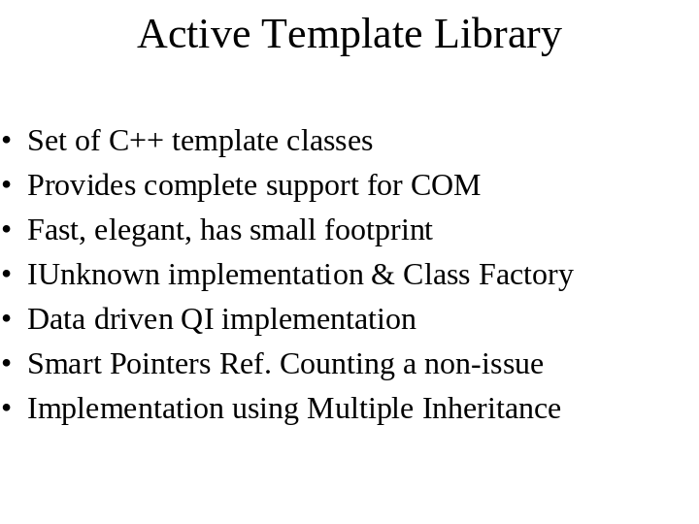

____________________________________________________________________________________________________________________________________________________________________________________________________________________________________________________________________________________________________________________________________________________________________________________________________________________________________________________________________________________________________________________________________________________________________________________________________________________________________________________________________________________________________________________________________________________________________________________________________________________________________________________________________________________________
Slide 3

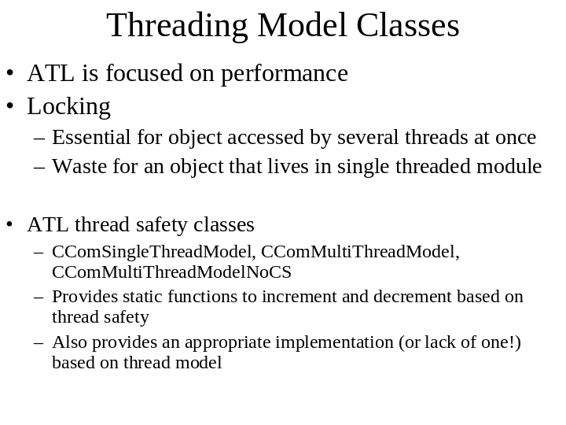

____________________________________________________________________________________________________________________________________________________________________________________________________________________________________________________________________________________________________________________________________________________________________________________________________________________________________________________________________________________________________________________________________________________________________________________________________________________________________________________________________________________________________________________________________________________________________________________________________________________________________________________________________________________________
Slide 4

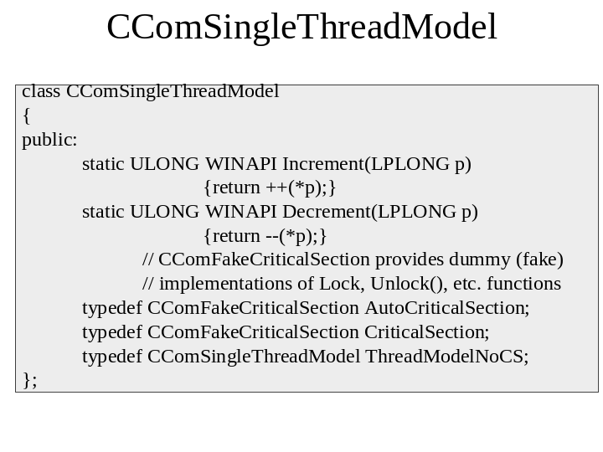

____________________________________________________________________________________________________________________________________________________________________________________________________________________________________________________________________________________________________________________________________________________________________________________________________________________________________________________________________________________________________________________________________________________________________________________________________________________________________________________________________________________________________________________________________________________________________________________________________________________________________________________________________________________________
Slide 5

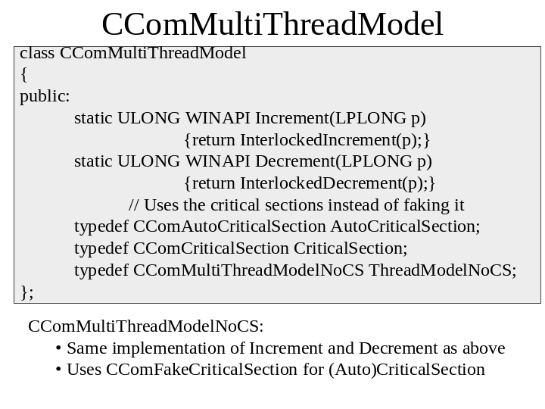

____________________________________________________________________________________________________________________________________________________________________________________________________________________________________________________________________________________________________________________________________________________________________________________________________________________________________________________________________________________________________________________________________________________________________________________________________________________________________________________________________________________________________________________________________________________________________________________________________________________________________________________________________________________________
Slide 6

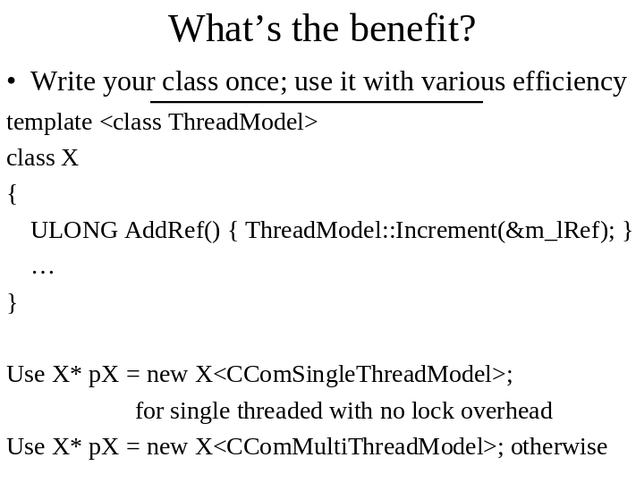

____________________________________________________________________________________________________________________________________________________________________________________________________________________________________________________________________________________________________________________________________________________________________________________________________________________________________________________________________________________________________________________________________________________________________________________________________________________________________________________________________________________________________________________________________________________________________________________________________________________________________________________________________________________________
Slide 7



____________________________________________________________________________________________________________________________________________________________________________________________________________________________________________________________________________________________________________________________________________________________________________________________________________________________________________________________________________________________________________________________________________________________________________________________________________________________________________________________________________________________________________________________________________________________________________________________________________________________________________________________________________________________
Slide 8

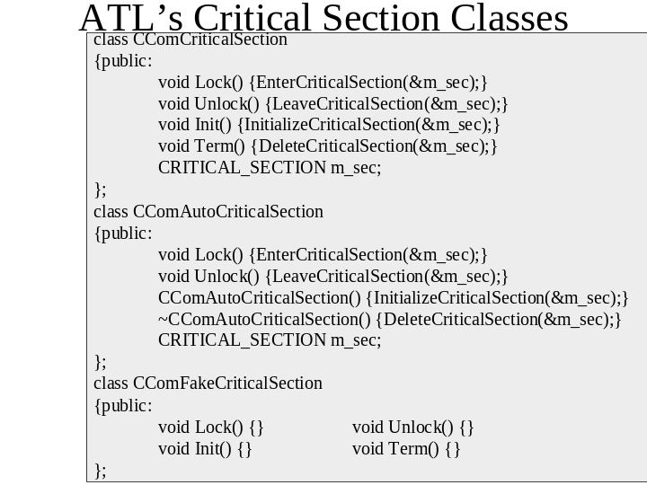

____________________________________________________________________________________________________________________________________________________________________________________________________________________________________________________________________________________________________________________________________________________________________________________________________________________________________________________________________________________________________________________________________________________________________________________________________________________________________________________________________________________________________________________________________________________________________________________________________________________________________________________________________________________________
Slide 9

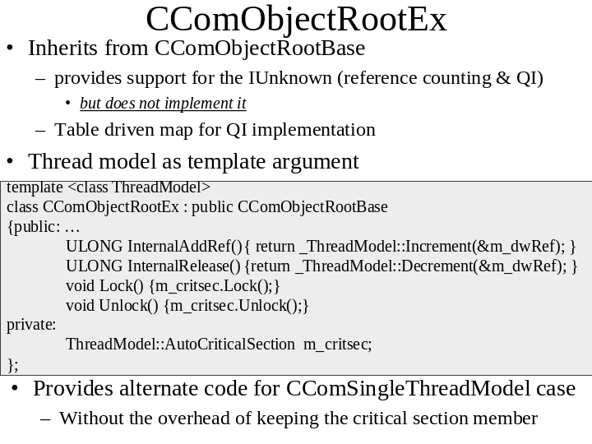

____________________________________________________________________________________________________________________________________________________________________________________________________________________________________________________________________________________________________________________________________________________________________________________________________________________________________________________________________________________________________________________________________________________________________________________________________________________________________________________________________________________________________________________________________________________________________________________________________________________________________________________________________________________________
Slide 10

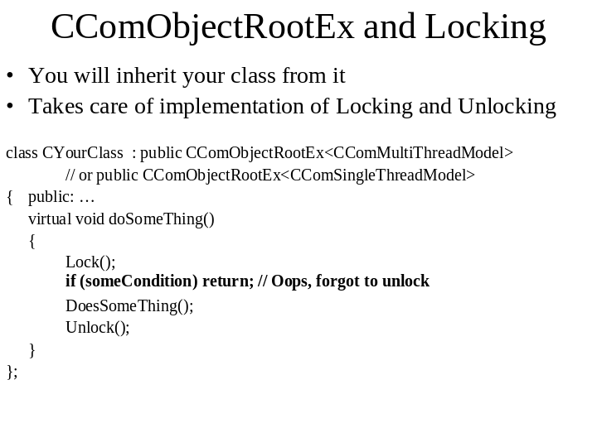

____________________________________________________________________________________________________________________________________________________________________________________________________________________________________________________________________________________________________________________________________________________________________________________________________________________________________________________________________________________________________________________________________________________________________________________________________________________________________________________________________________________________________________________________________________________________________________________________________________________________________________________________________________________________
Slide 11

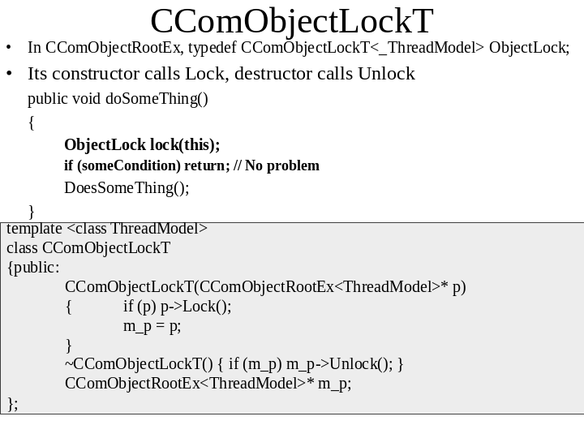

____________________________________________________________________________________________________________________________________________________________________________________________________________________________________________________________________________________________________________________________________________________________________________________________________________________________________________________________________________________________________________________________________________________________________________________________________________________________________________________________________________________________________________________________________________________________________________________________________________________________________________________________________________________________
Slide 12

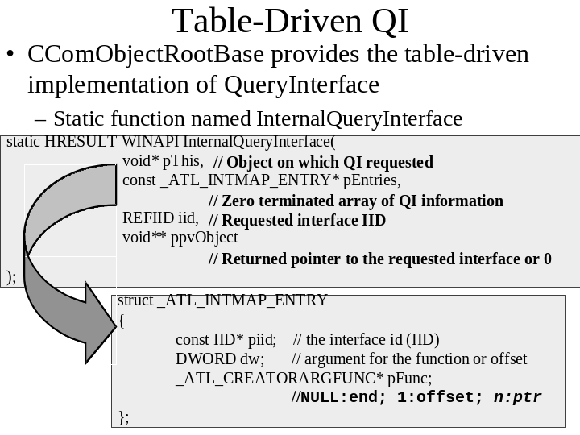

____________________________________________________________________________________________________________________________________________________________________________________________________________________________________________________________________________________________________________________________________________________________________________________________________________________________________________________________________________________________________________________________________________________________________________________________________________________________________________________________________________________________________________________________________________________________________________________________________________________________________________________________________________________________
Slide 13

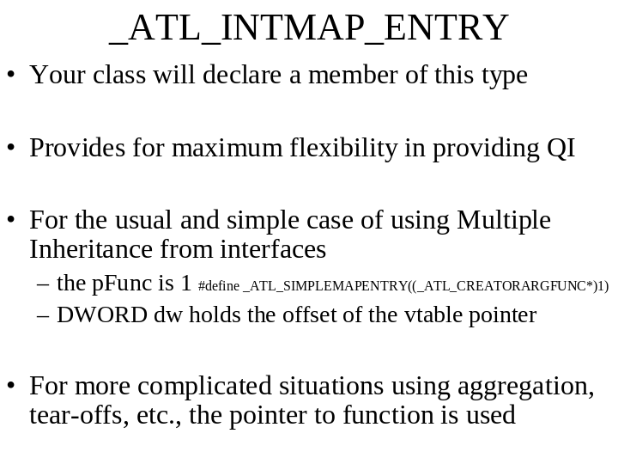

____________________________________________________________________________________________________________________________________________________________________________________________________________________________________________________________________________________________________________________________________________________________________________________________________________________________________________________________________________________________________________________________________________________________________________________________________________________________________________________________________________________________________________________________________________________________________________________________________________________________________________________________________________________________
Slide 14

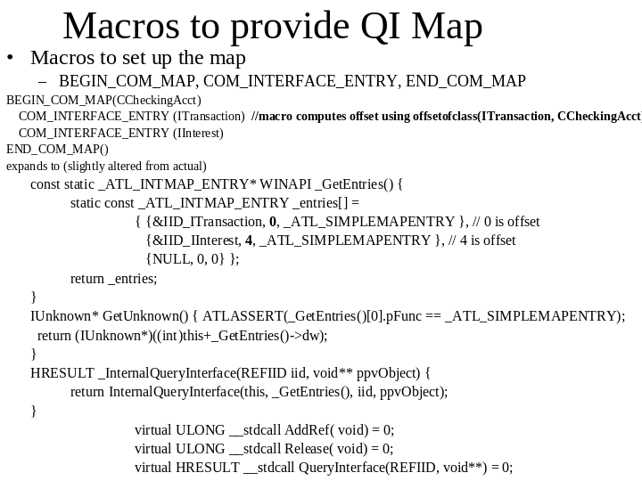

____________________________________________________________________________________________________________________________________________________________________________________________________________________________________________________________________________________________________________________________________________________________________________________________________________________________________________________________________________________________________________________________________________________________________________________________________________________________________________________________________________________________________________________________________________________________________________________________________________________________________________________________________________________________
Slide 15

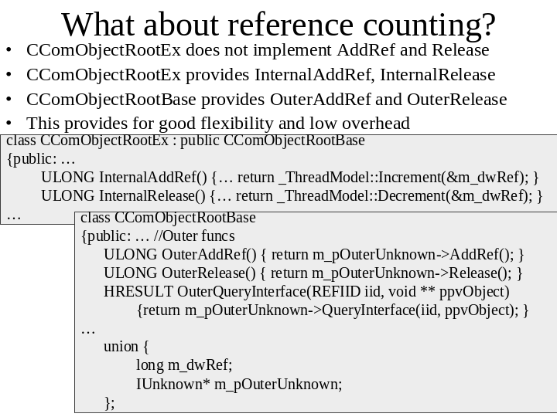

____________________________________________________________________________________________________________________________________________________________________________________________________________________________________________________________________________________________________________________________________________________________________________________________________________________________________________________________________________________________________________________________________________________________________________________________________________________________________________________________________________________________________________________________________________________________________________________________________________________________________________________________________________________________
Slide 16

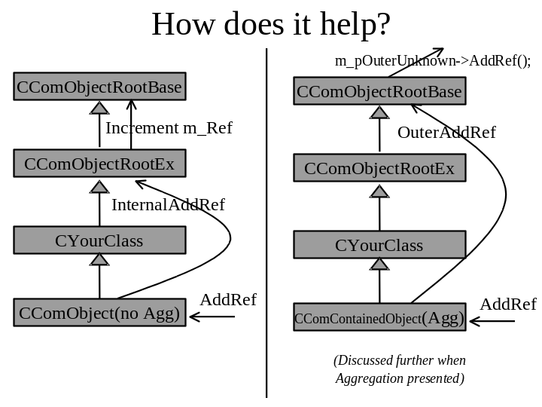

____________________________________________________________________________________________________________________________________________________________________________________________________________________________________________________________________________________________________________________________________________________________________________________________________________________________________________________________________________________________________________________________________________________________________________________________________________________________________________________________________________________________________________________________________________________________________________________________________________________________________________________________________________________________
Slide 17

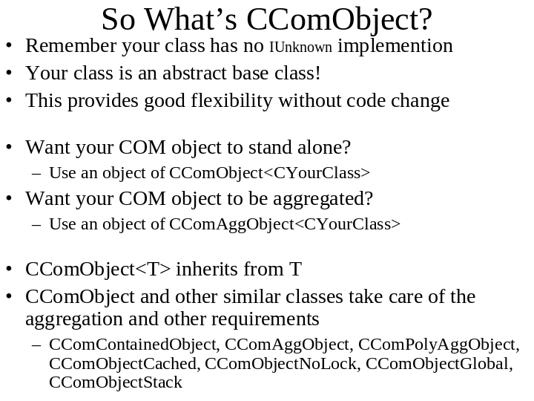

____________________________________________________________________________________________________________________________________________________________________________________________________________________________________________________________________________________________________________________________________________________________________________________________________________________________________________________________________________________________________________________________________________________________________________________________________________________________________________________________________________________________________________________________________________________________________________________________________________________________________________________________________________________________
Slide 18

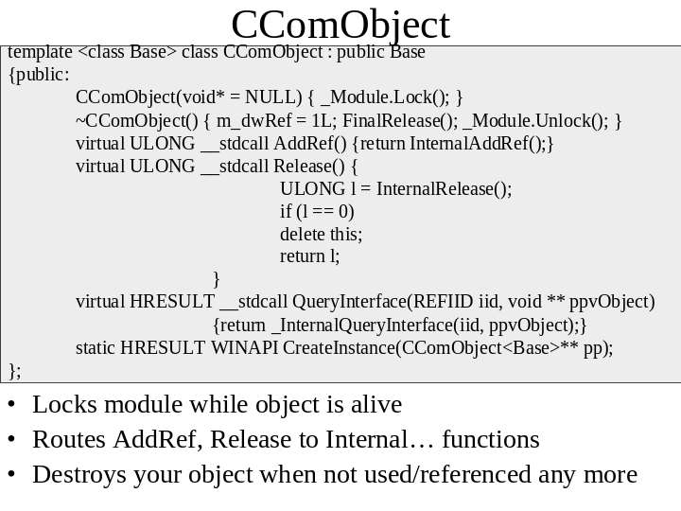

____________________________________________________________________________________________________________________________________________________________________________________________________________________________________________________________________________________________________________________________________________________________________________________________________________________________________________________________________________________________________________________________________________________________________________________________________________________________________________________________________________________________________________________________________________________________________________________________________________________________________________________________________________________________
Slide 19

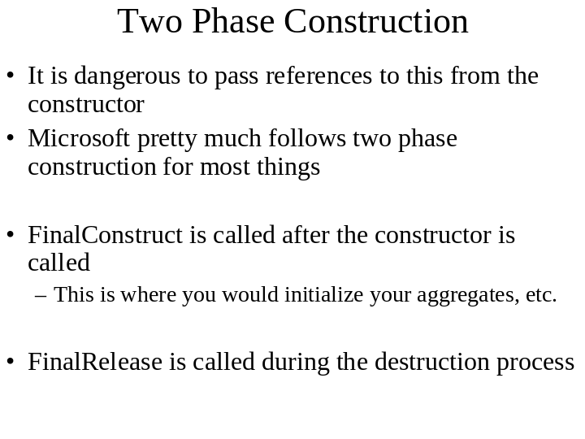

____________________________________________________________________________________________________________________________________________________________________________________________________________________________________________________________________________________________________________________________________________________________________________________________________________________________________________________________________________________________________________________________________________________________________________________________________________________________________________________________________________________________________________________________________________________________________________________________________________________________________________________________________________________________
Slide 20

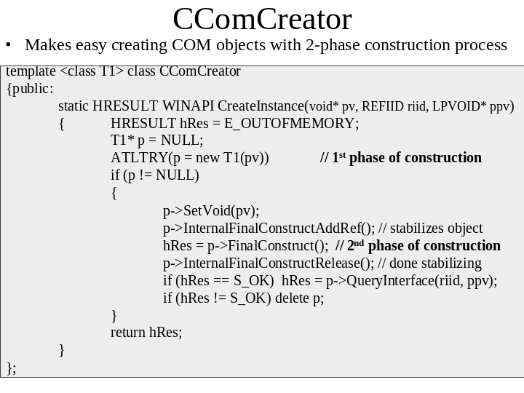

____________________________________________________________________________________________________________________________________________________________________________________________________________________________________________________________________________________________________________________________________________________________________________________________________________________________________________________________________________________________________________________________________________________________________________________________________________________________________________________________________________________________________________________________________________________________________________________________________________________________________________________________________________________________
Slide 21

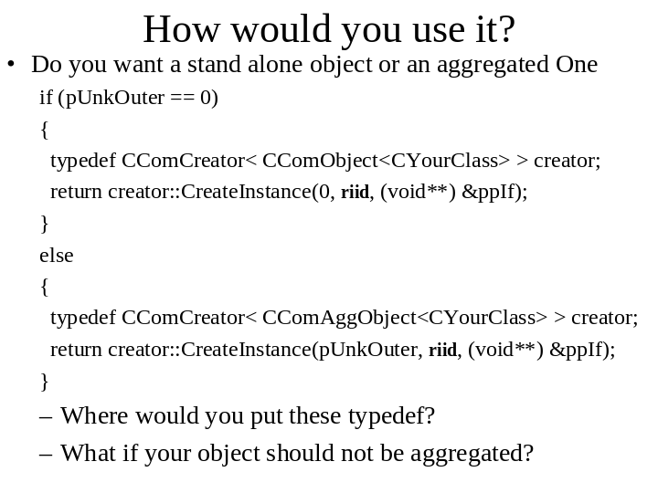

____________________________________________________________________________________________________________________________________________________________________________________________________________________________________________________________________________________________________________________________________________________________________________________________________________________________________________________________________________________________________________________________________________________________________________________________________________________________________________________________________________________________________________________________________________________________________________________________________________________________________________________________________________________________
Slide 22

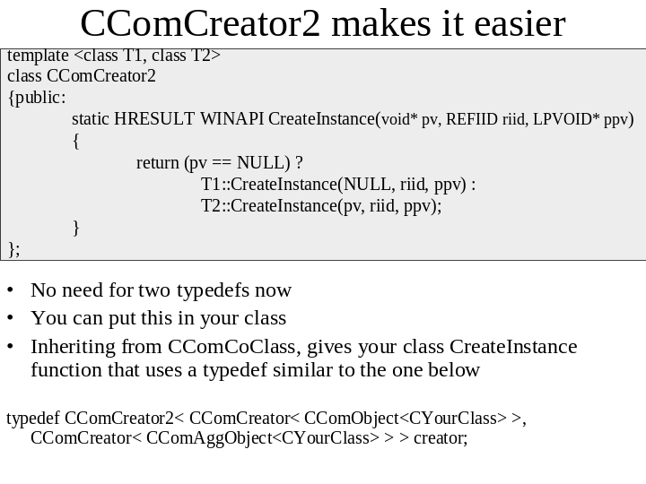

____________________________________________________________________________________________________________________________________________________________________________________________________________________________________________________________________________________________________________________________________________________________________________________________________________________________________________________________________________________________________________________________________________________________________________________________________________________________________________________________________________________________________________________________________________________________________________________________________________________________________________________________________________________________
Slide 23

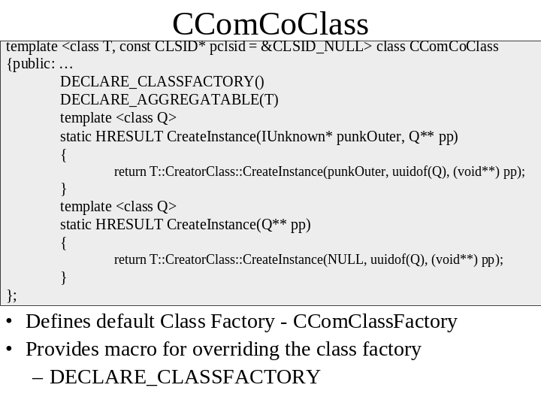

____________________________________________________________________________________________________________________________________________________________________________________________________________________________________________________________________________________________________________________________________________________________________________________________________________________________________________________________________________________________________________________________________________________________________________________________________________________________________________________________________________________________________________________________________________________________________________________________________________________________________________________________________________________________
Slide 24

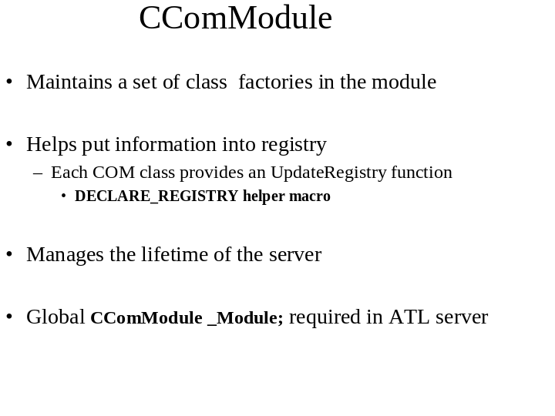

____________________________________________________________________________________________________________________________________________________________________________________________________________________________________________________________________________________________________________________________________________________________________________________________________________________________________________________________________________________________________________________________________________________________________________________________________________________________________________________________________________________________________________________________________________________________________________________________________________________________________________________________________________________________
Slide 25

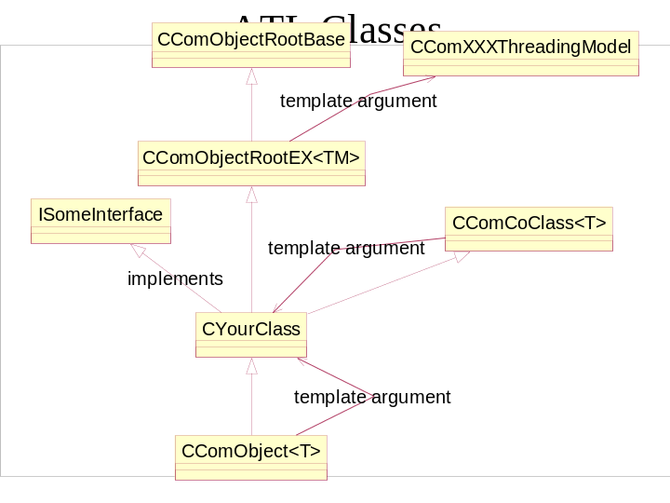

____________________________________________________________________________________________________________________________________________________________________________________________________________________________________________________________________________________________________________________________________________________________________________________________________________________________________________________________________________________________________________________________________________________________________________________________________________________________________________________________________________________________________________________________________________________________________________________________________________________________________________________________________________________________
Slide 26

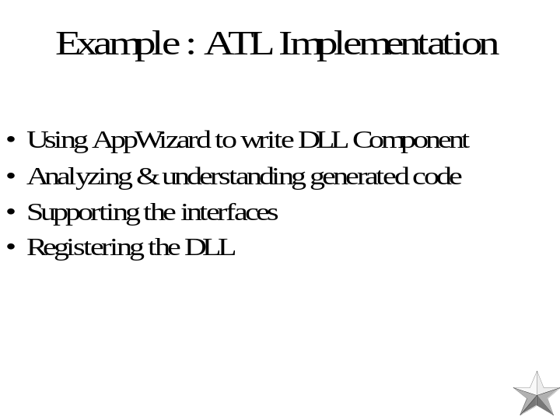

____________________________________________________________________________________________________________________________________________________________________________________________________________________________________________________________________________________________________________________________________________________________________________________________________________________________________________________________________________________________________________________________________________________________________________________________________________________________________________________________________________________________________________________________________________________________________________________________________________________________________________________________________________________________
Slide 27

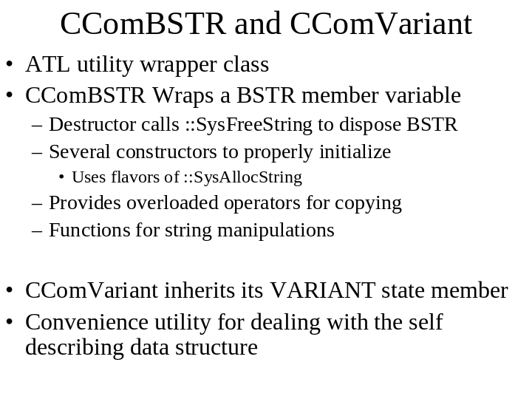

____________________________________________________________________________________________________________________________________________________________________________________________________________________________________________________________________________________________________________________________________________________________________________________________________________________________________________________________________________________________________________________________________________________________________________________________________________________________________________________________________________________________________________________________________________________________________________________________________________________________________________________________________________________________
Slide 28

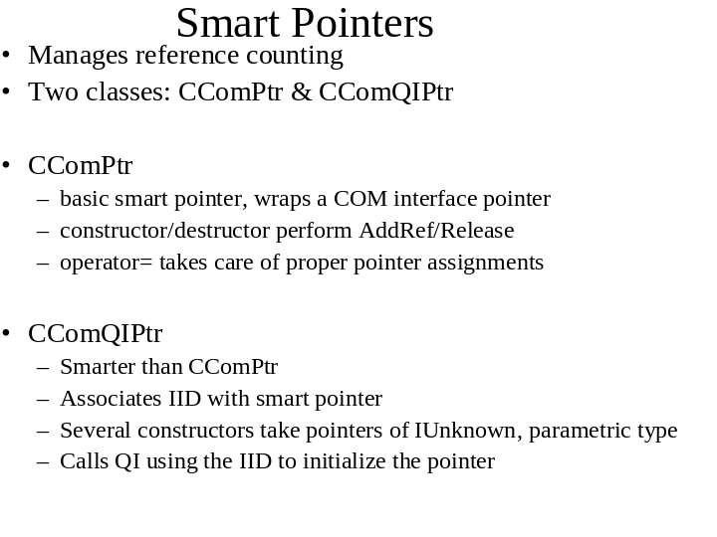

____________________________________________________________________________________________________________________________________________________________________________________________________________________________________________________________________________________________________________________________________________________________________________________________________________________________________________________________________________________________________________________________________________________________________________________________________________________________________________________________________________________________________________________________________________________________________________________________________________________________________________________________________________________________
Slide 29



____________________________________________________________________________________________________________________________________________________________________________________________________________________________________________________________________________________________________________________________________________________________________________________________________________________________________________________________________________________________________________________________________________________________________________________________________________________________________________________________________________________________________________________________________________________________________________________________________________________________________________________________________________________________

