Example Using ATL

- You must have created a project named accountInterfaces where you defined the interfaces in the IDL file [If not please refer to ExampleUsingMI].
- Create an ATL COM AppWizard project named CheckingAcctComp.
- In Step 1 of 1, choose the DLL option and click on Finish. Then click on OK.
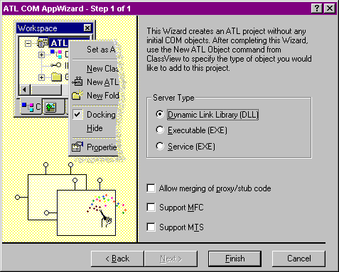
- Click on the Insert menu and select the New ATL object menu item.
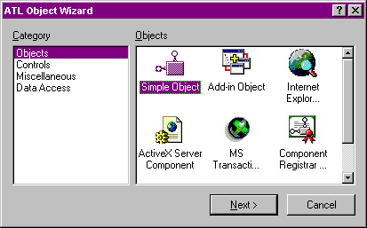
- Select the Objects under Category and select Simple Object under the Objects. Click Next.
- The object properties dialog appears. Type the appropriate information for the CCheckingAcct class.
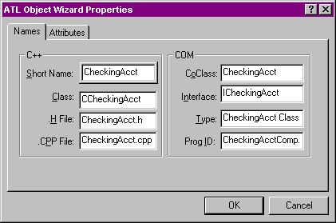
- Click on the Attributes tab and modify the settings as desired. OK when done.
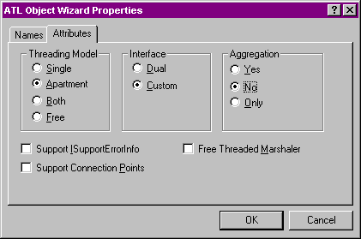
- In the Class View, double click on the class name to bring up the CheckingAcct.h file. In the top of the file, add #include to the accountInterfaces.h file that you created in the earlier session. This file includes the definitions of the interfaces ITransaction, IInterest and IOverdraft.
- Inherit the CCheckingAcct class from the ITransaction and IInterest interfaces:
class ATL_NO_VTABLE CCheckingAcct :
public CComObjectRootEx<CComSingleThreadModel>,
public CComCoClass<CCheckingAcct, &CLSID_CheckingAcct>,
public ICheckingAcct, public ITransaction, public IInterest
- In the CCheckingAcct class add the following variable and initialize it to 0 in the constructor:
private:
double m_balance;
- Also, add
public:

// ITransaction interface functions
HRESULT STDMETHODCALLTYPE deposit(double amount);

HRESULT STDMETHODCALLTYPE withdraw(double amount,
double* pWithdrawnAmount);

HRESULT STDMETHODCALLTYPE getBalance(double* pAmount);

// IInterest interface functions
HRESULT STDMETHODCALLTYPE computeInterest(
double* pInterestAmount);
- In the CheckingAcct.cpp file, add the following code
// ITransaction interface functions
HRESULT STDMETHODCALLTYPE CCheckingAcct::deposit(
double amount)
{
m_balance += amount;

return S_OK;
}

HRESULT STDMETHODCALLTYPE CCheckingAcct::withdraw(
double amount,
double* pWithdrawnAmount)
{
if (pWithdrawnAmount == 0)
return S_FALSE;

if (amount > m_balance)
{
*pWithdrawnAmount = m_balance;
m_balance = 0;
}
else
{
m_balance -= amount;
*pWithdrawnAmount = amount;
}

return S_OK;
}

HRESULT STDMETHODCALLTYPE CCheckingAcct::getBalance(
double* pAmount)
{
*pAmount = m_balance;

return S_OK;
}

// IInterest interface functions
HRESULT STDMETHODCALLTYPE CCheckingAcct::computeInterest(
double* pInterestAmount)
{
if (pInterestAmount == 0)
return S_FALSE;

*pInterestAmount = m_balance * .1; // A generous 10% interest.

m_balance += *pInterestAmount;

return S_OK;
}
- In the CheckingAcct.h file, find the macro BEGIN_COM_MAP and edit as follows:
BEGIN_COM_MAP(CCheckingAcct)
COM_INTERFACE_ENTRY(ICheckingAcct)
COM_INTERFACE_ENTRY(ITransaction)
COM_INTERFACE_ENTRY(IInterest)
END_COM_MAP()
- Compile the project. It self registers.
- Examine all the code that has been generated and written. Also, click on the Resource View and look at the registration details added as a resource.
- Run your accountUser client program to test the newly created ATL implementation. You may put some print statements in the ATL code to see that it is really being called from the client.

