Slide 1

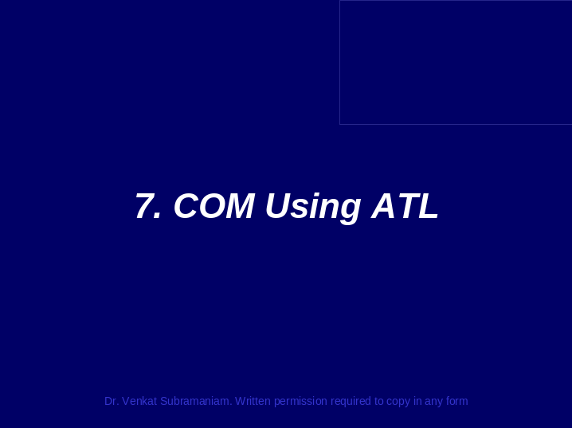

__________________________________________________________________________________________________________________________________________________________________________________________________________________________________________________________________________________________________________________________________________________________________________________________________________________________________________________________________________________________________________________________________________________________________________________________________________________________________________________________________________________________________________________________________________________________________________________________________________________________________________________________________________________
Slide 2

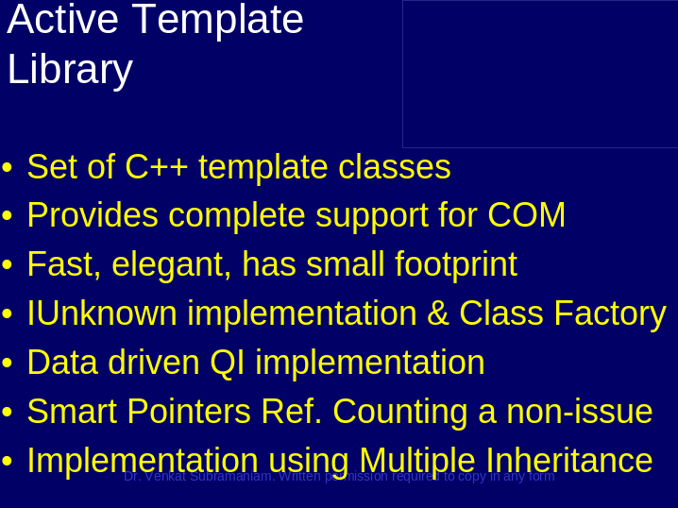

__________________________________________________________________________________________________________________________________________________________________________________________________________________________________________________________________________________________________________________________________________________________________________________________________________________________________________________________________________________________________________________________________________________________________________________________________________________________________________________________________________________________________________________________________________________________________________________________________________________________________________________________________________________
Slide 3

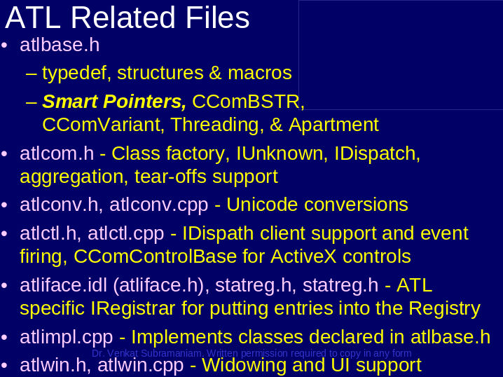

__________________________________________________________________________________________________________________________________________________________________________________________________________________________________________________________________________________________________________________________________________________________________________________________________________________________________________________________________________________________________________________________________________________________________________________________________________________________________________________________________________________________________________________________________________________________________________________________________________________________________________________________________________________
Slide 4

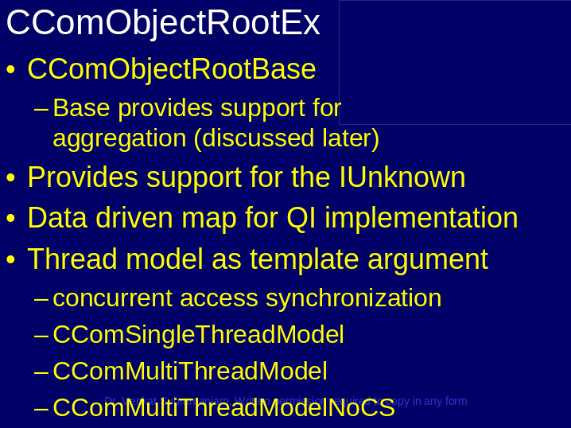

__________________________________________________________________________________________________________________________________________________________________________________________________________________________________________________________________________________________________________________________________________________________________________________________________________________________________________________________________________________________________________________________________________________________________________________________________________________________________________________________________________________________________________________________________________________________________________________________________________________________________________________________________________________
Slide 5

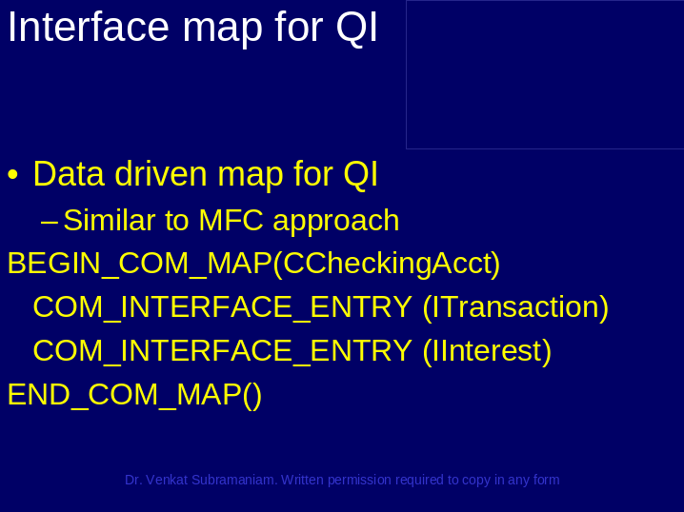

__________________________________________________________________________________________________________________________________________________________________________________________________________________________________________________________________________________________________________________________________________________________________________________________________________________________________________________________________________________________________________________________________________________________________________________________________________________________________________________________________________________________________________________________________________________________________________________________________________________________________________________________________________________
Slide 6

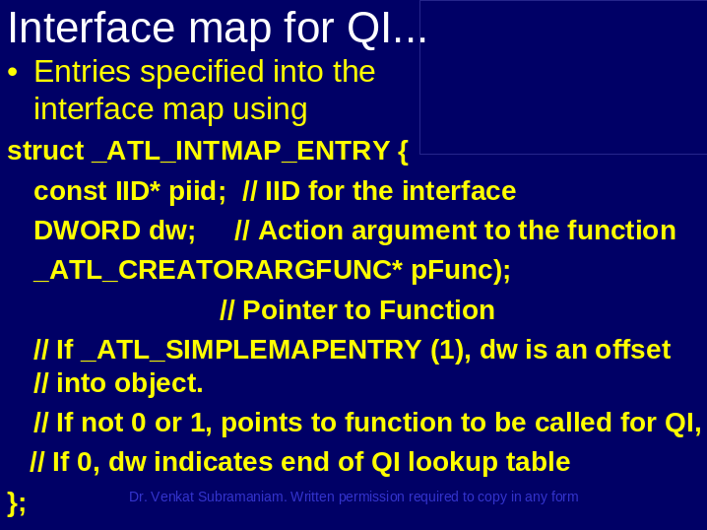

__________________________________________________________________________________________________________________________________________________________________________________________________________________________________________________________________________________________________________________________________________________________________________________________________________________________________________________________________________________________________________________________________________________________________________________________________________________________________________________________________________________________________________________________________________________________________________________________________________________________________________________________________________________
Slide 7

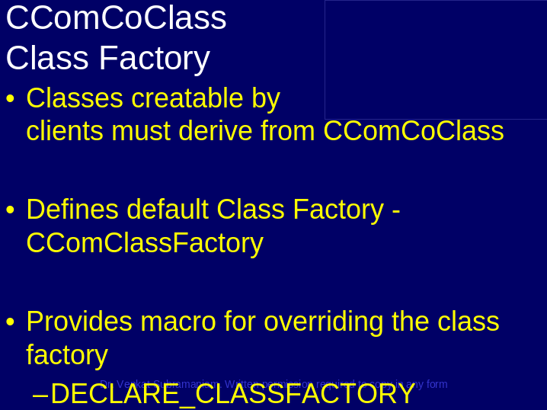

__________________________________________________________________________________________________________________________________________________________________________________________________________________________________________________________________________________________________________________________________________________________________________________________________________________________________________________________________________________________________________________________________________________________________________________________________________________________________________________________________________________________________________________________________________________________________________________________________________________________________________________________________________________
Slide 8

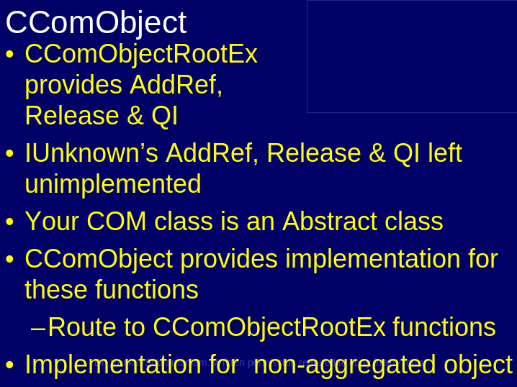

__________________________________________________________________________________________________________________________________________________________________________________________________________________________________________________________________________________________________________________________________________________________________________________________________________________________________________________________________________________________________________________________________________________________________________________________________________________________________________________________________________________________________________________________________________________________________________________________________________________________________________________________________________________
Slide 9

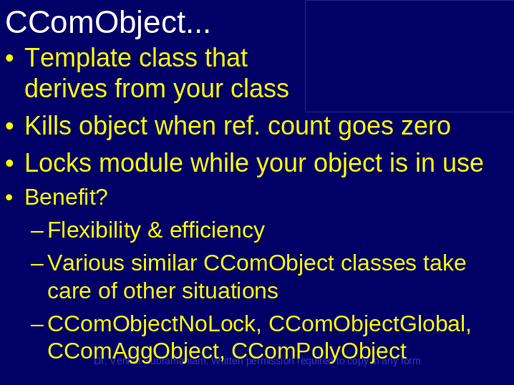

__________________________________________________________________________________________________________________________________________________________________________________________________________________________________________________________________________________________________________________________________________________________________________________________________________________________________________________________________________________________________________________________________________________________________________________________________________________________________________________________________________________________________________________________________________________________________________________________________________________________________________________________________________________
Slide 10

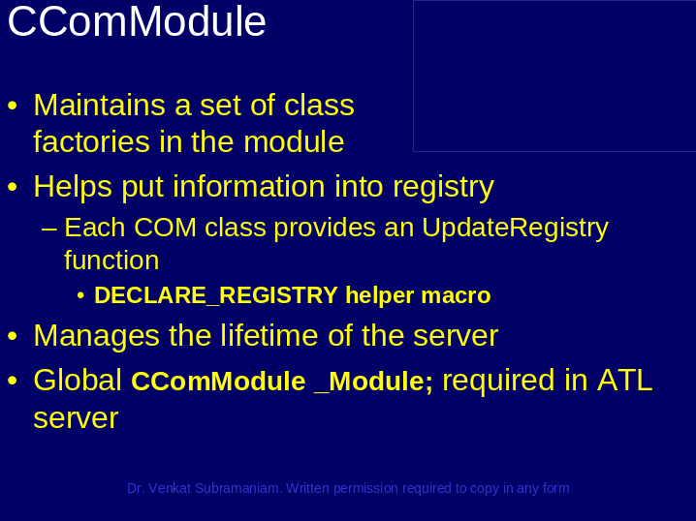

__________________________________________________________________________________________________________________________________________________________________________________________________________________________________________________________________________________________________________________________________________________________________________________________________________________________________________________________________________________________________________________________________________________________________________________________________________________________________________________________________________________________________________________________________________________________________________________________________________________________________________________________________________________
Slide 11

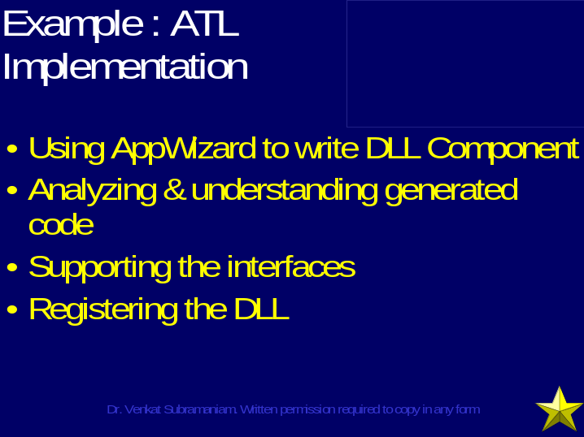

__________________________________________________________________________________________________________________________________________________________________________________________________________________________________________________________________________________________________________________________________________________________________________________________________________________________________________________________________________________________________________________________________________________________________________________________________________________________________________________________________________________________________________________________________________________________________________________________________________________________________________________________________________________
Slide 12

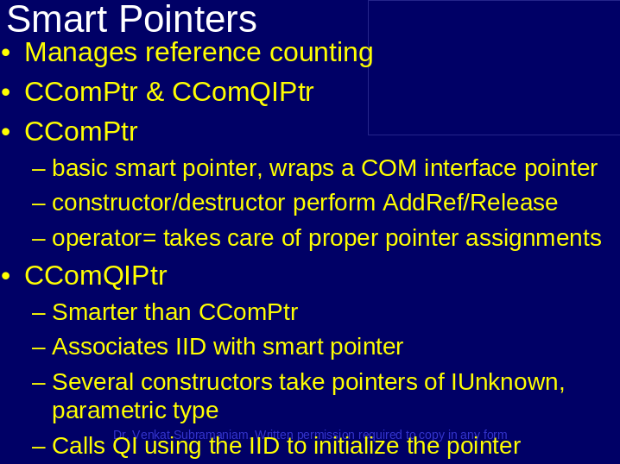

__________________________________________________________________________________________________________________________________________________________________________________________________________________________________________________________________________________________________________________________________________________________________________________________________________________________________________________________________________________________________________________________________________________________________________________________________________________________________________________________________________________________________________________________________________________________________________________________________________________________________________________________________________________
Slide 13





