COM Aggregation Example

The objective of this example is to understand how to use Aggregation in a COM object.

- Start Studio and create an ATL COM AppWizard (DLL) application named clockRadioComp.
- Open the IDL file, clockRadioComp.idl, and add the following interfaces. Note that the GUIs may be generated using the GUIGEN application.
import "oaidl.idl";
import "ocidl.idl";
[
object,
uuid(4262A1C0-E6F2-11d2-87A2-00609795C169),
]
interface ITime : IUnknown
{
HRESULT setTime([in] long hour, [in] long minute, [in] long second);
}

[
object,
uuid(4262A1C1-E6F2-11d2-87A2-00609795C169),
]
interface IAlarm : IUnknown
{
HRESULT setAlarm([in] long hour,
[in] long minute, [in] long second);
}

[
object,
uuid(4262A1C2-E6F2-11d2-87A2-00609795C169),
]
interface IMusic : IUnknown
{
HRESULT play();
}
- Create an ATL class named CClock by clicking on the Insert menu and selecting New ATL Object. Use the settings of Object for category and pick the Simply ATL Object. Provide the information as follows:
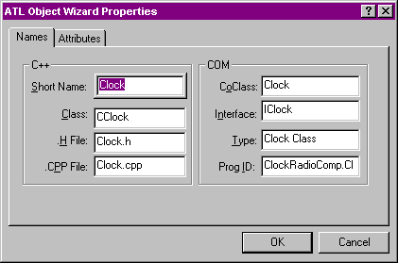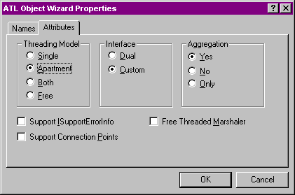
- Edit the code in Clock.h to inherit CClock from ITime and IAlarm interfaces and implement the interface functions as shown below:
HRESULT __stdcall setTime(long hour, long minute, long second)
{
::MessageBox(NULL, "CClock::SetTime called", NULL, 0);
return S_OK;
}

HRESULT __stdcall setAlarm(long hour, long minute, long second)
{
::MessageBox(NULL, "CClock::SetAlarm called", NULL, 0);
return S_OK;
}
- Remember to update the COM MAP entry for the two interfaces in the class CClock.
- Create a ATL Class named CRadio, inherit it from IMusic interface and similarly implement the method for the IMusic interface.
- Remember to update the COM MAP entry for the IMusic interface in the class CRadio.
- Examine the generated code and study the macros.
- We will now write a class that will aggregate these two COM classes. Create an ATL class with short name ClockRadio.
- The ClockRadio will implement the IAlarm interface by itself. It will aggregate other interfaces supported by the two aggregated components.
- Inherit the CClockRadio class from the IAlarm interface and provide the method :
HRESULT __stdcall setAlarm(long hour, long minute, long second)
{
::MessageBox(NULL, "In CClockRadio::setAlarm", NULL, 0);
return S_OK;
}
- Add the following members in the CClockRadio class:
CComPtr<IUnknown> m_pTime;
CComPtr<IUnknown> m_pMusic;
- Edit the COM Map as follows:
BEGIN_COM_MAP(CClockRadio)
COM_INTERFACE_ENTRY(IClockRadio)
COM_INTERFACE_ENTRY(IAlarm)
COM_INTERFACE_ENTRY_AGGREGATE_BLIND(m_pTime.p)
COM_INTERFACE_ENTRY_AGGREGATE(IID_IMusic, m_pMusic.p)
END_COM_MAP()

Notice that the IAlarm interface is supported directly by CClockRadio and so there is an entry for that interface. The CClockRadio blindly aggregates all interfaces supported by the COM object pointed by m_pTime, i.e., CClock. On the other hand, it performs selective aggregation of interfaces supported by the COM object pointed by m_pMusic, i.e., CRadio.
- On final thing to be done. The CClockRadio needs to create the aggregated objects. This is done in the FinalConstruct function:
DECLARE_GET_CONTROLLING_UNKNOWN()

HRESULT FinalConstruct()
{
CLSID clsid;
HRESULT hr;

hr = ::CLSIDFromProgID(L"clockRadioComp.Clock", &clsid);

if (!SUCCEEDED(hr))
return hr;

hr = ::CoCreateInstance(clsid, GetControllingUnknown(),
CLSCTX_INPROC_SERVER, IID_IUnknown,
(void**) &m_pTime);

if (!SUCCEEDED(hr))
return hr;

hr = ::CLSIDFromProgID(L"clockRadioComp.Radio", &clsid);

if (!SUCCEEDED(hr))
return hr;

hr = ::CoCreateInstance(clsid, GetControllingUnknown(),
CLSCTX_INPROC_SERVER, IID_IUnknown,
(void**) &m_pMusic);

if (!SUCCEEDED(hr))
return hr;

return S_OK;
}

void FinalRelease()
{
// No need to do any thing since smart pointers used.
}
- Compile and make sure the DLL registers.
- Now create a Dialog based MFC AppWizard (exe) project named clockRadioClient.
- In the stdafx.h file add #include <afxole.h>.
- Edit the resource of the dialog as shown below:
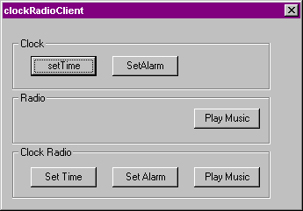
- Define the following in the Dialog class:
private:
LPUNKNOWN m_lpClockRadio;
LPUNKNOWN m_lpRadio;
LPUNKNOWN m_lpClock;
- Initialize these pointers to 0 in the constructor and release them in the destructor:
CClockRadioClientDlg::CClockRadioClientDlg(CWnd* pParent /*=NULL*/)
: CDialog(CClockRadioClientDlg::IDD, pParent)
{
//{{AFX_DATA_INIT(CClockRadioClientDlg)
// NOTE: the ClassWizard will add member initialization here
//}}AFX_DATA_INIT
// Note that LoadIcon does not require a subsequent DestroyIcon in Win32
m_hIcon = AfxGetApp()->LoadIcon(IDR_MAINFRAME);

m_lpClockRadio = 0;
m_lpRadio = 0;
m_lpClock = 0;
}

CClockRadioClientDlg::~CClockRadioClientDlg()
{
if (m_lpClockRadio != 0) m_lpClockRadio->Release();
if (m_lpRadio != 0) m_lpRadio->Release();
if (m_lpClock != 0) m_lpClock->Release();
}
- Edit the OnInitDialog function of the CClockRadioDlg class. Right before the return TRUE at the end of the function add the following:
CLSID clsid;

if (::CLSIDFromProgID(L"clockRadioComp.Clock", &clsid) != S_OK)
{
AfxMessageBox("Cant get class id from prog id");
return FALSE;
}

if (::CoCreateInstance(clsid, NULL,
CLSCTX_ALL, IID_IUnknown, (void**)&m_lpClock) != S_OK)
{
AfxMessageBox("Can create instance of Clock");
return FALSE;
}

if (::CLSIDFromProgID(L"clockRadioComp.Radio", &clsid) != S_OK)
{
AfxMessageBox("Cant get class id from prog id");
return FALSE;
}

if (::CoCreateInstance(clsid, NULL,
CLSCTX_ALL, IID_IUnknown, (void**)&m_lpRadio) != S_OK)
{
AfxMessageBox("Can create instance of Radio");
return FALSE;
}

if (::CLSIDFromProgID(L"clockRadioComp.ClockRadio", &clsid) != S_OK)
{
AfxMessageBox("Cant get class id from prog id");
return FALSE;
}

if (::CoCreateInstance(clsid, NULL,
CLSCTX_ALL, IID_IUnknown, (void**)&m_lpClockRadio) != S_OK)
{
AfxMessageBox("Can create instance of ClockRadio");
return FALSE;
}
- Add #include “..\clockRadioComp\clockRadioComp.h” in the dialog’s .h file.
- Provide the handlers for the buttons for the Clock:
void CClockRadioClientDlg::OnButtonClockSetTime()
{
ITime* pTime;

if (m_lpClock->QueryInterface(IID_ITime, (void**)&pTime) == S_OK)
{
pTime->setTime(12, 12, 12);
}
}

void CClockRadioClientDlg::OnButtonClockSetAlarm()
{
IAlarm* pAlarm;

if (m_lpClock->QueryInterface(IID_IAlarm, (void**)&pAlarm) == S_OK)
{
pAlarm->setAlarm(12, 12, 12);
}
}
- Provide handler for the button that deals with the Radio:
void CClockRadioClientDlg::OnButtonRadioPlayMusic()
{
IMusic* pMusic;

if (m_lpRadio->QueryInterface(IID_IMusic, (void**)&pMusic) == S_OK)
{
pMusic->play();
}
}
- Finally, implement the handler for the three buttons that deal with the ClockRadio:
void CClockRadioClientDlg::OnBUTTONClockRadioSetTime()
{
ITime* pTime;

if (m_lpClockRadio->QueryInterface(IID_ITime, (void**)&pTime) == S_OK)
{
pTime->setTime(12, 12, 12);
}
}

void CClockRadioClientDlg::OnBUTTONClockRadioSetAlarm()
{
IAlarm* pAlarm;

if (m_lpClockRadio->QueryInterface(IID_IAlarm, (void**)&pAlarm) == S_OK)
{
pAlarm->setAlarm(12, 12, 12);
}
}

void CClockRadioClientDlg::OnBUTTONClockRadioPlayMusic()
{
IMusic* pMusic;

if (m_lpClockRadio->QueryInterface(IID_IMusic, (void**)&pMusic) == S_OK)
{
pMusic->play();
}
}
- Remember to add the call to AfxOleInit() in the apps InitInstance() function.
- Compile and execute the program.
- Notice that clicking on the buttons invokes the appropriate methods that implement the interfaces. When you click on the CClockRadio related buttons, the setTime is routed to the CClock while the play is routed to the CRadio. However, the setAlarm is handled by the CClockRadio and is not routed to the CClock.
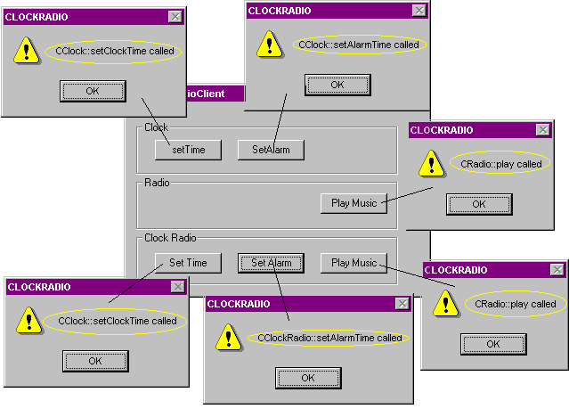
- Let us play with this a little bit. Now, the CClockRadio is supposed to give us the illusion that it is one component that supports three interfaces ITime, IAlarm and IPlay. In reality, however, it is made up of three components. Let us see if the CClockRadio does what it is supposed to.
- Change the handler for the button that deals with the play function for the CClockRadio. Instead of asking the clock radio for the IMusic interface, we will first get the ITime interface and ask it for the IMusic interface. Notice that the ITime is implemented by the CClock component and not the CClockRadio.
void CClockRadioClientDlg::OnBUTTONClockRadioPlayMusic()
{
#if 0
IMusic* pMusic;

if (m_lpClockRadio->QueryInterface(IID_IMusic, (void**)&pMusic) == S_OK)
{
pMusic->play();
}
#endif
ITime* pTime;

if (m_lpClockRadio->QueryInterface(IID_ITime, (void**)&pTime) != S_OK)
{
return;
}

IMusic* pMusic;

if (pTime->QueryInterface(IID_IMusic, (void**)&pMusic) == S_OK)
{
pMusic->play();
}
}
- Compile and execute the program. Note that the CClock component, when aggregated, does call the (correct) outer’s query interface. Let us make sure that this happens only when the CClock is aggregated. To test this, let us change the following function where we use the CClock component stand alone.
void CClockRadioClientDlg::OnBUTTONClockSetTime()
{
ITime* pTime;

if (m_lpClock->QueryInterface(IID_ITime, (void**)&pTime) == S_OK)
{
pTime->setTime(12, 12, 12);
}

//#if 0
AfxMessageBox("Request IMusic Interface from ITime");

IMusic* pMusic;

if (pTime->QueryInterface(IID_IMusic, (void**)&pMusic) == S_OK)
{
pMusic->play();
}
else
{
AfxMessageBox("No, IMusic not implemented by Clock");
}
//#endif
}
- Compile and execute the program. Click on the Set Time button in the Clock group (not the one in the ClockRadio group). The following widows appear:
- 