COM Containment Example

The objective of this example is to understand how to use Composition in a COM object.

- Start Studio and create an ATL COM AppWizard (DLL) application named CounterComp.
- Click on Insert and select New ATL Object. Create a Simple Object with short cut name Counter (select Custom interface).
- In the Class View, right click on the interface ICounter and click on Add Method and enter increment for method name:
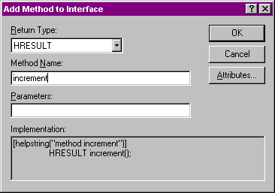
- Similarly add a method named reset. Then add a method named getValue which takes a parameter of type long* pValue.
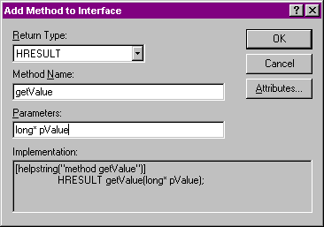
- In the Class View, expand the tree view for CCounter and further expand the node named ICounter and double click on the increment method. Implement this and the other two methods as shown below:
STDMETHODIMP CCounter::increment()
{
m_value++;
return S_OK;
}

STDMETHODIMP CCounter::reset()
{
m_value = 0;
return S_OK;
}

STDMETHODIMP CCounter::getValue(long *pValue)
{
*pValue = m_value;
return S_OK;
}
- In the CCounter class, define a private variable long m_value; and initialize it to 0 in the constructor.
- Compile and make sure the DLL is registered.
- Create another ATL COM AppWizard (DLL) project named ModuloCounterComp.
- Create an ATL Simple Object with short name ModuloCounter.
- In the IModuloCounter interface, add the following methods :
HRESULT increment();
HRESULT reset();
HRESULT getValue(long* pValue);
HRESULT setModLimit(long limit);
- In the CModuloCounter class, define the following private variables:
private:
long m_modLimit;
CComPtr<ICounter> m_pCounter;
- In the top of the ModuloCounter.h file add
#include "..\counterComp\counterComp.h"
- In the constructor of CModuloCounter, initialize the m_modLimit to 3.
- Declare methods named finalConstruct and finalRelease in the .h file of CModuloCounter and implement in the .cpp file as follows:
HRESULT CModuloCounter::FinalConstruct( )
{
return CoCreateInstance(CLSID_Counter, NULL,
CLSCTX_INPROC_SERVER, IID_ICounter,
(void**) &m_pCounter);
}

void CModuloCounter::FinalRelease( )
{
// No need to (should not) release m_pCounter since it is
// a smart pointer!
}
- Remember to add CounterComp_i.c to the project workspace.
- Implement the IModuloCounter interface methods for the CModuloCounter class :
STDMETHODIMP CModuloCounter::increment()
{
m_pCounter->increment();

long value;
m_pCounter->getValue(&value);

if (value == m_modLimit)
m_pCounter->reset();

return S_OK;
}

STDMETHODIMP CModuloCounter::reset()
{
m_pCounter->reset();
return S_OK;
}

STDMETHODIMP CModuloCounter::getValue(long *pValue)
{
m_pCounter->getValue(pValue);
return S_OK;
}

STDMETHODIMP CModuloCounter::setModLimit(long limit)
{
m_modLimit = limit;
return S_OK;
}
- Compile and make sure the ModuloCounterComp DLL registers.
- Now create a Dialog based MFC AppWizard exe named counterClient.
- Notice in the following steps, the client will not "see" either the ICounter interface or deal with the CCounter object directly. It does not "know" about the existence of such an interface/class.
- Edit the resource of the dialog as shown below:
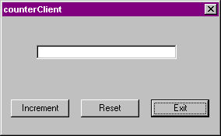
- Add a member variable for the edit control:
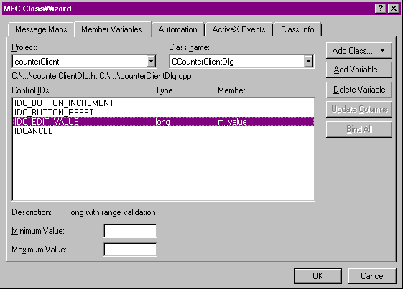
- In the top of the CCounterClientDlg’s header file, add
#include "../ModuloCounterComp/ModuloCounterComp.h"
- In the CCounterClientDlg class, add
private:
CComPtr<IModuloCounter> m_pModuloCounter;
Even though we use MFC to implement the client, we can still make use of the ATL smart pointers.
- In stdafx.h file before the last #endif, add the following
#include <atlbase.h>
- Edit the OnInitDialog function of the CCounterClientDlg class. Right before the return TRUE at the end of the function add the following:
CLSID clsid;

if (::CLSIDFromProgID(
L"ModuloCounterComp.ModuloCounter.1", &clsid) != S_OK)
{
AfxMessageBox("Cant get class id from prog id");
return FALSE;
}

if (::CoCreateInstance(clsid, NULL,
CLSCTX_ALL, IID_IModuloCounter, (void**)&m_pModuloCounter)
!= S_OK)
{
AfxMessageBox("Can create instance of mod counter");
return FALSE;
}

m_pModuloCounter->getValue(&m_value);
- Remember to add ModuloCounterComp_i.c to the project.
- Provide the handlers for the increment and reset buttons:
void CCounterClientDlg::OnButtonIncrement()
{
m_pModuloCounter->increment();

m_pModuloCounter->getValue(&m_value);

UpdateData(FALSE);
}

void CCounterClientDlg::OnButtonReset()
{
m_pModuloCounter->reset();

m_pModuloCounter->getValue(&m_value);

UpdateData(FALSE);
}
- Remember to add the call to AfxOleInit() in the CCounterClientApp::InitInstance() function.
- Compile and execute the program. Notice how the Modulo counter behaves, with out giving the details to the client, that it is really composed of the simple counter.
