Slide 1



__________________________________________________________________________________________________________________________________________________________________________________________________________________________________________________________________________________________________________________________________________________________________________________________________________________________________________________________________________________________________________________________________________________________________________________________________________________________________________________________________________________________________________________________________________________________________________________________________________________________________________________________________________________
Slide 2

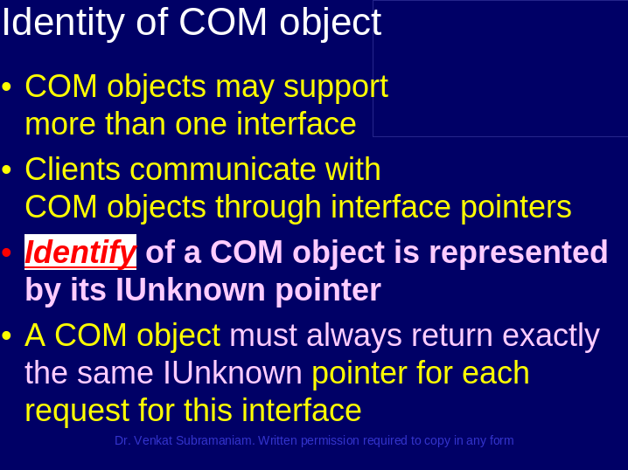

__________________________________________________________________________________________________________________________________________________________________________________________________________________________________________________________________________________________________________________________________________________________________________________________________________________________________________________________________________________________________________________________________________________________________________________________________________________________________________________________________________________________________________________________________________________________________________________________________________________________________________________________________________________
Slide 3

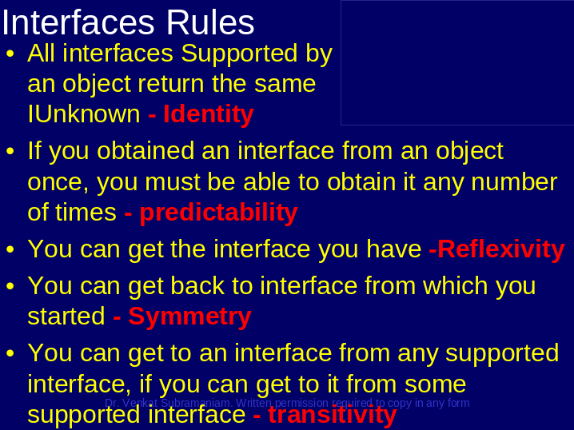

__________________________________________________________________________________________________________________________________________________________________________________________________________________________________________________________________________________________________________________________________________________________________________________________________________________________________________________________________________________________________________________________________________________________________________________________________________________________________________________________________________________________________________________________________________________________________________________________________________________________________________________________________________________
Slide 4

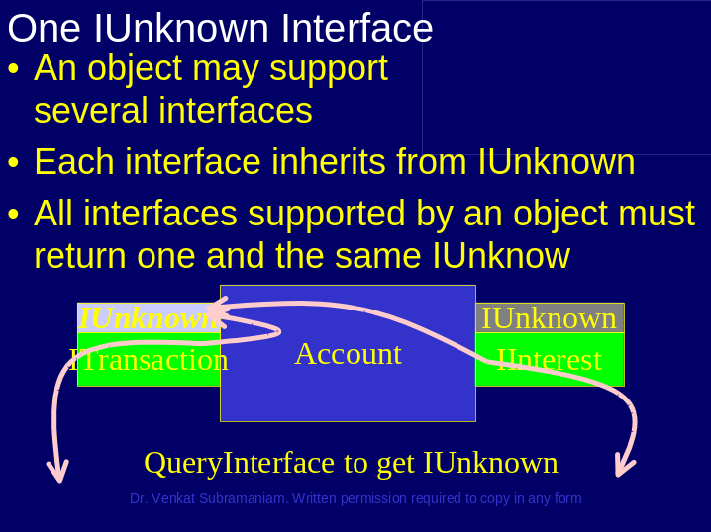

__________________________________________________________________________________________________________________________________________________________________________________________________________________________________________________________________________________________________________________________________________________________________________________________________________________________________________________________________________________________________________________________________________________________________________________________________________________________________________________________________________________________________________________________________________________________________________________________________________________________________________________________________________________
Slide 5

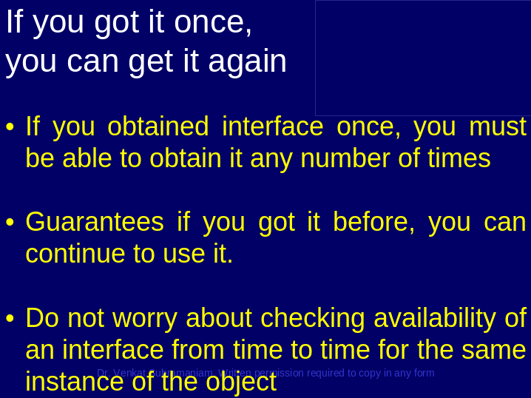

__________________________________________________________________________________________________________________________________________________________________________________________________________________________________________________________________________________________________________________________________________________________________________________________________________________________________________________________________________________________________________________________________________________________________________________________________________________________________________________________________________________________________________________________________________________________________________________________________________________________________________________________________________________
Slide 6

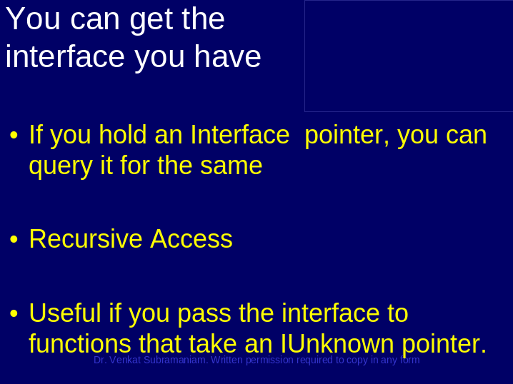

__________________________________________________________________________________________________________________________________________________________________________________________________________________________________________________________________________________________________________________________________________________________________________________________________________________________________________________________________________________________________________________________________________________________________________________________________________________________________________________________________________________________________________________________________________________________________________________________________________________________________________________________________________________
Slide 7

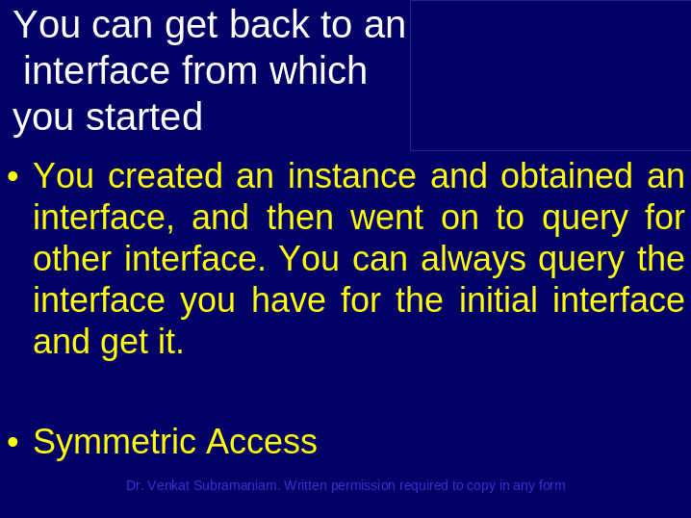

__________________________________________________________________________________________________________________________________________________________________________________________________________________________________________________________________________________________________________________________________________________________________________________________________________________________________________________________________________________________________________________________________________________________________________________________________________________________________________________________________________________________________________________________________________________________________________________________________________________________________________________________________________________
Slide 8

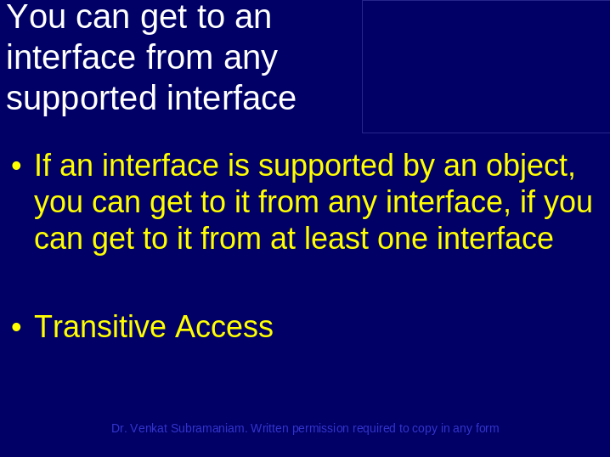

__________________________________________________________________________________________________________________________________________________________________________________________________________________________________________________________________________________________________________________________________________________________________________________________________________________________________________________________________________________________________________________________________________________________________________________________________________________________________________________________________________________________________________________________________________________________________________________________________________________________________________________________________________________
Slide 9

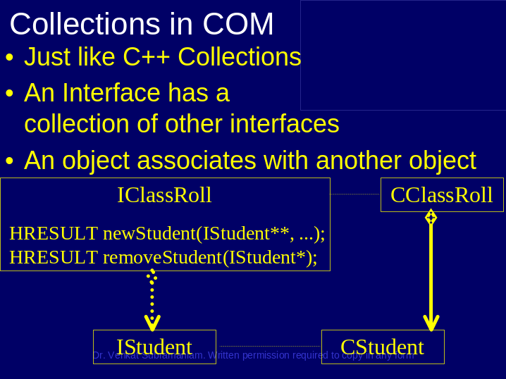

__________________________________________________________________________________________________________________________________________________________________________________________________________________________________________________________________________________________________________________________________________________________________________________________________________________________________________________________________________________________________________________________________________________________________________________________________________________________________________________________________________________________________________________________________________________________________________________________________________________________________________________________________________________
Slide 10

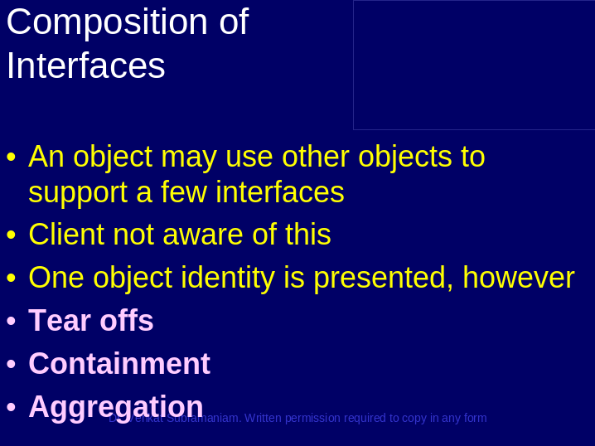

__________________________________________________________________________________________________________________________________________________________________________________________________________________________________________________________________________________________________________________________________________________________________________________________________________________________________________________________________________________________________________________________________________________________________________________________________________________________________________________________________________________________________________________________________________________________________________________________________________________________________________________________________________________
Slide 11

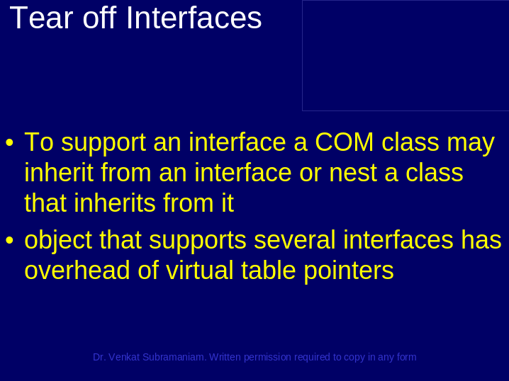

__________________________________________________________________________________________________________________________________________________________________________________________________________________________________________________________________________________________________________________________________________________________________________________________________________________________________________________________________________________________________________________________________________________________________________________________________________________________________________________________________________________________________________________________________________________________________________________________________________________________________________________________________________________
Slide 12

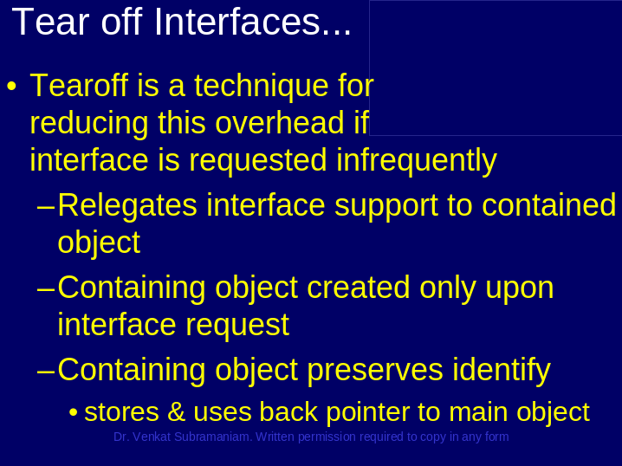

__________________________________________________________________________________________________________________________________________________________________________________________________________________________________________________________________________________________________________________________________________________________________________________________________________________________________________________________________________________________________________________________________________________________________________________________________________________________________________________________________________________________________________________________________________________________________________________________________________________________________________________________________________________
Slide 13

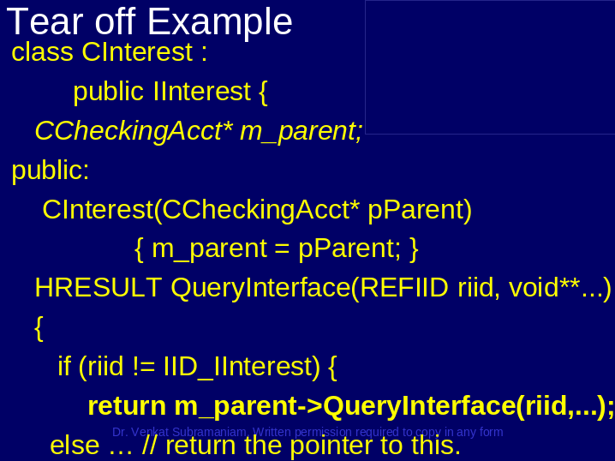

__________________________________________________________________________________________________________________________________________________________________________________________________________________________________________________________________________________________________________________________________________________________________________________________________________________________________________________________________________________________________________________________________________________________________________________________________________________________________________________________________________________________________________________________________________________________________________________________________________________________________________________________________________________
Slide 14

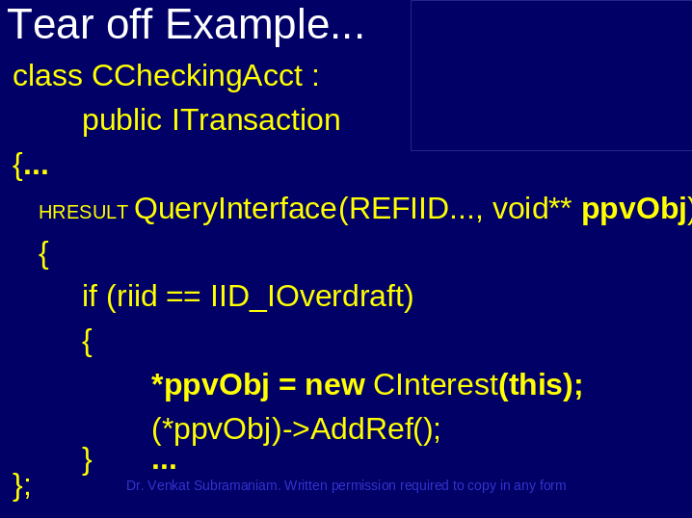

__________________________________________________________________________________________________________________________________________________________________________________________________________________________________________________________________________________________________________________________________________________________________________________________________________________________________________________________________________________________________________________________________________________________________________________________________________________________________________________________________________________________________________________________________________________________________________________________________________________________________________________________________________________
Slide 15

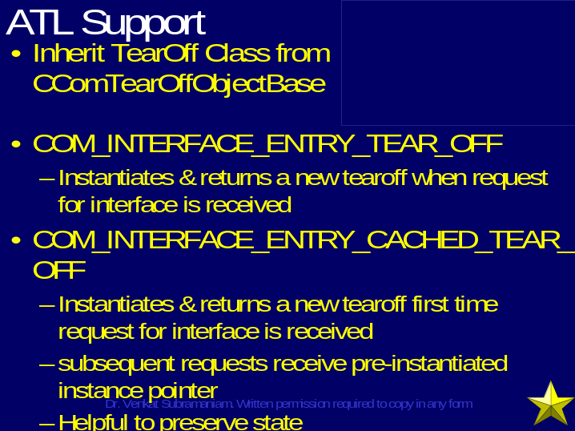

__________________________________________________________________________________________________________________________________________________________________________________________________________________________________________________________________________________________________________________________________________________________________________________________________________________________________________________________________________________________________________________________________________________________________________________________________________________________________________________________________________________________________________________________________________________________________________________________________________________________________________________________________________________
Slide 16

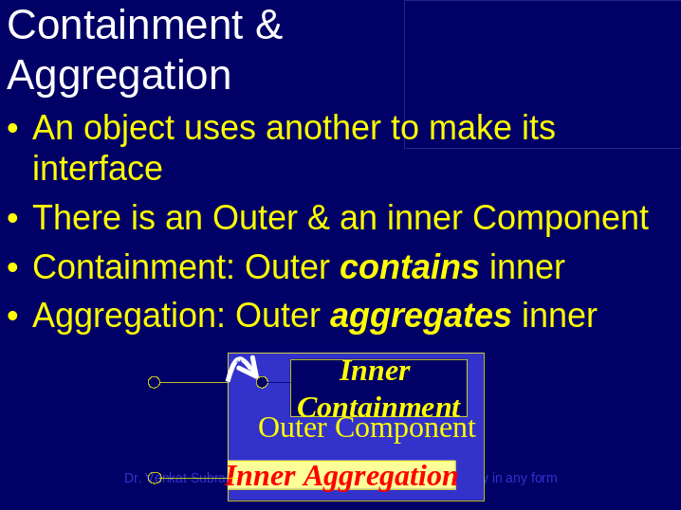

__________________________________________________________________________________________________________________________________________________________________________________________________________________________________________________________________________________________________________________________________________________________________________________________________________________________________________________________________________________________________________________________________________________________________________________________________________________________________________________________________________________________________________________________________________________________________________________________________________________________________________________________________________________
Slide 17

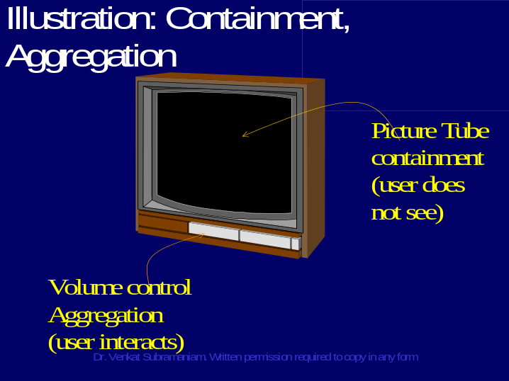

__________________________________________________________________________________________________________________________________________________________________________________________________________________________________________________________________________________________________________________________________________________________________________________________________________________________________________________________________________________________________________________________________________________________________________________________________________________________________________________________________________________________________________________________________________________________________________________________________________________________________________________________________________________
Slide 18

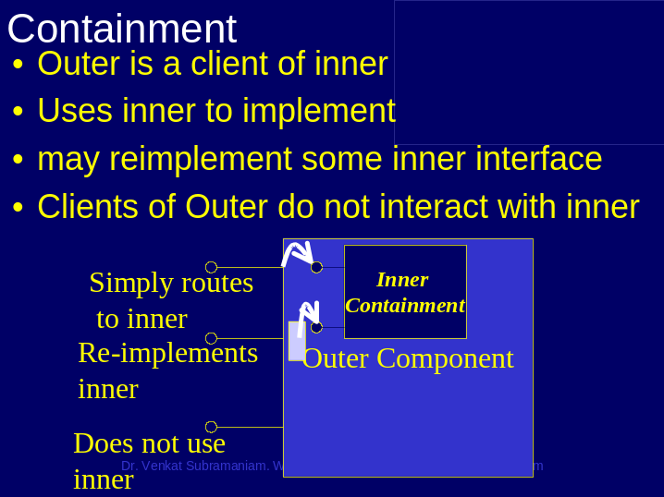

__________________________________________________________________________________________________________________________________________________________________________________________________________________________________________________________________________________________________________________________________________________________________________________________________________________________________________________________________________________________________________________________________________________________________________________________________________________________________________________________________________________________________________________________________________________________________________________________________________________________________________________________________________________
Slide 19

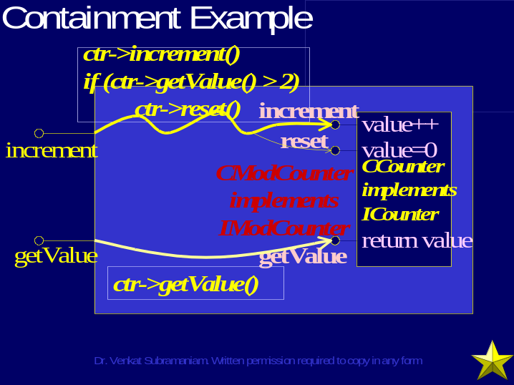

__________________________________________________________________________________________________________________________________________________________________________________________________________________________________________________________________________________________________________________________________________________________________________________________________________________________________________________________________________________________________________________________________________________________________________________________________________________________________________________________________________________________________________________________________________________________________________________________________________________________________________________________________________________
Slide 20

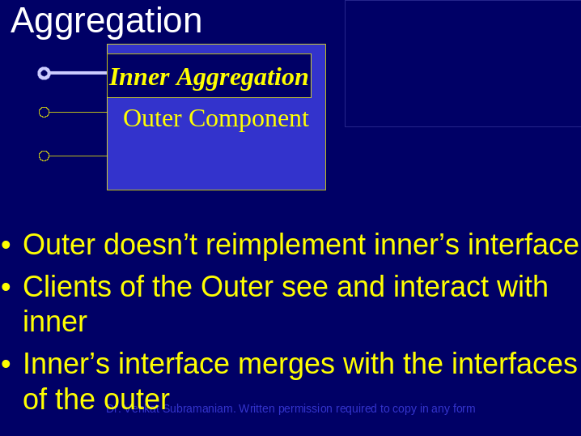

__________________________________________________________________________________________________________________________________________________________________________________________________________________________________________________________________________________________________________________________________________________________________________________________________________________________________________________________________________________________________________________________________________________________________________________________________________________________________________________________________________________________________________________________________________________________________________________________________________________________________________________________________________________
Slide 21

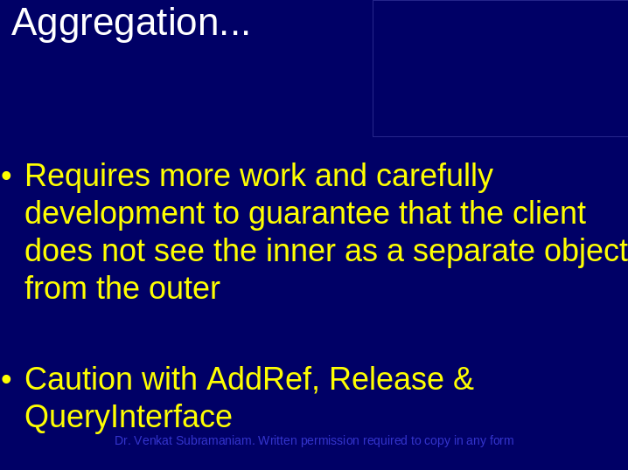

__________________________________________________________________________________________________________________________________________________________________________________________________________________________________________________________________________________________________________________________________________________________________________________________________________________________________________________________________________________________________________________________________________________________________________________________________________________________________________________________________________________________________________________________________________________________________________________________________________________________________________________________________________________
Slide 22

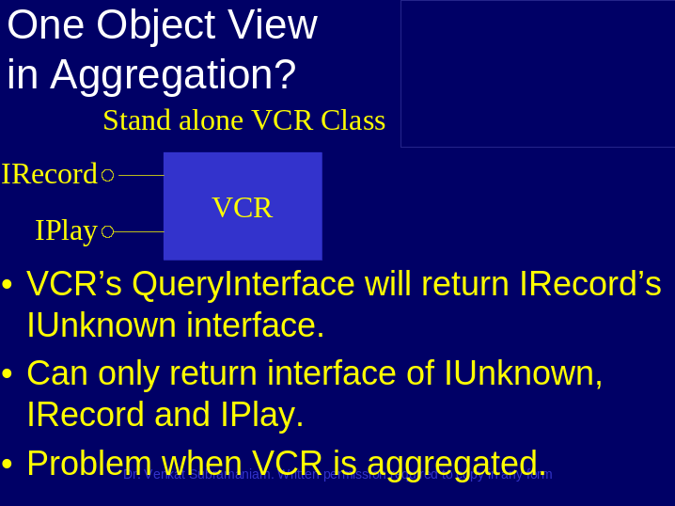

__________________________________________________________________________________________________________________________________________________________________________________________________________________________________________________________________________________________________________________________________________________________________________________________________________________________________________________________________________________________________________________________________________________________________________________________________________________________________________________________________________________________________________________________________________________________________________________________________________________________________________________________________________________
Slide 23

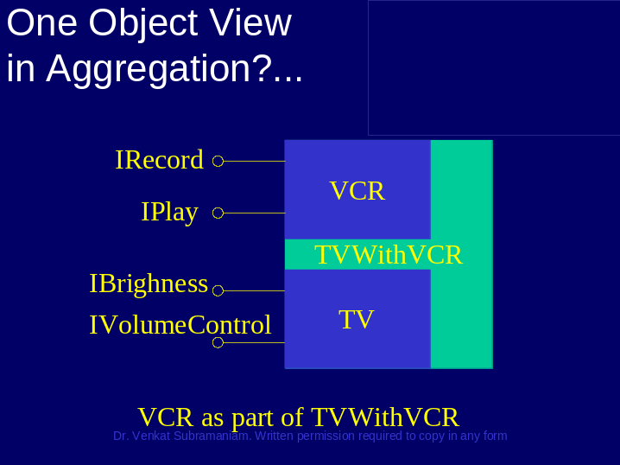

__________________________________________________________________________________________________________________________________________________________________________________________________________________________________________________________________________________________________________________________________________________________________________________________________________________________________________________________________________________________________________________________________________________________________________________________________________________________________________________________________________________________________________________________________________________________________________________________________________________________________________________________________________________
Slide 24

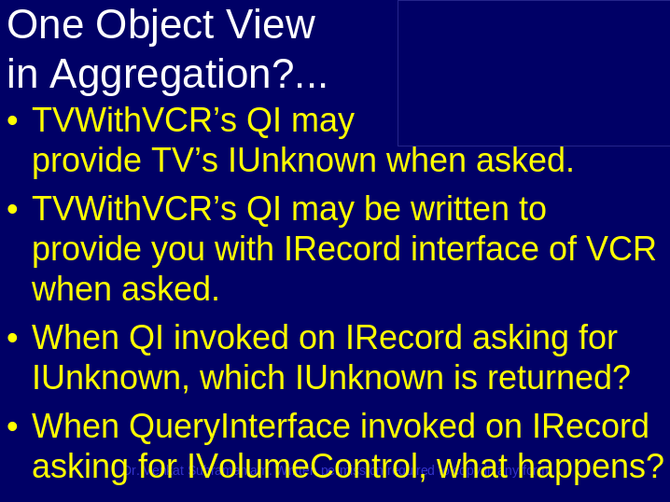

__________________________________________________________________________________________________________________________________________________________________________________________________________________________________________________________________________________________________________________________________________________________________________________________________________________________________________________________________________________________________________________________________________________________________________________________________________________________________________________________________________________________________________________________________________________________________________________________________________________________________________________________________________________
Slide 25

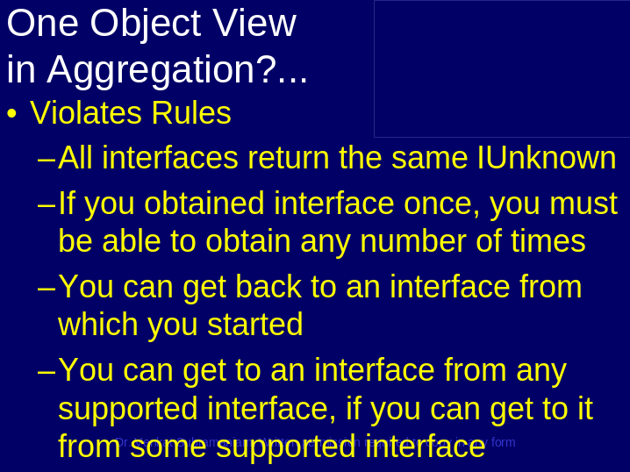

__________________________________________________________________________________________________________________________________________________________________________________________________________________________________________________________________________________________________________________________________________________________________________________________________________________________________________________________________________________________________________________________________________________________________________________________________________________________________________________________________________________________________________________________________________________________________________________________________________________________________________________________________________________
Slide 26

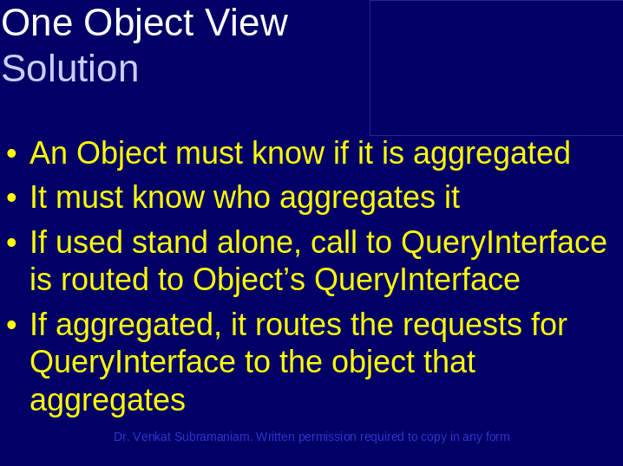

__________________________________________________________________________________________________________________________________________________________________________________________________________________________________________________________________________________________________________________________________________________________________________________________________________________________________________________________________________________________________________________________________________________________________________________________________________________________________________________________________________________________________________________________________________________________________________________________________________________________________________________________________________________
Slide 27

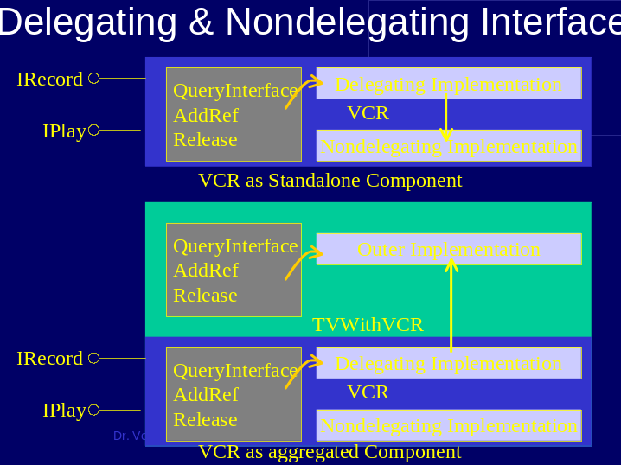

__________________________________________________________________________________________________________________________________________________________________________________________________________________________________________________________________________________________________________________________________________________________________________________________________________________________________________________________________________________________________________________________________________________________________________________________________________________________________________________________________________________________________________________________________________________________________________________________________________________________________________________________________________________
Slide 28

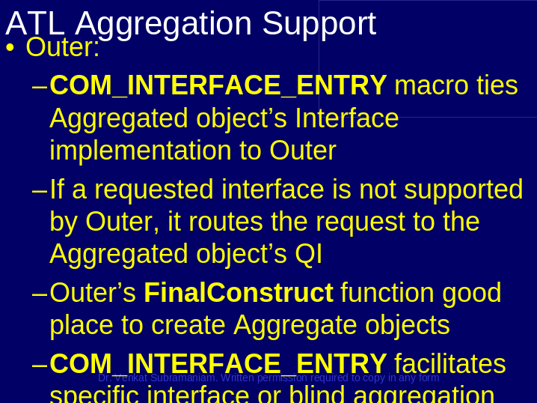

__________________________________________________________________________________________________________________________________________________________________________________________________________________________________________________________________________________________________________________________________________________________________________________________________________________________________________________________________________________________________________________________________________________________________________________________________________________________________________________________________________________________________________________________________________________________________________________________________________________________________________________________________________________
Slide 29

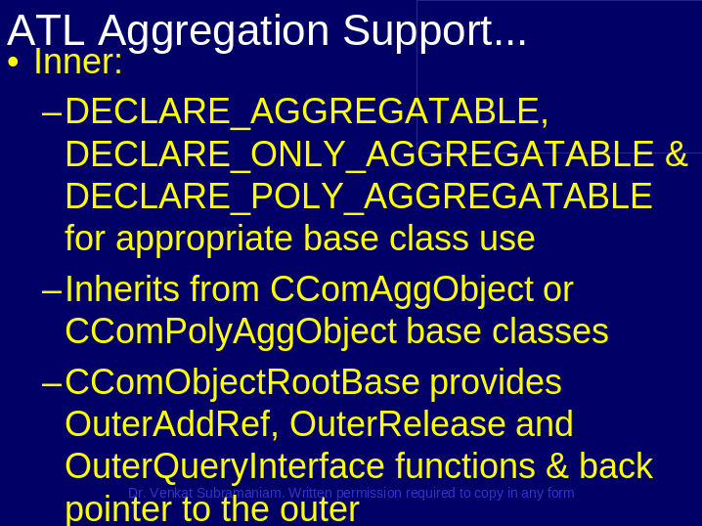

__________________________________________________________________________________________________________________________________________________________________________________________________________________________________________________________________________________________________________________________________________________________________________________________________________________________________________________________________________________________________________________________________________________________________________________________________________________________________________________________________________________________________________________________________________________________________________________________________________________________________________________________________________________
Slide 30





