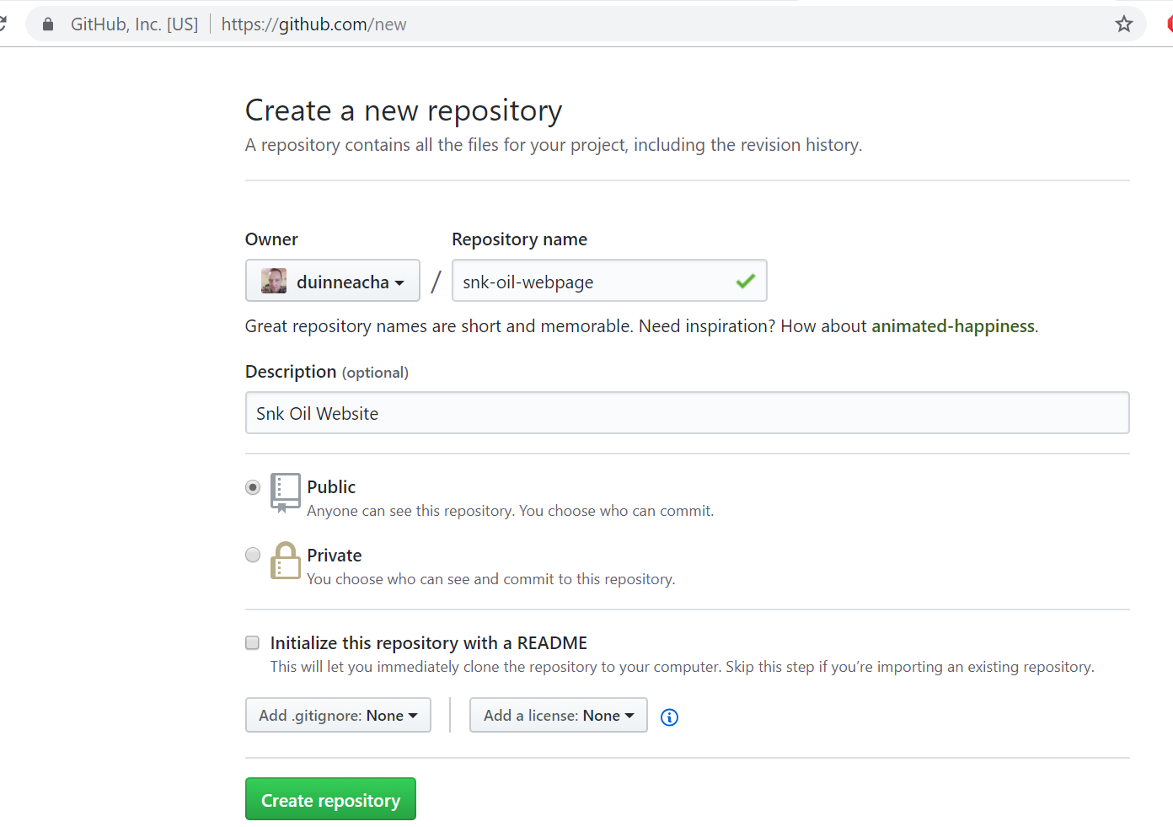

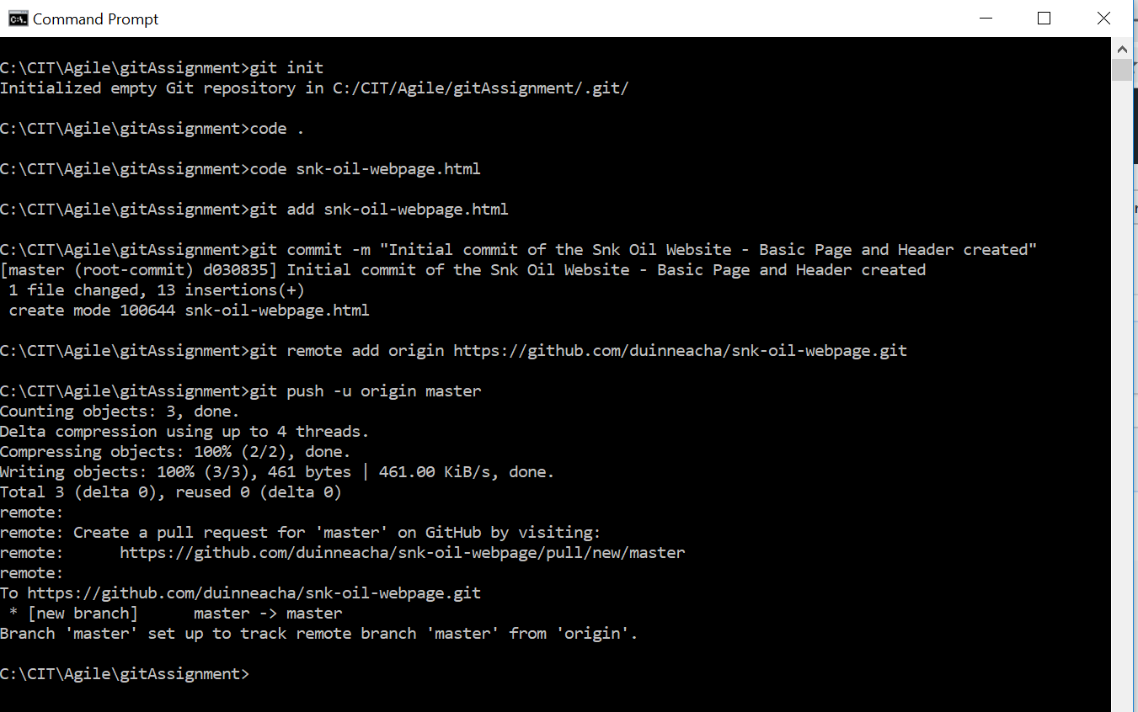

C:\CIT\Agile\gitAssignment>git init

Initialized empty Git repository in C:/CIT/Agile/gitAssignment/.git/

C:\CIT\Agile\gitAssignment>code .

C:\CIT\Agile\gitAssignment>code snk-oil-webpage.html

C:\CIT\Agile\gitAssignment>git add snk-oil-webpage.html

C:\CIT\Agile\gitAssignment>git commit -m "Initial commit of the Snk Oil Website - Basic Page and Header created"

[master (root-commit) d030835] Initial commit of the Snk Oil Website - Basic Page and Header created

1 file changed, 13 insertions(+)

create mode 100644 snk-oil-webpage.html

C:\CIT\Agile\gitAssignment>git remote add origin https://github.com/duinneacha/snk-oil-webpage.git

C:\CIT\Agile\gitAssignment>git push -u origin master

Counting objects: 3, done.

Delta compression using up to 4 threads.

Compressing objects: 100% (2/2), done.

Writing objects: 100% (3/3), 461 bytes | 461.00 KiB/s, done.

Total 3 (delta 0), reused 0 (delta 0)

remote:

remote: Create a pull request for 'master' on GitHub by visiting:

remote: https://github.com/duinneacha/snk-oil-webpage/pull/new/master

remote:

To https://github.com/duinneacha/snk-oil-webpage.git

* [new branch] master -> master

Branch 'master' set up to track remote branch 'master' from 'origin'.

C:\CIT\Agile\gitAssignment>

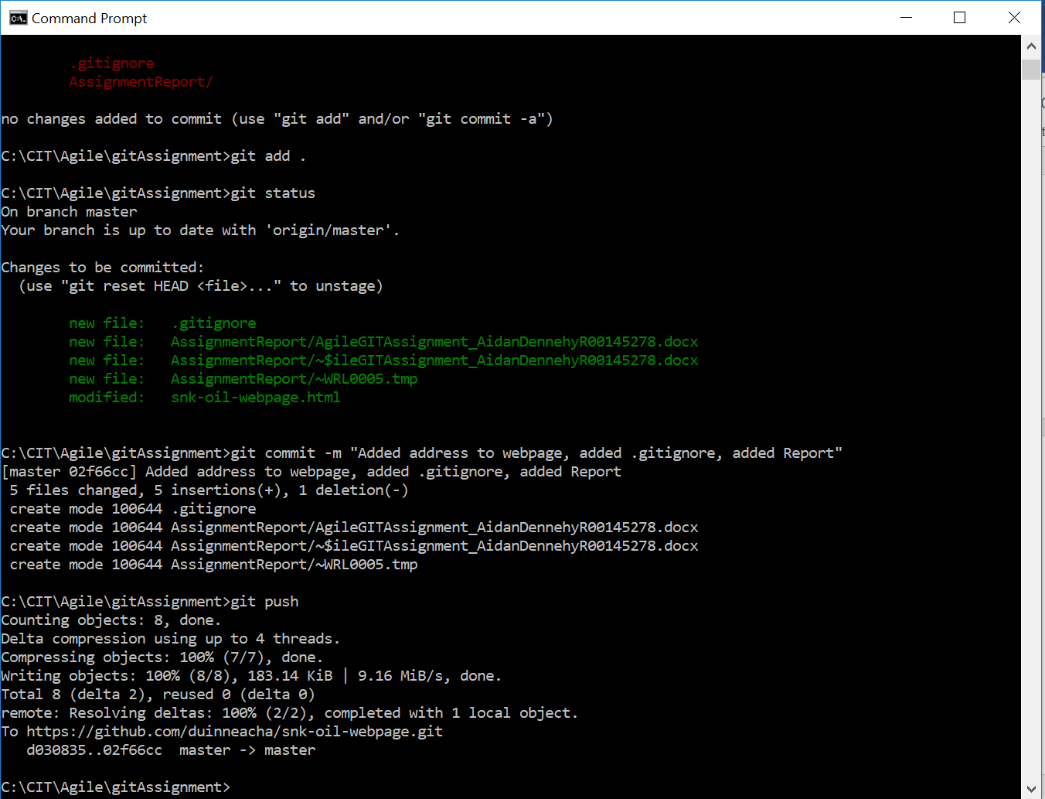

C:\CIT\Agile\gitAssignment>git add .

C:\CIT\Agile\gitAssignment>git status

On branch master

Your branch is up to date with 'origin/master'.

Changes to be committed:

(use "git reset HEAD <file>..." to unstage)

new file: .gitignore

new file: AssignmentReport/AgileGITAssignment_AidanDennehyR00145278.docx

new file: AssignmentReport/~$ileGITAssignment_AidanDennehyR00145278.docx

new file: AssignmentReport/~WRL0005.tmp

modified: snk-oil-webpage.html

C:\CIT\Agile\gitAssignment>git commit -m "Added address to webpage, added .gitignore, added Report"

[master 02f66cc] Added address to webpage, added .gitignore, added Report

5 files changed, 5 insertions(+), 1 deletion(-)

create mode 100644 .gitignore

create mode 100644 AssignmentReport/AgileGITAssignment_AidanDennehyR00145278.docx

create mode 100644 AssignmentReport/~$ileGITAssignment_AidanDennehyR00145278.docx

create mode 100644 AssignmentReport/~WRL0005.tmp

C:\CIT\Agile\gitAssignment>git push

Counting objects: 8, done.

Delta compression using up to 4 threads.

Compressing objects: 100% (7/7), done.

Writing objects: 100% (8/8), 183.14 KiB | 9.16 MiB/s, done.

Total 8 (delta 2), reused 0 (delta 0)

remote: Resolving deltas: 100% (2/2), completed with 1 local object.

To https://github.com/duinneacha/snk-oil-webpage.git

d030835..02f66cc master -> master

C:\CIT\Agile\gitAssignment>

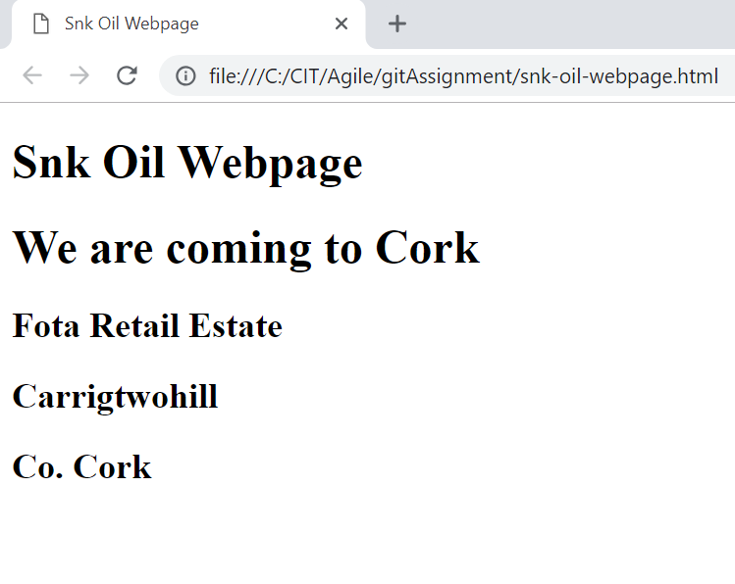

Adding paragraph indicating that we are opening soon

