**Task 1 - The Age Calculator**

let birthYear = 1970;

let futureYear = 2048;

let ageThen = futureYear - birthYear;

console.log(`I will be wither ${ageThen - 1} or ${ageThen} in ${futureYear}`);



**Task 2 - The Lifetime Supply Calculator**

const calculateSupply = (age, amountPerDay) => {

const maxAge = 88;

// Average Year is 365.2425 days long

const daysPerYear = 365.2425;

let amountNeeded = Math.round((((maxAge - age) * daysPerYear) * amountPerDay));

console.log(`You will need ${amountNeeded} to last you until the ripe old age of ${maxAge}`);

};

calculateSupply(20, 5.2);

calculateSupply(48, 25);

calculateSupply(45, 9.2323232);

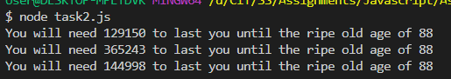

**Task 3 - The Geometrizer**

const calcCircumfrence = (radius) => {

circleCircumference = 2 * Math.PI * radius;

console.log(`The circumference for a circle with radius ${radius} is ${circleCircumference}`);

};

const calcArea = (radius) => {

circleRadius = Math.pow(Math.PI, 2) * radius;

console.log(`The area for a circle with a radius og ${radius} is ${circleRadius}`);

};

calcCircumfrence(4.5);

calcArea(4.5);

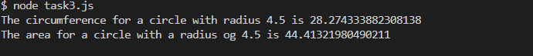

**Task 4 - The Temperature Converter**

const celciusToFaranheit = (celciusTemperature) => {

let faranheitTemperature = celciusTemperature * (9 / 5) + 32;

console.log(`${celciusTemperature}°C is ${faranheitTemperature}°F`);

};

const faranheitToCelcius = (faranheitTemperature) => {

let celciusTemperature = Math.round((((faranheitTemperature - 32) * 5) / 9));

console.log(`${faranheitTemperature}°F is ${celciusTemperature}°C`);

};

celciusToFaranheit(25);

faranheitToCelcius(99);

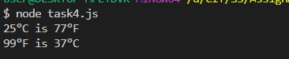

**Task 5 - Fortune Teller**

const tellFortune = (numChildren, partnersName, geoLocation, jobTitle) => {

console.log(`

You will have ${numChildren} children.

Your Partners name will be ${partnersName}.

You will live in ${geoLocation}.

Your job title will be ${jobTitle}.`)

};

tellFortune(4, "Michelle", "Cork", "Astronaut");

tellFortune(1, "Sandra", "Southampton", "Software Engineer");

tellFortune(7, "Aileen", "Wicklow", "Mechanic");

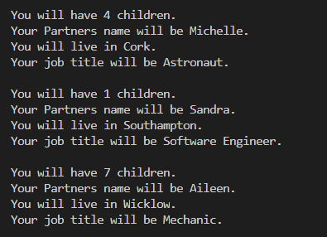

**Task 6 - The Puppy Age Calculator**

const calculateDogAge = (puppyAge, conversionRate) => {

let dogYears = puppyAge * conversionRate;

console.log(`Your doggie is ${dogYears} years old in dog years!`);

};

calculateDogAge(5, 7);

calculateDogAge(3, 4.5);

calculateDogAge(15, 7);

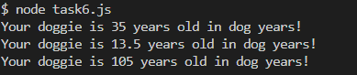

**Task 7 - The Leap Year**

const readline = require('readline').createInterface({

input: process.stdin,

output: process.stdout

})

readline.question(`Enter the Year? > `, (year) => {

if (((year % 4 === 0) && (year % 100 !== 0)) || (year % 400 === 0)) {

console.log(`${year} is a leap year`);

} else {

console.log(`${year} is not a leap year`);

}

readline.close()

})

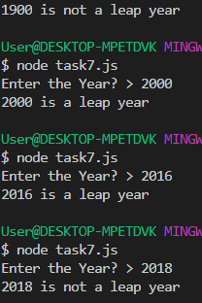

**Task 8 - Looping a triangle**

for (outerLoopCounter = 0; outerLoopCounter <= 7; outerLoopCounter++) {

var innerLoopString = "";

for (innerLoopCounter = 0; innerLoopCounter < outerLoopCounter; innerLoopCounter++) {

innerLoopString = innerLoopString + "#";

}

console.log(innerLoopString);

}



**Task 9 - FizzBuzz**

for (loopCounter = 0; loopCounter <= 100; loopCounter++) {

if (loopCounter % 15 === 0) {

console.log("FizzBuzz");

} else if (loopCounter % 3 === 0) {

console.log("Fizz");

} else if (loopCounter % 5 === 0) {

console.log("Buzz");

} else {

console.log(loopCounter);

}

}

$ node task9.js

FizzBuzz

1

2

Fizz

4

Buzz

Fizz

7

8

Fizz

Buzz

11

Fizz

13

14

FizzBuzz

16

17

Fizz

19

Buzz

Fizz

22

23

Fizz

Buzz

26

Fizz

28

29

FizzBuzz

31

32

Fizz

34

Buzz

Fizz

37

38

Fizz

Buzz

41

Fizz

43

44

FizzBuzz

46

47

Fizz

49

Buzz

Fizz

52

53

Fizz

Buzz

56

Fizz

58

59

FizzBuzz

61

62

Fizz

64

Buzz

Fizz

67

68

Fizz

Buzz

71

Fizz

73

74

FizzBuzz

76

77

Fizz

79

Buzz

Fizz

82

83

Fizz

Buzz

86

Fizz

88

89

FizzBuzz

91

92

Fizz

94

Buzz

Fizz

97

98

Fizz

Buzz

**Task 10 - Palindrome**

const isPalindrome = (word) => {

let lengthOfString = Math.floor(word.length / 2);

for (var loopCounter = 0; loopCounter < lengthOfString; loopCounter++)

if (word[loopCounter] !== word[word.length - loopCounter - 1]) {

return false;

}

return true;

};

var wordToVerify = "abba";

// var wordToVerify = "madam";

var wordToVerify = "Aidan";

let isPalin = isPalindrome(wordToVerify);

if (isPalin) {

console.log(`${wordToVerify} is a Palindrome`);

} else {

console.log(`${wordToVerify} is a not Palindrome`);

}



