**Task 1 - The Calculator**

const squareNumber = (number) => {

let numberSquared = number * number;

console.log(`The result of squaring the number ${number} is ${numberSquared}`);

return numberSquared;

};

const halfNumber = (number) => {

let numberHalved = number / 2;

console.log(`Half of ${number} is ${numberHalved}`);

return numberHalved;

};

const percentOf = (number1, number2) => {

let percentage = (number1 / number2) * 100;

console.log(`${number1} is ${percentage}% of ${number2}`);

return percentage;

};

const areaOfCircle = (radius) => {

circleArea = parseFloat(Math.PI * (radius * radius)).toFixed(2);

console.log(`The area for a circle with radius ${radius} is ${circleArea}`);

return circleArea;

};

const allOfTheAbove = (number) => {

console.log(`Running calculations on ${number}`);

hlfNum = halfNumber(number);

sqNum = squareNumber(hlfNum);

cirRad = areaOfCircle(sqNum);

resultPercentage = percentOf(cirRad, sqNum);

}

squareNumber(9);

halfNumber(5);

percentOf(2, 4);

areaOfCircle(2);

allOfTheAbove(5);

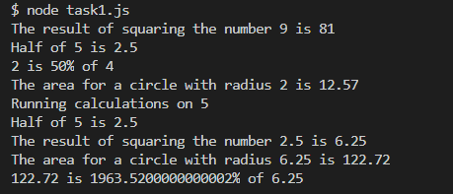

**Task 2 – DrEvil**

const DrEvil = (number) => {

if (number !== 1000000) {

console.log(`DrEvil(${number}): ${number} dollars`);

} else {

console.log(`DrEvil(${number}): ${number} dollars (pinky)`);

}

};

DrEvil(10);

DrEvil(1000000);

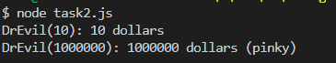

**Task 3 - MixUp**

const mixUp = (str1, str2) => {

newStr1 = str2.slice(0, 2) + str1.slice(2, str1.length);

newStr2 = str1.slice(0, 2) + str2.slice(2, str2.length);

console.log(newStr1, newStr2);

};

mixUp("hairy", "buck");

mixUp("Aidan", "Dennehy");

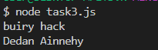

**Task 4 - FixStart**

const fixStart = (str1) => {

var newString = "";

theFirstCharacter = str1.charAt(0);

for (loopCounter = 0; loopCounter < str1.length; loopCounter++) {

var currentLetter = str1.charAt(loopCounter);

if (str1.charAt(loopCounter) === theFirstCharacter && loopCounter !== 0) {

newString += "*";

} else {

newString += currentLetter;

}

}

console.log(newString);

};

fixStart("bubble");

fixStart("mammal");

fixStart("a");

fixStart("aa");

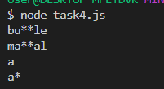

**Task 5 - Verbing**

const verbing = (word) => {

if (word.length > 3) {

if (word.slice(word.length - 3, word.length) === 'ing') {

word += 'ly';

} else {

word += 'ing';

}

}

console.log(word);

};

verbing("swimming");

verbing("walk");

verbing("go");

verbing("ferret");

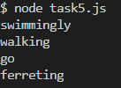

**Task 6 - Not Bad**

const notBad = (str) => {

var notWordFound = str.indexOf('not');

var badWordFound = str.indexOf('bad');

//console.log(notWordFound);

//console.log(badWordFound);

if (notWordFound === -1 || badWordFound === -1 || badWordFound < notWordFound) {

return str;

}

newStr = str.slice(0, notWordFound) + "good" + str.slice(badWordFound + 3);

return newStr;

};

console.log(notBad("The dinner is not that bad"));

console.log("The bad man was not right");

console.log(notBad("The sun shone in Florence"));

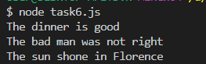

**Task 7 - Your Top Choices**

var topChoices = ["Dolly Parton", "blue", "Egg Fried Rice", "Strictly Come Dancing", "Jazz"];

for (var loopCounter = 0; loopCounter < topChoices.length; loopCounter++) {

console.log(`My #${loopCounter + 1} choice is ${topChoices[loopCounter]}`);

}

console.log("_______________________________________________________________________\n");

for (var loopCounter = 0; loopCounter < topChoices.length; loopCounter++) {

if (loopCounter === 0) {

var preFix = "1st";

} else if (loopCounter === 1) {

var preFix = "2nd";

} else if (loopCounter === 2) {

var preFix = "3rd";

} else if (loopCounter === 3) {

var preFix = "4th";

} else if (loopCounter === 4) {

var preFix = "5th";

} else if (loopCounter === 5) {

var preFix = "6th";

} else if (loopCounter === 6) {

var preFix = "7th";

} else if (loopCounter === 7) {

var preFix = "8th";

} else if (loopCounter === 8) {

var preFix = "9th";

} else if (loopCounter === 9) {

var preFix = "10th";

}

console.log(`My ${preFix} choice is ${topChoices[loopCounter]}`);

}

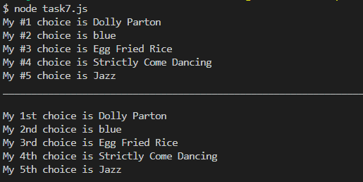

**Task 8 – Word Guesser**

// The Word Guesser

// ASCII Art found on github user account: juliemdyer - Thank you!

hangman = [`

+---+

| |

O |

|

|

|

=========

`, `

+---+

| |

O |

| |

|

|

=========

`, `

+---+

| |

O |

/| |

|

|

=========

`, `

+---+

| |

O |

/|\\\ |

|

|

=========

`, `

+---+

| |

O |

/|\\\ |

/ |

|

=========

`, `

+---+

| |

O |

/|\\\ |

/ \\\ |

|

=========

`];

//appendectomy

//const wordLetters = ["A", "P", "P", "E", "N", "D", "E", "C", "T", "O", "M", "Y"];

//const guessLetters = ["_", "_", "_", "_", "_", "_", "_", "_", "_", "_", "_", "_"];

// Fox

const wordLetters = ["F", "F", "O", "X", "F"];

const guessLetters = ["_", "_", "_", "_", "_"];

const guessArray = [];

// This control will exit the program if it reaches 6.

var timesIncorrect = 0;

// Total won or lost in dollars

var totalWon = 0;

// Get Randum Number Function

const getRandumNumber = () => {

var min = 1;

var max = 100;

return Math.floor(Math.random() * (max - min + 1)) + min;

}

// Guess Letter Function - passes in the letter to be found

const guessLetter = (letter) => {

// First check of this letter has been processed before

var alreadyProcessed = false;

var alreadyFound = false;

for (var gLoop = 0; gLoop < guessArray.length; gLoop++) {

if (letter === guessArray[gLoop]) {

// console.log("Already processed : " + letter);

alreadyProcessed = true;

}

}

// If letter processed before - do not proceed - exit the function

if (alreadyProcessed) {

return;

}

console.log("\n\nSearching for : " + letter)

var correctGuess = false;

var moreToGuess = false;

var currentWin = 0;

var timesFound = 0;

var finished = false;

for (var loopWordCounter = 0; loopWordCounter < wordLetters.length; loopWordCounter++) {

// Check for letter

if (wordLetters[loopWordCounter] == letter) {

//console.log("\nLetter Found -> " + letter + " at position: " + loopWordCounter);

guessLetters[loopWordCounter] = letter;

correctGuess = true;

timesFound = timesFound + 1;

//console.log("TimesFound: " + timesFound + " Lettter: " + letter);

if (timesFound === 1) {

currentWin = getRandumNumber();

console.log("Current Win: " + currentWin + " dollars for letter: " + letter);

}

//totalWon = totalWon + currentWin;

//console.log("Current Win: " + currentWin + " Running Total: " + totalWon + " for letter: " + letter)

}

if (guessLetters[loopWordCounter] == '_') {

moreToGuess = true;

}

}

if (timesFound > 0) {

totalWon = totalWon + (currentWin * timesFound);

console.log(`Current Win: ${currentWin} (timesWon ${timesFound}) SubTotal = ${(currentWin * timesFound)} Running Total: ${totalWon} dollars for letter: ${letter}`);

}

if (correctGuess) {

console.log(`Good Job!, Correct Letter: ${letter}`);

console.log(guessLetters.join(''));

if (!moreToGuess) {

if (totalWon < 0) {

console.log(`You eventually guessed right but you owe: ${(totalWon * -1)} dollars`);

} else {

console.log(`YOU WON! ${totalWon} dollars`);

finished = true;

}

// Exit now that you have won!!!!!!!

process.exit();

}

} else {

console.log(`Incorrect Choice - for letter: ${letter} `);

timesIncorrect++;

console.log(hangman[(timesIncorrect - 1)]);

if (timesIncorrect === 6) {

console.log(`You have reached 6 incorrect guesses - GAME OVER!`);

console.log(`The correct word was ${wordLetters.join('')} `);

process.exit();

} else {

console.log(`You have ${6 - timesIncorrect} chances remaining!`);

}

if (!finished) {

currentWin = (getRandumNumber() * -1);

totalWon = totalWon + currentWin;

console.log(`Current Win: ${currentWin} Running Total: ${totalWon} dollars`);

}

}

// Push the letter to the guessArray for future check to see if this letter is processed again

guessArray.push(letter);

//console.table(guessArray);

}

guessLetter('J');

// guessLetter('J');

// guessLetter('K');

// guessLetter('L');

guessLetter('M');

guessLetter('N');

guessLetter('D');

guessLetter('U');

//guessLetter('Z');

// guessLetter('O');

guessLetter('F');

guessLetter('F');

guessLetter('O');

guessLetter('X');

guessLetter('J');

guessLetter('J');

guessLetter('J');

guessLetter('J');

guessLetter('J');

// guessLetter('A');

// guessLetter('P');

// guessLetter('P');

// guessLetter('E');

// guessLetter('N');

// guessLetter('D');

// guessLetter('E');

// guessLetter('C');

// guessLetter('T');

// guessLetter('O');

// guessLetter('M');

// guessLetter('Y');

output

node task8.js

Searching for : J

Incorrect Choice - for letter: J

+---+

| |

O |

|

|

|

=========

You have 5 chances remaining!

Current Win: -76 Running Total: -76 dollars

Searching for : M

Incorrect Choice - for letter: M

+---+

| |

O |

| |

|

|

=========

You have 4 chances remaining!

Current Win: -1 Running Total: -77 dollars

Searching for : N

Incorrect Choice - for letter: N

+---+

| |

O |

/| |

|

|

=========

You have 3 chances remaining!

Current Win: -95 Running Total: -172 dollars

Searching for : D

Incorrect Choice - for letter: D

+---+

| |

O |

/|\ |

|

|

=========

You have 2 chances remaining!

Current Win: -63 Running Total: -235 dollars

Searching for : U

Incorrect Choice - for letter: U

+---+

| |

O |

/|\ |

/ |

|

=========

You have 1 chances remaining!

Current Win: -27 Running Total: -262 dollars

Searching for : F

Current Win: 23 dollars for letter: F

Current Win: 23 (timesWon 3) SubTotal = 69 Running Total: -193 dollars for letter: F

Good Job!, Correct Letter: F

FF__F

Searching for : O

Current Win: 5 dollars for letter: O

Current Win: 5 (timesWon 1) SubTotal = 5 Running Total: -188 dollars for letter: O

Good Job!, Correct Letter: O

FFO_F

Searching for : X

Current Win: 41 dollars for letter: X

Current Win: 41 (timesWon 1) SubTotal = 41 Running Total: -147 dollars for letter: X

Good Job!, Correct Letter: X

FFOXF

You eventually guessed right but you owe: 147 dollars

Output where the user loses the word guessing game

Searching for : J

Incorrect Choice - for letter: J

+---+

| |

O |

|

|

|

=========

You have 5 chances remaining!

Current Win: -62 Running Total: -62 dollars

Searching for : K

Incorrect Choice - for letter: K

+---+

| |

O |

| |

|

|

=========

You have 4 chances remaining!

Current Win: -57 Running Total: -119 dollars

Searching for : L

Incorrect Choice - for letter: L

+---+

| |

O |

/| |

|

|

=========

You have 3 chances remaining!

Current Win: -69 Running Total: -188 dollars

Searching for : M

Incorrect Choice - for letter: M

+---+

| |

O |

/|\ |

|

|

=========

You have 2 chances remaining!

Current Win: -12 Running Total: -200 dollars

Searching for : N

Incorrect Choice - for letter: N

+---+

| |

O |

/|\ |

/ |

|

=========

You have 1 chances remaining!

Current Win: -98 Running Total: -298 dollars

Searching for : D

Incorrect Choice - for letter: D

+---+

| |

O |

/|\ |

/ \ |

|

=========

You have reached 6 incorrect guesses - GAME OVER!

The correct word was FFOXF

**Task 9 – The Recipe Card**

// The Recipe Card

const recipe = {

title: "Bacon and Egg Toasted Sandwich",

serves: 1,

ingredients: [

"Bacon",

"Eggs",

"Cheese",

"Bread (Toasted)",

"Butter"

]

};

console.log(recipe.title);

console.log(`Serves: ${recipe.serves}`);

console.log(`Ingredients:

`);

console.log(` - ${recipe.ingredients[0]}`);

console.log(` - ${recipe.ingredients[1]}`);

console.log(` - ${recipe.ingredients[2]}`);

console.log(` - ${recipe.ingredients[3]}`);

console.log(` - ${recipe.ingredients[4]}`);

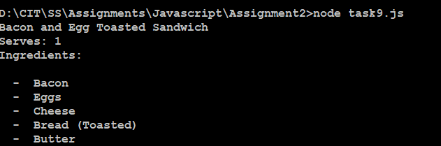

**10 The Cash Register**

const shoppingCart = {

banana: "1.25",

handkerchief: ".99",

Tshirt: "25.01",

apple: "0.60",

naglene: "10.34",

proteinShake: "22.36"

};

const cashRegister = (cartForParty) => {

const values = Object.values(cartForParty)

var cartTotal = 0;

for (valueLoop = 0; valueLoop < values.length; valueLoop++) {

cartTotal = cartTotal + parseFloat(values[valueLoop]);

}

return cartTotal;

}

total = cashRegister(shoppingCart);

console.log(`The total Price of the shopping cart is ${total}`);

