**Task 1 - Shortest Poem**

(a)

<?php

echo "<p>Adam</p>";

echo "<p>Had'em </p>";

?>



(b)

<?php

echo "<ul><li>Without flowing wine,</li>";

echo "<br>";

echo "<li>How to enjoy lovely</li>";

echo "<br>";

echo "<li>Cheery blossoms.</li></ul>";

?>

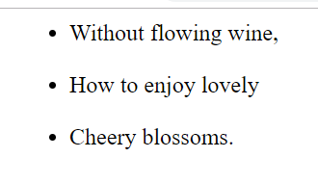

**Task 2 - Pet**

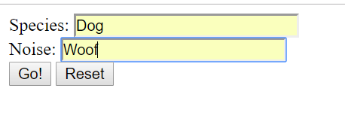

<?php

$petType = $_GET['species'];

$noiseMade = $_GET['noise'];

echo "<p>Your {$petType} goes {$noiseMade}-{$noiseMade}.</p>";

?>



**Task 3 – Bakuchi Game**

Bakuchi.php

<?php

$theStake = $_GET['stake'];

if (!is_numeric($theStake)) {

echo "The Stake is not a number";

echo "<br>";

return;

}

$winnings = 0;

$roll1 = rand(1, 6);

$roll2 = rand(1, 6);

if ($roll1 == $roll2) {

$winnings = $theStake*4;

}

echo "Roll 1 is {$roll1}, Roll 2 is: {$roll2}. Your winnings are :- {$winnings}";

?>

Stake is 5





Bakuchi1.php

<?php

$theStake = $_GET['stake'];

if (!is_numeric($theStake)) {

echo "The Stake is not a number";

echo "<br>";

return;

}

$winnings = 0;

$roll1 = rand(1, 6);

$roll2 = rand(1, 6);

$roll3 = rand(1, 6);

if ($roll1 == $roll2) {

if ($roll1 == $roll3) {

$winnings = $theStake*4;

}

}

echo "Roll1 is {$roll1}, Roll2 is: {$roll2}, Roll3 is: {$roll3}. Your winnings are : {$winnings}";

?>

Stake is 18





Bakuchi2.php

<?php

$theStake = $_GET['stake'];

if (!is_numeric($theStake)) {

echo "The Stake is not a number";

echo "<br>";

return;

}

$winnings = 0;

$roll1 = rand(1, 6);

$roll2 = rand(1, 6);

$roll3 = rand(1, 6);

if ($roll1 == $roll2 && $roll1 == $roll3) {

$winnings = $theStake*4;

}

echo "Roll1 is {$roll1}, Roll2 is: {$roll2}, Roll3 is: {$roll3}. Your winnings are : {$winnings}";

?>

Stake is 25





**Task 4 - Tax System**

<?php

$numGallons = $_GET['num_of_gallons'];

if (!is_numeric($numGallons)) {

echo "The Number of Gallons is not a number";

echo "<br>";

return;

}

$baseTax = 120;

$taxQuota = 12000;

$baseUsageTax = 0;

$taxRate = 0.05;

$extraCharge = 60;

// Check if number of gallons is larger than quota

if ($numGallons > $taxQuota) {

$extraTaxBaseQuantity = $numGallons - $taxQuota; // The amount that the extra tax is calculated on

$floorCount = floor($extraTaxBaseQuantity/1000);

} else if ($numGallons > 0) {

$extraTaxBaseQuantity = 0;

$floorCount = 0;

$taxRate = 0.05;

$taxQuota = $numGallons; // Set the tax quota to numGallons where it falls under the quota

} else {

$extraTaxBaseQuantity = 0;

$floorCount = 0;

$taxRate = 0; // Set the base tax rate to zero if the number of gallons falls under quota

}

$totalTaxToPay = ($baseTax + (($taxQuota*$taxRate) + ($floorCount * $extraCharge)));

echo "The total tax to pay on {$numGallons} gallons is {$totalTaxToPay}";

?>





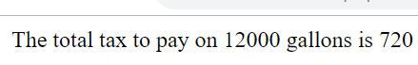









**Task 5 – Pint Conversion**

(a)

<body>

<table>

<tr>

<th colspan="4">A pint of plain is your only man</th>

</tr>

<tr>

<th>Pints</th>

<th>Quarts</th>

<th>Fluid ounces</th>

<th>Gills</th>

</tr>

<?php

// Define the table output variables

$numberOfPints = $_GET['num_pints'];

if (!is_numeric($numberOfPints)) {

echo "The Number of Pints is not a number";

echo "<br>";

return;

}

$numberOfQuarts = $numberOfPints / 2;

$numberOfFluidOunces = $numberOfPints * 16;

$numberOfGills = $numberOfFluidOunces / 4;

echo "<td>{$numberOfPints}</td>";

echo "<td>{$numberOfQuarts}</td>";

echo "<td>{$numberOfFluidOunces}</td>";

echo "<td>{$numberOfGills}</td>";

?>

</table>

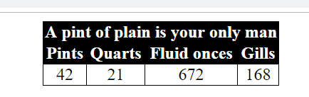

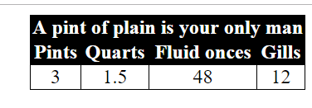

(b)

<body>

<table>

<tr>

<th colspan="2">A pint of</th>

</tr>

<tr>

<tr>

<th colspan="2">plain is your</th>

</tr>

<tr>

<tr>

<th colspan="2">only man</th>

</tr>

<tr>

<th>Pints</th>

<th>Ml</th>

</tr>

<?php

// Define the table output variables

$numberOfPints = $_GET['num_pints'];

if (!is_numeric($numberOfPints)) {

echo "The Number of Pints is not a number";

echo "<br>";

return;

}

$numberOfPintsRounded = round($numberOfPints,1);

$milliletresPerPint = 568.26125;

$numberOfMillimetres = round(($numberOfPintsRounded*$milliletresPerPint),1);

echo "<td>{$numberOfPintsRounded}</td>";

echo "<td>{$numberOfMillimetres}</td>";

?>

</table>

</body>

3.27 pints entered

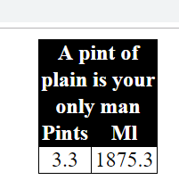

3 pints entered

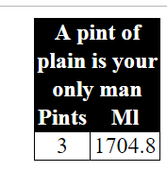

Task 6 - Coin Conversion

<?php

//Coins

$cents = 7;

$nickels = 3;

$dimes = 34;

$quarters = 2;

$halfDollars = 4;

$dollars = 9;

// Notes

$oneDollarNotes = 3;

$TwoDollarNotes = 1;

$fiveDollarNotes = 3;

$tenDollarNotes = 1;

$twentyDollarNotes = 3;

$fiftyDollarNotes = 1;

$hundredDollarNotes = 2;

$totalCents = 0;

$totalCents += ($cents);

$totalCents += ($nickels*5);

$totalCents += ($dimes*10);

$totalCents += ($quarters*25);

$totalCents += ($halfDollars*50);

$totalCents += ($dollars*100);

$totalCents += ($oneDollarNotes*100);

$totalCents += ($TwoDollarNotes*200);

$totalCents += ($fiftyDollarNotes*500);

$totalCents += ($tenDollarNotes*1000);

$totalCents += ($twentyDollarNotes*2000);

$totalCents += ($fiftyDollarNotes*5000);

$totalCents += ($hundredDollarNotes*10000);

echo "You have {$totalCents} cents.";

?>



**Task 7 - Sorting**

<?php

$num1 = $_GET['num1'];

$num2 = $_GET['num2'];

$num3 = $_GET['num3'];

if (!is_numeric($num1)) {

echo "The First Number is not a number";

echo "<br>";

return;

}

if (!is_numeric($num2)) {

echo "The Second Number is not a number";

echo "<br>";

return;

}

if (!is_numeric($num3)) {

echo "The Third Number is not a number";

echo "<br>";

return;

}

$highestNum = 0;

$middleNum = 0;

$lowestNum = 0;

// Rank with the first number as primary

if (($num1 >= $num2) && ($num1 >= $num3)) {

$highestNum = $num1; $middleNum = $num2; $lowestNum = $num3;

if ($num3 >= $num2) {

$middleNum = $num3; $lowestNum = $num2;

}

}

// Rank with the second number as primary

if (($num2 >= $num1) && ($num2 >= $num3)) {

$highestNum = $num2; $middleNum = $num3; $lowestNum = $num1;

if ($num1 >= $num3) {

$middleNum = $num1; $lowestNum = $num3;

}

}

// Rank with the third number as primary

if (($num3 >= $num1) && ($num3 >= $num2)) {

$highestNum = $num3; $middleNum = $num1; $lowestNum = $num2;

if ($num2 >= $num1) {

$middleNum = $num2; $lowestNum = $num1;

}

}

echo "{$highestNum}, {$middleNum}, {$lowestNum}";

?>

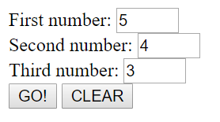



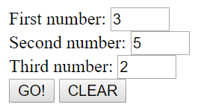



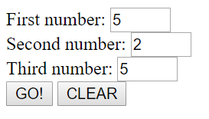



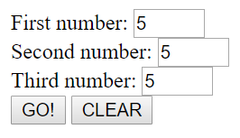



**Task 8 - Voting System**

<body>

<?php

$ageType = $_GET['age'];

$residency = $_GET['residency'];

$nationality = $_GET['nationality'];

$qualificationString = "";

$qualificationList = "";

if ($ageType == "adult" && $residency == "home") {

$qualificationString = "You are eligible to vote in the following:";

}

if ($nationality == "non_eu") {

$qualificationList .= "<li>Local Elections</li>";

}

if ($nationality == "other_eu") {

$qualificationList .= "<li>European Elections</li>";

$qualificationList .= "<li>Local Elections</li>";

}

if ($nationality == "british") {

$qualificationList .= "<li>Dáil Elections</li>";

$qualificationList .= "<li>European Elections</li>";

$qualificationList .= "<li>Local Elections</li>";

}

if ($nationality == "irish") {

$qualificationList .= "<li>Referenda</li>";

$qualificationList .= "<li>Presidential Elections</li>";

$qualificationList .= "<li>Dáil Elections</li>";

$qualificationList .= "<li>European Elections</li>";

$qualificationList .= "<li>Local Elections</li>";

}

if ($ageType == "child") {

$qualificationString = "You are ineligible to vote";

$qualificationList = "";

}

if ($residency == "abroad") {

$qualificationString = "You are ineligible to vote";

$qualificationList = "";

}

echo $qualificationString;

echo "<br>";

echo "<ul>";

echo $qualificationList;

echo "</ul>";

?>

</body>

Selection Irish, adult, living in Ireland

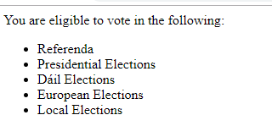

Selection British, adult, living in Ireland



Selection Other EU, adult, living in Ireland

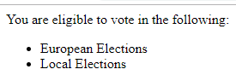

Selection Non EU, adult, living in Ireland

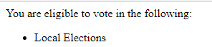

Selection Less than 18 years old with any other selection



Selection Live Not in Ireland with any other selection



**Task 9 - Does my BMI look big in this?**

*** Ambiguity in Category table is addressed using >=.

<?php

$weight = $_GET['weight'];

$height = $_GET['height'];

if (!is_numeric($weight)) {

echo "The Weight entered is not a number";

echo "<br>";

return;

}

if (!is_numeric($height)) {

echo "The Height entered is not a number";

echo "<br>";

return;

}

$idealBMI = 21.75;

$BMICalculation = round(($weight / ($height*$height)),2);

$idealWeight = $idealBMI * ($height * $height);

echo "<br>";

echo "BMI is {$BMICalculation}";

echo "<br>";

echo "Ideal Weight is {$idealWeight}";

// Find the BMI Category - Ambiguity addressed in table with >=

echo "<br>";

if ($BMICalculation < 15) {

echo "BMI Category is:- Very severely underweight";

} else if ($BMICalculation >= 15 && $BMICalculation < 16) {

echo "BMI Category is:- Severely underweight";

} else if ($BMICalculation >= 16 && $BMICalculation < 18.5) {

echo "BMI Category is:- Underweight";

} else if ($BMICalculation >= 18.5 && $BMICalculation < 25) {

echo "BMI Category is:- Normal (healthy weight)";

} else if ($BMICalculation >= 25 && $BMICalculation < 30) {

echo "BMI Category is:- Overweight";

} else if ($BMICalculation >= 30 && $BMICalculation < 35) {

echo "BMI Category is:- Obese Class I (Moderately Obese)";

} else if ($BMICalculation >= 35 && $BMICalculation < 40) {

echo "BMI Category is:- Obese Class II (Severely Obese)";

} else if ($BMICalculation >= 40 && $BMICalculation < 45) {

echo "BMI Category is:- Obese Class III (Very severely Obese)";

} else if ($BMICalculation >= 45 && $BMICalculation < 50) {

echo "BMI Category is:- Obese Class IV (Morbidly Obese)";

} else if ($BMICalculation >= 50 && $BMICalculation < 60) {

echo "BMI Category is:- Obese Class V (Super Obese)";

} else if ($BMICalculation >= 60) {

echo "BMI Category is:- Obese Class VI (Hyper Obese)";

} else {

echo "Not Classified";

}

?>

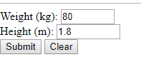

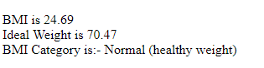

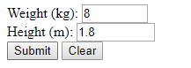

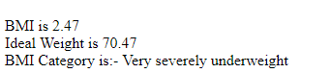

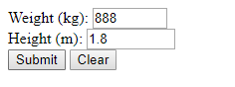

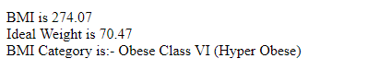

**Task 10 - Stamp Duty**

<?php

$house = $_GET['house'];

$buyer = $_GET['buyer'];

$buyerType = $_GET['occupation'];

$propertyPrice = $_GET['price'];

$propertyArea = $_GET['area'];

$stampDutyBand1 = 125000;

$stampDutyBand2 = 875000;

$stampDutyBand3 = 1000000;

$band1Rate = 0.00;

$band2Rate = 0.07;

$band3Rate = 0.09;

$stampDuty = 0.00;

$exemptionGranted = false;

if (!is_numeric($propertyPrice)) {

echo "The Price Entered is not a number";

echo "<br>";

return;

}

if (!is_numeric($propertyArea)) {

echo "The Area Entered is not a number";

echo "<br>";

return;

}

if($house == "new" && $buyer == "first" && $buyerType = "occupation") {

$exemptionGranted = true;

}

if ($propertyArea < 125) {

$exemptionGranted = true;

}

if (!$exemptionGranted) {

if ($propertyPrice < $stampDutyBand1) {

$stampDuty = 0.00;

} else if ($propertyPrice >= $stampDutyBand1 && $propertyPrice < $stampDutyBand3) {

$stampDuty = ($propertyPrice-$stampDutyBand1) * $band2Rate;

} else if ($propertyPrice >= $stampDutyBand3) {

// Calculate the first rate

$stampDuty = $stampDutyBand2 * $band2Rate;

// Calculate the tax on the remainder

$stampDuty += ($propertyPrice - ($stampDutyBand1 + $stampDutyBand2)) * $band3Rate;

}

}

echo "<br>";

echo "The Stamp Duty payable is {$stampDuty} eurines.";

?>

