**Task 1 - Spy**

<?php

$firstName = $_GET['fname'];

$lastName = $_GET['sname'];

if (empty($firstName) || empty($lastName)) {

echo "Please enter both your first and last name";

return;

}

$firstNameUpper = ucfirst($firstName);

$lastNameUpper = ucfirst($lastName);

echo "<p>";

echo "<h1> The story of {$firstNameUpper} {$lastNameUpper}.</h1>";

echo "The story began with . . .";

echo "</p>";

echo "<p>";

echo "Your name is {$lastNameUpper}, {$firstNameUpper} {$lastNameUpper}.";

echo "</p>";

echo "<p>";

echo "The story ended with . . .";

echo "<i>{$lastNameUpper} died!</i>";

echo "</p>"

?>

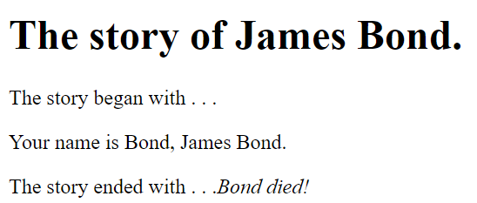

**Task 2 - Weight and Height Conversion**

Weight.php

<?php

$weightKG = $_GET['weight_kg'];

if (!is_numeric($weightKG)) {

echo "Please enter a number representing your weight in KG";

return;

}

$poundRatio = 2.20462262;

$weightInPounds = floor($weightKG * $poundRatio);

$weightInStones = floor($weightInPounds / 14);

$poundsRemaining = $weightInPounds%14;

echo "<p>";

echo "You weigh {$weightKG} kg, which is {$weightInStones} stone and {$poundsRemaining} pounds.";

echo "</p>";

?>





Height.php

<?php

$feet = $_GET['feet'];

$inches = $_GET['inches'];

if (!is_numeric($feet)) {

echo "Please enter a number representing your height in feet";

return;

}

if (!is_numeric($inches)) {

echo "Please enter a number representing the inches of your height";

return;

}

if ($inches < 0 || $inches > 11) {

echo "Invalid entry - Inches range from 0 to 11";

return;

}

$metricConversionRatio = 2.54;

$totalCentimeters = round(($feet * 12 * $metricConversionRatio) + ($inches * $metricConversionRatio));

$meters = floor(($totalCentimeters/100));

$centimeters = $totalCentimeters%100;

?>

<!DOCTYPE html>

<html lang="en">

<head>

<meta charset="UTF-8">

<meta name="viewport" content="width=device-width, initial-scale=1.0">

<meta http-equiv="X-UA-Compatible" content="ie=edge">

<style>

table

{

*margin-left* : auto;

*margin-right* : auto;

*border* : solid 1px black;

*border-collapse*: collapse;

}

caption

{

*text-align* : center;

*color* : white;

*background-color* : black;

}

th

{

*color* : white;

*background-color* : black;

}

th, td

{

*border* : solid 1px black;

*text-align* : center;

}

</style>

<title></title>

</head>

<body>

<?php

echo "<table>";

echo "<tr>";

echo "<th>Imperial</th>";

echo "<td>{$feet}</td>";

echo "<td>feet/foot</td>";

echo "<td>{$inches}</td>";

echo "<td>inch(es)</td>";

echo "</tr>";

echo "<tr>";

echo "<th>Metric</th>";

echo "<td>{$meters}</td>";

echo "<td>metre(s)</td>";

echo "<td>{$centimeters}</td>";

echo "<td>centimetre(s)</td>";

echo "</tr>";

echo "</table>";

?>

</body>

</html>

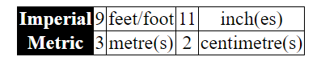

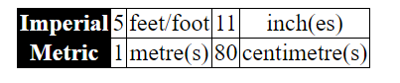

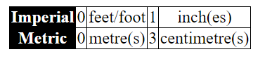

Task 3 - Exam Results System

**Task 4 - Yes, we have no bananas**

<?php

$fruitType = $_GET['fruit'];

$weight = $_GET['weight'];

if (!is_numeric($weight)) {

echo "Please enter a number a valid number for the weight";

return;

}

$fruit_prices = array('Apples' => 1.59, 'Pears' => 2.34, 'Kumquats' => 4.05, 'Jujubes' => 2.34);

$price = 0;

if ($fruitType == 'Apples') {

$price = $fruit_prices['Apples'];

} else if ($fruitType == 'Pears') {

$price = $fruit_prices['Pears'];

} else if ($fruitType == 'Kumquats') {

$price = $fruit_prices['Kumquats'];

} else if ($fruitType == 'Jujubes') {

$price = $fruit_prices['Jujubes'];

}

$totalPrice = $price * $weight;

echo "{$weight}kg of {$fruitType} costs {$weight} x {$price}, which is {$totalPrice}."

?>









**Task 5 - The Pants Pizza Parlour**

$size = $_GET['size'];

$crust = $_GET['crust'];

if(isset($_GET['toppings'])){

$toppingsChecked = $_GET['toppings'];

$toppingsSelected = true;

}else{

$toppingsChecked = "";

$toppingsSelected = false;

}

$deliveryChecked = false;

if (isset($_GET['delivery'])) {

$deliveryChecked = true;

} else {

$deliveryChecked = false;

}

$totalPizzaCost = 0;

if ($size == "small") {

$totalPizzaCost = 8;

} else if ($size == "medium") {

$totalPizzaCost = 12;

} else if ($size == "large") {

$totalPizzaCost = 16;

}

if ($crust == "deep") {

$totalPizzaCost += 2;

}

$toppingsString = "";

if ($toppingsSelected) {

for($loopCounter=0; $loopCounter < count($toppingsChecked); $loopCounter++){

if ($toppingsChecked[$loopCounter] == "mushrooms") {

$totalPizzaCost += .5;

$toppingsString .= "Mushrooms ";

} else if ($toppingsChecked[$loopCounter] == "olives") {

$totalPizzaCost += .5;

$toppingsString .= "Olives ";

} else if ($toppingsChecked[$loopCounter] == "nail") {

$totalPizzaCost += 1;

$toppingsString .= "Nail (eeuuurrrgh) ";

} else if ($toppingsChecked[$loopCounter] == "beef") {

$totalPizzaCost += 1.5;

$toppingsString .= "Spicy Beef";

}

}

}

$deliveryInstructions = "No Delivery";

if ($deliveryChecked) {

$deliveryInstructions = "To be delivered";

$totalPizzaCost += 3;

}

echo "Thank you for your order";

echo "<br>";

echo "You ordered a {$crust} {$size} pizza with $loopCounter toppings [$toppingsString] ({$deliveryInstructions})";

echo "<br>";

echo "The total cost of the pizza is {$totalPizzaCost} eurines";

echo "<br>";



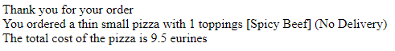

**Task 6 - For Practice**

echo "Ten Numbers: ";

for ($loopA = 0; $loopA <= 9; $loopA++) {

echo $loopA." ";

}

echo "<br>";

echo "Eleven Numbers: ";

for ($loopB = 0; $loopB <= 10; $loopB++) {

echo $loopB." ";

}

echo "<br>";

echo "Teenage Years: ";

for ($loopC = 0; $loopC <= 100; $loopC++) {

if ($loopC > 12 && $loopC < 20) {

echo $loopC." ";

}

}

echo "<br>";

echo "Evens: ";

for ($loopD = 1; $loopD <= 21; $loopD++) {

if ($loopD%2 == 0) {

echo $loopD." ";

}

}

echo "<br>";

echo "Descending odds: ";

for ($loopE = 20; $loopE >= 0; $loopE--) {

if ($loopE%2 == 1) {

echo $loopE." ";

}

}

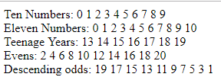

**Task 7 - Slip into something more comfortable?**

function validateNumber($number) {

echo '<br>';

if (!is_numeric($number)) {

echo "Please enter a valid number in the range 4-24";

return false;

}

if ($number < 4 || $number > 24) {

echo "The number you entered ({$number}) is outside of the dress size range (4-24)";

return false;

}

return true;

}

$dressSize = $_GET['size'];

$sizeOK = validateNumber($dressSize);

if ($sizeOK) {

echo "The dress size {$dressSize} is OK - Thank you!";

}

Enter 99



Enter cc



Enter 9



**Task 8 - Funny Farm**

if(isset($_GET['animals'])){

$animalsChecked = $_GET['animals'];

$animalsSelected = true;

}else{

$animalsChecked = "";

$animalsSelected = false;

}

function oldMacLine() {

echo "Old Macdonald had a farm ee-eye, ee-eye-oh.";

echo "<br>";

}

function singTheSongWith($animal, $sound) {

$singular = "a";

if ($sound == "oink") {

$singular = "an";

}

oldMacLine();

echo "And on that from he had a {$animal} ee-eye, ee-eye-oh.";

echo "<br>";

echo "With {$singular} {$sound}, {$sound} here and {$singular} {$sound}, {$sound} there.";

echo "<br>";

echo "Here {$singular} {$sound}, there {$singular} {$sound}, everywhere {$singular} {$sound} {$sound}.";

echo "<br>";

}

function singTheRepeatPart($sound) {

$singular = "a";

if ($sound == "oink") {

$singular = "an";

}

echo "With {$singular} {$sound}, {$sound} here and {$singular} {$sound}, {$sound} there.";

echo "<br>";

echo "Here {$singular} {$sound}, there {$singular} {$sound}, everywhere {$singular} {$sound} {$sound}.";

echo "<br>";

}

$animal_sounds = array('duck' => 'quack', 'cow' => 'moo', 'dog' => 'ruff', 'pig' => 'oink', 'badger' => 'growl');

$animalsString = "";

$soundArray = array();

if ($animalsSelected) {

for($loopCounter=0; $loopCounter < count($animalsChecked); $loopCounter++){

if ($animalsChecked[$loopCounter] == "duck") {

$animalsString .= 'duck,';

array_push($soundArray,$animal_sounds['duck']);

} else if ($animalsChecked[$loopCounter] == "cow") {

$animalsString .= 'cow,';

array_push($soundArray,$animal_sounds['cow']);

} else if ($animalsChecked[$loopCounter] == "dog") {

$animalsString .= 'dog,';

array_push($soundArray,$animal_sounds['dog']);

} else if ($animalsChecked[$loopCounter] == "pig") {

$animalsString .= 'pig,';

array_push($soundArray,$animal_sounds['pig']);

} else if ($animalsChecked[$loopCounter] == "badger") {

$animalsString .= 'badger';

array_push($soundArray,$animal_sounds['badger']);

}

}

} else {

echo "Please enter some animals - I want to sing the song!!!";

return;

}

$trimmedAnimalsString = rtrim($animalsString,',');

$animalArray = explode(',',$trimmedAnimalsString);

for ($outerLoop = 0; $outerLoop < count($animalArray); $outerLoop++) {

echo "<br>";

singTheSongWith($animalArray[$outerLoop], $soundArray[$outerLoop]);

if ($outerLoop > 0) {

for ($innerLoop = $outerLoop-1; $innerLoop >= 0; $innerLoop--) {

singTheRepeatPart($soundArray[$innerLoop]);

}

}

oldMacLine();

}

Badger

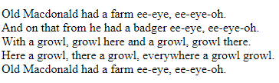

Dog & Pig

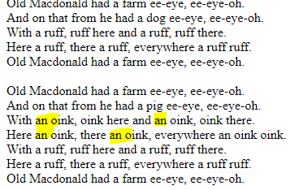

All

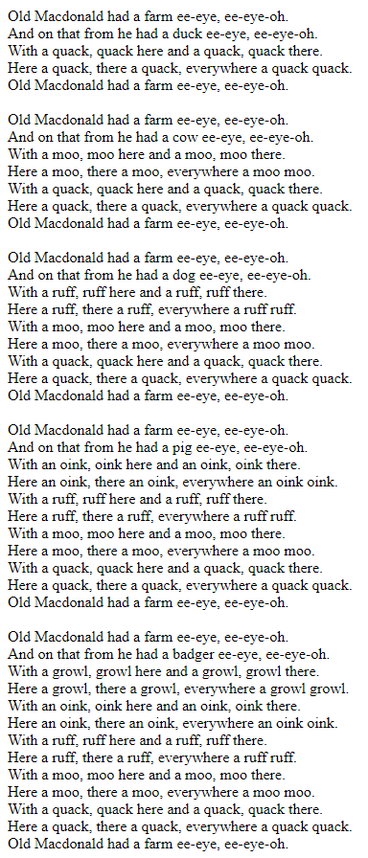

**Task 9 - Don’t foul your own nest**