**Appendix A. Additional data**

This appendix includes tables of supporting data.

**Table A.1.** Calculated view factors.

|  |  |  |  |  |  |
| --- | --- | --- | --- | --- | --- |
| Value | View factor | Value | View factor | Value | View factor |
| 0.53 | $$F_{T_{s}W}$$ | 0.44 | $$F_{WW}$$ | 0.237 | $$F_{RR}$$ |
| 0.235 | $$F_{T_{s}P}$$ | 0.3 | $$F_{WT_{s}}$$ | 0.763 | $$F_{RT_{s}}$$ |
| 0.235 | $$F_{T_{s}S}$$ | 0.13 | $$F_{WP}$$ | 1 | $$F_{T_{s}R}$$ |
| 0.271 | $$F_{BT_{s}}$$ | 0.13 | $$F_{WS}$$ | 0.427 | $$F_{AT_{s}}$$ |
| 0.134 | $$F_{BS}$$ | 0.44 | $$F_{PW}$$ | 0.47 | $$F_{ST_{s}}$$ |
| 0.461 | $$F_{BW}$$ | 0.47 | $$F_{PT_{s}}$$ | 0.45 | $$F_{SW}$$ |
| 0.134 | $$F_{BP}$$ | 0.01 | $$F_{PP}$$ | 0.08 | $$F_{SP}$$ |
|  |  | 0.08 | $$F_{PS}$$ | 0.573 | $F_{AR}$ |

**Appendix B. Supporting equations**

This appendix includes the energy balance equations for the greenhouse without thermal screen. Figure B.1 illustrates a schematic representation of the greenhouse without thermal screen. The following equations represent the energy balance for different components of the greenhouse.

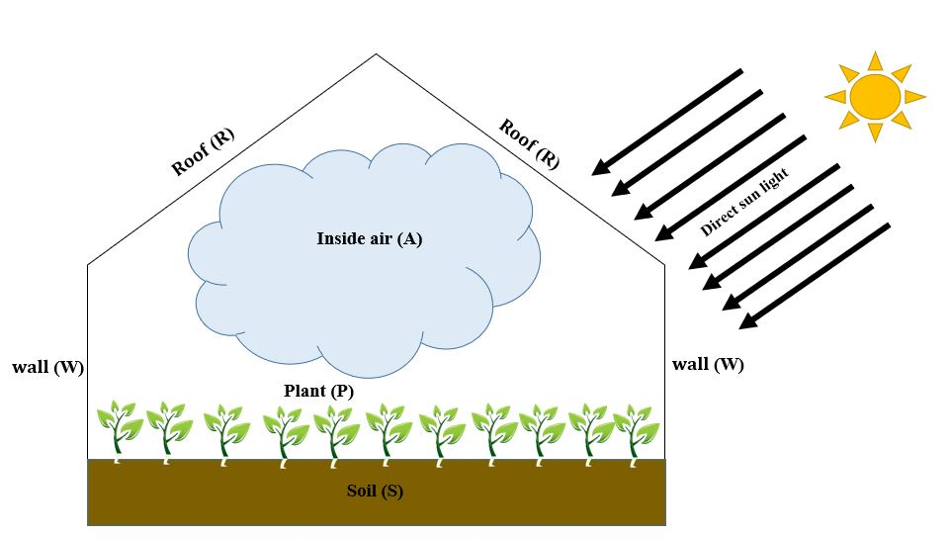

**Fig. B.1.** Greenhouse Schematic without thermal screen.

The energy balance for the roof is evaluated as follows:

**B.1. Roof**

$\left(G_{s,R}A_{R}{(α}_{R,sol}+τ_{R,sol}q_{RaR,sol })+G_{s,W }A_{W}τ_{W,s} q_{WaR,s }\right)+4κV_{A}σ{T_{A}}^{4}q_{AaR,t}$

$$+σ{T_{sky}}^{4}A_{R}F_{R-sky}(α_{R,t}+τ_{R,t}q_{RaR,t })+ ε_{P}σ{T_{p}}^{4}A_{p}q_{PaR,t }{ +ε}_{S}σ{T_{S}}^{4}A_{S}{ q}_{SaR,t}$$

$+(ε_{W}σ{T_{W}}^{4}A_{W} +σ{T_{sky}}^{4}A_{W}F_{W-sky}τ_{w,t})q_{WaR,t }-ε_{R}σ{T_{R}}^{4}A_{R}\left(2-q_{RaR,t}\right)$

$$-h_{RA}A_{R}\left(T_{R}-T_{A}\right)-h_{Ram}A_{R}\left(T_{R}-T_{am}\right)=0 (B.1)$$

The following equation represents the energy balance for the wall:

**B.2. Wall**

$$\left(G_{s,W}A_{W}{(α}_{W,sol}+τ_{W,sol}q_{WaW,sol })+G_{s,R}A_{R}τ_{R,sol}q_{RaW,sol}\right) +4κV_{A}σ{T_{A}}^{4}q_{AaW,t}$$

$$+\left(ε_{R}σ{T_{R}}^{4}A_{R}+σ{T_{sky}}^{4}A_{R}{ F}_{R-sky }τ_{R,t}\right) q_{RaW,t }+ε_{p}σ{T_{p}}^{4}A_{p}q_{PaW,t }$$

$$+ε_{S}σ{T_{S}}^{4}A_{S}q_{SaW,t }+σ{T_{sky}}^{4}A_{W}F_{W-sky}{(α}_{W,t}+τ_{W,t }q_{WaW,t })$$

$$-ε_{W}σ{T_{W}}^{4}A_{W}\left(2-q_{WaW,t} \right)-h_{WA} A_{W}\left(T_{W}-T_{A}\right)-h_{Wam} A_{W}\left(T_{W}-T_{am}\right)=0 \left(B.2\right)$$

The following equation represents the energy balance for the soil surface:

**B.3. Soil surface**

$$\left(G_{s,R}A_{R}τ_{R,sol}q_{RaS,sol}+G_{s,W }A_{W}τ_{W,s} q_{WaS,s }\right) +\left(ε_{R}σ{T_{R}}^{4}A_{R}+σ{T_{sky}}^{4}A_{R}F_{R-sky}τ_{R,t}\right)q_{RaS,t }$$

$$+ε_{p}σ{T_{p}}^{4}A_{p}q_{PaS,t }+4κV_{A}σ{T_{A}}^{4}q_{AaS,t} +{(ε}_{W}σ{T_{W}}^{4}A_{W}+σ{T_{sky}}^{4}A_{W}F_{W-sky}τ_{w,t} )q_{WaS,t }$$

$$-ε_{s}σ{T_{s}}^{4}A_{s}\left(1-q_{sas,t}\right)-h_{SA} A_{s}\left(T_{S}-T_{A}\right)-k_{s}A_{s}\frac{T_{s}-T_{s,∞}}{z}=0 \left(B.3\right)$$

The energy balance for the plant is evaluated as follows:

**B.4. Plant**

$$\left(G_{s,R}A_{R}τ_{R,sol}q_{RaP,sol}+G_{s,W }A_{W}τ_{W,s} q_{WaP,s }\right)+ε_{S}σ{T_{S}}^{4}A_{S}q_{SaP,t }+4κV_{A}σ{T_{A}}^{4} q_{AaP,t}$$

$$+\left(σ{T_{sky}}^{4}A_{R}{ F}_{R-sky }τ_{R,t}+ε_{R}σ{T_{R}}^{4}A_{R}\right)q_{RaP,sol}-Q_{ET}$$

$${+(ε}_{W}σ{T_{W}}^{4}A_{W}+σ{T_{sky}}^{4}A_{W}F_{W-sky}τ_{w,t}) q_{WaP,t }-ε_{p}σ{T_{p}}^{4}A_{p}(1-q_{PaP,t })= 0 (B.4)$$

The energy balance for the inside air is evaluated as follows:

**B.5. Inside air**

$$\left(G_{s,R}A_{R}τ_{R,sol} q_{RaA,sol}{+G}_{s,W }A_{W}τ_{W,s }q_{WaA,sol}\right)+\left(ε_{R}σ{T_{R}}^{4}A_{R}+σ{T_{sky}}^{4}A_{R}{ F}_{R-sky }τ_{R,t}\right)q_{RaA,t }$$

$$+ε_{p}σ{T_{p}}^{4}A_{p}q_{PaA,t}+ε_{s}σ{T_{s}}^{4}A_{s}q_{SaA,t}+Q_{ET}+(ε_{W}σ{T_{W}}^{4}A_{W}+σ{T_{sky}}^{4}A_{W}F_{W-sky}τ_{w,t} )q_{WaA,t}$$

$$-4κV_{A}σ{T_{A}}^{4}\left(1-q_{AaA,t}\right)-2V_{A}N_{inf}\frac{ρ_{A}c_{P,A}}{3600}\left(T_{A}-T_{am}\right)+h_{RA}A_{R}\left(T_{R}-T_{A}\right)$$

$$+h_{SA}A_{s}\left(T_{S}-T_{A}\right){+h}_{WA} A_{W}(T_{W}-T_{A})=0 (B.5)$$