Задание 1
All flights of a specific airline.
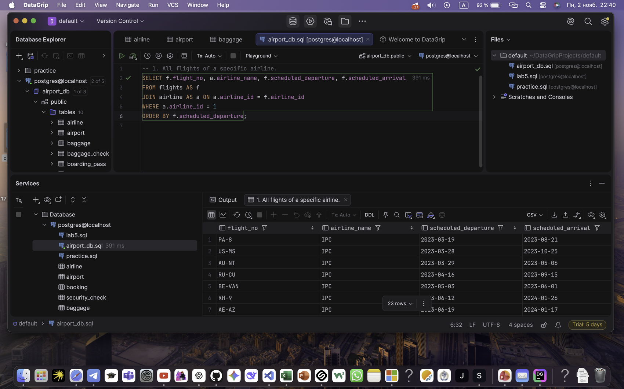

Задание 2
Flights and their departure airport names.
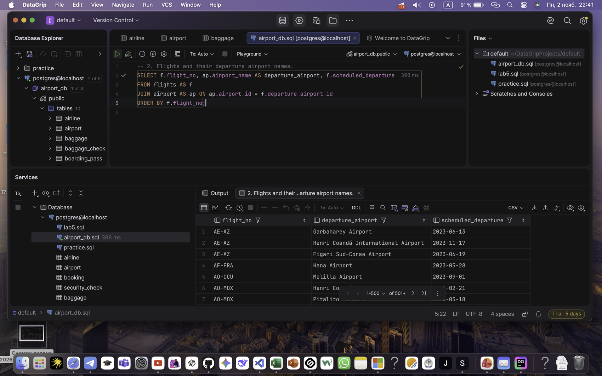

Задание 3
Airlines with no flights scheduled in the next calendar month.
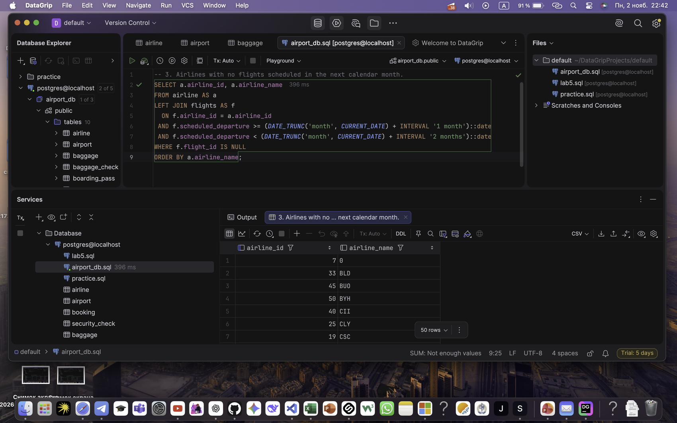

Задание 4
Passengers on a specific flight.
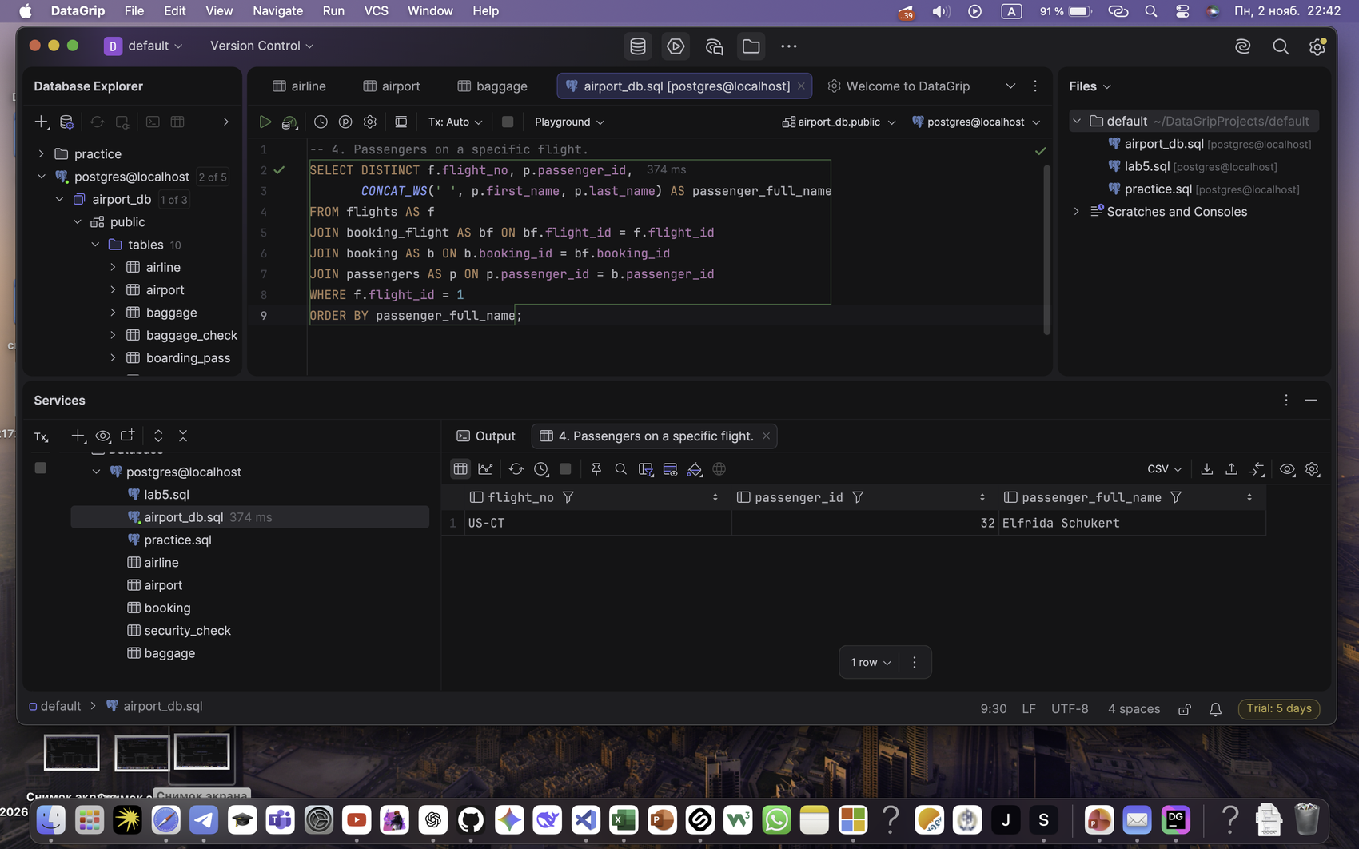

Задание 5
Average, total, maximum and minimum booking price for each flight.
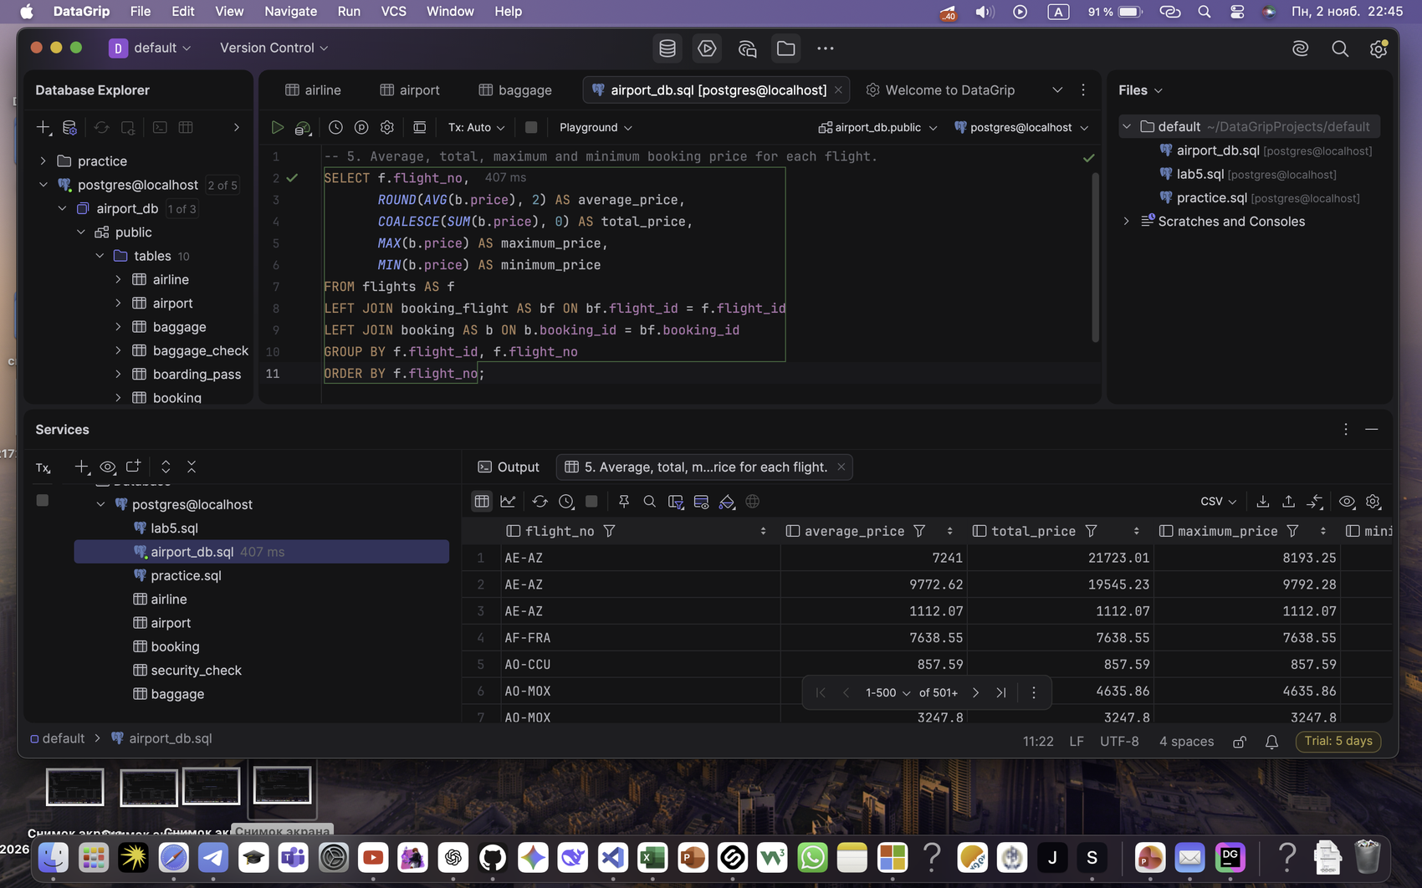

Задание 6
Flights to a specified destination country.
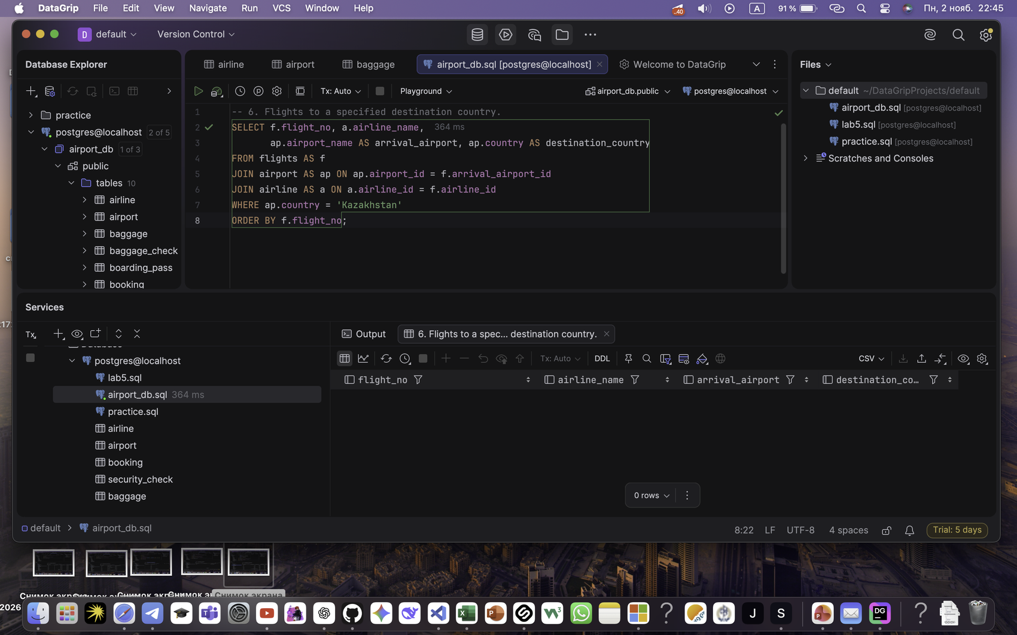

Задание 7
Minor passengers (under 18) and their destinations.
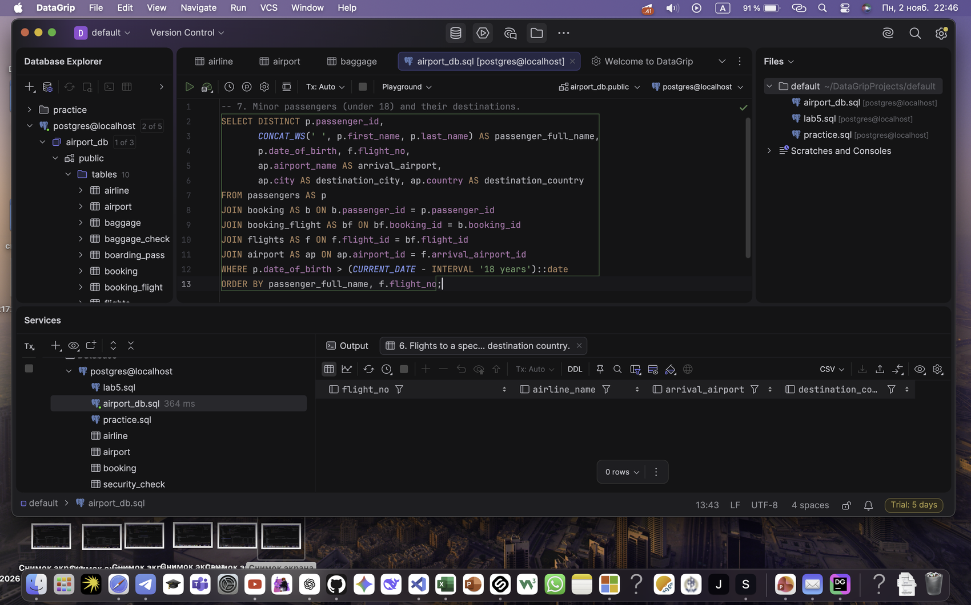

Задание 8
Passenger name, passport and actual arrival date.
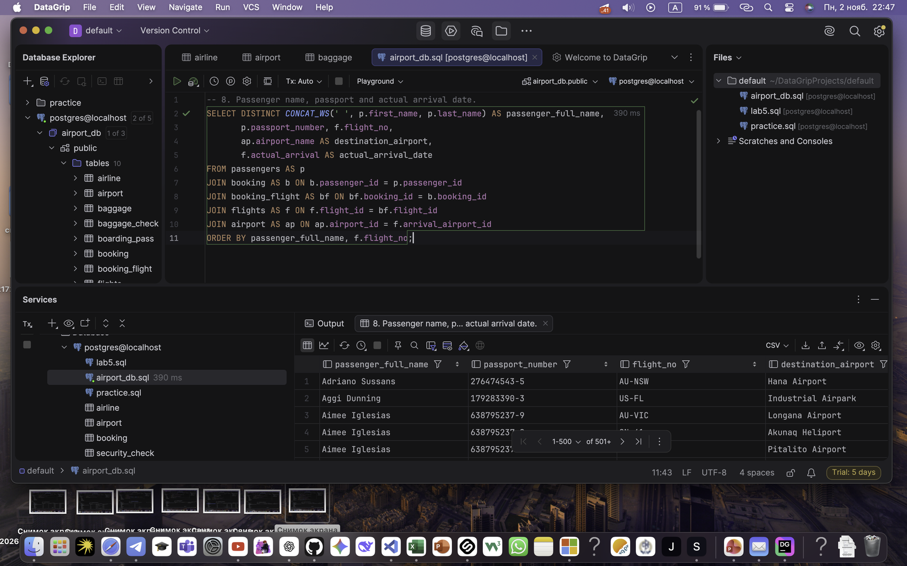

Задание 9
Flights whose airline country equals the departure airport country, grouped by country.
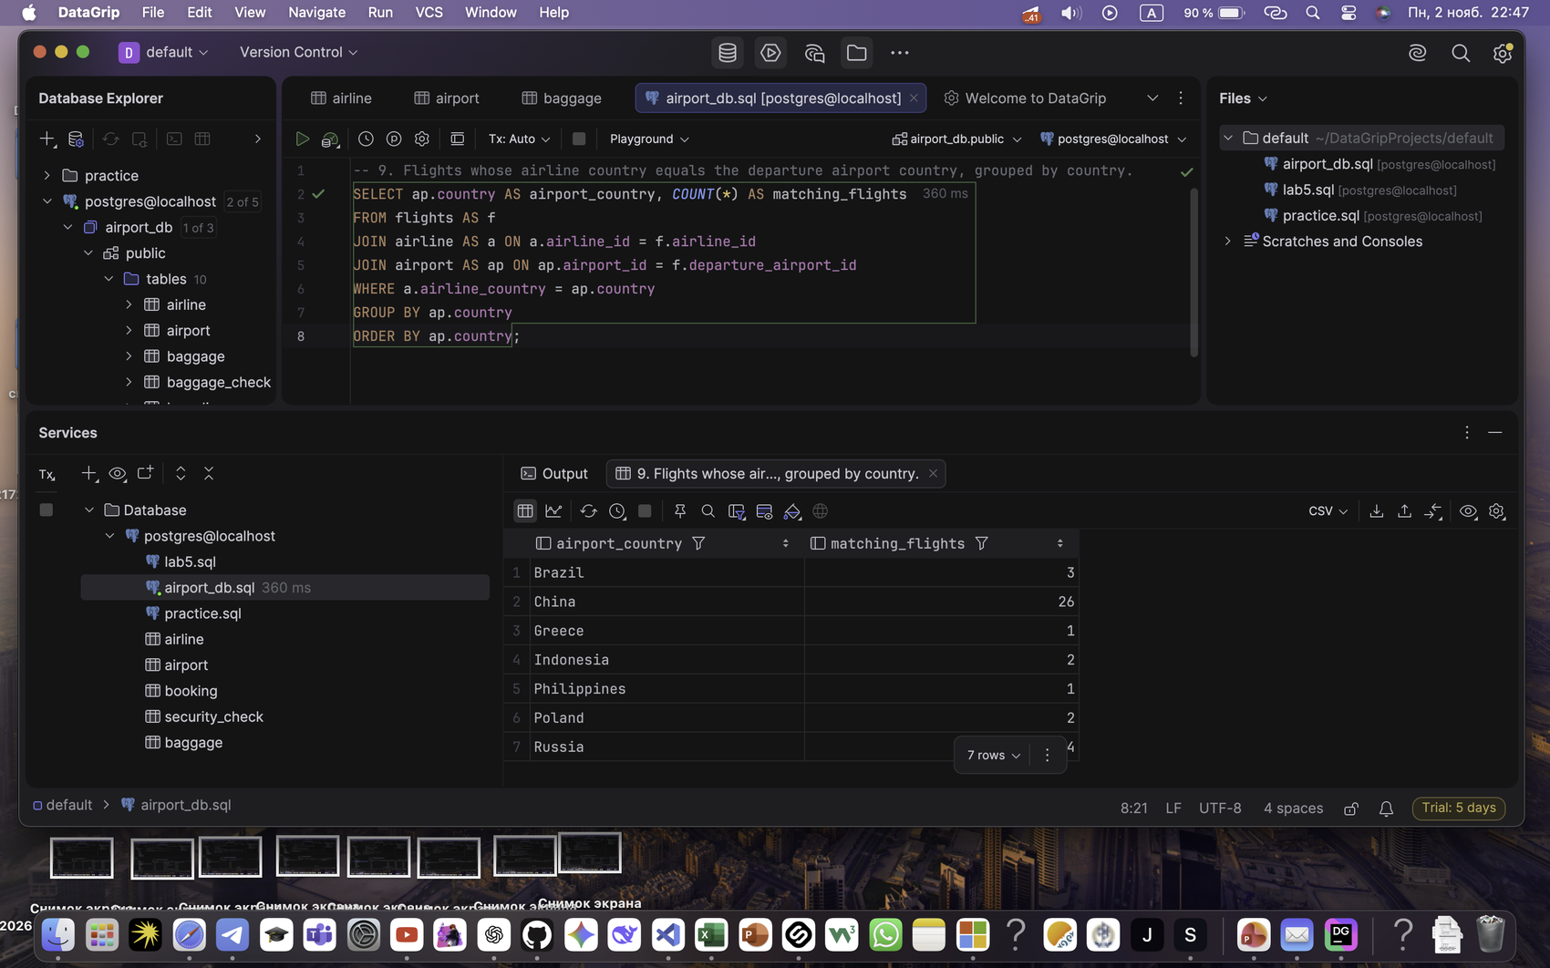

Задание 10
Flight number, airline, departure and arrival airport.
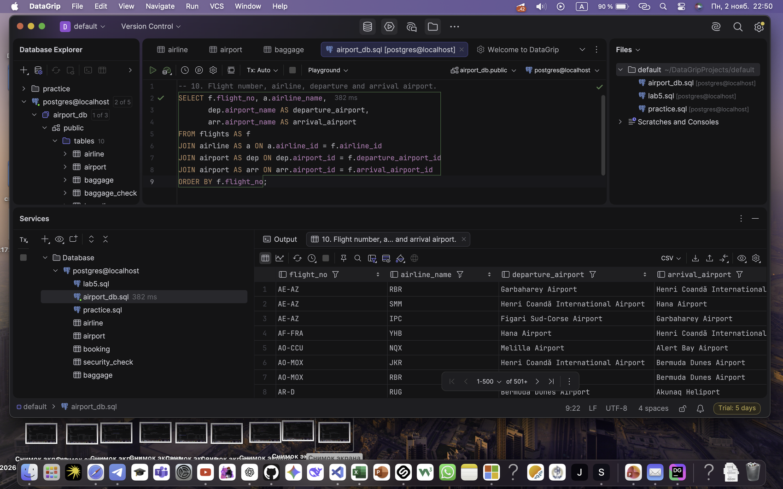

Задание 11
Passengers with bookings for flights of a specified airline.
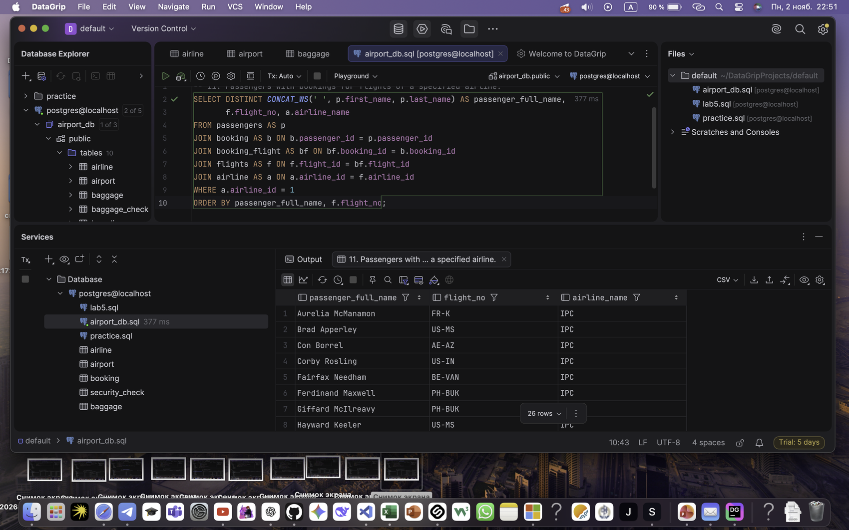

Задание 12
Booked passengers per flight, including flights with no bookings.
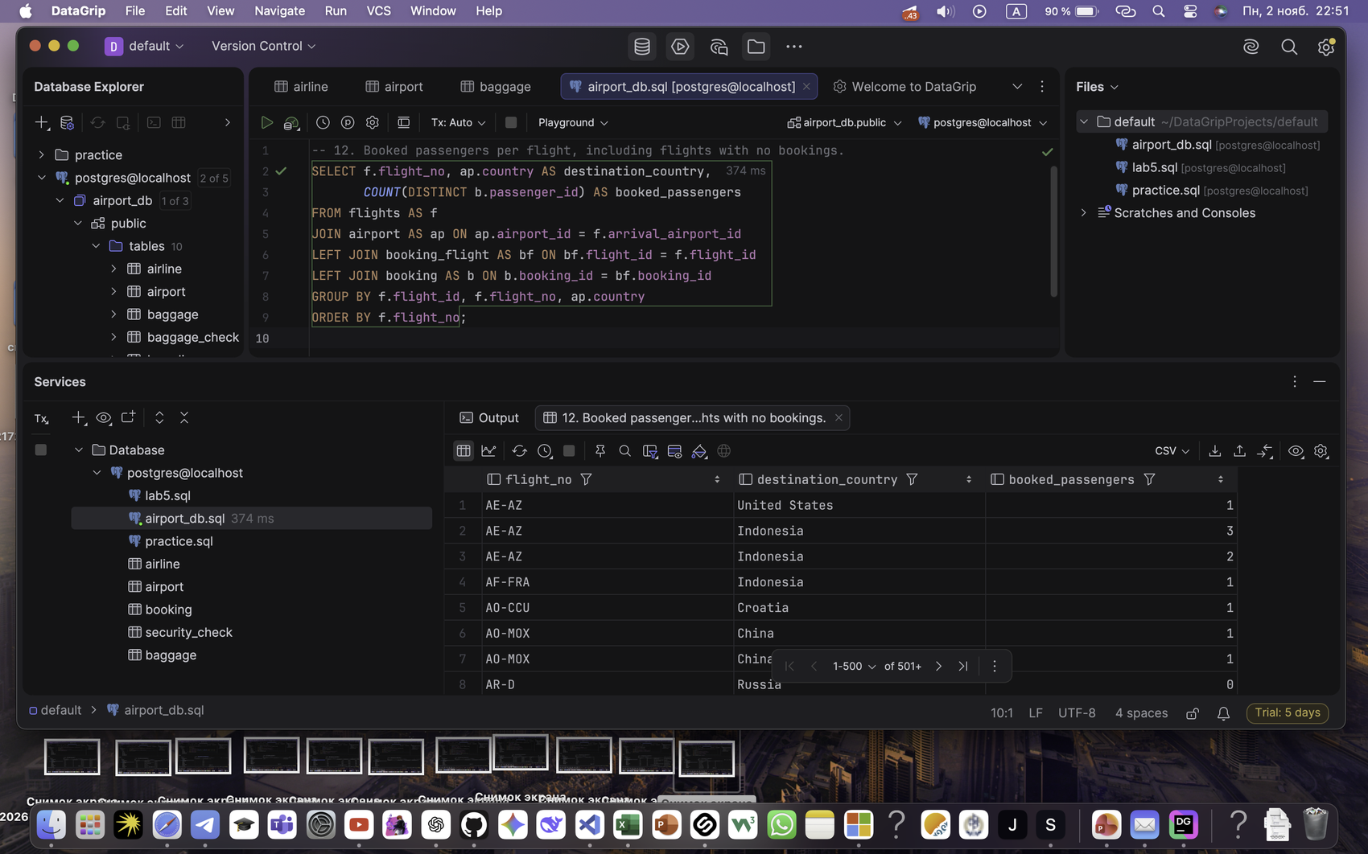

Задание 13
Passengers without any bookings.
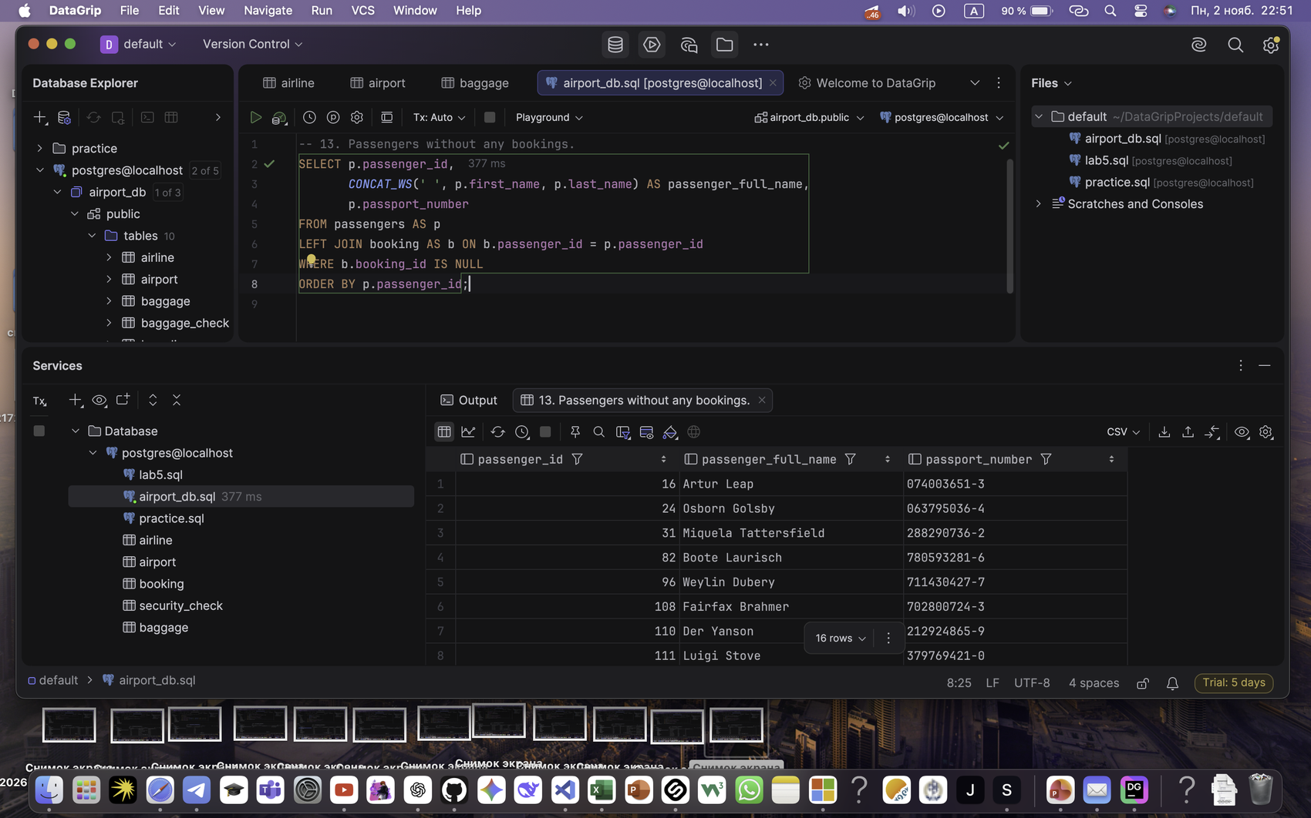

Задание 14
Flight count per airline, including airlines without flights.
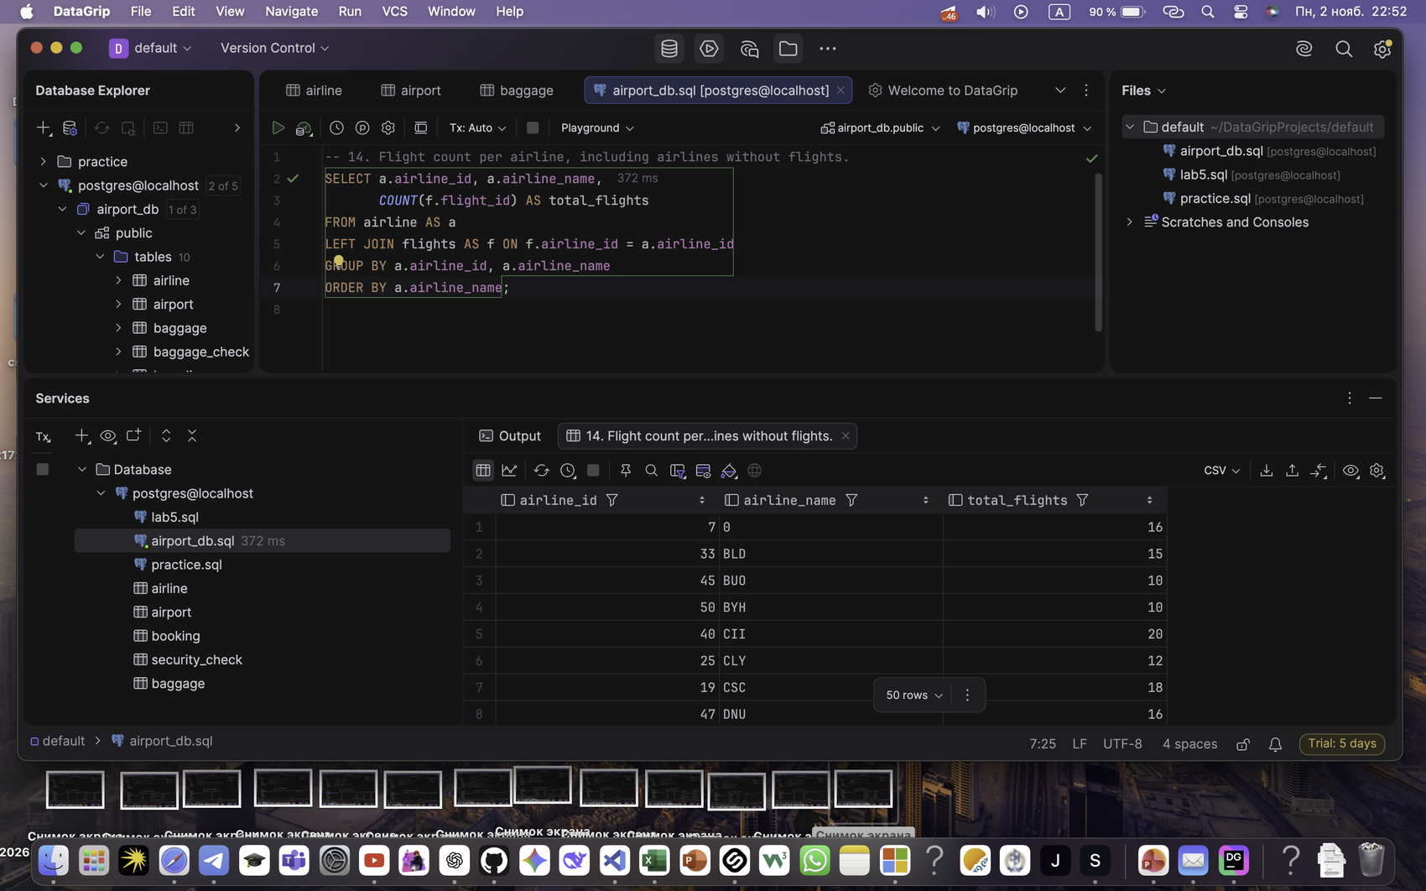

Задание 15
Flights departing from a specified country.


