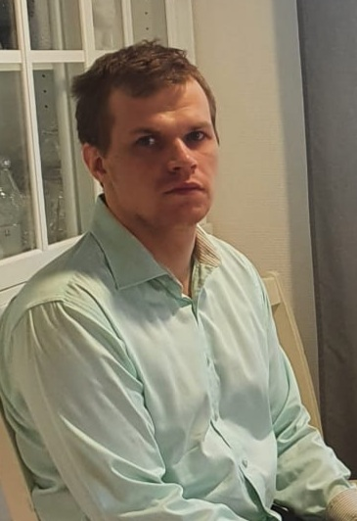
Ate Eskola (b. 23.07.1993) Resume
Saratie 5, 85500 Nivala, Finland
tel. +358 45 6505737
Email: ajieskola@gmail.com 2024-6-17

I am a 30-year programmer from Nivala of Finland. I have a Bachelor of Engineering degree from Indusrial Management, that includes a year in Gamelab where I worked as a programmer. My experience consists of around five years of experience in software development, an in addition of a bit of contribution to open source projects. My secondary occupation has been a swimming hall lifesaver since 2013.

Education
- Industrial Management, Bachelor of Engineering, Centria UAS Ylivieska, 2013-2019. C# and Unity employed in Gamelab.
- Vocational Metalworking degree, Machinist, Nivalan ammattiopisto, 2009-2012.
- Basic education, Nivala, 2000 – 2009

Work experience
- Programmer with consultancy contract, Symmetry Investments, 2021 – 2024. developing interpreter for inhouse programming language, developing inhouse accounting application.
- Programmer, Ylivieskan Kivihiomo Oy (lit. Stonecuttery of Ylivieska Ltd.), 2018 – 2021. Application design, implementation, testing and usage instruction as needed by employer. A HTML application written in C# (Bridge.NET) and desktop utility applications written in D. A small Vibe.D server embedded in a Docker container.
- Learning programmer, Freelance programmer Asko Rajamäki, 2017, 3 months. ASP.NET server programming with C# and SQL databases.
- Swimming hall Lifesaver, Town of Ylivieska, 2013-, continuing occasionally
- CAD drawer, Suomen Rakettitukku Oy (lit. Rocket wholesale of Finland Ltd.), 2013. Drawings for bureucracy applications with LibreCAD.
- Conscript, Kainuu Brigade, fall 2012 (six months)

Strengths
- Main programming languages C# and D. Also experience from C, C++, Haskell and Javascript.
- Best skills in terminal and desktop applications and file format handling, some experience also from servers, browser applicantions, games and CAD drawing.
- Tools I’m best with: Git, Godot, LibreCAD, Nix
- Tools I have some proficiancy with: ASP.NET, PostgreSQL, Unity, Vibe.D, miscellaenous Unix tools such as objdump and strace.
- I have a strong mathematical reasoning and good english skills in written form.
- An honest and sclupurous worker, thorought with what it do, and open to different angles of attack for problems.

Hobbies
-Regular exercising in underwater rugby since 2006 – also coaching children and competing.
-Free-time programming, sometimes contributing to open source – Dlang and Haskell plus the Nix package manager are my favourites.
-Reading.

Recommending me
Esa Hautamäki, Ylivieskan Kivihiomo Oy, +358 40 5952033 (Will only speak Finnish)
Asko Rajamäki, Ohjelmointi Asko Rajamäki Oy, +358 40 7641160
Github profile: www.github.com/dukc
Professional writing from me: dlang.org/blog/2022/06/21/dip1000-memory-safety-in-a-modern-system-programming-language-pt-1/

