**BLACK BOX TESTING**

|  |  |  |  |
| --- | --- | --- | --- |
| KML dataset for dengue cases | Online API for Pollution Standards Index | Expected Result | Actual Result |
| Ready | Ready | Report successfully generated. An email is sent to [examplePMO@gmail.com](mailto:examplePMO@gmail.com) | Report successfully generated. An email is sent to [examplePMO@gmail.com](mailto:examplePMO@gmail.com) |
| Not available/ Wrong format | Ready | The report is generated but the part for dengue cases is missing. An email is sent to [examplePMO@gmail.com](mailto:examplePMO@gmail.com) | The report is generated but the part for dengue cases is missing. An email is sent to [examplePMO@gmail.com](mailto:examplePMO@gmail.com) |
| Ready | Not available/ Wrong format | The report is generated but the part for Pollution Standards Index is missing. An email is sent to [examplePMO@gmail.com](mailto:examplePMO@gmail.com) | The report is generated but the part for Pollution Standards Index is missing. An email is sent to [examplePMO@gmail.com](mailto:examplePMO@gmail.com) |
| Not available/ Wrong format | Not available/ Wrong format | A report is generated but it contains nothing. An email is sent to [examplePMO@gmail.com](mailto:examplePMO@gmail.com) | A report is generated but it contains nothing. An email is sent to [examplePMO@gmail.com](mailto:examplePMO@gmail.com) |

**WHITE BOX TESTING**

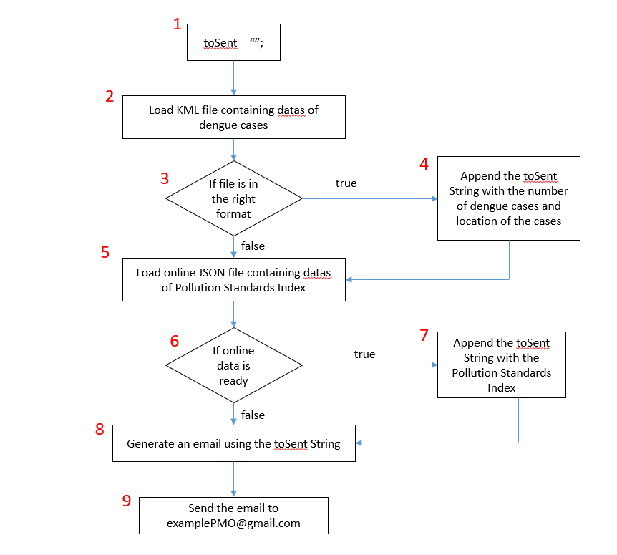

4 Basic Paths:

* 1,2,3,4,5,6,7,8,9
* 1,2,3,5,6,7,8,9
* 1,2,3,4,5,6,8,9
* 1,2,3,5,6,8,9

4 Test Cases:

* Send email to PMO with correct KML dataset for dengue cases and correct JSON dataset for Pollution Standards Index
* Send email to PMO with invalid KML dataset for dengue cases and correct JSON dataset for Pollution Standards Index
* Send email to PMO with correct KML dataset for dengue cases and invalid JSON dataset for Pollution Standards Index
* Send email to PMO with invalid KML dataset for dengue cases and invalid JSON dataset for Pollution Standards Index

4 Real Execution Paths:

* 1,2,3,4,5,6,7,8,9
* 1,2,3,5,6,7,8,9
* 1,2,3,4,5,6,8,9
* 1,2,3,5,6,8,9