Failsafe User Guide  
Version 1.0  
December 10, 2014

Table of Contents

Introduction 3

Managing Personal Information 3

Logging In 3

Steps for Logging In: 3

Steps for Viewing and Editing Personal Information 4

Steps for Viewing Personal On-Call Shifts 4

Steps for Viewing and/or Editing Day Assignments 4

Steps for Viewing and/or Editing Hourly Substitutions 4

Directory Operations 4

Add New Staff Member 4

Edit Information for a Staff Member 4

Delete Information for a Staff Member 4

Team Activation 5

Activate Call Team 5

Deactivate Call Team 5

Silence Alerts 5

Responding to an Activation 5

Stop the Alerts; Respond with Your ETA 5

Check the Status of the Team via SMS 6

Detailed Call Team Administration 6

Assign New Call Team 6

Edit Call Team 6

Delete Call Team 6

Detailed Substitution Administration 7

Create a Substitution 7

Edit a Substitution 7

Delete a Substitution 7

Additional Help 7

# 

# Introduction

Hello and welcome to the Failsafe User Guide! In this guide, you will learn every aspect to using the Failsafe system. This User Guide is for all users, but administrator functionality will also be discussed in detail. The guide will mark when a feature can only be accessed by administrators in order to provide clarity.

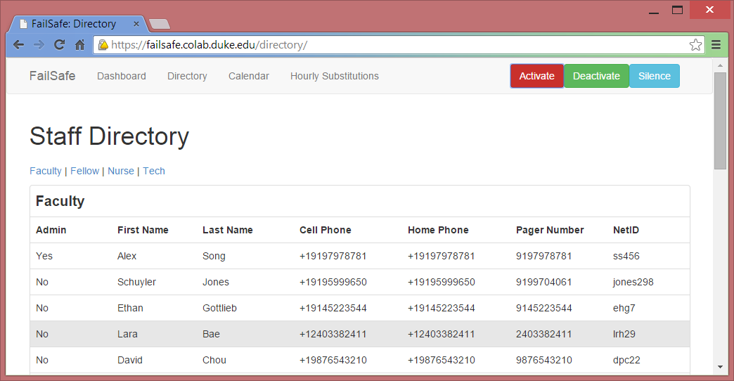

**NAVBAR**

# Managing Personal Information

Failsafe uses the Duke Shibboleth authentication system to manage user authentication. To access Failsafe, navigate to the Failsafe website (currently located at <failsafe.colab.duke.edu>). If you are already logged into the Duke system via ACES, Sakai, etc, Failsafe automatically recognizes your identity and identifies you as the appropriate user. If you are not yet logged in, log in with your Duke credentials.

## Logging In

Failsafe uses the Duke Shibboleth authentication system to manage user authentication. Using this system, Failsafe accepts logins from both current Failsafe users as well as first-time users with Duke credentials. New users will need to update their personal information upon login, a process outlined in the next subsection.

## Steps for Logging In:

1. Navigate to the Failsafe website (failsafe.colab.duke.edu)
2. If you are logged in on Failsafe or the overall Duke system (e.g. ACES, Sakai, etc.):
   1. You are automatically logged in.
3. Otherwise:
   1. Log in using your Duke credentials.

## Viewing and Editing Personal Information

All users have the ability to edit their own personal information; administrators can edit the personal information for all users.

1. Click Directory on the navbar at the top of the page.
2. Find user (ctrl-f then type in netID) in the directory and click on the *edit* button.
3. Update your information in the popup dialog.

## Viewing Personal On-Call Shifts

1. Click Dashboardon the navbar at the top of the page.
2. View the list of on-call shifts displayed in the table.
3. Click on link in the Team column to see full hour-by-hour on-call schedule for that day.

## Viewing and/or Editing Day Assignments

1. Click Calendar on the navbar at the top of the page.
2. Click Previous Month/Next Month until you reach the appropriate month.
3. Click on the box corresponding to the appropriate day.
4. Examine (and update if you are an administrator) as needed.

## Viewing and/or Editing Hourly Substitutions

1. Click Hourly Substitutions on the navbar at the top of the page.
2. Click Previous Day/Next Day until you reach the appropriate day.
3. Click on the box corresponding to the appropriate hour and role in the table.
4. Examine (and update if you are an administrator) as needed.

# Directory Operations

Note that all of these operations require admin status.

## Add New Staff Member

1. Click *Directory* at the top of the page to go to the directory.
2. Click the green *Add New Staff* button to pull up a dialog to add a new staff member.
3. Enter required information.

## Edit Information for a Staff Member

1. Click *Directory* at the top of the page to go to the directory.
2. Find the staff member you want to edit and click on the *edit* button.
3. Enter in the appropriate information in the popup dialog.

## Delete Information for a Staff Member

1. Click *Directory* at the top of the page to go to the directory.
2. Find the staff member you want to edit and click on the *delete* button.
3. Confirm that you want to delete this staff member for the directory.

# Team Activation

## Activate Call Team

1. Click the red *Activate* button at the top of the page.
2. Under **ETA**, enter the estimated time by which it is critical that the team arrives.
3. Under **Location**, enter the location that team members should travel to.
4. Under **Type**, enter the type of emergency that the team is responding to.
5. Under **Message**, enter any additional message you would like to send.
6. Click the grey *Activate* button within the dialog when you are satisfied.
7. Click *OK* in the resulting popup to confirm.
8. A message will be sent to all team members’ pagers in the format *[DATE]: ETA: [ETA], TYPE: [TYPE], LOCATION: [LOCATION], MSG: [MESSAGE] Please respond with your personal ETA in minutes, i.e. “eta 3” for 3 minutes*. After 30 seconds, the same message will be sent via SMS to all team members’ cell phones. Every 30 seconds from then on, the message will be communicated by voice over the phone. This process will continue for each team member until they respond to the texts with their ETA, or until the **Deactivate** or **Silence** procedures are followed.

## Deactivate Call Team

1. Click the green Deactivate button at the top of the screen.
2. Under Message, type the message you would like to send to all team members when they are deactivated [Note: this will stop any activation messages from being sent].
3. Click the Deactivate button when you are satisfied with your message.
4. Click OK in the resulting popup to confirm.
5. This message will be sent once to the team members’ pagers, cell phones, and SMS box.

## Silence Alerts

1. Click the blue Silence button at the top of the screen.
2. Click OK in the resulting popup to confirm.
3. This will deactivate all team members but not send them any messages. All message transmission will be stopped until the Activate or Deactivate procedures are followed.

# Responding to an Activation

## Stop the Alerts; Respond with Your ETA

1. On your cell phone, navigate to the SMS conversation with our server. If more than 30 seconds have passed since the emergency was reported, you will see a stream of messages alerting you to the emergency.
2. Respond to these messages with your ETA. Type ???
3. Verify that you have given a response in the correct format; the server should respond with approval.
4. All messages to you will stop; get to the location of the emergency ASAP!

## Check the Status of the Team via SMS

1. On your cell phone, navigate to the SMS conversation with our server.
2. If you are part of a currently activated team, send a message containing **only** the word “status” to our server.
3. The server will respond with ETAs of all the team members.

# Detailed Call Team Administration

## Assign New Call Team

1. Click Calendar on the Navigation Bar at the top of the page to go to the month view.
2. Navigate to the month of the date you would like to assign the new team to using the Previous Month & Next Month buttons at the top of the calendar.
3. Click the square (when highlighted in light blue) of the day of the month you would like to add a team for.
4. The Date field should be filled out with the date you clicked. In the unlikely event that this field is blank (a bug we are looking to resolve), please press Cancel and repeat step (3).
5. Use the dropdown menus for Faculty, Fellow, Nurse 1, Nurse 2, Tech 1, and Tech 2 to select the team members that you would like for this event.
6. Click Assign Team to submit.
7. Verify that your new event appears on the correct day of the calendar. If you would like to change any of this information, click your event and follow the instructions for Edit Call Team from step 4 on.

## Edit Call Team

1. Click *Calendar* on the Navigation Bar at the top of the page to go to the month view.
2. Navigate to the month that the team you would like to edit has been assigned to using the *Previous Month* & *Next Month* buttons at the top of the calendar.
3. Click the *square* (when highlighted in light blue) that contains the team you would like to edit.
4. The *Date* field should be filled out with the date you clicked. In the unlikely event that this field is blank (a bug we are looking to resolve), please press *Cancel* and repeat step 3.
5. Use the dropdown menus for *Faculty*, *Fellow*, *Nurse 1*, *Nurse 2*, *Tech 1*, and *Tech 2* to select the new team members that you would like for this event.
6. Click *Update Team* to save your changes.
7. Verify that the changes have successfully gone through; the calendar should update immediately.

## Delete Call Team

1. Follow steps 1-4 of the **Edit Call Team** instructions to pull up the information for the call team you would like to delete.
2. Click *Delete Assignment* to delete this team assignment.
3. Verify that the assignment has been successfully deleted; the calendar should update immediately, and the square that previously contained the team information should be empty.

# Detailed Substitution Administration

## Create a Substitution

1. Click *Hourly Substitutions* at the top of the page to go to the Day View of the Calendar.
2. Navigate to the day of the substitution you will create using the *Previous Day & Next Day* buttons at the top of the view.
3. Click the *rectangle* (when highlighted in blue) under the team role for the person you would like to substitute out, in the row of the time you would like the substitute to join the team.
4. Under **Duration (hours)** in the popup that comes up, enter the duration of the substitution you would like to create, in hours, in increments of half hours (ie: .5, 1, 1.5, …, 12, 12.5, 13)
5. Under **Substitute** use the dropdown to select the person you would like to substitute in.
6. Click *Submit Substitute* to submit your substitution.
7. Verify that the substitute was created at the correct time; if you made a mistake, click any of the boxes that the substitution you just created covers.

## Edit a Substitution

1. Click *Hourly Substitutions* at the top of the page to go to the Day View of the Calendar.
2. Navigate to the day of the substitution you would like to edit using the *Previous Day & Next Day* buttons at the top of the view.
3. Locate the substitution you would like to edit on the chart and click any of the boxes that it covers in its duration.
4. Edit the **Start Time**, **Duration**, or **Substitute** as desired. For **Start Time**, times must be in YYYY-MM-DD HH:MM:SS format. **Duration** is in hours, and **Substitute** must be chosen from the dropdown.
5. Click the *Update Sub* button to save your changes when you are satisfied.
6. Verify that the substitution has been updated to your satisfaction in the chart.

## Delete a Substitution

1. Follow steps 1-3 of the Edit a Substitution section to pull up information for the substitution you would like to delete.
2. Click the *Delete Sub* button to delete the substitution.
3. Verify that the substitution has been deleted.

# Additional Help

Please address all questions regarding Failsafe to Dr. Manesh Patel (manesh.patel@dm.duke.edu).