TEST REPORT designed by struct_by_lightning{};
Description of the testing conducted and results for the modules in the Connect 4 game interface.
All of the expected outputs was the actual output expected as described by each method implementation. The description for each method implementation can be found in their respective Module Interface Specification and Module Internal Design.
Table of Contents
(syntax: functionName( parameters ) : return type )
1. board.h
1.1 board_create() : Board
1.2 board_destroy() : Board
1.3 board_checkCell(Board b, int row, int col) : Token
1.4 board_dropToken(Board b, Token token, int col) : int
1.5 board_dropPosition(Board b, int col) : int
1.6 board_empty(Board b) : void
2. gameLogic.h
2.1. handleMainMenuMouseClick(int x, int y) : MenuState
2.2 checkBoardStatus(Board b) : BoardStatus
3. gaphics.h
3.1 init() : bool
3.2 loadMedia() : bool
3.3 close_sdl() : void
3.4 dropToken(Board b, Token tokenColour, int col) : bool
3.5 deleteStillToken(FallingToken *fallingToken) : void
3.6 drawFallingToken(FallingToken *token) : void
3.7 transitionSetupRender() : void
3.8 updateFallingToken(FallingToken *fallingToken, float dt) : void
3.9 displayBoard(void) : void
3.10 displaySetupTokens(void) : void
3.11 displayMainMenu(void) : void
3.12 mainMenuRender() : void
3.13 highlightToken(int row, int col) : void
4. linkedList.h
4.1 Template <T> class List
4.1.1 addToList(T *newitem, List<T> *list) : List<T> *
4.1.2 deleteFromList(T *toDeleteItem, List<T> *list) : List<T>*
4.1.3 traverseList(void (*f)(T *item), List<T> *list) : void
5. sdl2_connect4.h
5.1 connect4() : int
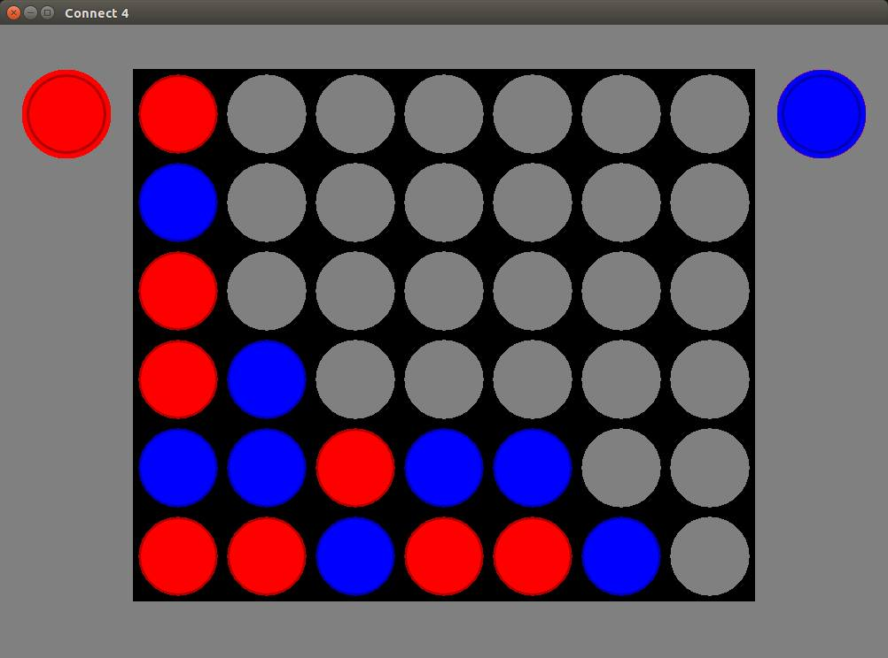
Notes:
(i) To avoid repetition throughout this report, whenever the symbol, b, is seen as input for a function, it refers to a valid state of an object of type Board as depicted by the following image :

(ii) Any input with the format < action > implies the import is some action performed on client side, such as mouse clicks, and opening/closing a program.

1. board.h
1.1 board_create() : Board
Input: none
Expected Output: A new board object that is empty

1.2 board_destroy(Board b) : Board
Input: A board object
Expected Output: The input board object should be freed from memory, nothing should be returned

1.3 board_checkCell(Board b, int row, int col) : Token
Input: b, 1, 1
Expected Output: BLUE
Input: b, 1, 6
Expected Output: EMPTY
Input: b, 0, 0
Expected Output: RED

1.4 board_dropToken(Board b, Token token, int col) : int
Input: b, RED, 3
Expected Output: 0 (successful token drop)
Input: b, BLUE, 0
Expected Output: -1 (column is full, cannot drop token)

1.5 board_dropPosition(Board b, int col) : int
Input: b, 5
Expected Output: 1
Input: b, 1
Expected Output: 3
Input: b, 0
Expected Output: -1 (full column, so row is out of bounds)

1.6 board_empty(Board b) : void
Input: b
Expected Output: An empty board, with no tokens in play

2. gameLogic.h
2.1 handleMainMenuMouseClick(int x, int y) : MenuState
Input: 450, 580
Expected Output: Open the Setup game mode
Input: 480, 750
Expected Output: Closes the game window
Input: 251, 30
Expected Output: Nothing, remain in the Main Menu

2.2 checkBoardStatus(Board b) : BoardStatus
Input: b
Expected Output: IN_PROGRESS
Input: b (where red token has 4 in a row in the setup mode)
Expected Output: INVALID_BOARD
Input: b (where red token has 4 in a row in 1 player mode)
Expected Output: RED_WON

3. gaphics.h
3.1 init() : bool
Input: < starting the program >
Expected Output: true
Input: < starting the program
Expected Output: false ( if error(s) occurred when starting the program such as: incorrect installation of SDL, and invalid window creation.)

3.2 loadMedia() : bool
Input: < starting the program >
Expected Output: true (all media file successfully found in given path)
Input: < starting the program >
Expected Output: false (one or more media files failed to load)

3.3 close_sdl() : void
Input: < Closing the game >
Expected Output: Sets all loaded media to NULL and program window closes

3.4 dropToken(Board b, Token tokenColour, int col) : bool
Input: b, RED, 3
` Expected Output: true
Input: b, BLUE, 0
Expected Output: false (column already full)

3.5 deleteStillToken(FallingToken *fallingToken) : void
Input: fallingToken->isFalling == true
Expected Output: Change noting
Input: fallingToken->isFalling == false
Expected Output: Removes the token from the structure

3.6 drawFallingToken(FallingToken *fallingToken) : void
Input: fallingToken->token == RED
Expected Output: Render (display) a red token in the appropriate column and row
3.7 transitionSetupRender() : void
Input: < Staring the setup mode gameplay >
Expected Output: All media required for the setup game mode is rendered onto the screen

3.8 updateFallingToken(FallingToken *fallingToken, float dt) : void
Input: fallingToken with the following properties:
fallingToken->isFalling == true
fallingToken->y == a
fallingToken->v == b
dt == c
Expected Output: using the values a, b, and c, calculate the new velocity and height of the falling token.
3.9 displayBoard(void) : void
Input: < start any game mode >
Expected Output: The game board is rendered on the screen

3.10 displaySetupTokens(void) : void
Input: < Starting setup game mode >
Expected Output: Renders any setup tokens needed in the setup game board
3.11 displayMainMenu(void) : void
Input: <Starting program or returning to the main menu from another screen >
Expected Output: The main menu is displayed

3.12 mainMenuRender() : void
Input: <Starting program or returning to the main menu from another screen >
Expected Output: Renders images of the main menu
3.13 highlightToken(int row, int col) : void
Input: 2,1
Expected Output: Token located in row 3, column 1 is highlighted

4. linkedList.h
4.1 Template <T> class List
This list is responsible for keeping track of all moving tokens in the game
To simplify testing we will assume the list is represented as:
{ obj0, obj1, obj2, obj3 }

4.1.1 addToList(T *newitem, List<T> *list) : List<T> *
Input: BLUE, { RED, RED, BLUE }
Expected Output: { BLUE, RED, RED, BLUE }

4.1.2 deleteFromList(T *toDeleteItem, List<T> *list) : List<T>*
Input: RED, { RED, BLUE, BLUE, RED }
Expected Output: { BLUE, BLUE, RED }
Input: BLUE, { }
Expected Output: NULL

4.1.3 traverseList(void (*f)(T *item), List<T> *list) : void
Input: free(), { BLUE, BLUE, RED }
Expected Output: { } (The list is traversed, and each element is set to NULL)

5. sdl2_connect4.h
5.1 connect4() : int
Input: <Starting the program> (This is the main function that starts the program)
Expected Output: 0 (When game closes successfully )

