These instruction are for the full and updated base installation of a

64bit Websphere environment. The architecture for the environment is a follows

(Any number) of DMZ Servers for the IHS node (s)

Prior to running install the following is required

* The creation of the /var/websphere mount
* The alias and host names of all Websphere servers that you will be installing for

This process is broken down as follows

* Run stage (Run from was7dmz server as wsadm)
* Install update installer (Run from was7dmz server as wsadm)
* Run prep for ihs server(s) (Run from was7dmz server as wsadm)
* Run install of ihs servers ( Run from respective dmz server as wsadm)
* Manually add unmanaged Node and Web Server ( run from tst admin console)

1. Run stage (Run from was7dmz server as wsadm)

**chmod -Rf 755 /var/websphere**

**/var/websphere/was7dmzstage/./runfirst.sh**

2. Install update installer (Run from was7dmz server as wsadm)

**/var/websphere/src/install/bin/prep/./updateinstall.sh**

3. Run prep for ihs server(s) (Run from was7dmz server as wsadm)

**/var/websphere/src/install/bin/prep/./dmz_ihs_prep.sh**

*Response Questions (examples given are for dmz tst):*

*Enter the web host name*

***cerp1605***

*Enter the web host alias*

***was7vndrweb1tst***

*type last 2 digits for fixpack you wish to apply*

***21***

4. Run install of ihs servers (Run from respective dmz ihs server as wsadm)

**/var/websphere/src/install/bin/install/./ihsinstall_was7vndrweb1tst.sh**

*Response Questions (examples given are for tst):*

Enter password for wsadm

**Password in keypass**

5. Manually add unmanaged Node and Web Server (run from tst admin console)

Log on to <http://was7dm1tst:9060/ibm/console>

Go to Systems administration -> Nodes

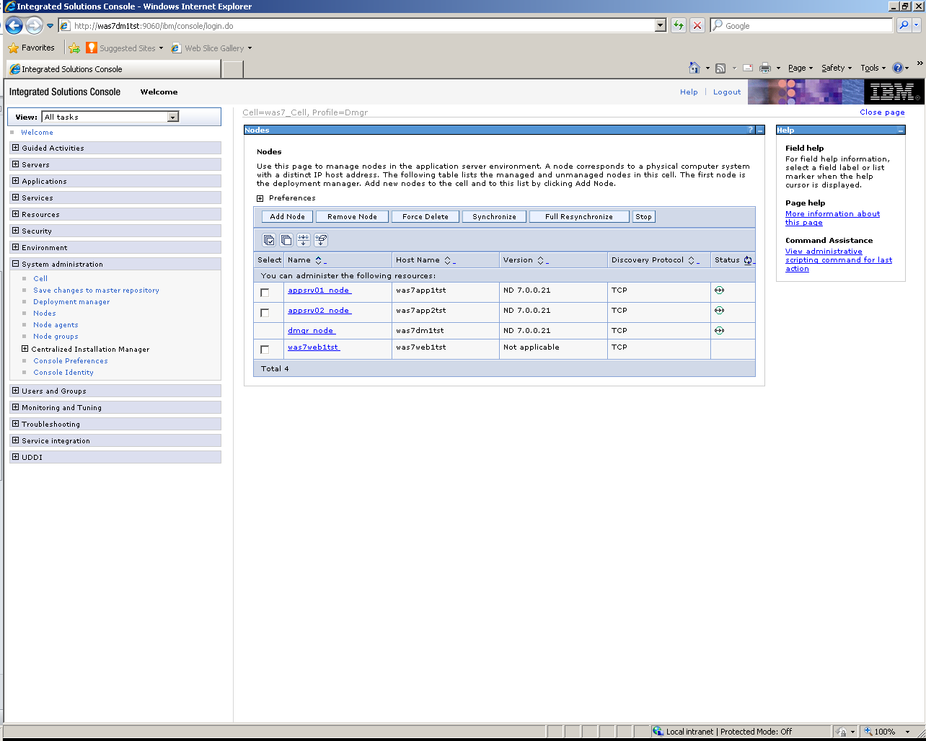

Click the Add Node Button on the next window that displays select Unmanaged node as seen below then click next

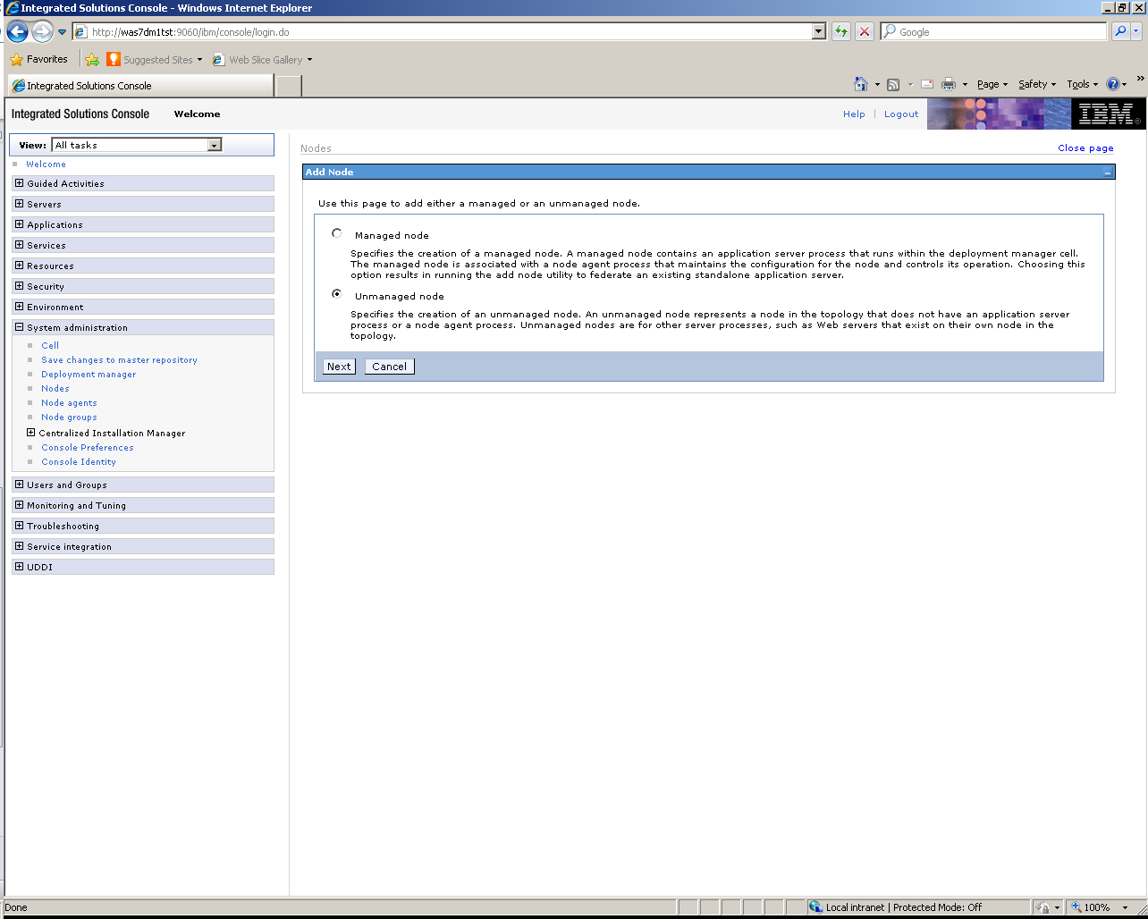

For Both the Name and Host Name enter the alias for ihs7 server. Platform should be Linux

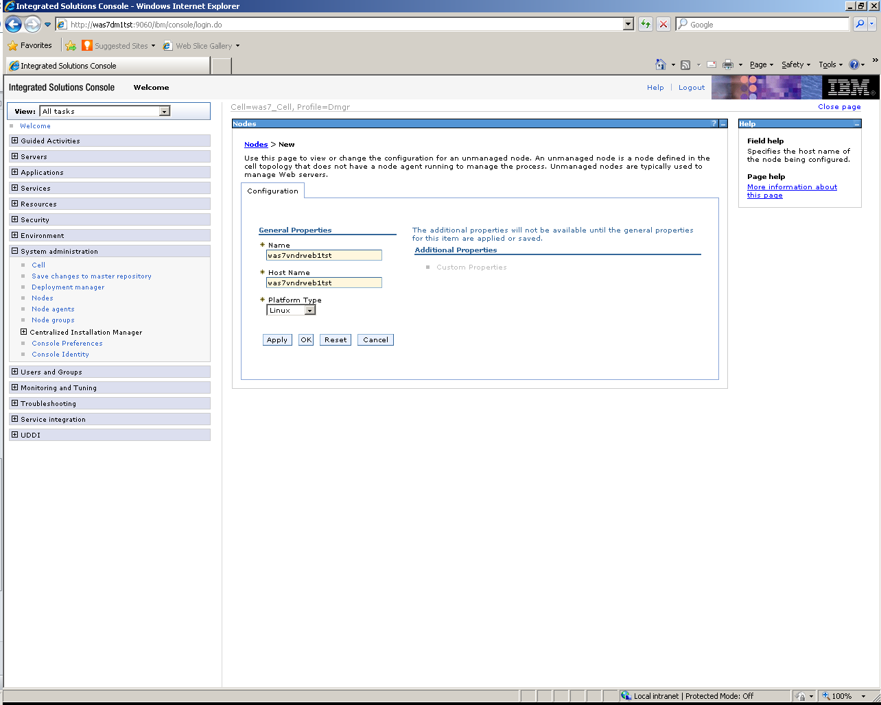

Click Apply then click Review

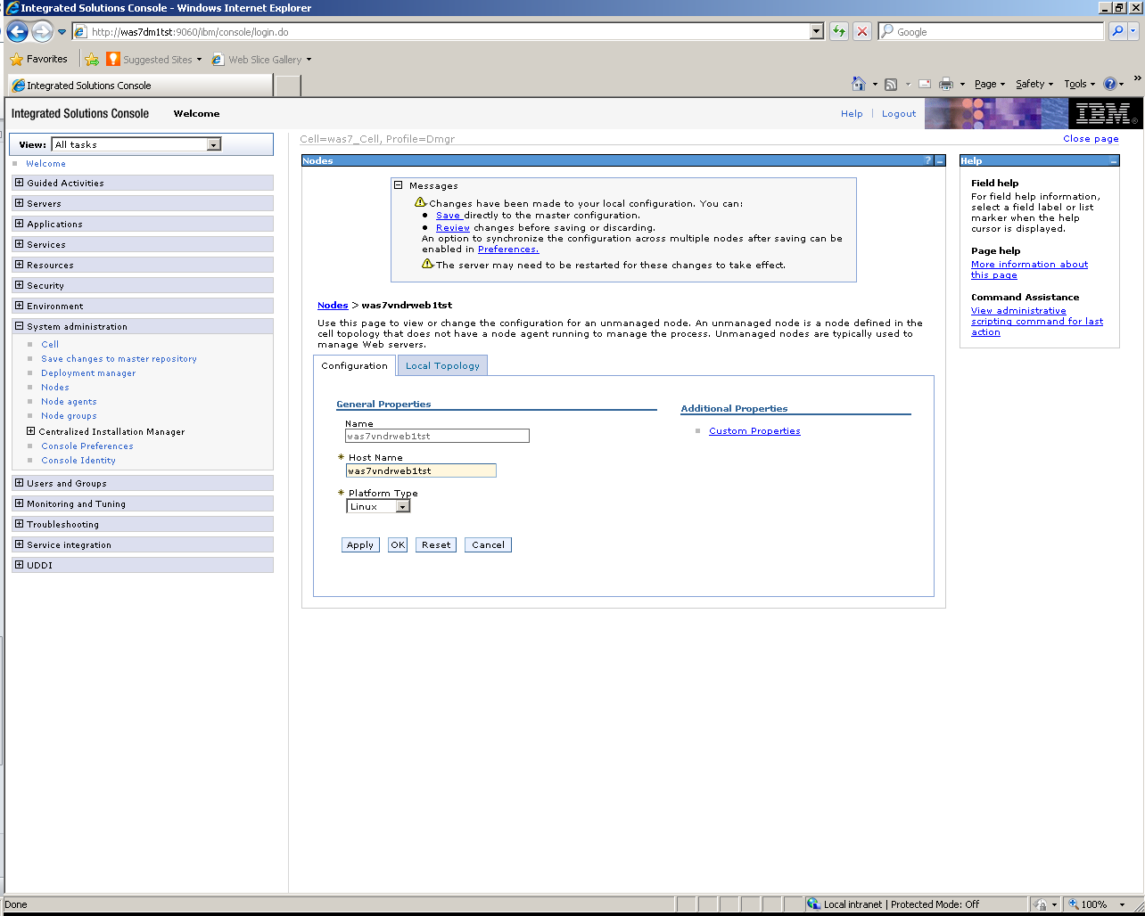

Check Synchronize changes with Nodes then save on next screen

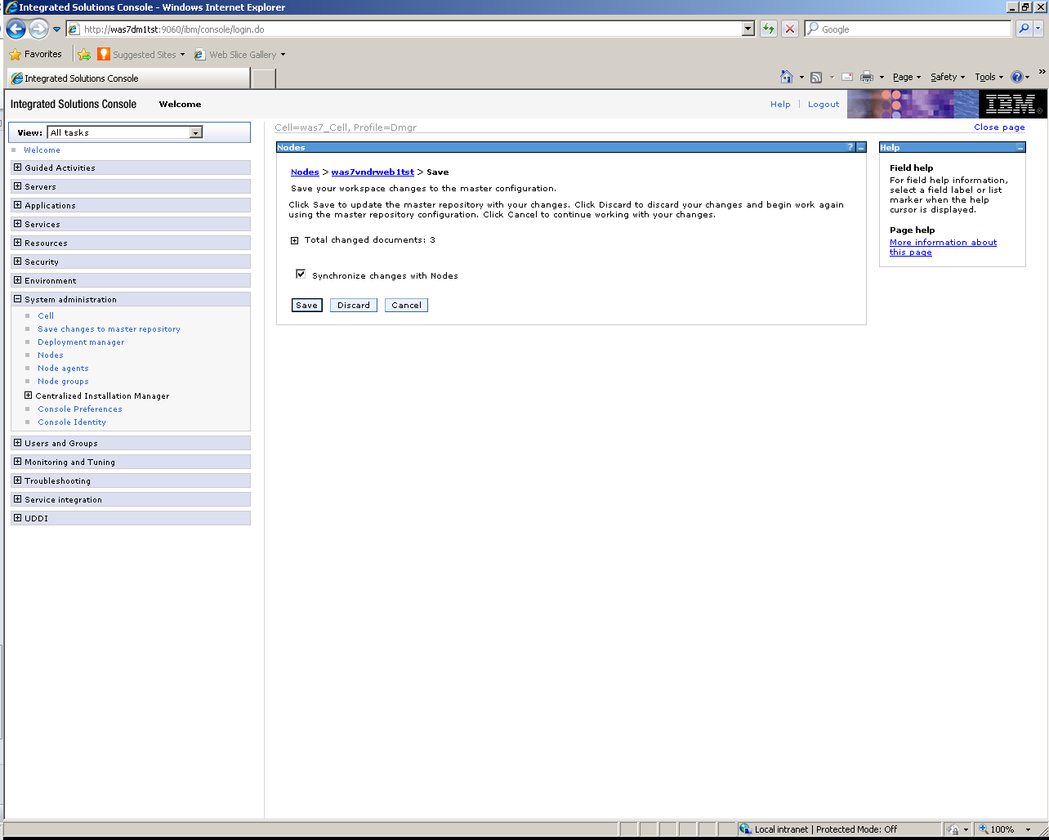

Then click ok

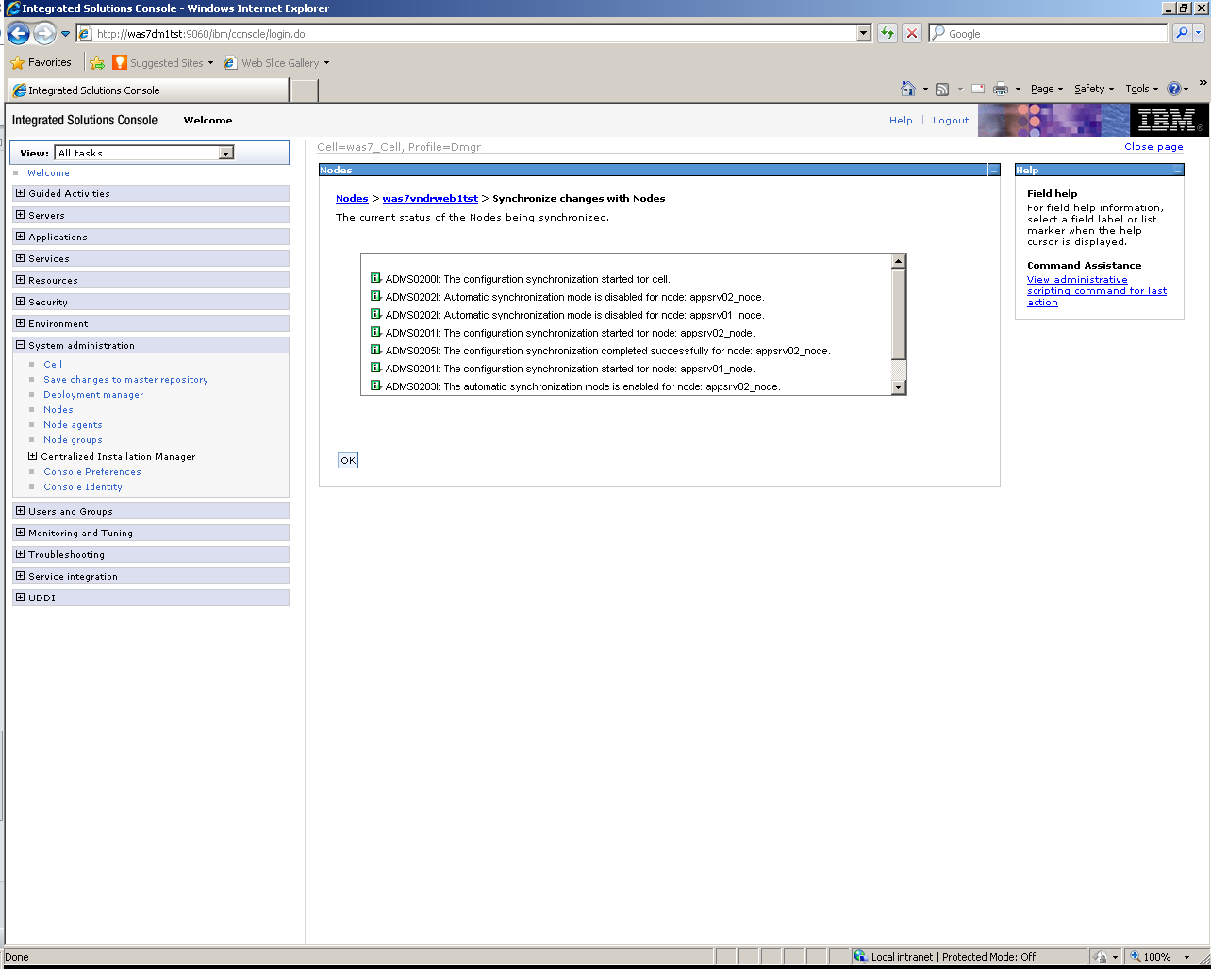

Now go to Server -> Server Types -> Web servers

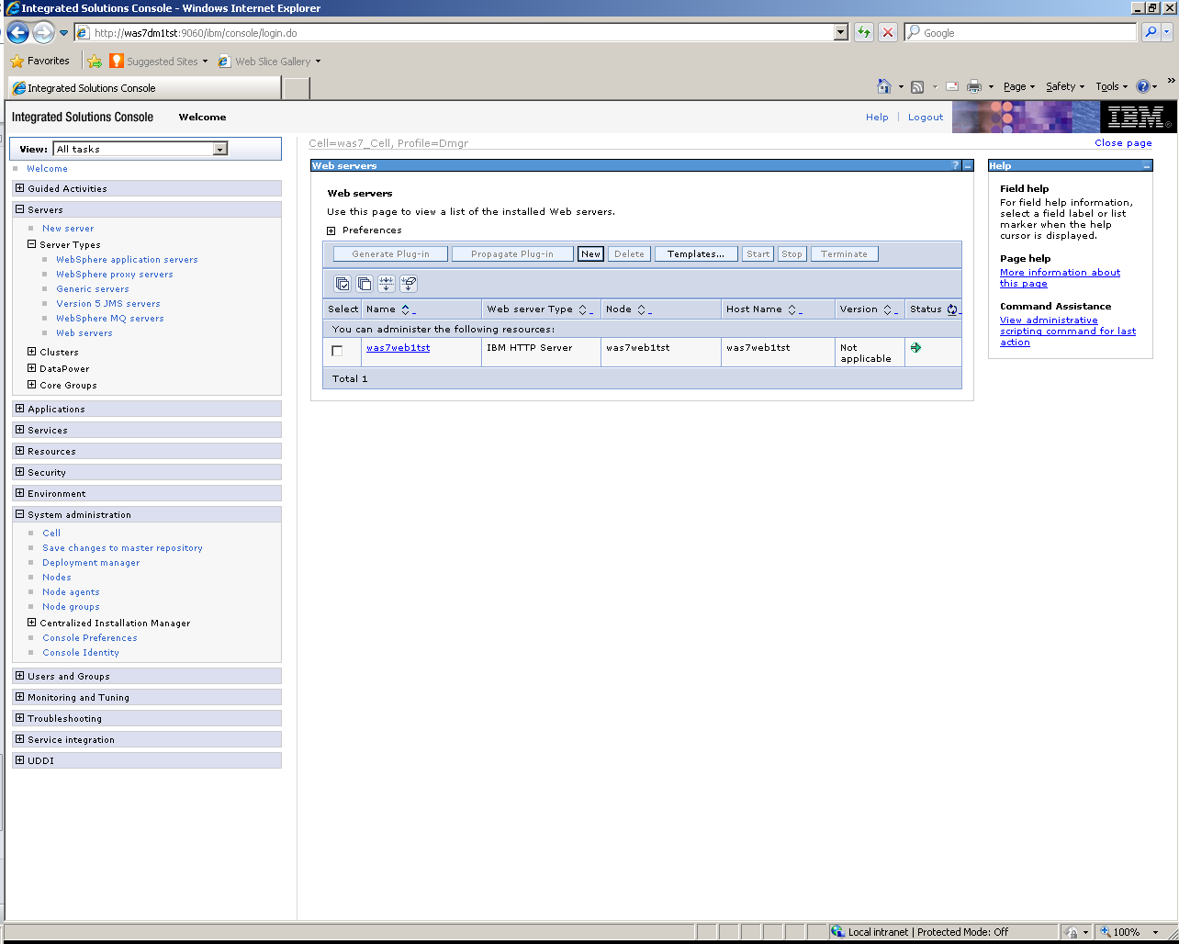

Click new select the appropriate node created for Server Name enter the alias for Ihs7 webserver you are adding and for Type IBM HTTP Server then click next

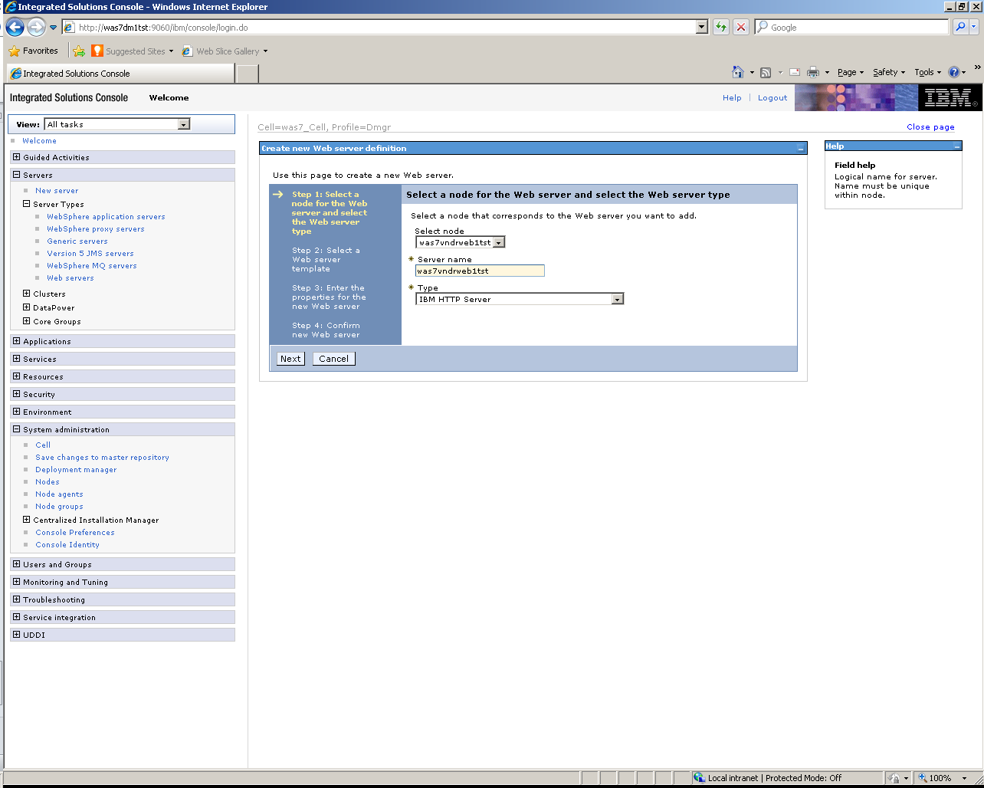

On next screen enter as follows then click next

Port=80

Web server installation location = /opt/websphere/ibmihs7

Plug-in installation location = /opt/websphere/ibmihs7/Plugins

Application mapping to the Web server keep as default all

Administration Server Port = 8008

Username = wsadm

Password = in keypass

Confirm password = same as above in keypass

leave Use SSL unchecked

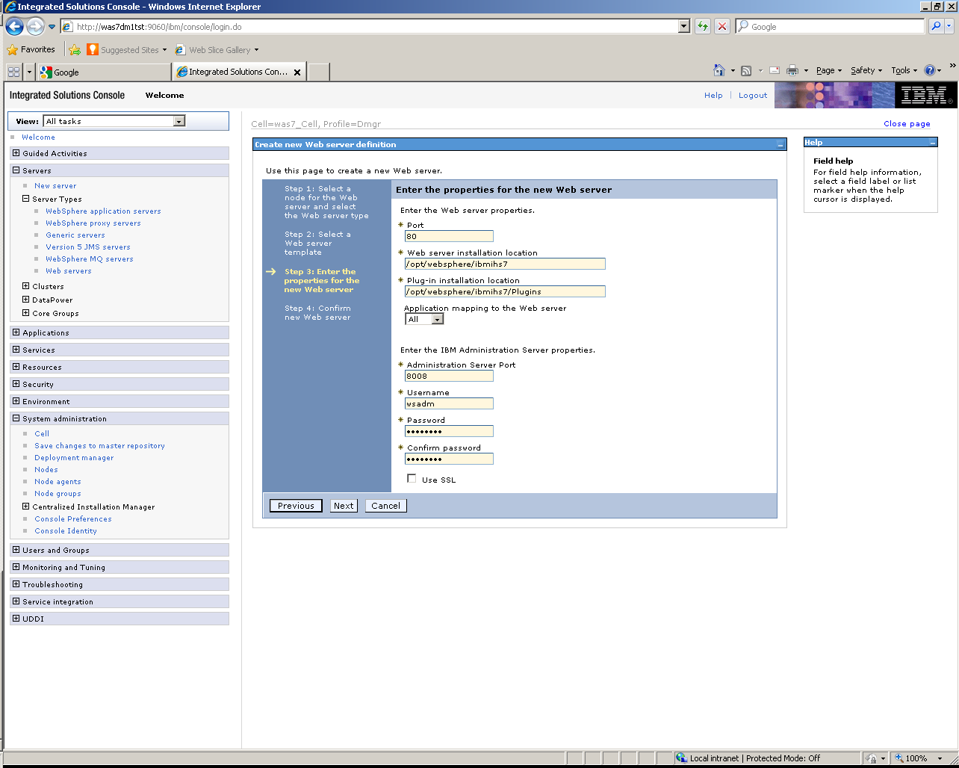

Click Finish

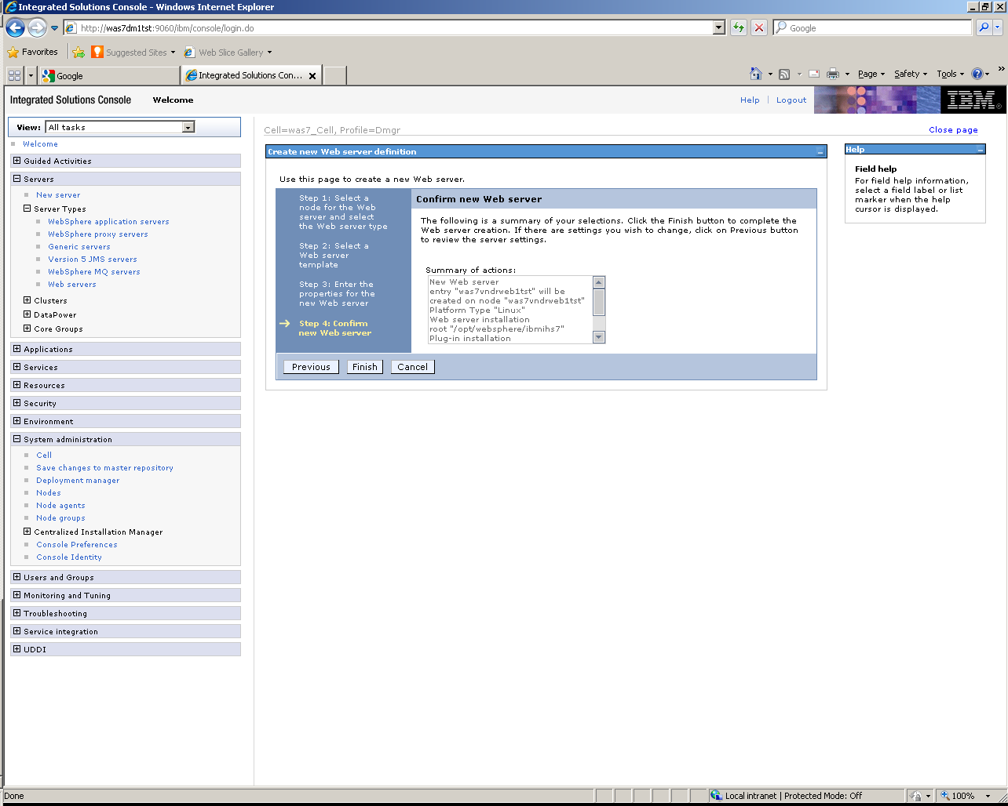

Then click review

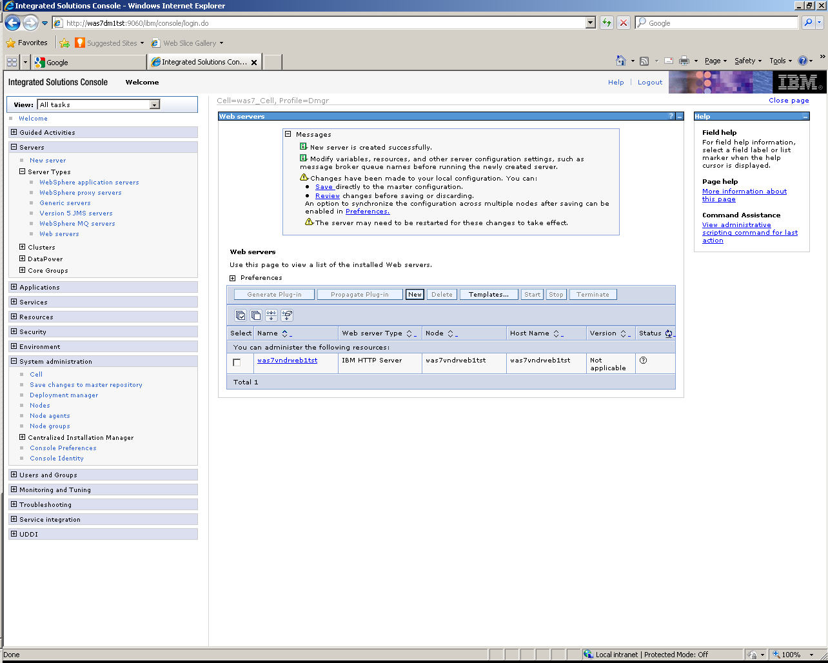

Select Synchronize Change with Nodes then click save

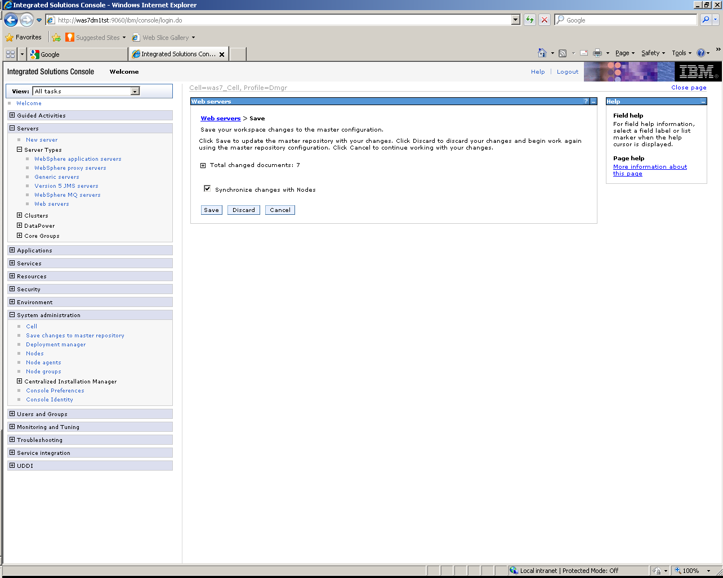

When done click ok

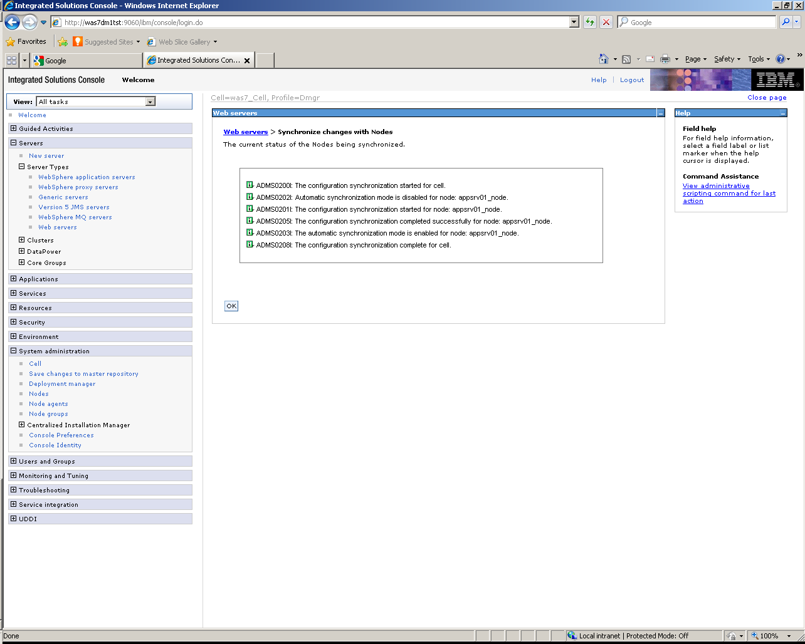

You should see the server now

