B. SIVA KRISHNA
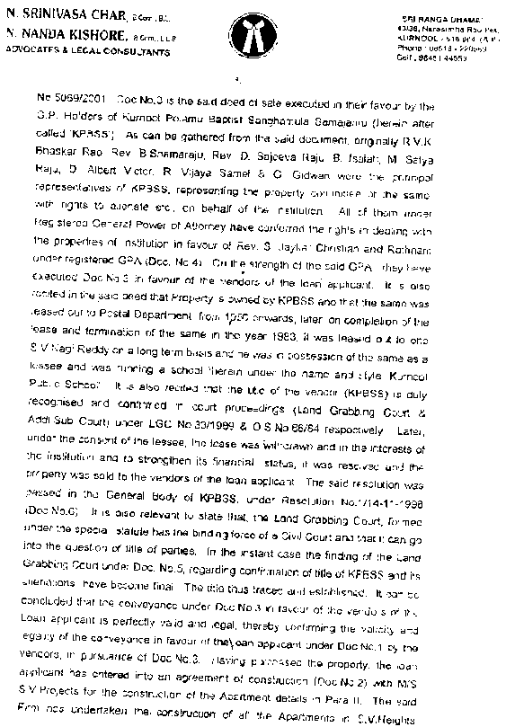
ADVOCATE
Shop N o. 220, 2nd Floor
C/o. Jagadeesh Mall
Birla Compound, Kurnool
Cell No. 8008086291
Email I.D. sivakrishnallb@gmail.com
Kurnool
Date :{{DATE}}
To
The Branch Manager
{{BRANCH_NAME}},
{{BRANCH_AREA}} Branch, {{BRANCH_AREA}}.

LEGAL SCRUTINY REPORT

Name of the Applicant  Application No | {{APPLICANT_BOLD_CAPS}}  {{APPLICATION_NO}}
DESCRIPTION OF THE PROPERTY:
The part and parcel of the House, bearing door No.{{DOOR_NO}} and Plot no.{{PLOT_NO}}, Assessment No. {{ASSESSMENT_NO}} measuring {{EXTENT_YARDS}} Square Yards in Survey number {{SURVEY_NO}} located in {{ADDRESS}}, {{VILLAGE}} village, {{GRAM_PANCHAYAT}} Gramapanchayat, and {{MANDAL}} Mandal within {{SRO}} Sub-Registration District and {{RO}} Registration District and {{DISTRICT}} District and bounded as follows :
East : {{EAST_BOUNDARY}}
West : {{WEST_BOUNDARY}}
North : {{NORTH_BOUNDARY}}
South : {{SOUTH_BOUNDARY}}

Within these boundaries site measuring
East – West : {{E_W}} Feet; North – South : {{N_S}} Feet
Admeasuring {{EXTENT_YARDS}} Square Yards
Within these boundaries Construction measuring
East – West : {{E_W_FEET}} Feet; North – South : {{N_S_FEET}} Feet
Admeasuring {{EXTENT_FEET}} Square Feets
DOCUMENTS VERIFIED:
{% for doc in DOCUMENTS %}
{{loop.index}}. Xerox Copy of Registered {{doc.type}} Deed bearing No. {{doc.number}} dated {{doc.date}} executed by {{doc.executant}} in favour of {{doc.owner}}
{% endfor %}
{% set n = DOCUMENTS|length %}
{{n+1}}. Xerox Copy of House Tax Dated {{HOUSE_TAX_DATE}} issued for the House bearing Door No. {{DOOR_NO}}, Assessment No. {{ASSESSMENT_NO}}, Receipt No {{HOUSE_TAX_RECIPT_NO}} paid for the financial year {{FINANCIAL_YEARS}} which stands in the name of {{HOUSE_TAX_NAME}} got issued by {{GRAM_PANCHAYAT}} Gram Panchayathi, {{MANDAL}} Mandal
{% if HAS_ELECTRICITY_BILL %}
{{n+2}}. Electricity bill Dated {{ELECTRICITY_BILL_DATE}} Service No {{SERVICE_NO}} Issued In the name of {{ELECTRICITY_NAME}} By APSPDCL
{% set m = n + 2 %}
{% else %}
{% set m = n + 1 %}
{% endif %}
{{m+1}}. Online Statement of Encumbrance Certificate dated {{EC_DATE}} vide Statement No. {{EC_NO}} of {{SRO}} S.R.O.
FLOW OF TITLE:
As verified from the Submitted documents the flow of title is:
Originally, the schedule property is the ancestral property of {{DOCUMENTS[0].executant}} who got inherited the same from ancestors and was in possession and enjoyment of the same.
{% for doc in DOCUMENTS %}
{% if doc.type == "Gift" %}
Subsequently, {{doc.executant}} voluntarily and out of love and affection on His/Her {{doc.relation}} /applicant {{doc.owner}} and in order to give some property for His/Her livelihood gave schedule property as Gift without any consideration by executing a Registered Gift Deed bearing No. {{doc.number}} dated {{doc.date}} which is worth of Rs. {{doc.worth}}/- by transferring absolute title over the said property and on acceptance of Gift Deed by {{doc.owner}} the possession and enjoyment of the schedule property was delivered to him/her on the same day itself.
{% endif %}

{% if doc.type == "Sale" %}
Subsequently, {{doc.executant}} in turn to meet His/her family necessities got sold the schedule property to {{doc.owner}} by executing a Registered Sale Deed bearing No. {{doc.number}} dated {{doc.date}} for sale consideration of Rs. {{doc.worth}}/- by transferring absolute rights over the schedule property and delivered the possession and enjoyment of the same to {{doc.owner}} on the same day itself.
{% endif %}
{% endfor %}
House Tax Dated {{HOUSE_TAX_DATE}} issued for the House bearing Door No. {{DOOR_NO}}, Assessment No. {{ASSESSMENT_NO}}, Receipt No {{HOUSE_TAX_RECIPT_NO}}, for the financial year {{FINANCIAL_YEARS}} which stands in the name of {{HOUSE_TAX_NAME}} got issued by {{GRAM_PANCHAYAT}} Gram Panchayathi, {{MANDAL}} Mandal, reflects His/Her present/Previous possession over the schedule property.
{% if HAS_ELECTRICITY_BILL %} Electricity bill Dated {{ELECTRICITY_BILL_DATE}} Service No {{SERVICE_NO}} Issued In the name of {{ELECTRICITY_NAME}} By APSPDCL, reflects possession of {{ELECTRICITY_NAME}} over the schedule property
{% endif %}
Thus, the flow of title for the Schedule Mentioned Property in the name of applicant {{APPLICANT_BOLD_CAPS}} is clear.
ENCUMBERANCE:
The Online Statement of Encumbrance Certificate dated {{EC_DATE}} vide Statement No. {{EC_NO}} of {{SRO}} S.R.O., reflects the transactions of schedule mentioned property {% if not HAS_MORTGAGE %}and it is free from encumbrances.{% endif %}
{% if HAS_MORTGAGE %} The property is mortgaged vide Deed No. {{ MORTGAGE_DEED_NO }} dated {{ MORTGAGE_DEED_DATE }} by disposition of title deeds in favour of {{ MORTGAGE_COMPANY }}.{% endif %}

OPINION :
Therefore, in view of the above discussion, I am of the opinion that the applicant {{APPLICANT_BOLD_CAPS}} is having clear, valid and marketable title over the Schedule property {% if HAS_MORTGAGE %}and Subject to mortgage.{% endif %}.
DOCUMENTS TO BE DEPOSITED FOR EXECUTING EQUITABLE MORTGAGE (In Originals)
{% for doc in DOCUMENTS %}
{{loop.index}}. Registered {{doc.type}} Deed bearing No. {{doc.number}} dated {{doc.date}} executed by {{doc.executant}} in favour of {{doc.owner}}
{% endfor %}
{% set n = DOCUMENTS|length %}
{{n+1}}. House Tax Dated {{HOUSE_TAX_DATE}} issued for the House bearing Door No. {{DOOR_NO}}, Assessment No. {{ASSESSMENT_NO}}, Receipt No {{HOUSE_TAX_RECIPT_NO}}, for the financial year {{FINANCIAL_YEARS}} which stands in the name of {{HOUSE_TAX_NAME}} got issued by {{GRAM_PANCHAYAT}} Gram Panchayathi, {{MANDAL}} Mandal
{% if HAS_ELECTRICITY_BILL %}
{{n+2}}.Electricity bill Dated {{ELECTRICITY_BILL_DATE}} Service No {{SERVICE_NO}} Issued In the name of {{ELECTRICITY_NAME}} By APSPDCL
{% set m = n + 2 %}
{% else %}
{% set m = n + 1 %}
{% endif %}
{{m+1}}. Online Statement of Encumbrance Certificate dated {{EC_DATE}} vide Statement No. {{EC_NO}} of {{SRO}} S.R.O.

The below points verified and noted here under:
1. Survey No. and Extent : As per the document the property is an
extent of {{EXTENT_YARDS}} Square Yards in Survey number {{SURVEY_NO}} located at {{VILLAGE}} Village Lands
2. Existing Loan to be discharged : NO
3. Partition Deed – Certified Copy : NO
4. Encumbrance Certificate : YES
5. Possession from : Applicant is in possession from {{TIME}}
6. House Tax/Electricity Bill
Receipt in favour of applicant : NO
7. Court Seal if any : NO
8. For M.O.D. Registered Doc.
To be obtained (original) : Registered Sale Deed
Doc. No: {{DEED_NO}} dated {{DEED_DATE}}

(B. SIVA KRISHNA)

