# **11ES**

# **HOME WORK # 5**

# **Nguyen Truong Trong Nhan**

# **Nguyen Duy Lanh**

# **Bui Viet Hung**

# **Le Huu Minh Hoang**

# 12/09/2014

# **1. CLEANING GLASS MACHINE: Level 0**

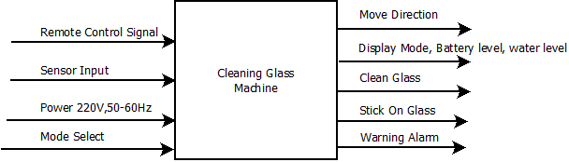

|  |  |
| --- | --- |
| Module | Cleaning Glass Machine |
| Inputs | Remote Control: 500 MHz radio signal, 500 meters in range.  Sensor Input: - Detect Edge Sensor: 2 level signal input (0 or 5V).  -Atmosphere sensor (to detect whether stick on glass or not) : analog input  -Power(to charge battery): 220V AC, 60-50 Hz  -Mode select: User variable (there are 3 mode to select) |
| Output | -Move direction: verify what ANGLE to rotate 2 legs(1800,900,2700)  -Display mode, battery level, water level: send data to LCD to display information  - Clean glass: when this signal is triggered, four cleaning fabrics will turning (its frequent is 2-5 Hz, depend on its mode)  - Stick On Glass: this signal to control 2 legs. When signal is 1, leg sticks on glass, otherwise, the leg releases the glass. (This signal can trigger LCD to display READY in initially work.)  - Warning Alarm: when battery or water level is LOW, it triggers this signal. (Optional function: detect wind strength – if wind speed> 25m/s-> trigger alarm) |
| Functionality | * Detect Edge function help machine change the way. * Battery is rechargeable. * Remote control or automatic operate. * Move with two legs make the machine become more flexible. * GUI interfaces by LCD(touchscreen). |

# **2. CLEANING GLASS MACHINE: Level 1**

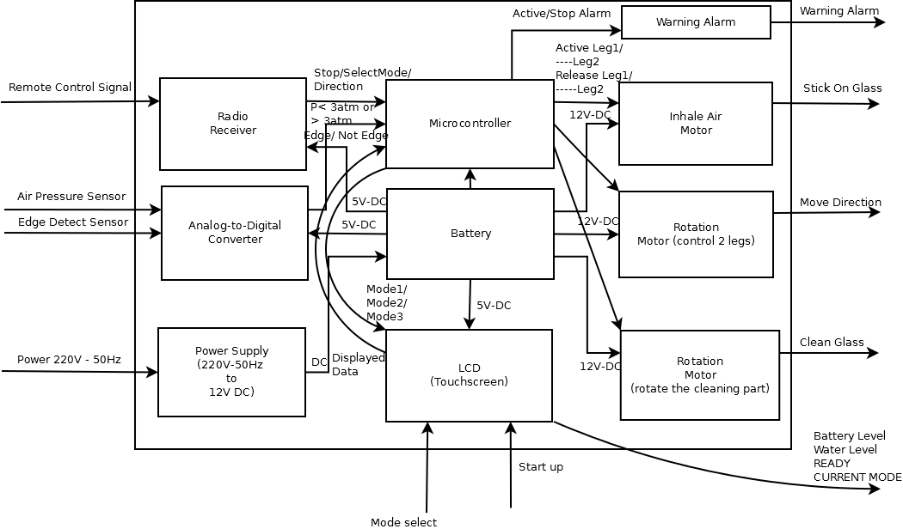

# **3. POWER SUPPLY: Level 1**

# 

|  |  |
| --- | --- |
| Module | Power Supply |
| Inputs | Power: 220V rms - 50Hz |
| Output | Power: +/- 12V DC with up to 2.5A of current with regulation of <1% |
| Functionality | Convert AC all outlet voltage to positive and negative DC output voltages, and provide enough current to drive all machine. |

# **4. RADIO RECEIVER: Level 1**

# 

|  |  |
| --- | --- |
| Module | Radio receiver |
| Input | Remote Control Signal: its 500 MHz radio waves.  This wave is encrypted by senders- remote controller. |
| Output | Stop: Make the machine stop working immediately. (without shutdown system). Press again to work(clean) again. (digital signal)  Selectmode: to select High Performance Mode, Standard Mode or Cleaning Floor Mode (can not switch to this mode, when machine sticks on glass).(digital signal)  Direction: make machine move to Right/Left/Up/Down from the current Position (digital signal). |
| Functionality | Filter and converter radio waves to digital signal. Send digital signal to Microcontroller |

# **5. MICROCONTROLLER: Level 1**

# 

|  |  |
| --- | --- |
| Module | Microcontroller |
| Input | -Water in tank/Battery level: there are 10 levels of water and battery. Completely FULL is level 10, LOW is < level 2(20% of total capacity).  -Stop/ModeSelect/Direction is digital signal.  - Pressure: the pressure at Leg1 and Leg2. If pressure >= 3 atm, pressure is “1”.  - Edge or not Edge: Detect edge of what direction. |
| Output | -Ready: If 2 Legs have enough pressure (>3atm), Ready is “1”.  -Active Alarm: If BatteryLevel and Water in Tank level below level 2, ActiveAlarm is “1”.  -Active Leg: Make pressure at this leg increase to 3atm, otherwise, reduce pressure to 1atm.  -RotationControl: rotate the Machine, when 1 leg is fixed (Pressure>3atm), another leg is released (Pressure~~1atm). Can rotate with 900,1800 and 2700 angle.  - Cleaning: If Cleaning = “1”, 4 cleaning parts will rotate.  - DisplayData: Microcontroller send new displayed data every second to LCD. |
| Functionality | - Microcontroller can work properly at low clock speed(1kHz). Reduce clock speed at Standard mode.  - Handling digital signal input, and output digital signal to other parts(motors, warning alarm). |

# **6. LCD TOUCHSCREEN: Level 1**

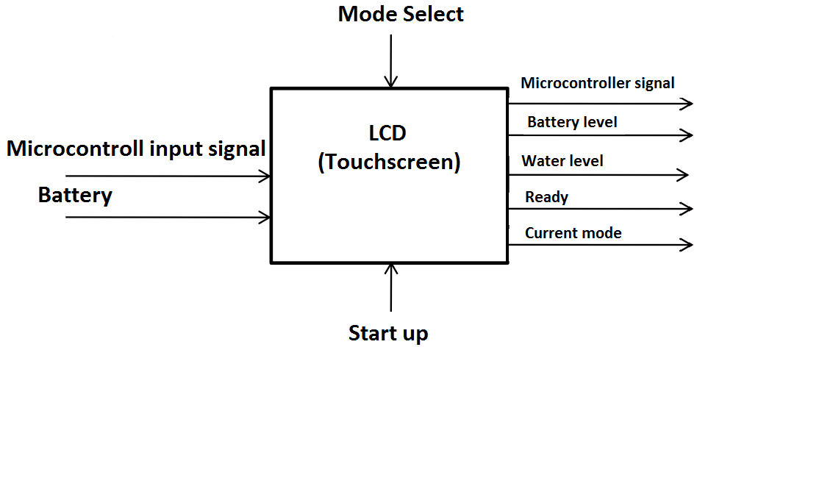

|  |  |
| --- | --- |
| Module | Touchscreen |
| Inputs | Microcontroller input signal : Battery level, water level, current mode and ready signals. (digital input)  Battery :5v DC.  -Mode Select  -Start up |
| Outputs | -Microcontroller signal (digital output)  -Battery level, Water level, Ready, Current mode (output is displayed on screen) |
| Functionality | Display the status of machine on the LCD. Send the mode select and turn on/off that the user chooses. |

# **7. WARNING ARLAM: Level 1**

# 

|  |  |
| --- | --- |
| Module | -Warning alarm |
| Input | -Alarm Signal: variable (digital input) -Power : 12V-DC |
| Output | -Warning Alarm: Alarm the user (analog signal is to Speaker) |
| Functionality | - Alarm the user when the machine done or have a problem.  - Receive digital output, then create analog signal to active speaker. |

**8. BATERY**

# Battery: Level 1

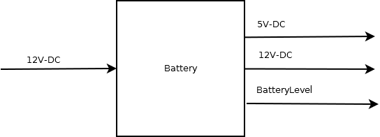

|  |  |
| --- | --- |
| Module | Battery |
| Input | Power supply (12V DC) |
| Output | - 5V-DC  -12V-DC |
| Functionality | -Provide the power to every part of device.  -Can be rechargeable .  - Store Enough Energy to work at least 5 hours. |

# **9. INHALE AIR MOTOR: Level 1**

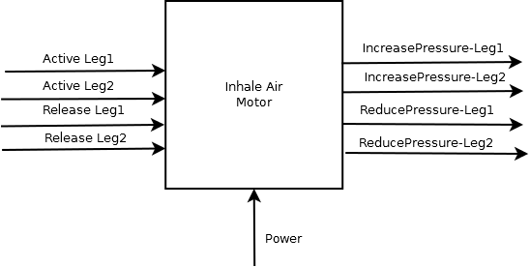

|  |  |
| --- | --- |
| Module | Inhale Air Motor |
| Input | ActiveLeg1 or 2 , ReleaseLeg1 or 2: digital input  Power: 12V- DC |
| Output | IncreasePressure: when ActivelecLeg1(2) is “1”, increase pressure at this leg into 3 atm.  ReducePressure: when ReleaseLeg1(2) is “1”, decrease pressure at this leg into 1 atm. |
| Functionality | - Inhale Air through legs, make these legs can strongly stick on glass.  - Easily to release each leg out of glass. |

# **10. ROTATION MOTOR (control 2 legs): Level 1**

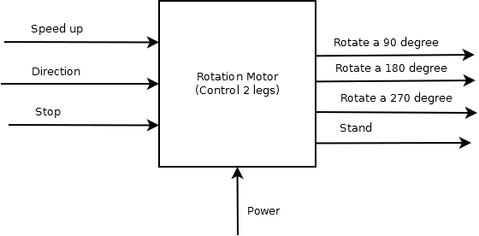

|  |  |
| --- | --- |
| Module | Rotation Motor (Control 2 legs) |
| Input | -Speedup, Direction, Stop are digital input.  -Power 12V-DC with 2-3 A. |
| Output | - Handling input, then rotate a 90, 180 or 270 degrees or stand. |
| Functionality | - Can speed up or slow down rotation speed.  - Can handle digital signal, then output the right action. |

# **11.** **ROTATION MOTOR (rotate the cleaning parts):**

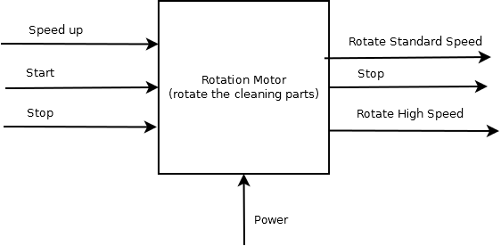

|  |  |
| --- | --- |
| Module | Rotation Motor( rotate the cleaning parts) |
| Input | -Speed up/ Start/Stop : Change the rotation speed/Start to rotate the cleaning part/ Stop working (digital input).  -Power: 12V-DC |
| Output | - Rotate Standard Speed: rotate the cleaning part at 3Hz frequent.  -Rotate High Speed: rotate the cleaning part at 6-10Hz frequent.  - Stop: stop working immediately. |
| Functionality | - Handling digital input, then output the suitable action.  -Speed up or slowdown rotation speed. |

# **12. ANALOG-TO-DIGITAL CONVERTER: Level 1**

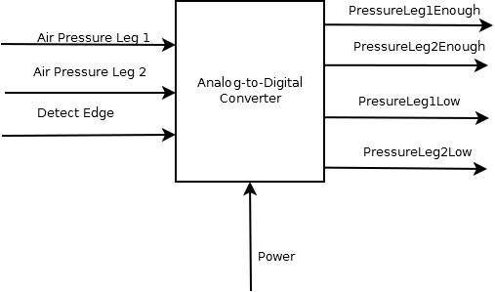

|  |  |
| --- | --- |
| Module | Analog-to-digital Converter |
| Input | -Air Pressure Leg 1/ Air Pressure Leg 1/Detect Edge: how many atm at leg 1/ --- at leg 2 / Edge or not Edge  -Power: 5V-DC |
| Output | -Pressure Leg 1 Enough/ Pressure Leg 2 Enough: if pressure at these leg > =3 atm, these signal are “1”.  -Pressure Leg 1 Low/ Pressure Leg 2 Low: if pressure at these leg =<1 atm, these signal are “1”. |
| Functionality | - Convert the analog signal into digital signal. |

# **13. INHALE AIR MOTOR: Level 2**

