Index.html

<!DOCTYPE html>
<html lang="en">

<head>
<meta charset="UTF-8">
<meta name="viewport" content="width=device-width, initial-scale=1.0">
<title>My Portfolio</title>

<!-- Google Fonts -->
<link rel="preconnect" href="https://fonts.googleapis.com">
<link rel="preconnect" href="https://fonts.gstatic.com" crossorigin>
<link href="https://fonts.googleapis.com/css2?family=Open+Sans:ital,wght@0,300..800;1,300..800&family=Roboto:ital,wght@0,100;0,300;0,400;0,500;0,700;0,900;1,100;1,300;1,400;1,500;1,700;1,900&display=swap" rel="stylesheet">

<!-- Font for icons -->
<link rel="stylesheet" href="https://cdnjs.cloudflare.com/ajax/libs/font-awesome/4.7.0/css/font-awesome.min.css">

<!-- Custom CSS stylesheets -->
<link rel="stylesheet" href="style.css">
<link rel="stylesheet" href="media.css">
</head>

<body>

<header>
<!-- Desktop navigation bar -->
<nav id="desktop-nav">
<div class="logo-container">
Dulain Perera
</div>
<div>
<ul class="nav-links">
<li><a href="index.html">Home</a></li>
<li><a href="about.html">About</a></li>
<li><a href="work.html">My Work</a></li>
<li><a href="contact.html">Contact</a></li>
</ul>
</div>
</nav>
</header>

<!-- Mobile navigation bar -->
<nav id="mobile-nav">
<div class="logo-container">Dulain Perera</div>

<!-- Menu button for mobile -->
<div class="mobile-menu" onclick="toggleMenu()">
<img src="Media/arrow-down.png" alt="Menu" class="mobile-icon">
<ul class="menu-links">
<li><a href="index.html" onclick="toggleMenu()">Home</a></li>
<li><a href="about.html" onclick="toggleMenu()">About</a></li>
<li><a href="work.html" onclick="toggleMenu()">My work</a></li>
<li><a href="contact.html" onclick="toggleMenu()">Contact</a></li>
</ul>
</div>
</nav>

<main>
<div class="profile">
<div class="section__pic-container">
<!-- Profile picture -->
<img src="./Media/profile-pic.jpg" alt="Dulain Perera profile picture" class="profile-pic">
</div>

<div class="section__text">
<p class="section_text_p1">Hello, I'm</p>
<h1 class="title">Dulain Perera</h1>
<p>Hello, and welcome to my portfolio! I’m a 2nd year computer science undergraduate with a strong foundation in Python, Java, and HTML and currently exploring other frameworks like Laravel and Spring Boot. My journey in tech has been shaped by a commitment to learning and a passion for building functional, engaging websites and applications.</p>

<div class="socials">
<!-- Contact button and social media links -->
<a href="contact.html" class="contact-button">Contact Me</a>
<a href="https://github.com/userinterface17" class="fa fa-github" target="_blank"></a>
<a href="https://www.linkedin.com/in/dulain-perera-091778292" class="fa fa-linkedin" target="_blank"></a>
</div>

</div>
</div>
</main>

<footer>
<div class="footer-content">
<!-- Footer content with copyright and contact info -->
<p>&copy; 2024 Dulain Perera - All rights reserved.</p>
<p class="footer-contact">Contact: <a href="mailto:dulainp337@gmail.com">dulainp337@gmail.com</a></p>
</div>
</footer>

<!-- JavaScript file-->
<script src="script.js"></script>
</body>

</html>

About.html

<!DOCTYPE html>
<html lang="en">

<head>
<meta charset="UTF-8">
<meta name="viewport" content="width=device-width, initial-scale=1.0">
<title>My Portfolio</title>

<!-- connect to Google Fonts -->
<link rel="preconnect" href="https://fonts.googleapis.com">
<link rel="preconnect" href="https://fonts.gstatic.com" crossorigin>

<!-- Link to Google Fonts -->
<link href="https://fonts.googleapis.com/css2?family=Open+Sans:ital,wght@0,300..800;1,300..800&family=Roboto:ital,wght@0,100;0,300;0,400;0,500;0,700;0,900;1,100;1,300;1,400;1,500;1,700;1,900&display=swap" rel="stylesheet">

<!-- Link to external CSS stylesheets -->
<link rel="stylesheet" href="style.css">
<link rel="stylesheet" href="media.css">

</head>

<body>

<!-- Header section with navigation -->
<header>
<nav id="desktop-nav">
<div class="logo-container">
<!-- Logo or Name -->
Dulain Perera
</div>

<div>
<!-- Navigation links -->
<ul class="nav-links">
<li><a href="index.html">Home</a></li>
<li><a href="about.html">About</a></li>
<li><a href="work.html">My Work</a></li>
<li><a href="contact.html">Contact</a></li>
</ul>
</div>
</nav>
</header>

<!-- Mobile navigation -->
<nav id="mobile-nav">
<div class="logo-container">Dulain Perera</div>

<div class="mobile-menu" onclick="toggleMenu()">
<!-- Mobile menu icon -->
<img src="Media/arrow-down.png" alt="Menu" class="mobile-icon">

<div class="menu-links">
<!-- Mobile navigation links -->
<li><a href="index.html" onclick="toggleMenu()">Home</a></li>
<li><a href="about.html" onclick="toggleMenu()">About</a></li>
<li><a href="work.html" onclick="toggleMenu()">My work</a></li>
<li><a href="contact.html" onclick="toggleMenu()">Contact</a></li>
</div>
</div>
</nav>

<!-- Main content area -->
<main>
<div class="about">
<h1 class="title">About Me</h1>

<h1>Education</h1>

<div class="education-grid">
<!-- Education cards -->
<div class="education-card">
<h2>Informatics Institute of Technology</h2>
<h4>BSc. Computer Science</h4>
<p>Undergraduate</p>
</div>

<div class="education-card">
<h2>Maliyadeva College</h2>
<p>GCE A/L & O/L</p>
</div>
</div>

<h1>Languages</h1>

<div class="languages-container">

<!-- Language proficiency list-->
<div class="language">
<h3>HTML</h3>
<p>Experienced</p>
</div>

<div class="language">
<h3>CSS</h3>
<p>Experienced</p>
</div>

<div class="language">
<h3>Python</h3>
<p>Experienced</p>
</div>

<div class="language">
<h3>Java</h3>
<p>Experienced</p>
</div>

<div class="language">
<h3>JavaScript</h3>
<p>Basic</p>
</div>

<div class="language">
<h3>Laravel</h3>
<p>Beginner</p>
</div>
</div>
</div>
</main>

<!-- Footer section -->
<footer>
<div class="footer-content">
<p>&copy; 2024 Dulain Perera - All rights reserved.</p>
<p class="footer-contact">Contact: <a href="mailto:dulainp337@gmail.com">dulainp337@gmail.com</a></p>
</div>
</footer>

<!-- Link to external JavaScript file -->
<script src="script.js"></script>
</body>

</html>

Work.html
<!DOCTYPE html>
<html lang="en">

<head>
<meta charset="UTF-8">
<meta name="viewport" content="width=device-width, initial-scale=1.0">
<title>My Portfolio</title>

<!-- Preconnect to Google Fonts for faster loading -->
<link rel="preconnect" href="https://fonts.googleapis.com">
<link rel="preconnect" href="https://fonts.gstatic.com" crossorigin>
<!-- Google Fonts stylesheet -->
<link href="https://fonts.googleapis.com/css2?family=Open+Sans:ital,wght@0,300..800;1,300..800&family=Roboto:ital,wght@0,100;0,300;0,400;0,500;0,700;0,900;1,100;1,300;1,400;1,500;1,700;1,900&display=swap" rel="stylesheet">

<!-- Link to external stylesheets -->
<link rel="stylesheet" href="style.css">
<link rel="stylesheet" href="media.css">
</head>

<body>

<header>
<nav id="desktop-nav">
<div class="logo-container">
Dulain Perera <!-- Logo or name -->
</div>
<div>
<ul class="nav-links"> <!-- Navigation links -->
<li><a href="index.html">Home</a></li>
<li><a href="about.html">About</a></li>
<li><a href="work.html">My Work</a></li>
<li><a href="contact.html">Contact</a></li>
</ul>
</div>
</nav>
</header>

<nav id="mobile-nav"> <!-- Mobile navigation -->
<div class="logo-container">Dulain Perera</div>

<div class="mobile-menu" onclick="toggleMenu()"> <!-- Menu toggle function -->
<img src="Media/arrow-down.png" alt="Menu" class="mobile-icon">
<ul class="menu-links"> <!-- Mobile menu links -->
<li><a href="index.html" onclick="toggleMenu()">Home</a></li>
<li><a href="about.html" onclick="toggleMenu()">About</a></li>
<li><a href="work.html" onclick="toggleMenu()">My Work</a></li>
<li><a href="contact.html" onclick="toggleMenu()">Contact</a></li>
</ul>
</div>
</nav>

<main>
<div>
<h1 class="section-title">My Work</h1> <!-- Section title for projects -->

<div class="project-grid"> <!-- Grid layout for projects -->

<!-- Project cards with details -->
<a href="#" class="project-card" target="_blank">
<div>
<h3>Student Mark Calculator</h3>
<p>A Python-based program that automates the calculation of student marks, including grade breakdowns and overall performance insights.</p>
</div>
</a>

<a href="#" class="project-card" target="_blank">
<div>
<h3>Plane Ticket Manager</h3>
<p>A Java application developed as coursework, designed to manage plane tickets, track passenger details, and streamline booking processes.</p>
</div>
</a>

<a href="#" class="project-card" target="_blank">
<div>
<h3>User Authentication System</h3>
<p>A Laravel-powered website with a secure user authentication system, including features for registration, login, and password management.</p>
</div>
</a>

<a href="#" class="project-card" target="_blank">
<div>
<h3>FRED Online Store</h3>
<p>An e-commerce prototype built for web development coursework, featuring product listings, shopping cart functionality, and responsive design with HTML, CSS, and JavaScript.</p>
</div>
</a>

</div>
</div>
</main>

<footer>
<div class="footer-content">
<p>&copy; 2024 Dulain Perera - All rights reserved.</p> <!-- Footer-->
<p class="footer-contact">Contact: <a href="mailto:dulainp337@gmail.com">dulainp337@gmail.com</a></p> <!-- Footer contact information -->
</div>
</footer>

<script src="script.js"></script> <!-- External JavaScript file -->
</body>

</html>

contact.html
<!DOCTYPE html>
<html lang="en">

<head>
<meta charset="UTF-8">
<meta name="viewport" content="width=device-width, initial-scale=1.0">
<title>My Portfolio</title>

<!-- Google Fonts -->
<link rel="preconnect" href="https://fonts.googleapis.com">
<link rel="preconnect" href="https://fonts.gstatic.com" crossorigin>

<!-- Google Fonts stylesheet -->
<link href="https://fonts.googleapis.com/css2?family=Open+Sans:ital,wght@0,300..800;1,300..800&family=Roboto:ital,wght@0,100;0,300;0,400;0,500;0,700;0,900;1,100;1,300;1,400;1,500;1,700;1,900&display=swap" rel="stylesheet">

<!-- Link to external stylesheets -->
<link rel="stylesheet" href="style.css">
<link rel="stylesheet" href="media.css">
</head>

<body>

<header>
<nav id="desktop-nav"> <!-- Desktop navigation bar -->
<div class="logo-container">
Dulain Perera <!-- Logo-->
</div>

<div>
<ul class="nav-links"> <!-- Navigation links -->
<li><a href="index.html">Home</a></li>
<li><a href="about.html">About</a></li>
<li><a href="work.html">My Work</a></li>
<li><a href="contact.html">Contact</a></li>
</ul>
</div>
</nav>
</header>

<nav id="mobile-nav"> <!-- Mobile navigation -->
<div class="logo-container">Dulain Perera</div>

<div class="mobile-menu" onclick="toggleMenu()"> <!-- Menu toggle function -->
<img src="Media/arrow-down.png" alt="Menu" class="mobile-icon"> <!-- Menu icon -->

<ul class="menu-links"> <!-- Mobile menu links -->
<li><a href="index.html" onclick="toggleMenu()">Home</a></li>
<li><a href="about.html" onclick="toggleMenu()">About</a></li>
<li><a href="work.html" onclick="toggleMenu()">My Work</a></li>
<li><a href="contact.html" onclick="toggleMenu()">Contact</a></li>
</ul> <!-- Corrected closing tag from <ul> to </ul> -->
</div>
</nav>

<main>
<!-- Contact form for users to reach out -->
<form id="contact-form" action="https://api.web3forms.com/submit" method="post">

<input type="hidden" name="access_key" value="95df5f76-881f-4a4c-be7b-f04242ff9e46"> <!-- Hidden field for API key -->

<h1 class="section-title">Contact Me</h1> <!-- Section title -->

<label for="name">Name:</label>
<input type="name" id="name" name="name" required> <!-- Input field for name -->

<label for="email">Email:</label>
<input type="email" id="email" name="email" required> <!-- Input field for email -->

<label for="message">Message:</label>
<textarea id="message" name="message" rows="4" required></textarea> <!-- Text area for message -->

<div class="contact-button-container">
<button type="submit">Submit</button> <!-- Submit button -->
</div>
</form>
</main>

<footer>
<div class="footer-content">
<p>&copy; 2024 Dulain Perera - All rights reserved.</p> <!-- Footer copyright -->
<p class="footer-contact">Contact: <a href="mailto:dulainp337@gmail.com">dulainp337@gmail.com</a></p> <!-- Footer contact information -->
</div>
</footer>

<script src="script.js"></script> <!-- External JavaScript file -->
</body>

</html>

Style.css
/*COMMON STYLES*/

* {
box-sizing: border-box;
margin: 0;
padding: 0;
}

body{
font-family: "Open Sans", sans-serif;

}

p{
color:rgb(68, 68, 68);
}

nav{
justify-content: space-around;
align-items: center;
height: 16vh;
box-shadow: 0 2px 4px rgba(0, 0, 0, 0.1);
width:100%;
}

nav, .nav-links{

display:flex;
}

a{text-decoration: none;}

.logo-container{
font-size: 2em;
text-decoration: bold;
}

.nav-links{
font-size: 1.5rem;
gap:2rem;
list-style: none;

}

.nav-links a{
color: black;
text-decoration: none;
transition: all 300ms ease;
}

.nav-links a:hover{
color:grey;
text-decoration: underline;
text-underline-offset:15px;
}

/* mobile menu */

#mobile-nav{
display:none;
width:100%;
}

.mobile-menu{
position:relative;
display:inline-block;
}

.mobile-icon {
width:30px;
height:auto;
cursor:pointer;
transition: transform 0.3s ease-in-out;

}

.menu-links{
position:absolute;
top:100%;
right:0;
background-color:white;
width:200px;
max-height: 0;
overflow:hidden;
transition:all 0.3 ease-in-out;
}

.menu-links a {
display:block;
padding:10px;
text-align:center;
font: size 1.5rem;
color:black;
text-decoration: none;
transition: all 0.3 ease-in-out;

}

.menu-links li {
list-style:none;

}

.menu-links.open{
max-height:400px;
}

/*main*/
main{
display:flex;
flex-direction: column;
align-items: center;
justify-content: center;
margin:0 auto;
min-height: fit-content;
}

/* footer */

footer{
margin-top: 30px;
padding: 10px 20px;
text-align: center;
gap: 20px;
box-shadow: 0 -2px 4px rgba(0, 0, 0, 0.1);
width: 100%;
}

.footer-content p {
margin: 10px ;
}

.footer-contact a{
color: black;
}

/*pages styling */

header, footer {
position: relative;
z-index: 10;
background-color: white;
}

.section-container {
display:flex;
}

.profile{
display:flex;
align-items: center;
justify-content: center;
padding: 0 180px;
gap:5rem;
height:80vh;
}

.profile-pic{
width: 400px;
height: auto;
border-radius: 50%;
margin-right: 30px;

}

.profile-section-text{
text-align: center;
}

.section_text_p1{
font-size: 2rem;
text-align: center;

}

.title{
font-size: 3rem;
text-align: center;
margin-bottom: 1rem;
}

.section_text_p2{
font-size: 1.8rem;
text-align: center;

}

.socials{
flex-direction: row;
text-align: center;
margin-top: 30px;
gap:50px;

}

.contact-button {
transition: all 300ms ease;
padding: 1rem;
width: 8rem;
color: rgb(53, 53, 53);
background-color: white;
border: 2px solid rgb(53, 53, 53);
border-radius: 2rem;
cursor: pointer;
border-color:rgb(53, 53, 53);
}

.contact-button:hover{
background: rgb(53, 53, 53);
color: white;
}

.fa {
align-items: center;
display: inline-flex;
justify-content: center;
width: 50px; /* Set a specific width */
height: 50px;
font-size: 1.5rem;
border-radius: 50%;
text-align: center;
text-decoration: none;
margin: 5px 5px;
border: 2px solid;
cursor: pointer;
transition: all 300ms ease;
}

.fa-github{
background-color:white;
color:#46505a;
border-color: #46505a;
}

.fa-github:hover{
background-color:#46505a;
color: white;
}

.fa-linkedin {
background-color: white;
color: #007bb5;
border-color: #007bb5;
}

.fa-linkedin:hover {
background-color:#0077B5;
color: white;
}

/*about page*/
.about {
padding: 20px;
text-align: center;
gap:20px;
}

.education-grid {
display: grid;
align-items: center;
grid-template-columns: repeat(2, 1fr);
gap: 20px;
margin:20px;
}

.education-card{
grid-template-columns: repeat(2, 1fr);
min-height: 150px;
border: 1px solid #ccc;
border-radius: 1rem;
place-items: center;
text-align: center;
padding: 20px;
margin: 10px 0;
align-items: center;
}

.languages-container{
display: grid;
margin: 40px;
align-items: center;
padding: 1;
grid-template-columns: repeat(2, 1fr);
gap: 20px;
border: 1px solid #ccc;
border-radius: 1rem;
}

/*work page*/

.project-grid {
display: grid;
grid-template-columns: repeat(2, 1fr);
gap:80px;
margin: 2rem 0;
padding: 0 200px;
}

.project-card {
display: flex;
flex-direction: column;
justify-content: space-between;
padding: 1.5rem;
border-radius: 1rem;
text-decoration: none;
background: rgb(250, 250, 250);
border: 1px solid rgb(163, 163, 163);
color: black;
transition: transform 0.3s ease, box-shadow 0.3s ease;
}

.project-card:hover {
transform: scale(1.03);
box-shadow: 0px 4px 15px rgba(0, 0, 0, 0.1);
}

.project-card h3 {
font-size: 1.25rem;
margin: 0;
color: black;
}

.project-card p {
font-size: 1rem;
margin-top: 0.5rem;
color: rgb(53, 53, 53);
}

.section-title {
text-align: center;
font-size: 2rem;
color: rgb(53, 53, 53);
margin-top: 1rem;
margin-bottom:1rem;
}

.color-container {
background: rgb(250, 250, 250);
border: 1px solid rgb(163, 163, 163);
}

.project-btn {
color: black;
border: 1px solid rgb(163, 163, 163);
text-decoration: none;
padding: 0.5rem 1rem;
border-radius: 0.5rem;
transition: 0.3s ease, color 0.3s ease;
}

.project-btn:hover {
background: rgb(53, 53, 53);
color: white;
}

/*contact page*/

#contact-form {
width: 100%;
max-width: 400px;
padding: 20px;
margin: 0 auto;
margin-bottom: 40px;
}

#contact-form input[type="email"],
#contact-form input[type="name"],
#contact-form textarea {
width: 100%;
padding: 15px;
margin: 15px 0;
border-radius: 5px;
border: 1px solid #ccc;
box-sizing: border-box;
}

#contact-form textarea {
resize: vertical;
}

.contact-button-container{
text-align: center;
}

#contact-form button[type="submit"] {
width: 150px;
padding: 15px;
background-color: rgb(57, 57, 57);
border: none;
color: white;
cursor: pointer;
border-radius: 50px;
margin-top: 10px;
margin-bottom: 20px;
border-radius: 50px;
transition: all 0.3s ease-in-out
}

#contact-form button[type="submit"]:hover {
background-color: black;
}

Media.css
/*for small scrren like tablets*/

@media (max-width: 768px) {
.desktop-nav {
display: none;
}
.mobile-nav {
display: flex;
}

.arrow {
display: none;
}

.profile,
.section-container {
display: flex;
flex-direction: column;
align-items: center;
padding: 20px 60px;
}

section,
.section-container {
height: fit-content;
}

section {
margin: 0 5%;
}

.section__pic-container {
width: 250px;
height: 250px;
margin: 0 auto 1rem;
padding-bottom: 10rem; /* Fixed spacing issue */
}

.profile-pic {
width: 100%;
height: auto;
}

.socials {
flex-direction: column;
text-align: center;
margin-top: 30px;
margin-bottom: 40px;
}

.about-containers {
margin-top: 0;
}

.contact-form {
width: 100%;
}

.project-grid {
margin-top: 5rem;
}

.project-card {
flex: 0 1 100%;
}

.section-title {
font-size: 1.75rem;
margin-bottom: 0;
}

.main {
flex-direction: column;
margin: 0;
}

footer {
padding: 20px;
flex-direction: column;
text-align: center;
display: flex;
margin-top: 30px;
}

.footer-content p {
font-size: 0.9rem;
margin: 5px;
}
}

/*for smaller screens like mobile*/
@media (max-width: 480px) {
/* General adjustments */
body {
margin: 0;
padding: 0;
display: flex;
flex-direction: column;
min-height: 100vh;
}

.main-content {
flex: 1;
padding-bottom: 20px;
}

/* Profile adjustments */
.profile {
padding: 0 15px;
gap: 1rem;
display: flex;
flex-direction: column;
align-items: center;
}

.profile-pic {
width: 180px;
height: auto;
margin-bottom: 15px;
}

/* Section adjustments */
.section-container {
padding: 10px;
text-align: center;
}

.section-title {
font-size: 1.4rem;
margin-bottom: 10px;
}

/* Social links adjustments */
.socials {
display: flex;
flex-direction: row;
flex-wrap: wrap;
justify-content: center;
margin: 20px 0;
}

/* Footer adjustments */
footer {
padding: 15px;
text-align: center;
display: flex;
flex-direction: column;
align-items: center;
margin-top: auto;
background-color: #f8f8f8;
}

.footer-content p {
font-size: 0.85rem;
margin: 5px 0;
}
}

script.css
function toggleMenu() {
// Select the menu element with the class 'menu-links'
const menu = document.querySelector(".menu-links");

// Select the icon element with the class 'mobile-icon'
const icon = document.querySelector(".mobile-icon");

// Toggle the 'open' class on the menu element
// This will add the 'open' class if it is not present, or remove it if it is
menu.classList.toggle("open");

// Toggle the 'open' class on the icon element
// This provides visual feedback (e.g., changing the icon) when the menu is opened/closed
icon.classList.toggle("open");
}

October 8, 2024

Created index.html file with basic html and inline css

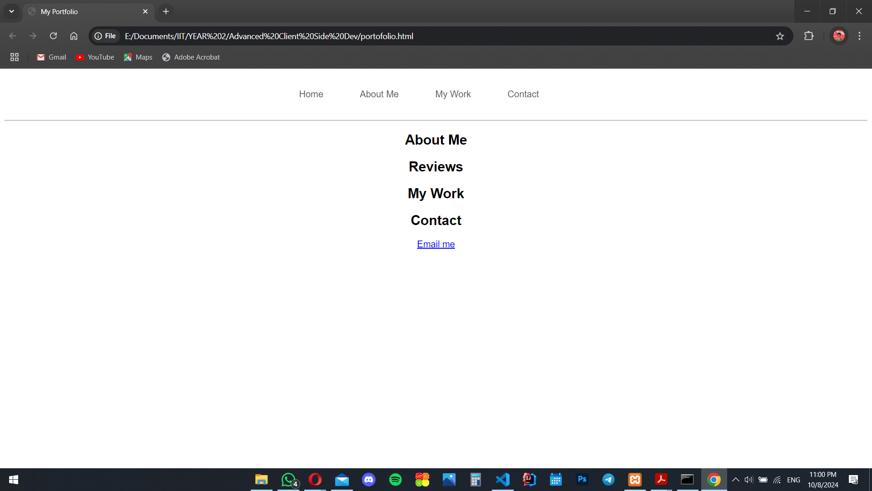

October 11, 2024
Completed the layout and styling of index.html. The header and footer, designed to be consistent across all pages. Elements like profile picture, description and social account links included.
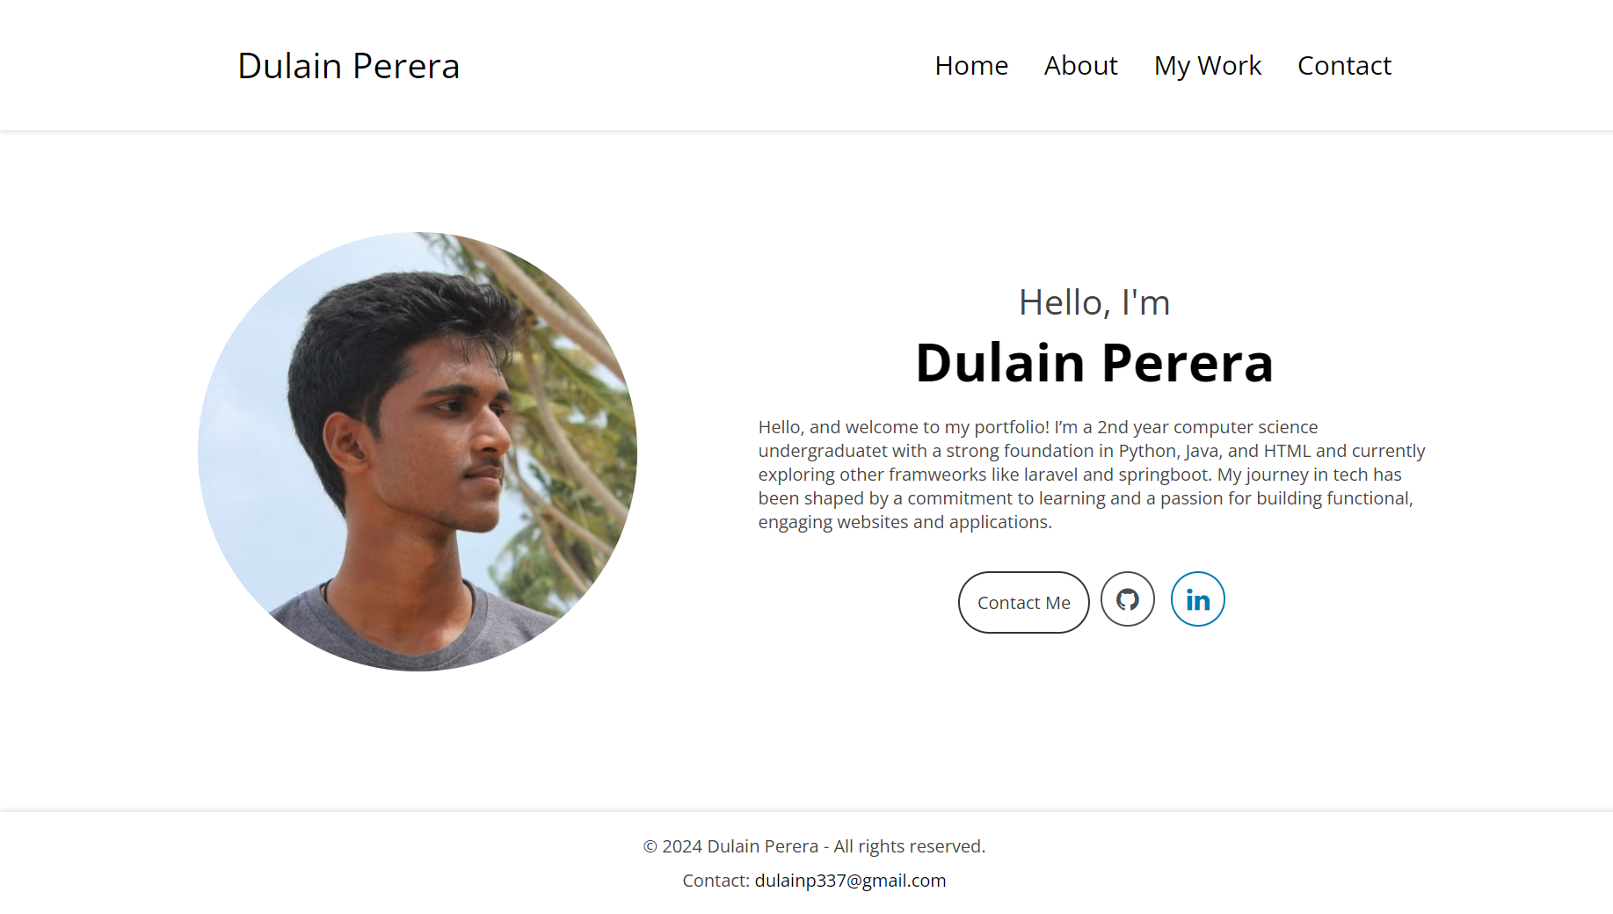

October 15,2024

The work details page has been completed

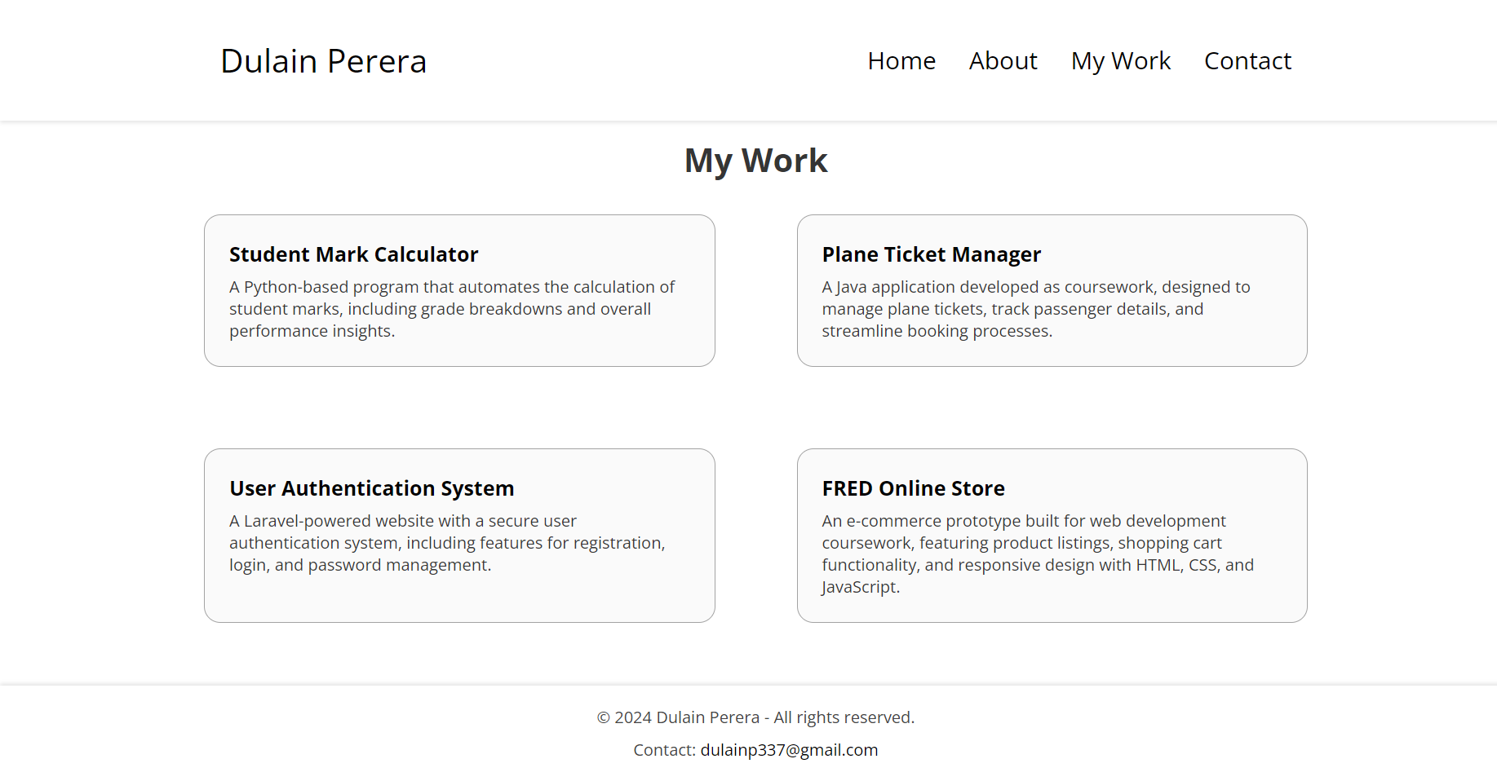
October 19,2024
Completed about.html which includes education and programming language information.
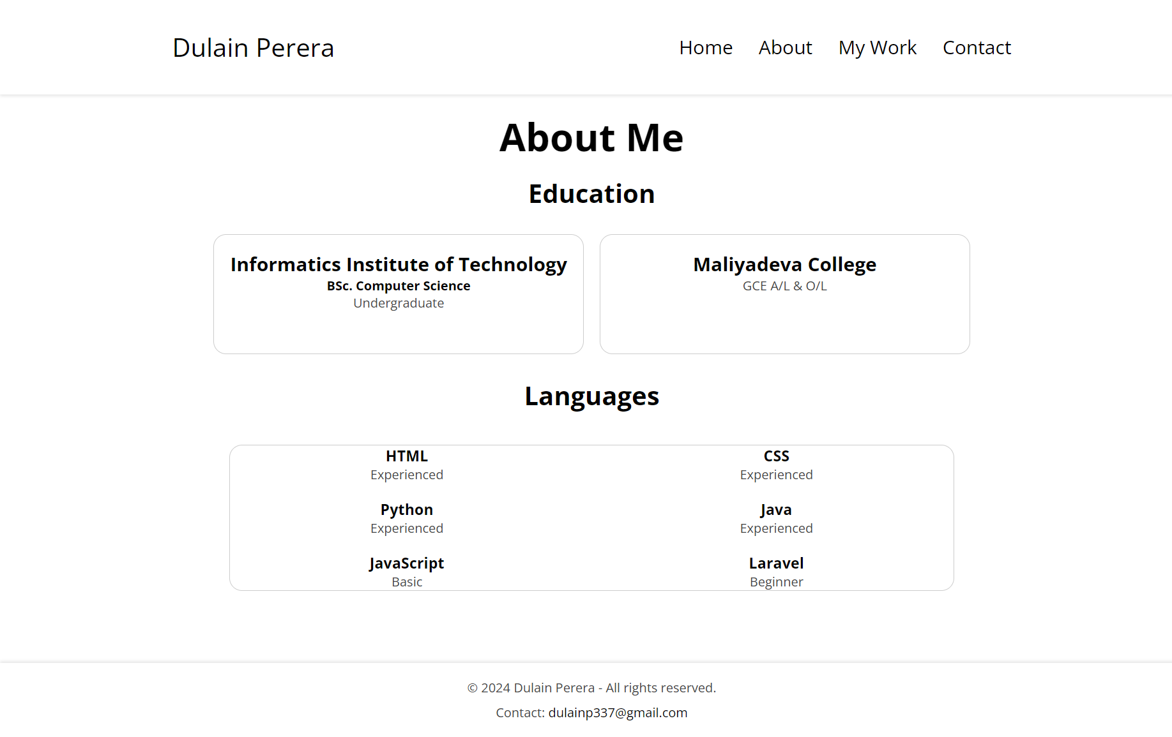

October 22, 2024
Completed the contact form for users to communicate with admin
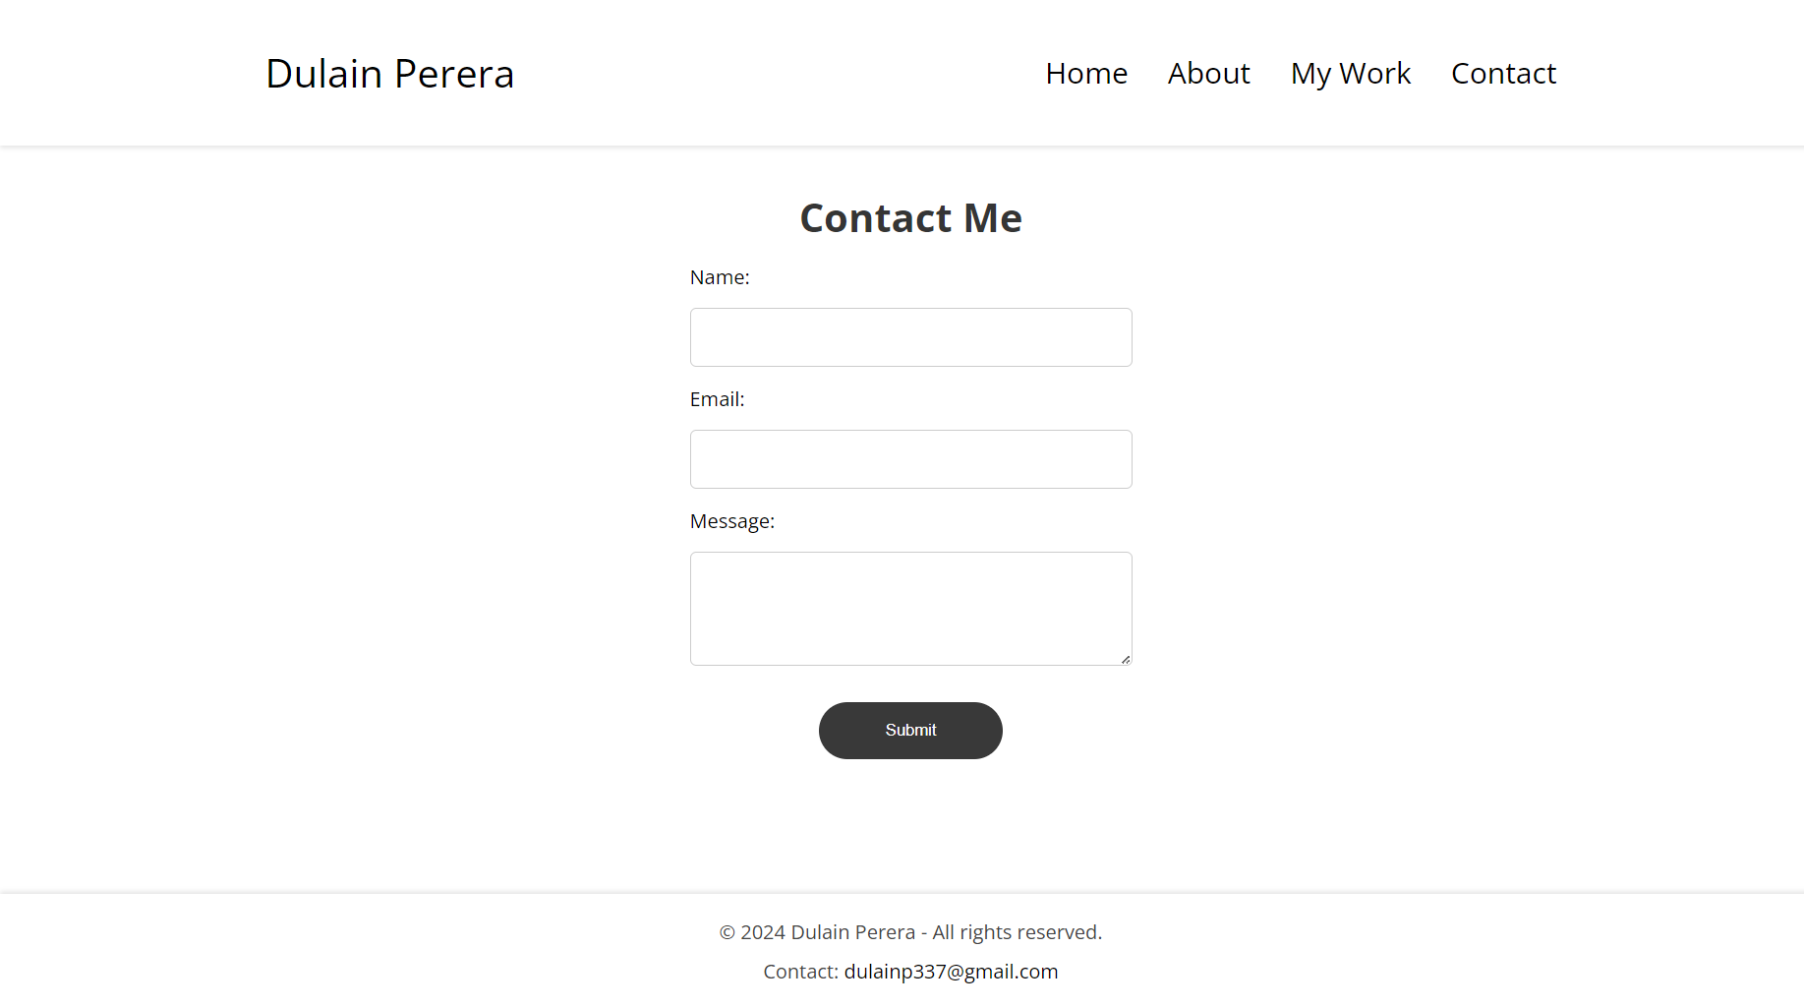

October 27, 2024
Made index.html page responsive with media queries

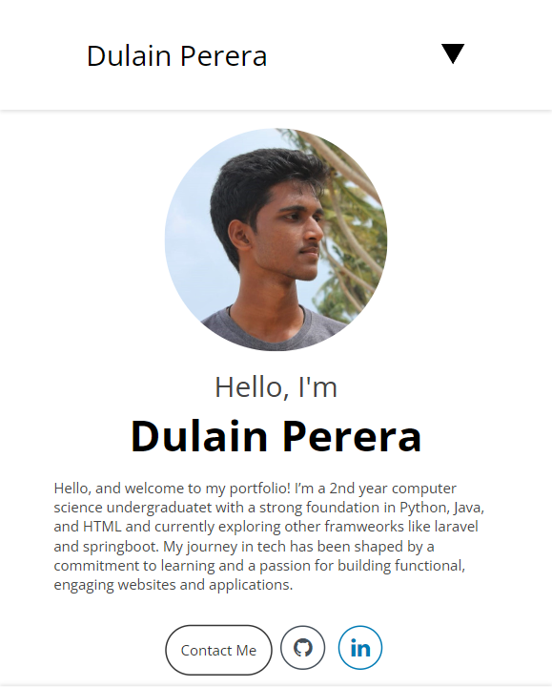

October 29, 2024
Made about.html page responsive.

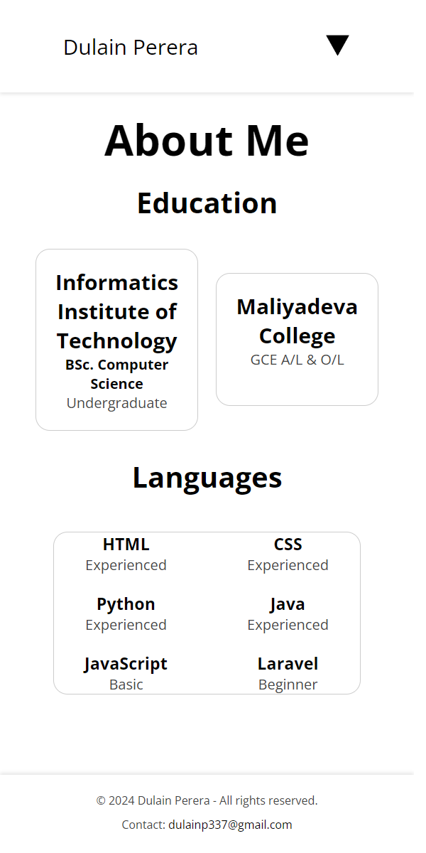

November 3,2024

Integrated Web3Forms for the contact form functionality. Now new user details can be obtained easily

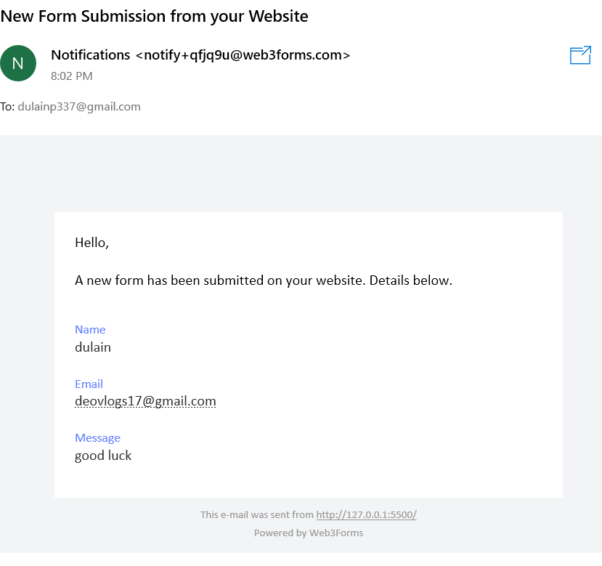

November 4, 2024

Made contact.html and work.html responsive with media queries in media.css
