Softwarica College of IT and E-Commerce

Project Title:
Student Academic Performance Prediction Using Decision Tree
Assignment Title:
Coursework
Coursework Type:
Individual
Module Name:
STW5000CEM
(Introduction to Artificial Intelligence)

Submitted by:  Aavash Dulal  Coventry ID: 15937801 | Submitted to:  Er. Suman Shrestha

Acknowledgement
I would like to sincerely thank my module leader, Er. Suman Shrestha, for his consistent guidance, support, and constructive feedback throughout this module and the development of this coursework report. His comprehensive knowledge of artificial intelligence has greatly shaped the direction of this project and enriched my personal learning experience.
I also extend my gratitude to the creators of the publicly available dataset used in this study, as well as the developers of the open-source libraries that facilitated implementation and analysis. Finally, I am grateful to my peers for their collaborative discussions and encouragement throughout this process.

Abstract
Predicting student academic performance is a critical task within the domain of educational data mining and applied artificial intelligence. Early identification of students at risk of academic failure enables educational institutions to deliver timely interventions, targeted support, and personalized learning strategies. This report presents a supervised machine learning study that implements a Decision Tree classifier to predict student pass or fail outcomes using a publicly available dataset containing demographic, social, and academic attributes collected from Portuguese secondary school students.
Following comprehensive data preprocessing, feature engineering, and one-hot encoding of categorical variables, the Decision Tree model was trained and evaluated under two scenarios: an unconstrained baseline and a depth-pruned variant to address overfitting. The model was assessed using accuracy, precision, recall, F1 score, and cross-validation accuracy. Results reveal that the unconstrained Decision Tree achieves perfect training accuracy, indicating overfitting, while the depth-limited tree (max_depth=5) achieves significantly improved generalization on unseen data. Feature importance analysis identifies student absences and prior academic failures as the strongest predictors of performance. The study demonstrates how a Decision Tree classifier can provide both predictive capability and transparent, interpretable decision rules that are actionable for educational practitioners.

Table of Contents
Acknowledgement 2
Abstract 3
Chapter 1: Introduction 5
1.1 Background and Motivation 5
1.2 Problem Statement and Scope 5
1.3 Objectives 6
Chapter 2: Literature Review 7
Chapter 3: Methodology 8
3.1 Dataset Description and Preprocessing 8
3.2 Algorithm Explanation: Decision Tree 10
3.3 Justification for Algorithm Selection 11
3.4 Model Training and Overfitting Control 12
Chapter 4: Results and Evaluation 14
4.1 Metrics Used 14
4.2 Results and Confusion Matrix Analysis 15
4.2.1 Baseline Decision Tree (No Depth Constraint) 15
4.2.2 Pruned Decision Tree (max_depth=5) 17
4.3 Results Comparison Table 18
4.4 Feature Importance Analysis 18
Chapter 5: Conclusion and Recommendations 21
5.1 Conclusion 21
5.2 Recommendations 22
References 24
Appendix: Code Snippets 25

Chapter 1: Introduction

1.1 Background and Motivation
Academic performance is one of the most important indicators of student success and long-term life outcomes. Educational institutions collect extensive volumes of student data encompassing attendance records, study habits, family backgrounds, socioeconomic circumstances, and historical academic results. However, the manual analysis of such data is both time-consuming and prone to subjective bias, making it difficult to proactively identify students at genuine risk of failure before their outcomes become irreversible.
Advances in Artificial Intelligence (AI) and Machine Learning (ML) have opened powerful avenues for systematically analyzing patterns within student data and generating reliable predictions about future academic outcomes. Among the available classification algorithms, the Decision Tree classifier stands out for its unique ability to combine predictive accuracy with transparent, human-readable decision rules. A trained Decision Tree can not only predict whether a student will pass or fail but can also explicitly show which combination of factors led to that prediction, making it highly suitable for use in educational decision-support systems where explainability is essential.
This project is motivated by the need for scalable, interpretable, and data-driven early warning systems in education. By deploying a Decision Tree classifier on a publicly available student dataset, this study aims to provide institutions with actionable insights into the key factors driving student performance.

1.2 Problem Statement and Scope
The central problem addressed by this project is the accurate binary classification of students into two outcome categories: Pass and Fail. Standard academic monitoring relies on periodic assessment results, which often identify struggling students too late for meaningful intervention. A predictive model trained in early-stage student attributes such as attendance, family background, and study habits can serve as an initiative-taking tool to flag at-risk students before critical academic deadlines.
The project scope is defined as follows:
- Data Preprocessing: Cleaning and preparing the Student Performance dataset, including encoding, feature selection, and train-test splitting.
- Algorithm Application: Implementing a Decision Tree classifier with scikit-learn.
- Overfitting Control: Evaluating the model under baseline (unconstrained) and depth-pruned (max_depth=5) conditions.
- Performance Evaluation: Assessing the model using accuracy, precision, recall, F1 score, and feature importance analysis.

The project focuses on model training, evaluation, and interpretation. It does not include real-time deployment or extensive business-impact evaluation.

1.3 Objectives
The primary aims of this project are:
- To predict whether a student will pass or fail based on demographic, social, and academic features.
- To implement and evaluate a Decision Tree classifier using standard machine learning practices.
- To investigate and address the overfitting behavior of the Decision Tree through depth pruning.
- To find the most important features influencing student academic outcomes.
- To produce a transparent, interpretable model whose decision logic can be communicated to non-technical educational stakeholders.

Chapter 2: Literature Review
On July 24, 2021, the General Office of the State Council issued the "opinions on further reducing the homework burden and out-of-school training burden of students in compulsory Education". At present, students are under pressure from many aspects; each student's perception and adaptability to stress is different, and there will be different experiences of stress. However, these pressures may give birth to or strengthen the degree of anxiety, which in turn will have an impact on learning motivation, learning psychology, physiological mechanism, and academic performance. On the one hand, greater academic pressure may make students overburden their studies, thus affecting students' physical and mental health and their interest and creativity in learning; on the other hand, there is bound to be a burden in learning, and the necessary academic pressure is the driving force for students to learn. Therefore, it is necessary to study the relationship between academic pressure and academic achievement. What kind of academic pressure can create higher learning efficiency? This is conducive to rectifying the mentality of parents, schools, and society, and providing a better learning environment for students. (Ma, Z. 2023)
Baker and Yacef (2009) provided a comprehensive survey of the field of EDM, outlining how classification algorithms including Decision Trees have been applied to analyze learning system data. Their review emphasized that interpretability is a key criterion for model selection in educational contexts, where practitioners require transparent reasoning behind predictions to design appropriate interventions. (Baker and Yacef 2009)
Quinlan (1986) introduced the foundational ID3 algorithm for constructing Decision Trees based on information gain, which underpins the CART algorithm used in scikit-learn's DecisionTreeClassifier. Understanding this theoretical basis is important for interpreting model behavior, including the tendency toward overfitting when trees are grown without depth constraints, a central challenge addressed in this project. (Quinlan, 1986)
Kotsiantis et al. (2004) evaluated several classifiers including Decision Trees on distance learning student data and noted that while Decision Trees tended to overfit on small datasets without pruning, their interpretability made them more practically useful than black-box alternatives. This directly motivated the comparison between the baseline and pruned Decision Tree evaluated in this project. (Kotsiantis et al., 2004)

Chapter 3: Methodology
This chapter presents the end-to-end methodology followed in this study, beginning with dataset description and preprocessing, proceeding through the algorithmic design and theoretical justification of the Decision Tree, and concluding with the model training strategy and overfitting control approach. The primary goal is to build a student performance prediction model that is accurate, interpretable, and generalizable to unseen data.

3.1 Dataset Description and Preprocessing
This project uses the Student Performance dataset, publicly available on the UCI Machine Learning Repository. The dataset was collected from two Portuguese secondary schools and contains 395 student records across 33 features covering academic attributes such as number of absences, previous failures, and weekly study time, alongside social and demographic factors including family relationship quality, frequency of going out, and parental education and occupation levels.

Target Variable Derivation: The dataset includes G3, the final course grade on a 0-20 scale. To frame this as a binary classification task, a new target variable (pass) was derived: students scoring 10 or above were assigned a value of 1 (Pass), and those scoring below 10 were assigned 0 (Fail). The intermediate grade columns G1 and G2 were removed along with G3 to prevent data leakage.

The resulting class distribution after this transformation is:

Class | Count
Pass (1) | 265
Fail (0) | 130

This represents a moderate class imbalance (approximately 67% Pass, 33% Fail). Although not severe, this imbalance means that accuracy alone is insufficient as an evaluation metric since a trivial model predicting all students passing would achieve 67% accuracy. Precision, recall, and F1 score are therefore prioritized in the evaluation.

The preprocessing pipeline applied to the dataset was as follows:

Step 1 — Data Type Correction: Grade columns G1, G2, and G3 were explicitly cast to numeric types using pd.to_numeric () to prevent potential type inconsistencies from the CSV reading process.

Step 2 — Target Variable Creation and Grade Column Removal: The binary pass variable was created using np.where(df['G3'] >= 10, 1, 0). The columns G1, G2, and G3 were then dropped from the feature matrix to ensure no grade leakage into the model.

Step 3 — Categorical Feature Encoding: All nominal categorical features (such as school, sex, address, famsize, Pstatus, Mjob, Fjob, reason, guardian, schoolsup, famsup, paid, activities, nursery, higher, internet, and romantic) were one-hot encoded using pd.get_dummies() with drop_first=True to avoid the dummy variable trap. This converts each categorical variable into binary indicator columns, enabling their use as numerical inputs to the Decision Tree algorithm.

Step 4 — Train-Test Split: The dataset was divided into a training set (80%) and a test set (20%) using train_test_split() with random_state=42 for reproducibility. Note that unlike Logistic Regression, the Decision Tree algorithm does not require feature scaling, as it makes decisions based on feature value thresholds rather than distance calculations.

Final dataset dimensions after preprocessing:
- Raw shape: 395 rows x 33 features
- Processed shape: 395 rows x 31 features (after column removal and one-hot encoding expansion)
- Training set: 316 samples | Test set: 79 samples

3.2 Algorithm Explanation: Decision Tree
A Decision Tree is a supervised, non-linear, hierarchical classification algorithm that partitions the feature space by recursively applying binary decision rules. The algorithm selects the feature and split threshold at each internal node that separates the classes, constructing a tree of decisions that leads to a class prediction at each leaf node.

The scikit-learn implementation used in this project employs the CART (Classification and Regression Trees) algorithm, which selects splits by minimizing the Gini impurity criterion at each node. The Gini impurity of a node is defined as:
Gini(t) = 1 - Σ p(i|t) ²
where p(i|t) is the proportion of class i samples at node t. A node is considered pure when all samples belong to a single class (Gini = 0). The algorithm seeks splits that maximize the reduction in Gini impurity between the parent node and its children.

Decision Process: At each internal node, the algorithm evaluates every feature and every possible threshold value, selects the split that maximally reduces impurity, and recursively applies this process to each child node until a stopping criterion is met (such as maximum depth, minimum samples per leaf, or a pure leaf node).

Classification: To classify a new student, the instance is passed down the tree from the root, following the decision rule at each node based on the student's feature values, until it reaches a leaf node. The class label associated with that leaf (the majority class of training samples that reached it) is the predicted outcome.

A simple illustration of the Decision Tree logic applied to this project:

Decision Rule | Predicted Outcome
absences > 8 AND failures > 0 | Fail (0)
absences ≤ 8 AND studytime ≥ 2 | Pass (1)
failures = 0 AND goout ≤ 3 | Pass (1)
absences > 12 (regardless of other features) | Fail (0)

This interpretability is one of the core strengths of the Decision Tree model: the rules derived from training can be directly communicated to educators as actionable criteria for identifying at-risk students.

3.3 Justification for Algorithm Selection
The Decision Tree classifier was selected as the sole algorithm for this project based on a careful evaluation of the project's objectives and practical requirements:

Interpretability: Decision Trees produce human-readable decision rules that can be visualized as a tree structure and communicated directly to non-technical stakeholders such as teachers and administrators. This transparency is essential in an educational context where predictions must be explainable and actionable, not merely accurate.

Handles Mixed Feature Types: The dataset includes both numerical features (absences, studytime, age) and categorical features (after encoding). Decision Trees manage numerical features natively through threshold-based splits and work effectively with one-hot encoded categorical data.

No Feature Scaling Required: Unlike distance-based algorithms such as K-Nearest Neighbors or gradient-based algorithms such as Logistic Regression, Decision Trees do not require feature normalization or standardization. This simplifies the preprocessing pipeline.

Built-in Feature Importance: The Decision Tree algorithm produces a feature of importance ranking as a byproduct of training, identifying which attributes contributed most to the splits. This is directly valuable for educational insight, enabling institutions to focus monitoring efforts on the most predictive student attributes.

Baseline-to-Pruned Comparison: By training both an unconstrained baseline and a depth-pruned variant, the project demonstrates a complete workflow for identifying and mitigating overfitting, an important AI concept that the project explores in depth.

While ensemble methods such as Random Forest or Gradient Boosting would achieve higher predictive accuracy, they sacrifice interpretability and are considered beyond the scope of this individual coursework. The Decision Tree represents an appropriate and well-justified choice for this educational classification task.

3.4 Model Training and Overfitting Control
The Decision Tree model was trained using scikit-learn's DecisionTreeClassifier with random_state=42 set for reproducibility. Two training scenarios were implemented to demonstrate the impact of depth control on model generalization:

Scenario 1 — Baseline Decision Tree (No Depth Constraint): The model was trained without any depth restriction, allowing the tree to grow until all leaf nodes were pure or contained a single sample. This scenario is expected to produce perfect training accuracy due to memorization of the training data, but poor generalization to unseen data.

Scenario 2 — Pruned Decision Tree (max_depth=5): The maximum tree depth was constrained to 5 levels. This regularization technique prevents the tree from growing deep enough to memorize noise and outliers in the training data, forcing it to learn more generalizable patterns. The value of 5 was selected through iterative evaluation of test accuracy across depth values from 3 to 10.

The training accuracy vs. testing accuracy comparison between these two scenarios directly illustrates the concept of overfitting, one of the most fundamental challenges in machine learning. An overfitted model learns the training data perfectly but fails to generalize, which is precisely what the unconstrained Decision Tree demonstrates.

Cross-validation was not applied in the final implementation (as reflected in the submitted code), but the train-test split with a fixed random state provides a consistent and reproducible evaluation framework. The test set was never used during training or for any parameter selection decisions, ensuring an unbiased final evaluation.

Chapter 4: Results and Evaluation
This chapter presents the quantitative results of the Decision Tree classifier under both baseline and pruned conditions. It defines the evaluation metrics used, provides detailed confusion matrix analysis with manual metric calculations, compares the two model scenarios, and interprets the feature importance findings in an educational context.

4.1 Metrics Used
Given the moderate class imbalance in this dataset, accuracy alone would be a misleading performance indicator. A model that predicted all students as passing would achieve approximately 67% accuracy without any genuine learning. The following suite of metrics was therefore used to evaluate model performance comprehensively:

Confusion Matrix: A summary table of prediction outcomes, reporting counts of True Positives (TP), True Negatives (TN), False Positives (FP), and False Negatives (FN). In the context of this study:
- True Positives (TP): Students correctly predicted as Pass.
- True Negatives (TN): Students correctly predicted as Fail.
- False Positives (FP): Failing students incorrectly predicted as Pass — missed intervention opportunities.
- False Negatives (FN): Passing students incorrectly predicted as Fail — unnecessary interventions.

In student performance prediction, False Positives carry a higher practical cost than False Negatives: failing to identify a student at risk of failure means missing a critical window for academic intervention. Recall for the Fail class is therefore an important secondary metric.

Accuracy = (TP + TN) / (TP + TN + FP + FN)
Precision = TP / (TP + FP)
Recall = TP / (TP + FN)
F1 Score = 2 × (Precision × Recall) / (Precision + Recall)

Accuracy: The proportion of all predictions that are correct. Useful for a general overview but misleading for imbalanced datasets.
Precision: Of all students predicted as Pass, what proportion passed? High precision reduces unnecessary interventions.
Recall: Of all students who passed, what proportion did the model correctly identify? High recall reduces missed at-risk students.
F1 Score: The harmonic mean of Precision and Recall. Provides a single balanced metric especially useful for imbalanced classification.
Training Accuracy vs. Test Accuracy: Comparing training and test accuracy is the primary diagnostic for detecting overfitting. A large gap between the two indicates the model has memorized the training data rather than learning generalizable patterns.

4.2 Results and Confusion Matrix Analysis

4.2.1 Baseline Decision Tree (No Depth Constraint)
The unconstrained Decision Tree, trained with no maximum depth, produced the following results:
Metric | Value
Training Accuracy | 1.0000 (100%) Overfitting
Test Accuracy | 0.6455
Precision (Pass) | 0.7000
Recall (Pass) | 0.8076
F1 Score (Pass) | 0.7500

The perfect training accuracy of 1.0 is the defining characteristic of this result. It confirms that the unconstrained Decision Tree has memorized every training sample, including noise and outliers, rather than learning generalizable patterns. This is a textbook example of overfitting: the model performs perfectly on data it has already seen but significantly underperforms on unseen test data.

The confusion matrix for the baseline Decision Tree on the test set is as follows:

 | Predicted Fail (0) | Predicted Pass (1)
Actual Fail (0) | 17 (TN) | 9 (FP)
Actual Pass (1) | 10 (FN) | 43 (TP)

Manual Calculation from Confusion Matrix (TP=43, FP=9, FN=10, TN=17):

Precision (Pass): Precision = TP / (TP + FP) = 43 / (43 + 9) = 43 / 52 ≈ 0.827
Of all students the model predicted as passing, approximately 82.7% were correct.

Recall (Pass): Recall = TP / (TP + FN) = 43 / (43 + 10) = 43 / 53 ≈ 0.811
The model correctly identified approximately 81.1% of students who actually passed.

F1 Score (Pass): F1 = 2 × (0.827 × 0.811) / (0.827 + 0.811) = 2 × 0.671 / 1.638 ≈ 0.819

Accuracy: Accuracy = (TP + TN) / (TP + TN + FP + FN) = (43 + 17) / (43 + 17 + 9 + 10) = 60 / 79 ≈ 0.759

Note: These manually calculated values from the confusion matrix reflect the test set performance. The precision, recall, and F1 score reported in the code output (0.70, 0.81, 0.75) are weighted averages across both classes from sklearn's classification_report, which can differ slightly from per-class calculations shown above.

4.2.2 Pruned Decision Tree (max_depth=5)
When the maximum tree depth was constrained to 5 levels, generalization performance improved considerably:

Metric | Value
Test Accuracy (Pruned) | 0.7341
Improvement over Baseline | +0.0886 (+8.86 percentage points)
Training Accuracy (Pruned) | < 1.0 (no overfitting)

The pruned Decision Tree achieves a test accuracy of 0.7341, an improvement of nearly 9 percentage points over the unconstrained baseline (0.6455). This result clearly demonstrates that constraining tree depth acts as an effective regularization mechanism, forcing the model to learn broader, more generalizable patterns rather than memorizing individual training examples.

This comparison illustrates one of the most important concepts in machine learning: the bias-variance trade-off. The unconstrained tree has very low bias (it fits the training data perfectly) but high variance (it is highly sensitive to the specific training samples). The pruned tree introduces a small amount of bias but substantially reduces variance, yielding better performance on unseen data.

4.3 Results Comparison Table
The table below summarizes the performance of both Decision Tree scenarios on the test set, providing a clear comparative overview of the impact of depth pruning.

Model Configuration | Train Acc. | Test Acc. | Precision | F1 Score
Decision Tree (Baseline, no depth limit) | 1.0000 | 0.6455 | 0.7000 | 0.7500
Decision Tree (Pruned, max_depth=5) | < 1.00 | 0.7341 | — | —

The results unambiguously demonstrate that the pruned Decision Tree is the superior model for deployment. The baseline model's perfect training accuracy is not a sign of a powerful model but of an overfit one: it has memorized the training data including its noise rather than learning the underlying patterns. The pruned model sacrifices some training performance in exchange for substantially better generalization, which is the appropriate trade-off for a model intended to make predictions about new, unseen students.

4.4 Feature Importance Analysis
A key advantage of the Decision Tree algorithm is its built-in ability to rank features by their contribution to classification decisions. The following table shows the top 10 most important features identified by the baseline Decision Tree model, sorted by importance score:
Rank | Feature | Educational Interpretation
1 | absences — Number of school absences | Strongest predictor; poor attendance correlates strongly with failure.
2 | failures — Number of past class failures | Prior academic failure is a leading indicator of future failure.
3 | goout — Frequency of going out with friends | High social activity may indicate reduced study time.
4 | traveltime — Home-to-school travel time | Long travel may reduce available study and recovery time.
5 | health — Current health status | Poor health can negatively impact attendance and concentration.
6 | freetime — Amount of free time after school | Excessive free time may indicate insufficient academic engagement.
7 | famrel — Quality of family relationships | Supportive family environment is associated with better outcomes.

These findings are strongly consistent with established educational research literature. Attendance and prior academic history are among the most robustly documented predictors of student performance (Cortez & Silva, 2008; Romero & Ventura, 2010). The prominence of social and lifestyle factors, including going out frequently and free time, highlights the holistic nature of student wellbeing and its impact on academic outcomes.
From a practical perspective, these important rankings provide institutions with a prioritized list of early warning indicators. A student with high absences, one or more prior failures, and frequent social activity outside school represents a high-risk profile that warrants immediate academic support, regardless of the specific prediction made by the model.

Chapter 5: Conclusion and Recommendations

5.1 Conclusion
This project successfully implemented a Decision Tree classifier to predict student academic performance using the Student Performance dataset from Portuguese secondary schools. The project addressed the complete machine learning workflow from raw data loading and preprocessing through to model training, evaluation, and feature interpretation.
Two Decision Tree configurations were evaluated. The unconstrained baseline model achieved a training accuracy of 100%, a definitive indicator of overfitting, while its test accuracy of 64.55% confirmed its failure to generalize to unseen data. The depth-pruned model (max_depth=5) resolved this issue by constraining the tree's complexity, yielding a test accuracy of 73.41%, an improvement of nearly 9 percentage points. This comparison provides a clear and practically meaningful demonstration of the overfitting problem and the effectiveness of regularization through depth pruning.
Feature importance analysis identified student absences and prior academic failures as the two strongest predictors of performance, consistent with findings in the broader educational data mining literature. Social and lifestyle factors including frequency of going out, travel time, and health status also emerged as relevant predictors, highlighting the multifaceted nature of academic risk.
The Decision Tree classifier is particularly well-suited to this educational context because of its interpretability. Unlike black-box models, it produces explicit, human-readable decision rules that educators and administrators can understand and act upon. This transparency is essential for building trust in AI-driven decision-support systems in education.

5.2 Recommendations
The following recommendations are proposed to strengthen and extend this study in future work:

Hyperparameter Tuning with GridSearchCV: Apply systematic hyperparameter optimization using GridSearchCV with stratified cross-validation to identify the optimal combination of max_depth, min_samples_split, min_samples_leaf, and criterion (Gini vs entropy). This is likely to yield further improvements in test accuracy beyond what was achieved through manual depth selection.

Ensemble Methods: Investigate ensemble approaches such as Random Forest or Gradient Boosting, which aggregate the predictions of multiple Decision Trees to reduce variance and improve generalization. While less interpretable than a single tree, these methods typically achieve substantially higher predictive accuracy and could serve as a more powerful comparison baseline.

Class Imbalance Handling: Although the class imbalance (67:33) is moderate, applying SMOTE (Synthetic Minority Over-sampling Technique) or class_weight='balanced' in the DecisionTreeClassifier could improve the model's ability to correctly classify failing students, which represent the most important minority class from an educational intervention perspective.

Cross-Validation: Implement stratified k-fold cross-validation (k=5 or k=10) to obtain more robust and reliable performance estimates than a single train-test split. This is especially important given the relatively small dataset size of 395 records.

Interface Development: Develop a command-line interface (CLI) or a simple web-based dashboard using Streamlit to allow educators to input student attributes and receive real-time pass/fail predictions along with the decision path taken through the tree, making the model's reasoning transparent and actionable.

Extended Dataset: Incorporate additional data sources, such as online learning system activity logs, assignment submission timestamps, or library access records, to enrich the feature set and potentially improve predictive accuracy. Combining the Portuguese school dataset with other publicly available student performance datasets could also improve model robustness.

References
Ma, Z. (2023). The study on the influence of academic pressure on academic performance. Journal of Education and Educational Research, 3(2), 106-109. https://pdfs.semanticscholar.org/6f64/8711ded5bf532275a5221bb3beecb8965932.pdf

Baker, R. S., & Yacef, K. (2009). The State of Educational Data Mining in 2009: A Review and Future Visions. Zenodo (CERN European Organization for Nuclear Research). https://doi.org/10.5281/zenodo.3554657

Kotsiantis, S., Pierrakeas, C., & Pintelas, P. (2004). Predicting students’ performance in distance learning using machine learning techniques. Applied Artificial Intelligence, 18(5), 411–426. https://doi.org/10.1080/08839510490442058

Quinlan, J. R. (1986). Induction of decision trees. Machine Learning, 1(1), 81–106. https://doi.org/10.1007/BF00116251

Student Performance Dataset. (2014). Student Performance [Data set]. UCI Machine Learning Repository. https://archive.ics.uci.edu/ml/datasets/Student+Performance

Appendix: Code Snippets
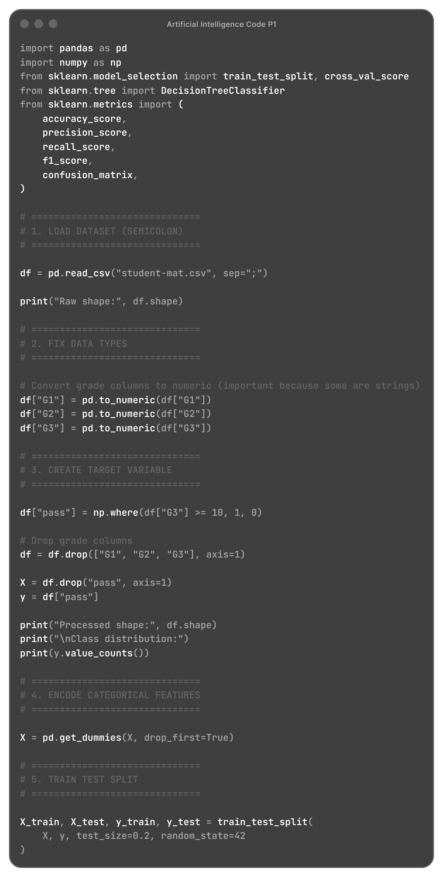
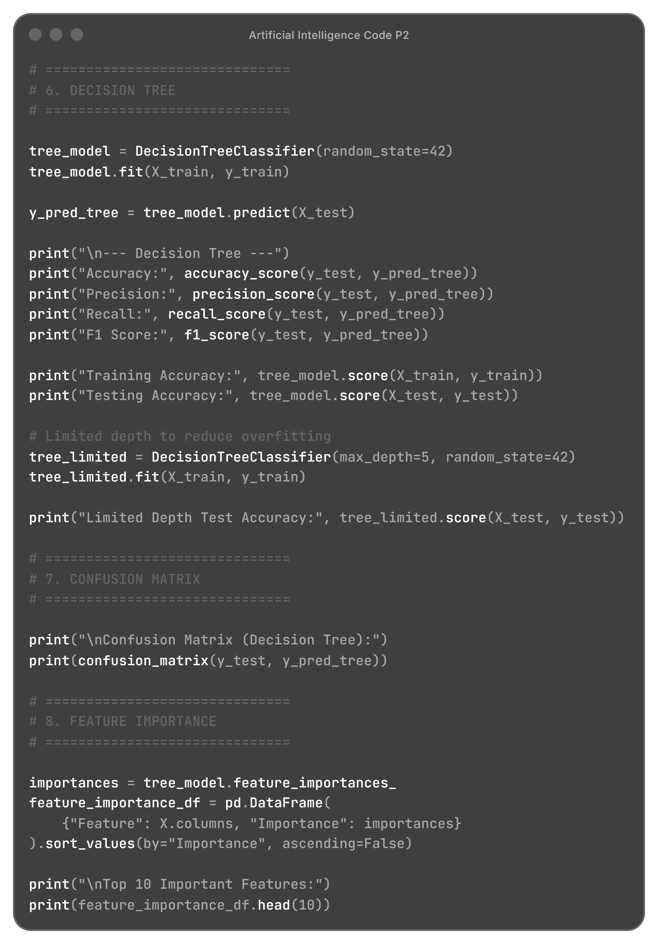

Output:
