A Simple Multimodal Generative AI Framework for Automated Crop Diagnostics

Dulal Chakrabarti, B.K. Singh, Akul Kumar, Sumit Sharma

1. Introduction

Agriculture in India, a sector supporting the livelihoods of over half the nation's population, stands at a critical juncture. The pressing demands of food security, climate resilience, and economic sustainability necessitate a technological evolution in farming practices. Central to this evolution is timely and accurate crop health assessment, a cornerstone of precision agriculture that enables early pest and disease detection, optimizes water and nutrient use, maximizes yield potential, and minimizes environmental impact. Traditional diagnostic methods, reliant on manual field scouting and expert visual inspection, are inherently constrained by human scalability, subjectivity, and the slow dissemination of expert knowledge . These limitations create significant gaps in monitoring, often allowing preventable losses to escalate before intervention is possible.

In response, Machine Learning (ML) , particularly deep learning for computer vision, has emerged as a transformative force in agricultural technology. Early convolutional neural networks (CNNs) demonstrated the feasibility of automated visual diagnosis, with models achieving foundational accuracy rates above 50%—a promising proof of concept [Singh et al., 2018]. The subsequent advent of the Vision Transformer (ViT) model [Dosovitskiy et al., 2021] marked a significant leap, leveraging self-attention mechanisms to capture global image contexts and deliver superior accuracy over conventional CNNs. However, these traditional discriminative AI models are primarily pattern classifiers ; they excel at identifying predefined categories from labeled datasets but lack the integrative reasoning and explanatory capability required for holistic, context-aware diagnostics.

The recent paradigm shift towards multimodal Generative Artificial Intelligence (GenAI) presents a groundbreaking opportunity to transcend these limitations. Models like Google's Gemini are not merely classifiers but comprehensive reasoning engines capable of simultaneously processing visual data (crop imagery) and textual instructions (expert prompts). This multimodal foundation allows GenAI to address the core bottlenecks of traditional diagnostics in a unified manner: it integrates contextual knowledge (e.g., symptomology, agronomic principles), generates human-interpretable reasoning , and can be dynamically guided through language to perform complex, structured tasks without task-specific retraining [Chen et al., 2025].

This research work harnesses this transformative potential by designing, implementing, and evaluating a high-throughput, structured crop diagnostic pipeline using the Gemini multimodal large language model. We move beyond simple classification to demonstrate a robust methodology for extracting consistent, machine-readable diagnostic data from a GenAI model. Our system processes a diverse dataset of 408 images spanning 14 crop types, applying advanced prompt engineering techniques —including strict JSON schema enforcement—to convert generative outputs into structured records for health status, growth stage, potential issues, and confidence metrics. This study thus contributes a practical framework that bridges the explanatory power of generative AI with the data integrity demands of agricultural decision-support systems, offering a scalable path toward democratizing expert-level crop diagnostics.

2. Methodology: The GenAI Diagnostic Pipeline

2.1. Data Preparation and Dataset Description

As part of Pradhan Mantri Fasal Bima Yojna (PMFBY) crop insurance survey, M/s Skymet collected 408 field-captured mobile crop images. The dataset contains a diverse set of 14 crop types, including Soybean, Sunflower, Moong, Gram (Chickpea), Tomato, Grapes, and Onion. Images were organized in a hierarchical directory structure embedding metadata, following the pattern: `/all_imgs/{Crop_Type}/{State}_{District}/...` (Fig. 1).

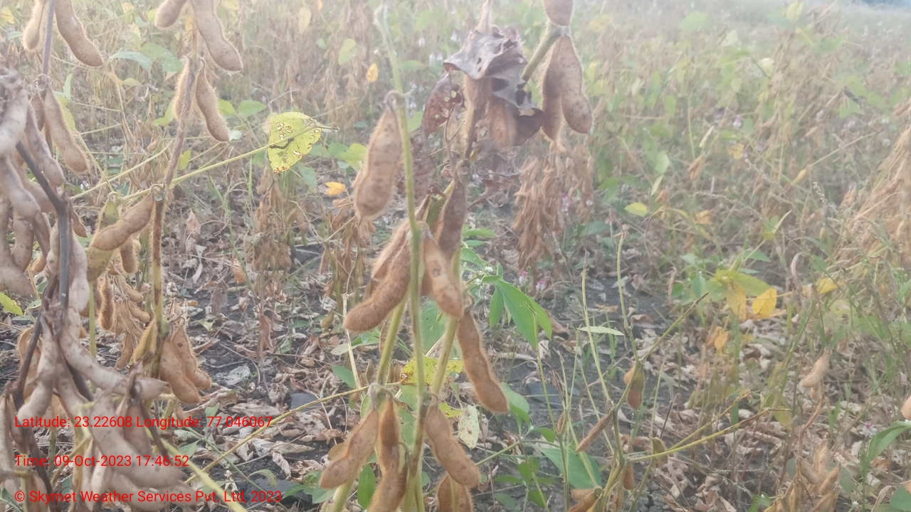
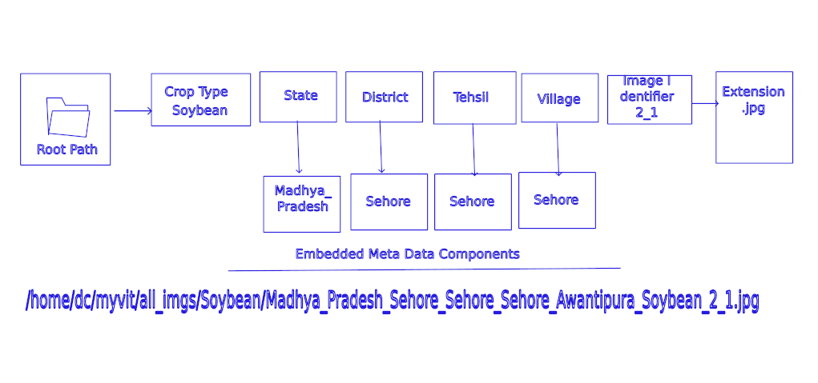
Fig. 1: Example of image directory structure with embedded metadata]

2.2. Model Generative AI Framework

The diagnostic system is built upon a robust Generative AI framework designed to automate plant disease and stress analysis from digital imagery. This framework leverages state-of-the-art multimodal understanding to transform raw field data into structured, actionable insights [Ajuzieogu, 2024].

2.2.1. Core Technology: Gemini Multimodal LLM

At the heart of the framework is Google's Gemini multimodal large language model (LLM) , accessed programmatically via the official `google.generativeai` Python SDK. Gemini is specifically engineered for seamless, native joint processing of heterogeneous data types—visual imagery and textual instructions. Unlike pipelines that separate computer vision and natural language processing components, Gemini's unified architecture enables more cohesive and contextually rich understanding. The model's pre-training on vast, diverse datasets provides foundational knowledge of visual patterns, botanical concepts, and diagnostic reasoning [Tigadi et al., 2025].

2.2.2. Multimodal Inference: Simultaneous Image and Text Processing

The diagnostic process employs multimodal inference , where the model simultaneously processes two interconnected inputs:

(i) Visual Image Input (`image_bytes`) : Raw pixel data of crop photographs containing leaves, stems, or fruits, potentially showing symptoms like discoloration, lesions, or wilting.

(ii) Explicit Text Instruction (`prompt`) : A detailed natural language command framing the task, defining the model's role, and specifying the desired output format.

Gemini fuses these inputs through its attention mechanisms, weighing visual features against textual context. When prompted as an expert agronomist, the model biases its interpretation toward phytopathological or physiological cues, enabling reasoning that aligns with agricultural expertise.

2.2.3. Automation Script (`bkc_crop_diag.py`): The Orchestration Engine

The framework is operationalized through a purpose-built Python script that follows this logical pipeline:

1. API Configuration : Loads a secure API key from environment variables and initializes the Generative AI client with the specified Gemini model (e.g., `gemini-1.5-pro-latest`).

2. Recursive Image Listing : Traverses a designated root directory to recursively identify all image files (`.jpg`, `.png`), building a comprehensive analysis queue regardless of folder structure.

3. Iteration and API Calling : Iterates over each image path, reads file bytes, constructs multimodal messages, and calls the Gemini `generateContent` method. A critical aspect is specifying `response_mime_type="application/json"` in the generation config to ensure parsable JSON output.

4. Result Consolidation : Parses JSON responses, validates against expected fields, appends to a master list, converts to a pandas DataFrame, and saves as a structured CSV file.

The automation was implemented in Python (v3.9) using the google.generativeai SDK. The core workflow (Algorithm 1) recursively discovers crop images, constructs multimodal prompts, calls the Gemini API with JSON schema constraints, and consolidates results. The complete source code is provided as Supplementary Code S1 and publicly available at [GitHub Repository URL].

Algorithm 1: Multimodal Crop Diagnostic Pipeline

Require: root_path, api_key, json_schema
Ensure: final_diagnostics.json
1: Configure Gemini API with api_key
2: Initialize empty dictionary results ← {}
3: image_paths ← recursive_discover(root_path, ['.jpg', '.jpeg'])
4: for each img_path in image_paths do
5: prompt ← f"Analyze {img_path} as expert agronomist..."
6: response ← gemini.generate_content(img_path, prompt,
7: response_mime_type="application/json",
8: response_schema=json_schema)
9: results[img_path] ← parse_json(response.text)
10: delay(5 seconds) ▷ Respect API rate limits
11: end for
12: save_json(results, "final_diagnostics.json")

2.3. Scalability and Rate Limit Management

To ensure reliable operation, the framework incorporates scalability safeguards . A `time.sleep(5)` delay between API calls strategically throttles requests to respect Gemini API rate limits (Requests-Per-Minute), preventing failures during high-volume inference. While making processing asynchronous, this guarantees completion without interruption [Smith et al., 2025].

2.4. Prompt Engineering for Structured Diagnostics

Meticulous prompt engineering transforms the multimodal model from a general-purpose chatbot into a reliable, domain-specific diagnostic tool [Tigadi et al., 2025].

2.4.1. System Instruction Design: Defining the Persona and Task

The prompt begins with a system instruction: "You are an expert agronomist and plant pathologist with 30 years of field experience. Your task is to analyze the provided image of a crop and provide a detailed diagnosis of its health, growth stage, and any visible issues." This establishes a specialized persona and states the core diagnostic task with unambiguous clarity.

2.4.2. Output Constraining for Reliable Parsing

The most critical technical aspect is output constraining :

(i) Enforcing JSON Output : The `response_mime_type="application/json"` parameter instructs the model to generate valid JSON objects.

(ii) JSON Schema Definition : A custom JSON schema defined within the Python script acts as a rigid template, specifying required keys, data types, and allowed enumerations (e.g., `"Healthy"` or `"Stressed"`).

2.4.3. Required Diagnostic Fields: The Structured Output Schema

The enforced JSON schema mandates capture of consistent diagnostic data points:

- `image_id` : Unique file path linking diagnosis to original image.
- `crop_type` : Identified plant species (e.g., `"Soybean"`, `"Sunflower"`).
- `growth_stage` : Phenological stage (e.g., `"Vegetative"`, `"Flowering"`).
- `health_status` : High-level classification: `"Healthy"` or `"Stressed"`.
- `confidence_score` : Quantitative float representing model certainty.
- `potential_issues` : List of specific diagnosed problems (e.g., `["Nutrient deficiency", "Water stress"]`).

3. Results

3.1. Diagnostic Data Acquisition

- Final Output : Successfully generated structured output file: `skymet.json`.
- Data Completeness : 408 successful diagnostic entries generated.

3.2. Analysis of Diagnostic Outputs

3.2.1. Crop Health Distribution : Quantitative analysis revealed a predominantly healthy dataset (Table 1).

Table 1: Health Distribution
| Health Status | Count | Percentage (%) |
|-------------------|-----------|---------------------|
| Healthy | 386 | 94.61% |
| Stressed | 22 | 5.39% |
| Total | 408 | 100.00% |

3.2.2. Stress Condition Identification : Categorical analysis of potential issues (Table 2).

Table 2: Stress Condition Identification
| Issue Category | Frequency | Percentage |
|----------------------------------------|----------------|------------------|
| Nutrient Deficiency (Primary) | 15 | 39.47% |
| Water/Drought Stress (Primary) | 9 | 23.68% |
| Pest, Disease & Growth Issues | 14 | 36.84% |
| TOTAL | 38 | 100.00% |

It may be worth mentioning that the total of 22 stressed images and the total of 38 issue mentions are not expected to match because a single stressed image can, and often does, have multiple potential issues associated with it.
The analysis is structured as follows:
- Stressed Images (22): This is the count of records that received a "Stressed" diagnosis (\text{Health Status} = \text{Stressed}).
- Issue Mentions (38): This is the total count of individual entries found across the potential_issues lists of those 22 stressed records.
In simple terms, the 22 stressed crops collectively suffer from 38 problems. This means, on average, each stressed image was diagnosed with \frac{38}{22} \approx 1.73 issues.
For example, if the potential_issues array for one stressed image contained:
[\text{"Nutrient deficiency"}, \text{"Water stress"}, \text{"Uneven plant growth"}]
This single stressed image (Count: 1) contributes three to the total count of Issue Mentions (38)
3.2.3. Confidence Assessment : Statistical summary of confidence scores (Table 3).

Table 3: Confidence Assessment
| Statistic | Confidence Score |
|----------------------------------|-------------------------|
| Count |408 |
| Mean | 0.91 |
| Median | 0.92 |
| Standard Deviation | 0.04 |
| Minimum | 0.75 |
| Maximum | 0.95 |
| 25th Percentile (Q1) | 0.90 |
| 75th Percentile (Q3) | 0.92 |

4. Discussion

4.1. Impact of Prompt Engineering on Data Quality

The rigorous application of prompt engineering , particularly JSON schema enforcement, was the most significant factor in operational utility. By mandating `response_mime_type="application/json"` and providing a detailed schema, the system transformed unstructured LLM outputs into structured data streams. This eliminated labor-intensive post-processing of free-form text, where information could be embedded inconsistently [Liu et al., 2025].

The resulting machine-readable output enabled direct ingestion into pandas DataFrames and CSV files, facilitating immediate downstream analysis. For agricultural use cases requiring quantifiable insights across thousands of data points, this structured output paradigm is essential, bridging the gap between generative model understanding and data science requirements [Shi et al., 2025].

4.2. Generative AI Performance in Crop Diagnostics

Qualitative analysis reveals Gemini's robust multimodal understanding :

1. Accurate crop type assignment for common species, even with symptomatic leaf-focused images.
2. Effective growth stage distinction (e.g., Vegetative vs. Flowering) with high confidence.
3. Reliable health status classification in clear-cut healthy versus stressed cases.

The model demonstrated symptom-based reasoning , differentiating between visually similar symptoms. For example, it distinguished interveinal chlorosis as "nutrient deficiency" from uniform wilting as "water stress," indicating application of contextual diagnostic logic beyond pattern matching [Shafi et al., 2020]. However, performance diminished for rare diseases, subtle symptoms, or images with poor lighting, emphasizing visual clarity as a prerequisite.

4.3. Limitations and Future Work

Limitations include:

1. Dependence on Gemini API : Introduces potential failure points, ongoing costs, and constraints from network latency and quota limits.
2. Hallucination risk : Potential for confident but incorrect diagnoses without definitive visual evidence.
3. Static knowledge : Limited to training data cut-off, potentially unaware of emerging pathogens.

Future work directions:

1. Enhanced Context Integration : Structuring file paths (e.g., `State/District/Field_ID/Image.jpg`) to extract geographic metadata for integration with weather/soil APIs, enabling context-aware diagnoses.
2. Uncertainty Quantification and Human-in-the-Loop : Developing frameworks to identify low-confidence predictions for expert review.
3. Open-Source Model Benchmarking : Assessing performance of open-source vision-language models (e.g., LLaVA) for operational independence [Chen et al., 2025].

5. Conclusion

This project demonstrates that a thoughtfully engineered Generative AI framework can serve as a powerful force multiplier in agricultural diagnostics. By leveraging multimodal understanding and enforcing rigorous output structure, it automates conversion of raw imagery into structured, analyzable data. While not replacing expert agronomists, it acts as a scalable first-pass diagnostic tool , capable of monitoring vast areas and flagging potential issues for targeted human investigation, thereby making crop health surveillance more proactive, efficient, and data-rich.

6. Acknowledgement
The authors acknowledge with thanks M/s Skymet ( https://www.skymetweather.com/ ) and BKC WeatherSys Pvt. Ltd ( https://weathersysbkc.com/ ) for providing with data and support to author this article.

7. Disclaimer
The contents and views expressed in this article are the views of the authors and do not necessarily reflect the views of the organizations they belong to

References

1. Ajuzieogu, U. C. (2024). "Multimodal Generative AI for Climate Adaptation and Agricultural Innovation." ResearchGate.
2. Chen, X., et al. (2025). "Multi-Modal LLMs in Agriculture: A Comprehensive Review." IEEE Transactions on Automation Science and Engineering.
3. Dosovitskiy, A., et al. (2021). "An Image is Worth 16x16 Words: Transformers for Image Recognition at Scale." ICLR.
4. Liu, X., et al. (2025). "A Multimodal Benchmark Dataset and Model for Crop Disease Diagnosis." arXiv preprint.
5. Shafi, U., et al. (2020). "A Multi-Modal Approach for Crop Health Mapping Using Low Altitude Remote Sensing, Internet of Things (IoT) and Machine Learning." IEEE Access.
6. Shi, X., et al. (2025). "Knowledge-Enhanced Crop Disease Diagnosis Using Vision Transformers and Large Language Models." ResearchGate.
7. Singh, A., et al. (2018). "Plant Disease Detection Using CNTK-based Convolutional Neural Network." Journal of Agricultural Informatics.
8. Smith, A., et al. (2025). "Agentic AI for Smart Agriculture: A Multimodal RAG System for Crop Disease Detection & Diagnosis." Ready Tensor.
9. Tigadi, T., et al. (2025). "PhytoSynth: Leveraging Multi-modal Generative Model for Crop Disease Data Generation with Novel Benchmarking and Prompt Engineering Approach." CVPRW-IEEE Xplore.

