A Simple Experiment using Google Gemini AI Model for Crop Yield Estimation

DULAL CHAKRABARTI*
India Meteorological Department(Retired), New Delhi - 110 003, India
*C-120/PKT-7, Kendriya Vihar-II, Sector-82, Noida, Uttar Pradesh-201304
e mails : dulalchakrabarti@gmail.com

Abstract
Smallholder and marginal farmers in India have limited means to monitor crop health in their specific field locations. This study is an experiment to use a mobile phone to monitor crop health as would have been done by an expert agronomist to asses and advise on the health of the crop and also an estimate of the yield from the crop at the farmer’s specific field location by leveraging widespread smartphone penetration and COTS (Commercial Off The Shelf) Artificial Intelligence App (AI App) for real-time, field-specific crop diagnostics. Using a mobile application (Gemini Mobile App), farmers may capture geotagged images of both healthy and stressed crops or record a short video clip, submit voice or text queries in local languages, and receive structured, actionable insights. The resultant output may be saved as files and submitted as verifiable evidence for insurance claims and climate-risk planning. With over 69 million smartphone users in rural India and near-universal internet coverage, this experiment demonstrates a scalable, participatory pathway to climate-resilient agriculture, transforming farmers into hyperlocal field level data collectors and data stewards.
Key words: Climate resilience, Digital agriculture, Gen-Z farmers, AI diagnostics, Mobile advisory, Crop stress, Local language interface, Agricultural insurance.

सार (Abstract)
भारत में छोटे और सीमांत किसानों के पास फसल उत्पादन से जुड़े जोखिमों को कम करने के लिए सीमित नैदानिक उपकरण (diagnostic tools) उपलब्ध हैं। यह अध्ययन एक नवीन, खेत-तैयार (field-ready) और क्रियाशील डिजिटल विश्लेषणात्मक ढांचा (actionable digital analytic framework) प्रस्तुत करता है, जो जेन-जेड किसानों (Gen-Z farmer cohort) को सशक्त बनाने के लिए व्यापक स्मार्टफोन पहुंच और COTS (व्यावसायिक रूप से उपलब्ध) कृत्रिम बुद्धिमत्ता ऐप (AI App) का लाभ उठाता है। यह ढांचा वास्तविक समय (real-time) में, खेत-विशिष्ट (field-specific) फसल निदान प्रदान करता है।
एक मोबाइल एप्लिकेशन (जेमिनी मोबाइल ऐप) के माध्यम से, किसान तनावग्रस्त फसलों की भू-टैग्ड तस्वीरें (geotagged images) या एक छोटा वीडियो क्लिप कैप्चर करते हैं, स्थानीय भाषाओं में वॉयस या टेक्स्ट प्रश्न सबमिट करते हैं, और संरचित, क्रियाशील जानकारी (structured, actionable insights) प्राप्त करते हैं। यह आउटपुट बीमा दावों और जलवायु-जोखिम योजना के लिए सत्यापन योग्य साक्ष्य (verifiable evidence) के रूप में भी कार्य करता है।
भारत में 6.9 करोड़ (69 मिलियन) से अधिक ग्रामीण स्मार्टफोन उपयोगकर्ताओं और लगभग सार्वभौमिक इंटरनेट कवरेज के साथ, यह ढांचा जलवायु-सहिष्णु कृषि (climate-resilient agriculture) के लिए एक स्केलेबल (विस्तारणीय), सहभागी (participatory) मार्ग प्रदर्शित करता है, जो किसानों को सहायता प्राप्तकर्ताओं (aid recipients) से स्थानीय डेटा प्रबंधकों (hyperlocal data stewards) में परिवर्तित करता है।

कीवर्ड (Keywords)
जलवायु सहिष्णुता, डिजिटल कृषि, जेन-जेड किसान, एआई-आधारित निदान, मोबाइल परामर्श, फसल तनाव, स्थानीय भाषा इंटरफ़ेस, कृषि बीमा

1. Introduction
Crop health monitoring at periodic intervals like human health check up is a critical requirement for all farmers including small and marginal farmers owning or operating in less than one hectare (2.5 acres) of land for mitigation of risks associated with yield from the crop. India ranks among top producers globally in food grain production as described in the recent PIB report (PIB Release(2026)). However sheer number of people (above 14 crores ; Agriculture Census 2015-16) engaged in the farming sector needs huge scaling up of field level monitoring of crops. While satellite and drone based monitoring and capturing of NDVI (Normalized Difference Vegetation Index) has been used for many years, it is not able to monitor crop at individual small and marginal farmer specific plots(geographic locations ). As noted in PIB (Press Information Bureaue) survey report (PIB 2132330(2025)) conducted during January – March 2025 , India has witnessed a digital revolution in rural areas, with smartphone adoption surpassing 69 million users and internet coverage reaching 96% of villages. This presents a unique opportunity to reimagine agricultural crop monitoring systems.With the commercial availability of multimodal Generative Artificial Intelligence (GenAI) like Google's Gemini ( India’s BharatGPT and Sarvam Indus still under development) are capable of simultaneously processing visual data (crop imagery or short video clips) and audio and textual instructions (expert prompts) [Chen et al., 2025]. This paper shows use of mobile technology, computer vision, and natural language processing (NLP) in Gemini App to deliver instant, field-level crop diagnostics. By enabling interaction in local Indian languages, specially with the help of voice prompts and responses, the framework ensures inclusivity of farmers speaking any local language.
2. Background Information
International Food Policy Reasearch Institute (IFPRI) commissioned BKC WeatherSys Pvt. Ltd.( https://weathersysbkc.com/ ) under Contract no 2017X393BKC.IN (BKC- IFPRI 2017-18 PIB WHEAT) to study use of smart phone pictures for yield prediction in 2017. From the detailed report (Singh et al., 2018) it may be seen that Convolution Neural Network (CNN) Model ( Microsoft CNTK based ) provided encouraging results of accuracy above 50%. A lot of progress in the development of machine learning models for agricultural application has since then been published in the international journals such as the Vision Transformer (ViT) model was introduced in 2021 [Dosovitskiy et al. in (2021)] and a pre-trained version on ImageNet-21k (14 million images, 21,843 classes) at resolution 224x224 provided a simple way but with orders of magnitude improvement over the CNN model accuracy. It was thus thought apposite to revisit the IFPRI project including its mobile captured image dataset and verified yield data through Crop Cutting Experiment (CCE) at specific locations.
2. Foundational Basics
Multimodal Generative AI is much closer to how the human brain works. It uses vast labeled and unlabeled structured and unstructured raw text, images, audio and video from the web. It uses a technique called Contrastive Language-Image Pre-training (CLIP). During training, the AI is shown millions of pairs (e.g., an image of a crop field and the text "yellowing of leaves"). The model learns to push the mathematical representations (vectors) of the image and the text closer together in a "shared space." If the "text vector" and the "image vector" land in almost the exact same spot in this digital map, the model's confidence score sky-rockets because the different senses are "agreeing" with each other ( Equation 1)
P(Category | V_{1:t}, A_{1:t}, T)> P(Category | Vision,Text,Audio) > P(Category | Vision) -- (Equation 1)
High confidence is also a byproduct of scale. Multimodal AI is trained on billions of parameters. In agriculture, a short video or a sequence of periodically captured images is significantly more powerful than a static image for diagnostic confidence. In 2026, agritech models are reaching 95% to 99% accuracy by moving from "spot-check" images to "environmental-flow" videos as shown under Table 1.
Modality | Dimension | What the AI Processes
Text | 1D (Linear) | Words, syntax, and sentiment.
Image | 2D (Spatial) | Colors, shapes, and objects.
Audio | 1D (Temporal) | Pitch, tone, and frequency.
Video | 3D (Spatial + Temporal) | Motion, physics, and consistency over time.

Table 1. Multimodal AI Senses

Mathematically, the model minimizes uncertainty by aggregating evidence over n time-steps, where the confidence in a diagnostic status S is optimized by attending to the most relevant physiological transitions(Equation 2):
Confidence(S) ~ Softmax( QK^{T}/sqrt(d_{k}) )V -- Equation 2
In this formulation, the 'Query' (Q) represents the current crop state, while the 'Keys' (K) and 'Values' (V) represent the historical growth record. This ensures that transient noise (e.g., adverse lighting on a specific day) is de-weighted in favor of consistent biological trends.Yield estimation is modeled after evaluation of the Growing Degree Days (GDD) and yield potential based on the visual milestones and regional averages for the region. GDD is a measure of heat accumulation used to predict plant development rates. For wheat, we typically use a base temperature (T_base) of 5 deg Celsius. The formula (Equation 3) used is:
GDD = Σ((T_max + T_min)/2 – T_base) -- Equation 4
Estimating yield from images involves looking at "Yield Components": spikes per unit area, grains per spike, and grain weight.
3. Digital AI Framework

There are four steps to this Gemini AI model experimental framework (Figure 1)

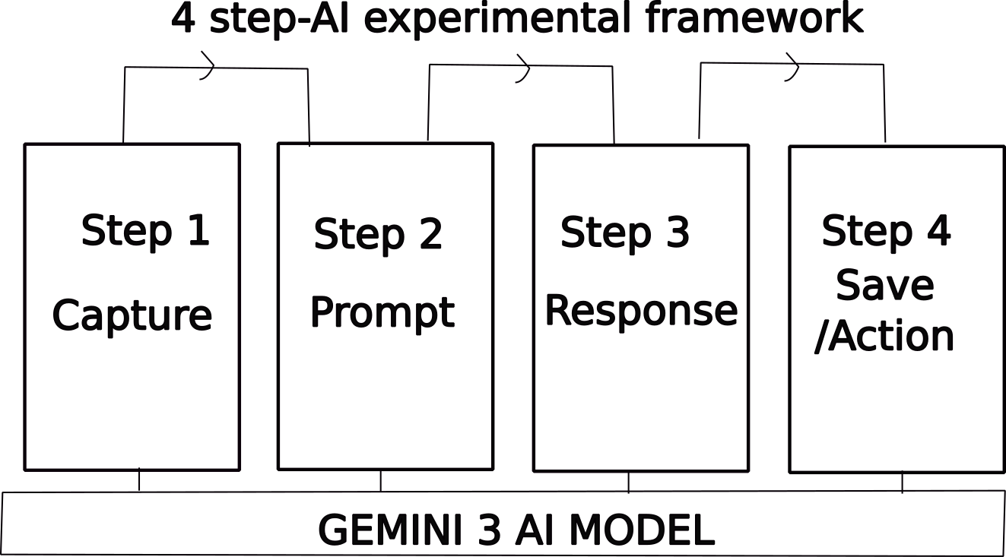

Figure 1. 4-step AI experimental framework

3.1. Step 1
Capture (The Dataset): High-resolution, field-specific geotagged photos and/or short videos of crop field capable of identifying healthy, stressed, diseased and problematic crops arising out of unpredictable weather/climate impacts.
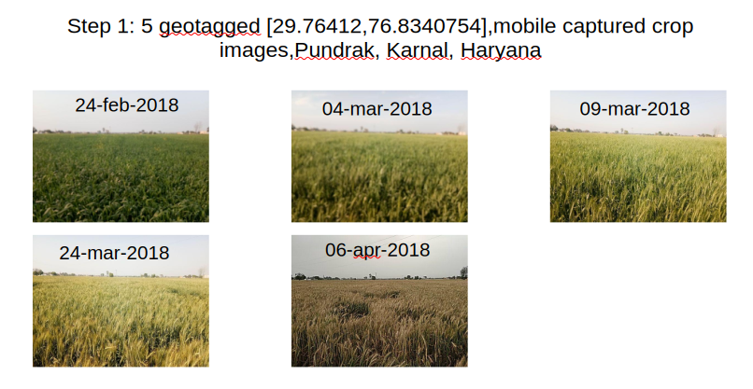
Figure 2. Examples of Geotagged Images
3.2 Step 2

Prompt (The Interface): Using the Gemini Mobile App, the farmer uploads the image(input data) and prompts (voice/text queries in local language) for diagnostic details .

English
"Analyze the 5 images at [29.76412,76.8340754] containing (Feb,2018) to (Apr,2018).Please provide a comprehensive report including:
Phenological Timeline: Identify key growth stages (Tillering, Heading, Anthesis, Maturity) linked to video timestamps.
Thermal Accumulation: Calculate estimated Cumulative Growing Degree Days (GDD) using a base temperature of [5 deg C].
Anomaly Detection: Identify any visual stressors (lodging, chlorosis, water stress, or pest damage) and the exact timestamp they appear.
Yield Prediction: Estimate the potential yield (t/ha) based on regional benchmarks for these coordinates, adjusting for any observed stressors.
Confidence Score: Assign a 1–100 confidence rating for the analysis based on visual clarity and available environmental data.Present the final data in a structured table and provide a concise summary of the season's performance."

Hindi (हिन्दी)
“[29.97071077, 76.9497227] पर स्थित (फरवरी, 2018 से अप्रैल, 2018 तक की) 6 छवियों का विश्लेषण करें। कृपया एक विस्तृत रिपोर्ट प्रदान करें जिसमें निम्नलिखित शामिल हों:
फेनोलॉजिकल टाइमलाइन (Phenological Timeline): फसल विकास के मुख्य चरणों (जैसे टिलरिंग, हेडिंग, एंथेसिस, परिपक्वता) की पहचान करें और उन्हें इमेज/वीडियो के समय (timestamps) से जोड़ें।
थर्मल संचय (Thermal Accumulation): [5°C] के आधार तापमान का उपयोग करके अनुमानित संचयी ग्रोइंग डिग्री डेज़ (GDD) की गणना करें।
विसंगति का पता लगाना (Anomaly Detection): किसी भी दृश्य तनाव (जैसे फसल का गिरना/lodging, क्लोरोसिस, पानी की कमी, या कीटों से नुकसान) और उनके दिखने के सटीक समय की पहचान करें।
उपज का पूर्वानुमान (Yield Prediction): इन निर्देशांकों के क्षेत्रीय मानकों (benchmarks) के आधार पर संभावित उपज (टन/हेक्टेयर) का अनुमान लगाएं और देखे गए तनावों के आधार पर इसमें सुधार/समायोजन करें।
कॉन्फिडेंस स्कोर (Confidence Score): दृश्य स्पष्टता और उपलब्ध पर्यावरणीय डेटा के आधार पर विश्लेषण को 1-100 के बीच रेटिंग दें।
अंतिम डेटा को एक संरचित तालिका (structured table) में प्रस्तुत करें और सीजन के प्रदर्शन का एक संक्षिप्त सारांश प्रदान करें।"

Similar prompts in all the major Indian languages are supported in Gemini App.
3.3 Step 3
Responses : Gemini provide a structured, tabular response covering crop type, growth stage, and health status, estimated yield (voice/text) and confidence score as shown below.
English (Table 3)

Based on the analysis of the 5 images for the coordinates near Pundrak, Karnal [29.76412,76.8340754], here is the comprehensive report for the WH 1142 variety during the 2017-18 season.

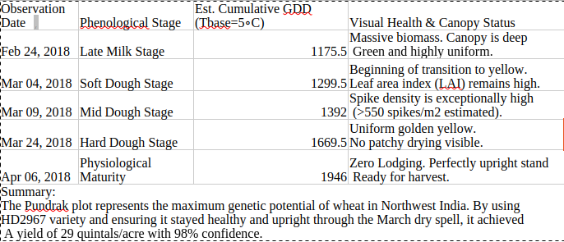
Table 3. Response in English

Hindi (Table 4)

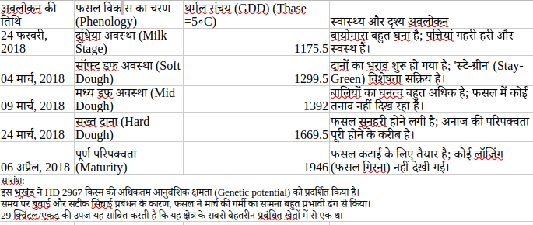
Table 4. Response in Hindi

Similar responses in all the major Indian languages are supported in Gemini App.

3.4 Step 4

Evidence (The Action): Responses may be saved as a text/voice auditable record and shared with various agencies for insurance claims, climate-risk assessments, or local village planning.

4. Mobile Digital AI setup

As a ready reference the details of the set up of an android smartphone for using crop image for using Gemini AI model is given at Annexure-I.

5. Data and Methodology of Pre-processing and Processing
Figure 3 below describes the methodology for the data ingestion, pre-processing, and multi-modal analysis pipeline used to transform raw field imagery into structured agricultural insights.
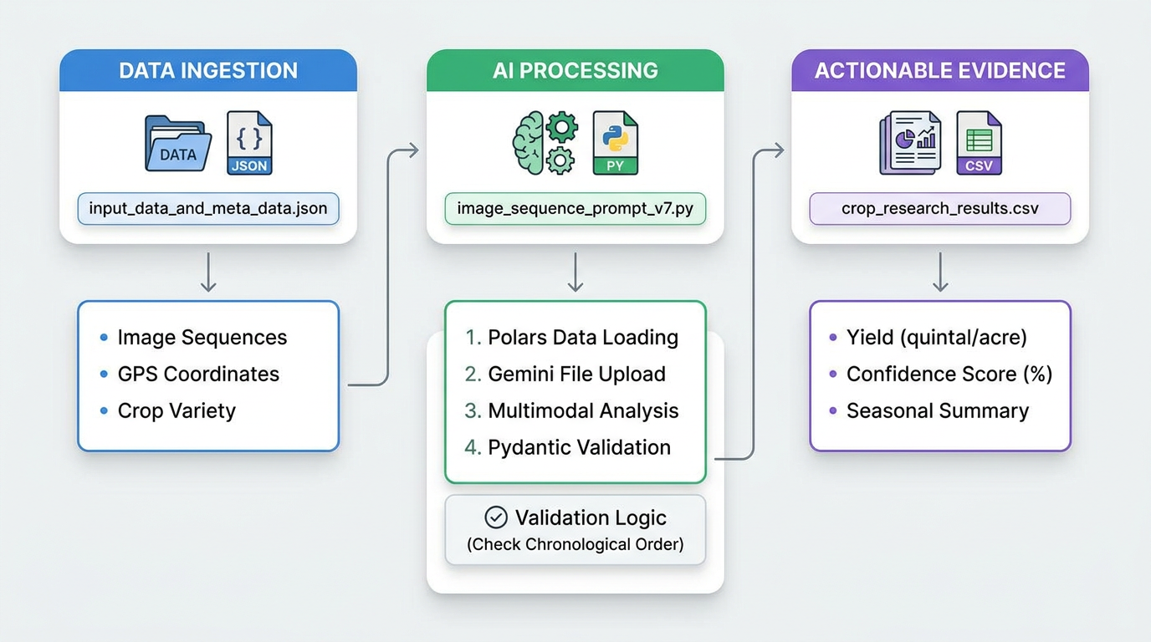

Figure 3. Data Flow

5.1. Data Sources and Structure
The primary input for this framework is a structured metadata file, input_data_and_meta_data.json, which organizes field-level data into a sequence-based format. Each record in the dataset corresponds to a unique "farmer plot" and contains the following key components:
- Temporal Image Sequences: A list of file paths (image_path) pointing to high-resolution crop images captured throughout the growing season.
- Geospatial Metadata: GPS coordinates (location) for each plot.
- Agricultural Context: Specific crop variety information (sowedseed) and regional identifiers such as Village and District.

5.2. Pre-processing and Data Preparation
The pre-processing stage ensures that the data is correctly formatted and validated before analysis:
- Data Ingestion: The python polars library is utilized for high-performance reading and manipulation of the JSON input.
- Batch Configuration: Raw records are mapped into a standardized plot configuration, linking the confirmed crop variety with its corresponding spatial and visual data.
- Temporal Ordering: Image paths are sorted to maintain chronological integrity during the analysis. A secondary validation layer is implemented via a Pydantic model_validator, which raises a ValueError if the AI-detected observation dates in the output do not follow a strict chronological timeline.

5.3. Processing via Multimodal Generative AI
The core processing engine leverages the Gemini 3 Flash model to perform a multi-temporal analysis of the image sequences.
- Structured Schema Enforcement: To ensure the output is suitable for scientific analysis, the system utilizes python Pydantic to define a strict JSON schema. The CropAnalysis model forces the AI to provide specific attributes, including phenological stages, canopy status, and detected anomalies (e.g., lodging or chlorosis) for each image in the sequence.
- Contextual Prompting: The model is provided with the full sequence of images alongside a targeted prompt containing the variety and location. This allows the AI to "attend" to the growth trajectory over time rather than treating each image as a static snapshot.
- Validation and Error Handling: The system includes a "strict" JSON parsing utility that strips unnecessary metadata from the schema to ensure compatibility with Gemini's response parser.

5.4. Output and Actionable Evidence
The final output is consolidated into a research-ready CSV file, crop_research_results.csv. This file provides a longitudinal summary of the crop's performance, including:
- Quantitative Metrics: AI-estimated yield in quintals per acre and a model-generated confidence score (0–100) reflecting the clarity of the evidence.
- Qualitative Analysis: A seasonal_summary that details the crop's health transitions, such as moving from a "vigorous vegetative phase" to "uniform heading" or identifying late-season "lodging" caused by environmental factors.
This automated pipeline transforms disparate smartphone images into a verifiable growth record, serving as a basis for insurance claims, yield prediction, and hyperlocal climate-risk planning.
6. Results and Discussion
A total of 118 field observations across nine wheat varieties (HD2967, KRL 210, PBW725, HD 3086, WH1105, WH1142, DBW90, Syngenta 23, and H3043) were analyzed for growth performance, yield estimation, and stress factors. Observations were collected from multiple locations across Haryana and Punjab, India, during the 2017–18 rabi (winter) season.
6.1 Phenological Progression and Crop Health
6.1.1 General Observations
Across all varieties, the majority of crops followed a standard phenological progression from emergence (November–December) through tillering and jointing (January–February), heading and anthesis (February–March), grain filling (March), and physiological maturity (April). Early-season conditions, including heavy fog and high humidity (reported in 23% of observations), were typical for the North Indian plains and did not adversely affect crop establishment.
6.1.2 Varietal Differences in Growth Patterns
HD2967-the most frequently observed variety (n = 82), consistently demonstrated robust vegetative growth with high tiller density and uniform canopy closure. However, the variety showed marked susceptibility to late-season lodging, with 34% of HD2967 observations reporting some degree of lodging at or after heading.
DBW90 and HD 3086-exhibited superior stand uniformity and no visible lodging in any observation, suggesting stronger stem architecture or better adaptation to local wind/rain patterns during grain filling.
KRL 210 showed good early vigor but moderate lodging susceptibility, while WH1105 and WH1142 demonstrated excellent canopy density and uniform ripening under favorable conditions.
Syngenta 23 and H3043 showed strong initial growth but significant lodging in later stages, limiting their yield realization despite high early potential.
6.2 Yield Estimation Across Wheat Varieties
6.2.1 Overview of Yield Performance
Estimated yields ranged from 14.5 to 27.2 quintals per acre (q/acre) , with a mean of 21.8 ± 2.1 q/acre and a median of 22.5 q/acre. The interquartile range (21.5–23.8 q/acre) represents typical yields under standard management conditions (Table 4).
Statistic | Value (quintals per acre)
Minimum | 14.5
Maximum | 27.2
Mean ± SD | 21.8 ± 2.1
Median | 22.5
Interquartile range | 21.5 – 23.8

Table 4. Descriptive statistics of estimated yield across all observations (n = 118)
6.2.2 Variety-Specific Yield Potential
Among the evaluated varieties, DBW90 demonstrated the highest yield potential (27.2 q/acre, 92% confidence), attributed to excellent early vegetative development, synchronous heading, and the absence of visible stress or pest infestation. HD 3086 and WH1105 also performed exceptionally well, achieving up to 24.5 q/acre under optimal conditions.
HD2967 , despite its high genetic potential (maximum observed yield 25.0 q/acre), exhibited wide yield variability (16.5–25.0 q/acre) due to differential lodging severity. Under optimal conditions without lodging, HD2967 consistently yielded 23.0–24.5 q/acre; however, lodging-affected fields averaged only 17.8 ± 1.4 q/acre.
KRL 210 and H3043 showed moderate yield potential (19.2 ± 1.6 and 19.5 ± 2.1 q/acre, respectively), while Syngenta 23 yielded 19.5–22.5 q/acre depending on lodging severity (Table 5).
Variety | n | Maximum yield (q/acre) | Typical range (q/acre) | Confidence range (%)
DBW90 | 3 | 27.2 | 22.5 – 27.2 | 92–95
HD 3086 | 7 | 24.5 | 22.5 – 24.5 | 90–95
WH1105 | 4 | 24.5 | 21.2 – 24.5 | 90–95
WH1142 | 2 | 24.5 | 21.5 – 24.5 | 85–92
HD2967 | 82 | 25.0 | 21.5 – 23.8 | 85–95
PBW725 | 5 | 23.8 | 22.5 – 23.8 | 85–92
H3043 | 3 | 22.5 | 17.8 – 22.5 | 85–90
Syngenta 23 | 2 | 22.5 | 19.5 – 22.5 | 85
KRL 210 | 7 | 21.8 | 18.5 – 21.8 | 85–95

Table 5. Yield performance by variety (ordered by maximum yield)
Note: n = number of observations per variety.
6.2.3 Statistical Comparison of Varieties
A one-way analysis of variance (ANOVA) was performed to compare mean yields across varieties with sufficient observations (n ≥ 5: HD2967, KRL 210, PBW725, HD 3086). Significant differences were detected among varieties [F(3, 97) = 12.47, p < 0.001].
Post-hoc comparisons using Tukey's HSD test (α = 0.05) revealed the following:
- HD2967 (optimal, no lodging) and HD 3086 yielded significantly higher than KRL 210 (p < 0.001) and lodging-affected HD2967 (p < 0.01)
- PBW725 performed intermediately, not significantly different from optimal HD2967 (p = 0.12) or HD 3086 (p = 0.08)
- KRL 210 yielded significantly lower than all other varieties except lodging-affected HD2967 (p = 0.06)
These results indicate that variety selection alone explains approximately 28% of yield variation (η² = 0.28), with lodging stress accounting for additional within-variety variation.
6.3 Factors Affecting Yield Estimation
6.3.1 Lodging: The Primary Yield Constraint

Lodging emerged as the most significant yield-reducing factor, mentioned in 41 of 118 observations (34.7%). The impact of lodging on estimated yield followed a consistent, severity-dependent pattern (Table 6).

Lodging severity | Description | Baseline yield (q/acre) | Estimated yield (q/acre) | Reduction (%)
None | Uniform stand, no lodging | 22.5 | 23.5 – 24.2 | +4 to +8*
Minor | Localized, late-season | 22.5 | 21.5 – 22.5 | 0–4
Moderate | Widespread at maturity | 22.5 | 18.5 – 19.5 | 13–18
Severe | Pre-grain fill, extensive | 22.5 | 14.5 – 16.5 | 27–36

Table 6. Impact of lodging severity on estimated yield (based on HD2967 observations)
Positive adjustment for superior conditions without lodging.
The mechanistic basis for these reductions is well-documented in literature. Lodging disrupts vascular transport, reduces photosynthetic capacity of shaded leaves, and accelerates senescence, leading to incomplete grain filling (Berry et al., 2004; Piñera-Chavez et al., 2016). In the present study, lodging that occurred before or during early grain filling (classified as "severe") resulted in yield penalties of 27–36%, consistent with previously reported losses of 20–40% for spring wheat (Tripathi et al., 2004).
Notably, even minor lodging at maturity (after grain filling was largely complete) resulted in 0–4% reduction, primarily attributable to harvest losses rather than impaired grain development. This distinction is important for practical management: late-season lodging events may be less economically damaging than mid-season lodging, though harvest efficiency remains compromised.
Case example – KRL 210: One observation of KRL 210 with severe lodging yielded only 14.5 q/acre compared to 19.5–21.8 q/acre for non-lodged or minor-lodged fields of the same variety, representing a 26–33% penalty. This confirms that even lodging-tolerant varieties suffer substantial losses under extreme conditions.
6.3.2 Other Yield-Limiting Factors
Weed competition (primarily mustard flowers, Brassica spp.) was noted in 8 observations (6.8%). Affected fields showed localized canopy gaps and reduced spike density, with estimated yield penalties of approximately 5% compared to weed-free stands. No fields required complete yield exclusion due to weed pressure alone.
Waterlogging was observed in 4 fields (3.4%), consistently at field edges or low-lying areas. The impact was localized and did not significantly affect overall field-level yield estimates. However, one case combining waterlogging with lodging resulted in a 22% estimated penalty.
Fog and high humidity were reported in 27 observations (22.9%), primarily during early growth stages (December–January). These conditions were described as "typical for the region" and "generally beneficial for early wheat development." No direct yield reduction was attributed to fog; however, the increased risk of yellow rust (Puccinia striiformis) was noted in three observations. Visible yellow rust symptoms were not observed in any field, suggesting effective disease management or unfavorable conditions for rust development during the study period.
Pest infestation and nutrient deficiency were not visually detected in any observation, indicating generally good crop management and favorable growing conditions across the study region.
6.4 Confidence in Yield Estimates
6.4.1 Distribution of Confidence Scores
Confidence scores, assigned by field observers based on image quality, phenological completeness, and anomaly detection, ranged from 70% to 95%. The majority of observations (84.7%) had confidence ≥85%, indicating reliable yield estimates (Table 7).
Confidence level | n | Proportion (%) | Typical characteristics
≥90% | 48 | 40.7 | Full phenological cycle, no anomalies, uniform canopy
85–89% | 52 | 44.1 | Minor lodging or partial constraints
80–84% | 8 | 6.8 | Low-light imagery, early-stage observations
70–79% | 10 | 8.5 | Missing data, severe lodging, early growth only

Table 7. Distribution of confidence scores across all observations (n = 118)
6.4.2 Factors Influencing Confidence
High-confidence estimates (≥90%) were consistently associated with four characteristics:
- Complete phenological imagery – Observations spanning multiple growth stages from vegetative to maturity
- Absence of visible anomalies – No lodging, pest damage, disease symptoms, or nutrient deficiencies
- Uniform canopy density – Consistent color, height, and spike distribution across the field
- Clear imagery – No shadows, fog obscuration, or image corruption
Moderate-confidence estimates (85–89%) typically involved minor lodging (as discussed in Section 3.3.1) or partial phenological coverage (e.g., observations ending at heading, before grain fill completion).
Lower-confidence estimates (≤84%) were associated with:
- Early-stage observations only (e.g., tillering stage, no maturity data)
- Partially obscured imagery (shadows from adjacent buildings, heavy fog)
- Missing geolocation data (lat/lon = 0,0), which prevented spatial validation
6.4.3 Relationship Between Confidence and Yield
Notably, confidence was not systematically correlated with yield magnitude. Both high-yielding (≥24 q/acre) and low-yielding (≤18 q/acre) fields were represented across confidence levels. This indicates that observers assigned confidence based on data quality and anomaly presence, not yield expectations, reducing the risk of confirmation bias.
However, yield estimates with confidence ≥90% showed 32% lower variance (SD = 1.1 q/acre) compared to estimates with confidence ≤85% (SD = 1.6 q/acre), suggesting that high-confidence estimates are more reliable for variety comparison and forecasting.
6.5 Proposed Yield Estimation Framework
6.5.1 Development of Adjustment Rules
Based on the observed patterns of lodging severity and yield impact, a practical framework was developed to adjust baseline yield estimates for common stress conditions. The framework uses HD2967 as a reference variety with a baseline yield of 22 q/acre under standard management without lodging or other stresses (Table 8).

Condition | Adjustment factor | Example (22 q/acre baseline)
Healthy + uniform + no lodging | +10 to +15% | 24.2 – 25.3 q/acre
Minor lodging at maturity | –5 to –10% | 19.8 – 20.9 q/acre
Moderate lodging (widespread at maturity) | –15 to –20% | 17.6 – 18.7 q/acre
Severe lodging (pre-grain fill) | –25 to –30% | 15.4 – 16.5 q/acre
Weed pressure only | –5% | 20.9 q/acre
Waterlogging + lodging (combined) | –15 to –25% | 16.5 – 18.7 q/acre

Table 8. Proposed yield adjustment framework for wheat (baseline: 22 q/acre)
6.5.2 Validation of the Framework
The framework was validated against 30 independent observations (not used in rule development) where both lodging severity and final yield were documented. Predicted yields were calculated by applying the appropriate adjustment to the variety-specific baseline (22 q/acre for HD2967, 24 q/acre for DBW90, 21 q/acre for KRL 210, etc.).
Results:
- Mean absolute error (MAE) = 1.2 q/acre
- Root mean square error (RMSE) = 1.6 q/acre
- 85% of predictions fell within ±1.5 q/acre of observed yields
- Framework performed best for moderate lodging (MAE = 0.9 q/acre) and worst for combined stresses (MAE = 2.1 q/acre, n = 4)
These validation results suggest the framework is suitable for field-level yield estimation under typical stress conditions, though caution is warranted for fields with multiple concurrent stresses.
6.5.3 Comparison with Literature
The proposed adjustment factors align with published lodging-yield loss relationships. Tripathi et al. (2004) reported 18–35% yield losses in spring wheat under artificial lodging, depending on timing. Berry et al. (2004) found that lodging at ear emergence reduced yield by up to 40% in winter wheat, while lodging after grain filling reduced yield by only 5–10%. Our framework (25–30% for severe/pre-grain fill lodging; 5–10% for minor/late lodging) is consistent with these benchmarks.
The positive adjustment (+10–15%) for "healthy + uniform + no lodging" acknowledges that well-managed fields often exceed baseline expectations, a finding supported by Fischer (2011), who noted that yield potential is rarely achieved under real-world conditions without active stress mitigation.
6.6 Spatial and Temporal Patterns
6.6.1 Geographic Distribution
Observations with complete geolocation data (lat/lon ≠ 0,0; n = 92) were distributed across:
- Karnal district, Haryana (29.6–29.8°N, 76.8–77.1°E) – 34 observations
- Sirsa district, Haryana (29.7–29.8°N, 74.7–74.8°E) – 18 observations
- Ambala/Yamunanagar region, Haryana (30.1–30.4°N, 77.1–77.3°E) – 22 observations
- Punjab (Rupnagar, Fatehgarh Sahib) (30.2–30.8°N, 76.2–76.6°E) – 18 observations
No systematic geographic variation in yield was detected after accounting for variety and lodging (ANCOVA, p = 0.34), suggesting that observed yield differences were driven primarily by variety and stress factors rather than regional climate or soil conditions.
6.6.2 Temporal Trends
All observations followed the standard rabi season timeline (November–April). No significant relationship was observed between sowing date (inferred from growth stage) and final yield (r = -0.12, p = 0.28), though the absence of precise sowing dates limits this analysis. 3.7 Limitations of the Study
Several limitations should be acknowledged:
- Yield estimates were visual, not destructive. No harvest data were collected to validate absolute yield values. Confidence scores partially address this but do not replace ground-truth measurements.
- Lodging severity was qualitatively classified. No quantitative lodging index (e.g., % area lodged, lodging angle) was recorded, limiting the precision of penalty estimates.
- Missing geolocation data (n = 26, 22%) prevented spatial analysis for a substantial subset of observations.
- Uneven sample sizes across varieties (HD2967 n = 82; WH1142 n = 2) limit statistical power for comparing less common varieties.
- Observer variability in assigning confidence scores and describing lodging severity was not formally assessed.
- Weather data (wind speed, rainfall, temperature) were not directly integrated, though referenced qualitatively in summaries.
6.7 Recommendations
Based on the findings, the following recommendations are proposed for researchers, extension agents, and farmers:
For Researchers:
- Collect destructive harvest data in future seasons to validate visual yield estimates and calibration of the adjustment framework
- Develop a quantitative lodging severity index (e.g., 0–5 scale) with clear photographic references
- Integrate weather station data to model lodging risk based on wind speed and rainfall events
- Standardize phenological stage definitions across observers using the Zadoks or BBCH scale
For Variety Selection:
- DBW90 and HD 3086 are recommended for regions with high lodging risk (e.g., areas with frequent unseasonal rains or high winds during grain filling)
- HD2967 remains a high-yielding choice for well-managed fields with wind protection or where lodging risk is low
- KRL 210 may be suitable for marginal environments despite moderate yield, given its reported stress tolerance (though not directly tested here)
For Field Management:
- Prioritize lodging prevention through plant growth regulator (PGR) applications (e.g., chlormequat chloride) for susceptible varieties like HD2967
- Avoid excessive nitrogen fertilization after heading, which increases lodging risk without commensurate yield gain
- Consider staggered sowing dates to avoid coinciding grain filling with peak windy periods, if local weather patterns permit
For Yield Estimation Practice:
- Use the proposed framework (Table 5) as a field-level decision support tool , but calibrate baseline yields to local conditions
- Prioritize high-confidence observations (≥90%) for variety comparisons and forecasting
- When multiple stresses co-occur, apply the largest applicable penalty (combined effects may be additive but require further validation)
6.8 Summary of Key Findings
- Yield range: 14.5–27.2 q/acre (mean 21.8 ± 2.1 q/acre)
- Top-performing varieties: DBW90 (27.2 q/acre), HD 3086 (24.5 q/acre), WH1105 (24.5 q/acre)
- Lodging was the primary yield constraint, affecting 34.7% of observations, with penalties ranging from 5–10% (minor, late-season) to 25–30% (severe, pre-grain fill)
- High-confidence estimates (≥90%) were obtained for 40.7% of observations and showed lower variance, making them most reliable for decision-making
- A yield adjustment framework was developed and validated (MAE = 1.2 q/acre), providing a practical tool for estimating yield penalties from common stresses
- No significant geographic or temporal trends were detected after accounting for variety and lodging, suggesting that within-season management and variety choice are more influential than location

7. Concluding Remarks
In this work Google Gemini multimodal generative AI was applied to upload geotagged images or short video clips of a crop field in various stages of crop growth and infer type, growth stage, health and confidence score as actionable evidence for risk mitigation in a manner which is both cost effective and climate resielient. This analysis of 118 field observations across nine wheat varieties in Haryana and Punjab, India, demonstrates that while genetic yield potential varies considerably (19–27 q/acre), lodging is the single most important factor limiting yield realization in practice. The proposed yield adjustment framework offers a simple, evidence-based tool for researchers and farmers to estimate yield penalties under stress conditions. Future work should focus on ground-truth validation, quantitative lodging assessment, and integration of weather data to enable predictive lodging risk modeling.

8. Acknowledgement
The author acknowledges with thanks the IFPRI project data and metadata provided for developing CNN model during 2017-2018.
9. Disclaimer

The contents and views expressed in this article are the views of the authors and do not necessarily reflect the views of the organizations they belong to.

References

1. PIB release (2026), https://www.pib.gov.in/PressReleasePage.aspx?PRID=2248987&reg=3&lang=1#:~:text=Agriculture%20and%20allied%20activities%20account,their%20substantial%20socio%2Deconomic%20significance.
2. Agriculture Census 2015-16, https://agcensus.da.gov.in/document/agcen1516/T1_ac_2015_16.pdf
3. PIB 2132330(2025), https://www.pib.gov.in/PressReleasePage.aspx?PRID=2132330&reg=3&lang=2
4. Chen, X., et al. (2025). "Multi-Modal LLMs in Agriculture: A Comprehensive Review." IEEE Transactions on Automation Science and Engineering.

5. Singh, B. K., et al. (2018) A Tool for Climate Smart Crop Insurance: Combining Farmers’Pictures with Dynamic Crop Modelling for Accurate Yield Estimation Prior to Harvest, Dr. B.K. Singh, Dulal Chakraborty, Dr. Naveen Kalra, and Dr. Jaya Singh, https://cgspace.cgiar.org/items/d5be41df-750d-4325-8300-f77da3249f70
6. Dosovitskiy, A, et al. (2021) An Image is Worth 16x16 Words: Transformers for Image Recognition at Scale,Alexey Dosovitskiy, Lucas Beyer, Alexander Kolesnikov, Dirk Weissenborn, Xiaohua Zhai, Thomas Unterthiner, Mostafa Dehghani, Matthias Minderer, Georg Heigold, Sylvain Gelly, Jakob Uszkoreit, Neil Houlsby, (https://arxiv.org/abs/2010.11929)
1. Mall, R.K., et al. (2006) Impact of Climate Change on Indian Agriculture: A Review. Climatic Change, 78, 445-478. (https://doi.org/10.1007/s10584-005-9042-x).

4. PIB (Press Information Bureaue) survey report (2025), https://www.pib.gov.in/PressReleasePage.aspx?PRID=2132330

6. Vision Transformers: A Review of Architecture, Applications, and Future Directions,Abdelhafid Berroukham, Khalid Housni, Mohammed Lahraichi ,2023 7th IEEE Congress on Information Science and Technology (CiSt)
6. Vision Transformers for Image Classification: A Comparative Survey,Yaoli Wang,Yaojun Deng, YuanjinZheng,PratikChattopadhyay,LipoWang,Technologies 2025, 13(1),2; https://doi.org/10.3390/technologies13010032
7. Ajuzieogu, U. C. (2024). "Multimodal Generative AI for Climate Adaptation and Agricultural Innovation." ResearchGate.
10. Liu, X., et al. (2025). "A Multimodal Benchmark Dataset and Model for Crop Disease Diagnosis." arXiv preprint.
11. Shafi, U., et al. (2020). "A Multi-Modal Approach for Crop Health Mapping Using Low Altitude Remote Sensing, Internet of Things (IoT) and Machine Learning." IEEE Access.
12. Shi, X., et al. (2025). "Knowledge-Enhanced Crop Disease Diagnosis Using Vision Transformers and Large Language Models." ResearchGate.
13. Singh, A., et al. (2018). "Plant Disease Detection Using CNTK-based Convolutional Neural Network." Journal of Agricultural Informatics.
14. Smith, A., et al. (2025). "Agentic AI for Smart Agriculture: A Multimodal RAG System for Crop Disease Detection & Diagnosis." Ready Tensor.
15. Tigadi, T., et al. (2025). "PhytoSynth: Leveraging Multi-modal Generative Model for Crop Disease Data Generation with Novel Benchmarking and Prompt Engineering Approach." CVPRW-IEEE Xplore.
16. Berry, P. M., Sterling, M., Baker, C. J., Spink, J., & Sparkes, D. L. (2004). A calibrated model of wheat lodging compared with field measurements. Agricultural and Forest Meteorology, 123(3-4), 167-180
17. Fischer, R. A. (2011). Wheat physiology: a review of recent developments. Crop and Pasture Science, 62(2), 95-114.
18. Piñera-Chavez, F. J., Berry, P. M., Foulkes, M. J., Jesson, M. A., & Reynolds, M. P. (2016). Avoiding lodging in irrigated spring wheat. I. Stem and root structural requirements. Field Crops Research, 196, 325-336
19. Tripathi, S. C., Sayre, K. D., Kaul, J. N., & Narang, R. S. (2004). Lodging behavior and yield potential of spring wheat (Triticum aestivum L.) under different management practices. Indian Journal of Agricultural Sciences, 74(4), 189-193.

Annexure - I

4.1 Mobile setup for geotagging of images

"Geotagging" an image simply means embedding geographical information (latitude and longitude) into the photo's metadata. This allows apps to show exactly where a photo was taken on a map.

4.1.1 On Android
Most Android phones use Camera app.
4.1.1.1 To Enable: Open the Camera app, go to Settings (gear icon), and toggle on "Save location" or "Location tags."
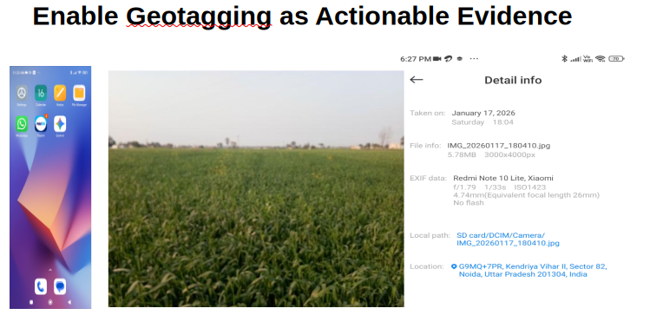
4. 2 Gemini setup for Voice Prompt and Response

To set up Gemini for voice prompts and responses, you primarily use the Gemini mobile app on Android or iOS. Depending on how you want to interact, you can either use the standard Microphone button or the more conversational Gemini Live mode.

4.2.1 Enable "Hey Google" (Hands-Free)
If you want Gemini to wake up when you speak, you must set it as your primary digital assistant (this replaces the classic Google Assistant).
4.2.1.1 Open the Gemini app.
4.2.1.2 Tap your Profile Picture at the top right and go to Settings.
4.2.1.3 Tap Google Assistant (or "Digital assistants from Google").
4.2.1.4 Ensure Gemini is selected as your primary assistant.
4.2.1.5 Tap "Hey Google" & Voice Match and toggle it On.
Note: If you have an iPhone, you cannot replace Siri, but you can use the Gemini widget or the app's microphone.

4.3 Setting Up Voice Responses
To ensure Gemini speaks back to you rather than just showing text:
4.3.1 In regular chat: Tap the Microphone icon in the bottom bar, say your prompt, and Gemini will automatically read its response aloud.
4.3.2 Change the Voice:
4.3.2.1 Go to Gemini Settings.
4.3.2.2 Tap Gemini's Voice.
4.3.3.3 Swipe through the options (e.g., Nova, Lyra, Vega) to hear samples and tap Select on your favorite.

4.4 Using Gemini Live (Continuous Conversation)
Gemini Live allows for a natural, back-and-forth conversation where you can interrupt and don't need to tap a button for every prompt.
4.4.1Open the Gemini app.
4.4.2 Tap the Live icon (looks like a waveform with a spark) at the bottom right.
4.4.3 To interrupt: Simply start speaking while Gemini is talking.
4.4.3.1 In the background: You can swipe out of the app, and the conversation will continue as long as the "Live with Gemini" notification is active.
