Three Use Cases of Generative AI (GenAI) App for Gen-Z Farmers
Dulal Chakrabarti*
India Meteorological Department (Retired), New Delhi - 110 003, India
*C-120/PKT-7, Kendriya Vihar-II, Sector-82, Noida, Uttar Pradesh-201304
*Email: dulalchakrabarti@gmail.com

Field level monitoring of crop health is crucial for precision agriculture and climate risk management. This study proposes a simple field-ready and actionable digital analytic framework to empower the Gen-Z farmers by leveraging widespread smartphone penetration and COTS (Commercial Off The Shelf) Artificial Intelligence App (AI App) for real-time, field-specific crop diagnostics. Using a mobile application (Gemini Mobile App or OpenAI’s ChatGPT or Microsoft’s Copilot), farmers may capture geo-tagged images of stressed crops or a short video clip, submit voice or text queries in local languages, and receive structured, actionable insights. The output also serves as verifiable evidence for insurance claims and climate-risk planning.
Hyper-local Crop Health Monitoring
India achieved (PIB Release April 2026) a record food grain production of 357.73 MMT (Million Metric Ton) (2024-25), with horticulture output at 362.08 MMT, reflecting a strong shift towards high-value crops. India ranks among the top producers globally, with 150.18 MMT of rice, 117.94 MMT of wheat, 25.68 MMT of pulses, and 18.59 MMT of millets, reinforcing its role in global food security (2024-25). 96% village-level internet connectivity ( PIB - Results of Comprehensive Modular Survey (2025) coupled with 21+ hours of daily electricity opens a transformational infrastructure frontier: enabling Gen-Z farmers to use generative AI as a real-time diagnostic and decision-making tool in the face of climate extremes, crop stress, and insurance disputes. With over 69 million smartphone users in rural India this framework demonstrates a scalable, participatory pathway to climate-resilient agriculture, transforming farmers into hyper-local data collector as well as data steward when networked through cooperatives.

Generative Artificial Intelligence (GenAI)
Generative AI helps in monitoring soil health, farm mechanization and price realization in addition to crop health monitoring. The model's pre-training on vast, diverse datasets provides foundational knowledge of visual patterns, botanical concepts, and diagnostic reasoning [Rai et al., 2025]. The diagnostic process employs multimodal inference, where the model simultaneously processes two interconnected inputs: ( i ) Visual Image Input (`image bytes`): Raw pixel data of crop photographs containing leaves, stems, or fruits, potentially showing symptoms like discoloration, lesions, or wilting. (ii) Explicit Text Instruction (`prompt`): A detailed natural language command framing the task, defining the model's role, and specifying the desired output format. Gemini fuses these inputs through its attention mechanisms, weighing visual features against textual context. When prompted as an expert agronomist, the model biases its interpretation toward Phyto pathological or physiological cues, enabling reasoning that aligns with agricultural expertise. Yield estimation considers visual indicators of yield components (spikes per unit area, grains per spike, and grain weight) to estimate the crop yield in quintals per acre.

Data and Methodology
In case of a farmer, it is the crop data in a field which can earn money for him at hyper-local scale, and he needs to use his smartphone app only for this purpose. By uploading the image of a crop in the field to a Generative AI app like Google Gemini or Open AI’s ChatGPT or Microsoft’s Copilot a farmer can query and receive response about (1) crop type (2) growth stage (3) health (4) yield on maturity (5) stress signs from diseases or weather induced damages (6) remedial actions for crop insurance claims etc. and ultimately (7) archive these information as actionable evidence for monetized data stewardship. The steps below describe for actual ease of use by all farmers in respect of the crops in their specific fields -
Step 1 (Install and set up Google Gemini Live): Most of the Android phones come with Google Apps preinstalled. It can also be downloaded from Google Play Store and opened for conversation. All conversations are stored in the phone memory. Here is how it looks (Figure 1).
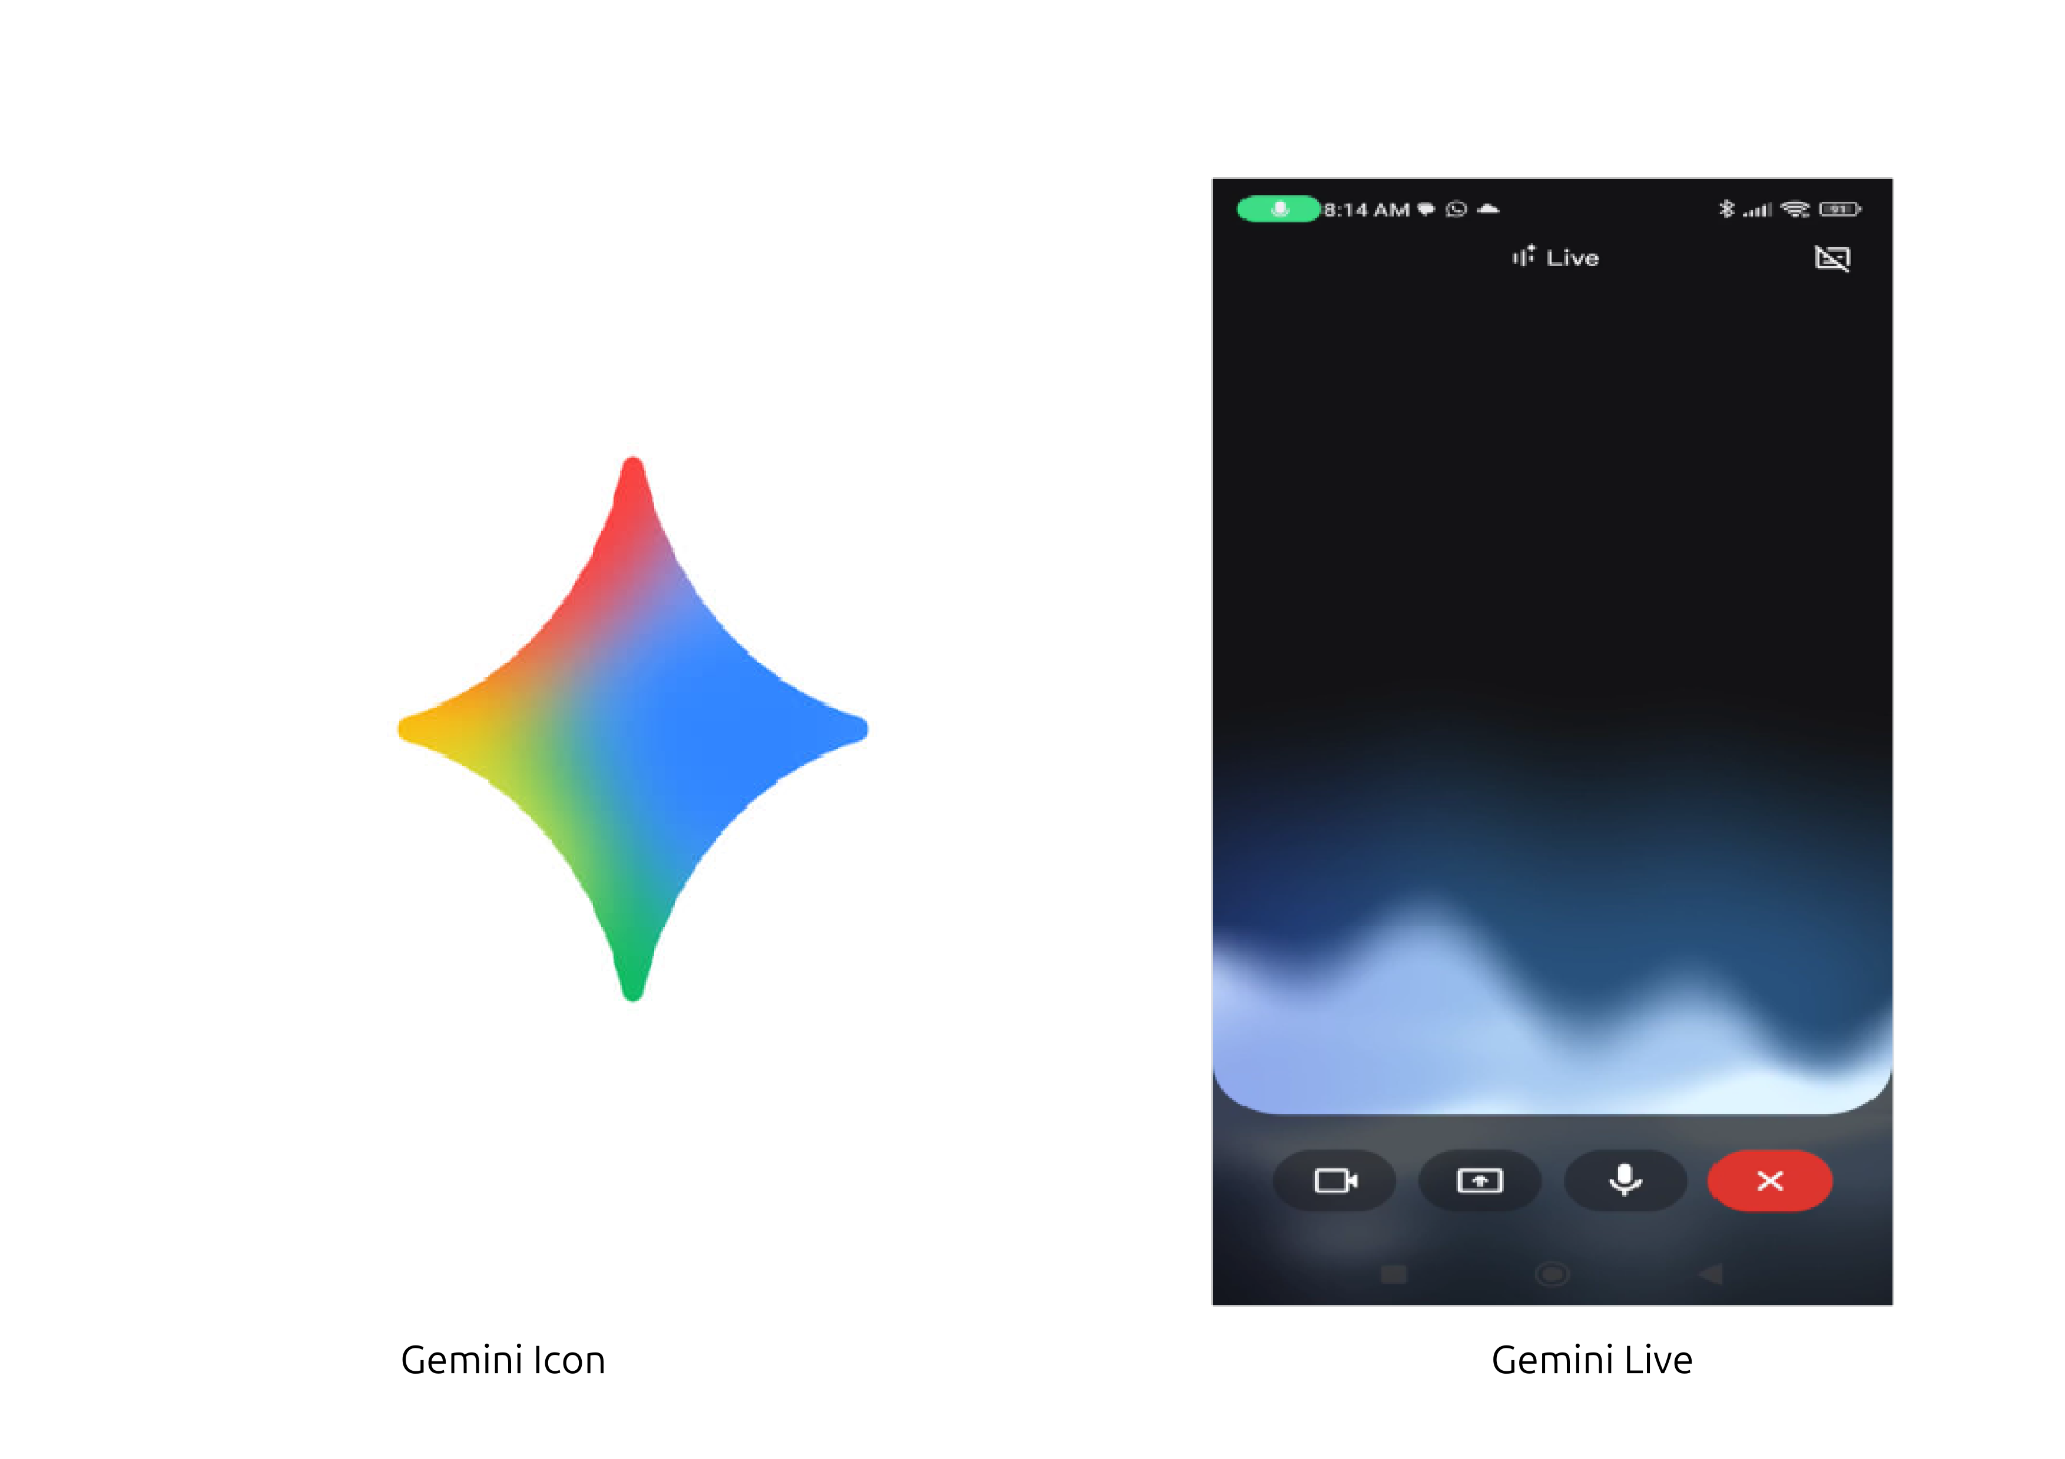
Figure 1. Gemini setup

Step 2 (Capture): Smartphone camera pointed towards the crop field with geo-tagging enabled and photo button tapped captures a geo-tagged image of the crop as the basic unit of data (Figure 2).
Case of healthy Crop
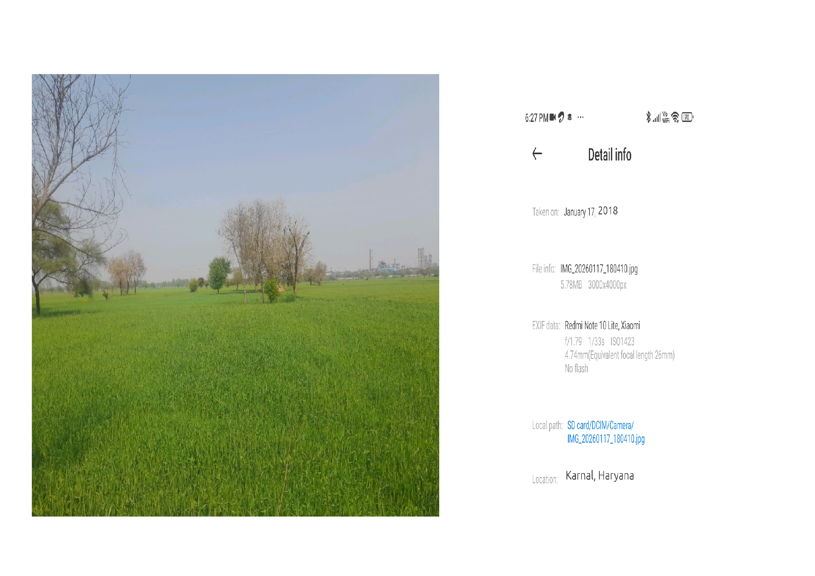
Figure 2: Geo-tagged crop image
Step 2a Prompt (The Interface): Using the Gemini Mobile App, the farmer uploads the image (Figure 2) and prompts (optionally asking Gemini using voice/text in local language) for details as noted below -
“Based on the image uploaded above from a field located in Karnal, Haryana, India during the Rabi season of 2017–18, please provide a summary of (1) crop type (2) growth stage (3) crop health (4) estimated yield in quintals/acre and (5) confidence score in scale of 1 to 100 in the form of a table”
Step 2b Response (The Interface): The response is generated in tabular form as shown under Table 1 below.
Table 1: Response to step 3a prompt
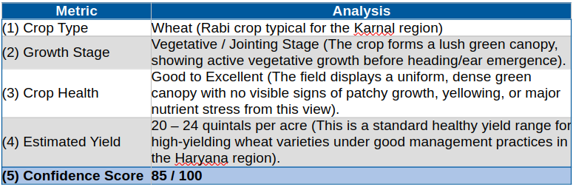
Case of Damaged Crop
Let us take another crop image with weather induced damage as an example (Figure 3).
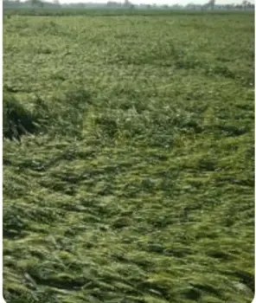

Figure 3: Wind lodged crop image
Step 3a Prompt (The Interface):
“Based on the image uploaded above from another field in Haryana during the rabi season of 2017–18, pl. provide a summary of (1) crop type (2) growth stage (3) crop health (4) estimated yield in quintals/acre and (5) confidence score in scale of 1 to 100 in the form of a table”
Step 3b Response (The Interface): The response is generated as shown under Table 2 below.

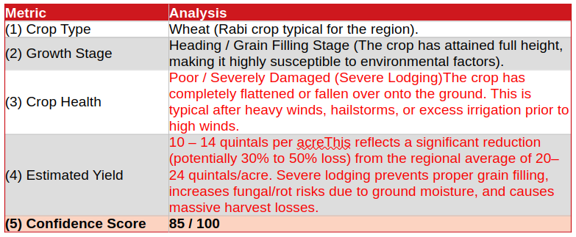
Table 2: Response to step 3b prompt

Case of a sequence of images
In this case images were captured at multiple phenological stages from emergence to physiological maturity. This constituted a temporal sequence of images for processing. One such sequence is shown as an example below (Figure 4).
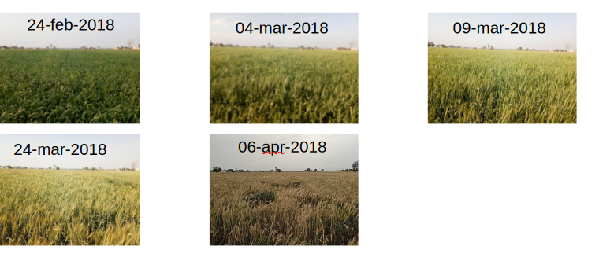
Figure 4. Geotagged [29.76412,76.83407] wheat field (Pundrak, Karnal, Haryana) images
Step 4a Prompt (The Interface): Using the Gemini Mobile App, the farmer uploads the images (Figure 4) and prompts (optionally asking Gemini using voice/text in local language) for details as noted below -
"Analyze the 5 images at [29.9784248,77.1770939] containing (Feb,2018) to (Apr,2018) of ‘HD2967’ wheat variety. Please provide a comprehensive report including: (1) Phenological Timeline: Identify key growth stages (Tillering, Heading, Anthesis, Maturity), (2) Thermal Accumulation: Calculate estimated Cumulative Growing Degree Days (GDD) using a base temperature of [5degC], (3) Anomaly Detection: Identify any visual stressors (lodging, chlorosis, water stress, or pest damage), (4) Yield Prediction: Estimate the potential yield (Quintal / Acre) based on regional benchmarks for these coordinates, (5) Confidence Score: Assign a 1–100 confidence rating for the analysis based on visual clarity and available environmental data. Present the final data in a structured table and provide a concise summary of the season's performance."
Step 4b Response (The Interface): The response is generated as shown under Table 3 below.
Table 3: Step 4b response
Observation Date | Phenological Stage | Est. Cumulative GDD (Tbase​=5∘C) | Visual Health & Observations
Feb 24, 2018 | Full heading | 871.5 | Inflorescence is fully emerged. Canopy is closed and uniform.
Mar 4, 2018 | Anthesis / Flowering Stage | 971.5 | Flowering. The field is very dense, suggesting good nutrient management.
Mar 09, 2018 | Anthesis / Milk Stage | 1280 | Flowering. The field is very dense, suggesting good nutrient management.
Mar 24, 2018 | Grain set / Minor Lodging | 1798 | Field has turned almost golden. Minor lodging seen
Apr 06,2018 | Physiological Maturity | 1800 | Ready for harvest
Summary: The HD2967 wheat variety exhibited excellent growth throughout the season. It maintained canopy health through the critical booting and heading stages in February and March. Grain filling proceeded normally under favorable conditions, concluding with a well-matured crop by mid-April. Minor lodging in late March did not significantly impact the overall high yield potential of 22.8 quintals per acre.

Conclusion
Press enter or click to view image in full size

Thus, the project has demonstrated that a thoughtfully engineered Generative AI framework can serve as a powerful force multiplier in farming practices. By leveraging multimodal understanding and enforcing rigorous output structure, it automates conversion of raw imagery into structured, analyzable data. While not replacing expert agronomists, it acts as a scalable first-pass diagnostic tool, capable of monitoring vast areas and flagging potential issues for targeted human investigation, thereby making crop health surveillance more proactive, efficient, and data-rich. It is also demonstrated in this study that any farmer irrespective of being tech savvy or not can use voice prompt (speak to Gemini in any major local Indian language) to extract actionable response and record and save for future use.
Acknowledgment
The author acknowledges with thanks M/s BKC WeatherSys Pvt. Ltd ( https://weathersysbkc.com/ ) and also IFPRI (International Food Policy Research Institute) (Singh, B. K., et al. (2018)) for providing with data and support to this work.
Disclaimer
The contents and views expressed in this article are the views of the authors and do not necessarily reflect the views of the organizations they belong to.
References
1. PIB Results of Comprehensive Modular Survey: Telecom, 2025 2132330(2025), https://www.pib.gov.in/PressReleasePage.aspx?PRID=2132330&reg=3&lang=2
2. PIB Release April 2026: India’s Resilient Production Systems in Agriculture
- https://www.pib.gov.in/PressReleasePage.aspx?PRID=2248987&reg=3&lang=2-
3. Singh, B. K., Chakraborty, Dulal, Kalra, Naveen, and Singh, Jaya (2018), A Tool for Climate Smart Crop Insurance: Combining Farmers’ Pictures with Dynamic Crop Modelling for Accurate Yield Estimation Prior to Harvest https://cgspace.cgiar.org/items/d5be41df-750d-4325-8300-f77da3249f70
4. Rai, Nitin, Schumann, Arnold, Nathan Boyd (2025), PhytoSynth: Leveraging Multi-modal Generative Model for Crop Disease Data Generation with Novel Benchmarking and Prompt Engineering Approach CVPRW-IEEE Xplore. https://doi.org/10.48550/arXiv.2505.01823

