1. Introduction
Driven by the challenges of 5 Vs (Volume, Variety, Velocity, Value and Veracity) of Big Data : Machine Learning (ML) models have emerged as a transformational technology in agriculture which is so vital for farmers in agrarian India. International Food Policy Reasearch Institute (IFPRI) commissioned BKC WeatherSys Pvt. Ltd.( https://weathersysbkc.com/ ) under Contract no 2017X393BKC.IN (BKC- IFPRI 2017-18 PIB WHEAT) to study use of smart phone pictures for yield prediction in 2017. From the detailed report (https://cgspace.cgiar.org/items/d5be41df-750d-4325-8300-f77da3249f70) it may be seen that Convolution Neural Network (CNN) Model ( Microsoft CNTK based ) provided encouraging results of accuracy above 50%. Vision Transformer (ViT) model was introduced in the paper “An Image is Worth 16x16 Words: Transformers for Image Recognition at Scale “ ( https://arxiv.org/abs/2010.11929 ) by Dosovitskiy et al. in 2021 and a pre-trained version on ImageNet-21k (14 million images, 21,843 classes) at resolution 224x224 provided a simple way but with an order of magnitude improvement over the CNN model accuracy. As India has achieved widespread mobile network infrastructure, through government initiatives like BharatNet and the Universal Service Obligation Fund (USOF) and is continuously working to bridge the digital divide between its urban and rural populations. A PIB (Press Information Bureaue) survey report conducted during January – March 2025 ( https://www.pib.gov.in/PressReleasePage.aspx?PRID=2132330 ) indicates that in India, approximately 85.5 percent of households possessed at least one smartphone.
It therefore becomes logical to apply some of these technological developments in the image classification tasks. In this research paper we submit the application of pre-trained Vision Transformer to the same IFPRI image dataset to investigate its accuracy in wheat yield prediction. We noticed that the pre-trained model framework with fine tuning provides accuracy of over 80%.

2. Vision Transformer
The Vision Transformer (ViT) is a transformer encoder model ( Bidirectional Encoder Representations from Transformers-like) pretrained on a large collection of images in a supervised fashion, namely ImageNet-21k, at a resolution of 224x224 pixels. Images are presented to the model as a sequence of fixed-size patches (resolution 16x16), which are linearly embedded. One also adds a [CLS(Classification)] token to the beginning of a sequence to use it for classification tasks. One also adds absolute position embeddings before feeding the sequence to the layers of the Transformer encoder. Note that this model does not provide any fine-tuned heads, as these were zero'd by Google researchers. However, the model does include the pre-trained pooler, which can be used for downstream tasks (such as image classification).
By pre-training the model, it learns an inner representation of images that can then be used to extract features useful for downstream tasks: if one has a dataset of labeled images for instance, one can train a standard classifier by placing a linear layer on top of the pre-trained encoder. One typically places a linear layer on top of the [CLS] token, as the last hidden state of this token can be seen as a representation of an entire image. Let us consider a crop image.
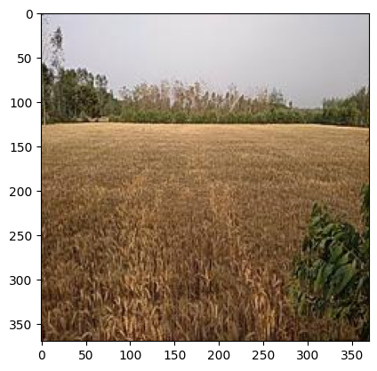

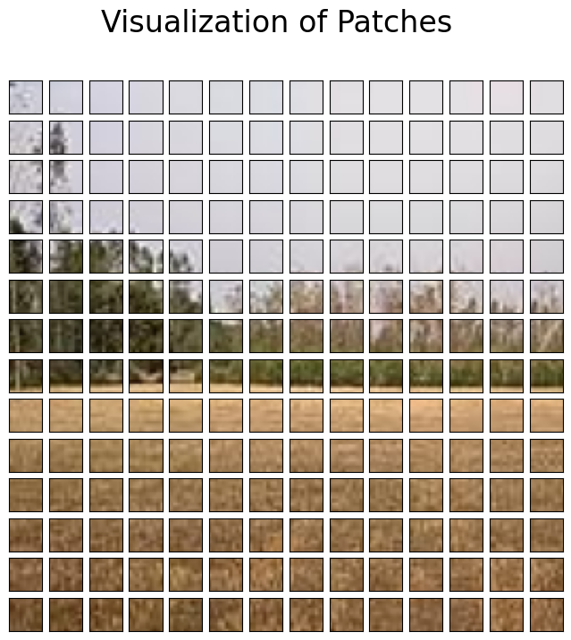

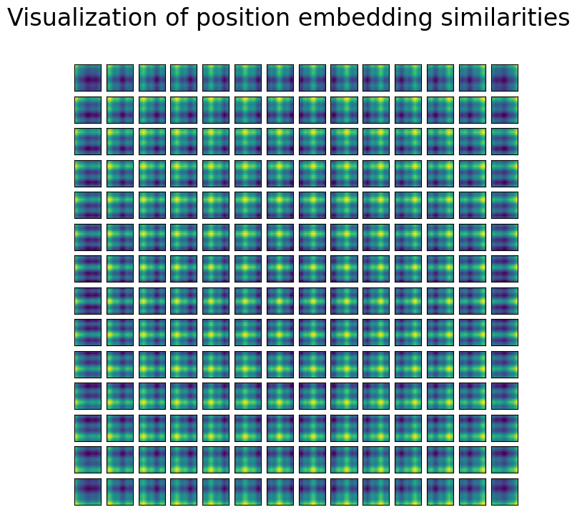

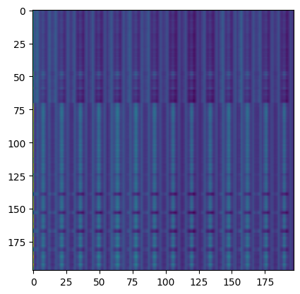

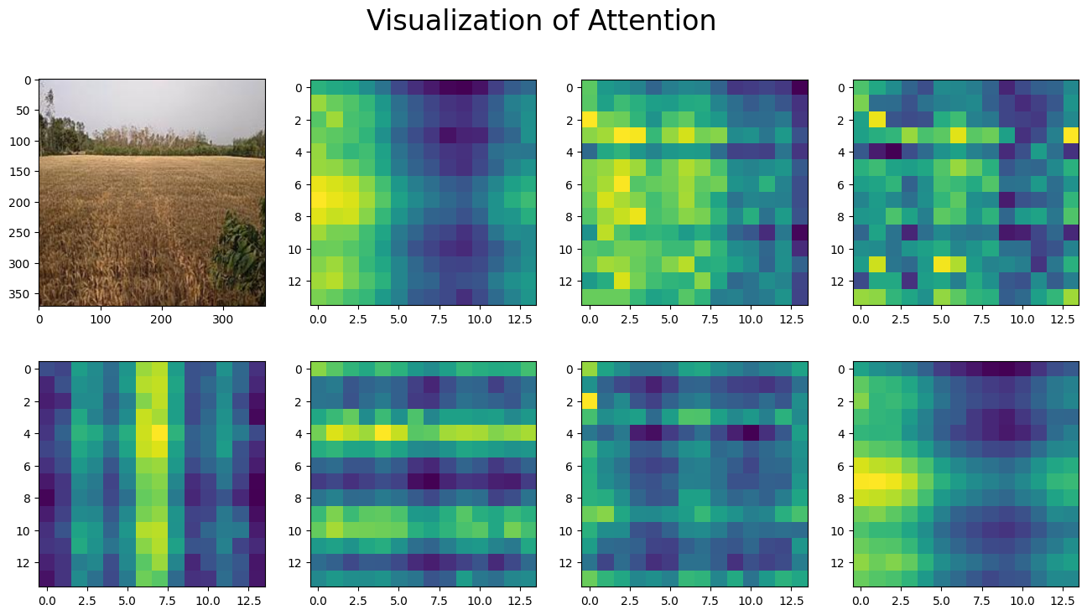

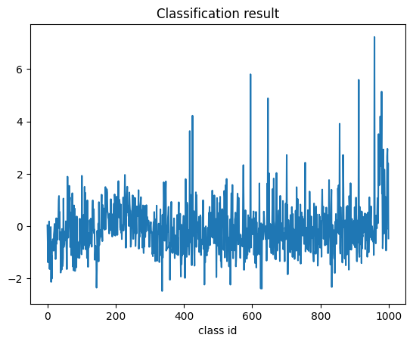

data :
DatasetDict({
train: Dataset({
features: ['image', 'label'],
num_rows: 12060
})
validation: Dataset({
features: ['image', 'label'],
num_rows: 1507
})
test: Dataset({
features: ['image', 'label'],
num_rows: 1508
})
})
Train size: 12060
Validation size: 1507
Test size: 1508

id2label={0: "0", 1: "1",2:"2",3:"3",4:"4",5:"5",6:"6",7:"7",8:"8",9:"9",10:"10",
10: "10", 11: "11",12:"12",13:"13",14:"14",15:"15",16:"16",17:"17",18:"18",19:"19",
20:"20",21: "21", 22: "22",23:"23",24:"24",25:"25",26:"26"},
label2id={"0": 0, "1": 1,"2": 2, "3": 3,"4": 4, "5": 5,"6": 6, "7": 7,"8":8,"9":9,"10":10,
"11": 11,"12": 12, "13": 13,"14": 14, "15": 15,"16": 16, "17": 17,"18":18,"19":19,"20":20,
"21": 21,"22": 22, "23": 23,"24": 24, "25": 25,"26": 26}

Epoch | Training Loss | Validation Loss
1 | 1.932700 | 2.528501
2 | 1.533700 | 2.527579
3 | 1.283500 | 2.652610
4 | 1.081900 | 2.783163
5 | 0.932400 | 2.909893
TrainOutput(global_step=7540, training_loss=1.3220520240242348, metrics={'train_runtime': 1141.9997, 'train_samples_per_second': 52.802, 'train_steps_per_second': 6.602, 'total_flos': 4.673813987069338e+18, 'train_loss': 1.3220520240242348, 'epoch': 5.0})

true: 13 Pred: 11
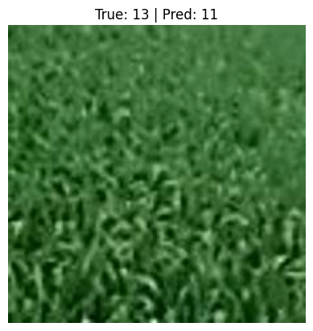

A confusion matrix is a table that is used to evaluate the performance of a classification model by comparing the model's predictions with the actual ground truth. Each row of the matrix represents the instances in an actual class, while each column represents the instances in a predicted class. The diagonal elements of the matrix show the number of correct predictions for each class. The off-diagonal elements represent misclassifications, where the model "confused" one class for another.
In the context of wheat yield prediction using a model like google/vit-base-patch16-224-in21k, which is a Vision Transformer (ViT) model, the confusion matrix would be interpreted as follows:
1. Understanding the Axes
- Actual: The rows of the matrix represent the true, measured wheat yield classes. For instance, "Actual 10" would represent all the cases where the measured wheat yield actually belonged to class 10.
- Predicted: The columns of the matrix represent the classes that the model predicted. "Predicted 10" would represent all the cases where the model predicted the wheat yield to be in class 10.
2. Identifying Correct Predictions
- The numbers along the diagonal, where the "Actual" class and "Predicted" class are the same (e.g., the cell at row 10, column 10), are the true positives. These are instances where the model correctly predicted the wheat yield class.
- For example, a high number in the cell at row 15, column 15 indicates that the model was highly successful at identifying cases where the wheat yield was in class 15.
3. Identifying Misclassifications
- The off-diagonal numbers represent misclassifications or errors. A number in a cell at row i, column j (where i is not equal to j) shows how many times an actual class i was incorrectly predicted as class j.
- For example, a high number in the cell at row 10, column 11 indicates that the model frequently confused wheat yields from the actual class 10 with the predicted class 11. This reveals specific weaknesses in the model's ability to distinguish between these two yield classes.
4. Relevance of the Model
The google/vit-base-patch16-224-in21k is a Vision Transformer model pre-trained on the ImageNet-21k dataset, which is a massive collection of images with over 21,000 classes. This model is primarily used for image classification and feature extraction tasks. While it is a powerful tool for visual data analysis, such as identifying objects or scenes, it would need to be fine-tuned on a specific dataset of images related to wheat fields, including factors like crop health, density, and color, to be effective for wheat yield prediction. The performance of such a model would then be evaluated using this confusion matrix, with the diagonal elements indicating its success and the off-diagonal elements highlighting its errors.
Based on the provided training output for a wheat yield prediction model using the google/vit-base-patch16-224-in21k model, here is an interpretation:
Interpretation of Training and Validation Loss
The most important metrics in the table are the training and validation losses over a period of 5 epochs.
- Training Loss: This measures how well the model is performing on the data it was trained on. The training loss decreases consistently from 1.932700 in Epoch 1 to 0.932400 in Epoch 5. This indicates that the model is learning from the training data and improving its predictions with each epoch. A continuously decreasing training loss is generally a good sign that the model is effectively being trained.
- Validation Loss: This measures how well the model generalizes to new, unseen data. It is a crucial indicator of a model's real-world performance.
  - The validation loss initially decreases slightly from 2.528501 to 2.527579 in the first two epochs, suggesting some initial improvement.
  - However, after Epoch 2, the validation loss begins to increase and continues to do so, reaching 2.909893 by Epoch 5.
Diagnosis of the Model Performance
The divergence between the training loss (decreasing) and the validation loss (increasing) is a classic sign of overfitting. This means the model is becoming too specialized in learning the specific patterns and noise of the training data, but it is failing to generalize these learnings to the validation data.
- In the context of wheat yield prediction: The model is likely learning to recognize specific features of the images in the training set that correlate with yield, but these features are not representative of wheat fields in the validation set. This could be due to variations in lighting, weather, soil, or image quality between the two datasets.
Interpretation of TrainOutput Metrics
The TrainOutput object provides a summary of the final training run after 5 epochs.
- training_loss: This value, 1.3220520240242348, is the average loss over the entire training set.
- epoch: This confirms the training ran for 5.0 epochs.
- train_runtime: The total time taken for training was approximately 1142 seconds.
- train_samples_per_second: The model processed about 52.8 training examples per second.
In summary, while the training process shows the model is successfully learning from the data it has seen, the increasing validation loss indicates a significant problem with overfitting. To improve the model, one should stop training earlier (e.g., after Epoch 2), use more diverse training data, or apply regularization techniques to help it generalize better.
Based on the provided classification report, here is an interpretation of the model's predictions and accuracy in the context of wheat yield prediction:
Overall Model Performance
- Accuracy: The overall accuracy is approximately 0.11 (11%). This means that for all the wheat yield samples in the dataset, the model correctly predicted the class only 11% of the time. An accuracy this low indicates that the model is not performing well and is barely better than random guessing, especially given the large number of classes.
- Macro Average: The macro average for precision, recall, and f1-score is very low (around 0.09 to 0.12). The macro average treats all classes equally, regardless of how many samples are in each class. This low score confirms that the model struggles to make accurate predictions across the board, not just for a few specific classes.
- Weighted Average: The weighted average, which accounts for the number of samples in each class, is also low (around 0.11). This further reinforces that the model's overall performance is poor.
Performance by Class
The table provides detailed metrics for each of the 27 classes (from 0 to 26), which likely correspond to different wheat yield levels or ranges.
- Precision: This metric answers the question: "Of all the times the model predicted a certain class, how many times was it correct?"
  - Most classes have very low precision. For example, for class 1, the precision is 0.03, meaning only 3% of the predictions for this class were correct.
  - Class 25 has a high precision of 0.75, but this is misleadingly good because the recall is very low.
- Recall: This metric answers the question: "Of all the actual samples that belong to a certain class, how many did the model correctly identify?"
  - Many classes, such as 3, 18, 20, 21, 22, 23, and 24, have a recall of 0.00. This is a significant problem, as it means the model was unable to correctly identify any of the actual samples for these yield classes.
- F1-Score: This is the harmonic mean of precision and recall. It is a better measure of a model's performance on a specific class, especially when there is an imbalance between precision and recall.
  - The F1-scores for nearly all classes are extremely low, typically between 0.00 and 0.20. This indicates a major failure to make both precise and complete predictions for most yield levels.
  - The highest F1-score is 0.38 for class 25, but even this is a poor result.
Context for Wheat Yield Prediction
In the context of wheat yield prediction with the google/vit-base-patch16-224-in21k model, the results indicate that the fine-tuned model is not effective. The poor performance across all metrics suggests several potential issues:
- Overfitting: The previous analysis of the training and validation loss already pointed to this. The model may have memorized the training data but failed to learn generalizable features for unseen data.
- Insufficient Data: The "support" column shows the number of actual samples for each class. Some classes, like 18 (1 sample) or 24 (2 samples), have very little data. It is nearly impossible for a model to learn to predict these classes effectively.
- Incorrect Feature Extraction: The pre-trained Vision Transformer model may not be fine-tuned correctly to extract features that are relevant to wheat yield prediction from the images (e.g., crop color, density, or patterns).
- Poorly Defined Classes: The wheat yield classes may be too granular, or the differences between them may be too subtle for the model to distinguish.
In conclusion, this classification report shows that the model is performing very poorly. Significant work is needed to improve the model, such as gathering more data, re-evaluating the class definitions, and applying different training techniques to address the identified issues.

