An IMDian remembers

Dulal Chakrabarti
Ex-DDGM

There is a saying “once an IITian always an IITian” or another saying “once an IAS ever an IAS” and the same applies to India Meteorological Department (IMD) also “once an IMDian always an IMDian”. It signifies the all-India nature of the profession achieved through rigorous training and postings across the various offices of IMD within India and even outside the country.

MONEX-79

Prior to my joining IMD in 1977, I was a Deputy Magistrate and Deputy Collector in the Deputy Commissioner’s office in the Darjeeling Collectorate of West Bengal. My first point of call before joining IMD was Dr. N. Sen Roy, Regional Director in charge of the largest region covering states of Bihar, West Bengal, Orissa, Assam, Meghalaya, Nagaland, Mizoram, Manipur, Tripura and the Andamans comprising the Kolkata region of IMD. Dr. Sen Roy, an alumnus of the Radio Physics and Electronics Department of the University of Kolkata was always an example and source of inspiration for me in the department. I remember his advice to the duty officers of Regional Telecommunication Hub (RTH), New Delhi was to go to forecasting room to see the plotted weather charts for assessing reception of basic weather observations and take steps using alternative ways (telephone call) to improve reception. Immediately after joining as an Assistant Meteorologist, I was sent for training in the instruments discipline and after completion of ab-initio training in the offices of Deputy Director General Instruments (DDGI), New Delhi I was asked to report to the Tata Institute of Fundamental Research for association with the development of a radar project called “Digital Video Integrator and Processor” or DVIP for measurement of areal rainfall with the Mitsubishi 10 cm (S Band) radar (non-doppler) located at Kolkata and Chennai. TIFR at that time was one of the best equipped research institutions in India and I had an opportunity to work in their radar group so as to be familiar with the development of a prototype of the equipment. Prof. Govind Swarup headed the radio astronomy group at that time assisted by Sh. S.S. Bhave for DVIP hardware and Dr. Cooper for DVIP software who were jointly leading the DVIP development. This association left an indelible impression in my mind about the nitty-gritties of scientific project management. After returning from TIFR in 1979 I was put in charge of PBO (Pilot Balloon Observatory) at Dum Dum Airport to supervise both the surface and the upper air observations during Monsoon Experiment 1979 (MONEX-79) between May,1979 to September 1979. We had to prepare radio-sonde payloads carefully 4 times a day (00/06/12/18 UTC) so that the balloon can reach maximum height recording pressure, temperature, humidity, wind speed and direction up to stratospheric levels most of the time reaching heights of 30 kms and above before bursting. Imported Totex balloons were used for flying the radio-sonde payload. We had to participate in taking observations with specially equipped IAF Avro aircrafts to take observations on board. This provided me exposure to learn how internationally coordinated scientific experiments were conducted in which scientists from USA and USSR also participated. I still remember the night when we exchanged upper air sounding data with the Russian team on board a ship anchored over Hoogly river at Princep Ghat, Kolkata. I also remember meeting Dr. S. Sethuraman from the Brookhaven National Laboratory who set up a tower at Digha beach in West Bengal to study the air-sea interaction processes responsible for cyclogenesis or lack of it over the Bay of Bengal. It was a deficient rainfall monsoon year and the data collected would have provided a wealth of information on the onset and progress of monsoon in 1979.

Ramanna Committee

A look at the year-on-year variation (Fig. 1.) of monsoon rainfall in India reveals the uncertainties associated with its prediction. Ever since my school days in the sixties I remember drought years 65-67, 73-75, 79-80, 86-88, 2002-03, 2009 each underpinned the upsurge in the prices of essential commodities. In 1966 we switched from rice eating to roti eating in my family in West Bengal due

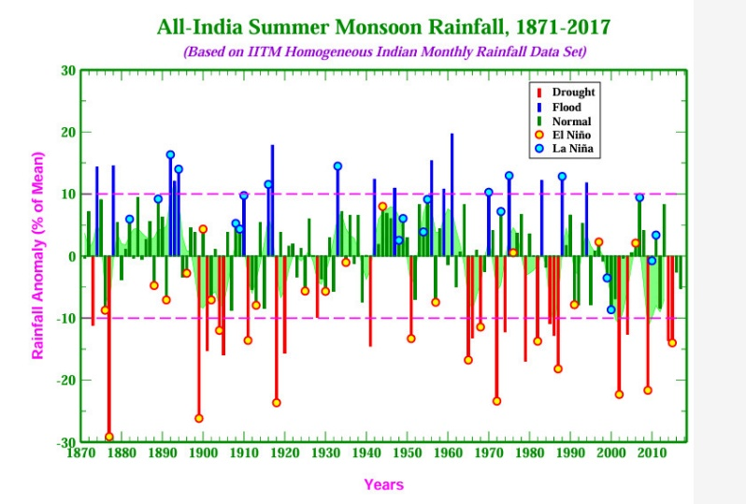
Fig. 1. Monsoon Rainfall variability

to the shortage of rice and there were large scale anti-hoarding operation and levying of rice from land owners. The incidence of consecutive droughts and floods in the early seventies led Government of India to constitute a one-member commission under the chairmanship of Dr. Raja Ramanna in April 1977 to suggest remedies to improve scientific prediction of monsoon rainfall by India Meteorological Department in line with the advancements achieved by the Bhabha Atomic Research Centre for nuclear energy and the Indian Space Research Organization for Space Sciences which were the two premiere scientific departments under Government of India. At that time IMD was attached to the Ministry of Civil Aviation and used to be administered by a met section. The report recommended a suitable structure for a Scientific Department with Council of Meteorology and Atmospheric Science (CMAS) as an apex body to approve various projects for the department for improving forecast accuracy. It also recommended induction of scientists as a trainee directly and be on a stipend before confirmation after a year of rigorous training and assessment by UPSC for absorption in the regular pay scale. This would ensure induction of fresh talent directly from the universities as well as any serving departmental officer purely on merit basis.

Direct Recruit Trainee Meteorologist Grade-II

Just after the MONEX was over, I was posted to the Cyclone Warning Radar (CWR) located on top of the tallest building at that time in Kolkata called the New Secretariate Building on the bank of the Hooghly River. Dr. B. N. Datta, another alumnus of the Radio Physics and Electronics Department, University of Kolkata was in charge of the radar establishment. I learnt a lot on electronic equipment maintenance from him and he was also very helpful and inspiring in all my works in the department. While working in CWR Kolkata, I appeared for the written test for selection to the post of direct recruit trainee Meteorologist Grade-II in the instruments discipline which was advertised following the acceptance of recommendations of the Ramanna Committee. After passing the written test I was called for an interview at UPSC and was informed to have been selected in the instruments discipline as trainee Meteorologist Grade-II and was asked to report at Pune for training in General Meteorology along with similar batch mates in the forecasting, hydrology, seismology and agricultural meteorology disciplines. So, I came to be one among the 1st batch of direct recruit trainee Meteorologist Grade-II following the acceptance of the Ramanna Committee report by the Government of India. In the first batch of the instruments group, we were 8 trainees, namely, 3 of us serving as Assistant Meteorologists from IMD, 2 from Overseas Communication Service (OCS), 1 from Defence Research and Development Organisation, 1 from ISRO and 1 from Wireless Planning and Coordination (WPC). Fig.2 below shows 4 of us from the first batch of Meteorologist Grade-II in the instruments group taken at the time of completion of our training in 1981.

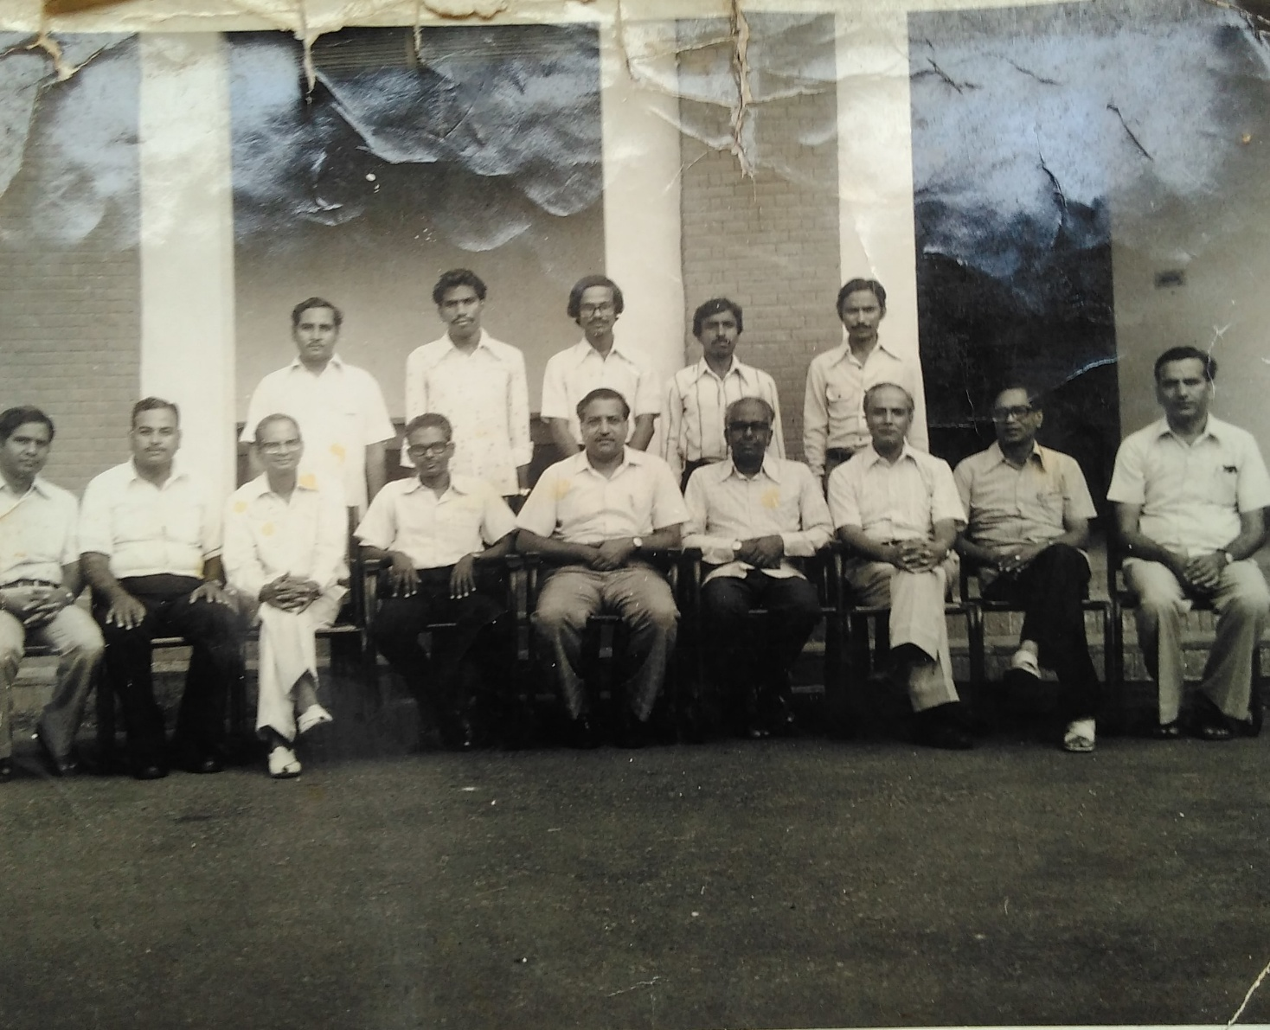

Fig.2. 1st batch of Met-II (Instruments) in 1981
Standing from L to R: Lekhmi Singh, M.D. Ramchandran, myself(author) and S. Krishnaiah
Sitting from L to R: S. K. Srivastav, Rabinder Nath, B.B.D. Bhargava, N. Sen Roy, S.M. Kulshreshtha, N. Seshadri, K. Chatterjee, R.C. Maheswari and P.D. Saddy

As I mentioned before we first had a common training in General Meteorology at Pune before we were sent for instruments training in DDGM(I), New Delhi. Our Pune training was quite memorable as we reported there in September, 1980. Dr. K. V. Rao, DDGM (Dynamic Meteorology) was head of the training division and Dr. P. V. Joseph was director in charge of training but our course director was Dr. U. S. De. We stayed in Guruprasad Lodge which used to be the only hostel for all Pune trainees. Dr. De was a tough task master and we used to be reminded of our trainee status who needed to clear UPSC assessment after completion of one year. Our morning classes were mostly on theoretical subjects like general meteorology, dynamical meteorology, thermodynamics, radiation, statistics, climatology etc. while the evening sessions were devoted to practical exercises like plotting of charts, taking surface and pilot balloon observations etc. We had two lady officer trainees in the first batch, namely, Dr. N. Jayanthi who was already serving as an Assistant Meteorologist in Chennai and Dr. Surinder Kaur who joined fresh from university and they were staying in a chummery accommodation in one of the large bungalows of Shimla office at Pune. Fig.3 below shows a photograph of the first batch of direct recruit trainee Meteorologist Grade-II in the forecasting, hydrology, seismology and agricultural meteorology disciplines taken after completion of their training in 1981 and shared with me.

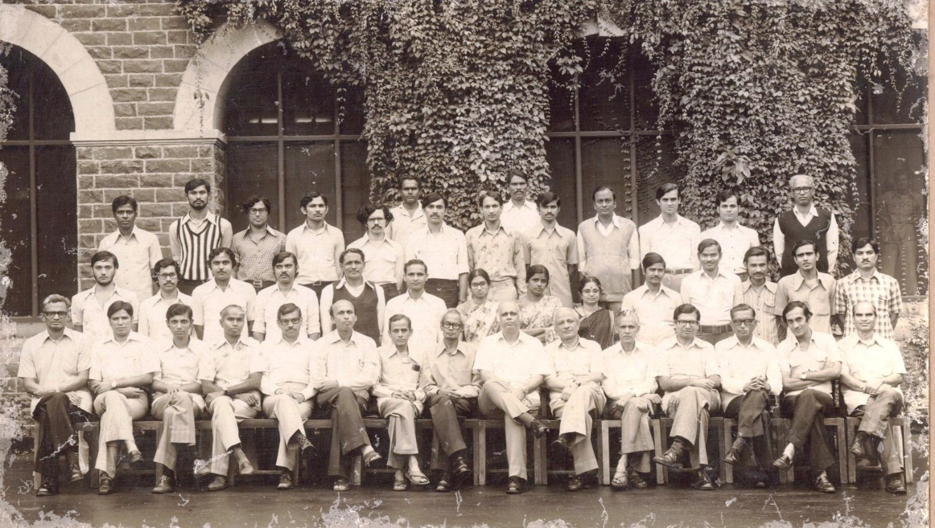

Fig.3. 1st batch of Met-II (forecasting, hydrology, seismology and agricultural meteorology) in 1981

SDUC (Secondary Data Utilization Centre)

After completion of training and clearing of the UPSC assessment, I was posted as a Met-II in the satellite meteorology division in which the meteorological component of the INSAT program was in the process of implementation. Sh. U.V. Gopala Rao was in charge of the INSAT program in IMD and a new multistorey building was coming up to house the ground segment. Even when the building was not formally handed over to IMD, I was asked by Sh. Gopala Rao to start working (one of the first occupants) from the new INSAT building in 1981. After a few months hardware equipment arrived and installation started. Meteorology had three components-(1) Very High Resolution Radiometer (VHRR) for recording cloud imagery in visible, infrared and water vapour channels (2) Data Relay Transponder for relaying of surface meteorological observations from 100+ Data Collection Platform (DCP) (3) 100 Cyclone Warning Dissemination System (CWDS) at Andhra and Tamil Nadu coasts. For processing of VHRR imagery a Meteorological Data Utilization Centre (MDUC) was set up on the third floor of INSAT building while the second-floor housed equipment for DCP data processing and equipment for transmission through data circuits to 20 sub-offices called Secondary Data Utilization Centre (SDUC) and reception there of VHRR images at low resolution. I was entrusted with the responsibility for implementation of SDUC project with setting up of data circuits, preparing Alden and Muirhead recorders and installation at the stations. I remember burning midnight oils with the hardware engineer named Frank Miller from SDC (System Development Corporation) who supplied MDUC system on turnkey basis to IMD. SDUC systems were later replaced by Digital Meteorological Data Dissemination (DMDD) which was a digital satellite broadcast systems with DMDD receivers and workstations at the field units. U. V. Gopala Rao will always be remembered in IMD for successful implementation of meteorology component of the INSAT program.

PROJECT MERRYWEATHER

My posting at Satellite Meteorology Division came to an end in 1984 when I was asked to report to Telecommunications Division for training in the new RTH system which would replace the Philips DS-714 Automatic Message Switching System which came into operation in 1975. Initially Philips, Netherlands offered to replace the DS-714 Mark-II system by a DS-714 Mark-IV system but the negotiations with the Department of Electronics, which was the nodal agency for procurement of computer systems for GOI, fell through for commercial reasons. Global Weather Dynamics Inc., Monterey, USA in partnership with Hinditron of India offered to replace DS714 with Vax 11/750 mini computer system in 1988. 6 officers including me were asked to proceed for training in hardware and software of the new AMSS system in USA and 5 of them can be seen below (Fig. 4.).

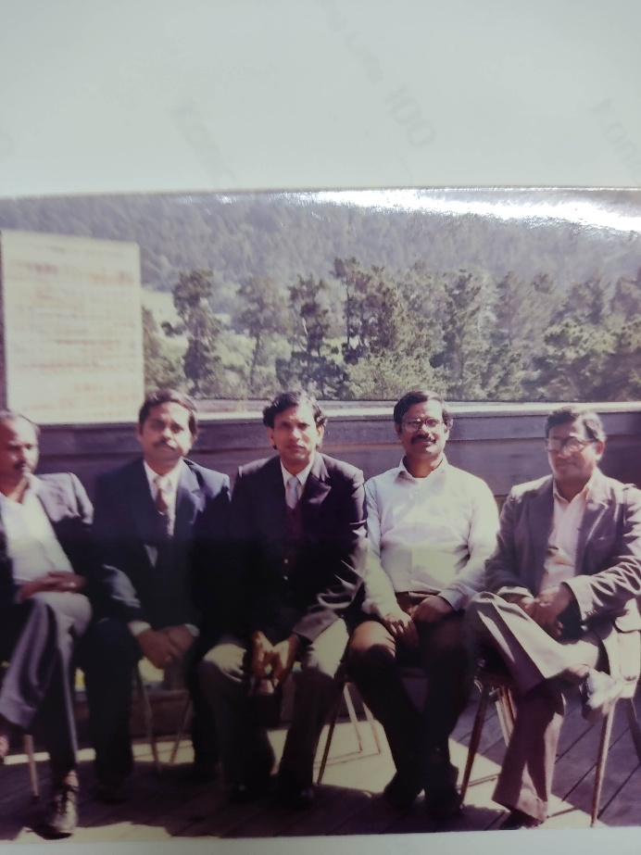
Fig. 4. IMD trainees in GWDI, Monterey, USA (1988)
L to R Surya Bali, M. C. Rastogi, Satya Prakash, myself and A. K. De

GWDI was providing meteorological data on commercial basis to the airlines operators in USA to support domestic and international flights and had Data General computers running application software in Pascal programming language. M/s Hinditron offered to port this software to Vax-11/750 computers in Fortran programming language. The project was code named “MERRY WEATHER” by Hinditron team. It took almost 2 years by Hinditron to complete porting and it was decided to send IMD officers for training during first quarter of 1988. Even after the system was handed over to IMD large number of customisations had to be done by IMD officers for operation of the system. Our training in Boston training school of Digital Equipment Corporation and GWDI, Monterey came in handy for the purpose of hardware and software maintenance of the system. Dr. S. M. Kulshrestha (SMK) was DGM at that time and while the system was being accepted, he advised us to check every item in detail as specified by us but while checking we should not keep counting the trees while missing the forest. He meant thereby that there should not be any major deviation while accepting the system. SMK used to write a one-page leaflet every month called “from DGM” which used to be an enjoyable reading on different subjects of meteorology, seismology, positional astronomy etc.

Internet in IMD

Internet at that time was not a commercial service and was limited to government only. There was a WMO seminar on Internet in Singapore in 1994 and there I learnt as a participant delegate from India that ERNET in India is the nodal agency for the internet services. After returning to IMD I started looking for a way to start an experimental connection for IMD and I found an interested scientist in NCMRWF (National Centre for Medium Range Weather Forecasting). We talked to Dr. Ramani of TIFR who had a satellite link with Carnegie Melon University (CMU), USA. We wanted to have a feel for the internet and requested Dr. Ramani to allow us access to their internet system. So, we were allowed to login to CMU server through dial-up telephone line established by Cray engineers for maintenance of their Cray supercomputing system in NCMRWF. We tried telnet and ftp applications to have a feel for the internet. Dr. Ramani advised us to contact ERNET for establishing internet link at IMD. I was lucky to find that Dr. G. S. Mandal, DDGM was in need of climate data for monsoon forecast from Climate Data Centre (CDC), Ashville which used to come in print format on payment basis in US currency and in much delayed mode. Dr. Mandal was informed by CDC, Ashville that he could get it free through email and without any delay. So, we created a small project which was approved by Council of Meteorology and Atmospheric Sciences (CMAS) to purchase a PC, Telephone, Modem and rental for ERNET connection and the internet could be made operational in IMD in 1994.

Guwahati Days

I worked as a director for 15 years (1990 to 2005) because promotion to the post of DDGM was vacancy based and my turn came only in 2005 when I was promoted to the post of DGGM (Telecommunication) and after a few months was transferred as DDGM of Regional Meteorological Centre, Guwahati. It was an eye opener for me to see the ground realities of field offices in IMD. First handicap I found was the small financial power delegation not allowing purchase of even petty service requirements. So, I had to ask Head Quarter for almost everything such as installing a PC for updating the RMC website hosted by Videsh Sanchar Nigam Limited server. I used good offices of my colleagues in HQ to expedite approvals. I concentrated on reorganising the forecasting services by establishing weather section in RMC building in which effort I found great enthusiasm among the officers and the forecasts started being issued in time and efforts were made to improve the skill score. Among many initiatives I began there one was the weekly map discussion on Thursdays in which all officers participated with great enthusiasm and this helped them to improve speaking power and lead discussion based on data analysis. One important project called Severe Thunderstorm Observation and Regional Modelling (STORM) was launched by the Ministry of Science and Technology and RMC Guwahati participated very actively in the project including dissemination of observational data through RMC Guwahati website. One important event during my stay in 2006 was the visit of the Honourable Minister (HM) of Science, Technology and Earth Sciences to RMC Guwahati. A press conference was arranged by me in the small conference hall of the RMC building and the HM explained the various projects of the Government of India for the north eastern states and replied to questions from the local press and the media people.

VARSAMANA

In the year 2006 a new ministry called Ministry of Earth Sciences (MOES) was formed and IMD was moved from the Ministry of Science and Technology to MOES. Dr. P. S. Goel who was Secretary, MOES set up several committees for modernization and restructuring of IMD to become at par with the national meteorological services of the developed nations in the world like Japan, Australia, UK, France, Germany and USA. As per the recommendation of these committees Government of India approved proposal to automate observation, communication, modelling, forecasting, visualization, climate system, public weather services and training of personnel to transform the quality of operational services from a largely manual subjective analytic framework to an objective digital framework in the form of 10 sub-projects which provided a major thrust for improving weather forecasts to all stakeholders in India. My tenure at Guwahati came to an end in 2007 when I was transferred back to HQ as Project Director of an overarching project called “Commissioning of Forecasting system” code named VARSAMANA of IMD. The photograph below (Fig.5) shows some officers after completion of their training in France in 2009.

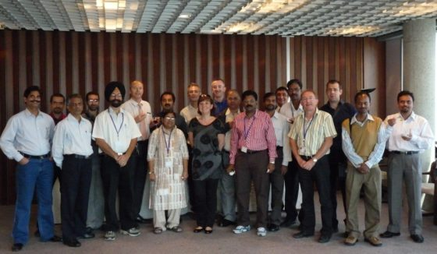

Fig.5 IMD officers after completion of training in France

Dr. Goel like Dr. Raja Ramanna in the seventies will be remembered for his vision of modern IMD as a digitally enabled huge man-machine enterprise capable of serving all weather sensitive activities in any corner of the country. He introduced Project Mode functioning in the department comprising small team of officers executing one particular project irrespective of their postings and office locations in addition to their existing hierarchical working arrangements. This ensured parallel execution of all projects and the whole department worked as a team for faster execution of the final objective which is to issue accurate and high-resolution weather forecast for all users in different sectors of the economy and also for the safety of life and property of all citizens. He also defined the enabling mechanism for the project teams in terms of budget provision and administrative support of head of their office so as to be able to implement the project without time and cost overrun. This also ensured complete transparency in the execution and enabled the department as a whole to be able to own the project. IMD modernization phase-I also brought change management by restructuring of the organisation by implementation of flexible complimenting of promotions at all levels in time bound manner. Whereas in my time we were only a hierarchy of 3 G levels, 14 E levels vacancies in the department, it is heartening to see today 14 G, 38 F and 44 E level scientists in IMD which is the result of implementation of working in project mode instead of vacancy mode. I conclude with this Shakespearean quote from “Julius Ceaser”-

“
We at the height are ready to decline.
There is a tide in the affairs of men
Which, taken at the flood, leads on to fortune;
Omitted, all the voyage of their life
Is bound in shallows and in miseries.
On such a full sea are we now afloat,
And we must take the current when it serves,
Or lose our ventures.
“

