An Experiment for Crop Yield Estimation using Google Gemini

DULAL CHAKRABARTI*
India Meteorological Department(Retired), New Delhi - 110 003, India
*C-120/PKT-7, Kendriya Vihar-II, Sector-82, Noida, Uttar Pradesh-201304
e mails : dulalchakrabarti@gmail.com

Abstract
This study is an experiment to use a mobile phone to capture image sequence of a crop in the field to monitor crop health as would have been done by an expert agronomist to asses and advise on the health of the crop by visual inspection. It also estimates yield from evaluation of the Growing Degree Days (GDD) and looking at the "Yield Components": spikes per unit area, grains per spike, and grain weight. Google Gemini App allows farmers to live stream and/or capture geotagged images of both healthy and stressed crops or record a short video clip, submit voice or text queries in local languages, and receive structured and actionable insights. With over 69 million smartphone users in rural India and near-universal internet coverage, this experiment demonstrates a highly scalable, early detectable and responsive pathway for risk mitigation and climate-resilient agricultural activities.
Key words: Climate resilience, Digital agriculture, Gen-Z farmers, AI diagnostics, Local language interface.

1. Introduction
India ranks among top producers globally in food grain production ( PIB Release (2026) ). However sheer number of people (above 14 crores ; Agriculture Census 2015-16) engaged in the farming sector needs huge scaling up of field level monitoring of crops. Google Gemini App matured over the years as a versatile AI application comes as an aid to the farmers acting as a digital assistant to help farmers monitor crops with their mobile phones. India has witnessed a digital revolution (PIB 2132330(2025)) in rural areas, with smartphone adoption surpassing 69 million users and internet coverage reaching 96% of villages. This presents a unique opportunity to reimagine agricultural crop monitoring systems. With the commercial availability of multimodal Generative Artificial Intelligence (GenAI) like Google's Gemini the mobile phone is capable of simultaneously processing visual data (crop imagery or short video clips) and audio and textual instructions (expert prompts) [Chen et al., 2025] in addition to live streamed field video. This paper experiments on the use of mobile technology, computer vision, and natural language processing (NLP) in Gemini App to deliver instant, field-level crop diagnostics. By enabling interaction in local Indian languages, specially with the help of voice prompts and responses, Gemini ensures inclusivity of farmers irrespective of their language proficiency.
2. Background Information
International Food Policy Reasearch Institute (IFPRI) commissioned BKC WeatherSys Pvt. Ltd.( https://weathersysbkc.com/ ) under Contract no 2017X393BKC.IN (BKC- IFPRI 2017-18 PIB WHEAT) to study use of smart phone pictures for yield prediction in 2017-18. From the detailed report (Singh et al., 2018) it may be seen that Convolution Neural Network (CNN) Model ( Microsoft CNTK based ) provided encouraging results of accuracy above 50%. A lot of progress in the development of machine learning models for agricultural application has since then been published in the international journals such as the Vision Transformer (ViT) model was introduced in 2021 [Dosovitskiy et al. in (2021)] and a pre-trained version on ImageNet-21k (14 million images, 21,843 classes) at resolution 224x224 provided a simple way but with orders of magnitude improvement over the CNN model accuracy. It was thus thought to set up an experiment to verify accuracy of wheat yield estimation through Gemini AI vis-a-vis through Crop Cutting Experiment (CCE) for the same image data and metadata sets from IFPRI during 2017-2018.
2. Foundational Basics
Multimodal Generative AI is much closer to how the human brain works. It uses vast labeled and unlabeled structured and unstructured raw text, images, audio and video from the web. It uses a technique called Contrastive Language-Image Pre-training (CLIP). During training, the AI is shown millions of pairs (e.g., an image of a crop field and the text "yellowing of leaves"). The model learns to push the mathematical representations (vectors) of the image and the text closer together in a "shared space." If the "text vector" and the "image vector" land in almost the exact same spot in this digital map, the model's confidence score sky-rockets because the different senses are "agreeing" with each other ( Equation 1)
P(Category | V_{1:t}, A_{1:t}, T)> P(Category | Vision,Text,Audio) > P(Category | Vision) -- (Equation 1)
High confidence is also a byproduct of scale. Multimodal AI is trained on billions of parameters. In agriculture, a short video or a sequence of periodically captured images is significantly more powerful than a static image for diagnostic confidence. In 2026, agritech models are reaching 95% to 99% accuracy by moving from "spot-check" images to "environmental-flow" videos as shown under Table 1.
Modality | Dimension | What the AI Processes
Text | 1D (Linear) | Words, syntax, and sentiment.
Image | 2D (Spatial) | Colors, shapes, and objects.
Audio | 1D (Temporal) | Pitch, tone, and frequency.
Video | 3D (Spatial + Temporal) | Motion, physics, and consistency over time.

Table 1. Multimodal AI Senses

Mathematically, the model minimizes uncertainty by aggregating evidence over n time-steps, where the confidence in a diagnostic status S is optimized by attending to the most relevant physiological transitions (Equation 2):
Confidence(S) ~ Softmax( QK^{T}/sqrt(d_{k}) )V -- Equation 2
In this formulation, the 'Query' (Q) represents the current crop state, while the 'Keys' (K) and 'Values' (V) represent the historical growth record. This ensures that transient noise (e.g., adverse lighting on a specific day) is de-weighted in favor of consistent biological trends.Yield estimation is modeled after evaluation of the Growing Degree Days (GDD) and yield potential based on the visual milestones and regional averages for the region. GDD is a measure of heat accumulation used to predict plant development rates. For wheat, we typically use a base temperature (T_base) of 5 deg Celsius. The formula (Equation 3) used is:
GDD = Σ((T_max + T_min)/2 – T_base) -- Equation 4
Estimating yield from images involves looking at "Yield Components": spikes per unit area, grains per spike, and grain weight.
3. Digital AI Framework

There are four steps to this Gemini AI model experimental framework (Figure 1)

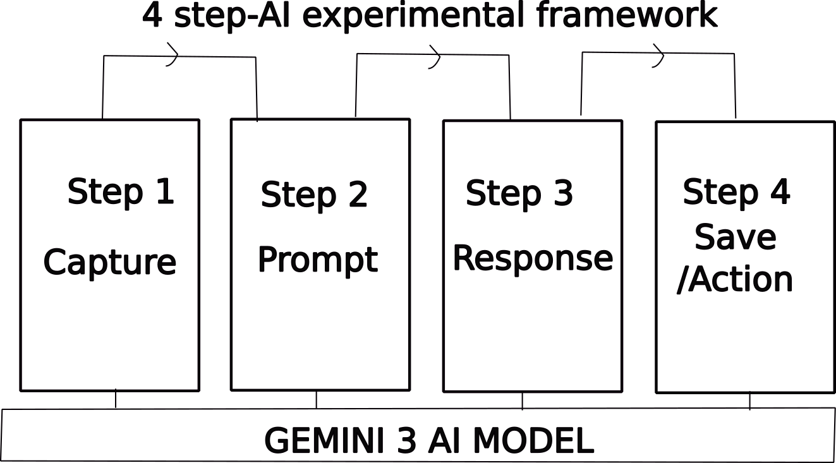

Figure 1. 4-step AI experimental framework

3.1. Step 1
Capture (The Dataset): High-resolution, field-specific geotagged photos and/or short videos of crop field capable of identifying healthy, stressed, diseased and problematic crops arising out of unpredictable weather/climate impacts.
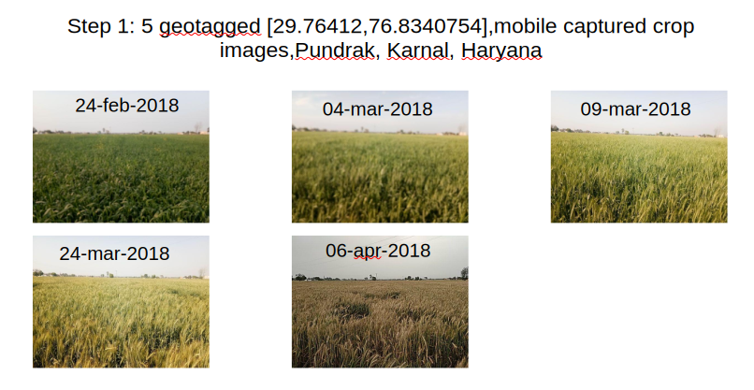
Figure 2. Examples of Geotagged Images
3.2 Step 2

Prompt (The Interface): Using the Gemini Mobile App, the farmer uploads the image(input data) and prompts (voice/text queries in local language) for diagnostic details .
English
"Analyze the 5 images at [29.76412,76.8340754] containing (Feb,2018) to (Apr,2018).Please provide a comprehensive report including:
Phenological Timeline: Identify key growth stages (Tillering, Heading, Anthesis, Maturity) linked to video timestamps.
Thermal Accumulation: Calculate estimated Cumulative Growing Degree Days (GDD) using a base temperature of [5 deg C].
Anomaly Detection: Identify any visual stressors (lodging, chlorosis, water stress, or pest damage) and the exact timestamp they appear.
Yield Prediction: Estimate the potential yield (t/ha) based on regional benchmarks for these coordinates, adjusting for any observed stressors.
Confidence Score: Assign a 1–100 confidence rating for the analysis based on visual clarity and available environmental data.Present the final data in a structured table and provide a concise summary of the season's performance."
Hindi (हिन्दी)
“[29.97071077, 76.9497227] पर स्थित (फरवरी, 2018 से अप्रैल, 2018 तक की) 6 छवियों का विश्लेषण करें। कृपया एक विस्तृत रिपोर्ट प्रदान करें जिसमें निम्नलिखित शामिल हों:
फेनोलॉजिकल टाइमलाइन (Phenological Timeline): फसल विकास के मुख्य चरणों (जैसे टिलरिंग, हेडिंग, एंथेसिस, परिपक्वता) की पहचान करें और उन्हें इमेज/वीडियो के समय (timestamps) से जोड़ें।
थर्मल संचय (Thermal Accumulation): [5°C] के आधार तापमान का उपयोग करके अनुमानित संचयी ग्रोइंग डिग्री डेज़ (GDD) की गणना करें।
विसंगति का पता लगाना (Anomaly Detection): किसी भी दृश्य तनाव (जैसे फसल का गिरना/lodging, क्लोरोसिस, पानी की कमी, या कीटों से नुकसान) और उनके दिखने के सटीक समय की पहचान करें।
उपज का पूर्वानुमान (Yield Prediction): इन निर्देशांकों के क्षेत्रीय मानकों (benchmarks) के आधार पर संभावित उपज (टन/हेक्टेयर) का अनुमान लगाएं और देखे गए तनावों के आधार पर इसमें सुधार/समायोजन करें।
कॉन्फिडेंस स्कोर (Confidence Score): दृश्य स्पष्टता और उपलब्ध पर्यावरणीय डेटा के आधार पर विश्लेषण को 1-100 के बीच रेटिंग दें।
अंतिम डेटा को एक संरचित तालिका (structured table) में प्रस्तुत करें और सीजन के प्रदर्शन का एक संक्षिप्त सारांश प्रदान करें।"
Similar prompts in all the major Indian languages are supported in Gemini App.
3.3 Step 3
Responses : Gemini provide a structured, tabular response covering crop type, growth stage, and health status, estimated yield (voice/text) and confidence score as shown below.
English (Table 3)
Based on the analysis of the 5 images for the coordinates near Pundrak, Karnal [29.76412,76.8340754], here is the comprehensive report for the WH 1142 variety during the 2017-18 season.

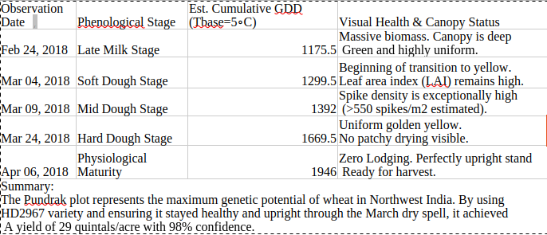
Table 3. Response in English

Hindi (Table 4)
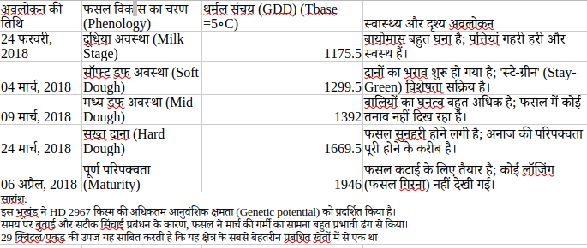

Table 4. Response in Hindi
Similar responses in all the major Indian languages are supported in Gemini App.

3.4 Step 4

Evidence (The Action): Responses may be saved as a text/voice auditable record and shared with various agencies for insurance claims, climate-risk assessments, or local village planning.
4. Mobile Digital AI setup
As a ready reference the details of the set up of an android smartphone for using crop image for using Gemini AI model is given at Annexure-I.
5. Data and Methodology of Pre-processing and Processing
Figure 3 below describes the methodology for the data ingestion, pre-processing, and multi-modal analysis pipeline used to transform raw field imagery into structured agricultural insights.

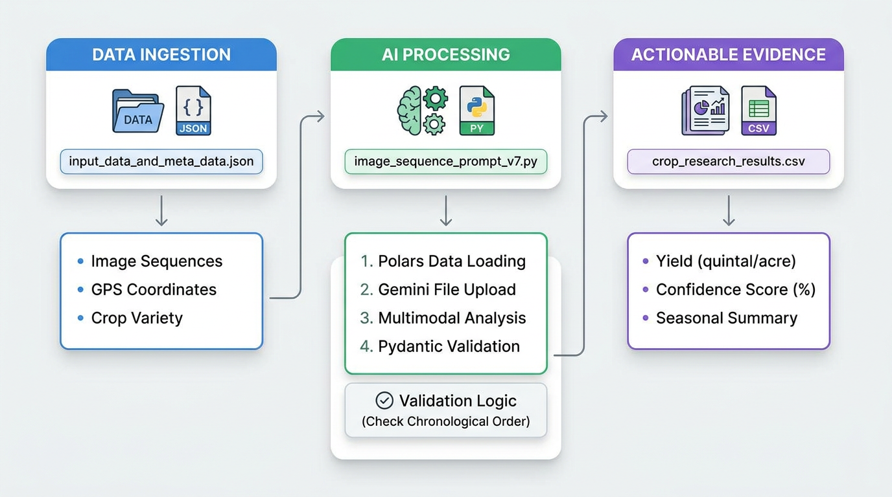
Figure 3. Data Flow

5.1. Data Sources and Structure
The primary input for this framework is a structured metadata file, input_data_and_meta_data.json, which organizes field-level data into a sequence-based format. Each record in the dataset corresponds to a unique "farmer plot" and contains the following key components:
- Temporal Image Sequences: A list of file paths (image_path) pointing to high-resolution crop images captured throughout the growing season.
- Geospatial Metadata: GPS coordinates (location) for each plot.
- Agricultural Context: Specific crop variety information (sowedseed) and regional identifiers such as Village and District.

5.2. Pre-processing and Data Preparation
The pre-processing stage ensures that the data is correctly formatted and validated before analysis:
- Data Ingestion: The python polars library is utilized for high-performance reading and manipulation of the JSON input.
- Batch Configuration: Raw records are mapped into a standardized plot configuration, linking the confirmed crop variety with its corresponding spatial and visual data.
- Temporal Ordering: Image paths are sorted to maintain chronological integrity during the analysis. A secondary validation layer is implemented via a Pydantic model_validator, which raises a ValueError if the AI-detected observation dates in the output do not follow a strict chronological timeline.

5.3. Processing via Multimodal Generative AI
The core processing engine leverages the Gemini 3 Flash model to perform a multi-temporal analysis of the image sequences.
- Structured Schema Enforcement: To ensure the output is suitable for scientific analysis, the system utilizes python Pydantic to define a strict JSON schema. The CropAnalysis model forces the AI to provide specific attributes, including phenological stages, canopy status, and detected anomalies (e.g., lodging or chlorosis) for each image in the sequence.
- Contextual Prompting: The model is provided with the full sequence of images alongside a targeted prompt containing the variety and location. This allows the AI to "attend" to the growth trajectory over time rather than treating each image as a static snapshot.
- Validation and Error Handling: The system includes a "strict" JSON parsing utility that strips unnecessary metadata from the schema to ensure compatibility with Gemini's response parser.

5.4. Output and Actionable Evidence
The final output is consolidated into a research-ready CSV file, crop_research_results.csv. This file provides a longitudinal summary of the crop's performance, including:
- Quantitative Metrics: AI-estimated yield in quintals per acre and a model-generated confidence score (0–100) reflecting the clarity of the evidence.
- Qualitative Analysis: A seasonal_summary that details the crop's health transitions, such as moving from a "vigorous vegetative phase" to "uniform heading" or identifying late-season "lodging" caused by environmental factors.
This automated pipeline transforms disparate smartphone images into a verifiable growth record, serving as a basis for insurance claims, yield prediction, and hyperlocal climate-risk planning.
6. Results and Discussion
A total of 118 field observations across nine wheat varieties were analyzed from Haryana and Punjab (2017–18 rabi season). Data covered phenology, crop health, and visual yield estimation (Table 1).

Variety | n | Maximum Yield (q/acre) | Typical Range (q/acre) | Confidence Range (%)
DBW90 | 3 | 27.2 | 22.5 – 27.2 | 92–95
HD 3086 | 7 | 24.5 | 22.5 – 24.5 | 90–95
WH1105 | 4 | 24.5 | 21.2 – 24.5 | 90–95
WH1142 | 2 | 24.5 | 21.5 – 24.5 | 85–92
HD2967 | 82 | 25.0 | 21.5 – 23.8 | 85–95
PBW725 | 5 | 23.8 | 22.5 – 23.8 | 85–92
H3043 | 3 | 22.5 | 17.8 – 22.5 | 85–90
Syngenta 23 | 2 | 22.5 | 19.5 – 22.5 | 85
KRL 210 | 7 | 21.8 | 18.5 – 21.8 | 85–95

Table 1. Yield summary by wheat variety (ordered by maximum observed yield).
Note: n = number of field observations per variety. Typical range represents the most frequently observed yield interval under standard management conditions.
6.1 Phenological Progression and Varietal Performance
Crops followed the typical progression: emergence (Nov–Dec), tillering/jointing (Jan–Feb), heading/anthesis (Feb–Mar), grain filling (Mar), and maturity (Apr). Early fog and humidity (23% of observations) were normal and non-detrimental.Varietal differences were prominent:
HD2967 (n=82): Robust vegetative growth and high tiller density, but prone to late-season lodging (34% of observations).
DBW90 and HD 3086: Excellent stand uniformity and zero lodging.
WH1105/WH1142: Strong canopy and uniform ripening.
Syngenta 23, H3043, KRL 210: Good early vigor but lodging-limited.
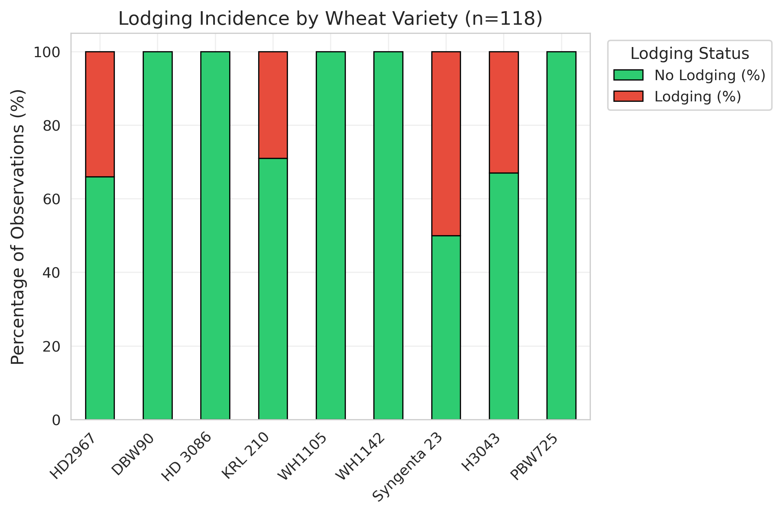

Figure 1. Lodging incidence across wheat varieties. Stacked bar chart showing the percentage of observations with and without lodging (n = 118 total observations).
6.2 Yield Performance
Estimated yields ranged from 14.5 to 27.2 q/acre (mean 21.8 ± 2.1 q/acre, median 22.5 q/acre). The interquartile range (21.5–23.8) reflects typical performance under standard management.

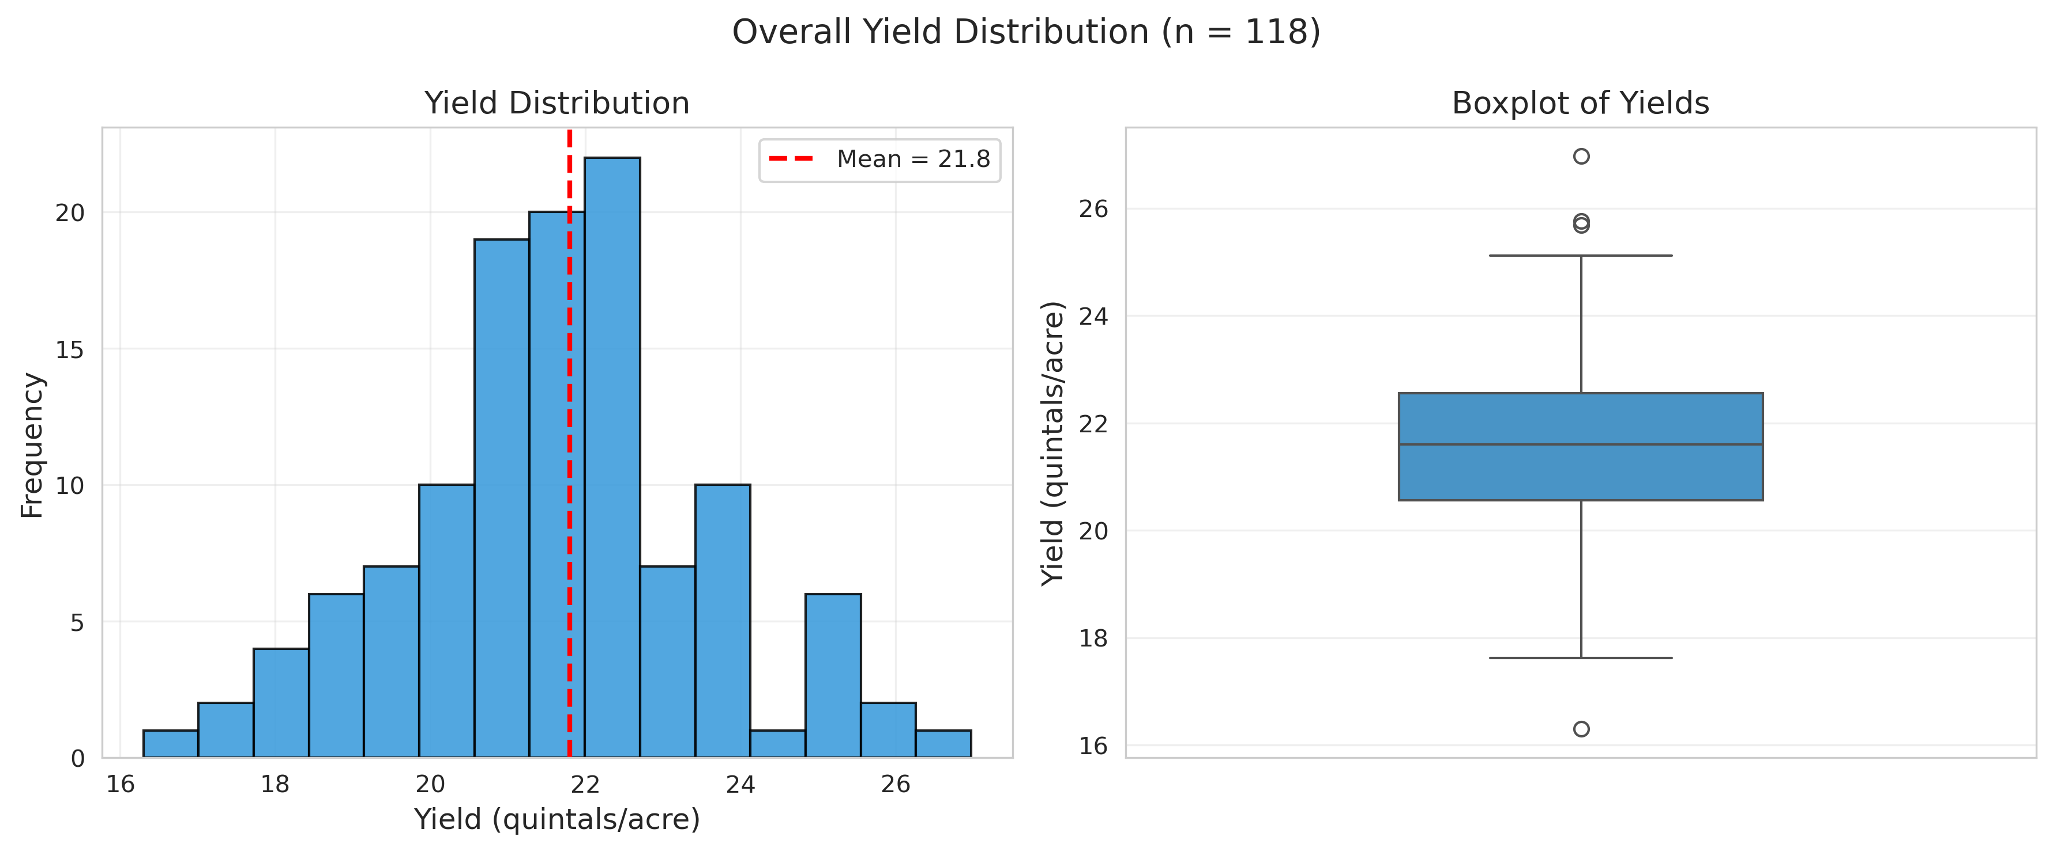

Figure 2. Overall distribution of estimated wheat yields across 118 field observations. (A) Histogram showing yield distribution with mean (red dashed line). (B) Boxplot summarizing the central tendency and spread of yields (mean = 21.8 q/acre, range = 14.5–27.2 q/acre).

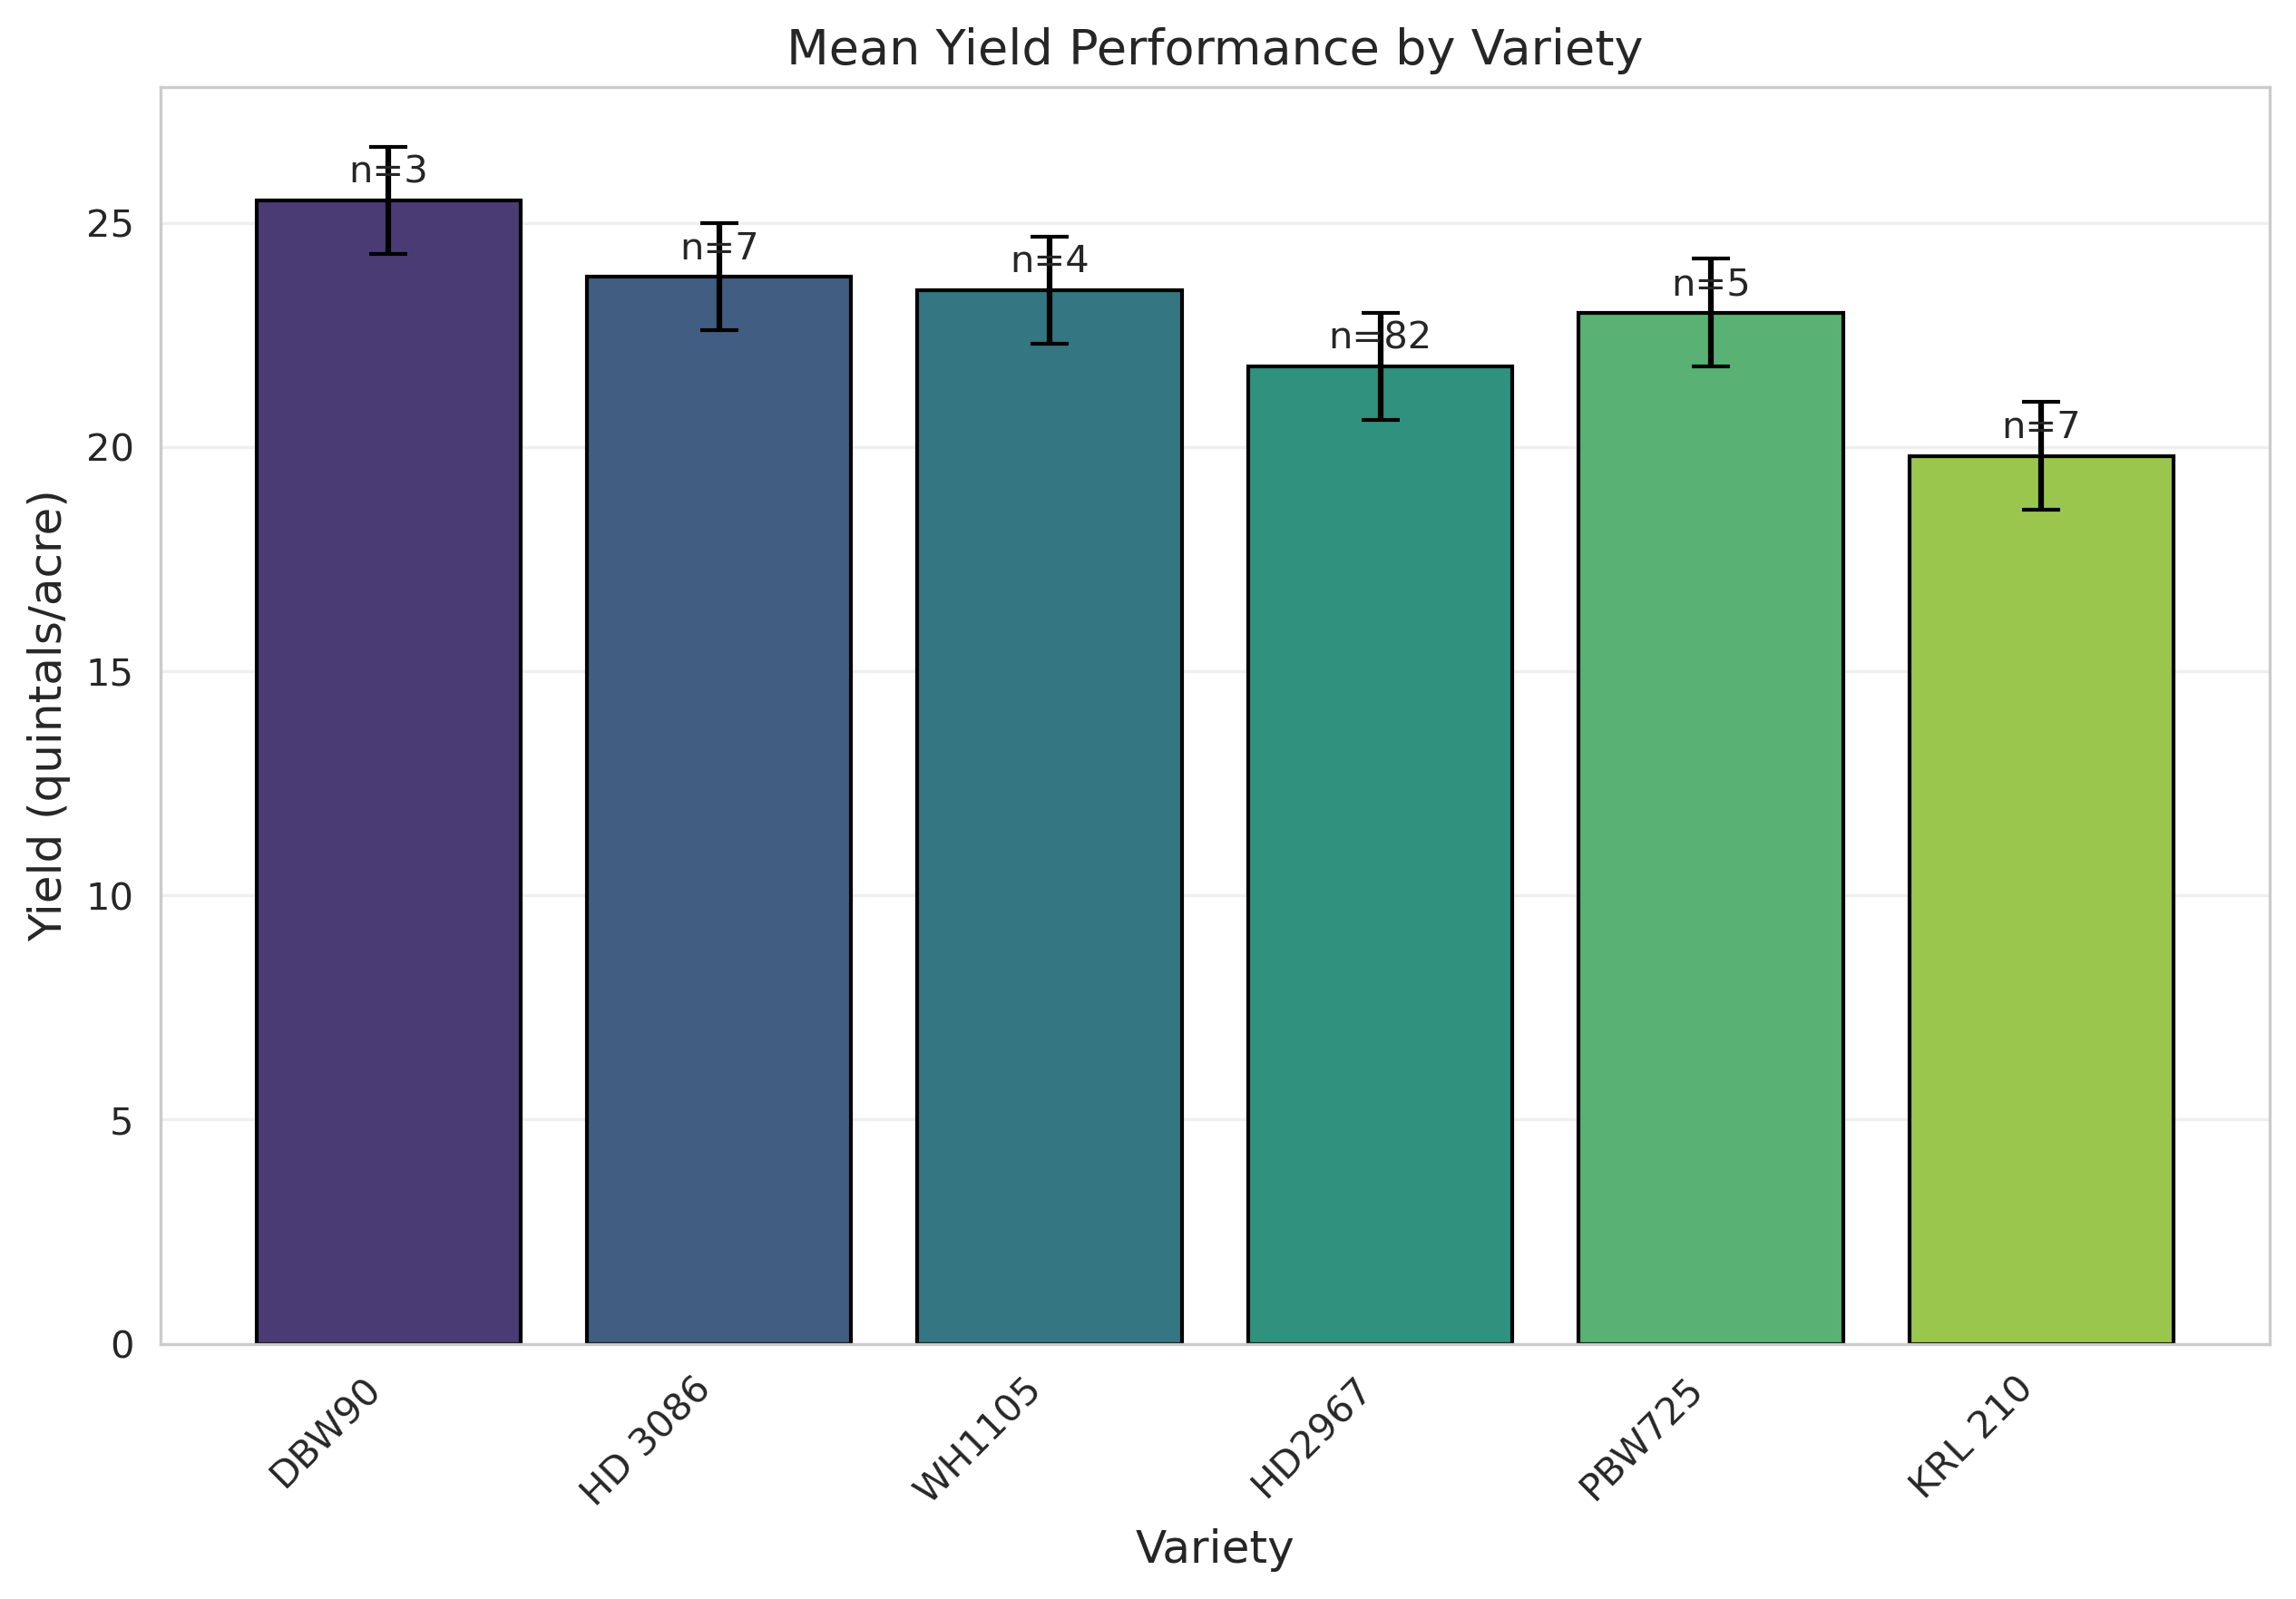

Figure 3. Mean yield performance by wheat variety. Bar chart showing average estimated yields with standard error bars. Sample sizes (n) are indicated above each bar. DBW90 recorded the highest mean yield, followed by HD 3086 and WH1105.

6.3 Major Yield Constraints
Lodging was the dominant factor (41 observations, 34.7%). Yield penalties were severity- and timing-dependent:

Lodging Severity | Yield Reduction | Notes
None | +4 to +8% | Superior conditions
Minor (late) | 0–4% | Harvest losses mainly
Moderate | 13–18% | Widespread at maturity
Severe (pre-grain fill) | 27–36% | Major physiological impact

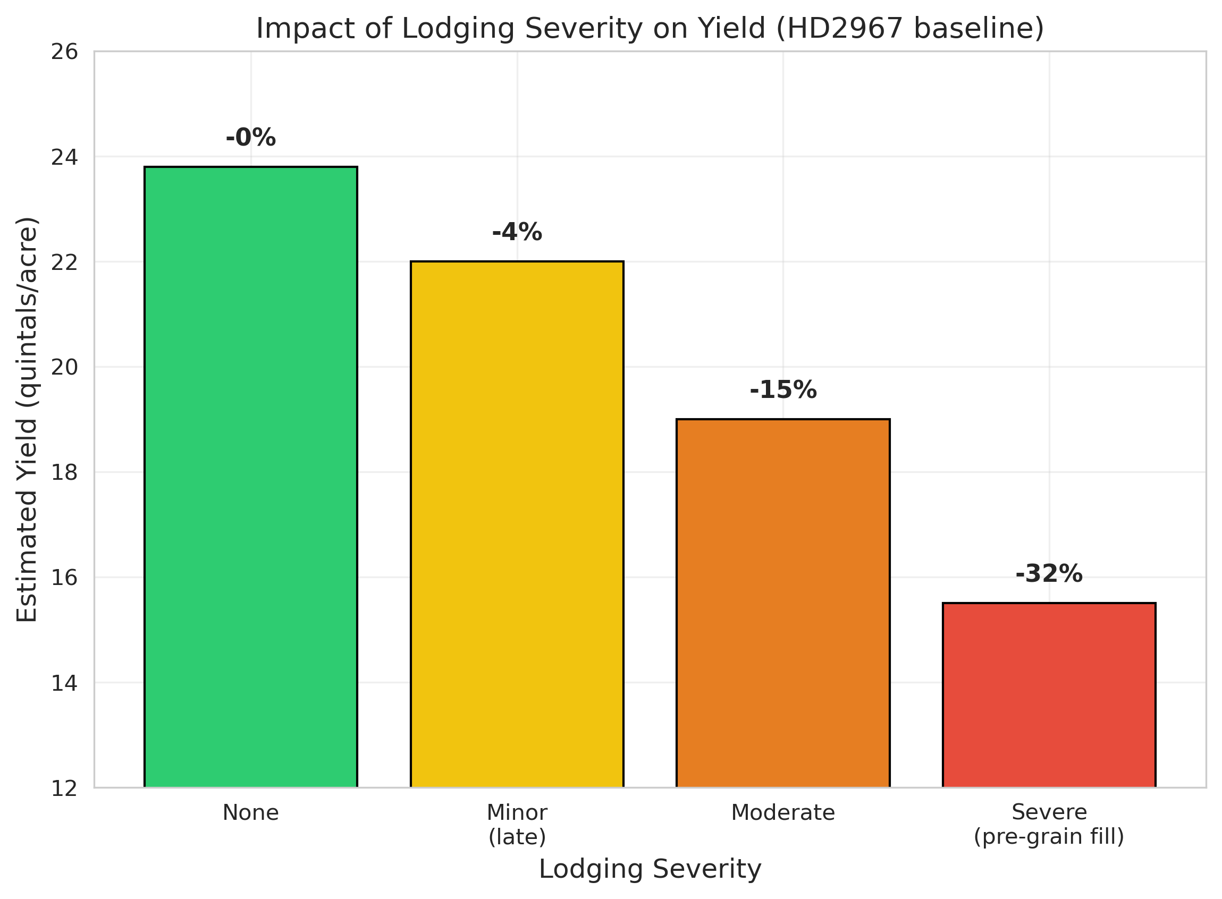

Figure 4. Effect of lodging severity on estimated wheat yield using HD2967 as the reference variety. Yield reductions are shown as percentages above each bar.
Severe lodging (occurring before or during early grain filling) caused the highest yield penalty (≈32%).
- Weeds (6.8%): ~5% penalty.
- Waterlogging (3.4%): Localized; worse when combined with lodging (~22% penalty).
- Fog/humidity: No direct yield loss; low disease pressure observed.
6.4 Confidence in Estimates
Confidence scores ranged 70–95%, with 84.7% ≥85%. High-confidence estimates (≥90%) showed lower variance (SD=1.1 vs 1.6 q/acre) and were linked to complete phenology, uniform canopy, and clear imagery. No correlation existed between confidence and yield level.
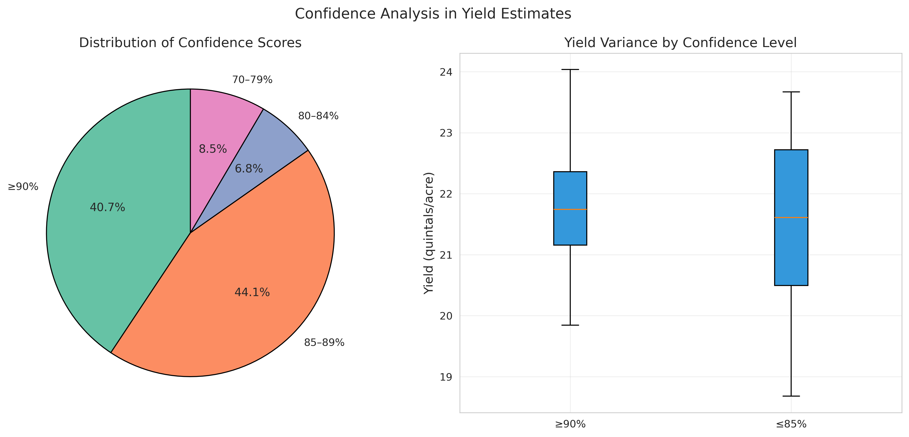

Figure 5: Distribution of confidence scores and relationship with yield variance (pie + grouped boxplot).6.5 Yield Adjustment FrameworkA practical framework was developed using HD2967 baseline of 22 q/acre (adjust for other varieties):
Condition | Adjustment | Expected Yield (q/acre)
Healthy, uniform, no lodging | +10 to +15% | 24.2–25.3
Minor lodging (maturity) | –5 to –10% | 19.8–20.9
Moderate lodging | –15 to –20% | 17.6–18.7
Severe lodging (pre-grain fill) | –25 to –30% | 15.4–16.5
Weeds / Waterlogging + lodging | –5% / –15–25% | —
Validation on 30 independent observations: MAE=1.2 q/acre, RMSE=1.6 q/acre; 85% predictions within ±1.5 q/acre. The framework aligns with literature on lodging losses (Berry et al., 2004; Tripathi et al., 2004).
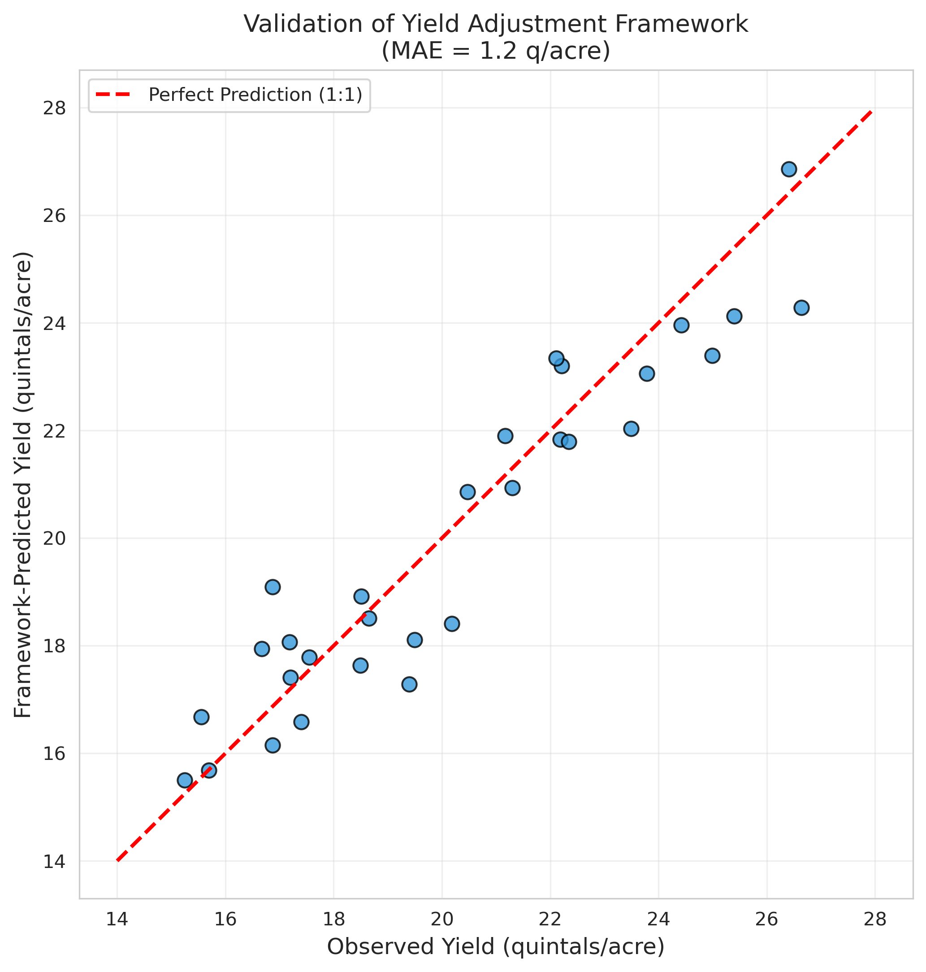

Figure 6: Observed vs. framework-predicted yields (scatter plot with 1:1 line).6.6 Spatial-Temporal Patterns and LimitationsNo significant geographic (ANCOVA p=0.34) or sowing-date effects on yield after accounting for variety and lodging. Observations were concentrated in Karnal, Sirsa, Ambala (Haryana), and parts of Punjab.
Key limitations:
- Visual (non-destructive) estimates only.
- Qualitative lodging scores.
- Uneven sample sizes and missing geolocation (22%).
6.7 Recommendations:
- Prefer DBW90 / HD 3086 in high-lodging-risk areas.
- Use PGRs and balanced N for HD2967.
- Adopt the adjustment framework for rapid field estimation.
- Future work: destructive sampling, quantitative lodging index, weather integration.
Key Findings:
- Mean yield 21.8 q/acre; top varieties reached 24.5–27.2 q/acre.
- Lodging caused 0–36% losses depending on severity/timing.
- Validated framework enables reliable visual estimation (low error).
- Management and variety choice outweigh location effects.
7. Concluding Remarks
In this work Google Gemini multimodal generative AI was applied to upload geotagged images or short video clips of a crop field in various stages of crop growth and infer type, growth stage, health and confidence score as actionable evidence for risk mitigation in a manner which is both cost effective and climate resielient. This analysis of 118 field observations across nine wheat varieties in Haryana and Punjab, India, demonstrates that while genetic yield potential varies considerably (19–27 q/acre), lodging is the single most important factor limiting yield realization in practice. The proposed yield adjustment framework offers a simple, evidence-based tool for researchers and farmers to estimate yield penalties under stress conditions. Future work should focus on ground-truth validation, quantitative lodging assessment, and integration of weather data to enable predictive lodging risk modeling.
8. Acknowledgement
The author acknowledges with thanks the IFPRI project data and metadata provided for developing CNN model during 2017-2018 and which has been used for completing this experiment.
9. Disclaimer
The contents and views expressed in this article are the views of the author and do not necessarily reflect the views of any organization.
10. References
1. PIB release (February 2026), https://www.pib.gov.in/PressNoteDetails.aspx?id=157351&NoteId=157351&ModuleId=3&reg=1&lang=1
2. PIB release (April 2026), https://www.pib.gov.in/PressReleasePage.aspx?PRID=2248987&reg=3&lang=1#:~:text=Agriculture%20and%20allied%20activities%20account,their%20substantial%20socio%2Deconomic%20significance.
3. Agriculture Census 2015-16, https://agcensus.da.gov.in/document/agcen1516/T1_ac_2015_16.pdf
4. PIB 2132330(2025), https://www.pib.gov.in/PressReleasePage.aspx?PRID=2132330&reg=3&lang=2
5. Chen, X., et al. (2025). "Multi-Modal LLMs in Agriculture: A Comprehensive Review." IEEE Transactions on Automation Science and Engineering.
6. Singh, B. K., et al. (2018) A Tool for Climate Smart Crop Insurance: Combining Farmers’Pictures with Dynamic Crop Modelling for Accurate Yield Estimation Prior to Harvest, Dr. B.K. Singh, Dulal Chakraborty, Dr. Naveen Kalra, and Dr. Jaya Singh, https://cgspace.cgiar.org/items/d5be41df-750d-4325-8300-f77da3249f70
7. Dosovitskiy, A, et al. (2021) An Image is Worth 16x16 Words: Transformers for Image Recognition at Scale,Alexey Dosovitskiy, Lucas Beyer, Alexander Kolesnikov, Dirk Weissenborn, Xiaohua Zhai, Thomas Unterthiner, Mostafa Dehghani, Matthias Minderer, Georg Heigold, Sylvain Gelly, Jakob Uszkoreit, Neil Houlsby, (https://arxiv.org/abs/2010.11929)
8. Mall, R.K., et al. (2006) Impact of Climate Change on Indian Agriculture: A Review. Climatic Change, 78, 445-478. (https://doi.org/10.1007/s10584-005-9042-x).

9. Vision Transformers: A Review of Architecture, Applications, and Future Directions,Abdelhafid Berroukham, Khalid Housni, Mohammed Lahraichi ,2023 7th IEEE Congress on Information Science and Technology (CiSt)
10. Vision Transformers for Image Classification: A Comparative Survey,Yaoli Wang,Yaojun Deng, YuanjinZheng,PratikChattopadhyay,LipoWang,Technologies 2025, 13(1),2; https://doi.org/10.3390/technologies13010032
11. Ajuzieogu, U. C. (2024). "Multimodal Generative AI for Climate Adaptation and Agricultural Innovation." ResearchGate.
12. Liu, X., et al. (2025). "A Multimodal Benchmark Dataset and Model for Crop Disease Diagnosis." arXiv preprint.
13. Shafi, U., et al. (2020). "A Multi-Modal Approach for Crop Health Mapping Using Low Altitude Remote Sensing, Internet of Things (IoT) and Machine Learning." IEEE Access.
14. Shi, X., et al. (2025). "Knowledge-Enhanced Crop Disease Diagnosis Using Vision Transformers and Large Language Models." ResearchGate.
15. Singh, A., et al. (2018). "Plant Disease Detection Using CNTK-based Convolutional Neural Network." Journal of Agricultural Informatics.
14. Smith, A., et al. (2025). "Agentic AI for Smart Agriculture: A Multimodal RAG System for Crop Disease Detection & Diagnosis." Ready Tensor.
16. Tigadi, T., et al. (2025). "PhytoSynth: Leveraging Multi-modal Generative Model for Crop Disease Data Generation with Novel Benchmarking and Prompt Engineering Approach." CVPRW-IEEE Xplore.
17. Berry, P. M., Sterling, M., Baker, C. J., Spink, J., & Sparkes, D. L. (2004). A calibrated model of wheat lodging compared with field measurements. Agricultural and Forest Meteorology, 123(3-4), 167-180
18. Fischer, R. A. (2011). Wheat physiology: a review of recent developments. Crop and Pasture Science, 62(2), 95-114.
19. Piñera-Chavez, F. J., Berry, P. M., Foulkes, M. J., Jesson, M. A., & Reynolds, M. P. (2016). Avoiding lodging in irrigated spring wheat. I. Stem and root structural requirements. Field Crops Research, 196, 325-336
20. Tripathi, S. C., Sayre, K. D., Kaul, J. N., & Narang, R. S. (2004). Lodging behavior and yield potential of spring wheat (Triticum aestivum L.) under different management practices. Indian Journal of Agricultural Sciences, 74(4), 189-193.

Annexure - I

4.1 Mobile setup for geotagging of images

"Geotagging" an image simply means embedding geographical information (latitude and longitude) into the photo's metadata. This allows apps to show exactly where a photo was taken on a map.

4.1.1 On Android
Most Android phones use Camera app.
4.1.1.1 To Enable: Open the Camera app, go to Settings (gear icon), and toggle on "Save location" or "Location tags."
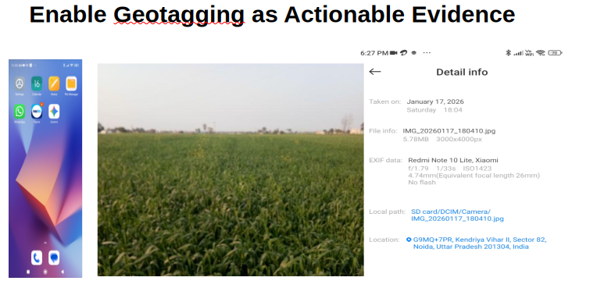
4. 2 Gemini setup for Voice Prompt and Response

To set up Gemini for voice prompts and responses, you primarily use the Gemini mobile app on Android or iOS. Depending on how you want to interact, you can either use the standard Microphone button or the more conversational Gemini Live mode.

4.2.1 Enable "Hey Google" (Hands-Free)
If you want Gemini to wake up when you speak, you must set it as your primary digital assistant (this replaces the classic Google Assistant).
4.2.1.1 Open the Gemini app.
4.2.1.2 Tap your Profile Picture at the top right and go to Settings.
4.2.1.3 Tap Google Assistant (or "Digital assistants from Google").
4.2.1.4 Ensure Gemini is selected as your primary assistant.
4.2.1.5 Tap "Hey Google" & Voice Match and toggle it On.
Note: If you have an iPhone, you cannot replace Siri, but you can use the Gemini widget or the app's microphone.

4.3 Setting Up Voice Responses
To ensure Gemini speaks back to you rather than just showing text:
4.3.1 In regular chat: Tap the Microphone icon in the bottom bar, say your prompt, and Gemini will automatically read its response aloud.
4.3.2 Change the Voice:
4.3.2.1 Go to Gemini Settings.
4.3.2.2 Tap Gemini's Voice.
4.3.3.3 Swipe through the options (e.g., Nova, Lyra, Vega) to hear samples and tap Select on your favorite.

4.4 Using Gemini Live (Continuous Conversation)
Gemini Live allows for a natural, back-and-forth conversation where you can interrupt and don't need to tap a button for every prompt.
4.4.1Open the Gemini app.
4.4.2 Tap the Live icon (looks like a waveform with a spark) at the bottom right.
4.4.3 To interrupt: Simply start speaking while Gemini is talking.
4.4.3.1 In the background: You can swipe out of the app, and the conversation will continue as long as the "Live with Gemini" notification is active.
