A Smart-vision Tool Empowering Gen-Z Farmers

Dulal Chakrabarti*
India Meteorological Department (Retired), New Delhi - 110 003, India
*C-120/PKT-7, Kendriya Vihar-II, Sector-82, Noida, Uttar Pradesh-201304
Email: dulalchakrabarti@gmail.com

Field level monitoring of crop health is crucial for precision agriculture, crop insurance, and climate risk management. This study focuses on the ability of Google Gemini, a multi modal generative AI chat bot, to monitor crop health and estimate wheat yield using sequences of geotagged smartphone images as actionable evidence. A total of 118 field observations covering nine wheat varieties from Haryana and Punjab (2017–18 Rabi season) were processed and analyzed. Gemini-based visual estimates ranged from 14.5 to 27.2 quintals per acre (mean 21.8 ± 2.1 q/acre) and were in quite good agreement with actual values evaluated using Crop Cutting Experiment (CCE). Lodging was identified as the dominant yield-limiting factor, causing yield penalties of 0–36% depending on severity and timing. A practical yield adjustment framework using Growing Degree Days (GDD) was developed and validated on 30 independent observations (Mean Absolute Error = 1.2 q/acre, Root Mean Square Error = 1.6 q/acre), with 85% of predictions falling within ±1.5 q/acre of observed values. The results demonstrate that multi modal generative AI can effectively transform farmer-captured image sequences into reliable phenological, stress, and yield insights. This approach offers a scalable, low-cost solution for digital agriculture in resource-constrained smallholder systems.
Keywords: Generative AI, Crop yield , Digital agriculture, Smart-vision, Crop Dignostics
Introduction
India faces the dual challenge of increasing food production while adapting to climate variability. Timely and accurate crop monitoring and yield estimation at hyper local field scale remain critical and challenging for smallholder farmers, extension services, and crop insurance systems. Recent advances in multi-modal generative Artificial Intelligence (GenAI), particularly models like Google Gemini, OpenAI ChatGPT, Microsoft Copilot and many more mobile apps enable simultaneous processing of images, temporal sequences, short videos and even live streaming of crop field and natural language prompts. These capabilities closely replicate expert visual assessment by agronomists while offering scalability through widely available smartphones (PIB 2132330(2025)). This study builds on earlier work using Convolutional Neural Networks (CNNs) under the IFPRI-BKC WeatherSys project (Singh et al., 2018). It evaluates Google Gemini’s performance in analyzing temporal sequences of geotagged wheat images for phenological staging, stress detection (especially lodging), and visual yield estimation. The specific objectives are: (1) To assess Gemini’s ability to estimate wheat yield across multiple varieties. (2) To quantify the impact of lodging and other stresses on yield. (3) To validate the yield estimation framework by comparing with actual yield obtained by Crop Cutting Experiment (CCE).
Materials and Methods
Study Area and Datasets
The dataset comprises 118 field observations collected during the 2017–18 Rabi season across Karnal, Sirsa, Ambala (Haryana), and parts of Punjab. Nine wheat varieties were evaluated, with HD2967 being the most represented (n=82).
Image Acquisition
At each field location geotagged sequence of high-resolution smartphone images were captured at multiple phenological stages from emergence to physiological maturity. This constituted a temporal sequence of images for processing. One such sequence is shown as an example below.

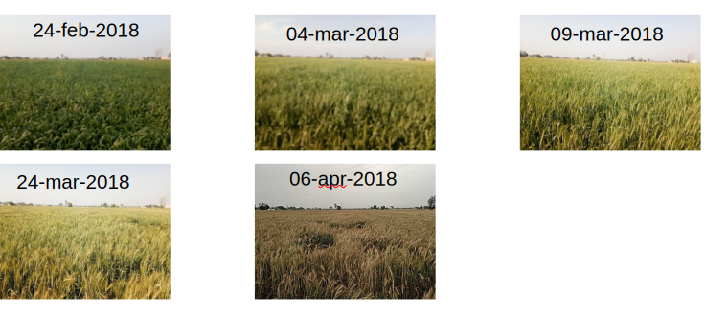
Figure 1. Geotagged [29.76412,76.83407] wheat field (Pundrak, Karnal, Haryana) images
AI Analysis Framework
Google Gemini (multi-modal Generative AI model) was used to process image sequences. A structured prompting strategy (Annexure-I) guided the model to extract: (1) Phenological stages and timeline (2) Detection and severity of lodging and other stresses (3) Visual yield estimation (quintals per acre) (4) Confidence score (0–100%)
Yield Components and Growing Degree Days (GDD)
Yield estimation considered visual indicators of yield components (spikes per unit area, grains per spike, and grain weight). Growing Degree Days were computed using:
GDD = Σ [(T_max + T_min)/2) – 5°C] (base temperature = 5°C).
Statistical Analysis
Descriptive statistics, one-way ANOVA, and Tukey’s HSD post-hoc test were performed. A rule-based yield adjustment framework was developed using HD2967 as reference and validated on 30 independent observations using Mean Absolute Error (MAE) and Root Mean Square Error (RMSE).
Results
Yield Performance
Estimated yields ranged from 14.5 to 27.2 q/acre (mean 21.8 ± 2.1 q/acre, median 22.5 q/acre).
Table 1. Yield summary by wheat variety (ordered by maximum observed yield).
Variety | n | Maximum Yield (q/acre) | Typical Range (q/acre) | Confidence Range (%)
DBW90 | 3 | 27.2 | 22.5 – 27.2 | 92–95
HD 3086 | 7 | 24.5 | 22.5 – 24.5 | 90–95
WH1105 | 4 | 24.5 | 21.2 – 24.5 | 90–95
WH1142 | 2 | 24.5 | 21.5 – 24.5 | 85–92
HD2967 | 82 | 25.0 | 21.5 – 25 | 85–95
PBW725 | 5 | 23.8 | 22.5 – 23.8 | 85–92
H3043 | 3 | 22.5 | 17.8 – 22.5 | 85–90
Syngenta 23 | 2 | 22.5 | 19.5 – 22.5 | 85
KRL 210 | 7 | 21.8 | 18.5 – 21.8 | 85–95
One-way ANOVA revealed significant differences among varieties (p < 0.001). DBW90, HD 3086, and non-lodged HD2967 performed best.

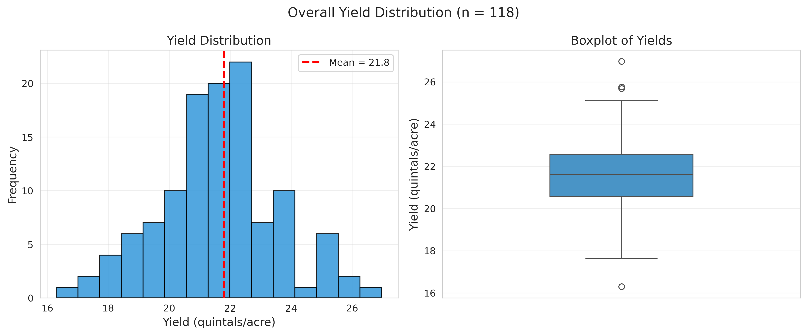
Figure 2: Overall Yield distribution
Overall yield distribution of estimated wheat yields across 118 field observations. (A) Histogram showing yield distribution with mean (red dashed line). (B) Boxplot summarizing the central tendency and spread of yields (mean = 21.8 q/acre, range = 14.5–27.2 q/acre).
Stacked bar chart (Figure 3) showing the percentage of observations with and without lodging (n = 118 total observations).

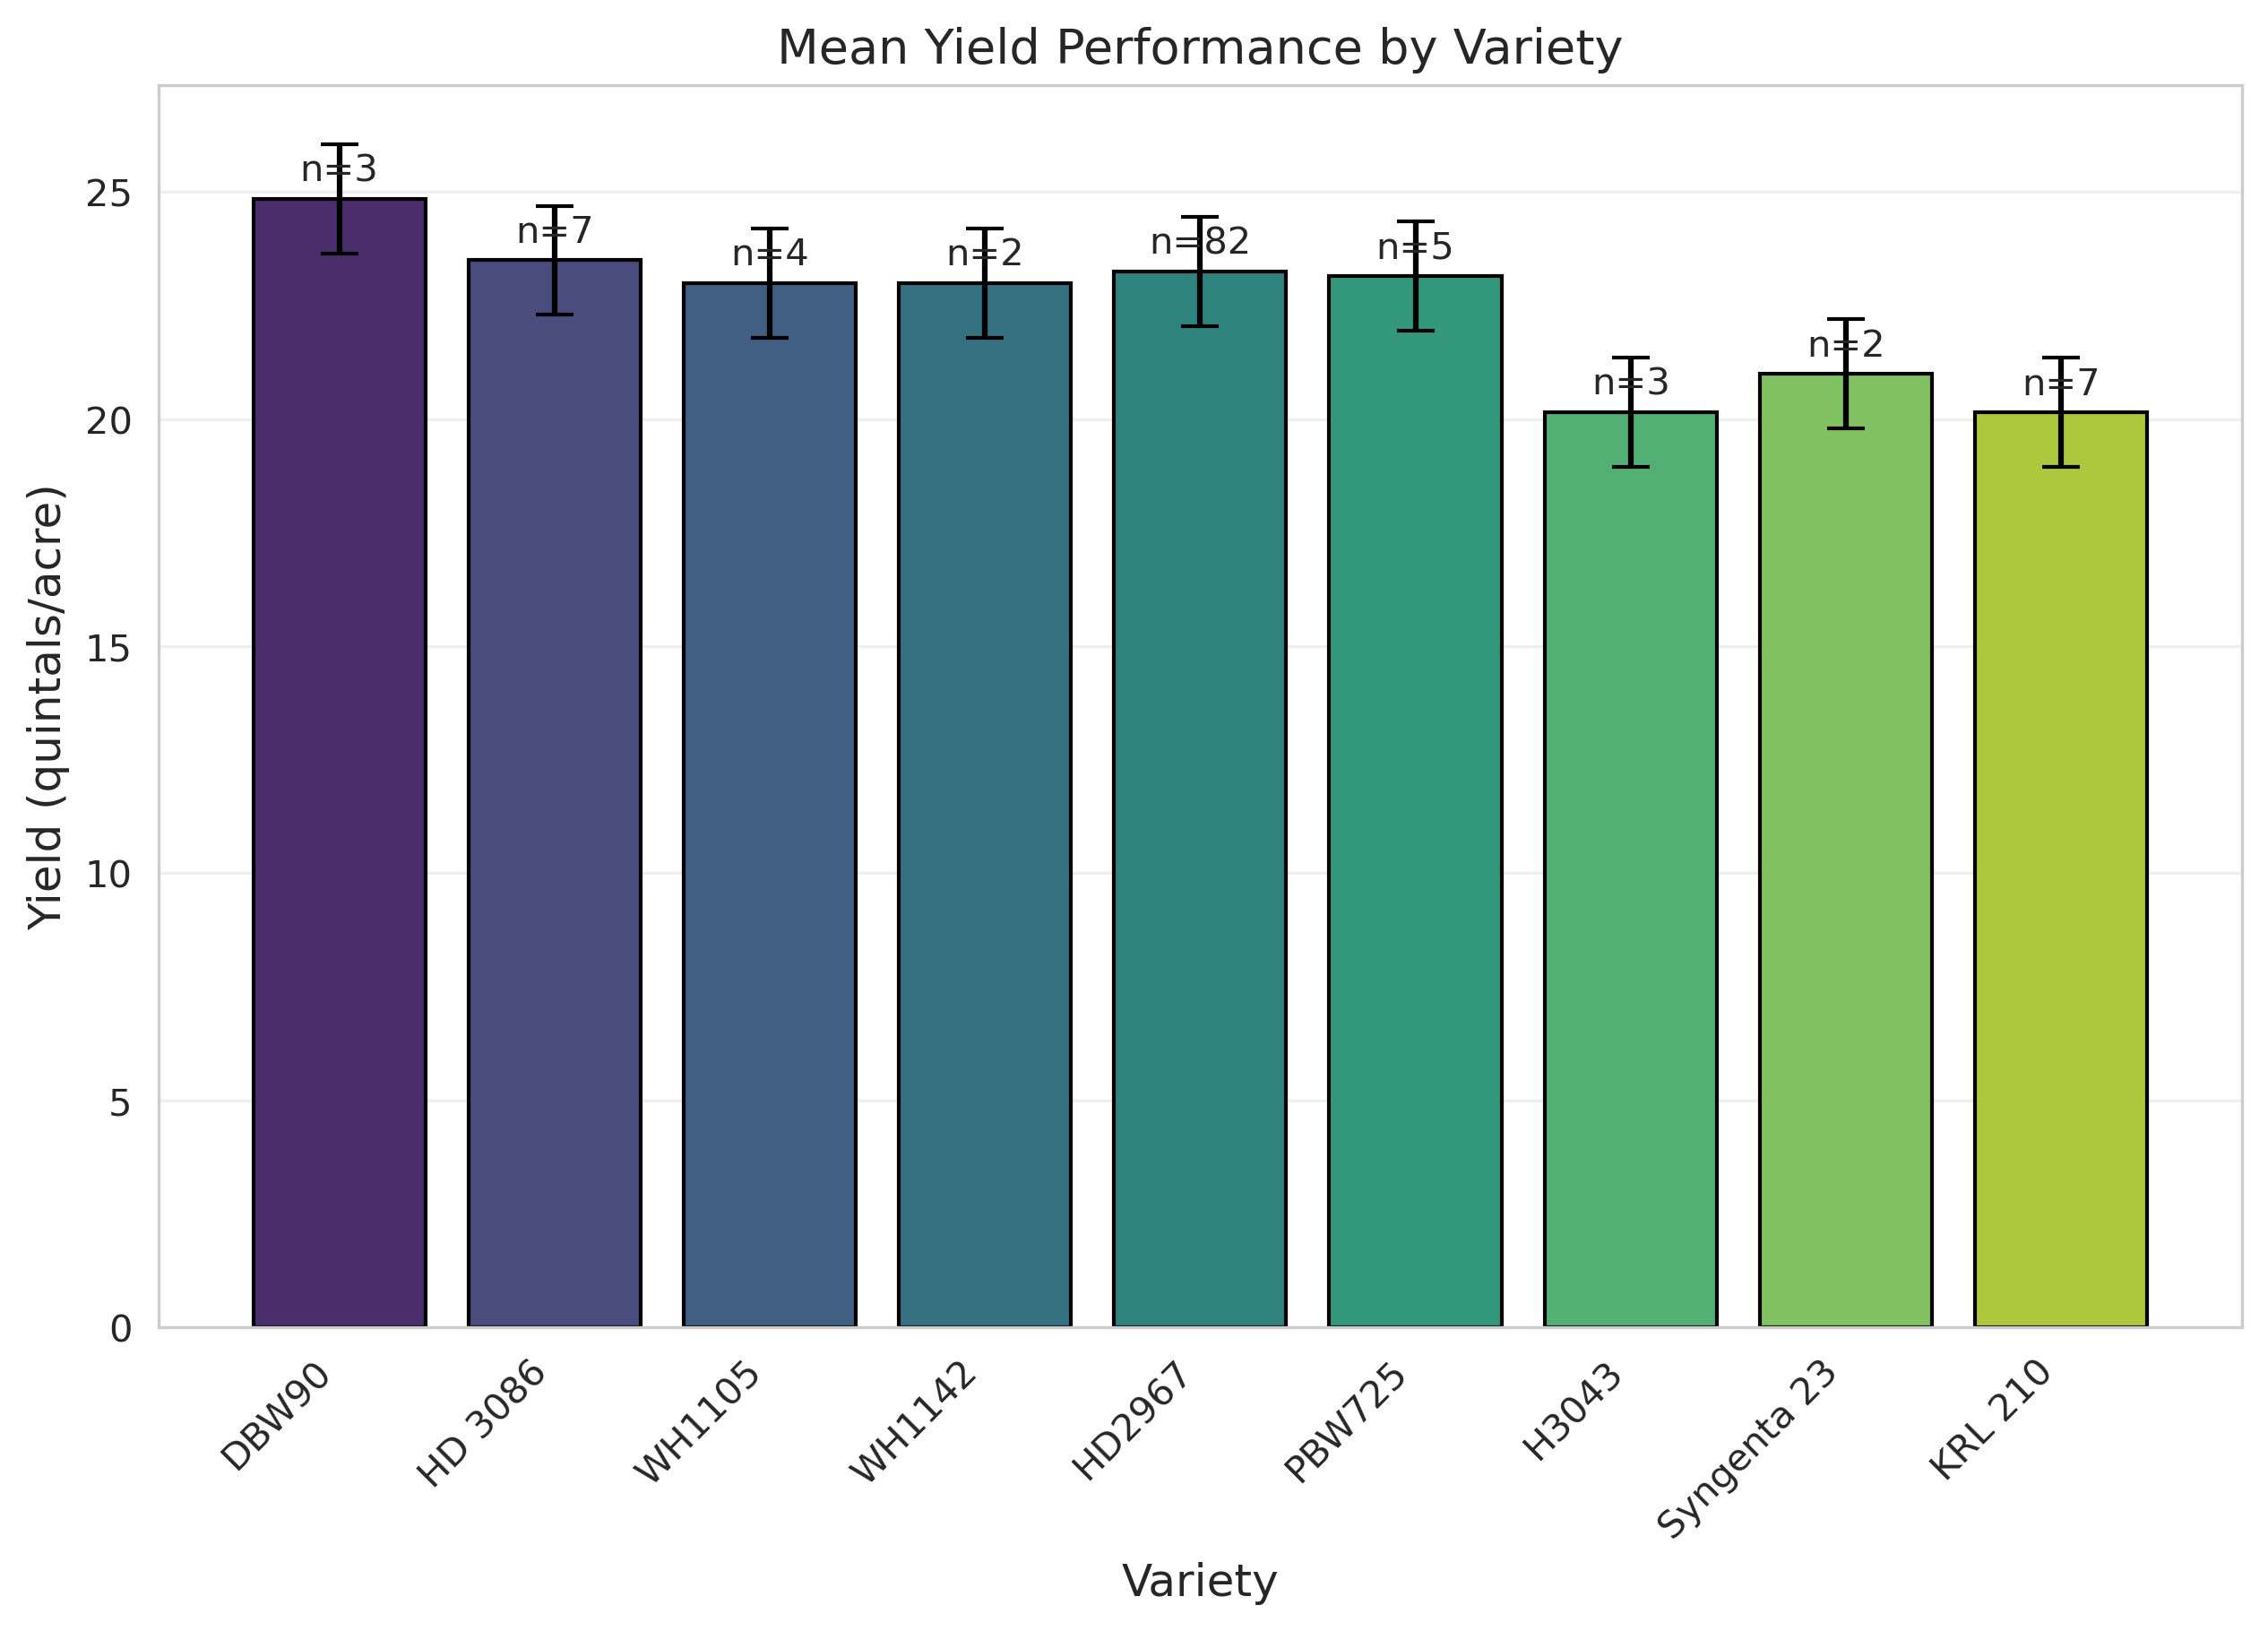

Figure 3. Mean yield performance by variety.
Bar chart (Figure 3) showing average estimated yields with standard error bars. Sample sizes (n) are indicated above each bar. DBW90 recorded the highest mean yield, followed by HD 3086 and WH1105.
Major Yield Constraints
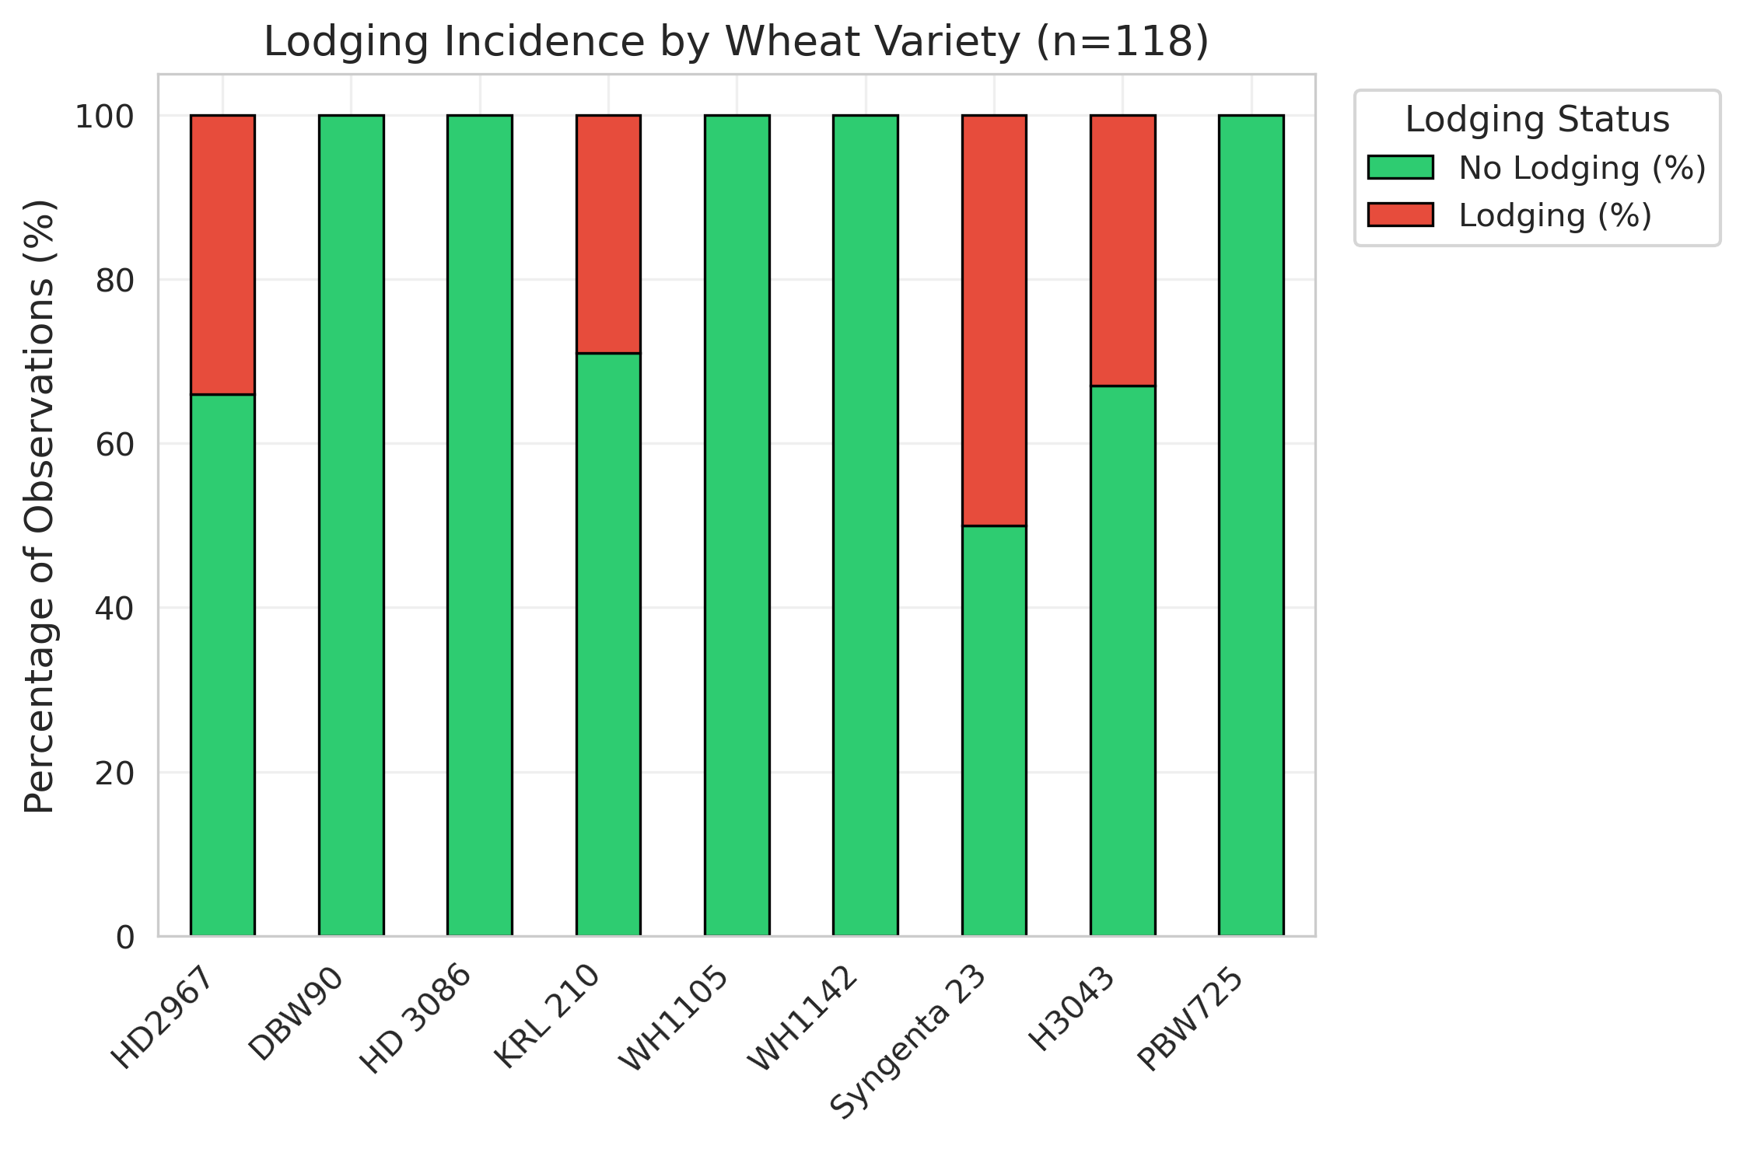

Figure 4. Lodging incidence across wheat varieties.
Lodging affected 34.7% of observations and was the primary yield constraint(Figures 4 & 5).

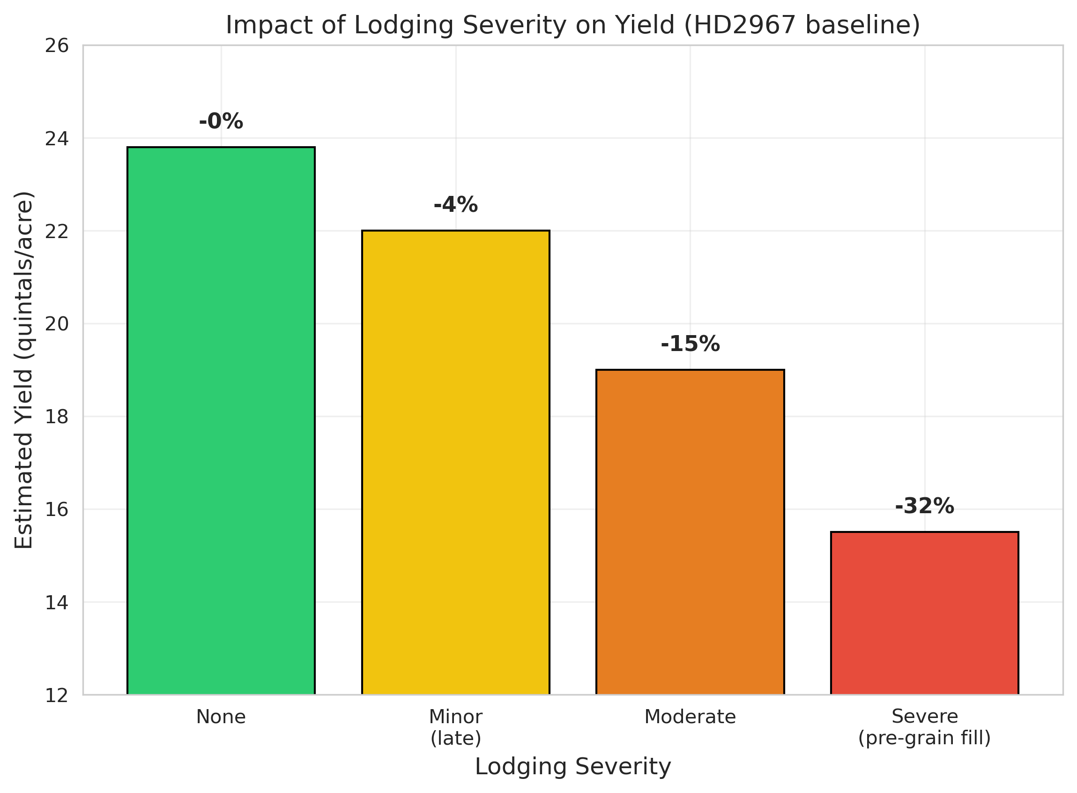

Figure 5. Impact of lodging severity on estimated yield (HD2967 baseline).

Yield reductions are shown as percentages above each bar.
Severe lodging (occurring before or during early grain filling) caused the highest yield penalty (≈32%). (1) Weeds (6.8%): ~5% penalty. (2) Waterlogging (3.4%): Localized; worse when combined with lodging (~22% penalty). (3) Fog/humidity: No direct yield loss; low disease pressure observed.
Confidence in Estimates
Confidence scores (Figure 6) ranged 70–95%, with 84.7% ≥85%. High-confidence estimates (≥90%) showed lower variance (SD=1.1 vs 1.6 q/acre) and were linked to complete phenology, uniform canopy, and clear imagery. No correlation existed between confidence and yield level.
84.7% of estimates had confidence ≥85%. High-confidence estimates showed lower variance (SD = 1.1 q/acre).

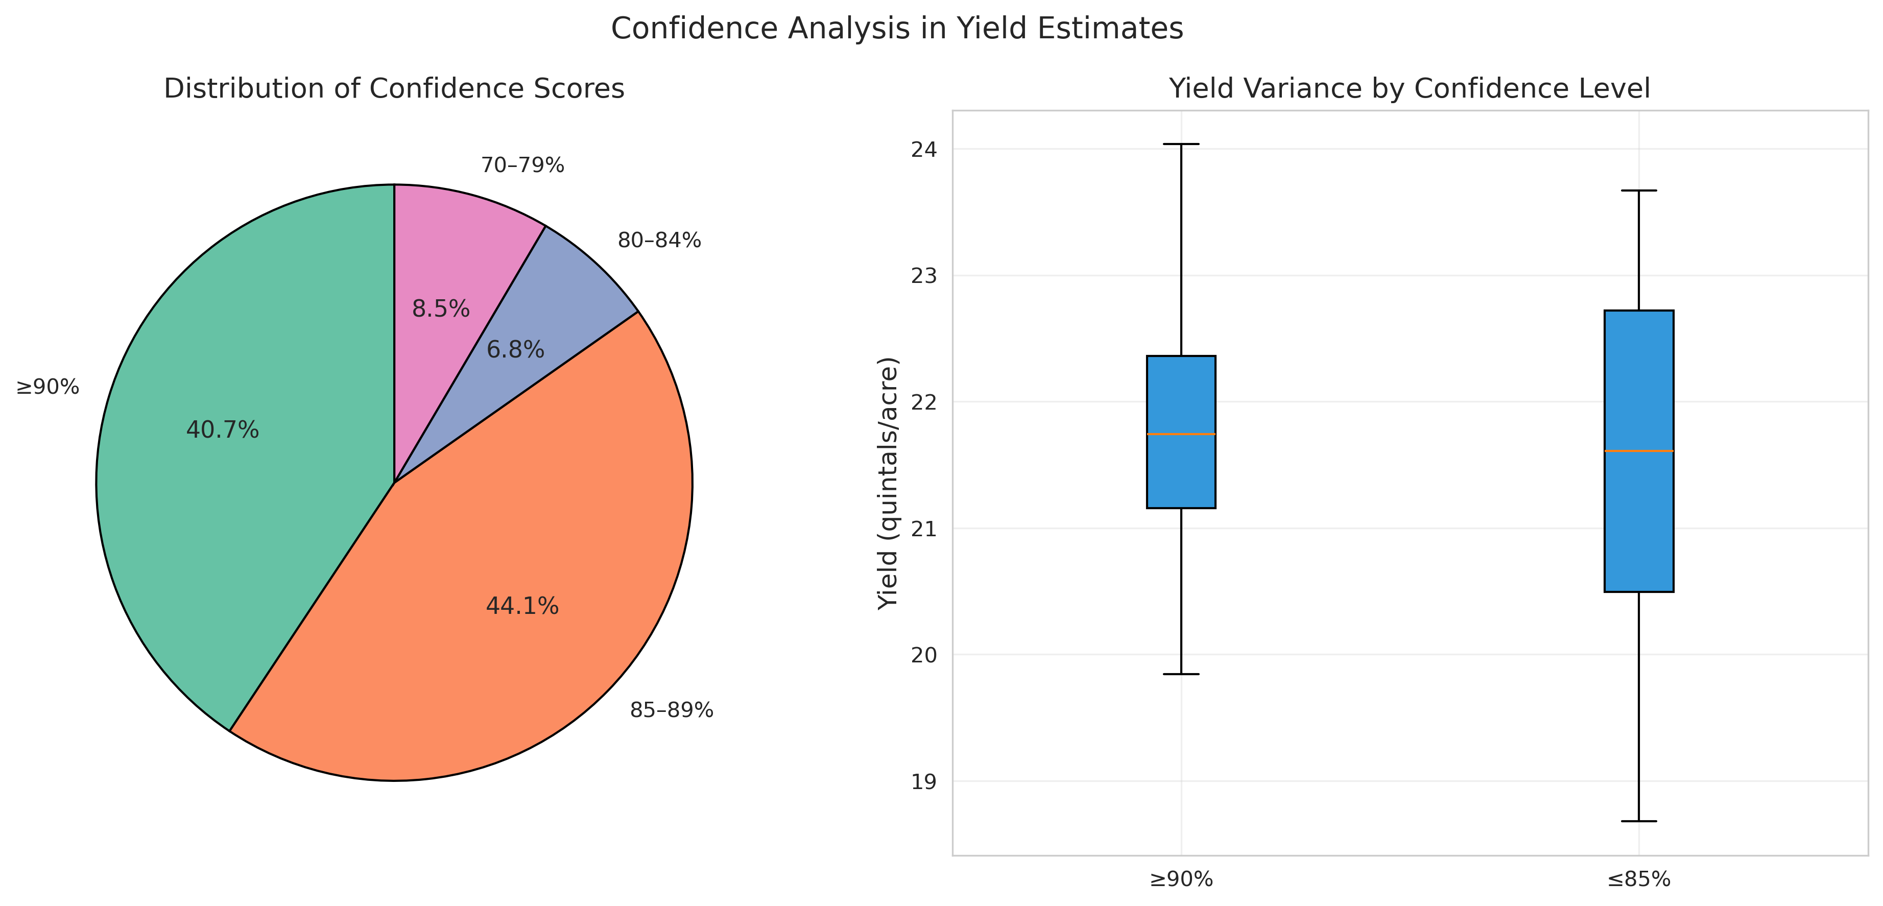
Figure 6. Distribution of confidence scores and relationship with yield variance (pie + grouped boxplot).
3.4 Yield Adjustment Framework
A practical framework was developed using HD2967 baseline of 22 q/acre (adjust for other varieties):
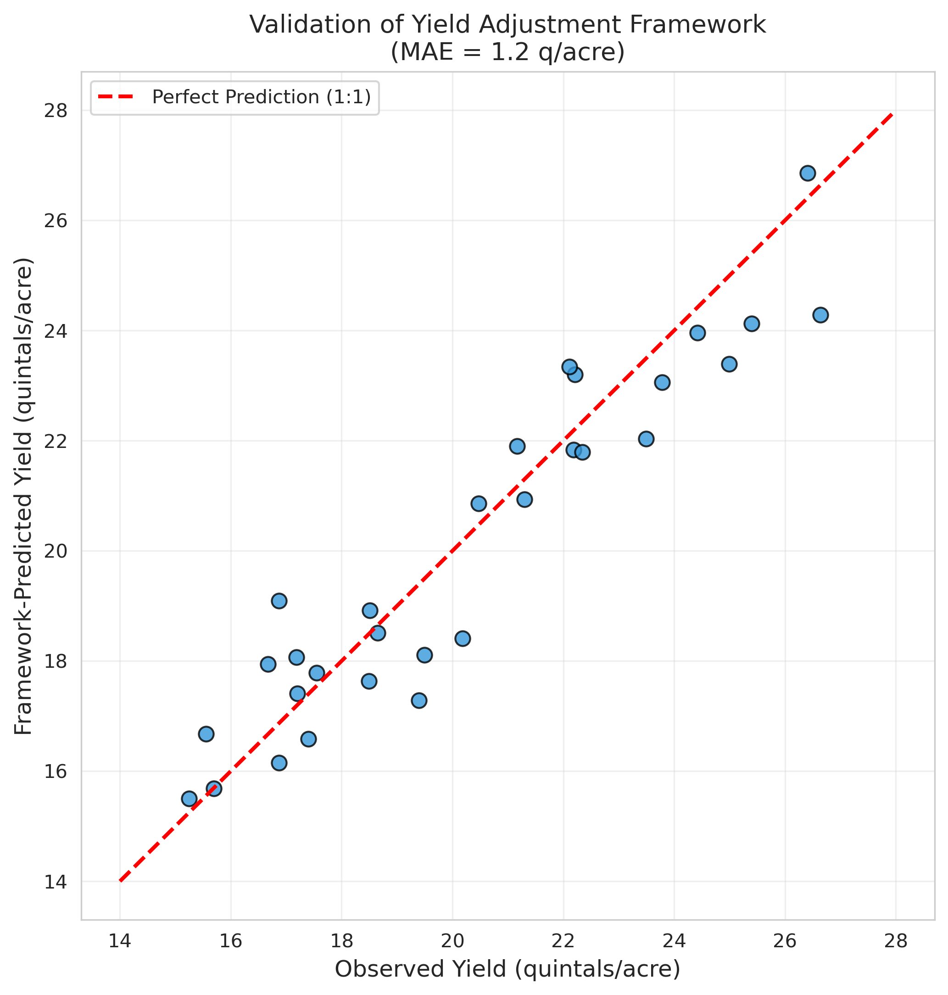

Figure 7. Observed (CCE-Red line) vs. framework-predicted(GDD-Blue dots) yields.
Table 2 : Adjustment Table HD2967 baseline of 22 q/acre
Condition | Adjustment | Expected Yield (q/acre)
Healthy, uniform, no lodging | +10 to +15% | 24.2–25.3
Minor lodging (maturity) | –5 to –10% | 19.8–20.9
Moderate lodging | –15 to –20% | 17.6–18.7
Severe lodging (pre-grain fill) | –25 to –30% | 15.4–16.5
Weeds / Waterlogging + lodging | –5% / –15–25% | —

Validation on 30 independent observations: MAE=1.2 q/acre, RMSE=1.6 q/acre; 85% predictions within ±1.5 q/acre.
Discussion
The results demonstrate that Google Gemini can effectively analyze temporal image sequences for wheat phenology, stress detection, and yield estimation. The strong performance of DBW90 and HD 3086 highlights the importance of variety selection in lodging-prone environments. The developed yield adjustment framework provides a practical, easy-to-use tool for extension workers and farmers. Its alignment with established lodging-yield loss relationships (Berry et al., 2004; Tripathi et al., 2004) adds credibility.
Conclusions
This study demonstrates the potential of multi-modal generative AI (Google Gemini) as a scalable tool for smartphone-based wheat monitoring and yield estimation. The proposed framework offers a practical solution for precision agriculture and climate-resilient farming in India. With continued validation and integration of meteorological data, such AI systems can significantly enhance decision support for all farmers including smallholder farmers.
Acknowledgments
The author gratefully acknowledges the IFPRI-BKC WeatherSys project for providing the 2017–18 field data and metadata.
Annexures
Annexure-I: Detailed prompts and responses in English and Hindi
Annexure-II: Mobile setup
References
1. PIB 2132330(2025), https://www.pib.gov.in/PressReleasePage.aspx?PRID=2132330&reg=3&lang=2
2. Singh, B. K., et al. (2018) A Tool for Climate Smart Crop Insurance: Combining Farmers’Pictures with Dynamic Crop Modelling for Accurate Yield Estimation Prior to Harvest, Dr. B.K. Singh, Dulal Chakraborty, Dr. Naveen Kalra, and Dr. Jaya Singh, https://cgspace.cgiar.org/items/d5be41df-750d-4325-8300-f77da3249f70
3. Berry, P. M., Sterling, M., Baker, C. J., Spink, J., & Sparkes, D. L. (2004). A calibrated model of wheat lodging compared with field measurements. Agricultural and Forest Meteorology, 123(3-4), 167-180
4. Tripathi, S. C., Sayre, K. D., Kaul, J. N., & Narang, R. S. (2004). Lodging behavior and yield potential of spring wheat (Triticum aestivum L.) under different management practices. Indian Journal of Agricultural Sciences, 74(4), 189-193.

