**Assignment#4**

Q#1) Apply POS (Part of speech on your data) and describe which part (Noun, Verb, Adjective etc) could be useful to define topic of discussion?

Write a paragraph. Use POS library for java.

Q#2) considering we have the following schema:

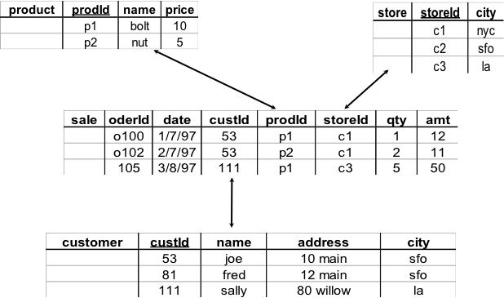

* 1. Show the result of pivoting the relation on prodid and date (with measure qty)

1/7/97

|  |  |
| --- | --- |
| **prodid** | **qty** |
| P1 | 1 |
| P2 |  |

2/7/97

|  |  |
| --- | --- |
| **prodid** | **qty** |
| P1 |  |
| P2 | 2 |

3/8/97

|  |  |
| --- | --- |
| **prodid** | **qty** |
| P1 | 5 |
| P2 |  |

select prodid, sum(qty) from sale where date = ‘1/7/97’ groupby prodid;

select prodid, sum(qty) from sale where date = ‘2/7/97’ groupby prodid;

select prodid, sum(qty) from sale where date = ‘3/8/97’ groupby prodid;

* 1. Show the result of roll-up on storied.

|  |  |  |
| --- | --- | --- |
| **storeid** | **qty** | **amt** |
| C1 | 3 | 33 |
| C3 | 5 | 50 |

select storied, sum(qty), sum(amt) from sale where groupby storied;

* 1. Show the result of roll-up on storid followed by drill-down on prodid.

|  |  |  |  |
| --- | --- | --- | --- |
| **storeid** | **prodid** | **qty** | **amt** |
| C1 | P1 | 1 | 12 |
| P2 | 2 | 11 |
|  | **3** | **33** |
| C3 | P1 | 5 | 50 |
|  | **5** | **50** |

select storied, prodid, qty, amt from sale where groupby GROUPING SETS(storied, prodid).

**or** select storied, prodid, sum(qty), sum(amt) from sale where groupby GROUPING SETS(storied, prodid).

* 1. Write a collection of SQL queries for a, b, & c.

Q#3) Given a fact table (i.e. sale table format from Question 5):

1. Write a SQL query with group-by on storid and prodid for total of quality.

select storied, prodid, sum(qty) from sale where groupby GROUPING SETS(storied, prodid).

1. Implement a Java program to do the computation.

(input: the sale table as a file where each row is on a line, separated by “,” or “ “).