# Section 1

Data Source: - Airbnb Website

Data Collection Layer: - ETL

Storage Layer: - HDFS, Cloud (S3), NoSQL

Processing Layer: - Batch Processing

Querying Layer: - Hive, Pig, SparkSQL, MapReduce

Analytics Layer: - Machine Learning, Predictive Modelling, Statistical Analytics

Visualization Layer: - JavaScript Webpage

# Section 2.1

## 2.1.1

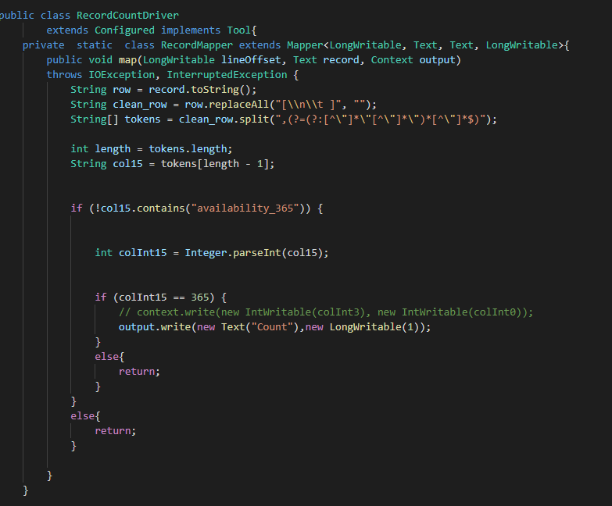

# 

# 

## 2.1.2

## 

# 

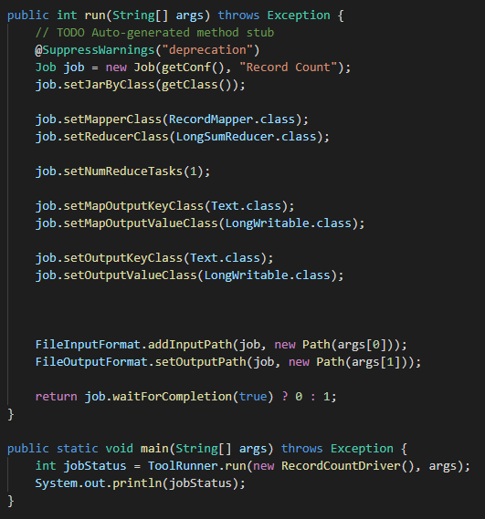

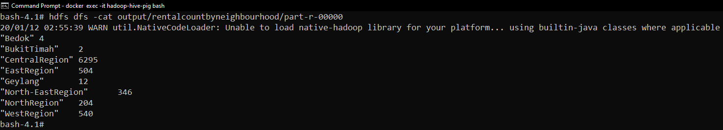

# Section 2.2

## 2.2.1

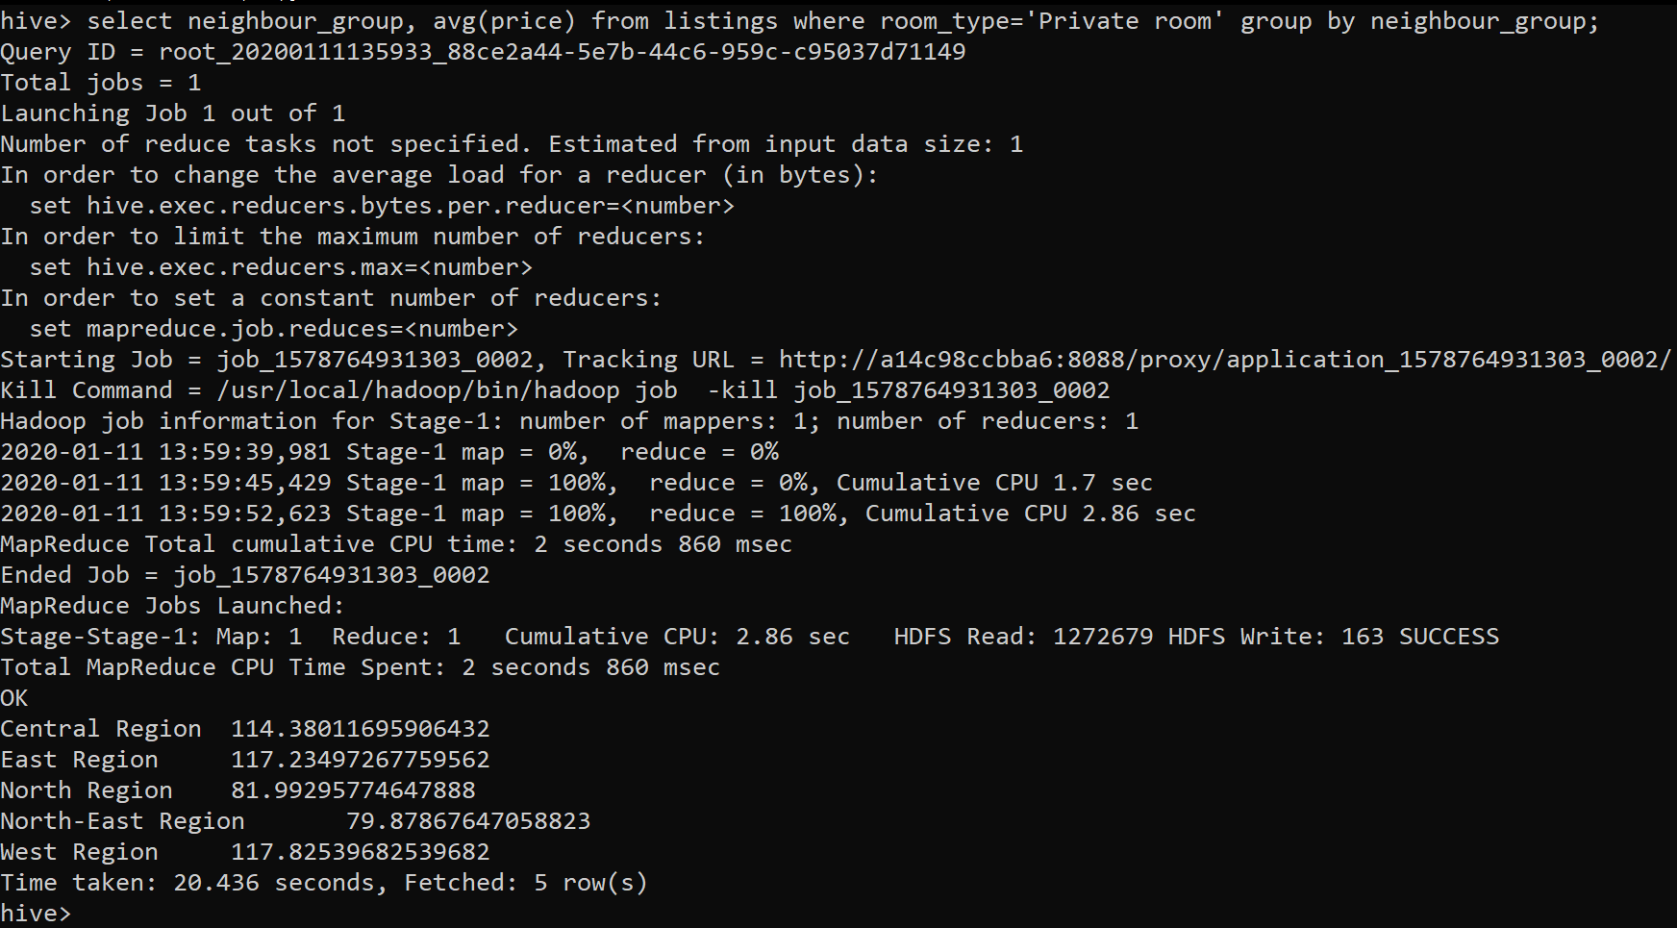

## 2.2.2

## 

## 2.2.3

## 

# Section 2.3

## 2.3.1

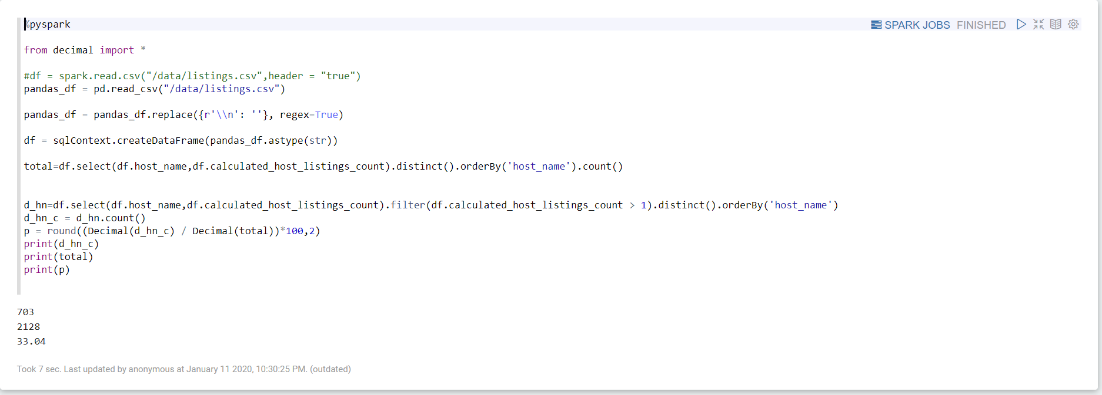

## 2.3.2

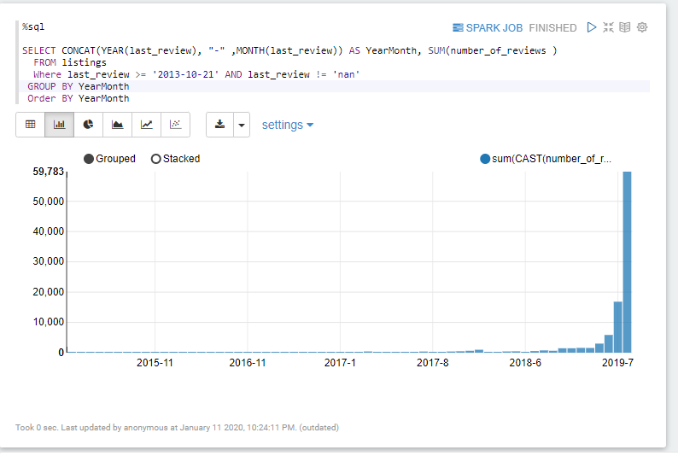

## 2.3.3

