6SENG002W Concurrent Programming

FSP Process Analysis & Design Form

Name | H.K Dulana Hansisi
Student ID | UOW ID: W1654550 | IIT ID: 2016342
Date | 1/11/2019

1. FSP Process Attributes

Attribute | Value
Name | GRANDMOTHER
Description | Actions which can be performed by grandmother and its states.
Alphabet | {addingBirthdayMoney[5][1], calculateBalance[6], depositMoney[5][1], readBalance[5], sendBDayCard, updateAccount[3..7]}
Number of States | 4
Deadlocks (yes/no) | N/A
Deadlock Trace(s) | N/A

2. FSP Process Code

FSP Process:
range BALANCE = 5..5
range TRANSACTION = 1..1
range ALLTRANSACTION = 1..1
range BALANCENEW = 3..7
range DEPOSIT = 1..1

GRANDMOTHER = EXISTINGAMOUNT,
EXISTINGAMOUNT = (readBalance[balance:BALANCE] ->EXISTINGAMOUNT|addingBirthdayMoney[balance:BALANCE][amount:DEPOSIT]->calculateBalance[balance+amount] ->NEWBALANCE[balance+amount]
|depositMoney[balance:BALANCE][amount:DEPOSIT]->calculateBalance[balance+amount]->NEWBALANCE[balance+amount]),
NEWBALANCE[balance:BALANCENEW] = (updateAccount[balance]->EXISTINGAMOUNT)+{sendBDayCard}.

3. Actions Description
A description of what each of the FSP process' actions represents, i.e. is modelling. In addition, indicate if the action is intended to be synchronised (shared) with another process or asynchronous (not shared). (Add rows as necessary.)

Actions | Represents | Synchronous or Asynchronous
addingBirthdayMoney[balance:BALANCE][amount:DEPOSIT] | Initial state changes into state 4. | Asynchronous
calculateBalance[balance+amount] | State 3 changes into NEWBALANCE state. State 1 changes into NEWBALANCE. | Asynchronous
depositMoney[balance:BALANCE][amount:DEPOSIT] | Initial state changes into state 2 | Asynchronous
readBalance[balance:BALANCE] | EXISTINGMONEY state comes back to EXISTINGMONEY state | Asynchronous
sendBDayCard | Extends alphabet | Asynchronous
updateAccount[balance] | NEWBALANCE state goes to EXISTINGMONEY state. | Asynchronous

4. FSM/LTS Diagrams of FSP Process
Note that if there are too many states, more than 64, then the LTSA tool will not be able to draw the diagram. In this case draw small diagrams of the most important parts of the complete diagram.

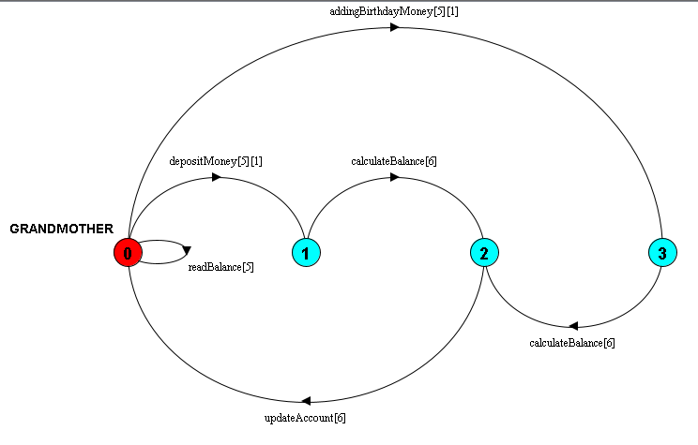

5. LTS States
A description of what each of the FSP process' states represents, i.e. is modelling. If there are a large number of states, then you can group similar states together &/or only include the most important ones. For example, identify any states related to mutual exclusion (ME) & the associated critical section (CS), e.g. waiting to enter the CS state, in the CS state(s), left the CS state. (Add rows as necessary.)

States | Represents
Q0 | Initial state. After invoking readBalance [5]. After invoking updateAccount [6]
Q1 | After invoking depositMoney[5][1].
Q2 | After invoking calculateBalance[6] on Q3. After invoking calculateBalance[6] on Q1.
Q3 | After invoking addingBirthdayMoney[5][1].
Q4 | After invoking addingBirthdayMoney.

6. Trace Tree for FSP Process
The trace tree for the process. Use the conventions given in the lecture notes.

