6SENG002W Concurrent Programming

FSP Process Analysis & Design Form

Name | H.K Dulana Hansisi
Student ID | UOW ID: W1654550 | IIT ID: 2016342
Date | 1/11/2019

1. FSP Process Attributes

Attribute | Value
Name | STUDENT
Description | Actions which can be performed by a Student and its states.
Alphabet | {calculateBalance[4], readBalance[5], subtractMoney[1], updateAccount[3..7], withdrawMoney[5][1]}
Number of States | 7
Deadlocks (yes/no) | No deadlocks/errors
Deadlock Trace(s) | N/A

2. FSP Process Code

FSP Process:
range BALANCE = 5..5
range TRANSACTION = 1..1
range ALLTRANSACTION = 1..1
range BALANCENEW = 3..7
range DEPOSIT = 1..1

STUDENT = EXISTINGAMOUNT,
EXISTINGAMOUNT = (readBalance[balance:BALANCE]->EXISTINGAMOUNT
| withdrawMoney[balance:BALANCE][transaction:TRANSACTION]->subtractMoney[transaction]->calculateBalance[balance-transaction]->NEWBALANCE[balance-transaction]|withdrawMoney[balance:BALANCE][transaction:TRANSACTION] ->buyNewPhone->subtractMoney[transaction]->calculateBalance[balance-transaction] ->NEWBALANCE[balance-transaction]),
NEWBALANCE[balance:BALANCENEW] = (updateAccount[balance]->EXISTINGAMOUNT) \{buyNewPhone}.

3. Actions Description
A description of what each of the FSP process' actions represents, i.e. is modelling. In addition, indicate if the action is intended to be synchronised (shared) with another process or asynchronous (not shared). (Add rows as necessary.)

Actions | Represents | Synchronous or Asynchronous
readBalance[balance:BALANCE] | EXISTINGAMOUNT state will be met again because of the recursion. | Asynchronous
withdrawMoney[balance:BALANCE][transaction:TRANSACTION] | EXISTINGAMOUNT state changes into State 1. EXISTINGAMOUNT state changes into State 5. | Asynchronous
subtractMoney[transaction] | State 5 changes into state 6. State 2 changes into state 3. | Asynchronous
calculateBalance[balance-transaction] | State 3 changes into NEWBALANCE state. State 6 changes into NEWBALANCE state. | Asynchronous
updateAccount[balance] | NEWBALANCE state changes into EXISTINGAMOUNT | Asynchronous
buyNewPhone | State 1 changes into state 2 | Asynchronous

4. FSM/LTS Diagrams of FSP Process
Note that if there are too many states, more than 64, then the LTSA tool will not be able to draw the diagram. In this case draw small diagrams of the most important parts of the complete diagram.

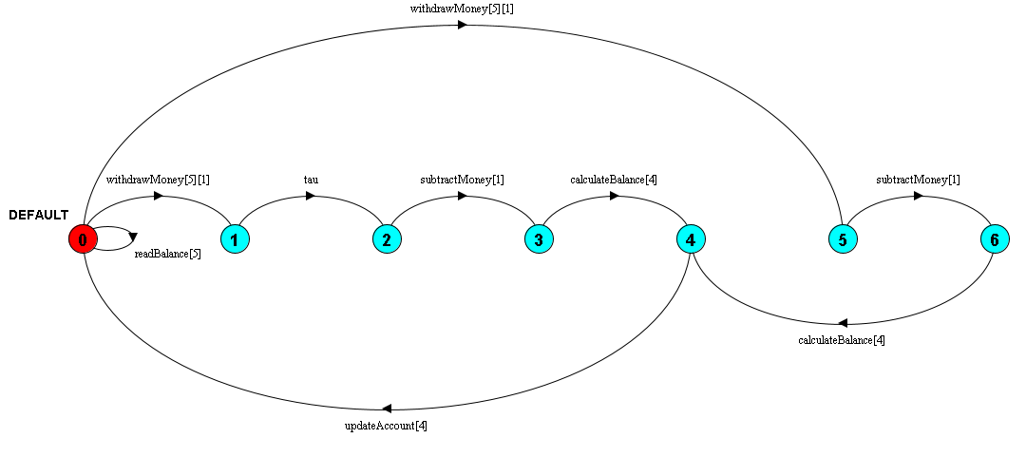

5. LTS States
A description of what each of the FSP process' states represents, i.e. is modelling. If there are a large number of states then you can group similar states together &/or only include the most important ones. For example, identify any states related to mutual exclusion (ME) & the associated critical section (CS), e.g. waiting to enter the CS state, in the CS state(s), left the CS state. (Add rows as necessary.)

States | Represents
Q0 | Initial state. After invoking readBalance[5]. After invoking updateAccount[4] on Q4.
Q1 | After invoking withdrawMoney[5][1] on Q0.
Q2 | After invoking tau.
Q3 | After invoking subtractMoney[1].
Q4 | After invoking calculateBalance[4] on Q3. After invoking calculateBalance[4] on Q6
Q5 | After invoking withdrawMoney[5][1] on Q0.
Q6 | After invoking subtractMoney[1] on Q5.

6. Trace Tree for FSP Process
The trace tree for the process. Use the conventions given in the lecture notes.

