Software Requirements Document for ?????

Author: Group ??
REPLACE-WITH-YOUR-NAME(s)

Version | Date | Author | Change
0.1 | 09/13/07 |  | Initial Document

Table of Contents
1 Introduction 3
1.1 Purpose 3
1.2 Scope 3
1.3 Definitions, acronymns, abbreviations 3
1.4 References 3
1.5 Overview 3
2 Overall Description 4
2.1 Product Perspective 4
2.2 Product functions 5
2.3 User characteristics 5
2.4 Constraints 5
2.5 Assumptions and Dependencies 5
3 Specific Requirements 6
3.1 External Interface Requirements 6
3.2 FEATURES 6
3.3 Performance requirements 6
3.4 Design Constraints 6
3.5 Software System Attributes 6
3.6 Other Requirements 7

Introduction

Purpose
The purpose of this document is to provide detailed information about Universities.kz

Scope
This document will describe the use cases and the features of the Universities.kz

Definitions, acronymns, abbreviations
// alphabetical list of terms and their descriptions
// This is part of analysis and you must make sure you describe terms used in this document
Term | Description

References
LinkedIN API : https://api.linkedin.com/v1/people/~?format=json
Google maps API: https://maps.googleapis.com/maps/api/geocode/output?parameters

Overview
[OMIT]

Overall Description

University.kz is the information portal specializing on making the independent ranking of universities

Concept of Operations
This application is similar to several existing websites such as www.topuniversities.com www.timeshighereducation.com. It is unique, though, there is no such a great website analog in our country.

Major User Interfaces
The University.kz will run on heroku server system (see: https://www.heroku.com/). The website will store information in a database, which is going to be MySQL. The application
will communicate with the social networks servers through the API to retrieve and update information on users profile. The application will communicate with the Google server through the Google Maps API to synchronize location and show upcoming nearby events.

Hardware Interfaces
// Server, laptop, internet,wlan,mouse,keyboard

Software Interfaces
// example: CGI-URL or function signatures etc (OMIT for now).

Communication Interfaces
// example: modem etc (OMIT for now)

Memory Constraints
// RAM, and other storage constraints (OMIT for now)

Operations
// special operations (if any) (OMIT for now)

Site Adaptation Requirements
//ex: Kazakh, russian , english language , cross-browsing

Product functions
// Share contacts of the educational , National Test preparation , language courses and add option of university searching by choosing the criterias, like: cost, demand, speciality, student organization( clubs etc..).

Example use case
// 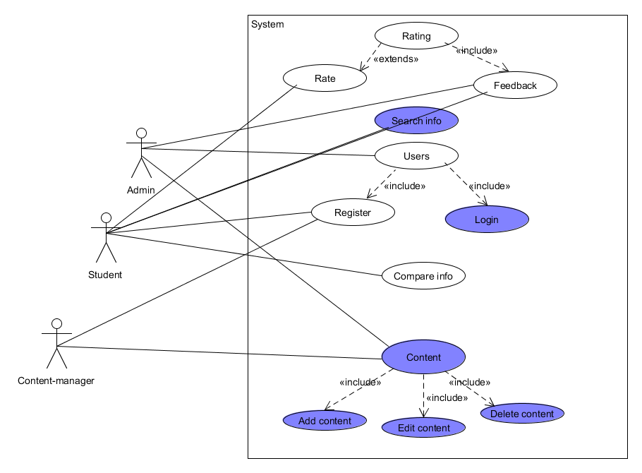

User characteristics

// typical user characteristics, frequency of usage etc

Constraints
// all conditions that may limit design options (INCLUDE NON FUNCTION CONSTRAINTS)

Assumptions and Dependencies
// hardware and software assumptions and dependencies

Specific Requirements

// Here you need to put in details (if any). Mark items [None] if you do not have any information.

External Interface Requirements

User Interfaces

Hardware Interfaces

Software Interfaces

Communications Interfaces

FEATURES

FEATURE-1 ….

…

…..

Performance requirements

Design Constraints

Software System Attributes

Reliability

Availability

Security

Maintainability

Portability

Other Requirements

// ADD Appendices (if any)
// Regenerate Table of Contents

