Software Requirements Document for ?????

Author: Group ??
REPLACE-WITH-YOUR-NAME(s)

Version | Date | Author | Change
0.1 | 09/13/07 |  | Initial Document

Table of Contents
1 Introduction 3
1.1 Purpose 3
1.2 Scope 3
1.3 Definitions, acronymns, abbreviations 3
1.4 References 3
1.5 Overview 3
2 Overall Description 4
2.1 Product Perspective 4
2.2 Product functions 5
2.3 User characteristics 5
2.4 Constraints 5
2.5 Assumptions and Dependencies 5
3 Specific Requirements 6
3.1 External Interface Requirements 6
3.2 FEATURES 6
3.3 Performance requirements 6
3.4 Design Constraints 6
3.5 Software System Attributes 6
3.6 Other Requirements 7

Introduction

Purpose
The purpose of this document is to provide detailed information about Universities.kz

Scope
This document will describe the use cases and the features of the Universities.kz

Definitions, acronymns, abbreviations
// alphabetical list of terms and their descriptions
// This is part of analysis and you must make sure you describe terms used in this document
Term | Description

References
LinkedIN API : https://api.linkedin.com/v1/people/~?format=json
Google maps API: https://maps.googleapis.com/maps/api/geocode/output?parameters

Overview
[OMIT]

Overall Description

University.kz is the information portal specializing on making the independent ranking of universities

Concept of Operations
This application is similar to several existing websites such as www.topuniversities.com www.timeshighereducation.com. It is unique, though, there is no such a great website analog in our country.

Major User Interfaces
The University.kz will run on heroku server system (see: https://www.heroku.com/). The website will store information in a database, which is going to be MySQL. The application
will communicate with the social networks servers through the API to retrieve and update information on users profile. The application will communicate with the Google server through the Google Maps API to synchronize location and show upcoming nearby events.

Hardware Interfaces
// Server, laptop, internet,wlan,mouse,keyboard

Software Interfaces
// example: CGI-URL or function signatures etc (OMIT for now).

Communication Interfaces
// example: modem etc (OMIT for now)

Memory Constraints
// RAM, and other storage constraints (OMIT for now)

Operations
// special operations (if any) (OMIT for now)

Site Adaptation Requirements
//ex: Kazakh, russian , english language , cross-browsing

Product functions
// Share contacts of the educational , National Test preparation , language courses and add option of university searching by choosing the criterias, like: cost, demand, speciality, student organization( clubs etc..).

Example use case
// 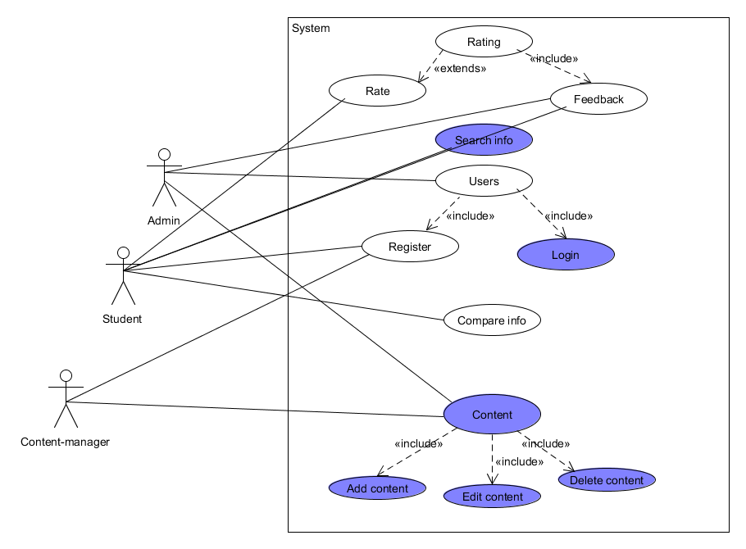

User characteristics
Types | Characteristics | frequency of usage
Administrator | has the privelegy to manage the content and users | med
user | has ability to see information and get personal content | med
viewer | has ability to see information, register | high

Assumptions and Dependencies
- It is assumed to be a website
- University.kz also depends on information provided by LinkedIn, official websites of universities

Specific Requirements

Design Constraints

php, html, jS, mysql, angular js

Software System Attributes

Reliability (KP)

Availability (JH)

Security (NS)

Maintainability (ZD)

Portability (ZD)

It is extremely portable, because software is web based.

Other Requirements
none
// ADD Appendices (if any)
// Regenerate Table of Contents

