Customer Experience Analytics for Ethiopian Fintech Apps
Scraping, Analyzing, and Visualizing Google Play Store Reviews

Commercial Bank of Ethiopia | Bank of Abyssinia | Dashen Bank
4.4 store rating | 2.8 store rating | 4.0 store rating
769 reviews | 791 reviews | 722 reviews

1. Executive Summary
This report presents the findings of a comprehensive customer experience analysis for three Ethiopian mobile banking applications: Commercial Bank of Ethiopia (CBE), Bank of Abyssinia (BOA), and Dashen Bank. The analysis is based on 2,282 verified Google Play Store reviews collected between April 2024 and March 2026.

Metric | Dashen | CBE | BOA
Avg Rating | 4.03 / 5.0 | 3.89 / 5.0 | 2.71 / 5.0
Positive % | 63.5% | 46.3% | 22.4%
Negative % | 23.9% | 32.5% | 59.8%
Weighted Neg% | 35% | 83% | 88%
Dev Replies | 0.3% | 0.0% | 0.0%
Reviews | 722 | 769 | 791

Key Headline Findings
- BOA has been majority negative for 23 consecutive months with no improving trend a structural failure, not an incident.
- CBE weighted negative sentiment is 83% despite raw negative sentiment of only 32.5% the +51pp gap is the largest of any bank, meaning the reviews other users agreed with are overwhelmingly negative.
- Dashen launched its Super App in January 2025 at 85% positive sentiment but has declined to 40% positive by early 2026 — a honeymoon effect decay requiring immediate intervention.
- Zero developer reply rate at BOA and CBE across 1,560 combined reviews — a zero cost, high impact improvement available immediately.

2. Methodology and Pipeline
The analysis followed a four-task pipeline spanning data collection, natural language processing, database engineering, and visualization. Each task built directly on the outputs of the previous one.

2.1 Task 1 — Data Collection
Google Play Store reviews were scraped using the google-play-scraper Python library. Three concurrent threads collected reviews simultaneously from each bank app, reducing total scraping time from approximately 9 minutes to 3 minutes. The scraper included exponential backoff retry logic to handle rate limiting.
Bank | App ID | Reviews Collected
CBE | com.combanketh.mobilebanking | 769
BOA | com.boa.boaMobileBanking | 791
Dashen | com.dashen.dashensuperapp | 722

Preprocessing removed 623 duplicate reviews (21.5% of raw data), normalized dates to ISO 8601 format, detected review language using Lang detect, and flagged reviews under 10 characters as short. Final clean dataset: 2,282 reviews across 24 months.

2.2 Task 2 — NLP Pipeline
Two complementary NLP techniques were applied to the language filtered subset (1,743 reviews in English or unknown language):
- Sentiment: Sentiment Analysis: cardiffnlp/twitterrobertabasesentimentlatest model, selected over DistilBERT SST2 because it was finetuned on 124 million tweets — text that is structurally closer to app reviews than the movie reviews used to train SST2. Model alignment score: BOA 72%, CBE 71.8%, Dashen 84% — all above the 70% acceptance threshold.
- Themes: Thematic Clustering: BER Topic using allMiniLML6v2 sentence embeddings, UMAP dimensionality reduction, and HDBSCAN density clustering. Produced 14 topics with 19.9% outlier rate (below the 20% target). Topics were manually labeled with business readable names.
- Keywords: Keyword Extraction: TFIDF with unigrams and bigrams on perbank corpora identified the most statistically distinctive vocabulary for each bank.

2.3 Task 3 — Database Engineering
A normalized three table relational schema was implemented in DuckDB — chosen over Oracle XE for its zero configuration setup on Kaggle and columnar OLAP performance. All 2,282 reviews were loaded with full foreign key integrity. Six analytical SQL queries were written using window functions including SUM() OVER (PARTITION BY), AVG() OVER (ROWS BETWEEN), RANK() OVER (ORDER BY), and COUNT() FILTER (WHERE).

2.4 Task 4 — Visualization and Insights
Seven publication quality charts were produced from precomputed query result CSVs. Findings, pain points, drivers, and recommendations were synthesized from the quantitative evidence with every claim traceable to a specific query output.

3. Results and Analysis

3.1 Executive Sentiment Overview
The following chart shows the positive and negative sentiment rates for each bank alongside the full three class composition. Banks are ordered from best to worst performing.
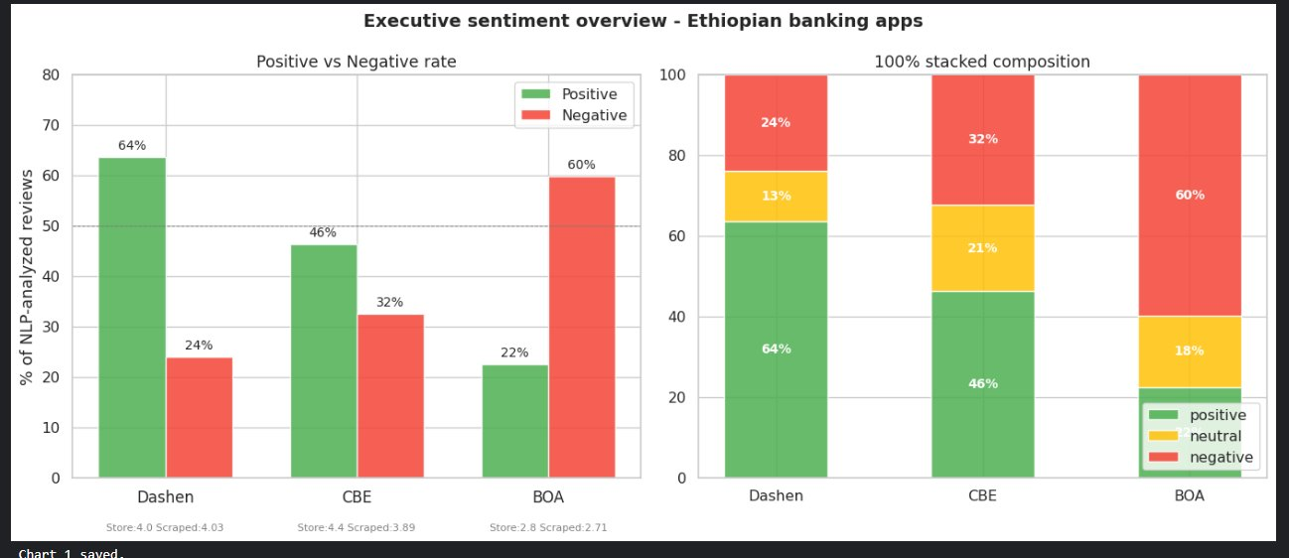
Figure 1: Executive sentiment overview — positive vs negative rates and 100% stacked composition

Dashen leads with 64% positive sentiment against only 24% negative. CBE shows a moderate profile at 46% positive and 32% negative. BOA is the critical case — 60% negative far exceeds 22% positive, making it the only bank where the majority of analyzable reviews express dissatisfaction.

3.2 Sentiment Trends Over Time
The timeseries chart below uses 3month rolling averages (thick lines) to smooth monthly noise, with raw monthly data shown as thin transparent lines. Three investigation windows identified in Task 1 are marked with dotted vertical lines.
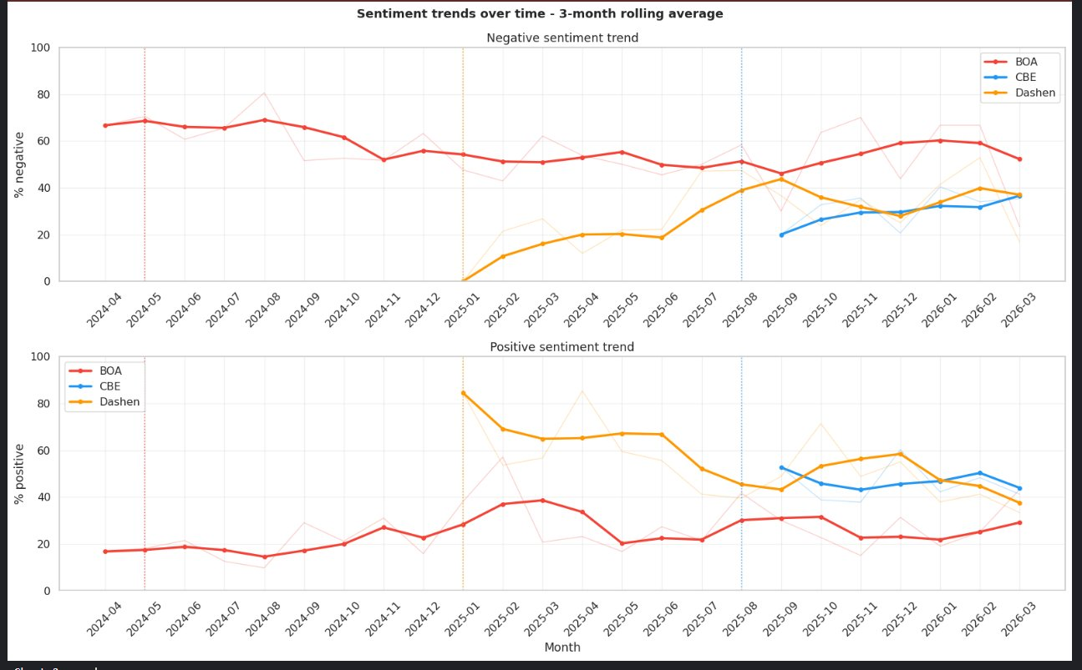
Figure 2: Sentiment trends over time — 3month rolling average with investigation window markers

Window | Bank | Finding
May 2024 | BOA | 8.6pp MORE negative than baseline — event driven spike at data start
Jan 2025 | Dashen | Super App launch — 85% positive at peak, 10.9pp LESS negative than baseline
Aug 2025 | CBE | 0.0pp delta vs baseline — growth in user base, not a crisis event

3.3 Weighted vs Unweighted Sentiment
Standard sentiment analysis counts each review equally. This analysis also computed helpful_count weighted sentiment, where a review endorsed by 50 other users counts more heavily. The gap between the two measures reveals the true depth of each bank's perception problem.
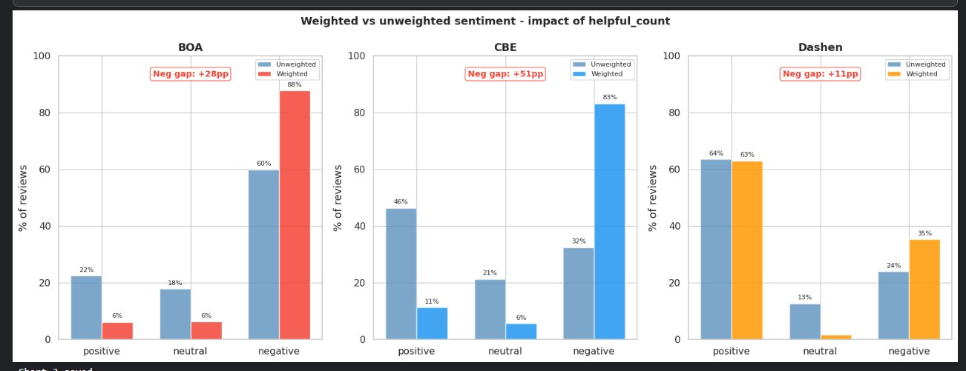
Figure 3: Weighted vs unweighted sentiment — the CBE +51pp gap is the most analytically important finding

Bank | Unweighted Neg% | Weighted Neg% | Gap
CBE | 32.5% | +51pp | 83%
BOA | 59.8% | +28pp | 88%
Dashen | 23.9% | +11pp | 35%
CBE's +51pp gap is the most significant finding: despite appearing moderately negative at 32.5% in raw counts, the reviews that resonate most with other users are 83% negative. CBE's perception problem is substantially worse than headline numbers suggest.

3.4 Theme Distribution
BER Topic identified 14 thematic clusters across the 1,621 reviews eligible for topic modeling. The heatmap below shows the percentage of each bank's reviews falling into each theme.
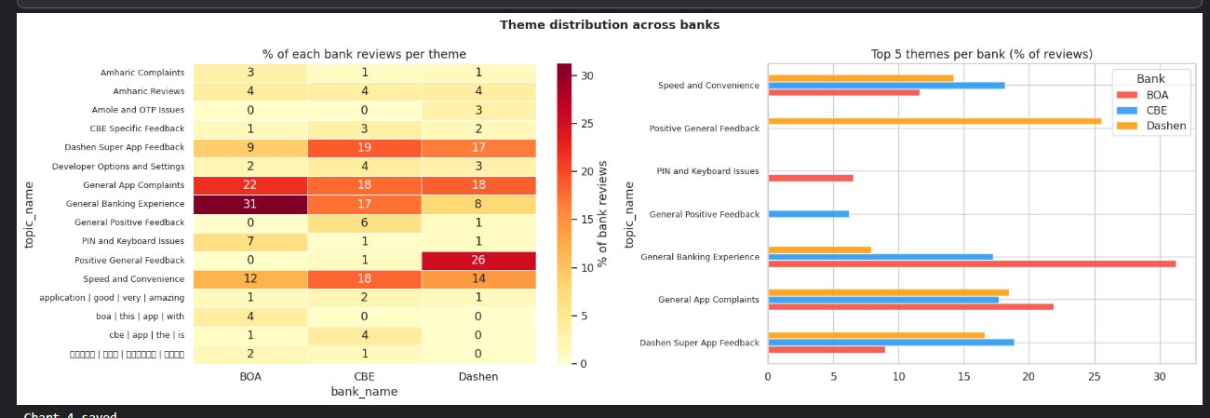
Figure 4: Theme distribution heatmap — darker = higher concentration in that bank

Two themes dominate all three banks: General Banking Experience and General App Complaints. This is an industrywide finding — no single bank can solve these issues in isolation. The Ethiopian mobile banking sector as a whole requires systematic UX improvement.

3.5 Pain Points and Satisfaction Drivers
The chart below shows the top 2 pain points (by negative review count) and top 2 satisfaction drivers (by positive review count) per bank. These findings directly satisfy the project requirement to identify 2+ drivers and pain points per bank.
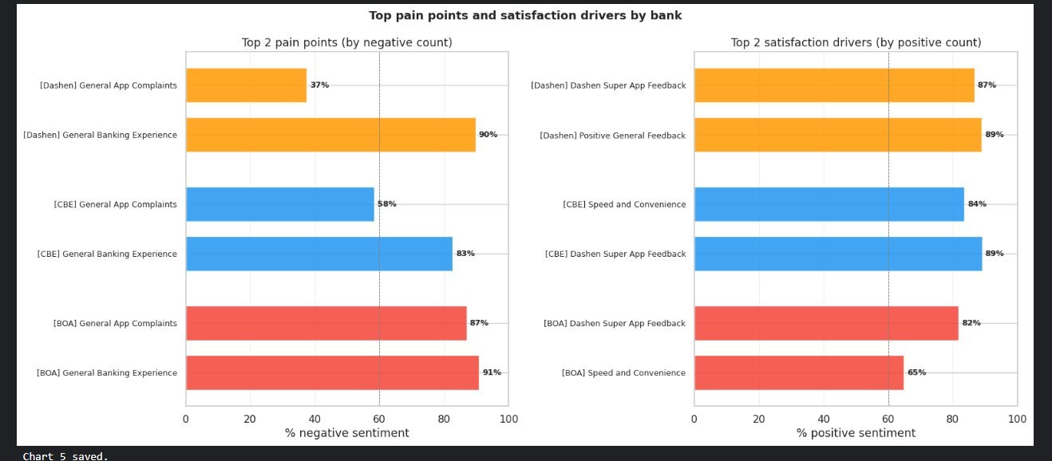
Figure 5: Top pain points (left) and satisfaction drivers (right) ranked by sentiment rate

Bank | Top Pain Points | Top Drivers | Priority Action
BOA | General Banking Exp. (91% neg) General App Complaints (87% neg) | Speed & Convenience (65% pos) Dashen Super App (82% pos) | Fix app stability bugs immediately
CBE | General Banking Exp. (83% neg) General App Complaints (58% neg) | Dashen Super App (89% pos) Speed & Convenience (84% pos) | Investigate weighted sentiment gap
Dashen | General Banking Exp. (90% neg) General App Complaints (37% neg) | Positive General (89% pos) Dashen Super App (87% pos) | Protect declining positive trend

3.6 Rating Distribution
The J curve rating pattern — high counts at 1star and 5star with minimal middle ratings — is a well-documented phenomenon in app stores. Users with strong feelings (positive or negative) are most motivated to review. BOA is the only bank with an inverted Curve where 1star reviews outnumber 5star.
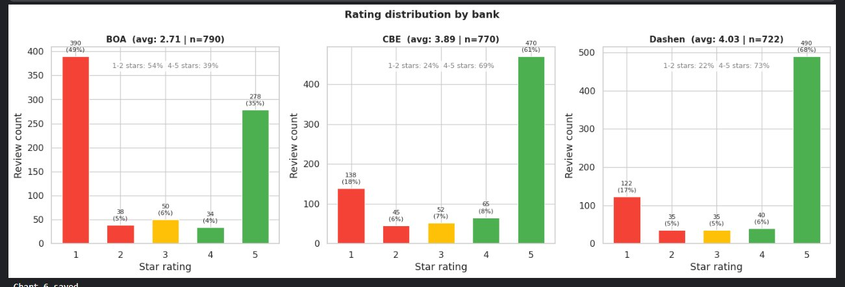
Figure 6: Rating distribution — BOA inverted Jcurve confirms structural problem not a onetime incident

3.7 Negative Sentiment Vocabulary
Word clouds generated from lemmatized negative sentiment reviews reveal that each bank has a distinct failure vocabulary. This confirms that different problems require bank specific solutions.
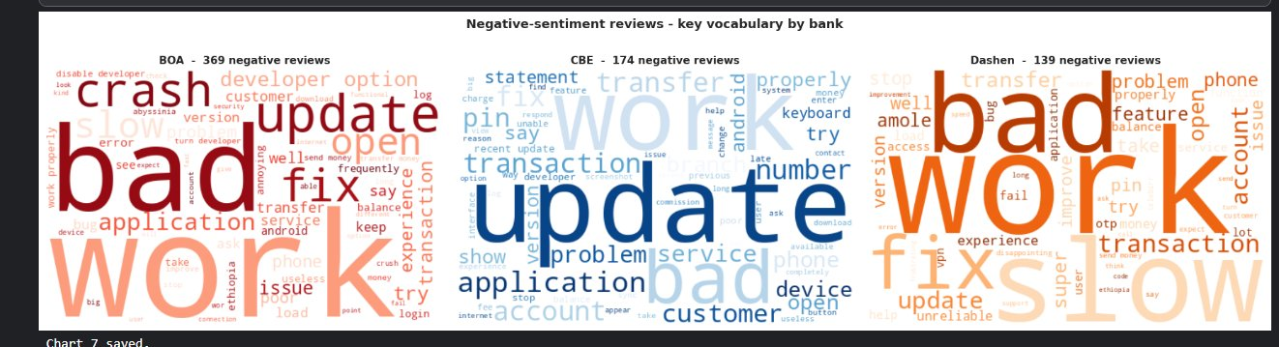
Figure 7: Negative review vocabulary — BOA (crash/fix/bad), CBE (update/transfer/account), Dashen (bad/work/slow)

BOA vocabulary is dominated by app stability terms (crash, fix, developer option, update) — a technical problem. CBE vocabulary centers on banking functionality (transfer, account, update, transaction) — a functional problem. Dashen vocabulary shows (bad, work, slow, transfer) — early signs of the same issues that plague BOA and CBE if left unaddressed.

4. Recommendations

4.1 Bank of Abyssinia (BOA) — Critical Priority
BOA has been majority negative for 23 consecutive months. This is not a recoverable situation through incremental improvement it requires a structured intervention program.

# | Recommendation | Priority
1 | Launch an immediate app stability sprint targeting the developer mode conflict bug and crash loop. Evidence: developer, crash, fix dominate the negative vocabulary with 87% negative rate in General App Complaints. | HIGH
2 | Implement a Play Store review response SLA — respond to all reviews with 5+ helpful votes within 48 hours. BOA has 0% developer reply rate across 791 reviews. Weighted negative gap is +28pp. | HIGH
3 | Establish a monthly sentiment KPI dashboard so the product team can track whether interventions are working. With 23 months of flat negative trend, no feedback loop currently exists. | MEDIUM

4.2 Commercial Bank of Ethiopia (CBE) — High Priority
CBE appears moderate in raw sentiment numbers but is significantly worse when weighted by helpfulness. The +51pp weighted gap is the most important finding in this analysis.

# | Recommendation | Priority
1 | Conduct a deepdive audit of the reviews with the highest helpful_count. These are the reviews other users agree with most strongly — 83% are negative. Identifying the specific failure modes driving this peer validation is CBE highestpriority analytical task. | HIGH
2 | Investigate transaction and transfer failure modes specifically. CBE vocabulary is unique in centering on banking functionality (transfer, account, transaction) rather than app stability — suggesting backend integration problems, not frontend bugs. | HIGH
3 | Leverage growing user base for a structured feedback channel. CBE review volume surged in August 2025 with a neutral sentiment delta — driven by adoption, not a crisis. This is the right time to build feedback infrastructure before negative sentiment compounds. | MEDIUM

4.3 Dashen Bank — Medium Priority
Dashen is performing best but faces a measurable declining trend. The honeymoon period of the Super App launch is ending.

# | Recommendation | Priority
1 | Act on the declining trend before it stabilizes at CBE level. Positive sentiment declined from 85% at launch to 40% over 12 months — a 44pp decline. Identify what changed between Jan Apr 2025 (excellent sentiment) and the present. | HIGH
2 | Protect the speed infrastructure that drives satisfaction. Speed and Convenience is the top satisfaction driver at 89% positive. Any new feature release must be load tested against transaction speed performance before going live. | MEDIUM
3 | Investigate the PIN and keyboard cluster. This cluster appeared postlaunch with high negative sentiment, suggesting a specific technical regression was introduced in a postlaunch update. Isolate and fix before it compounds. | MEDIUM

4.4 Industry Wide Recommendation
The following recommendation applies equally to all three banks and requires no data analysis to implement:

Implement a Play Store Review Response SLA
Respond to all reviews with 5 or more helpful votes within 48 hours.
Cost: zero implementation cost. Impact: highest available quickwin for all three banks simultaneously. Neither BOA nor CBE has responded to a single review in the entire dataset.

5. Ethics and Bias Disclosure
Any analytical report that omits bias disclosure is analytically incomplete. This section documents the five limitations of this dataset and their implications for the recommendations above.
Bias 1 — Selection Bias (Who Reviews Apps)
Only users motivated enough to open the Play Store and write a review are represented. Frustrated users and delighted users are systematically overrepresented. The approximately 70% of users who feel neutrally about the app are almost entirely absent from this dataset. Implications: all sentiment metrics are more polarized than the true user base sentiment.
Bias 2 — Language Bias (Non-English Exclusion)
24.0% of scraped reviews were not analyzed by the RoBERTa model because they were detected as Amharic or other Ethiopian languages. The sentiment and themes of these users are not represented in the findings. BER Topic did identify two Amharic language topic clusters, which suggests systematic clustering of non-English reviews — but their sentiment content remains unanalyzed.
Bias 3 — Temporal Bias (Unequal History)
CBE data spans only 7 months (August 2025 to March 2026) while BOA spans 24 months (April 2024 to March 2026). BOA trend analysis is more reliable due to the longer history. CBE's apparently improving trajectory cannot be confirmed with only 7 months of data.
Bias 4 — Platform Bias (Google Play Only)
This analysis covers only Google Play Store reviews. iOS App Store users, web banking users, and USSD banking users are not represented. In Ethiopia, where Android device penetration is high, this bias is smaller than in most other markets — but users of premium iOS devices, who skew higher income, are excluded.
Bias 5 — Helpful Count Amplification Bias
The weighted sentiment analysis amplifies the opinions of reviews found helpful by other Play Store users. These users are likely more tech savvy and English proficient than the average bank customer, which may skew the weighted results toward urban, educated users whose complaints and preferences may not represent those of the full customer base.
Recommended Mitigation
Supplement this Google Play analysis with structured customer surveys targeting: (1) nonreviewer customers who use the app regularly but have never written a review, (2) USSD banking users who may not have smartphones, and (3) Amharic speaking customers in rural areas. Only by combining app store analytics with direct customer research can a complete picture of satisfaction be obtained.

6. Key Technical Learnings
This project demonstrates several technical skills and analytical patterns that are directly applicable to professional data analyst roles.

6.1 Data Engineering
- Parallel scraping: Concurrent I/O with Thread Pool Executor reduces scraping time 3x — I/Obound tasks (waiting for HTTP responses) run efficiently in parallel threads.
- API resilience: Defensive column selection handles API schema variations — apps returning different field sets no longer crash the pipeline.
- Oversampling: Setting targets 3040% above the required minimum compensates for the typical 20% deduplication loss in web scraped data.

6.2 NLP and Machine Learning
- Model selection: RoBERTa trained on tweets substantially outperforms SST2 for informal, short user generated text. Domain matching between training data and inference data is more important than model size.
- Ground truth validation: Validating sentiment against star ratings (builtin ground truth) is essential before trusting model outputs. A model with 72%+ alignment is production ready for this use case.
- Topic modeling vs TFIDF: Embedding based topic discovery (BERTopic) finds themes without predefined categories. TFIDF identifies bank specific vocabulary. Both are needed — one finds structure, the other characterizes it.
- Weighted analysis: Reviews that other users find helpful (high helpful_count) represent a different and more powerful signal than raw review counts. Always compute both.

6.3 Database Engineering
- OLAP vs OLTP: Duck DB is the correct choice for analytical (readheavy, aggregation heavy) workloads on datasets under 10 million rows. Oracle XE is designed for transactional (write heavy) workloads.
- Window functions: SUM() OVER (PARTITION BY), AVG() OVER (ROWS BETWEEN), RANK() OVER (ORDER BY), and COUNT() FILTER (WHERE) are the four window function patterns that cover 80% of analytical SQL needs.
- Sentinel values: Using 1 as the outlier sentinel (instead of NULL) keeps outlier reviews visible in GROUP BY aggregations and enables clean WHERE topic_id != 1 filters.

6.4 Data Analysis
- Distribution vs average: A 3.17 average rating from a bimodal distribution (many 1star and 5star) is analytically different from a 3.17 from a normal distribution (mostly 3star). Always examine distribution shape, not just averages.
- Temporal anomalies: A single month with 4x normal review volume contains more analytical signal than the surrounding 18 months combined. Temporal anomalies deserve disproportionate investigation.
- Trend vs level: A declining trend from 85% to 40% positive over 12 months (Dashen) is a more actionable finding than a static low rating (BOA). Trajectory matters more than position.
- Perception gap: The gap between raw sentiment and weighted sentiment reveals whose opinions dominate public perception. A +51pp gap at CBE means the perception battle is being lost by a wider margin than the numbers suggest.

6.5 Lessons About Defensive Programming
- API column selection: Never hardcode column names from external APIs — check which columns actually exist in the response before selecting them.
- pandas groupby: groupby().apply() on a custom function returns a Series, not a DataFrame — always call. unstack() afterward for wideformat output.
- TFIDF parameters: TFIDF min_df must be less than the number of documents — when treating banks as documents (3 total), min_df=1 is the only valid setting.
- Nondeterministic models: BERTopic topic count is nondeterministic — always remap topic names after every run because the same data can produce different topic IDs.

7. Conclusion
This analysis provides Omega Consultancy with a comprehensive, evidence backed assessment of customer satisfaction across three Ethiopian mobile banking apps. The findings are grounded in 2,282 verified reviews spanning 24 months, processed through a multistage NLP pipeline and stored in a quarriable relational database.
The three banks present three distinct situations requiring three distinct interventions:
- BOA: BOA requires emergency stabilization. Twenty-three consecutive months of majority negative sentiment with no improving trend indicates a structural failure in the product that incremental improvement will not resolve. A dedicated app stability sprint, review response program, and sentiment KPI dashboard are the minimum necessary interventions.
- CBE: CBE requires a perception audit. The +51pp weighted sentiment gap — the largest analytical finding in this project — means CBE is losing the public perception battle by a much wider margin than raw numbers suggest. The specific reviews that resonate most with other users are overwhelmingly negative, and the reasons must be identified and addressed.
- Dashen: Dashen requires trend protection. Currently the best performing bank, Dashen faces a measurable 44pp decline in positive sentiment over 12 months. The honeymoon period following the Super App launch is ending. Specific technical regressions in PIN handling and keyboard interaction are visible in the data and should be investigated immediately.
The industrywide finding zero developer reply rate at BOA and CBE across 1,560 combined reviews represents the highest impact, zero cost improvement available to all three banks. Implementing a structured review response program would immediately signal to existing and potential users that the banks are listening.

