ShopSphere
Enterprise-Grade Social E-Commerce Platform
with Microservices Architecture

____________________________________________________________

PROJECT REPORT

March 2026

Table of Contents
1. Introduction
2. GIT Repository Link
3. Application Architecture
4. Backend Details
5. Frontend Details (With Screenshots)
6. Technology Stack Details
7. Workload Matrix (Individual User Contribution)
8. How to Run the Application

1. Introduction
ShopSphere is a modern, enterprise-grade e-commerce platform built using a microservices architecture. The platform combines traditional online shopping capabilities with social commerce features to create an engaging and scalable shopping experience.

1.1 Project Objectives
- Build a fully functional e-commerce platform using microservices architecture
- Implement independent, loosely coupled services that can be developed, tested, and deployed separately
- Provide a rich user experience with a modern React-based frontend
- Demonstrate real-world distributed systems patterns including event-driven communication, caching, and search indexing

1.2 Key Features
- User Management - Registration, authentication (JWT-based), profile management, and address book
- Product Catalog - Full product CRUD with advanced search, faceted filtering, visual search, and Elasticsearch integration
- Inventory Tracking - Real-time stock management, bulk updates, and availability checks
- Order Management - Complete order lifecycle from placement to delivery tracking
- Payment Processing - Stripe integration for payments and refund handling
- Shipping Management - Shipment tracking and delivery status updates
- Reviews & Ratings - Product reviews with rating aggregation
- AI-Powered Recommendations - Trending products, similar items, co-purchase suggestions, and personalized recommendations
- Notifications - Multi-channel notifications (email via SendGrid), templating, and preference management
- Analytics Dashboard - Business intelligence with sales metrics, user behavior, and product performance

1.3 Project Scope
The project consists of 10 microservices, a Next.js frontend, shared infrastructure (databases, message brokers, cache, search engine), and a centralized Docker Compose orchestration for local development and deployment.

2. GIT Repository Link
Repository URL: https://github.com/dulhara19/ShopSphere

- Main Branch: main (production-ready code)
- Development Branch: dev (active development)
- Service Branches: Each microservice was developed on its own feature branch (e.g., service/user-service, service/product-service) and merged into dev via Pull Requests

3. Application Architecture

3.1 High-Level Architecture
ShopSphere follows a microservices architecture where each service is independently deployable and communicates via REST APIs and asynchronous message queues.
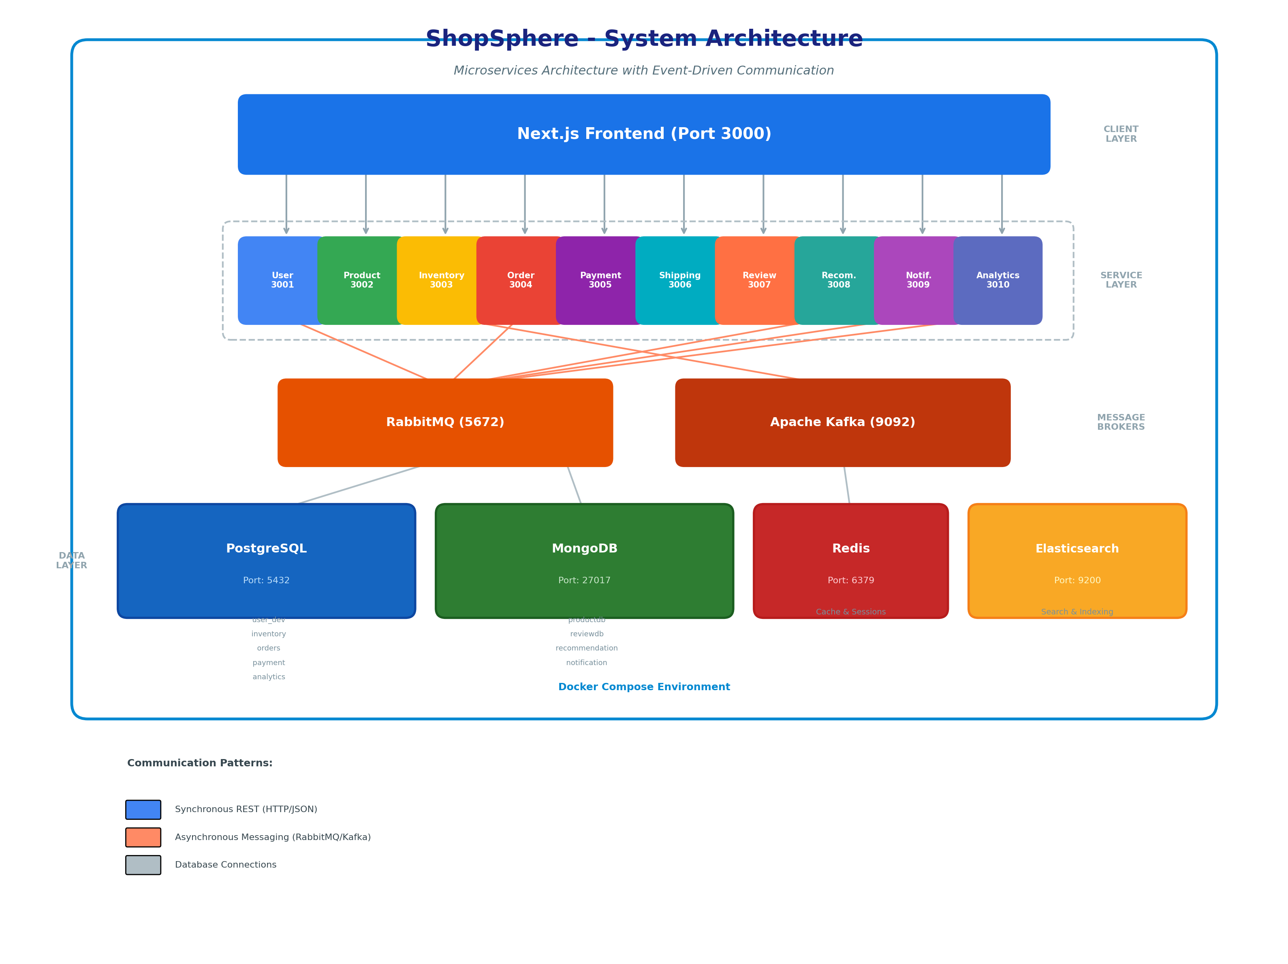
Figure 1: ShopSphere System Architecture Overview

3.2 Communication Patterns
Pattern | Technology | Use Case
Synchronous REST | HTTP/JSON | Direct request-response (e.g., fetching products, placing orders)
Asynchronous Messaging | RabbitMQ | Event-driven communication (e.g., order placed -> notification)
Event Streaming | Apache Kafka | Inventory updates, real-time event streams
Caching | Redis | Session management, frequently accessed data, recommendation caching
Full-Text Search | Elasticsearch | Product search, faceted filtering, visual search

3.3 Database Architecture
Database | Type | Services Using It
PostgreSQL | Relational | User Service, Inventory Service, Order Service, Payment Service, Analytics Service
MongoDB | Document | Product Service, Review Service, Recommendation Service, Notification Service
Redis | In-Memory Cache | User, Inventory, Order, Review, Recommendation, Analytics Services

3.4 Service Communication & Data Flow
The following diagram shows how services communicate with each other and connect to the data layer:
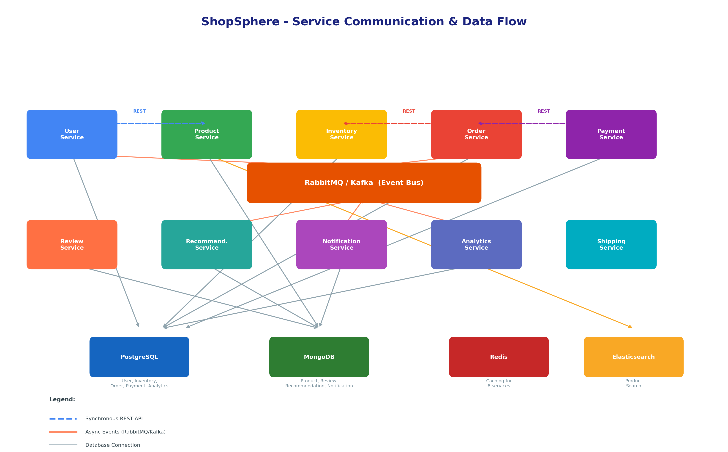
Figure 2: Service Communication & Data Flow

4. Backend Details

4.1 Microservices Overview
Each backend microservice is a Spring Boot application (Java 17) following a layered architecture:
src/main/java/com/shopsphere/<service>/
config/ # Configuration classes (CORS, Security, etc.)
controller/ # REST API endpoints
dto/ # Data Transfer Objects
event/ # Event publishers/listeners (RabbitMQ/Kafka)
exception/ # Custom exception handling
model/ # Domain entities
repository/ # Data access layer
service/ # Business logic layer

4.2 Service Details

User Service (Port 3001)
- JWT-based authentication and authorization
- User registration, login, profile management
- Address book management
- Password reset functionality
Technologies: PostgreSQL, Redis (sessions), RabbitMQ (user events)

Product Service (Port 3002)
- Full product CRUD operations
- Advanced search with Elasticsearch (faceted search, brand filtering, rating filtering)
- Visual search using DJL ResNet model with cosine similarity
- Product variants with auto-generated SKUs
- Review integration for rating aggregation
Technologies: MongoDB, Elasticsearch

Inventory Service (Port 3003)
- Real-time stock level management
- Bulk inventory updates and batch availability checks
- Audit trail for inventory changes
- Kafka-based event streaming for stock updates
Technologies: PostgreSQL, Redis, Kafka

Order Service (Port 3004)
- Complete order lifecycle management (create, update, cancel)
- Order status tracking
- Admin order management
- JWT-secured endpoints
Technologies: PostgreSQL, Redis, RabbitMQ

Payment Service (Port 3005)
- Stripe payment gateway integration
- Payment processing and refund handling
- Transaction history
- Database migrations via Flyway
Technologies: PostgreSQL, Stripe API

Shipping Service (Port 3006)
- Shipment creation and tracking (skeleton implementation)
- Delivery status management
Technologies: Under development

Review Service (Port 3007)
- Product review creation and retrieval
- Rating aggregation
- MongoDB-based document storage
Technologies: MongoDB, Redis

Recommendation Service (Port 3008)
- User behavior event tracking
- Trending products algorithm
- Similar product recommendations
- Co-purchase suggestions
- Personalized recommendations
- Redis caching for performance
Technologies: MongoDB, Redis, RabbitMQ

Notification Service (Port 3009)
- Multi-channel notification delivery (Email via SendGrid)
- Template-based notification rendering
- Notification preference management
- Inbox with pagination and soft-delete
- RabbitMQ event listeners for cross-service triggers
- Scheduled notifications
Technologies: MongoDB, RabbitMQ, SendGrid

Analytics Service (Port 3010)
- Sales metrics and reporting
- User behavior analytics
- Product performance tracking
- Business intelligence dashboard data
Technologies: PostgreSQL, Redis, RabbitMQ

5. Frontend Details (With Screenshots)

5.1 Frontend Architecture
The frontend is a Next.js 14 application using the App Router with TypeScript, Tailwind CSS for styling, Zustand for state management, and TanStack React Query for server state management.
frontend/src/
app/
(auth)/ # Authentication pages (login, register, forgot-password)
(shop)/ # Shopping pages (homepage, products, cart, checkout)
products/ # Product listing and detail pages
cart/ # Shopping cart
checkout/ # Checkout flow
admin/ # Admin dashboard
(user)/ # User account pages (profile, orders, addresses, settings)
components/ # Reusable UI components
lib/
api/ # API client modules (one per service)
stores/ # Zustand state management stores
types/ # TypeScript type definitions

5.2 Key Pages

Authentication Pages
- Login Page - Email/password authentication with JWT tokens
- Register Page - New user registration form
- Forgot Password - Password reset flow

Shopping Pages
- Homepage - Featured products, categories, promotional banners
- Products Listing - Product grid with search, filters, and sorting
- Product Detail - Product information, images, reviews, ratings, variant selection
- Shopping Cart - Cart management with quantity updates
- Checkout - Multi-step checkout with Stripe payment integration

User Account Pages
- Profile - User profile management
- My Orders - Order history and status tracking
- Addresses - Address book management
- Settings - Account settings and preferences

Admin Pages
- Admin Dashboard - Sales overview, analytics charts, key metrics
- Admin Orders - Order management and status updates
- Admin Products - Product CRUD, add new product form
- Admin Customers - Customer management
- Admin Analytics - Business intelligence dashboards

5.3 Screenshots
Below are screenshots of the key pages of the ShopSphere application. (Insert screenshots of each page here)
1. Login Page
[Insert Screenshot Here]
2. Registration Page
[Insert Screenshot Here]
3. Homepage
[Insert Screenshot Here]
4. Products Listing Page
[Insert Screenshot Here]
5. Product Detail Page (with reviews)
[Insert Screenshot Here]
6. Shopping Cart
[Insert Screenshot Here]
7. Checkout Page (with Stripe payment)
[Insert Screenshot Here]
8. User Profile Page
[Insert Screenshot Here]
9. My Orders Page
[Insert Screenshot Here]
10. Admin Dashboard
[Insert Screenshot Here]
11. Admin Products Management
[Insert Screenshot Here]
12. Admin Orders Management
[Insert Screenshot Here]

6. Technology Stack Details
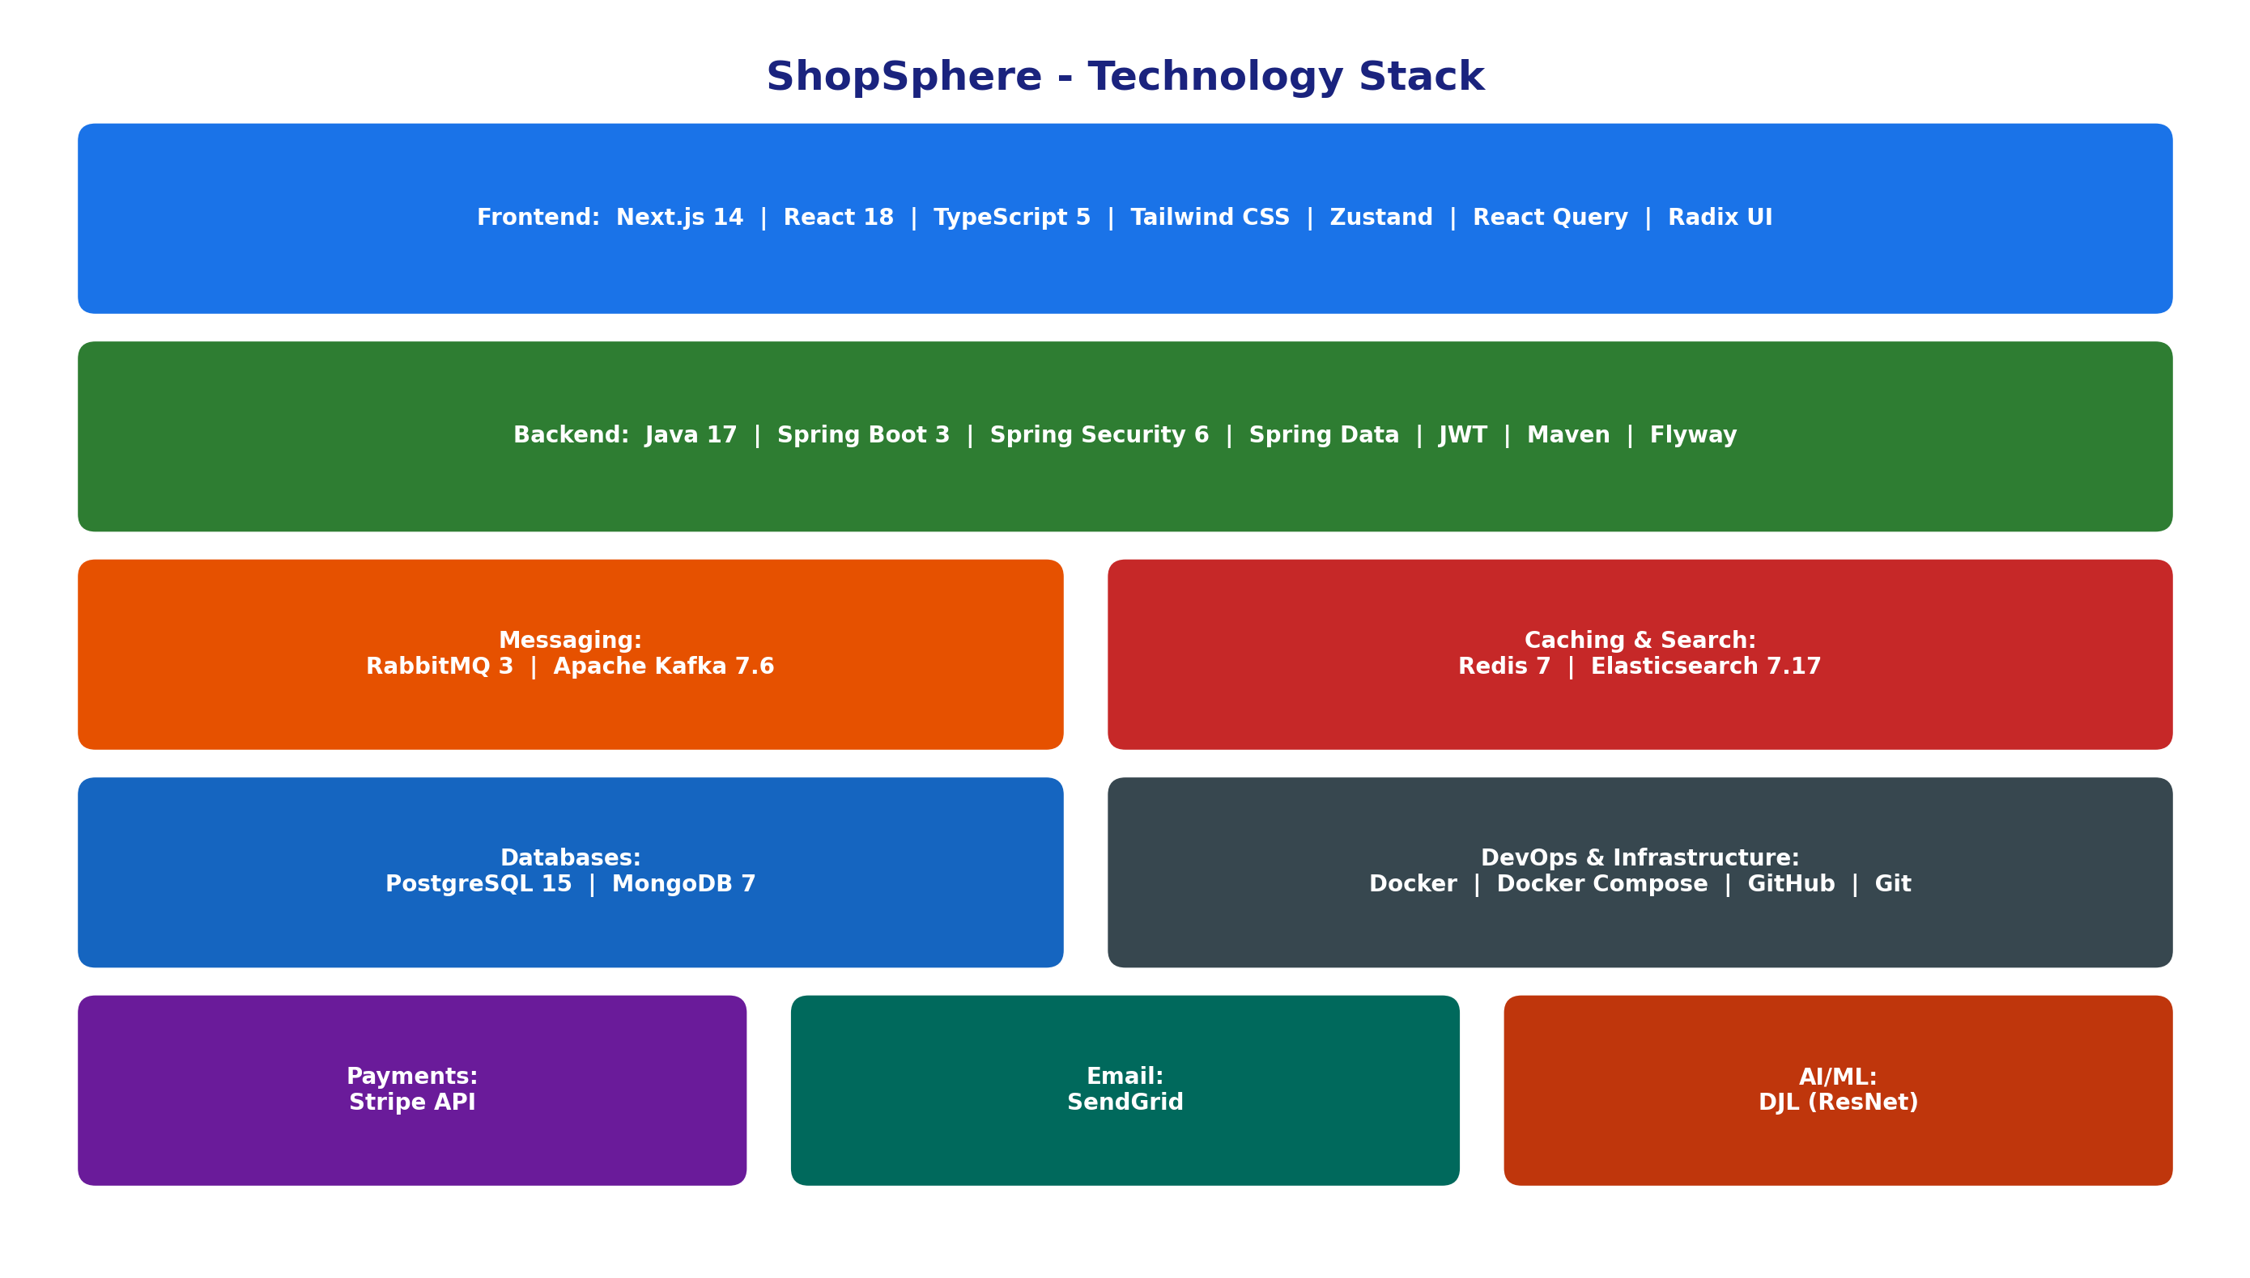
Figure 3: Technology Stack Overview

6.1 Backend Stack
Technology | Version | Purpose
Java | 17 | Primary backend language
Spring Boot | 3.x | Microservices framework
Spring Data JPA | 3.x | ORM for PostgreSQL
Spring Data MongoDB | 3.x | MongoDB data access
Spring Data Redis | 3.x | Redis caching
Spring AMQP | 3.x | RabbitMQ messaging
Spring Kafka | 3.x | Kafka event streaming
Spring Security | 6.x | Authentication & authorization
Flyway | Latest | Database migration (Payment Service)
JWT (jjwt) | Latest | Token-based authentication
Stripe Java SDK | Latest | Payment processing
DJL (Deep Java Library) | Latest | Visual search / AI model inference
Maven | 3.x | Build tool & dependency management

6.2 Frontend Stack
Technology | Version | Purpose
Next.js | 14.2 | React framework (App Router)
React | 18.3 | UI library
TypeScript | 5.5 | Type-safe JavaScript
Tailwind CSS | Latest | Utility-first CSS framework
Zustand | 4.5 | Lightweight state management
Axios | 1.7 | HTTP client for API calls
TanStack React Query | 5.51 | Server state management & caching
Radix UI | Latest | Accessible UI component primitives
Stripe React | 2.7 | Payment UI components
React Hook Form | Latest | Form handling
Vitest | Latest | Unit testing
Playwright | Latest | End-to-end testing

6.3 Infrastructure & DevOps
Technology | Version | Purpose
Docker | Latest | Containerization
Docker Compose | 3.9 | Multi-container orchestration
PostgreSQL | 15 | Relational database
MongoDB | 7 | Document database
Redis | 7 | In-memory cache & session store
RabbitMQ | 3 (with management) | Message broker
Apache Kafka | 7.6.1 (Confluent) | Event streaming platform
Elasticsearch | 7.17 | Search engine
Git | Latest | Version control
GitHub | - | Repository hosting & collaboration

7. Workload Matrix (Individual User Contribution)

7.1 Team Member Contributions
# | Team Member | Primary Responsibility | Commits | Key Contributions
1 | W.L.C. Wicramasingha | Product Service | 44 | Product CRUD, Elasticsearch integration, faceted search, visual search (DJL/ResNet), product variants, rating integration
2 | Dulhara Lakshan | Frontend & DevOps | 70 | Next.js frontend (all pages), API client integration, Docker Compose setup, Dockerfiles, project coordination
3 | Janethra Dissanayake | Notification Service | 18 | SendGrid email integration, notification templates, preference management, inbox, RabbitMQ event listeners
4 | Dilshan Rajapaksha | User Service | 10 | User authentication (JWT), registration, profile management, multi-phase implementation
5 | Kavishka | Review Service | 8 | Review entity & APIs, MongoDB integration, review creation and retrieval
6 | Praveen Kakulandala | Inventory Service | 7 | Inventory CRUD, bulk updates, batch availability, audit trail, Kafka integration
7 | A.P.N. Perera | Recommendation Service | 7 | Behavior tracking, trending products, similar items, co-purchase suggestions, personalized recommendations
8 | Hansika Keeragala | Payment Service | 5 | Stripe payment integration, refund processing, transaction history, Flyway migrations
9 | Akash Hettiarachchi | Shipping Service | 4 | Shipping service structure, DTOs, directory setup
10 | Dulvanya | Analytics Service | 2 | Analytics service Phase 1 & 2, sales metrics, user behavior analytics

7.2 Contribution Summary by Area
Area | Contributor(s)
Frontend (Next.js) | Dulhara Lakshan
Infrastructure & Docker | Dulhara Lakshan
Product Service | W.L.C. Wicramasingha
User Service | Dilshan Rajapaksha
Order Service | Dulhara Lakshan
Inventory Service | Praveen Kakulandala
Payment Service | Hansika Keeragala
Shipping Service | Akash Hettiarachchi
Review Service | Kavishka
Recommendation Service | A.P.N. Perera
Notification Service | Janethra Dissanayake
Analytics Service | Dulvanya

8. How to Run the Application

8.1 Prerequisites
Ensure the following are installed on your machine:
- Docker Desktop (latest version)
- Node.js (v18 or later)
- npm (comes with Node.js)
- Git
- Java 17 (JDK) - Required only if building services locally without Docker
- Maven 3.x - Required only if building services locally without Docker

8.2 Clone the Repository
git clone https://github.com/dulhara19/ShopSphere.git
cd ShopSphere
git checkout dev

8.3 Run Backend Services (Docker)
All backend microservices and infrastructure are orchestrated via a single docker-compose.yml at the project root.
# Start all infrastructure and services
docker-compose up -d
# Verify all containers are running
docker-compose ps
This will start all infrastructure containers (PostgreSQL, MongoDB, Redis, RabbitMQ, Kafka, Elasticsearch) and all 10 microservices. Wait 2-3 minutes on first run for Docker images to build.
# Check service logs if needed
docker-compose logs -f <service-name>

8.4 Run Frontend
cd frontend
npm install
npm run dev
The frontend will be available at http://localhost:3000

8.5 Access Points
Service | URL | Description
Frontend | http://localhost:3000 | Main web application
User Service | http://localhost:3001 | User API
Product Service | http://localhost:3002 | Product API
Inventory Service | http://localhost:3003 | Inventory API
Order Service | http://localhost:3004 | Order API
Payment Service | http://localhost:3005 | Payment API
Shipping Service | http://localhost:3006 | Shipping API
Review Service | http://localhost:3007 | Review API
Recommendation Service | http://localhost:3008 | Recommendation API
Notification Service | http://localhost:3009 | Notification API
Analytics Service | http://localhost:3010 | Analytics API
RabbitMQ Management | http://localhost:15672 | Message broker UI (guest/guest)
Elasticsearch | http://localhost:9200 | Search engine

8.6 Stopping the Application
# Stop all containers
docker-compose down
# Stop and remove all data volumes (clean start)
docker-compose down -v

8.7 Troubleshooting
Issue | Solution
Port already in use | Stop any existing services using the port, or modify the port mapping in docker-compose.yml
Service fails to start | Check logs with docker-compose logs <service-name>. Common cause: infrastructure not ready yet
Database connection errors | Ensure PostgreSQL/MongoDB containers are healthy: docker-compose ps
Frontend cannot reach backend | Ensure all services are running and .env.local feature flags are set to true
First build is slow | Docker needs to download base images and build all services. Subsequent starts are faster

