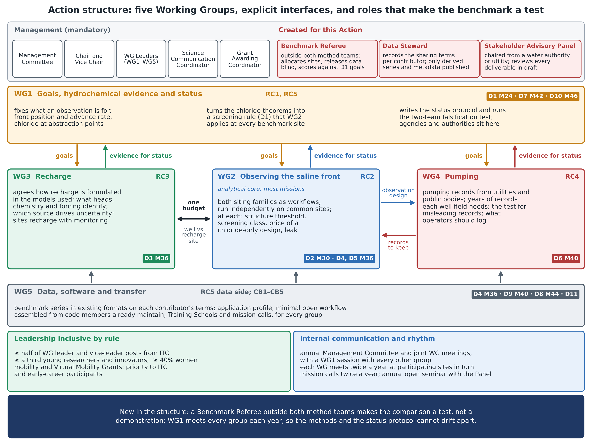
Figure. Action structure: the mandatory management roles and the three created for this Action; the five Working Groups with their tasks, objectives and deliverables (with months); the interfaces between them; inclusive leadership; and the rhythm of internal communication. Content as in annex sections 3.A, 3.B and 3.C.

