From sparse hydrochemistry to decision-relevant information: probabilistic chloride mapping and goal-oriented monitoring design for seawater intrusion in the Fushë-Kuqe coastal aquifer, Albania
Dulian Zeqiraj^{a,*}
ª Department of Energy Resources, Faculty of Geology and Mining, Polytechnic University of Tirana, Tirana, Albania
* Corresponding author. E-mail address: dulian.zeqiraj@fgjm.edu.al
Prepared for submission to Journal of Hydrology (Elsevier). Manuscript type: research paper. Companion to Zeqiraj (2026), J. Hydrol. 680, 136559.

Highlights
- A geolocated shoreline limits Adriatic contact to 23 km of the aquifer margin
- Ion exchange separates active salinization (BEX < 0) from freshening (BEX > 0)
- Calibrated chloride maps give 250 mg/L exceedance areas at three aquifer depths
- Three upper-screen samples at chosen wells capture most of the goal information
- Twelve tested modules link monitoring, pumping limits, attribution and feedback

Abstract
Coastal alluvial aquifers are monitored to protect supply wells from seawater intrusion, but monitoring networks are usually designed to describe the saline wedge rather than to inform the decisions that depend on it, and many intruded aquifers have too few chloride data to calibrate a model. This paper develops a decision-centred, data-constrained framework and applies it to chloride in the Fushë-Kuqe–Lezhë sector of the Tirana–Fushë-Kuqe–Lezhë aquifer (Albania), where four hydrochemical analyses, two chloride time series and a set of documented facts are available. Geolocating the Adriatic shoreline against the 349 km² aquifer polygon restricts sea contact to the northern 23 km of the western margin, and DRASTIC depth values at 43 wells, read as the depth to the top of the confined aquifer, give the cover geometry. Deviations from conservative mixing separate active salinization in the coastal wells (seawater fraction 4.7–4.8 %, base-exchange index −2.8 to −2.6 meq/L) from freshening in the central well field (1.9 %, +2.4 meq/L). A Strack single-potential model with a dispersive transition zone, calibrated by importance weighting to four documented facts (20,000 prior draws, effective sample size 3,249), maps the probability that chloride exceeds 250 mg/L: the median affected areas are 31, 94 and 132 km² in the first aquifer, the second aquifer and at the aquifer base (90 % intervals 10–62, 67–126 and 111–165 km²). The held-out central analysis is not reproduced, consistent with legacy salinity being flushed. A variable-density section, verified against the Henry benchmark, gives a mixing-zone half-width of 27 m against a calibrated posterior median of 29 m. Goal-oriented expected information gain then selects where and at which depth to sample chloride next: three upper-screen samples at wells found by exhaustive or pairwise-greedy search carry 1.55 nats about the first-aquifer affected area, against 0.02 nats for the two in-sector wells of an earlier design. The goal-oriented principle is then extended to twelve decision modules (threshold-risk design, early warning of tipping, return-period-safe pumping, robust learning rates, causal attribution, targeted regime risk, safe threshold selection, and the information flows between pumping, interface and operator), each tested on models parameterized for the site. MATLAB R2026b code reproduces every number and figure.
Keywords: Seawater intrusion; Chloride; Base-exchange index; Strack potential; Bayesian calibration; Optimal experimental design; Expected information gain; Albania

1. Introduction
Seawater intrusion threatens a large share of the coastal aquifers that supply drinking and irrigation water, and in alluvial settings it is slow to reverse once a wedge has advanced inland (Werner et al., 2013; Custodio, 2010; Ketabchi et al., 2016; Lu and Werner, 2013). Chloride is the quantity on which management turns: it is the regulated indicator of seawater in drinking water, with an indicator value of 250 mg/L in the European Union under Directive (EU) 2020/2184 (European Union, 2020), and taste becomes detectable above about the same concentration (World Health Organization, 2022), and it is the variable that operators and regulators read when they decide whether a supply well must be throttled, relocated or protected by recharge. Monitoring networks are therefore built to observe chloride, heads and the position of the freshwater–saltwater interface.
How such networks should be designed has been studied from two directions. Simulation–optimization approaches select pumping schedules or monitoring sites with a forward model in an outer search loop (Sreekanth and Datta, 2010; Lal and Datta, 2019), and Bayesian optimal experimental design (OED) chooses observations that maximize the expected information gain about uncertain quantities (Lindley, 1956; Chaloner and Verdinelli, 1995; Alexanderian, 2021; Huan et al., 2024; Rainforth et al., 2024). Goal-oriented OED targets a scalar prediction rather than the full parameter field (Attia et al., 2018; Neuberger et al., 2025), and a companion study brought it to variable-density seawater intrusion with a discrete adjoint, a joint monitoring–recharge objective and a facies poolability criterion, with an application to the Tirana–Fushë-Kuqe–Lezhë aquifer of Albania (Zeqiraj, 2026). That application was explicitly a design recommendation under documented conditions: it used a conductivity-derived facies proxy, no chloride data, and a seaward boundary placed along the whole western margin of the aquifer polygon.
Two gaps remain, and they motivate this paper. The first is the state itself. In many intruded aquifers, including Fushë-Kuqe, the chloride record consists of a handful of analyses whose positions are known only by sector, a few time series and qualitative facts from earlier surveys. A design method needs a probabilistic description of where chloride is now, and that description must be built from such data, with an honest account of what they can and cannot constrain. The second gap is the decision. The quantity a network is designed for is usually a property of the wedge (the toe, the salt mass, the intruded area), whereas the manager asks different questions: whether a given supply well will exceed a threshold, how much can be pumped before a tipping point becomes likely over a planning horizon, whether a salinization event was caused by a pumping increase or would have occurred anyway, what the risk of a pumping rule is, and whether the monitoring information actually reaches the pumping decision. Each question has its own target quantity and its own most informative data, and the literatures that answer them, from early warning of critical transitions (Scheffer et al., 2009) and escape-time theory (Kramers, 1940; Hänggi et al., 1990) to misspecified Bayesian inference (Grünwald and van Ommen, 2017; Syring and Martin, 2019), causal attribution and targeted estimation (Pearl, 2009; Tian and Pearl, 2000; van der Laan and Rose, 2011; Rytgaard et al., 2022) and information flow (Massey, 1990; Schreiber, 2000; Ay and Polani, 2008), have rarely been brought to coastal aquifer management.
This paper addresses both gaps for the Fushë-Kuqe–Lezhë coastal sector. Its contributions are:
- (C1) A data-constrained chloride state for a data-poor aquifer. The Adriatic contact is geolocated against the aquifer polygon, the cover geometry is read from DRASTIC depth values, and the four analyses are diagnosed by their deviations from conservative mixing. A Strack single-potential model with a dispersive transition zone is calibrated to documented facts by importance weighting, with one analysis held out as a predictive check, and gives maps of the probability that chloride exceeds 250 mg/L at three depths. A variable-density section, verified against the Henry benchmark, checks the transition zone.
- (C2) Goal-oriented chloride sampling. The expected information gain about the chloride-affected area ranks every existing well and sampling depth; linear (ensemble) and exact (nonlinear) gains are compared, and greedy, pairwise-greedy and exhaustive searches are contrasted.
- (C3) A decision chain. Twelve modules extend the goal-oriented principle from the state to the decisions: threshold-risk design, early warning, return-period-safe pumping, robust learning rates, causal attribution, targeted regime risk, safe threshold selection and the information flows between pumping, interface and operator. Each was tested numerically on models parameterized for the site; their key results are summarized here and documented in the Supplementary Material.
- (C4) Reproducibility. A MATLAB R2026b package, using base MATLAB only, reproduces every number and figure from the data workbook; an independent Python implementation agrees with it to round-off.
Section 2 describes the site and the data, Section 3 the methods, Section 4 the results, Section 5 discusses them and Section 6 concludes.

2. Study area and data

2.1. Hydrogeological setting
The Tirana–Fushë-Kuqe–Lezhë alluvial system of north-western Albania (Fig. 2) is a Quaternary gravel–sand aquifer in hydraulic contact with the Adriatic Sea (Eftimi, 2003; Kumanova et al., 2014; Cenameri and Beqiraj, 2016). In the coastal Fushë-Kuqe sector the gravel–sand body is 180–200 m thick and thins to 5–10 m at the eastern margin; it is confined by 30–40 m of silt–clay and contains up to four gravel layers separated by silt–clay intercalations, so that a first (upper) and a second (deeper) aquifer are distinguished in practice. The maximum alluvial thickness, about 270 m, is reached under the Mat delta. Regional flow is from the north-east, where the Mat river and the piedmont recharge the system, toward the coast; piezometric heads are near 3 m a.s.l. along the littoral, and abstraction at the Fushë-Kuqe well field lowered the artesian head from about 8.0 to 1.5 m above ground (as compiled from earlier surveys by Cenameri and Beqiraj, 2016). Seawater intrusion has been documented hydrochemically: groundwater evolves from Ca–Mg–HCO₃ in the recharge zone to Na–Cl near the coast, about 15 % of the upper aquifer layer is affected, and salinity reaches 1500 mg/L in the first aquifer and 3500 mg/L in the second (Cenameri and Beqiraj, 2016).

2.2. Data
All data come from one workbook (Table 1). The aquifer polygon (3411 vertices, 349.1 km²), 180 well locations with a DRASTIC vulnerability index, 43 hydraulic conductivities and 43 DRASTIC depth values belong to the Albanian Geological Survey and A. Beqiraj and are used with permission; the chemistry sheets transcribe Tables 1 and 2 and the quantitative statements of Cenameri and Beqiraj (2016). Coordinates are Gauss–Krüger zone 4 (Krasovsky 1940). Local coordinates in this paper are kilometres east and north of the south-west corner of the polygon, as in Zeqiraj (2026). The four analysed wells (503, 341, 340, 193) are not in the coordinate list; the source places them by sector along a south-west to north-east transect, and no coordinates are invented here.
Table 1. Data used in this study (workbook Fushe_Kuqe_All_Data.xlsx).
Sheet | Content | n | Use here
3_Boundary_Coords | aquifer polygon, 349.1 km² | 3411 | model domain
2_All_Wells | well positions, DRASTIC index, inside flag | 180 | sampling candidates (79 in the sector)
2_All_Wells | hydraulic conductivity K (50–200 m/d) | 43 | IDW conductivity, facies prior
2_All_Wells | DRASTIC depth parameter (4–65 m) | 43 | depth to the aquifer top (Section 2.4)
5_Cenameri2016_Chemistry | major ions, TDS of wells 503, 341, 340, 193 | 4 | mixing, ion exchange, calibration
6_Cenameri2016_Cl_Trend | chloride 1984, 1999, 2001 (wells 341, 503) | 6 | trend
7_Cenameri2016_SWI_Facts | documented facts (heads, area, maxima) | 19 | calibration targets and checks

2.3. Geolocating the sea contact
The seaward boundary was located by transforming the GLOBE one-kilometre land mask (GLOBE Task Team, 1999) to the Gauss–Krüger grid and taking, for each 0.25 km row of the model grid, the easternmost sea point west of the aquifer. A row is in contact with the Adriatic when the western edge of the aquifer lies within 5 km of that point; the gap between the two is kept and used as the length of the outflow path. The result (Fig. 2a) is unambiguous: from y ≈ 29.5 km, near the mouth of the Ishëm, to the northern tip at Lezhë, the western edge of the polygon follows the shoreline within 0–4 km (Patok lagoon lies in this stretch), whereas south of y ≈ 29 km the western edge runs 5–15 km inland of the shore of Lalëz Bay, behind the hills between Durrës and Cape Rodon, and is an inland margin. The sea contact is therefore 23 km long (92 boundary cells), not the full 52 km western margin used as a seaward boundary by the companion model. The chloride model of this paper covers the coastal sector north of y = 24 km (221.6 km², 3545 cells), which contains all the sea contact; its southern edge is treated as a no-flow cut.

2.4. Aquifer-top depth from the DRASTIC depth parameter
The workbook column labelled piezometric level cannot be a head above sea level: it is largest at the coast (35–50 m) and smallest at the Tirana end of the plain (4–6 m), with a correlation of −0.79 with the distance inland, while documented littoral heads are near 3 m. It is the depth parameter of the DRASTIC survey from which the well list derives, which for a confined aquifer is the depth to the top of the aquifer (Aller et al., 1987). Read this way the values agree with the documented 30–40 m silt–clay cover at the coast, with the low DRASTIC index of the coastal wells and with their clay-loam vadose zone. They are interpolated by inverse distance weighting (power 2) to give the aquifer-top depth d (Fig. 2b), from which an uncertain ground elevation of 0–5 m is subtracted.
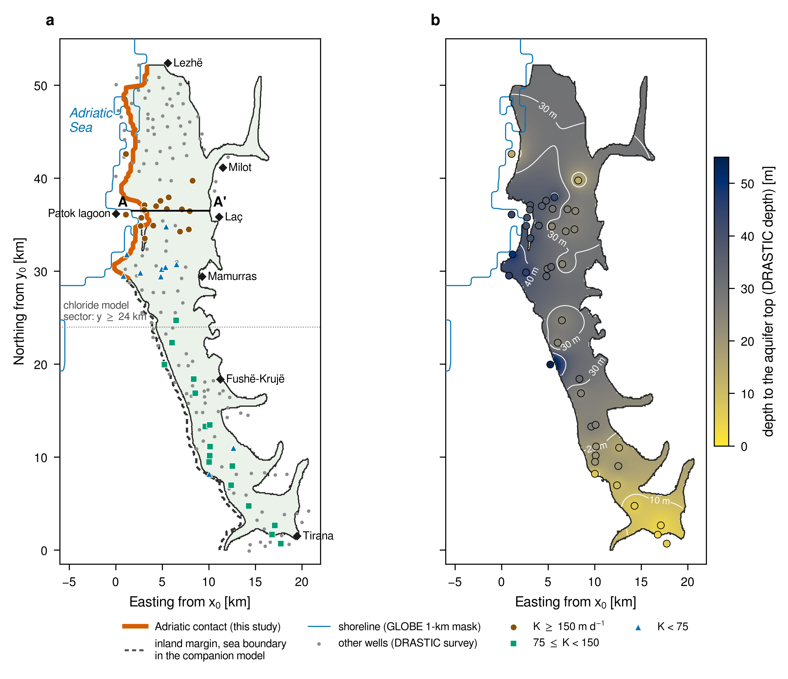
Fig. 2. Study area and data. (a) Aquifer polygon (349 km²), GLOBE shoreline, the Adriatic contact identified in Section 2.3 (thick line) and the inland western margin that the companion model treated as a sea boundary (dashed); wells with a hydraulic conductivity are classed by K, the other wells of the DRASTIC survey are grey; A–A′ is the variable-density section of Section 3.4 and the dotted line the southern cut of the chloride model. (b) Depth to the aquifer top from the DRASTIC depth parameter at 43 wells (circles) and its IDW interpolation. Coordinates are kilometres from the south-west corner of the polygon (Gauss–Krüger zone 4, x₀ = 4 381 751 m, y₀ = 4 576 244 m).

3. Methods
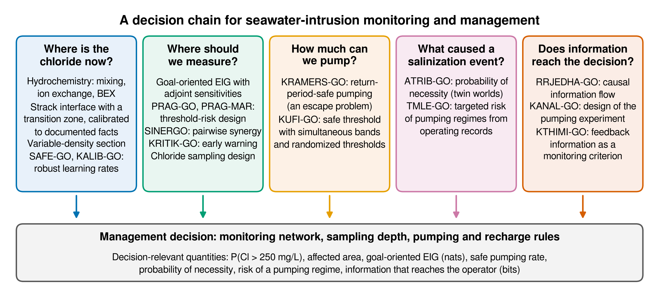
Fig. 1. The decision chain of this paper. Five questions that a manager of a coastal well field asks, the modules that answer them and the decision-relevant quantity each returns. The chloride state (first column) and the chloride sampling design (second column) are developed and applied to Fushë-Kuqe here; the other modules were tested on models parameterized for the site and are summarized in Section 4.6 and the Supplementary Material.

3.1. Hydrochemical diagnosis
Each analysis is compared with the conservative mixing of the freshest sample (well 193, Cl_{f} = 12.9 mg/L) and Adriatic seawater. The seawater fraction from chloride is
$$f=\frac{Cl−{Cl}_{f}}{{Cl}_{sw}−{Cl}_{f}}$$ | (1)
and the deviation of each cation and of sulphate from the mixing line, in meq/L, is
$$ΔX=X_{obs}−\left[X_{f}+f\left(X_{sw}−X_{f}\right)\right]$$ | (2)
A sodium deficit with a calcium and magnesium excess indicates reverse cation exchange as seawater displaces fresh water; a sodium excess indicates freshening (Appelo and Postma, 2005). The base-exchange index of Stuyfzand (2008),
$$BEX=Na+K+Mg−1.0716 Cl \left(meq/L\right)$$ | (3)
is negative under salinization and positive under freshening, and the Revelle (1941) ratio Cl/HCO₃ (meq/L) grades the degree of seawater influence. The seawater end-member is standard seawater (Millero et al., 2008) scaled to the salinity of the southern Adriatic, S ≈ 38.3 (Artegiani et al., 1997), which gives Cl_{sw} = 21781 mg/L.

3.2. Areal chloride model
Flow in the confined aquifer is described with the single potential of Strack (1976), widely used for the management of coastal aquifers (Mantoglou, 2003), which is exact for a Dupuit sharp interface and turns the two-zone problem (fresh water over the full thickness inland of the toe, fresh water over salt water seaward of it) into one linear equation:
$$∇⋅\left(K∇ϕ\right)+R=0, ϕ=0 \text{at the shoreline}$$ | (4)
where K is the horizontal hydraulic conductivity, R the net recharge and φ [m²] the potential. The 92 sea-contact cells drain to φ = 0 through a link whose length is the shoreline gap plus half a cell; every other margin, including the inland western edge, is no-flow. With d the depth of the aquifer top and B the aquifer thickness below sea level, and δ = (ρ_{s} − ρ_{f})/ρ_f = 0.025, the head h and the interface depth ζ follow from φ zone by zone:
$$ζ=d+\sqrt{2ϕ/δ}, h=δd+\sqrt{2δϕ} \left(ϕ<1/2δB^{2}\right)$$ | (5)
$$h=\frac{ϕ}{B}+δ\left(d+\frac{B}{2}\right), ζ=\frac{h}{δ} \left(ϕ≥1/2δB^{2}\right)$$ | (6)
The two branches meet at the toe, where ζ = d + B. Chloride is not a sharp step: wells sample a dispersive transition zone. The relative seawater concentration at depth z (positive downward) is taken as c(z) = Φ((z − ζ)/w), with Φ the standard normal distribution function and w a transition-zone half-width, and a well screened between z₁ and z₂ samples its average, which has the closed form
$$\overset{‾}{c}=\frac{w}{z_{2}−z_{1}}\left[G​\left(\frac{z_{2}−ζ}{w}\right)−G​\left(\frac{z_{1}−ζ}{w}\right)\right], G\left(u\right)=u Φ\left(u\right)+φ\left(u\right)$$ | (7)
with φ the standard normal density, so that Cl = Cl_{f} + c̄ (Cl_{s} − Cl_{f}). Three 40 m screens are used: the top of the aquifer (first aquifer), an interval centred at mid-thickness (second aquifer) and the base (the toe zone). The geometry follows the documented thinning, B = b_{e} + (b_{c} − b_{e}) max(0, 1 − s/L_B), with s the distance to the shoreline, and the conductivity is K = η K_{IDW} exp(θ_{z}), where K_{IDW} interpolates the 43 measured values, η is the fraction of the thickness that transmits water (the gravel layers) and θ_{z} are log-multipliers of 12 pilot zones with the facies-conditional prior of the companion study at the field cross-facies correlation ρ_{F} = 0.805. The grid is the 0.25 km grid of the companion model.

3.3. Bayesian calibration to documented facts
The parameters θ = (θ_{z}, R, η, b_{c}, b_{e}, L_{B}, ground elevation, w, Cl_{s}) have the priors of Table 2. Four documented facts serve as data, each with a deliberately generous error: (T1) the area whose first-aquifer chloride exceeds 250 mg/L is about 15 % of the aquifer, taken relative to the 349 km² polygon as in Zeqiraj (2026), with standard deviation 5 %; (T2) the median littoral head, 0.5–2.5 km from the shore in the Fushë-Kuqe sector (y = 30–40 km), is about 3 ± 1 m; (T3a) wells 341 and 503 in the south-western coastal sector have a seawater fraction of 4.7 %, matched in logarithm with a standard deviation of 0.7; and (T3c) upper-aquifer chloride in the north-eastern recharge band (≥ 7 km from the shore) is below 30 mg/L, as at well 193. Wells 341 and 503 are assigned to the second aquifer: their total dissolved solids (2331 and 2452 mg/L) exceed the documented maximum of the first aquifer (1500 mg/L). The central analysis (T3b, well 340, 1.9 %) is held out of the likelihood and used as a predictive check. With S_{j}(θ) the corresponding model summaries, the posterior is represented by 20,000 prior draws with importance weights
wi∝exp−12j​Sjθi−sjσj21+eS3cθi−30/5−1, ESS=1i​wi2 | (8)
and a systematic resample of 2000 members carries the posterior to the maps. Six alternative readings of the facts (Supplementary Table S3) test how much the conclusions depend on these choices.
Table 2. Prior distributions and posterior quantiles (5 %, 50 %, 95 %) of the chloride-model parameters.
Parameter | Prior | Posterior 5 / 50 / 95 %
zone log-K multipliers θ_{z} (12) | N(0, Γ_{F}(ρ_{F} = 0.805)) | see Supplement
net recharge R [mm/yr] | 183 × LN(0, 0.7²) | 94 / 177 / 337
transmissive fraction η [–] | U(0.3, 0.8) | 0.33 / 0.56 / 0.77
thickness at the coast b_{c} [m] | U(180, 200) | 181 / 189 / 199
thickness at the margin b_{e} [m] | U(5, 10) | 5.3 / 7.5 / 9.7
thinning distance L_{B} [km] | U(12, 20) | 12.3 / 15.7 / 19.6
ground elevation [m] | U(0, 5) | 0.3 / 2.5 / 4.7
transition half-width w [m] | 20 × LN(0, 0.6²) | 13 / 29 / 48
Adriatic chloride Cl_{s} [mg/L] | U(20 500, 22 000) | 20568 / 21250 / 21927
LN(0, s²): log-normal multiplier with median 1. Γ_{F}: facies-conditional covariance of Zeqiraj (2026).

3.4. Variable-density section
To check the transition zone, steady variable-density flow and transport are solved on section A–A′ (y = 36.5 km, through the coarse-gravel wells of the Fushë-Kuqe field to Laç; Fig. 2a) in the equivalent-freshwater-head form of the companion study:
$$∇⋅\left[K\left(∇h_{f}+εc e_{z}\right)\right]=0, q=−K\left(∇h_{f}+εc e_{z}\right)$$ | (9)
$$∇⋅\left(q c\right)−∇⋅\left(n D∇c\right)=0, D=D_{m}I+α_{T}\left|q\right|I+\left(α_{L}−α_{T}\right)\frac{qq^{⊤}}{\left|q\right|}$$ | (10)
with ε = 0.025, porosity n = 0.25, vertical anisotropy K_{z}/K_x = 0.1, α_{L} = 10 m and α_{T} = 1 m (Gelhar et al., 1992). The section takes, from a posterior member, the aquifer top and base, the horizontal conductivity and the freshwater discharge to the sea on the rows within 1 km (inflow at the inland end); the sea face carries a hydrostatic seawater column with c = 1 on inflow. The discretization is that of the validated solver of the companion study (cell-centred finite volumes, harmonic face conductivity, first-order upwind advection), extended to a masked domain and a diagonal dispersion tensor; the steady state is reached by a fully implicit march in time with inner Picard iterations, stopped when the steady residual falls below 10⁻⁶. On Henry's (1964) problem the solver reproduces the toes of the companion solver on the whole refinement ladder (1.4226, 1.3971, 1.3918 and 1.3864 m at 16 × 8 to 61 × 31). Sections are solved at 100 × 5 m, and at 50 × 4 m for the median member.

3.5. Goal-oriented chloride sampling design
The design goal is the quantity that the documented facts and the drinking-water rule share, the area of the sector whose first-aquifer chloride exceeds 250 mg/L,
Q=k​Ak 1Clkupper>250 mg/L | (11)
with the second-aquifer area as a secondary goal. A candidate is one of the 79 existing wells inside the polygon and the sector, sampled at the upper, middle or base screen (237 candidates); a sample returns y = log₁₀ Cl + e with e ~ N(0, 0.1²), which covers analytical, sampling and representativeness error. For a set S of samples the goal-oriented expected information gain is computed in two ways. The linear form uses the posterior ensemble moments (Lemma 1 of Zeqiraj, 2026):
$${EIG}_{lin}\left(S\right)=−\frac{1}{2}ln\left(1−R_{Q}^{2}\left(S\right)\right), R_{Q}^{2}\left(S\right)=\frac{b_{S}^{⊤}{\left(C_{SS}+σ^{2}I\right)}^{−1}b_{S}}{var\left(Q\right)}$$ | (12)
where C_{SS} is the ensemble covariance of the sampled log-chlorides and b_{S} their covariance with Q. The exact form is the mutual information between the goal, discretized in eight equiprobable classes B, and the samples, computed by leave-one-out likelihood reweighting of the ensemble,
$${EIG}_{ex}\left(S\right)=H\left(B\right)−E_{y}\left[H\left(B∣y_{S}\right)\right]≤I\left(Q;y_{S}\right)$$ | (13)
which is a lower bound on the information about Q. Because R²_{Q} is not submodular, greedy selection can miss pairs that are informative only together; for two samples with correlations r_{a}, r_{b} with the goal and ρ with each other, R²_{Q}({a,b}) exceeds r²_a + r²_b exactly when ρ(ρ(r²_a + r²_b) − 2r_a r_{b}) > 0 (the SINERGO condition, Supplementary Section S6; see also Das and Kempe, 2018). Greedy, pairwise-greedy (best pair first, then the best addition) and exhaustive searches over the 40 best single samples are compared.

3.6. Decision modules
The remaining modules address the other questions of Fig. 1. Each was tested numerically with a known truth on models parameterized for Fushë-Kuqe: a Strack toe on the coast–well axis with K = 100 m/d, B = 30 m, δ = 0.025, regional flux q₀ = 1.5 m²/d and a supply well 2 km inland, whose critical rate is Q_{c} = 3651 m³/d, driven where needed by recharge fluctuations modelled as an Ornstein–Uhlenbeck process with correlation time 0.5 yr; the threshold-risk design also used the Henry problem and the companion field model with the geolocated sea boundary, and the information-flow modules a simulated field of 200 000 wells operated over 10 years. The central quantity of each module is stated below; Table 5 gives the test results and the Supplementary Material the models, the experiments and the full results.
- Threshold-risk design (PRAG-GO, PRAG-MAR). The goal is the indicator that a supply well exceeds a threshold rather than a property of the wedge; its expected information gain is approximated in closed form from the two adjoint sensitivities of the companion operator and checked against the exact gain over all designs. PRAG-MAR places recharge to minimize the probability that a supply well is intruded, using the same adjoint.
- Early warning (KRITIK-GO). Near Q_{c} the toe loses stability through a saddle-node bifurcation and its recovery rate k decays as (1 − Q/Q_c)^{1/2}; loggers are placed to maximize the Fisher information on ln k from paired head and salinity records, instead of the classical rising autocorrelation of one series.
- Return-period-safe pumping (KRAMERS-GO). The mean time to salinization T solves the backward Kolmogorov equation of the toe–recharge process, A ∂_X T − (ε/θ) ∂_ε T + (s²/θ) ∂²_ε T = −1, and the safe rate Q_{T} is the largest pumping with mean escape time at least T years.
- Robust learning rates (SAFE-GO, KALIB-GO). Exact shoreline readings mixed with noisy inland ones make standard Bayesian regression overconfident (Grünwald and van Ommen, 2017); the generalized posterior π_{η}(θ | y) ∝ p(y | θ)^η π(θ) is used with η chosen by SafeBayes or calibrated on the goal by bootstrap (Syring and Martin, 2019).
- Causal attribution (ATRIB-GO). For a salinization event after a pumping increase, the probability of necessity PN(D) = P(Y₀ = 0 | Y₁ = 1, D) is computed in twin worlds that share the recharge history (Pearl, 2009; Tian and Pearl, 2000), and data D are ranked by how much they reduce its entropy.
- Targeted regime risk and safe thresholds (TMLE-GO, KUFI-GO). The risk of salinization within H years under a pumping rule d, ψ_{d} = E[Y^d], is estimated from irregular operating records by continuous-time targeted minimum loss estimation (Rytgaard et al., 2022); a pumping threshold is chosen as the largest whose simultaneous upper confidence band stays below α, from records or from a randomized-threshold experiment with a marginal structural model (Robins et al., 2000).
- Information flows (RRJEDHA-GO, KANAL-GO, KTHIMI-GO). The interventional information flow from pumping A to the toe change ΔX, TE_{do} = Σ_{r} p(r) Σ_{a} π(a | r) KL(P(ΔX | do(a), r) ‖ P̄), is compared with transfer entropy (Schreiber, 2000; Ay and Polani, 2008); for small effects TE_{do} ≈ 4π(1 − π) C, with C the causal channel capacity, so that a 50/50 randomized pumping experiment measures it best; and Massey's (1990) conservation law, I(A^n; X^n) = I(A^n → X^n) + I(0X^{n−1} → A^n), splits the information between pumping and toe into a forward part and a feedback part, the latter measuring how much of the monitoring reaches the pumping decision.

3.7. Implementation and verification
The chloride study is implemented twice. The MATLAB package (chloride_fk/matlab, 32 functions, base MATLAB only, written for R2026b) reads the workbook with readcell, runs the calibration, posterior, design and sections, and draws Figs. 1–8 with exportgraphics; fkcl_run_all reproduces everything and fkcl_selftest runs six checks (screen-average closed form, continuity of the Strack branches, the EIG closed form, the Henry ladder, the hydrochemical indices and agreement with the reference implementation). A Python implementation, written first, rendered the figures shown here. Given the same random draws, the two agree to a relative difference of 10⁻⁷ on 500 × 15 calibration summaries, and the MATLAB run reproduces the effective sample size (3249) and the posterior areas to the reported digits. The full MATLAB run takes about 4 min without the sections and 10–20 min with them; the decision modules were implemented in Python (experiments/ folder of the repository).

4. Results

4.1. Hydrochemical state of the four analyses
The four analyses fall into two groups that conservative mixing alone does not separate (Fig. 3, Table 3). The coastal wells of the south-western sector, 503 and 341, contain 1048 and 1038 mg/L chloride, a seawater fraction of 4.76 and 4.71 % (Cenameri and Beqiraj (2016) give 5.5 %, consistent with a seawater chloride near 19 000 mg/L; the Adriatic end-member used here is about 15 % more saline). Both show the signature of active intrusion: sodium is depleted relative to mixing by 10.5 and 4.9 meq/L, calcium is enriched by 3.3 and 2.5 meq/L, the molar Na/Cl ratio (0.52, 0.71) is below that of seawater (0.86), and BEX is negative (−2.80 and −2.64 meq/L). As seawater enters a sediment equilibrated with fresh Ca–HCO₃ water, its sodium is taken up by the exchanger and calcium is released (Appelo and Postma, 2005). The sulphate deficit of both wells (−3.7 and −1.7 meq/L) is consistent with sulphate reduction under the silt–clay cover. Their Cl/HCO₃ ratios (6.4 and 12.4) are 50–100 times that of the recharge water (0.12).
The central well 340 (Gorre–Fushë-Kuqe) has the opposite signature. Its seawater fraction is lower (1.86 %, 417 mg/L chloride), but sodium is in excess of mixing (+2.1 meq/L), calcium and magnesium are deficient, Na/Cl is 1.07 and BEX is +2.43 meq/L, as high as in the recharge water of well 193 (+2.45 meq/L). This is the signature of freshening: fresh water flushing a sediment whose exchanger still holds marine sodium (Stuyfzand, 2008). The chloride at well 340 is therefore read as residual salinity being displaced, not as an advancing front. The two time series agree with this division only in part (Fig. 3d): chloride at well 503 rose from 961 mg/L in 1984 to 1070 mg/L in 1999 and 1048 mg/L in 2001 (+5.1 mg/L per year over the period), whereas at well 341 it fell from 1136 to 1008 and 1037 mg/L (−5.8 mg/L per year); with three values each, and a possible sampling-depth effect in the artesian well 341, these are indications rather than trends.
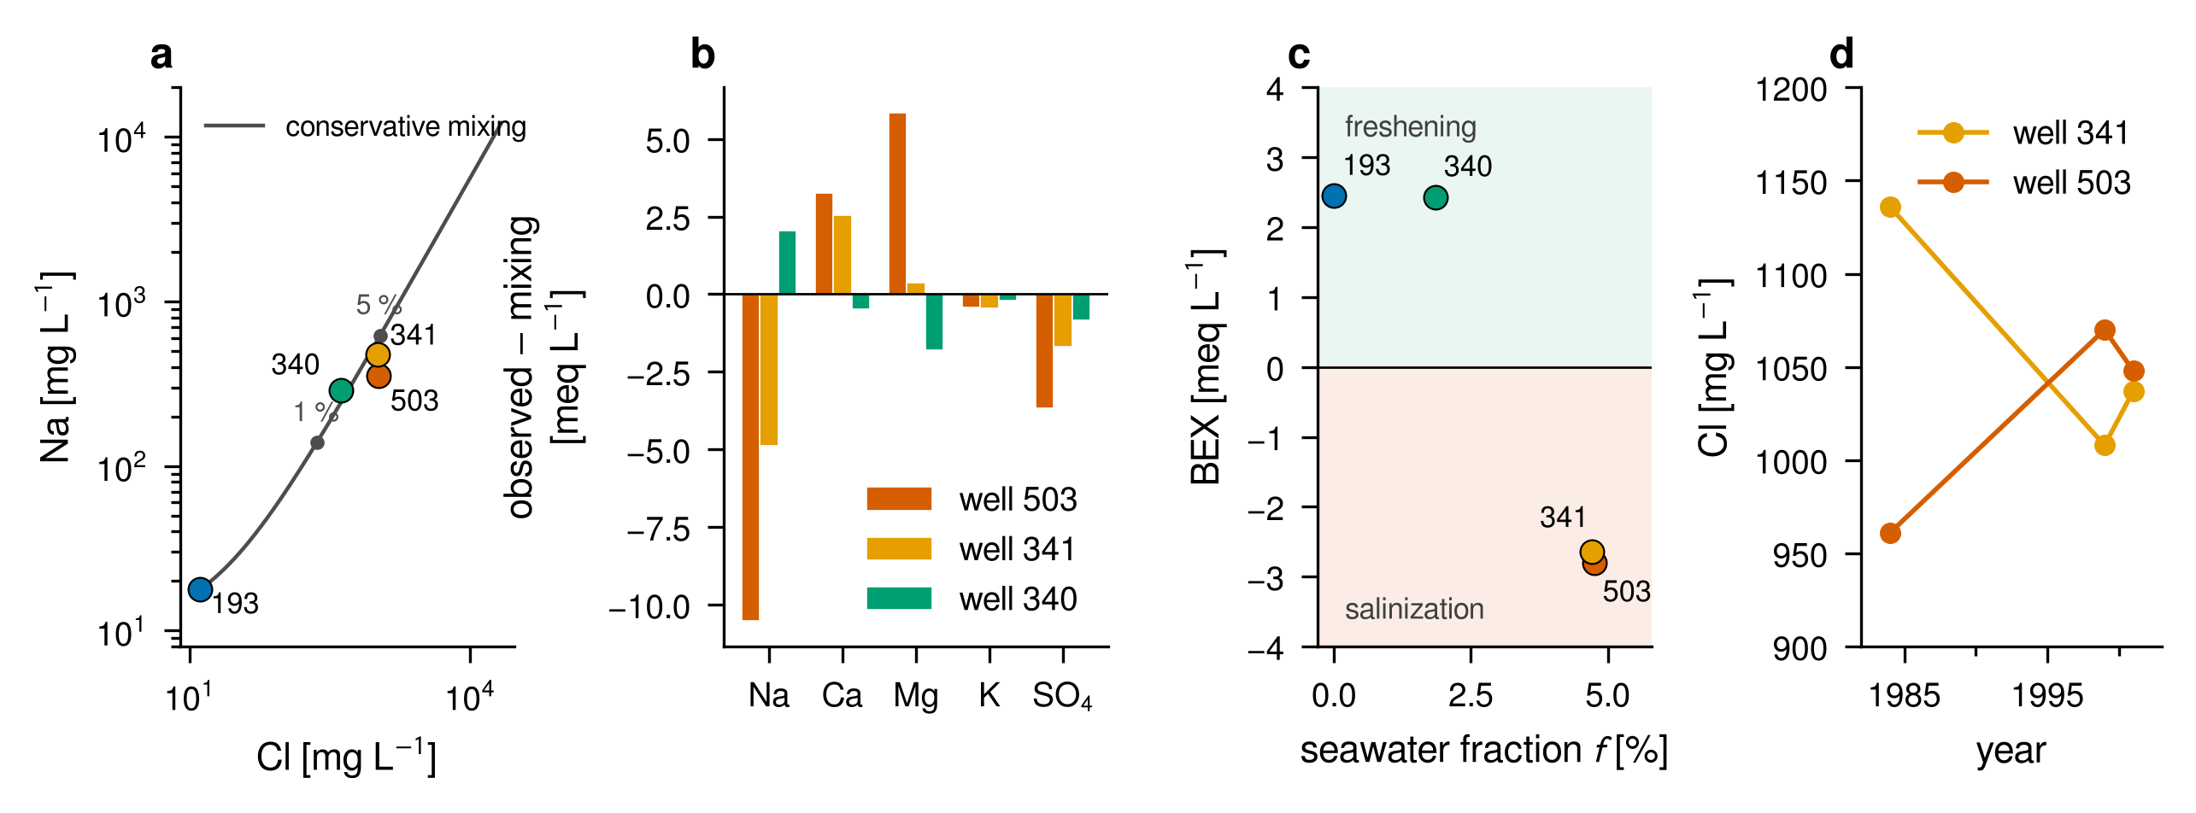
Fig. 3. Hydrochemistry of the four analysed wells (data of Cenameri and Beqiraj, 2016). (a) Sodium against chloride with the conservative mixing line between well 193 and Adriatic seawater; dots on the line mark 1 % and 5 % seawater. (b) Deviation of each ion from conservative mixing. (c) Base-exchange index BEX against seawater fraction; negative values indicate salinization, positive values freshening. (d) Chloride in wells 341 and 503 in 1984, 1999 and 2001.
Table 3. Seawater fraction and deviations from conservative mixing (meq/L) of the four analyses. Cl in mg/L; Na/Cl is molar; Cl/HCO₃ is in meq/L. Seawater: Na/Cl = 0.86.
Well | Sector | Cl | f [%] | ΔNa | ΔCa | ΔMg | ΔSO₄ | Na/Cl | Cl/HCO₃ | BEX | State
503 | SW coast | 1048 | 4.76 | −10.52 | +3.26 | +5.84 | −3.67 | 0.52 | 6.36 | −2.80 | salinization
341 | SW coast | 1038 | 4.71 | −4.88 | +2.54 | +0.37 | −1.70 | 0.71 | 12.41 | −2.64 | salinization
340 | central, Gorre–Fushë-Kuqe | 417 | 1.86 | +2.05 | −0.47 | −1.81 | −0.84 | 1.07 | 3.54 | +2.43 | freshening
193 | NE, recharge zone | 13 | 0.00 | 0.00 | 0.00 | 0.00 | 0.00 | 2.12 | 0.12 | +2.45 | fresh end-member

4.2. Calibration and the held-out analysis
Of the 20,000 prior draws, the four facts retain an effective sample of 3,249 (16 %). The calibration narrows the prior strongly (Fig. 4a–d). The first-aquifer affected area moves from a prior median of 3.9 % of the polygon with a 90 % range of 0.6–43 % to a posterior of 9.0 (2.8–18.1) %. That is below the documented 15 %, because the same parameters must also keep the littoral head near 3 m (posterior 4.03 (3.45–4.85) m) and the north-eastern band fresh (12.9 mg/L, constraint T3c). The second-aquifer seawater fraction in the south-western band, 9.6 (2.9–25.8) %, brackets the 4.7 % of wells 341 and 503. Of the parameters, the recharge (177 (94–337) mm/yr) and the transition-zone half-width are informed; the half-width moves up from a prior median of 20 m to 29 (13–48) m. The thickness, thinning distance and transmissive fraction stay close to their priors (Table 2), so the facts constrain the combination of recharge, conductivity and mixing that sets chloride, not the geometry.
The held-out central analysis is not reproduced (Fig. 4e, f). The posterior predicts essentially fresh water at the position of well 340 in the first aquifer and 0.05 (0.00–1.33) % seawater in the second, against 1.86 % observed. Forcing the model to fit it does not resolve the conflict (Supplementary Table S3). With well 340 treated as a first-aquifer sample, the effective sample falls to 165 and the first-aquifer affected area becomes 93.5 (75.4–109.8) km², 27 % of the polygon and far above the documented 15 %. As a second-aquifer sample it is fitted only with a transition zone of 35 m. A steady model consistent with the facts cannot place 1.9 % seawater 3–6 km inland, while the freshening signature of the same sample (Section 4.1) shows salinity that is being removed. The two lines of evidence together identify the chloride of well 340 as legacy salinity, probably from the period of strong drawdown, which a steady state cannot represent and which is not part of the present wedge. Slow flushing of saline water emplaced under earlier conditions is a common feature of coastal aquifers (Kooi et al., 2000; Lu and Werner, 2013).
The conclusions are robust to the main alternative readings, with one exception. Assigning wells 341 and 503 to the first aquifer contradicts the documented 1500 mg/L limit of the first aquifer, lowers the effective sample to 797 and doubles the first-aquifer area (70.8 (51.2–91.0) km²). Expressing T1 relative to the modelled sector instead of the polygon gives 23.7 (9.1–42.8) km², and dropping T1 gives 13.8 (6.0–49.4) km². The wedge area at the base moves by less than 10 % across all variants, so the deep salinity is constrained by the heads and the geometry, while the shallow salinity depends on how the documented facts are read.
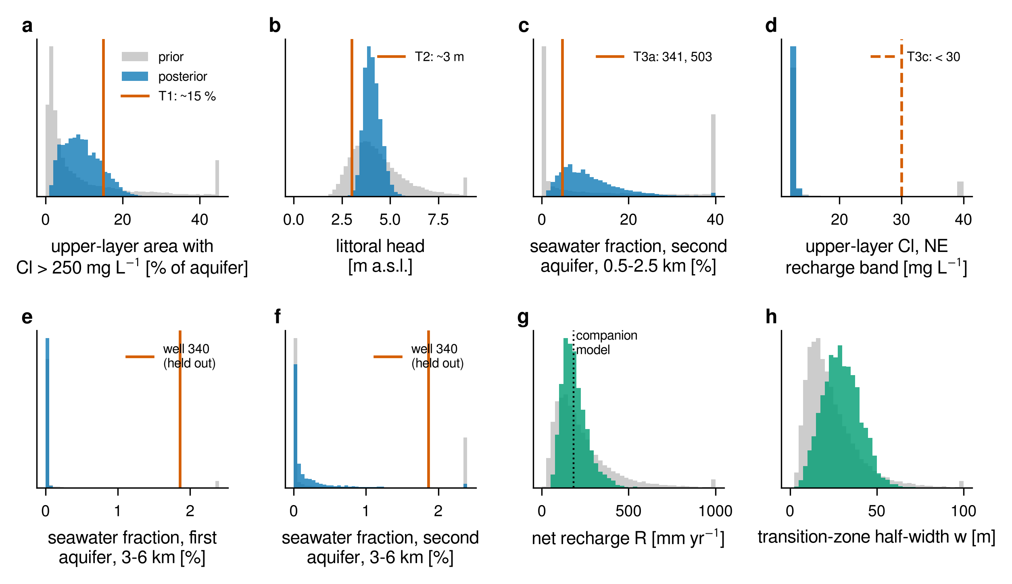
Fig. 4. Calibration to documented facts. Prior (grey) and importance-weighted posterior (colour; effective sample size 3,249) distributions of (a–d) the four calibration summaries with their targets T1, T2, T3a and T3c; (e, f) the seawater fraction predicted at the position of the central well 340 in the first and second aquifer (held out; observed 1.86 %); and (g, h) the net recharge and the transition-zone half-width. In (g) the dotted line is the recharge of the companion model. Values outside the axis range are collected in the last bin.

4.3. Probabilistic chloride maps
The posterior maps (Fig. 5) show a chloride distribution that is layered as well as zoned. In the first aquifer, chloride above 250 mg/L is confined to a coastal strip north of y ≈ 38 km, reaching about 2 km from the shore at y = 40 km and 3 km near Lezhë, and to a small area at the mouth of the Ishëm (y = 32–35 km). The median affected area is 31.4 (9.6–62.0) km² (9.0 (2.8–17.8) % of the polygon). In the second aquifer the 50 % exceedance line runs 3 km inland at section A–A′ and 5–6 km inland between y = 40 and 50 km, for an area of 93.9 (67.1–126.1) km². At the base, chloride exceeds 250 mg/L over 131.8 (110.9–165.4) km², and the seawater wedge itself, where the sharp interface lies above the base, covers 94.2 (63.4–125.3) km², with its toe 3.4 km inland at A–A′ and about 5 km at y = 45–50 km.
Two features matter for management. First, south of the sea contact (y < 29.5 km) the first and second aquifers are fresh in every member, and only the base carries salt water a short distance south of the contact. The southern half of the western margin, which the companion model treated as a sea boundary, does not contribute to the intrusion. Second, the uncertainty is concentrated in narrow bands. The area where the exceedance probability lies between 0.1 and 0.9 is 44.5, 48.6 and 45.8 km² at the three depths. Its first-aquifer part, a 2–4 km wide band along the inland edge of the coastal strip between y = 38 and 51 km, is where new data can change the estimate of the affected area. The Fushë-Kuqe well field, 4–8 km from the shore around y = 35–38 km, lies outside the first-aquifer band but inside the second-aquifer one.
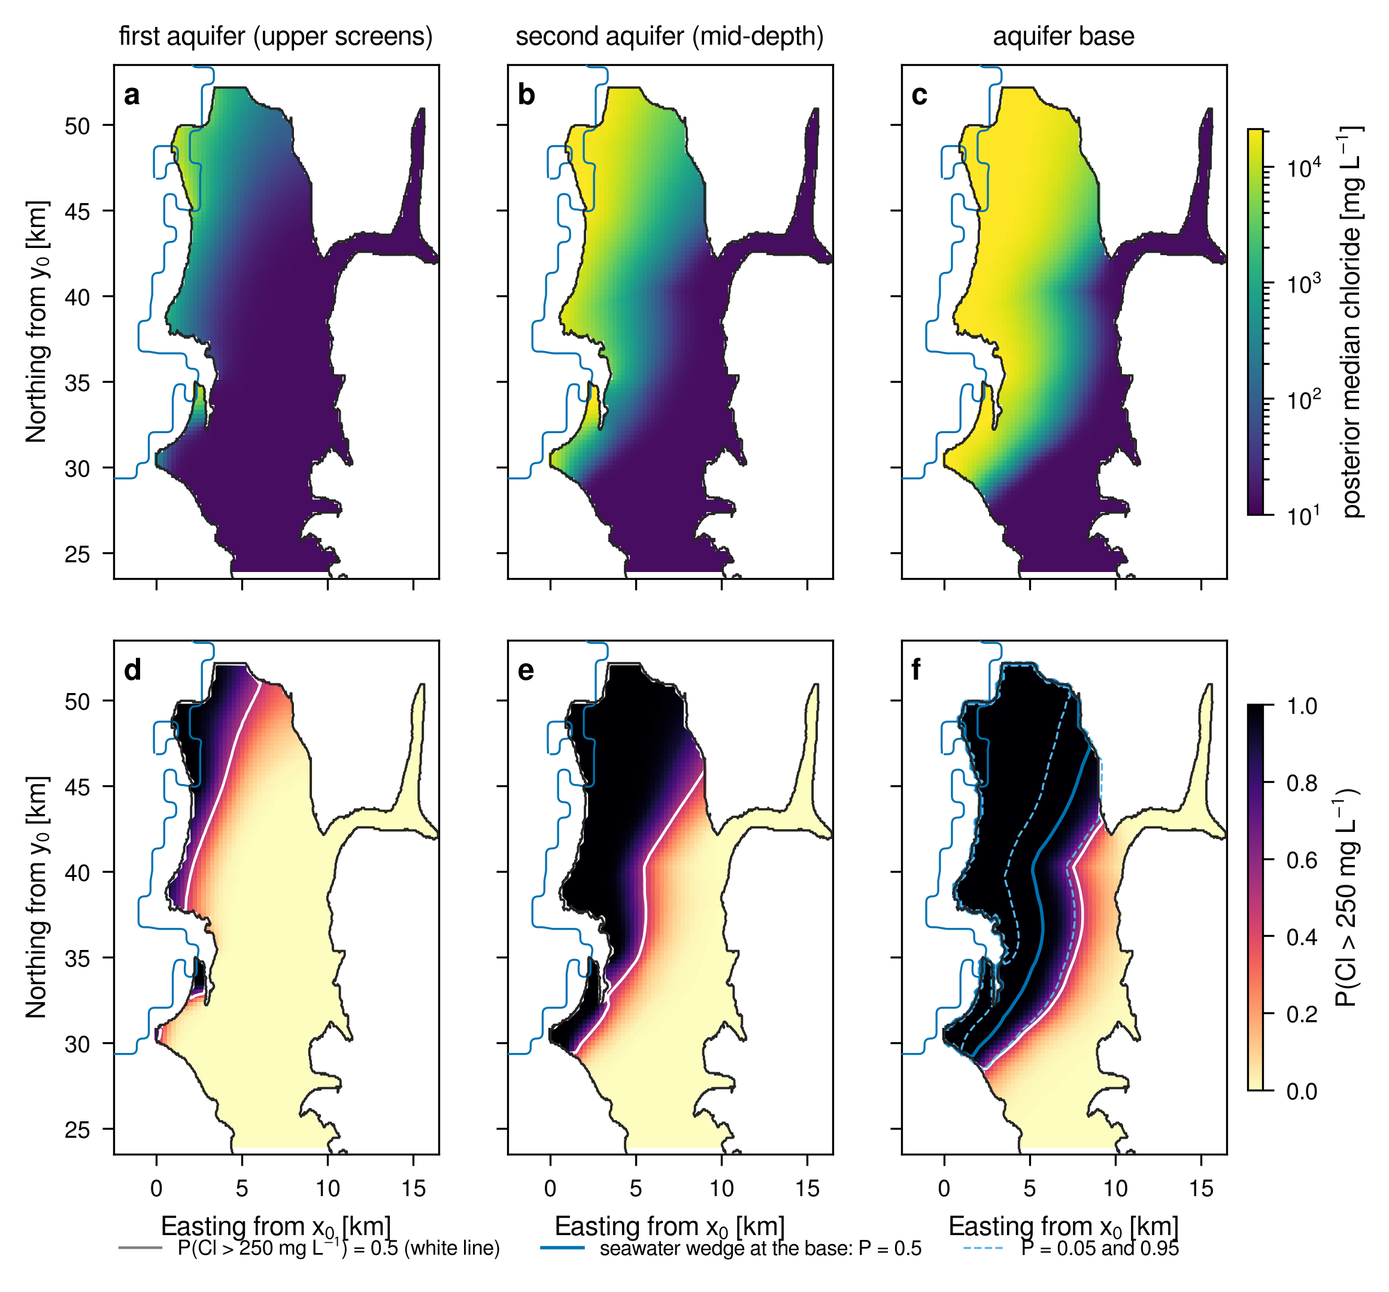
Fig. 5. Probabilistic chloride maps of the coastal sector from the posterior ensemble (2000 members). (a–c) Posterior median chloride at the upper screens (first aquifer), at mid-depth screens (second aquifer) and at the base of the aquifer. (d–f) Probability that chloride exceeds 250 mg/L at the same depths; the white line is P = 0.5. In (f) the blue lines mark the toe of the seawater wedge (probability 0.5, solid; 0.05 and 0.95, dashed). The blue line west of the aquifer is the GLOBE shoreline.

4.4. Variable-density section
On section A–A′ the variable-density solution of the median member (Fig. 6a) places the toe, the c = 0.5 point at the base, 2.71 km from the shoreline (2.74 km on the coarser 100 × 5 m grid), shorter than the 3.92 km of the same member's sharp interface. The same holds for the 5th and 95th percentile members (2.05 against 2.67 km and 3.35 against 5.92 km; Fig. 6b). The difference is expected. Dispersive mixing returns salt to the sea with the outflowing brackish water and shortens the wedge (Abarca et al., 2007), and the vertical anisotropy adds resistance that the Dupuit potential ignores; mixing corrections to sharp-interface toe estimates are of the same sign (Pool and Carrera, 2011). The sharp interface of the areal model is therefore an upper estimate of the toe, by 23–43 % on this section.
The transition zone is the more useful check, because it is what wells sample. Measured as half the vertical distance between the c = 0.16 and 0.84 isolines (one standard deviation of the profile Φ used in the areal model), the simulated half-width is 27.2 m for the median member, and 27.8 and 29.1 m for the 5th and 95th percentile members. It is almost independent of the member and set by the dispersivity: 16.8 m for α_{T} = 0.1 m and 46.9 m for α_{T} = 3 m. The calibration, which used only chloride facts, gave a posterior median of 29 m with a 90 % interval of 13–48 m. The variable-density section thus reproduces the calibrated mixing width with a transverse dispersivity of about 1 m, and the calibrated interval corresponds to α_{T} between about 0.1 and 3 m, within the range of field-scale values (Gelhar et al., 1992). The isochlors of Fig. 6a also show why the sampling depth matters: 1000 mg/L reaches the top of the aquifer about 1.6 km from the shore, whereas at the base seawater extends 2.7 km inland.
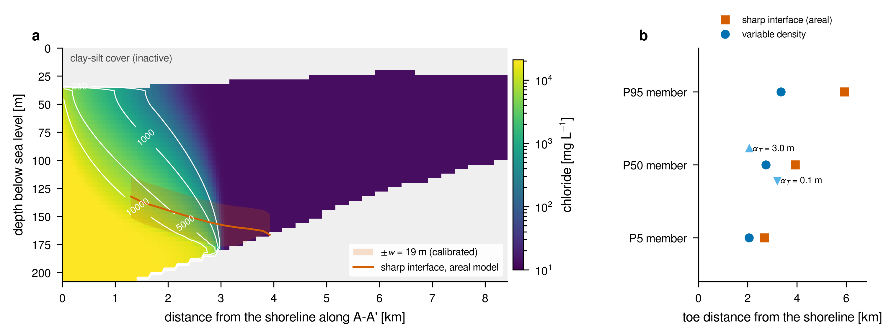
Fig. 6. Variable-density section A–A′ (y = 36.5 km). (a) Steady chloride of the median member (50 × 4 m cells; α_{L} = 10 m, α_{T} = 1 m) with the 250, 1000, 5000 and 10 000 mg/L isochlors, the sharp interface of the same member in the areal model and its calibrated transition zone ±w. Grey: silt–clay cover above the aquifer and substratum below it. (b) Toe distance from the shoreline in the variable-density solution (circles) and in the sharp-interface areal model (squares) for the members at the 5th, 50th and 95th percentiles of the wedge area, and for α_{T} = 0.1 and 3 m (triangles).

4.5. Goal-oriented chloride sampling
The design goal, the first-aquifer affected area of the sector, has a posterior median of 30.7 km² and a standard deviation of 16.6 km². The information that one upper-screen sample carries about it varies by two orders of magnitude over the sector (Fig. 7a). It is highest, above 1 nat, in a band 3–8 km inland between y = 40 and 50 km, the inland edge of the uncertain zone of Fig. 5d, and close to zero in the south, at the coast and inland of the well field, where chloride is certain in every member. The best single sample, the upper screen of well L102, has a linear gain of 1.32 nats (R²_{Q} = 0.93) and an exact gain of 1.26 nats.
The sampling depth is the first design decision. For the first-aquifer goal the best upper-screen sample is worth 1.32 nats, the best mid-depth sample 0.53 and the best base sample 0.14 nats. For the second-aquifer goal the order changes: a mid-depth sample at well A28 is worth 1.15 nats and the best upper or base samples about 0.55 nats (Fig. 7c). A deep sample, which sees the wedge, is nearly uninformative about the shallow affected area that the drinking-water rule concerns. Each goal has its own depth.
Pairs and triples show the synergy that greedy selection misses (Fig. 7b, Table 4). Greedy selection keeps L102 and adds L109, for 1.40 nats, whereas the pairwise-greedy search finds E52 and L117, 1.47 nats, which is also the exhaustive optimum among the 40 best single samples. Neither well of that pair is the best single sample: they are informative together because they constrain the affected strip at two latitudes, and their errors partly cancel. For three samples the exhaustive optimum, the upper screens of L110, L117 and H31, gives 1.55 nats against 1.45 for the greedy triple. In Gaussian terms its linear gain of 1.77 nats reduces the standard deviation of the affected area from 16.6 to 2.8 km². Beyond three samples the searches converge (1.64–1.67 nats for four and five samples) and the gain saturates. The exact gain is bounded by the entropy of the eight goal classes (ln 8 = 2.08 nats) and grows more slowly than the linear one; the two criteria rank single samples alike (Spearman ρ = 0.95 and 0.99 for the two goals; Fig. 7d), so the linear criterion can screen candidates and the exact one compare finalists.
For this goal, the two wells of the companion design that lie in the sector, A13 and A10, carry 0.024 nats together. They are placed where chloride is certain (A13 in the south, A10 inland of the uncertain band) because that design targeted other quantities under the full-margin sea boundary. A design is only optimal for the goal and the model it was computed for. Measured on the chloride goal, the information is in the north-western coastal strip.
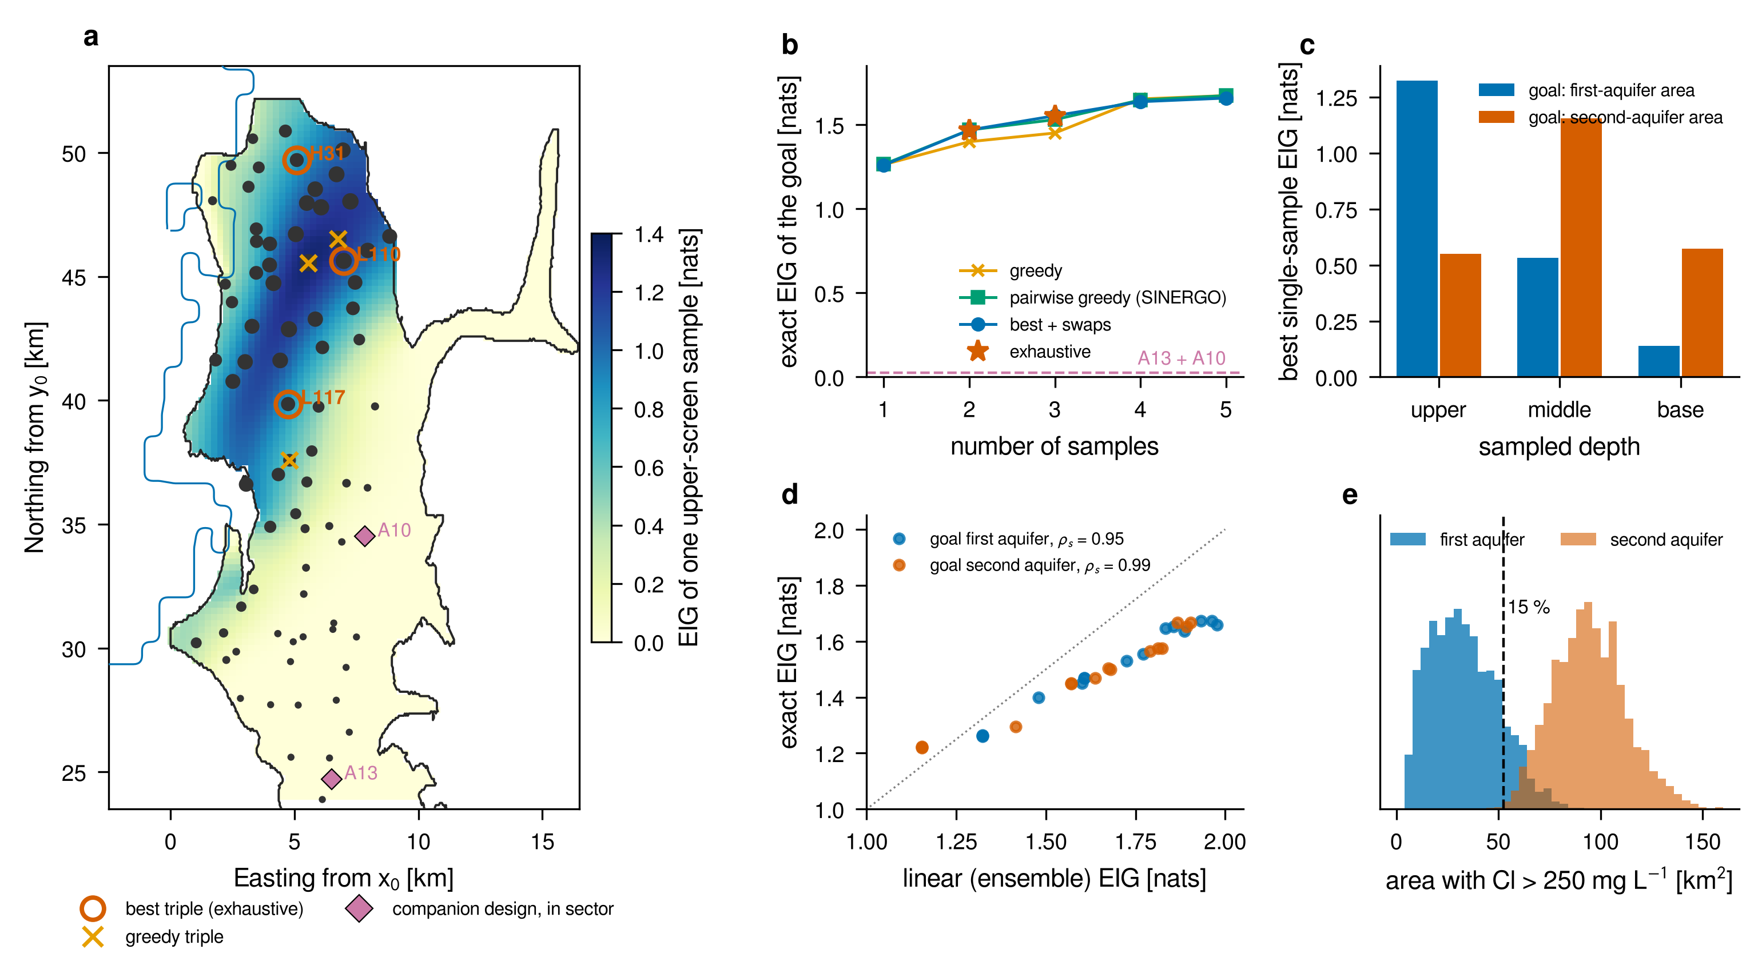
Fig. 7. Goal-oriented chloride sampling. (a) Linear EIG of one upper-screen sample about the first-aquifer affected area, over the sector, with the 79 candidate wells (symbol size proportional to their EIG), the best triple from exhaustive search, the greedy triple and the two in-sector wells of the companion design. (b) Exact EIG of the best designs of one to five samples from greedy, pairwise-greedy (SINERGO), swap and exhaustive searches; dashed: the companion design. (c) Best single-sample EIG at each sampling depth for the first- and second-aquifer goals. (d) Exact against linear EIG of the multi-sample designs of both goals; ρ_{s} is the Spearman correlation of the two criteria over 80 single samples. (e) Posterior distributions of the two goals; the dashed line marks 15 % of the aquifer polygon.
Table 4. Best chloride sampling designs found by three searches, with linear / exact EIG in nats. All samples are upper screens for the first-aquifer goal and mid-depth screens for the second-aquifer goal. Exhaustive search covers pairs and triples of the 40 best single samples.
k | Greedy | EIG | Pairwise greedy | EIG | Exhaustive | EIG
Goal: first-aquifer area with Cl > 250 mg/L
1 | L102 | 1.32 / 1.26 | L102 | 1.32 / 1.26 | – | –
2 | L102, L109 | 1.48 / 1.40 | E52, L117 | 1.61 / 1.47 | E52, L117 | 1.61 / 1.47
3 | L102, L109, P4 | 1.60 / 1.45 | E52, L117, L103 | 1.72 / 1.53 | L110, L117, H31 | 1.77 / 1.55
4 | L102, L109, P4, V1 | 1.86 / 1.65 | E52, L117, L112, L99 | 1.83 / 1.65 | – | –
5 | L102, L109, P4, V1, L113 | 1.96 / 1.67 | E52, L117, L112, L99, P4 | 1.93 / 1.67 | – | –
Goal: second-aquifer area with Cl > 250 mg/L
1 | A28 | 1.15 / 1.22 | A28 | 1.15 / 1.22 | – | –
2 | A28, A10 | 1.42 / 1.30 | L113, H2/4 | 1.57 / 1.45 | L113, H2/4 | 1.57 / 1.45
3 | A28, A10, L110 | 1.64 / 1.47 | L113, H2/4, P3 | 1.67 / 1.50 | L116, H2/4, L110 | 1.72 / 1.56
Companion design, wells A13 and A10 (upper screens): 0.01 / 0.02 nats for the first-aquifer goal. Exact EIG is estimated from 1905 distinct members with eight goal classes; its Monte Carlo error is about ±0.01 nats.

4.6. Decision modules
Table 5 summarizes the tests of the decision modules, and Fig. 8 shows six of them. Each module was tested against a known truth, and in each the design or estimator that targets the decision quantity outperformed the one that targets the state of the wedge or a standard statistical default.
For threshold risk, a design built on the adjoint of the exceedance indicator reached 97–100 % of the optimal information on Henry's problem, against 75–96 % for a design built for the salt mass. On the field model with the geolocated sea boundary, where the risk comes from pumping two wells of the Fushë-Kuqe field, the three-well design for the supply-well risk reaches 100 % of the optimal information about the risk, whereas the design built for the intruded area, as in the published pipeline, reaches 52–74 % (100 % against 48–69 % with five wells; Supplementary Section S7.2b and Fig. S2). Recomputed with the geolocated sea boundary, where the risk comes from pumping at the well field, recharge at three PRAG-MAR sites (5000 m³/d each) lowers the probability that one of two pumped supply wells is intruded from 0.56 to 0.06, close to the exact optimum (0.04); sites chosen for the intruded area reach 0.30, and the published sites, two of which lie in the southern plain without sea contact, 0.53 (Supplementary Section S7.2a and Fig. S1). For tipping, the logger position that maximizes information on the recovery rate (1200 m from the coast, inside the range of the critical toe) predicts warning skill with ρ_{s} = 0.96, whereas a status criterion (800 m) gives ρ_{s} = 0.21. The classical rising-autocorrelation warning gives two years of lead time in at most 7 % of the runs. For safe pumping, the Kramers rule overestimates the mean escape time at 0.8 Q_{c} by an order of magnitude (1482 yr against 132 yr from simulation and the full backward equation), and the 100-year safe rate is 0.82 Q_{c} (0.62–0.89 Q_{c} under the prior).
For learning, standard Bayesian regression with 240 exact shoreline readings covers the toe in 48 % of the cases with a nominal 90 % interval, against 96 % for SafeBayes and 87 % for the goal-calibrated rate, close to an oracle (91 %). For attribution, toe monitoring settles fewer than 6 % of the events, whereas quarterly recharge records do so for 92 %: the data that attribute an event are those that describe the counterfactual, not the event. For regime risk and thresholds, targeted estimation removes the bias of the naive estimate (+0.157 to −0.006), and a threshold chosen with a simultaneous band is unsafe in 5–10 % of the cases against 57–72 % for the plug-in choice. For information flow, transfer entropy from pumping records overstates the causal flow by a factor of 1.9, a 50/50 randomized pumping experiment measures it best (TE_{do} ≈ 4π(1 − π)C), while a partial information decomposition (Williams and Beer, 2010; Bertschinger et al., 2014) assigns pumping almost no unique information (0–1.8 mbit) although its causal flow is 13 mbit, so its atoms cannot be read as causal contributions; and among monitoring designs the feedback information from the toe to the pumping decision predicts the salinization risk (ρ_{s} = −0.97) whereas the sensor information does not (ρ_{s} = −0.16).
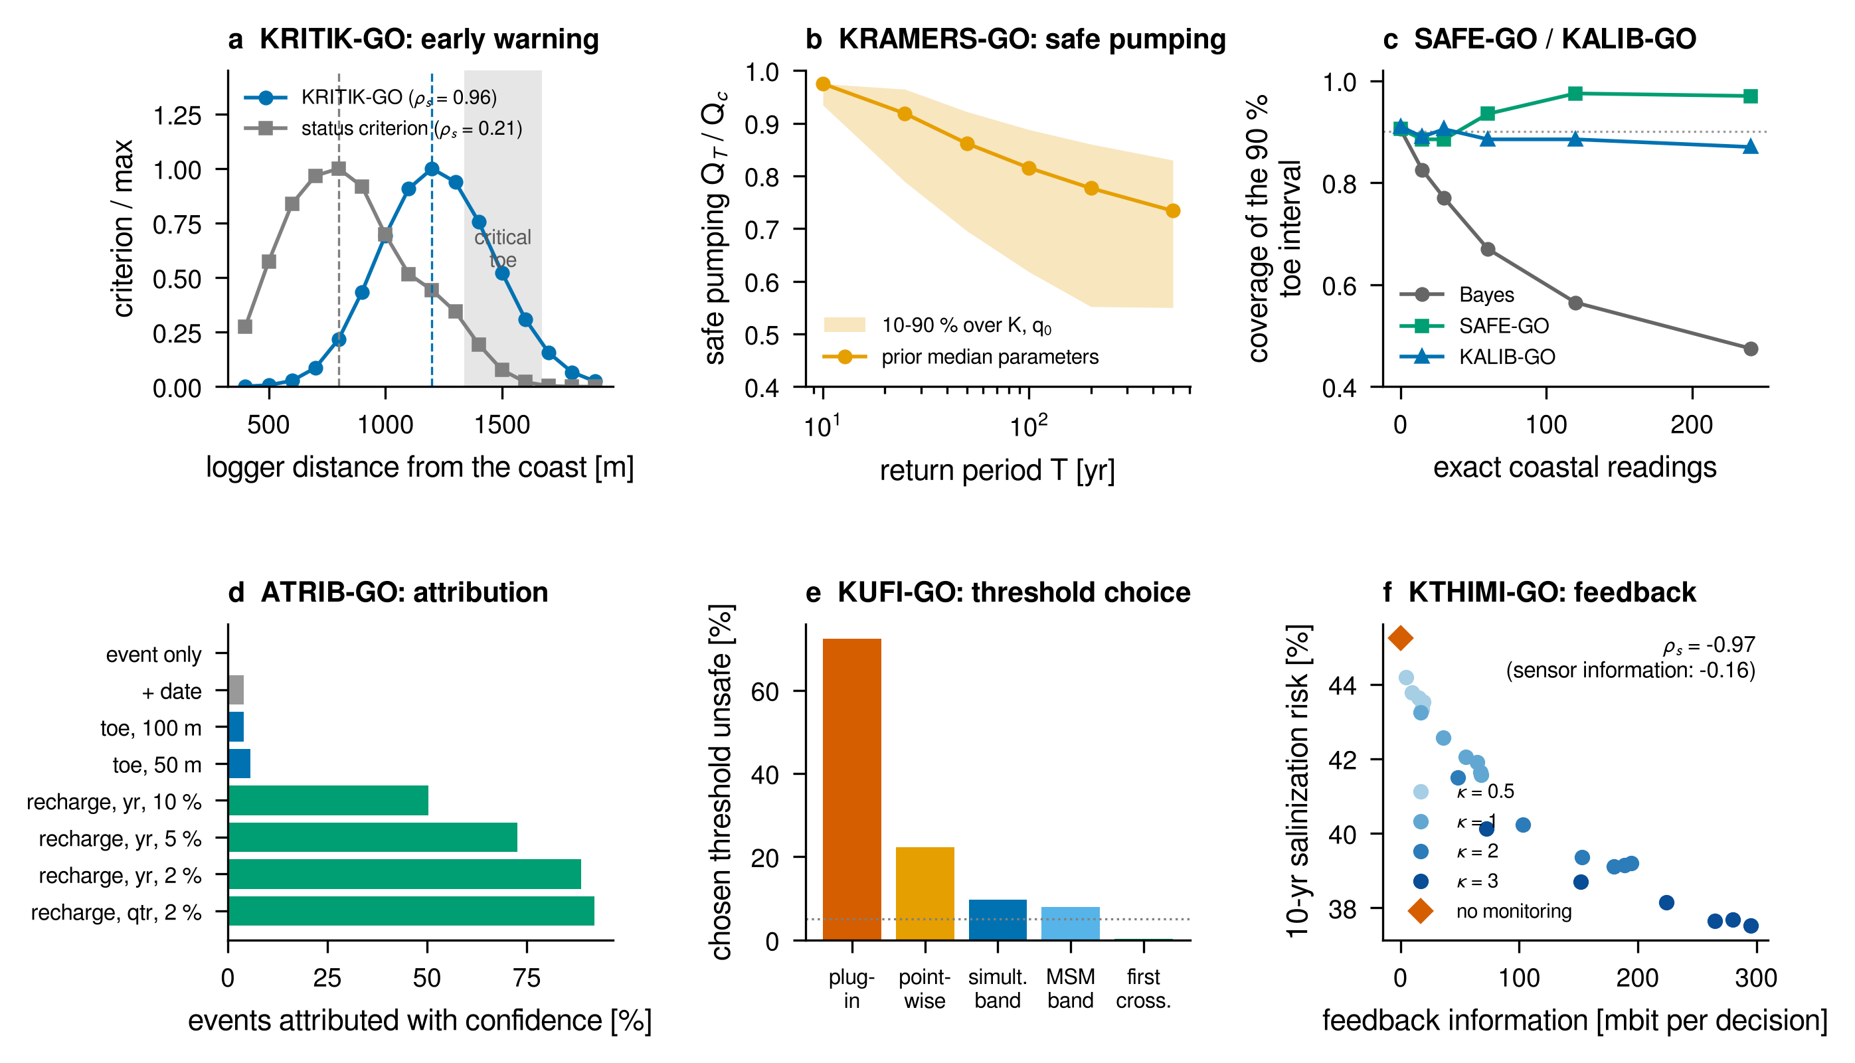
Fig. 8. Six decision modules tested on models parameterized for Fushë-Kuqe (details in Supplementary Section S7). (a) KRITIK-GO: normalized design criterion against logger distance from the coast for the goal-oriented Fisher information on the recovery rate and for a status criterion; ρ_{s} is the rank correlation of each criterion with the realized warning skill; grey: range of the critical toe. (b) KRAMERS-GO: safe pumping rate for a return period T relative to the critical rate Q_{c}, at the prior median and over the 10–90 % range of K and q₀. (c) SAFE-GO and KALIB-GO: coverage of the nominal 90 % toe interval as exact coastal readings are added to noisy inland ones. (d) ATRIB-GO: events attributed to pumping with confidence, for different data. (e) KUFI-GO: frequency with which the chosen pumping threshold is unsafe (dotted: 5 % target). (f) KTHIMI-GO: 10-year salinization risk against the feedback information from the toe to the pumping decision, for monitoring designs with different decision gains κ.
Table 5. Decision modules: question, test and main result. All tests use models parameterized for Fushë-Kuqe with a known truth; full descriptions are in Supplementary Section S7. The field tests of PRAG-GO and PRAG-MAR use the companion model with the geolocated sea boundary of Section 2.3.
Module | Decision question | Test | Main result
PRAG-GO | Which data best predict whether a supply well exceeds a threshold? | Henry problem; companion physics with the geolocated sea boundary, two pumped supply wells | Threshold-goal design reaches 97–100 % (Henry) and 100 % (field, three wells; 100 % with five) of the optimal EIG; salt-mass (Henry) and intruded-area (field) designs reach 75–96 % and 52–74 % (48–69 % with five).
PRAG-MAR | Where should recharge be placed to protect supply wells? | Companion physics with the geolocated sea boundary; two pumped wells of the Fushë-Kuqe field | P(A or B intruded) 0.56 → 0.06 with PRAG-MAR sites (exact optimum 0.04), against 0.30 for area-adjoint sites and 0.53 for the published sites (5000 m³/d per site).
SINERGO | Can a sequential search miss jointly informative data? | 40 random head-data tests | Greedy finds the optimal pair in 15 % of tests (mean 93.5 %, min 76.9 % of optimum); pairwise greedy in 100 %.
KRITIK-GO | Is the toe approaching a tipping point? | Strack toe, Q_{c} = 3651 m³/d, OU recharge | Optimal logger 1200 m from the coast (status criterion 800 m); rank correlation with warning skill 0.96 vs 0.21; classical warning gives ≥ 2 yr lead in ≤ 7 % of runs.
KRAMERS-GO | How much can be pumped for a T-year return period? | Toe–recharge diffusion, backward Kolmogorov equation | Mean escape time at 0.8 Q_{c}: 132 yr (simulation and 2-D solution) vs 1482 yr (Kramers rule); Q₁₀₀ = 0.82 Q_{c} (0.62–0.89 Q_{c} under the prior).
SAFE-GO | How much should exact and noisy readings be trusted? | Toe regression, 240 exact + noisy readings | Coverage of the 90 % toe interval: Bayes 48 %, SafeBayes 96 %; Bayes picks redundant readings in 62 % of designs.
KALIB-GO | Which learning rate gives calibrated goal intervals? | As SAFE-GO, bootstrap calibration | Coverage 87 % with width 68 m (oracle 91 %, 69 m; SafeBayes 95 m).
ATRIB-GO | Was a salinization event caused by a pumping increase? | Twin worlds, 0.80 → 0.90 Q_{c} | Probability of necessity 0.72; confident attribution for ≤ 6 % of events with toe monitoring, 92 % with quarterly recharge records (99.6 % correct).
TMLE-GO | What is the salinization risk of a pumping rule? | Simulated well field, 10 yr | Naive bias +0.157, TMLE −0.006 (coverage 85 %); with a decision log −0.002 (95 %).
KUFI-GO | Which pumping threshold is safe at level α? | As TMLE-GO, α = 0.35 | Unsafe choices: plug-in 57–72 %, pointwise bound 12–22 %, simultaneous band 5–10 %; randomized thresholds with an MSM band ≤ 1 %, keeping 38–84 % of the gain.
RRJEDHA-GO | How much does pumping cause toe change? | Simulated field, drought confounder | TE from records 24.9 vs interventional 13.0 mbit (1.9×); back-door adjusted 12.5 mbit; randomized rotation halves the estimator SD (2.4 vs 5.5 mbit).
KANAL-GO | How should a pumping experiment be randomized? | Causal channel of the toe | Small-effect law TE_{do} ≈ 4π(1 − π)C (12.981 vs 12.976 mbit at the operating point); optimum π = 1/2; records with back-door adjustment have 3.8–5.1× the variance of a 50/50 experiment.
KTHIMI-GO | Does the monitoring information reach the decision? | Feedback loop toe → pumping | Risk vs feedback information ρ_{s} = −0.97 (sensor information −0.16); risk 45.2 % → 37.5 %.

5. Discussion

5.1. What sparse chloride data can and cannot constrain
The Fushë-Kuqe record is typical of many intruded aquifers: four analyses without coordinates, two short series and a list of statements from earlier surveys. Used as likelihood terms with honest errors, such data constrain the combination of recharge, conductivity and mixing width that determines where chloride exceeds a threshold, and the calibrated maps carry the remaining uncertainty explicitly. They do not constrain the aquifer geometry, which stays at its prior, nor the shallow affected area independently of how the documented 15 % is read (Section 4.2). The documented facts are the weakest link, and the sensitivity variants show how much each reading matters.
The held-out analysis is the most informative result of the calibration. A steady model that satisfies the documented facts cannot reproduce 1.9 % seawater in the centre of the plain, and the ion-exchange signature of the same sample shows freshening. The two observations, one physical and one geochemical, are independent and point the same way. The central well field carries legacy salinity that is being flushed, and the present wedge is a coastal feature of the northern sector. Using such a sample as a calibration target would have produced a much larger affected area (Supplementary Table S3) and a wrong picture of where intrusion is active. Combining the base-exchange index with a predictive check is a simple, general way to identify legacy salinity in data-poor aquifers before it is used for calibration.

5.2. The sea contact and the companion design
The geolocated shoreline refines the boundary of the companion study (Zeqiraj, 2026), which placed a seaward boundary along the whole western margin of the aquifer polygon. That choice was stated as an assumption, and it does not affect the methods of that paper (the discrete adjoint, the goal-oriented criterion and its closed form, the facies poolability), which are used again here. It does affect the site-specific design. Along the southern 29 km of the margin the aquifer meets the hills behind Lalëz Bay, not the sea, and the chloride maps show no intrusion there. Design recommendations of the companion study that rely on southern sea contact must be recomputed with the boundary of Section 2.3, and the recharge design shows why. With the full-margin boundary the companion model has an intruded area of 92.7 km² and supply wells at risk without any pumping. With the geolocated boundary and the same physics the intruded area is 10.1 km², confined to the northern coast, no well is at risk unless it is pumped, and two of the three published recharge sites lie in the southern plain, which has no sea contact. Recomputed for two pumped wells of the Fushë-Kuqe well field, the threshold-risk designs keep their advantage over designs for the intruded area, for monitoring as for recharge (Section 4.6), but their wells and sites move to the well field and to inland cells up-gradient of it (Supplementary Figs. S1 and S2). The chloride goal of this paper places the information in the north-western coastal strip instead (Section 4.5). The general lesson is that a goal-oriented design inherits every boundary assumption of the model, and the boundary should be checked against independent geographic data before a design is recommended.

5.3. A sampling campaign for Fushë-Kuqe
The results translate into a concrete campaign. (i) For the first-aquifer affected area, which the drinking-water rule concerns: upper-screen samples at L110, L117 and H31, or at E52 and L117 if only two are possible. (ii) For the second aquifer: a mid-depth sample at A28, or at L116, H2/4 and L110 for three samples. (iii) For the legacy-salinity hypothesis: a depth-resolved sample at well 340 with the full major-ion analysis, since a positive BEX at decreasing chloride would confirm freshening. (iv) Repeat analyses of wells 341 and 503 with the screen depth recorded, to turn the three-point series into trends. The first two items cost a handful of analyses and, in Gaussian terms, would reduce the uncertainty of the affected area about fivefold. The same procedure, with the posterior updated after each campaign, gives a sequential design.

5.4. From the state of the wedge to the decision
The decision modules share one result: the data that best describe the state of the wedge are rarely the data that best inform a decision. A logger that tracks the toe accurately is not the logger that warns of tipping; toe monitoring does not attribute a salinization event, whereas recharge records do; and a monitoring network informative about the interface reduces the salinization risk only if its information reaches the pumping decision, which is what the feedback term of Massey's law measures. Each module replaces a state-oriented criterion with one tied to the quantity a manager acts on: an exceedance indicator, a recovery rate, an escape time, a probability of necessity, a regime risk, a safe threshold or a feedback information. Together they form the decision chain of Fig. 1, and their combination is the main innovation of this work. The chloride study shows the first two links on field data; the other modules are, at this stage, tested methods with a site-specific parameterization, and their field application requires the corresponding data (head and salinity loggers, operating logs, recharge records).

5.5. Limitations and outlook
- The four analyses have no coordinates or screen depths; they enter the likelihood as band averages, and the assignment of wells 341 and 503 to the second aquifer rests on their dissolved solids.
- The model is steady. It describes the present wedge but not the legacy salinity of the central plain or the response to the abstraction history; a transient variable-density model calibrated to the head decline of the well field is the natural next step.
- The Dupuit single potential ignores vertical flow resistance between gravel layers; the section shows that this makes the sharp-interface toe an upper estimate. The layering is represented only through three screens and a transmissive fraction.
- The aquifer-top depth rests on the reading of the DRASTIC depth parameter (Section 2.4); borehole logs would confirm it. The shoreline is known to about 1 km (GLOBE resolution), and the Patok lagoon and the river mouths are not represented as separate boundaries.
- The exact EIG is a lower bound computed with eight goal classes from about 1900 distinct members, with a Monte Carlo error of about 0.01 nats, and the observation error of 0.1 in log₁₀ chloride is an assumption.
- The decision modules were tested on simplified models with a known truth; they show what each criterion achieves, not its performance with the Fushë-Kuqe records.

6. Conclusions
A decision-centred, data-constrained framework was developed for chloride in the Fushë-Kuqe–Lezhë coastal aquifer and extended to the decisions that depend on it. The main conclusions are:
- The Adriatic is in contact with the aquifer along 23 km of its north-western margin only; the southern margin is inland, and the aquifer behind it is fresh in the first and second aquifer.
- Ion exchange separates active salinization at the south-western coast (BEX ≈ −2.7 meq/L) from freshening in the central well field (BEX = +2.4 meq/L). Together with a predictive check that fails, this identifies the chloride of the central well as legacy salinity.
- Calibrated to four documented facts, the model gives median areas with chloride above 250 mg/L of 31 km² in the first aquifer, 94 km² in the second and 132 km² at the base, with 90 % intervals. A variable-density section reproduces the calibrated mixing width (27 against 29 m) with a transverse dispersivity of about 1 m.
- Goal-oriented sampling selects both the well and the depth. Three upper-screen samples chosen by exhaustive or pairwise-greedy search carry 1.55 nats about the first-aquifer affected area; greedy selection misses the synergy of pairs, and the in-sector wells of an earlier design carry 0.02 nats.
- Twelve modules extend the goal-oriented principle from the state of the wedge to threshold risk, tipping, safe pumping, robust learning, attribution, regime risk, safe thresholds and the flow of information to the pumping decision. In every test the decision-targeted criterion outperformed the state-targeted one.
- A MATLAB R2026b package reproduces every number and figure of the chloride study from the data workbook and agrees with an independent Python implementation to round-off.

CRediT authorship contribution statement
Dulian Zeqiraj: Conceptualization, Methodology, Software, Formal analysis, Investigation, Data curation, Visualization, Writing – original draft, Writing – review & editing.

Declaration of competing interest
The author declares that they have no known competing financial interests or personal relationships that could have appeared to influence the work reported in this paper.

Declaration of generative AI and AI-assisted technologies in the writing process
During the preparation of this work the author used Claude Code (Anthropic) in order to [author to specify: e.g. implement and test the code, run the analyses, prepare the figures and draft the text]. After using this tool, the author reviewed and edited the content as needed and takes full responsibility for the content of the publication.

Data availability
The data workbook (aquifer polygon, well list, hydraulic conductivities, DRASTIC parameters and the compiled water chemistry) is the property of the Albanian Geological Survey and A. Beqiraj and is redistributed with their permission in the code repository; the water-chemistry data are published in Cenameri and Beqiraj (2016). The MATLAB and Python code, the derived inputs and all results are available at https://github.com/dulianzeqiraj/swi-goal-oed (folder chloride_fk; decision modules in folder experiments).

Acknowledgements
The author thanks the Albanian Geological Survey and A. Beqiraj for the permission to use and redistribute the data. [Author to complete.]

Funding
[Author to confirm:] This research did not receive any specific grant from funding agencies in the public, commercial, or not-for-profit sectors.

References
Abarca, E., Carrera, J., Sánchez-Vila, X., Dentz, M., 2007. Anisotropic dispersive Henry problem. Adv. Water Resour. 30 (4), 913–926. https://doi.org/10.1016/j.advwatres.2006.08.005
Alexanderian, A., 2021. Optimal experimental design for infinite-dimensional Bayesian inverse problems governed by PDEs: A review. Inverse Probl. 37 (4), 043001. https://doi.org/10.1088/1361-6420/abe10c
Aller, L., Bennett, T., Lehr, J.H., Petty, R.J., Hackett, G., 1987. DRASTIC: A standardized system for evaluating ground water pollution potential using hydrogeologic settings. EPA/600/2-87/035. U.S. Environmental Protection Agency, Robert S. Kerr Environmental Research Laboratory, Ada, Oklahoma.
Appelo, C.A.J., Postma, D., 2005. Geochemistry, Groundwater and Pollution, second ed. A.A. Balkema, Leiden. https://doi.org/10.1201/9781439833544
Artegiani, A., Bregant, D., Paschini, E., Pinardi, N., Raicich, F., Russo, A., 1997. The Adriatic Sea general circulation. Part I: Air–sea interactions and water mass structure. J. Phys. Oceanogr. 27 (8), 1492–1514. https://doi.org/10.1175/1520-0485(1997)027<1492:TASGCP>2.0.CO;2
Attia, A., Alexanderian, A., Saibaba, A.K., 2018. Goal-oriented optimal design of experiments for large-scale Bayesian linear inverse problems. Inverse Probl. 34 (9), 095009. https://doi.org/10.1088/1361-6420/aad210
Ay, N., Polani, D., 2008. Information flows in causal networks. Adv. Complex Syst. 11 (1), 17–41. https://doi.org/10.1142/S0219525908001465
Bertschinger, N., Rauh, J., Olbrich, E., Jost, J., Ay, N., 2014. Quantifying unique information. Entropy 16 (4), 2161–2183. https://doi.org/10.3390/e16042161
Cenameri, S., Beqiraj, A., 2016. Assessment of seawater intrusion in Fushe Kuqe aquifer, Albania. Bull. Geol. Soc. Greece 50 (2), 665–670. https://doi.org/10.12681/bgsg.11772
Chaloner, K., Verdinelli, I., 1995. Bayesian experimental design: A review. Stat. Sci. 10 (3), 273–304. https://doi.org/10.1214/ss/1177009939
Custodio, E., 2010. Coastal aquifers of Europe: An overview. Hydrogeol. J. 18 (1), 269–280. https://doi.org/10.1007/s10040-009-0496-1
Das, A., Kempe, D., 2018. Approximate submodularity and its applications: Subset selection, sparse approximation and dictionary selection. J. Mach. Learn. Res. 19 (3), 1–34.
Eftimi, R., 2003. Some considerations on seawater–freshwater relationship in Albanian coastal area. In: López-Geta, J.A., et al. (Eds.), Coastal Aquifers Intrusion Technology: Mediterranean Countries (TIAC'03), Tomo II. IGME, Madrid, pp. 239–250.
European Union, 2020. Directive (EU) 2020/2184 of the European Parliament and of the Council of 16 December 2020 on the quality of water intended for human consumption (recast). Off. J. Eur. Union L 435, 23.12.2020, 1–62.
Gelhar, L.W., Welty, C., Rehfeldt, K.R., 1992. A critical review of data on field-scale dispersion in aquifers. Water Resour. Res. 28 (7), 1955–1974. https://doi.org/10.1029/92WR00607
GLOBE Task Team and others (Hastings, D.A., Dunbar, P.K., Elphingstone, G.M., Bootz, M., Murakami, H., Maruyama, H., Masaharu, H., Holland, P., Payne, J., Bryant, N.A., Logan, T.L., Muller, J.-P., Schreier, G., MacDonald, J.S.), eds., 1999. The Global Land One-kilometer Base Elevation (GLOBE) Digital Elevation Model, Version 1.0. National Oceanic and Atmospheric Administration, National Geophysical Data Center, Boulder, Colorado. https://doi.org/10.7289/V52R3PMS
Grünwald, P., van Ommen, T., 2017. Inconsistency of Bayesian inference for misspecified linear models, and a proposal for repairing it. Bayesian Anal. 12 (4), 1069–1103. https://doi.org/10.1214/17-BA1085
Hänggi, P., Talkner, P., Borkovec, M., 1990. Reaction-rate theory: Fifty years after Kramers. Rev. Mod. Phys. 62 (2), 251–341. https://doi.org/10.1103/RevModPhys.62.251
Henry, H.R., 1964. Effects of dispersion on salt encroachment in coastal aquifers. In: Sea Water in Coastal Aquifers. U.S. Geological Survey Water-Supply Paper 1613-C. U.S. Government Printing Office, Washington, DC.
Huan, X., Jagalur, J., Marzouk, Y., 2024. Optimal experimental design: Formulations and computations. Acta Numer. 33, 715–840. https://doi.org/10.1017/S0962492924000023
Ketabchi, H., Mahmoodzadeh, D., Ataie-Ashtiani, B., Simmons, C.T., 2016. Sea-level rise impacts on seawater intrusion in coastal aquifers: Review and integration. J. Hydrol. 535, 235–255. https://doi.org/10.1016/j.jhydrol.2016.01.083
Kooi, H., Groen, J., Leijnse, A., 2000. Modes of seawater intrusion during transgressions. Water Resour. Res. 36 (12), 3581–3589. https://doi.org/10.1029/2000WR900243
Kramers, H.A., 1940. Brownian motion in a field of force and the diffusion model of chemical reactions. Physica 7 (4), 284–304. https://doi.org/10.1016/S0031-8914(40)90098-2
Kumanova, X., Marku, S., Fröjdö, S., Jacks, G., 2014. Recharge and sustainability of a coastal aquifer in northern Albania. Hydrogeol. J. 22, 883–892. https://doi.org/10.1007/s10040-014-1097-1
Lal, A., Datta, B., 2019. Application of monitoring network design and feedback information for adaptive management of coastal groundwater resources. Int. J. Environ. Res. Public Health 16 (22), 4365. https://doi.org/10.3390/ijerph16224365
Lindley, D.V., 1956. On a measure of the information provided by an experiment. Ann. Math. Stat. 27 (4), 986–1005. https://doi.org/10.1214/aoms/1177728069
Lu, C., Werner, A.D., 2013. Timescales of seawater intrusion and retreat. Adv. Water Resour. 59, 39–51. https://doi.org/10.1016/j.advwatres.2013.05.005
Mantoglou, A., 2003. Pumping management of coastal aquifers using analytical models of saltwater intrusion. Water Resour. Res. 39 (12), 1335. https://doi.org/10.1029/2002WR001891
Massey, J.L., 1990. Causality, feedback and directed information. In: Proceedings of the 1990 International Symposium on Information Theory and its Applications (ISITA-90), Waikiki, Hawaii, pp. 303–305.
Millero, F.J., Feistel, R., Wright, D.G., McDougall, T.J., 2008. The composition of Standard Seawater and the definition of the Reference-Composition Salinity Scale. Deep Sea Res. Part I Oceanogr. Res. Pap. 55 (1), 50–72. https://doi.org/10.1016/j.dsr.2007.10.001
Neuberger, J.N., Alexanderian, A., van Bloemen Waanders, B., 2025. Goal oriented optimal design of infinite-dimensional Bayesian inverse problems using quadratic approximations. J. Sci. Comput. 105 (2), 55. https://doi.org/10.1007/s10915-025-03073-y
Pearl, J., 2009. Causality: Models, Reasoning, and Inference, second ed. Cambridge University Press, Cambridge. https://doi.org/10.1017/CBO9780511803161
Pool, M., Carrera, J., 2011. A correction factor to account for mixing in Ghyben-Herzberg and critical pumping rate approximations of seawater intrusion in coastal aquifers. Water Resour. Res. 47 (5), W05506. https://doi.org/10.1029/2010WR010256
Rainforth, T., Foster, A., Ivanova, D.R., Bickford Smith, F., 2024. Modern Bayesian experimental design. Stat. Sci. 39 (1), 100–114. https://doi.org/10.1214/23-STS915
Revelle, R., 1941. Criteria for recognition of the sea water in ground-waters. Trans. Am. Geophys. Union 22 (3), 593–597. https://doi.org/10.1029/TR022i003p00593
Robins, J.M., Hernán, M.A., Brumback, B., 2000. Marginal structural models and causal inference in epidemiology. Epidemiology 11 (5), 550–560. https://doi.org/10.1097/00001648-200009000-00011
Rytgaard, H.C., Gerds, T.A., van der Laan, M.J., 2022. Continuous-time targeted minimum loss-based estimation of intervention-specific mean outcomes. Ann. Stat. 50 (5), 2469–2491. https://doi.org/10.1214/21-AOS2114
Scheffer, M., Bascompte, J., Brock, W.A., Brovkin, V., Carpenter, S.R., Dakos, V., Held, H., van Nes, E.H., Rietkerk, M., Sugihara, G., 2009. Early-warning signals for critical transitions. Nature 461 (7260), 53–59. https://doi.org/10.1038/nature08227
Schreiber, T., 2000. Measuring information transfer. Phys. Rev. Lett. 85 (2), 461–464. https://doi.org/10.1103/PhysRevLett.85.461
Sreekanth, J., Datta, B., 2010. Multi-objective management of saltwater intrusion in coastal aquifers using genetic programming and modular neural network based surrogate models. J. Hydrol. 393 (3–4), 245–256. https://doi.org/10.1016/j.jhydrol.2010.08.023
Strack, O.D.L., 1976. A single-potential solution for regional interface problems in coastal aquifers. Water Resour. Res. 12 (6), 1165–1174. https://doi.org/10.1029/WR012i006p01165
Stuyfzand, P.J., 2008. Base exchange indices as indicators of salinization or freshening of (coastal) aquifers. In: Proceedings of the 20th Salt Water Intrusion Meeting (SWIM 20), Naples, Florida, pp. 262–265.
Syring, N., Martin, R., 2019. Calibrating general posterior credible regions. Biometrika 106 (2), 479–486. https://doi.org/10.1093/biomet/asy054
Tian, J., Pearl, J., 2000. Probabilities of causation: Bounds and identification. Ann. Math. Artif. Intell. 28, 287–313. https://doi.org/10.1023/A:1018912507879
van der Laan, M.J., Rose, S., 2011. Targeted Learning: Causal Inference for Observational and Experimental Data. Springer, New York. https://doi.org/10.1007/978-1-4419-9782-1
Werner, A.D., Bakker, M., Post, V.E.A., Vandenbohede, A., Lu, C., Ataie-Ashtiani, B., Simmons, C.T., Barry, D.A., 2013. Seawater intrusion processes, investigation and management: Recent advances and future challenges. Adv. Water Resour. 51, 3–26. https://doi.org/10.1016/j.advwatres.2012.03.004
Williams, P.L., Beer, R.D., 2010. Nonnegative decomposition of multivariate information. arXiv preprint arXiv:1004.2515. https://arxiv.org/abs/1004.2515
World Health Organization, 2022. Guidelines for Drinking-Water Quality: Fourth Edition Incorporating the First and Second Addenda. World Health Organization, Geneva.
Zeqiraj, D., 2026. Goal-oriented Bayesian experimental design for variable-density seawater intrusion: Adjoint expected information gain for joint monitoring and managed-aquifer-recharge placement. J. Hydrol. 680, 136559. https://doi.org/10.1016/j.jhydrol.2026.136559

