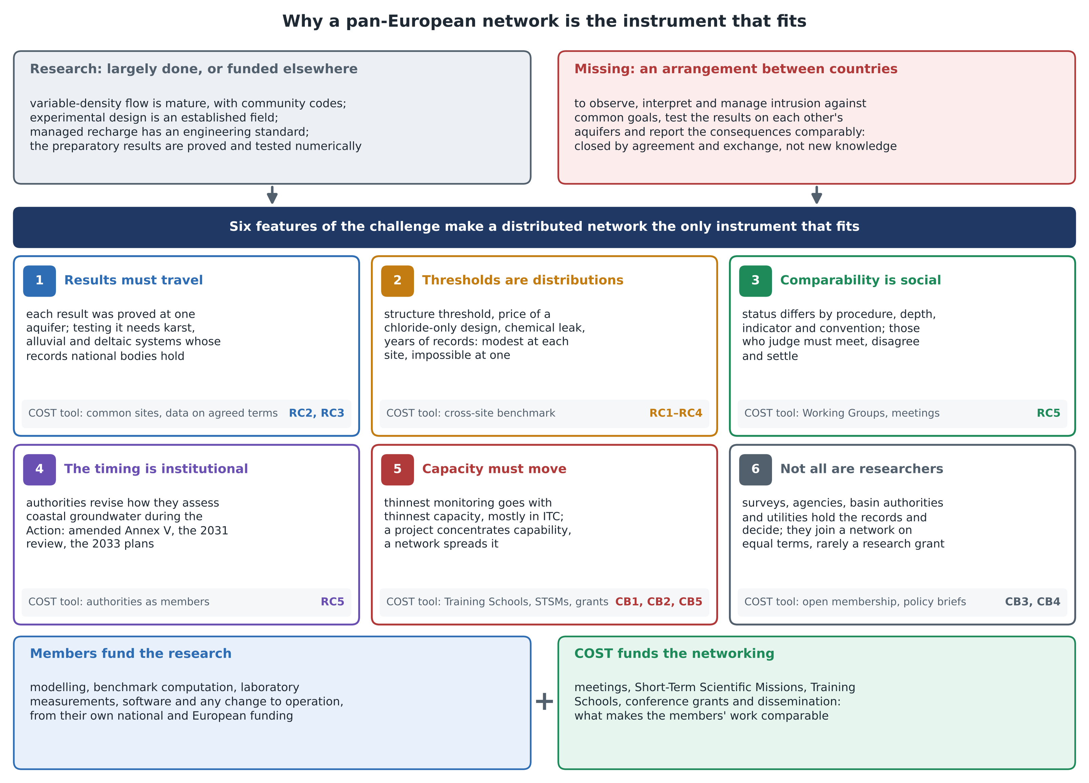
Figure. Why a pan-European network is the most appropriate instrument: the research is largely done or funded elsewhere, what is missing is an arrangement between countries, and six features of the challenge each call for a networking tool tied to the objectives it serves.

