CERTAIN-COAST — Innovation
Certified early warning for seawater intrusion, liquefaction and extreme sea levels at the wellfields, port and energy landfall of a subsiding Adriatic coast
1. The core innovation
CERTAIN-COAST builds the first early warning for critical coastal infrastructure whose miss rate is certified in advance and verified in operation: one system for seawater intrusion at the wellfields, liquefaction at the port and the energy landfall, and extreme sea levels at all three, driven by one physical model of a subsiding coast. It closes three gaps that the State of the Art identifies in the 2020–2026 literature:
• No early warning treats the three hazards as one system, although they share relative sea level and pore pressure and are moved by the same pumping lever (closed by P1, P2, P3, M2).
• No warning for any of them carries a guarantee: certified methods assume exchangeable data or hold on time average, and none covers a slow physics model or states beyond the record (closed by M1, M4, M5).
• The new sensors are measured but not designed: no study chooses InSAR, seismic noise and fibre jointly with wells and samples to reduce missed warnings (closed by M3, P5).
Numbers in brackets refer to the 30 key papers of the State of the Art; [L1] is the local Durrës study and letters to the additional sources listed at the end.
2. Innovations at a glance
Code | Innovation | Beyond today | Novelty check | Tested in
M1 | Certified multi-hazard alarm | Guarantees exist for exchangeable data [19–23]; here they hold for a slow physics model, under nonstationarity and beyond the record | Goes beyond cited work | D3.1–D3.2 (M24–27); D5.1
M2 | A joint guarantee across hazards | Single-alarm guarantees only | No direct precedent found | D3.1 (M24); D3.2 (M27)
M3 | Multi-hazard goal-oriented sensor design | Design for one quantity and one sensor type [30]; here three warnings and seven sensor types | Goes beyond cited work | D4.1 (M6)
M4 | An error-certified surrogate of the coupled model | Approximation guarantees [25, 26]; here a certificate on each forecast of a coupled model | Goes beyond cited work | D2.2 (M22)
M5 | Nonstationary extremes with measured land motion | Linear land-motion trend [4–6]; here measured, time-varying land motion | Goes beyond cited work | D1.1 (M12); D3.2 (M27)
P1 | One relative-sea-level boundary for all three hazards | Subsidence measured but not used as a shared boundary [1–3] | Goes beyond cited work | D1.1 (M12)
P2 | A time-varying liquefaction factor of safety | Static susceptibility, fixed water table [10, 12] | Goes beyond cited work | D2.1 (M18)
P3 | The pumping lever made explicit | One effect at a time [1] | No direct precedent found | T5.3 (M33)
P4 | The compaction tipping point as a warning in itself | Detected after the fact [2, 3]; here a formal alarm and a pumping limit | Goes beyond cited work | D1.1 (M12)
P5 | Seismic velocity as a pore-pressure sensor in saturated coastal sediments | Dry or inland basins [16–18]; here saturated coastal sediments | Goes beyond cited work | T4.4 (M24)
V1 | A certified value of the warning for each user | Value computed after the fact [a, b]; here guaranteed in advance | Goes beyond cited work | D5.1 (M34)
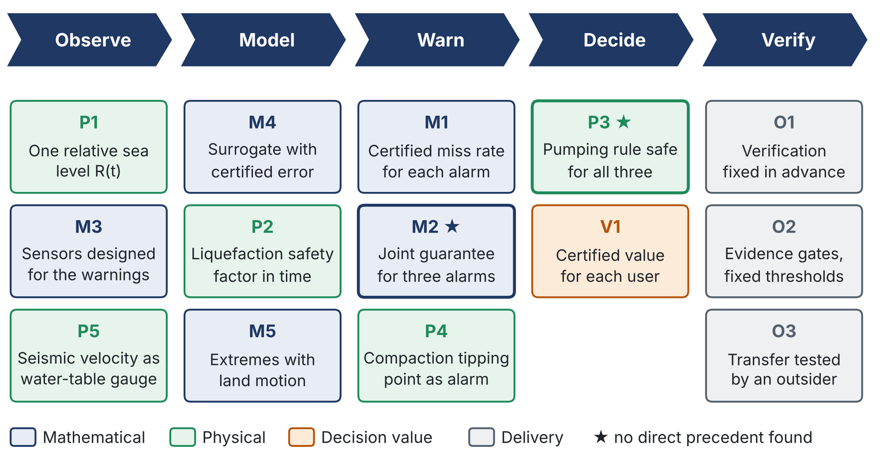
Figure 1. Where each innovation acts in the warning chain, from observing the coast to verifying the warnings. Colour: type of innovation; ★: no direct precedent found in our search.
3. The innovations one by one
M1 Certified multi-hazard alarm Mathematical
Today | Distribution-free risk control and online conformal prediction give long-run guarantees [19–21], and conformal coverage exists for neural-operator surrogates [23]. They assume exchangeable data or hold only on time average, have not been applied to slow physics models of coastal hazards, and say nothing beyond the observed record.
What is new | Alarm k fires when the forecast indicator exceeds its threshold minus a margin mₖ made of three certified parts: the surrogate error bound, an online conformal risk-control term and an extreme-aware term. The long-run miss rate stays at or below αₖ under nonstationarity and when the forcing leaves the record.
Why it matters | The operator knows in advance how often a warning will be missed, and therefore what silence means.
Tested by | D3.1 proofs (M24); D3.2 back-testing (M27, gate MS5): miss rate ≤ αₖ with Clopper–Pearson interval; D5.1 live verification (M34).
M2 A joint guarantee across hazards Mathematical · no direct precedent found
Today | Guarantees are stated one alarm at a time. Our search found no warning that controls the probability that any of several dependent alarms is missed.
What is new | The three alarms share inputs, so their misses are dependent. The probability that any of them is missed is held at or below Σαₖ (union bound), tightened by joint calibration, and the αₖ are allocated by consequence.
Why it matters | A water-supply alarm and a landfall alarm are not held to the same tolerance by accident; civil protection receives one joint guarantee for the three assets.
Tested by | T3.3 and D3.1 proofs (M24); joint miss rate in back-testing, D3.2 (M27).
M3 Multi-hazard goal-oriented sensor design Mathematical
Today | Optimal experimental design has a unified theory [30], and groundwater can be sensed with seismic noise and fibre [16, 17]. No study chooses InSAR, wells, chemical samples, seismic noise and fibre together to minimise the miss probability of warnings.
What is new | Seven sensor types are chosen jointly to maximise the expected reduction in the miss probability of the three alarms per unit cost.
Why it matters | Every euro of equipment is spent where it most reduces missed warnings at the three assets.
Tested by | D4.1 design report (M6, MS1); after installation, forecast spread reduced as the design predicted (T4.3).
M4 An error-certified surrogate of the coupled model Mathematical
Today | Neural operators approximate PDE solution maps [25], kernel methods solve nonlinear PDEs [26], and conformal prediction calibrates operator learning [23]. These give approximation guarantees, not a certificate on each forecast of a coupled variable-density and poroelastic model.
What is new | A neural or kernel operator of the coupled model whose error Δₖ is bounded a posteriori for every forecast and calibrated conformally, fast enough for thousands of storylines per day.
Why it matters | Real-time warnings and storylines become affordable without losing the guarantee.
Tested by | D2.2 (M22, gate MS4): coverage of Δₖ ≥ 1 − δ on held-out full-model runs; fallback: full model on a reduced domain.
M5 Nonstationary extremes with measured land motion Mathematical
Today | Land motion at tide gauges changes its rate with fluid withdrawal and earthquakes [4]; sea-level change and its causes are reconstructed probabilistically [5]; extremes have become more frequent with relative sea-level rise [6]. Local extreme-value models still use a straight-line land-motion trend.
What is new | Extreme water levels are modelled with InSAR/GNSS land motion as a time-varying covariate of the location parameter.
Why it matters | Design and warning levels at the port and landfall follow the land as it actually moves, including after earthquakes.
Tested by | D1.1 (M12) and D3.2 (M27): the extreme-water-level alarm meets its miss target; the covariate model is compared with a linear trend on held-out years.
P1 One relative-sea-level boundary for all three hazards Physical
Today | Subsidence is measured with InSAR and GNSS and used to set sustainable pumping [1–3], but it is not used as a time-varying boundary condition of intrusion, flooding and liquefaction models at the same site.
What is new | One relative sea level, R(t) = η(t) − u_z(t), with u_z from InSAR/GNSS, drives all three hazard models.
Why it matters | The three warnings agree on where the sea is relative to the land, so they cannot contradict each other.
Tested by | D1.1 (M12, MS2): vertical-velocity uncertainty of the order of 1–2 mm/yr at asset points; InSAR and GNSS agree.
P2 A time-varying liquefaction factor of safety Physical
Today | Liquefaction is mapped from data with spatial correlation [10], and the water table is known to control near-surface stiffness [12]; liquefaction after the 2019 Durrës earthquake was mapped [L1]. Susceptibility stays static, with a fixed design water table.
What is new | A time-varying factor of safety, FS(x, t) = CRR / CSR(z_w(x, t)), with the water table from the calibrated groundwater model and checked by seismic velocity.
Why it matters | The port and landfall learn how their liquefaction risk changes with pumping, drought and sea level, not only in a design scenario.
Tested by | D2.1 (M18, gate MS3): held-out heads and seismic velocity inside the 90% predictive intervals at close to the nominal rate.
P3 The pumping lever made explicit Physical · no direct precedent found
Today | Pumping limits are set for one effect at a time, for example subsidence from InSAR [1]. Our search found no pumping rule evaluated against intrusion, subsidence and liquefaction together.
What is new | Every pumping rule is evaluated against the three hazards at once: more pumping raises intrusion and subsidence but lowers the water table and liquefaction susceptibility.
Why it matters | The warning recommends actions that do not shift the risk from one asset to another.
Tested by | T5.3 (M24–33): the rule keeps the three alarms within their targets together and is agreed with the water utility.
P4 The compaction tipping point as a warning in itself Physical
Today | An abrupt switch to irreversible compaction has been detected with InSAR, GNSS and wells and proposed as an early warning [2]; elastic and inelastic compaction can be separated geodetically [3]. The switch is not yet a formal alarm.
What is new | The switch from elastic to inelastic compaction becomes an alarm in itself, and its permanent rise of R(t) is propagated into the intrusion and flooding warnings; a pumping limit h_pc avoids it.
Why it matters | An irreversible loss of land elevation is caught before it permanently worsens all three hazards.
Tested by | T1.3 and D1.1 (M12): elastic and inelastic parameters and the head limit h_pc with uncertainty.
P5 Seismic velocity as a pore-pressure sensor in saturated coastal sediments Physical
Today | Ambient seismic noise tracks groundwater levels [16], telecom fibre senses soil moisture [17], and twenty years of seismic velocity separate droughts, floods and earthquakes [18], in dry or inland basins. Never used to warn of liquefaction.
What is new | Seismic velocity change is calibrated as a pore-pressure and water-table sensor in saturated coastal sediments at the port and the landfall.
Why it matters | A dense, low-cost view of the water table where liquefaction matters, from stations and fibre that already exist.
Tested by | T4.4 (M12–24): relation significant against piezometers at the port or landfall; fallback: piezometers alone.
V1 A certified value of the warning for each user Decision value
Today | The cost-loss model gives the relative economic value of a forecast for a user [a, b], computed after the fact from verification data.
What is new | Because the miss rate is certified, each user's relative value has a guaranteed lower bound, V ≥ 1 − (rF(1−s) + αₖs(1−r)) / (min(r, s) − rs), known before live operation for every cost-loss ratio r (Impact, Section 5).
Why it matters | Each operator knows in advance what the warning is at least worth for its own decision.
Tested by | T3.1 (cost-loss ratios agreed, M13–15); D5.1 (M34): bound reported for each user and compared with the observed value.
4. Preliminary evidence
In preparatory synthetic tests on a coupled variable-density model, an extreme-aware margin (the third part of M1) kept the share of seasons above the chloride limit at 4–9% across drought, human-feedback and compound storylines, where a static alarm allowed 13–21% (Figure 2). The value bound of V1 was checked against a direct calculation of the cost-loss model (Impact, Section 5).
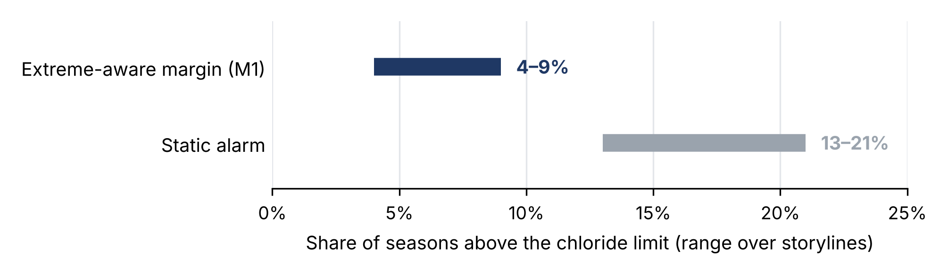
Figure 2. Preparatory synthetic result: range over storylines of the share of seasons above the chloride limit. These are tests on a synthetic coast, not results at Durrës.
5. Readiness now and at the end of the project
Technology readiness levels (TRL) on the EU definitions [c]: TRL 2 technology concept formulated, TRL 3 experimental proof of concept, TRL 6 technology demonstrated in a relevant environment, TRL 7 system prototype demonstration in an operational environment. Levels are the consortium's estimates.
Component | Innovations | TRL now | TRL M36 | Evidence behind the step
Certified multi-hazard warning system as a whole | M1–M5, P1–P5 | 3 | 7 | Proof of concept on a synthetic coast → twelve months of live operation with the operators
Certified alarm margin and joint guarantee | M1, M2 | 3 | 7 | Synthetic tests (4–9% vs 13–21%) → back-tested and verified live
Error-certified surrogate of the coupled model | M4 | 3 | 7 | Method components published → used for every live forecast
Coupled model with R(t), FS(x,t) and compaction | P1, P2, P4 | 3 | 7 | Preparatory coupled model → calibrated at the site and run live
Multi-hazard sensor design | M3 | 3 | 7 | Theory and preparatory design → network installed and streaming
Seismic velocity as coastal water-table sensor | P5 | 3 | 6 | Shown in inland basins → calibrated at the port or landfall
Pumping rule safe for three hazards | P3 | 2 | 6 | Concept formulated → evaluated and agreed with the utility
Certified value for each user | V1 | 2 | 6 | Bound derived → reported for each user from live data
6. Innovation in delivery
O1. Verification registered in advance. The back-testing protocol of D3.2 is published with a DOI before the results are computed, and D5.1 publishes the observed miss and false-alarm rates of the live warnings.
O2. Evidence gates with fixed thresholds. Live operation starts and the guarantees are stated only after gates MS3, MS4 and MS5 are passed, each with a go, go-with-conditions and no-go rule fixed in advance (Milestones).
O3. Transfer tested by an outsider. The software release D6.1 is accepted only when someone outside the team installs it and reproduces the synthetic test coast.
7. Protecting and sharing the innovation
• Open by default. Software under Apache-2.0 and data under CC BY 4.0 (D6.1), papers in open access, so Allies and partners can use the innovations without licence barriers.
• Restricted where security requires it. Asset-level results, sensor locations and vulnerability details stay with the operators and authorities (two-tier dissemination, Data Management Plan).
• Credit and reuse. Each release carries a DOI and a citation file; the synthetic test coast lets others reproduce the results without access to restricted site data.
8. What is new in this section
• Every novelty claim is checked against the literature. Each innovation names the 2020–2026 work it goes beyond, or states that no direct precedent was found in our search (M2, P3).
• Every innovation is a testable claim. Each has a pass test, a deliverable and a month, and the tests of M1, M4 and P2 decide the evidence gates.
• Innovations placed in the warning chain. Figure 1 shows where each acts, from observing the coast to verifying the warnings, so gaps and overlaps are visible.
• Readiness measured, not asserted. The TRL of each component is given now and at the end, on the EU definitions, with the evidence behind each step.
Sources cited
[1] Zheng, Y. and Simons, M. (2025). Integrating long-term InSAR monitoring into local groundwater management: insights from the Hollywood Basin, California. Water Resources Research 61(11). doi.org/10.1029/2024WR039161
[2] Larochelle et al. (2026). Abrupt transition to irreversible damage in the overdrafted Sacramento Valley aquifer system. PNAS 123(31). doi.org/10.1073/pnas.2526041123
[3] Li et al. (2025). Geodetic monitoring of elastic and inelastic deformation in compacting reservoirs due to subsurface operations. Journal of Geophysical Research: Solid Earth 130(3). doi.org/10.1029/2024JB030794
[4] Dangendorf et al. (2026). Variable contributions of vertical land motion to sea-level change inferred at tide gauges. Nature Geoscience 19, 814–821. doi.org/10.1038/s41561-026-02005-1
[5] Dangendorf et al. (2024). Probabilistic reconstruction of sea-level changes and their causes since 1900. Earth System Science Data 16, 3471–3494. doi.org/10.5194/essd-16-3471-2024
[6] Dangendorf et al. (2026). Human-driven sea-level rise has quadrupled the frequency of coastal sea-level extremes since 1900. Nature Climate Change 16(7), 796–803. doi.org/10.1038/s41558-026-02659-0
[10] Bullock et al. (2023). A latent Gaussian process model for the spatial distribution of liquefaction manifestation. Earthquake Spectra 39(2), 1189–1213. doi.org/10.1177/87552930231163894
[12] Qin et al. (2022). Monitoring seasonal shear wave velocity changes in the top 6 m at Garner Valley in Southern California with borehole data. Geophysical Research Letters 49. doi.org/10.1029/2022GL101189
[16] Mao et al. (2022). Space-time monitoring of groundwater fluctuations with passive seismic interferometry. Nature Communications 13. doi.org/10.1038/s41467-022-32194-3
[17] Shen et al. (2024). Fiber-optic seismic sensing of vadose zone soil moisture dynamics. Nature Communications 15. doi.org/10.1038/s41467-024-50690-6
[18] Clements, T. and Denolle, M.A. (2023). The seismic signature of California's earthquakes, droughts, and floods. Journal of Geophysical Research: Solid Earth 128(1). doi.org/10.1029/2022JB025553
[19] Angelopoulos et al. (2024). Conformal risk control. International Conference on Learning Representations (ICLR 2024). proceedings.iclr.cc/paper_files/paper/2024/hash/f3549ef9b5ff520a7e41ff3cc306ab2b-Abstract-Conference.html
[20] Angelopoulos et al. (2024). Online conformal prediction with decaying step sizes. Proceedings of the 41st International Conference on Machine Learning, PMLR 235, 1616–1630. proceedings.mlr.press/v235/angelopoulos24a.html
[21] Zhang et al. (2024). Discounted adaptive online learning: towards better regularization. Proceedings of the 41st International Conference on Machine Learning, PMLR 235, 58631–58661. proceedings.mlr.press/v235/zhang24e.html
[22] Dixit et al. (2023). Adaptive conformal prediction for motion planning among dynamic agents. Proceedings of the 5th Learning for Dynamics and Control Conference, PMLR 211, 300–314. proceedings.mlr.press/v211/dixit23a.html
[23] Ma et al. (2024). Calibrated uncertainty quantification for operator learning via conformal prediction. Transactions on Machine Learning Research, August 2024. openreview.net/forum?id=cGpegxy12T
[25] Kovachki et al. (2023). Neural operator: learning maps between function spaces with applications to PDEs. Journal of Machine Learning Research 24(89), 1–97. www.jmlr.org/papers/v24/21-1524.html
[26] Chen et al. (2021). Solving and learning nonlinear PDEs with Gaussian processes. Journal of Computational Physics 447. doi.org/10.1016/j.jcp.2021.110668
[30] Huan et al. (2024). Optimal experimental design: formulations and computations. Acta Numerica 33, 715–840. doi.org/10.1017/S0962492924000023
[L1] Mavroulis, S., Lekkas, E. and Carydis, P. (2021). Liquefaction phenomena induced by the 26 November 2019, Mw = 6.4 Durrës (Albania) earthquake and liquefaction susceptibility assessment in the affected area. Geosciences 11(5), 215. doi.org/10.3390/geosciences11050215
[a] Richardson, D. S. (2000). Skill and relative economic value of the ECMWF Ensemble Prediction System. Quarterly Journal of the Royal Meteorological Society 126, 649–667. www.ecmwf.int/en/elibrary/76153-skill-and-relative-economic-value-ecmwf-ensemble-prediction-system
[b] Murphy, A. H. (1977). The value of climatological, categorical and probabilistic forecasts in the cost-loss ratio situation. Monthly Weather Review 105(7), 803.
[c] European Commission. Horizon 2020 Work Programme 2014–2015, General Annexes, Annex G: Technology readiness levels (TRL). ec.europa.eu/research/participants/data/ref/h2020/wp/2014_2015/annexes/h2020-wp1415-annex-g-trl_en.pdf

