MACHINE LEARNING · PARADIGM 2 OF 4 · LEARNING CAUSES, NOT CORRELATIONS
Causal generative modelling: hidden causes, interventions and “what if”
CLASSICAL fit p(x) · factors up to a rotation · one condition
NEW latent causal model · regimes as interventions · counterfactuals

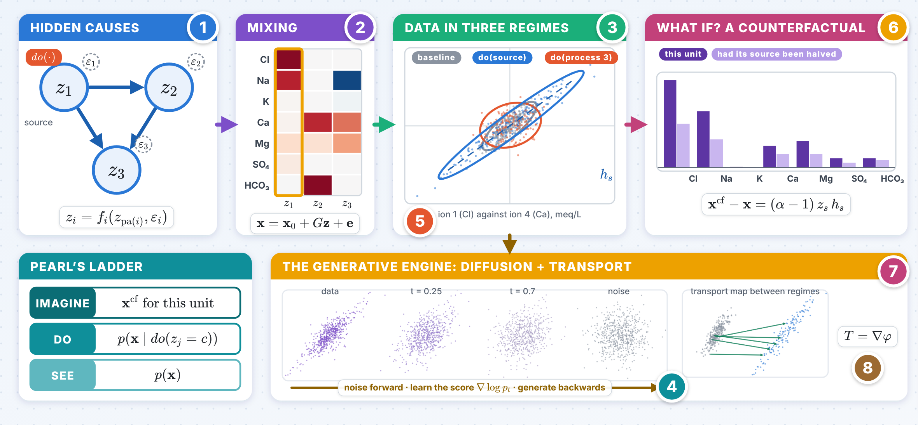
The numbers 1–8 in the picture point to the eight panels on the next pages; the innovation follows on the next page.

INNOVATION Known signatures replace interventions
Example: three hidden processes behind the chemistry of a well, with their stoichiometric signatures partly known.
1 One scale for knowledge and experiments
$$dim\left(\text{fibre of equally good models}\right)=\left(n−k\right)\left(n−1\right)$$
Baseline data leave $n\left(n−1\right)$ free dimensions. Each known column of the mixing removes $n−1$, as much as one intervention: 6, 4, 2, 0 for three processes with 0–3 known signatures, at 20 random parameter values.
6 → 0 with 3 signatures
2 One regime on a source identifies its counterfactual
$$Σ_{k}−Σ_{0}=\left(σ_{k}^{2}−1\right) h_{s}h_{s}^{⊤}, x^{cf}−x=\left(α−1\right) z_{s} h_{s}$$
A period of different pumping identifies the chemistry of a well had its seawater fraction been halved, while four dimensions of the model stay free; median error 2.8% from simulated wells.
2.8% median error
3 Identify the answer, not the model
$$J_{q}N=0 ⇒ q \text{is constant on the fibre}, \text{share}=\frac{∥J_{q}N∥}{∥J_{q}∥}$$
Identified queries have shares below ${10}^{−14}$, the others above $5⋅{10}^{−5}$. The exchange counterfactual needs a regime on exchange itself, and identified is not estimable: a rival optimum within the noise gave 169% error.
10¹⁰ separation

Causal generative modelling · panels 1–4
1 Hidden causes: structural models  IDEA Latent causes follow their own mechanisms and the data mix them. An intervention replaces one mechanism and keeps the others.  $$z_{i}=f_{i}\left(z_{pa\left(i\right)},ε_{i}\right), x=g\left(z\right)+e$$  pz∣dozj=c=i≠j​pzi∣zpai∣zj=c  2020–2026 Causal hierarchy: data from a lower rung of the ladder do not fix the answers of a higher one. The field follows the survey of Komanduri, Wu, Wu & Chen (TMLR 2024). |  | 2 Identifiability needs variability  IDEA With nonlinear mixing one condition cannot recover independent latents (Darmois); variation across regimes, domains or time restores them.  pz∣u=i​QiziZiuexp​j​Tijziλiju  $$⇒ T\left(z\right)=M T\left(\hat{z}\right)+c, {\hat{z}}_{B}=h_{B}\left(z_{π\left(B\right)}\right)$$  2020–2026 iVAE (Khemakhem, Kingma, Monti & Hyvärinen 2020); additive decoders identify blocks (Lachapelle et al. 2023); graph layers from observational data (Welch, Zhang & Uhler 2024); partial views (Yao et al. 2024).
3 Interventions identify  IDEA An intervention changes one mechanism, so it moves the data along a direction that reveals the mixing.  $$Θ_{k}=H^{⊤}B_{k}^{⊤}B_{k}H, B_{k}=Ω_{k}^{−1/2}\left(I−A_{k}\right)$$  $$B_{k}−B_{0}≠0 \text{ only in the row of the intervened latent}$$  2020–2026 One intervention per latent is sufficient and in the worst case necessary (Squires, Seigal, Bhate & Uhler 2023); soft ones leave ancestors mixed (Zhang et al. 2023); unknown targets need pairs (von Kügelgen et al. 2023) or graph conditions (Jiang & Aragam 2023). |  | 4 Scores reveal the mixing  IDEA Under an intervention the score of the latent law changes only in the intervened variable and its parents.  $$∇_{z}lnp^{k}−∇_{z}lnp^{0}=∇_{z}ln\frac{q_{i}^{k}\left(z_{i}∣z_{pa\left(i\right)}\right)}{q_{i}^{0}\left(z_{i}∣z_{pa\left(i\right)}\right)}$$  $$∇_{x}lnp_{X}^{k}−∇_{x}lnp_{X}^{0}=J_{g}^{−⊤}\left(∇_{z}lnp^{k}−∇_{z}lnp^{0}\right)$$  2020–2026 Score-based causal representation learning for linear and general mixing (Varıcı, Acartürk, Shanmugam, Kumar & Tajer 2025): the same score functions that diffusion models learn.

Causal generative modelling · panels 5–8
5 Time and hidden regimes  IDEA Latents independent given the past, with transitions that vary enough, are identified; a hidden regime can be inferred first and then used as the auxiliary variable.  pzt∣zt−1=i​pzt,i∣zt−1,ut  $$⌊\log_{2}n⌋+2 \text{distinct actions identify }n \text{latents}$$  2020–2026 BISCUIT: binary interactions of an agent with the system (Lippe et al. 2023); unknown nonstationarity as a hidden Markov regime (Song et al. 2023). Monitoring records with operating decisions are such sequences. |  | 6 Counterfactuals for one unit  IDEA Abduction recovers the unit’s own noise, action changes a mechanism, prediction replays the model.  $$ε_{i}=f_{i}^{−1}\left(x_{i};{pa}_{i}\right), x_{i}^{cf}=f_{i}\left(ε_{i};{pa}_{i}^{cf}\right)$$  $$x^{cf}=∇φ\left(x\right), {\left(∇φ\right)}_{\#} p\left(x∣pa\right)=p\left(x∣{pa}^{′}\right)$$  2020–2026 Bijective models identify counterfactuals (Nasr-Esfahany, Alizadeh & Shah 2023); dynamic optimal transport (De Sousa Ribeiro, Santhirasekaram & Glocker 2025); fitting data does not fix the edits (Pan & Bareinboim 2024); bounds under hidden confounding (Jesson, Mindermann, Gal & Shalit 2021).
7 The generative engine: diffusion  IDEA Noise the data with an Ornstein–Uhlenbeck process and learn its score to run it backwards.  $$dX_{t}=−X_{t} dt+\sqrt{2} dW_{t}$$  $$dY_{t}=\left(Y_{t}+2∇lnp_{T−t}\left(Y_{t}\right)\right)dt+\sqrt{2} d{\overline{W}}_{t}$$  2020–2026 KL bounds nearly linear in the dimension (Benton, De Bortoli, Doucet & Deligiannidis 2024), linear in the intrinsic dimension (Potaptchik, Azangulov & Deligiannidis 2025); denoising Markov models (Benton et al. 2024); Riemannian score models (De Bortoli et al. 2022). |  | 8 Transport, rates and honest scores  IDEA Entropic optimal transport compares regimes at a rate free of the dimension; recovered latents are scored by matching them to the truth.  $${OT}_{ε}\left(μ,ν\right)=\min_{π∈Π\left(μ,ν\right)}∫c dπ+ε KL\left(π ∥ μ⊗ν\right)$$  $$E\left|{OT}_{ε}\left({\hat{μ}}_{n},{\hat{ν}}_{n}\right)−{OT}_{ε}\left(μ,ν\right)\right|≲C_{ε}/\sqrt{n}$$  2020–2026 Dimension-free sample complexity of entropic transport (Rigollet & Stromme 2025); the mean correlation coefficient after matching and the structural Hamming distance as benchmarks.

